Adam Mead
Watchlist Investing
Copart Update
What we know so far about the $1.9 billion ACV acquisition and an update on FY 2026 results.
Adam Mead
Sep 16, 2026



Private Investment Coaching

Copart Update
Disclosure: Long CPRT (prior analysis)
On September 10, Copart released its Q4 and Fiscal 2026 earnings and announced the largest acquisition in the company’s history. All in a day’s work, I guess.
The Q4 results were uninspiring, but there’s more going on beneath the surface. Then there’s the $1.9 billion acquisition of ACV…

ACV Auctions
Copart and ACV will combine in a friendly cash transaction that values ACV at $1.9 billion. Enterprise value = equity value as ACV has no net debt. Copart is paying 2.5x ACV’s 2025 revenue and 32x adjusted EBITDA.
The deal is expected to close by the end of the calendar year and will eat up 40% of Copart’s current $4.5 billion cash/equivalents.

What is ACV?
ACV operates the largest digital-only dealer-to-dealer wholesale vehicle auction business in the US. It sold over 800,000 vehicles worth over $10 billion in 2025. And it did this with an average of just $10 million in net fixed assets.
ACV makes money through its digital marketplace that connects 22,000+ buyers and 14,900+ sellers of used vehicles. A vehicle trade-in is inspected on the dealer’s lot by one of ACV’s 850 inspectors, whose condition report feeds into a live, 20-minute auction.
The two interrelated keys to ACV’s operation are its comprehensive inspection report that describes what the buyer will receive, and its assurance guarantee that the report is accurate. If a buyer finds the report and the vehicle don’t agree, they can receive compensation under industry-standard NAAA Policy guidelines (Manheim and OPENLANE also adhere to it).
ACV’s success stems from building a two-sided network in which trust is established.

How Does ACV Make Money?
Of the company’s $760mm revenue in 2025:
- $348mm (46%): Auction marketplace. These are fees from buyers and sellers upon the successful completion of an auction.
- $296mm (39%): Other marketplace services such as transportation and ACV Capital (dealer financing of inventory)
- $82mm (11%): Customer assurance revenue from sellers guaranteeing the vehicle will sell.
- Data / SaaS (5%): Reports and inventory management

ACV’s Cost Structure
Its 2025 expenses of $823mm (operating loss of $63mm) fall under five categories:
- $288mm (38% of sales): Marketplace and service cost of revenue.
- $73mm (10%): Customer assurance cost of revenue.
- $183mm (24%): Operations and technology.
- $235mm (31%): Selling, general, and administrative.
- $44mm (6%): Depreciation and amortization.
A little more on the D&A expense. As noted above, the company operates with almost no fixed assets. At year-end 2025, gross fixed assets were $19mm and were made up of fairly short-lived assets (computers, equipment, furniture, leasehold improvements, vehicles). The bulk is from “A” stemming from acquired intangibles and internal-use software (about $80mm each, net, at the end of 2025).

What Does Copart See in ACV?
- Complementary assets: ACV brings its extensive network and volume to Copart’s existing assets, allowing for a complete digital remarketing platform across trade-ins, wholesale, salvage, and international.
  - ACV can leverage Copart’s extensive network of physical assets. With no real home base, ACV must rely on dealers to house inventory. Copart can allow ACV to remove vehicles to its yards and free space on dealer lots (Adair noted they would create dedicated ACV areas in certain locations).
  - Copart gains additional volume for its international buyers and can leverage its existing infrastructure (moving 15,000 to 20,000 cars per day in the US alone).
  - Technology. Both companies have unique technology that’s worth more together. Essentially, it widens both sides of their respective networks with shared underlying logistics infrastructure.
- Immediate presence in wholesale. Copart will have an immediate foothold in wholesale auctions. Already, 25% of Copart’s volume is from noninsurance BluCar (banks, rental fleets, and the like) and dealer services. ACV’s network is better suited to the types of buyers of these vehicles.
- Culture. I was struck by the comments Adair made regarding ACV’s culture on its Q4 earnings call. He called them a scrappy, friendly bunch with a start-up culture. Just like Copart.
- Growth Engine. The table below shows a clear progression of unit volume growth and revenue per unit growth. While ACV was founded in 2014 and has an accumulated deficit of half a billion dollars ($568 million to be exact), the trends are positive. Copart expects the acquisition to be neutral to earnings in FY 27 and accretive beginning in FY 28.
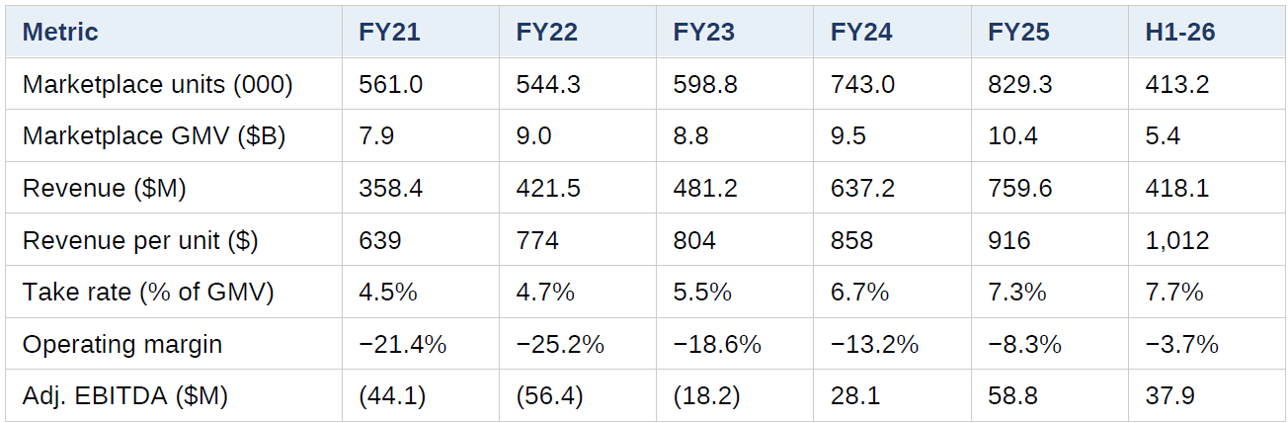
This slide from Copart’s Investor Presentation sums up the deal nicely:
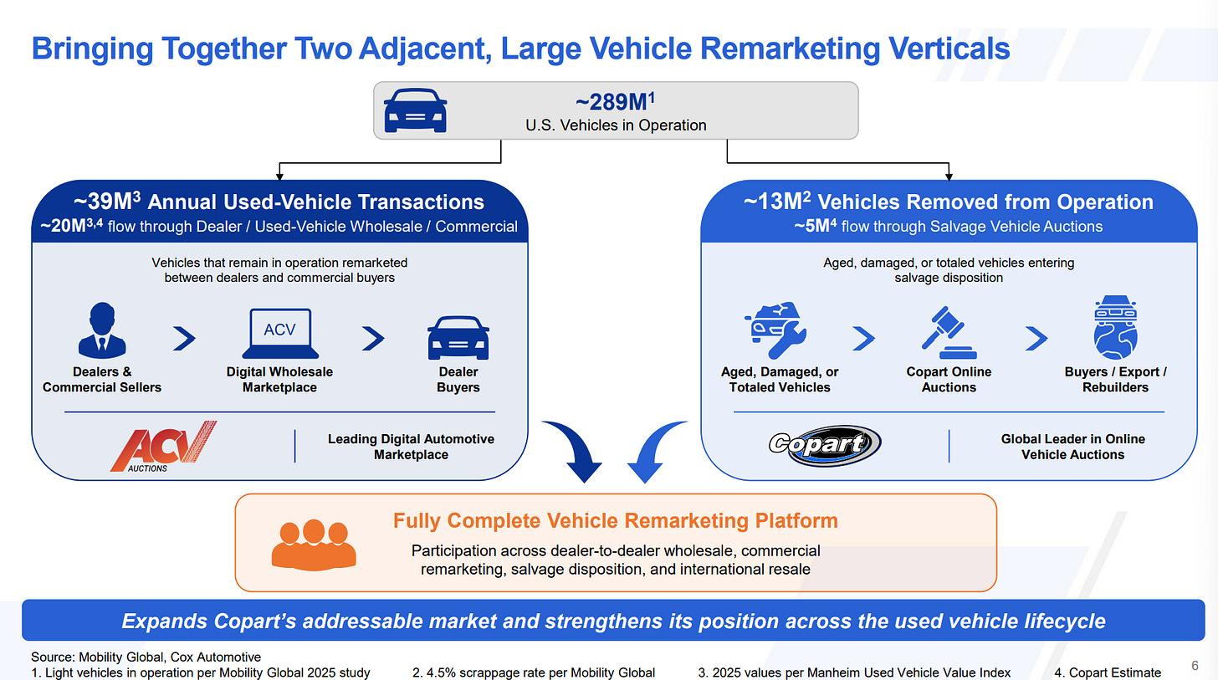

Copart Q4 and FY 2026 Results
Jay Adair exuded confidence on the most recent conference call. Sure, results weakened in FY 26 (G&A ex. depreciation increased 7% for the year, and Q4 US operating margin fell five points, from 38.6% to 33.6%; US operating margin fell 110 bps, from 38.4% to 37.3% for the year), but there’s a clear sense that this is truly cyclical (insurance prices up > coverages down > Copart volume down) coupled with some one-off factors like the loss of assignments from Progressive. Excluding the single lost customer (cough: PGR), US insurance assignments would have been up 2.3%. Adair’s confidence in Copart’s ability to deliver comes through in his couched comments on IAA: “You either can generate the liquidity … that are going to bring the dollars in for the customer. Or you’ve just got to cut pricing dramatically… we don’t need to play that game.”
There’s also the matter of facility costs increasing 14% on a unit basis, which appears to be partly a result of Copart’s investment in long-haul delivery service. Adair pointed to a focus on reducing per-unit costs as a priority.
The other big plus: International units and revenue increased about 11% in Q4, and units increased 3.7% for the year, with Adair noting that all international markets are now profitable.
To sum up: global units fell 5.5% for the year, but revenue per unit increased 5.7%, leading to global revenues up 0.4% to $4.67 billion. Meanwhile, costs increased, partly due to investments, leading to a 2.6% decline in operating income to $1.65 billion; operating margin fell 110 bps from 36.5% to 35.4%. Net income declined 4.4% to $1.48 billion due to the lower operating income, a higher tax rate, and a one-time gain in FY 25.
The major capital allocation moves in FY 26 were $1.63 billion of buybacks and $87mm growth capex ($337mm gross).
On buybacks: There was no buyback activity in Q4. Given that shares trade at $32 vs. the $38 range where they bought back shares earlier, I’m wondering if management sees more M&A coming sooner rather than later.

Q4:
- Revenue $1,152mm, +2.4% (service +1.4%; purchased vehicle sales +8.3%)
- Gross profit $481mm, -5.5%; margin 41.8% vs. 45.3%
- Operating income $369mm, -10.6%; margin 32.0% vs. 36.7%
- Net income $327mm, -17.4%; diluted EPS $0.35 vs. $0.41 (Q4 FY25 had a $13mm one-time gain; lower interest income after buybacks)
- US facility costs +7.7% (+14.2% per unit) on new services: long-haul delivery, Title Express, dedicated wholesale facilities
- OpEx per car +12.7%; Adair says cutting it is a focus
FY 2026:
- Revenue $4,666mm, +0.4% (+2.4% ex-FY25 hurricanes)
- Gross profit $2,084mm, -0.8%; margin 44.7%
- Operating income $1,653mm, -2.6%; margin 35.4% vs. 36.5%
- Net income $1,484mm, -4.4%; diluted EPS $1.55 vs. $1.59
- US facility costs -0.7% (+6.6% per unit)
- Operating cash flow $1,604mm; gross capex $337mm (vs. $569mm)
- Buybacks $1.63bn; $4.5bn cash/HTM securities, no debt
Volumes and other metrics (Q4 y/y unless noted):
- Global units -2.9% (FY -5.5%; -3.1% ex-CAT)
- US units -5.7% (FY -6.9%); International +10% (FY +3.7%)
- US insurance units -7.5% (FY -8%). Ex-one lost customer, US insurance assignments would be +2.3%
- US non-insurance units +0.2%, back to growth (FY -3.9%): dealer +5.8%, BluCar ~+20%, Copart Direct -11.7%
- International insurance units +11.2%; International revenue +11.7%, op margin 25.6%
- ASPs: global +3.5%, US insurance +3.7% (Manheim index +2.8%); global FY +5.5%
- Revenue per unit +5.4% (FY ~+5.7%, per management); International fee revenue per unit +3.5%
- Industry: collision claim frequency -3.4%; total loss frequency 23.3% (record calendar Q2); severity +8.8%
- International buyers: 38.2% of US units, 45.7% of US dollars sold (FY26)

Impact on Valuation
Copart thinks it’s worth laying out $1.9 billion for ACV and understands its own return profile. Maybe it’s not going to earn 30% on capital, but even 20% (low for Copart standards) would need to produce almost $400 million in incremental EBIT to justify the purchase.
Things will look messy until the integration and synergies begin to accrue in FY 28. In my valuation framework, it’ll immediately add $1.9 billion to capital employed. This will cause lower capital turnover and margin, resulting in a temporarily depressed average ROCE for FY 27.
So where does that leave us for valuation? I’m leaving my previous analysis unchanged. Exchanging cash for a business simply changes the asset, and I’ll leave it at a 1:1 ratio for now until the facts dictate otherwise.

More thoughts? Let me know in a private message or leave a comment.
Leave a comment
Stay Rational!
Adam
Watchlist Investing is a reader-supported publication. To receive new posts and support my work, consider becoming a free or paid subscriber.
Subscribe

Order the 2nd Edition Now!


Praise for the 2nd Edition
I’m incredibly grateful for the people who took the time to review early drafts of the new material and provided feedback, as well as praise for both editions:
“If you want to understand how Warren Buffett built Berkshire Hathaway into one of the most valuable businesses in the world, you have to read this book. This is your opportunity to stand beside Picasso as he paints each brush stroke. A must read for all Buffett and Berkshire groupies.”
- Bill Ackman, Founder and CEO of Pershing Square
“I and my teammates at the Gabelli Organization have been tracking Warren’s success for some 50 years. Adam’s book captures the work and highlights the history of Berkshire and the hard and diligent work of Buffett and Munger, Jain and Abel, and Combs and Weschler.”
- Mario Gabelli, Chairman and CEO, Gabelli Funds
“Adam Mead’s discussion of the values and virtues which have shaped Berkshire Hathaway over 50 years is a must read for those investors in search of the forces that have delivered such investment value over time.” – Thomas A. Russo, Gardner Russo & Quinn LLC
“Few activities can be more rewarding for any value investor than studying the history and evolution of Warren Buffett and Berkshire Hathaway. Adam has done us a huge favor with his yeoman efforts in producing this treatise. Since it is chronologically ordered, it is an invaluable reference guide for all things Berkshire.” — Mohnish Pabrai
“Adam continues to deliver a resource very valuable to both Berkshire fans and the investor community as a whole, his depth of knowledge is clearly demonstrated here again. I thoroughly enjoyed this latest addition.” - Dan Calkins, Chairman & CEO, Benjamin Moore
“The question must be asked, ‘Why another Berkshire book?’ When you read this monumental effort by Adam Mead, the answer will be obvious. Read cover to cover, both the uninitiated to Berkshire and its most ardent followers will derive enormous utility and satisfaction from it. I learned so many new and important things about Berkshire and its history. It is my pleasure to encourage you to enjoy this gem.”
- Christopher P. Bloomstran
“Whatever Adam writes is always first-class - guaranteed.
-Andy Kilpatrick, Author, Of Permanent Value: The Story of Warren Buffett

Undiscoveredcompounders

CoCopart: a wonderful company at a wonderful price (I bought it, of course)

It's not a small cap, but the opportunity is too asymmetric to ignore.

Undiscovered Compounders

Aug 29, 2026

Copart (CPRT.NAS) just lost about 50% over the past year, falling back to historically low valuations. I'm convinced the market is wrong, so I bought it.

Of course, you shouldn't invest based on my conviction alone (or anyone else's). That's why I'm giving you the entire thesis behind it: every source, every argument, every figure, every assumption, so that even someone who knows nothing about the company or the industry can form their own judgment. Better still, I built this deep dive so that anyone who reads it in full knows the company and its sector better than 99% of its shareholders.

Over 55k words, representing hundreds of hours of work. I'm also providing a fully built-out valuation model so you can easily plug in your own assumptions. Don't take my word for any of it. Check the work. Then check it again.

This is simply how I work. I take the "deep" in deep dive very seriously, and I respect my readers' intelligence and rigor. One small detail: this piece is entirely free. That's exceptional. Think of it as a preview of the work I deliver behind the paywall. I'm not going to market it; I'll let the quality of the work speak for itself. Let's get into it.

Subscribe

3 things before we start:

All the sources/citations I don’t attribute by name come from Copart’s recent filings and transcripts. That way I’m not stacking four citations per paragraph and making the whole thing harder to read. When it’s really relevant, I’ll cite the specific filing/transcript.

This email is a heavy one, so you’ll probably get a much better experience reading it in the app or on the website.

A word of advice: we’re going to be together for a few hours, so you might want to grab a coffee/tea and a source of glucose. Your neurons are going to need both.

For those who'd rather start compressed, here's a 10-minute version of the most important bits. I can't compress the alpha any more than that.

0. Table of Contents

The basics

The Copart model

The land, the crown jewels

The auction

Scale and pace

The business model: both sides of the counter

The two main variables

Salvage vs. non-salvage

Vocabulary and logic

How it actually plays out

The impact of the salvage title

The seller who brings the cars

The seller typology

Properly counting supply

Properly qualifying supply

The particular paradigm of rental car companies (Blue Car)

The three contracts Copart bills the seller for

How an insurer account is won, lost, and split

Winning a contract

Losing a contract

The built-in symmetry

What the insurer decides

Repair vs. Totaling

The entire spectrum

Copart’s weapons

Pure sale vs. managed sale

The buyers

Buyer typology

The power of exporters

Cross-selling

The buyer fee schedule

The convexity of prices

Fees outside the auction

What the fee schedule can’t tell you

When Copart buys the car

What we know now

The Lands

What a Copart site is

The permit vs. the land

What happens when you don’t own

Who built it, and when

The contract that drew the map

How Copart chooses where to buy

Recreating the land

CAT capacity

Making the land produce

The limits of the land

The competition

Who the competitors really are

IAA

The two buyer fee schedules

Where the competition really plays out

How to measure a delivered outcome

Comparison between competitors

Comparing a single entity over time

The duopoly clients keep alive

The asymmetry of accounts

Competing with repair

Total-loss frequency

The equation and its implications

Total Loss Share of Claim Count

The numbers

The trend

Repair and recovery

Global trends

Local trends

The consequences for the insurer

The marginal vehicle

Electric vehicles

The fleet on the road, and its accidents

Self-driving

Current scale

The clock

The self-driving car inside Copart’s machine

Legislation

The trend summed up

The crux

A summary of the current situation

The clean series

The dislocation

Coverage

The carrier mix

What’s left over

Cyclical vs. secular

Prices

The Mix effect

The Progressive shift

Mr. Market’s timeline vs. reality

The financials

A quick glance

The P&L

Balance sheet

Cash Flow Statement

How to read the numbers

Where the costs go

When the machine stalls

What one point of unit growth means for earnings

The logic

The formula

The complexity of the real world

Capex, and what normalization really tells us

A summary of the present and the recent past

Capital allocation

What to do with each dollar

Share buybacks

The strategy so far

The 2026 buybacks

M&A

M&A history

A concrete example: Purple Wave

What will they do with future cash?

The people

Who decides, under what incentives?

The incentives

Insider buying/selling

A retrospective on each tenure

Is management a moat?

Future growth

A typology of growth

United States, insurance

United States, non-insurance

International

The current situation

The ceiling and the real source of growth

Non-insurance and the foot in the door

Growth and M&A

What money can buy

The US

International

CCC Intelligent Solutions Holdings

A summary of growth

The risks

The existential risks

The TLF/ASP dynamic

The number of accidents

The current trend

The self-driving car

Everything else

The auction room

Non-existential risks

Competition

The near-to-medium term and the insurance cycle

The long term

Losing land in a closed zone

Key-person dependency

The CCC price tag

The return to managed sale

VB3’s single point of failure

CAT events

Legislation that closes a door

The DOJ

How I approach these risks as an investor

Valuation

The heart of the matter: the multiple

The logic of the multiple

The limits of EV/unlevered FCF

The valuation method

The construction

The false sampling bias

The variables

US units

International units

Revenue per unit

Costs

The exit multiple

The values

The multiple’s time horizon

Capital allocation

The final table

What I’ll be watching

Conclusion & Disclosure

I’m not a financial advisor and this isn’t financial advice. Your money, your judgment, your risks, your returns. The fine print here.

1. The basics

1.1 The Copart model

A car is involved in a severe crash. The car is towed to a suitable location. An adjuster assesses the cost of repairs and sends his report to the insurer. The insurer compares the estimate to the vehicle’s value before the accident. When the repair estimate comes back too high (generally > 70-80% of the value), the insurer decides not to repair the car. It declares the car a total loss, compensates the owner for its pre-accident value, and takes ownership of the car, which it then resells. The adjuster has done his job, the insured is insured, and the insurer is left with a two-ton wreck taking up space that it doesn’t know what to do with.

Copart’s business model is to arbitrage away as much friction as possible in this process. It picks up the crashed car wherever it is (at a repair shop, on the roadside, etc.) and tows it to one of its 281 sites. Once the car has been assessed and declared a total loss, it cleans it (apparently that’s very important), photographs it from 30 different angles, handles a bit of paperwork, and lists it on its auction platform. The buyer (very often an auto professional) could be in Dubai, in Vilnius, or just three kilometers away. Copart takes a fee from the insurer and from the buyer, and everyone goes home happy.

Copart has provided the capacity, moved the vehicle to its site, provided the land, prepped the car, handled the paperwork, published the listing on its platform, taken care of a bit more logistics, and there you go.

If needed, Copart offers a few additional services. It operates its own appraisal services (Copart Co.ai), its DMV processing services (title transfer, status filing with registration authorities, etc.) and a few other services whose objective never changes: making life simpler for everyone who needs to get rid of a vehicle.

Copart has two types of revenue from vehicle sales:

Service fees, when Copart positions itself as an agent between a seller and a buyer ($3.97B in FY25, or 85.4% of revenue).

Buying and reselling vehicles on its own account, often out of obligation ($0.68B in FY25, or 14.6% of revenue). Some service fees can still apply in this case, but they’re fairly immaterial.

More than 85% of its revenue comes from commissions on someone else’s property, and for that 85%, Copart carries neither the inventory nor the working capital that comes with it. The remaining 15% comes largely from how insurers operate abroad and from its own ability to take advantage of its highly liquid auction floor. We’ll obviously come back to all of this in depth.

Copart is a textbook example of arbitraging away constraints that bother everyone, pushed to the extreme over decades. That has made it an unavoidable player in the industry, and it remains one as long as incentives stay aligned.

1.2 The land, the crown jewels

A Copart site is a parking lot. A very large parking lot, and a well-maintained one at that: it’s fenced, drained, lit, and above all, full of crashed cars patiently waiting to be assessed, auctioned, or shipped. The latest 10-K counts 281 of them worldwide. In total, Copart operates “more than 21,000 acres of land globally,” owning more than 90 percent outright.

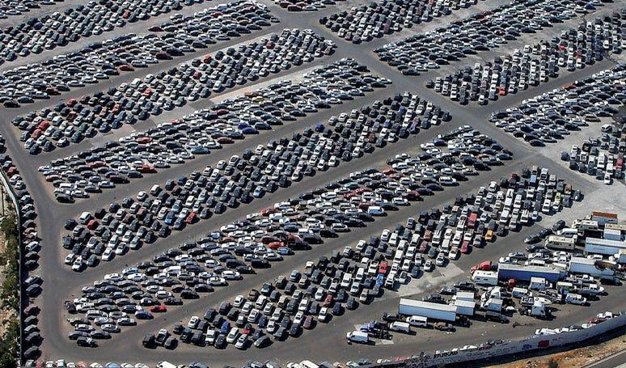

Copart is the dominant player in a de facto duopoly, and its main competitor is IAA (Insurance Auto Auctions). I’m saving why I call it “dominant,” how the duopoly came about, and why it’ll stay a duopoly for later.

1.3 The auction

Copart began selling cars on its own online platform in 1998 (that’s early, very early, 3 years after eBay) before going fully online in 2003. The platform is called Virtual Bidding Third Generation (VB3) and soaks up a good chunk of the group’s 1,000 engineers.

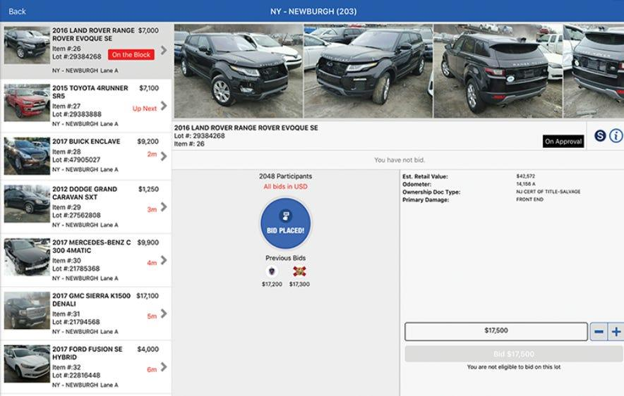

Like any auction platform, the first link in the chain is the seller, the one who has the car, so in most cases for Copart, the auto insurer. The seller has little involvement on the platform, often acting as little more than an observer. In most cases, Copart picks up the car, brings it to one of its sites, prepares the listing, and sells it (all of it governed by contracts of varying length).

The last link in the chain is the car’s buyer. It’s almost always an auto professional (dismantlers, repairers, exporters, dealers, etc.).

Both parties have their own fee structures that define the industry, but I’m saving that for the next part.

1.4 Scale and pace

Copart was founded in 1982 and has traded on the Nasdaq since 1994. The company’s founder, Willis Johnson (who started out in a junkyard in Vallejo, California), is chairman of the board. Jay Adair (incidentally the founder’s son-in-law) joined Copart in 1989 and was CEO from 2010 to 2022, then became CEO again on July 31, 2026. Jeff Liaw held the role in between (Adair co-led with Liaw from 2022 to 2024). This is the kind of company where there’ll be a lot to say about management and how it’s evolved over time.

But first, a little eye candy:

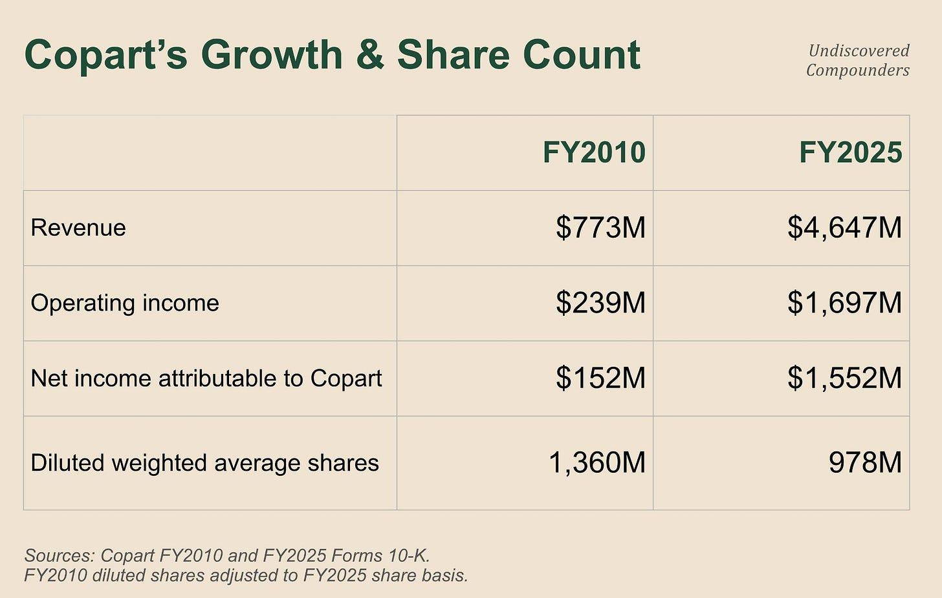

Revenue that’s 6x’d, net income that’s 10x’d, with 28% of shares retired along the way. Operating margin was 36.5% in the latest fiscal year, with $1.8B of OCF, and $4.8B of cash on the balance sheet with zero financial debt. The US accounts for 83% of revenue, and international markets for 17%. Small subtlety: foreign exporters who buy wrecked cars in the US to export them elsewhere count as US revenue. So the figure lies a little (but I forgive it).

Everything screams exceptional business. It’s a favorite of the quality-investor sect, and deservedly so.

Yet the company has been in free fall since 2025, down about 50% from its high, and back to historically low valuations: the theoretically perfect entry point for a quality investor.

The eternal question: at what price does the probability-weighted range of possible outcomes offer enough return relative to the risks?

First step toward answering it: the business model, and its many, many subtleties.

2. The business model: both sides of the counter

2.1 The two main variables

Revenue = Units x Revenue per Unit (RPU). The number of vehicles put up for sale, multiplied by what Copart collects on each one. Nearly everything else in this deep dive will help us understand, more or less directly, how these two terms move, why, and by how much.

In total, Copart remarkets roughly 3.5 to 4.5M cars a year. Most of that volume consists of salvage vehicles, meaning cars that, at some point in their life, were declared a total loss by an insurer, a rental company, a bank, etc., rather than repaired (they can still be in running condition). The salvage title is the official document issued by a state DMV (Department of Motor Vehicles) that officially recognizes the vehicle as salvage. Unit prices range from a few tens of dollars to several tens of thousands (and more for certain special vehicles), with most of the volume concentrated around $5-10k.

The second variable, RPU, is even more complicated. The fee schedule is public only on the buyer side. Everything on the seller side (so mostly insurers) is close to a closely guarded secret, both on Copart’s side and on the insurers’ own side. But you can manage without it. Keep in mind that RPU depends mainly on the Average Selling Price (ASP, the average price of vehicles sold on Copart’s platform): the higher the ASP, the higher the RPU, and vice versa. So note that a lower number of units paired with a higher ASP (and therefore a higher RPU) can be positive for Copart; that’s part of the essential subtleties to keep in mind.

These two variables (plus ASP) also depend on how the auto sector evolves globally, how the insurance sector evolves, and on macro conditions as well. This will actually be one of the key points of the write-up, and one of the bears’ big arguments. Sometimes wrongly, sometimes rightly. But one thing at a time.

2.2 Salvage vs. non-salvage

2.2.1 Vocabulary and logic

A DMV issues a title with “salvage” written on it. From that point on, the vehicle can no longer legally be driven. Yet a lot has happened between the accident and getting the title, and quite a bit more will happen after.

But first, a little vocabulary.

A DMV can issue 4 types of titles for a car:

Clean -> No issues, or damage that stayed under the legal threshold set by the state.

Salvage -> Total loss declared with damage deemed repairable. Registration stays suspended until a state inspector has personally conducted a thorough inspection to determine whether the vehicle can be driven: VIN check part by part against stolen parts, itemized invoices required for every part, before-and-after photos, etc. Nobody goes through this process for fun.

Rebuilt -> A salvage vehicle that’s been repaired and inspected by the state, back in legal circulation. That said, insurers are less fond of this type of vehicle and sometimes even refuse to insure them.

Nonrepairable/junk -> Deemed irreparable, never returns to circulation and in most cases goes off for parts.

The logic is simple. However, neither insurers nor Copart think about it quite the same way.

The insurer simply thinks in terms of repairing vs. totaling, based on economic arguments. The salvage/clean process only comes into play if there’s been a total loss.

For Copart, management talks about:

Clean title -> Never declared a total loss by an insurer.

Non-Clean Title -> Declared a total loss by an insurer at some point, whether because of an accident five years ago after which it was legally “Rebuilt,” or because of a recent accident that just resulted in a salvage title. This category obviously also includes nonrepairable/junk.

Enough theory, on to practice.

2.2.2 How it actually plays out

Most situations fit the following scenario:

An incident damages a vehicle. The insurer decides whether to repair or total it before the question of a salvage title even arises.

If it chooses to repair, the salvage question doesn’t come up and the car keeps its clean title and gets back on the road after repair, with no special inspection.

If it chooses to total it, the insurer takes ownership of the vehicle (in the large majority of cases), and has a legal obligation to notify the National Motor Vehicle Title Information System (NMVTIS) within 30 days of the total-loss declaration.¹ If the repair cost exceeds a certain threshold of the Actual Cash Value (ACV), the insurer is required to request a salvage title from the DMV (which can take several weeks, even months). These thresholds are set state by state, we’ll come back to them.

So it’s the total-loss declaration that triggers the potential reclassification as salvage. This subtlety is essential, so let me restate it: the salvage-title question only comes up if the insurer has totaled the vehicle. (To be fully rigorous, that’s not always true. For instance, a vehicle can be automatically classified as salvage by the state even if the insurer hasn’t decided on the total loss yet. But those cases are too unusual to be relevant here.)

2.2.3 The impact of the salvage title

In practice, Copart handles a lot of salvage titles. To understand what that implies, let’s go back to the root of Copart’s business model: auctioning off vehicles that not many people want.

The salvage title is going to affect both sides. It’s going to make the price hard to “guess,” and it’s going to make sure fewer people want it.

On price. A salvage vehicle loses its standard valuation, literally. Kelley Blue Book (the car pricing guide consulted by pretty much every player in the US) stops publishing values for salvage vehicles and points to a case-by-case appraisal instead.² Pricing difficulty means arbitrage opportunity. To arbitrage, you need to be able to buy the cars, and that’s where Copart positions itself with its auction platform.

For buyers themselves, it’s very often a matter of law. In a majority of states, you need to hold a specialized license or go through a licensed broker to be able to buy salvage vehicles. It’s purely arbitrary: take two identical cars, with the same damage. One classified clean, one classified salvage. Everyone can buy the first one, while only a very small subset of buyers can buy the second. For nonrepairables, the number of players able to buy them shrinks even further.

Conversely, the US clean vs. salvage distinction doesn’t matter at all to a foreign buyer. This type of buyer thinks almost exclusively in economic terms (economic arbitrage is sometimes just legislative arbitrage in disguise, we’ll come back to it).

Before moving on to buyers, let’s look at sellers.

2.3 The seller who brings the cars

2.3.1 The seller typology

About 80% of the units that pass through Copart’s hands come from insurers and their policyholders. When I write “insurers,” think mainly of the big insurers with nationwide footprints. The top 10 biggest auto insurers together represent 75% of the market, with number 10 accounting for less than 3% market share.³ Each local branch of a big insurer has some discretion, but only some. At the group level, insurers tend to diversify by splitting volumes. We’ll come back to that later. The point to remember here: insurance = a few big clients, but where each big client has a branch-by-branch volume-allocation strategy.

Three sub-segments make up the remaining 20%, what management calls non-insurance:

Blue Car. Blue Car consists of banks, rental car companies, and fleets. Picture a lender that repossesses a defaulted vehicle in rough shape and doesn’t know what to do with it. The poor thing sometimes even has to go pick it up from the impound lot. The friction is total. Fortunately, Copart has logistics and storage capacity inherited from its insurance business, and these players tend to end up in the same places as insurers (thank urbanization). So Copart took advantage of that to offer them its service, wiping out that friction entirely, to “recover vehicles they previously would have abandoned altogether.”

Dealers, via Copart Dealer Services (CDS) and National Powersports Auctions (motorcycles, RVs, boats). A trade-in too old or too beat-up for the dealer’s lot goes straight to auction. This is mainly Buy Here Pay Here, meaning in-house financing for borrowers nobody else dares lend to, with the dealer repossessing the vehicle after payment defaults. The dealer hires Copart to auction off these repossessed vehicles on its platform. This is a channel Copart is increasingly opening up to independents and franchisees.

Copart Direct, formerly Cash for Cars: the individual who sells directly to Copart because Copart makes that buyback simple. Once again, a reduction in friction.

CDS is the biggest of the three, and keeps getting bigger. That’s it, that’s about the only relevant piece of information an analyst has managed to extract from management on this topic. Get used to this pervasive secrecy. Copart has a culture of extreme discretion.

These players and the characteristics of their sectors (where the frictions come from) define the rules of the game for Copart. Obviously, a few important subtleties make those numbers harder to read and interpret.

2.3.2 Properly counting supply

Overall, Copart is at the mercy of supply more than anything else.

Insurers generally sign long-term contracts with Copart. Once Copart has signed the contract, it commits to handling future volume under the agreed terms, regardless of what the future brings. Apart from the occasional contract (re)negotiation, Copart has to handle whatever demand comes in, whether that’s the $250 carcass or the stolen car recovered after the policyholder has already been compensated to the tune of $40k.

In non-insurance, long-term contracts are much rarer, but Copart still remains limited in its choices. It does, however, have some discretion, which it exercises mainly toward one goal: no longer handling vehicles under $1,000, the true wrecks considered junk even by the used-car industry. The goal is to lower Units in order to raise ASP. Small spoiler: it pursues a similar strategy in its own buying-and-reselling business (where it still manages to scrape together a few commissions regardless).

That leaves the ultimate variable that does and inevitably will test Copart’s resilience: the weather. Not the mild autumn weather, the violent kind, several sigma out, that comes and destroys cars by the thousands (hurricanes, hail, floods, etc.), what the industry calls a CAT event (catastrophe event). During every CAT event, Copart’s supply (and the demand for its services: towing, appraisals, etc.) explodes. Copart needs to have the land, the people, and the logistics necessary to handle all of that.

This demand may be imposed, but it’s welcome. If Copart shows its insurer clients that it’s capable of handling the most extreme situations by recovering and selling cars faster, it shows them:

that it lets them offload policyholders’ unusable carcasses,

that it speeds up the process leading to the policyholder’s reimbursement (so the policyholder is less likely to switch insurers),

that it lightens insurers’ balance sheets faster (where applicable).

Show insurers you’re capable of efficiently handling multi-sigma events, and they’ll love you for it. That’s actually a big part of why Copart is the leader of its duopoly, but one thing at a time.

CAT events have enough of an impact on Copart that they publish CAT-adjusted numbers, and it’s far from cosmetic: in Q2-25, US insurance shows +9% as reported and about +2% ex-CAT.

To sum up, reading the numbers on the supply side means accounting for CAT demand and its volatility. Other, more localized adjustments (over 1 quarter or a year) are sometimes necessary (adjustments too many people forget to make), but we’ll come back to that in due time.

2.3.3 Properly qualifying supply

Copart wouldn’t be Copart without its huge pool of buyers, which makes its marketplace very liquid and price-competitive. But I insist: the real bottleneck for Copart is supply.

No client exceeds 10% of consolidated revenue, even when revenue swings sharply. But that doesn’t mean supply is fully diversified: “a limited number of vehicle sellers historically have collectively accounted for a substantial portion.” The scarce resource for Copart is the seller. And in most cases, the seller is an insurer.

A supplier capable of delivering hundreds of thousands of vehicles a year? There’s only a finite number of them. Copart knows them all, they all know each other (quick anecdote: Copart once won GEICO as a major client because the CEO was friends with one of GEICO’s executives).⁴ It’s a small world where everyone knows everyone and everyone knows the reality of the industry: Copart has no single indispensable client, but it can almost never replace an insurer client that leaves.

(For those wondering, yes, some insurers have tried reselling their own salvage vehicles themselves, and thus competing with Copart. But “most vehicle sellers have abandoned or reduced efforts to sell salvage vehicles directly.” That’s a sentence in the past tense, and it’s already dated. My guess is that arbitraging away such a disruptive constraint requires a level of focus that doesn’t survive insurers’ limited capital and attention.)

One last subtlety I haven’t found anywhere else: management’s change in language.

When Copart discussed agreements in its 10-K, it only mentioned “insurance companies.” But since the 2025 10-K, management has referred to “an insurance company, fleet, financial institutions, and rental car companies and other vehicle sellers.” They even talk about “rental car companies.” You might find that trivial, but those who follow me on Substack or on X have seen me mention plenty of studies on the impact of language and word choice in official filings, and in particular, on how much it matters when the wording changes from one filing to the next.

That was in FY25, so that leaves us 3 quarters to check, doesn’t it?

I checked, and it doesn’t settle things either way. Over the first three quarters of FY26:

non-insurance units declined 1.5%, 2.7%, and 1.4%,

US dealer holds up (+5.3%, +5%, +1%),

and Blue Car yo-yos (-1%, -11.8%, +4%, rental calendar effect in the first, repairs at rental companies in the second).

Part of that decline is a model change on Copart Direct, which we’ll talk about a bit further below. The rest has as many causes as it does channels, notably the insurance cycle, which we’ll get the chance to revisit many times over. To sum up, plenty of potential confounding variables, but the change in language is, in my view, a non-trivial piece of information (even if I’m unable to properly qualify or quantify it, future quarters and years will tell us whether I’m wrong).

Still, among all these suppliers, there’s one with its own logic, and the fact that Copart added it to its description of these agreements is fairly significant.

2.4 The particular paradigm of rental car companies (Blue Car)

For a rental car company, a vehicle is an investment that directly contributes to revenue. No cars, no revenue. It doesn’t need insurance; it self-insures through its own P&L and balance sheet. This subtlety has 3 consequences.

When one of these vehicles gets banged up, the rental company has no outsider to consult. It’s its job to decide whether to repair or get rid of the car. But that luxury comes at a cost: every day off the road is a day of lost rental income, so lost revenue. So when it compares the cost of repairs to that of totaling it (totaling, Copart’s hunting ground), the scale tips more and more toward totaling as time goes by. It might therefore want to replace the vehicle by totaling it even if it’s relatively lightly damaged. Put simply: the tipping point shifts further toward totaling for a rental company than it does for an insurer.

And that’s not all.

You’re a rental car company. You own vehicle fleets and rental counters. But you (generally) don’t have big specialized lots to store your unusable vehicles. And Copart “can provide them storage while we’re auctioning the vehicles” (CFO, fireside Baird, June 2024). That’s even, according to management, the most decisive argument for rental companies. Yet another edge that the land makes possible.

Last, processing speed. When the rental company’s vehicle arrives on Copart’s lot, it stands out from the other vehicles in 3 ways:

Its overall quality is often far better than what you find on the lot.

Copart doesn’t need to wait for the salvage title to send it to auction.

Often, the rental company already knows what it wants to do with it.

In the end, a rental company’s cycle time on a car is much lower than an insurer’s: typically within 7 days (true for all non-salvage) versus 45 to 60 days for insurers just to get the salvage title. That gap ends up distorting performance metrics. In Q1-26, US cycle time fell -9% year over year. That could suggest better efficiency on Copart’s side, but it’s largely a reflection of the growing share of units coming from non-insurance, notably rental companies, and their shorter cycle time.

To sum up, rental companies are excellent clients for Copart, but only once they become clients.

Their freedom to repair or not means that sometimes they choose to repair (surprising, isn’t it). Worse, they very often have no contract with Copart unlike insurers, so they can more easily go to a competitor (IAA or local players like dismantlers). These are fairly volatile clients, with fairly volatile numbers. Blue Car ended Q2-26 at -11.8% despite growth in banks and fleets, which was completely offset by the drop in rental companies.

If you add in the cycles of Copart’s other clients:

dealers, who depend on leasing cycles (clean cars flooding the market and competing with dealer trade-ins),

the insurance cycle (insurance premiums rise -> policyholder coverage drops -> fewer policyholders -> fewer vehicles coming from those policyholders -> and so fewer vehicles for Copart),

it becomes clear that the various metrics (revenue included) can be fairly lumpy and create a lot of distortion and confusion for a reader moving too quickly.

Copart has recently focused on rental companies, notably by creating an industry executive committee (the Blue Car Advisory Board) that guided the build-out of functions specific to rental companies (and partly to non-insurance in general): intake, inspection, condition reporting, and arbitration. It’s a set of services whose goal is, once again, to reduce friction and push the client toward Copart.

Now on to the contract between the seller and Copart.

2.5 The three contracts Copart bills the seller for

Copart offers 3 types of contracts.

Consignment first. Copart sells the vehicle for a flat fee (the consignment fee) and bills for transport to its site on top, plus of course storage and incidental fees. The flat fee only covers access to the auction platform. Everything else is paid à la carte.

The Percentage Incentive Program (which the company abbreviates as PIP, and so do I). An insurer signs a contract with Copart, which commits to moving every vehicle the insurer recovers in exchange for a predetermined percentage of the sale price. Copart takes on towing at its own cost, sometimes at a loss on individual vehicles, but comes out well ahead overall. This is constraint arbitrage pushed to the extreme, with aligned incentives: Copart has every interest in pushing the auction price up if its compensation depends on the final price.

The purchase program. Copart buys a vehicle at a formula-based price indexed to its pre-accident value, then resells it for its own account. According to management itself, this program exists “primarily in the U.K.”

Two contracts out of three therefore leave ownership with the seller (what I’ll call the service program, vs. the purchase program). A vehicle under a consignment or PIP program never hits Copart’s balance sheet, and revenue is recognized when the auction closes, net (“not gross vehicle selling price”). The corollary is that everything that happens between the roadside and the auction hammer (towing, storage, paperwork, and listing) forms a single performance obligation, summarized in one accounting line. A line that makes up 85% of revenue. Calling that low granularity is probably an understatement, and that uncertainty will be a formidable opponent throughout this deep dive.

In the purchase program, the Copart-seller relationship is “very naturally adversarial”; value extracted by one is a loss for the other. Under PIP, both benefit from every extra dollar the auction brings in. That’s why Copart far prefers the PIP program for the majority of its clients, notably insurers. To the point that when Copart buys the vehicles itself, it sees that as “a transitional step over time to a consignment model” (except for individuals, as we’ll see later).

The idea is to buy in order to reassure the seller and show that the auction platform’s liquidity is enough for the car to sell at a good price, so it can later offer to move them to a different program. It’s a genuine commercial strategy that’s already proven itself, notably in the UK, and that’s playing out more recently in Germany. The one small problem is that the vast majority of them are insurers. You’d be hard-pressed to find anyone more conservative than insurers, most of whom were in business before your parents were even born (and probably your grandparents too). It’s a strategy that takes years, even decades, to put in place, but that stays profitable the whole way through.

That leaves the ultimate question: how much? What percentage, what flat fee, what schedule? No idea. Copart and its clients have every interest in keeping all of that “secret.” The only official piece of information worth anything is that agreements are “customized to each vehicle seller’s needs” (not exactly decisive either, huh). As for unofficial figures, the only one sometimes mentioned is 1-2% in PIP for insurers, but no doubt that’s where competition is fiercest for Copart, and figures can vary a lot from one client to another, one category to another.

That leaves the question of how to win a client and keep them.

2.6 How an insurer account is won, lost, and split

We’re going to focus on US insurers. First because that’s the vast majority of revenue, but also because the rules of the game barely change for this type of client.

2.6.1 Winning a contract

Forget RFPs. Here the sequence is more pragmatic, and it’s been the same for 30 years: a pilot on a limited scope, quantified proof of performance, and the client expanding the scope if satisfied.

Fireman’s Fund, then Farmers, then GEICO, etc.⁵ A few decades have brought some progress, though:

Copart regularly benchmarks its insurer clients against each other, and quantifies what their own decisions cost them (for example, you’ll earn X% more on our platform if you total this type of vehicle more often at this threshold); that’s the advantage of accumulating a lot of data nobody else can accumulate.

Copart brings its biggest US insurer clients together every year for its Insurance Advisory Board. Keep your friends close, your enemies closer, knowing that they’re sometimes allies, sometimes enemies.

Every signed contract wins a market. Every contract terminated or not renewed loses one. As for the scale of the market, the language has changed too. We’ve gone from “We typically contract with the regional or branch office” to “with the national, regional or branch office.”

But decision-making power is rarely at the local level. It’s headquarters that decides, and it has one objective: capture as much short-term value as possible without endangering long-term value. In practice: not giving all the contracts to Copart so it doesn’t become too powerful, even if that means signing contracts with IAA even when the deal is sometimes, objectively, less favorable (and vice versa). Simply the strategy of a player thinking 50 years out. It’s not a constant either. Copart and IAA are capable of converting an insurer to a single-source arrangement (notably smaller insurers). The logic still prevails at the scale of the insurance industry overall: the duopoly will stay a duopoly.

As for duration, that’s just as much of a mystery. “Many of our customers are under long-term contracts,” but neither the “many” nor the “long-term” is defined (CFO, fireside Baird, June 2024). Only the notice period is known, at 30 to 90 days depending on the case (an industry figure).⁶ Competition plays out mostly where there’s “the absence of long-term contractual commitments.”

2.6.2 Losing a contract

Copart has already lost clients, sometimes even big ones. Fortunately, here management gives a lot more information: “we aren’t in a position and generally don’t comment on individual accounts” (are you really surprised?). A few rare exceptions exist, notably during the July 6, 2026 call for the CEO transition (Adair, the founder’s son-in-law with 30+ years at the company who’s becoming CEO again): “There was an account that was lost in some ways,” then “in some ways, Copart chose not to do business.”

Why did the incoming CEO decide to talk about this client? Because it made a bit of noise, maybe even a lot.

At the scale of an industry, secrecy never really exists, and hallway rumors eventually make their way all the way to shareholders’ ears: Progressive, one of the auto insurers that’s been outperforming the market for a few years, reportedly moved entirely over to IAA.⁷ No doubt this rumor contributed significantly to the recent decline, which is why management decided to address it during the call. But the precision matters: Copart and the insurer reportedly had disagreements, notably on pricing, and the insurer decided to look elsewhere.

If true, this loss was partly a choice, and above all a way of showing the rest of the industry that Copart has limits on what it’s willing to concede to win a client. From a long-term perspective, that choice can make sense.

We’ll come back to this whole story in detail when we analyze the current bear thesis.

2.6.3 The built-in symmetry

Let’s sum up:

Allocation happens market by market.

It’s bidirectional (signing, termination).

Insurers have a built-in incentive (but not a deterministic one) to split their volumes.

This structure creates a symmetry: what limits Copart’s ability to lose an insurer all at once also limits its ability to win one back all at once. Every win, and every loss, happens market by market, over several fiscal years.

The criteria that trigger a signing or a termination are the same. In FY25, in order of importance:

return on salvage (profit above all),

the range of services and their quality (e.g., processing speed),

price of services,

ability to absorb a storm (the 5-sigma event, their worst nightmare, which used to rank 5th),

geographic coverage,

analytical data.

That’s still management language in an official filing. What actually wins the battle, and how much it costs to compete, will be the subjects of the next two sections.

For now, let’s focus on the power insurers have that Copart doesn’t.

2.7 What the insurer decides

2.7.1 Repair vs. Totaling

The insurer’s logic is simple:

Repair = Cost of the estimate + Cost of replacement vehicles + Storage cost at repair shops + Cost of the appraisal + Weeks of repairs.

Total = Reimbursement to the insured for the car’s pre-accident value - what it nets back by reselling the wreck.

An insurer therefore generally chooses to total when the cost of pure repairs approaches 70-80% of ACV, the gap being offset by ancillary costs on one side and the carcass’s value on the other. Reality is a bit more complex, but we’ll come back to it later (5.1). For now, just keep the overall logic in mind.

2.7.2 The entire spectrum

How the insurer decides whether a car gets totaled or not, and whether the vehicle receives a salvage title, falls along a whole spectrum of possibilities (below the legal thresholds, obviously).

At one end of the spectrum, the statutory reflex. Several states impose total loss above a percentage of the intact value. In some cases, insurers have made it their own absolute line. It has the advantage of being simple: above it, everything is totaled, below it, nothing is.

At the other end, case by case. Each situation is evaluated based on repair cost, downtime, expected auction proceeds, etc. A complexity fairly typical of certain insurers.

Between the two extremes, a whole world of possibilities: “there’s a huge dispersion among insurance carriers today.” This dispersion also exists within a single insurer, from one region to another.

The total-loss rate therefore depends on which clients brought their cars in that particular quarter. One more variable that shifts the mix and makes reading the numbers a bit more complex. But it will be very useful to us for filtering out noise later.

Copart, however, doesn’t sit idly by.

2.7.3 Copart’s weapons

For starters, it knows the numbers and the various policies of its insurer clients very well: “by market, by carrier, we know their current total loss frequency thresholds” (CFO, fireside Baird, June 2024). Even insurers themselves don’t have as complete a view on this aspect of their own industry.

But above all, Copart is active. It’s capable of pushing insurers toward salvage rather than repair, all on its own. Try to guess how.

If you guess it, you’ve probably already understood a good part of Copart’s moat.

Last chance.

The resale price. If Copart is able to deliver higher resale prices for the same repair cost, the insurer will choose to total. For that you need a very liquid and very competitive auction platform, which is what Copart offers, with buyers in 160+ countries.

The logic is simple: the more cars Copart offers, the more buyers will go to Copart’s platform, the more competitive prices will be, the more money the seller, including non-insurance sellers, will make on resale, the more cars it will offer, the more cars Copart will offer, etc. This kind of positive-feedback-loop logic, which often resembles chicken-or-egg logic, is typical of certain wide moats (and of the finest companies this world has ever produced, in my humble opinion).

Is Copart satisfied with its clients’ numbers? No: “in many cases, we think they aren’t totaling enough vehicles.” At the same time, if it said yes, that would be the equivalent of saying “we’re capped on this segment.” But management went further: “to capture the economic opportunities related to optimizing total loss decision making” (2025 proxy). It even created new executive positions precisely for this. This is a significant strategy for Copart, and one that could support growth in the years ahead.

It has built the tools to do it: Pro Quote, which became Co.ai in 2025, is a suite of AI visual-recognition tools to quickly assess a vehicle’s damage and quickly determine whether it’s a total loss. It remains a decision-support tool rather than a decision-making one. Copart insists on this; understandably so, given that it’s a tool offered by Copart, which itself has every incentive in the world to push insurers toward totaling (but not to the point of trying to lie “too much” to its handful of insurer clients).

But even convincing them to total isn’t always enough.

2.7.4 Pure sale vs. managed sale

A car has been totaled and put up for auction on Copart’s platform. But who decides the terms of sale (reserve price, acceptance of the final price, etc.)? It depends.

If the insurer tells Copart “handle it, I trust you,” that’s pure sale. If the insurer decides the terms of the sale itself, that’s managed sale.

Overall, the trend is clear. Across Copart’s entire history, the transition has mostly gone from managed to pure, with a strong acceleration over the last 5-7 years. Big insurers generally sell everything through pure sale (except for a few rare exotic vehicles). The mix is a bit more volatile among smaller insurers.

This shift is essential. If everyone were on managed sale, you’d expect tougher sale conditions, which would dampen buyer participation, resulting in lower prices across the rest of the auction, so sellers get less, total fewer vehicles or send them elsewhere, hence fewer buyers, etc. The chicken-or-egg logic also works for negative feedback loops.

To sum up:

The insurer keeps a certain amount of power over the two decisions that govern volume (total or not) and price (pure or managed sale).

But Copart also has indirect power over these two decisions. For volume, by offering better prices and tipping the scale more often toward totaling. For price, by convincing insurers of the pure model’s superiority, evidence in hand, by letting the market freely do its pricing work.

Copart’s power over volumes and prices directly depends on its platform’s ability to be as liquid and as competitive as possible (on both the buyer and seller sides). That ability also depends on Copart’s ability to secure the right land in the right places to maximize the vehicle supply on its auction platform.

Notice how the elements that make up Copart’s moat are interdependent. As long as the moat’s foundation, meaning the quantity of land and its location, is preserved, the business as a whole will benefit from it, and the castle will most likely remain unshakeable.

It’s finally time to move on to buyers.

2.8 The buyers

2.8.1 Buyer typology

On the buyer side, buyers are abundant: the platform’s ten biggest buyers together buy “a low single-digit percentage of all the vehicles we sell at U.S. auctions.” That buyer base consists of thousands of “licensed vehicle dismantlers, rebuilders, repair licensees, used vehicle dealers, exporters,” with some participation from the general public at certain sites. In those cases, the individual has to go through a broker registered with the Registered Broker Program, or through a Copart Lounge that an existing member opens on their behalf. Obviously, this broker charges its own margin on top of Copart’s (for example “$299.00 or 5% whichever is greater”⁸).

Access to the platform itself is divided into tiers: Guest, Basic, Premier. The differences mostly come down to fee structures and quality of access, with a special mention for Premier members and their “complimentary safety vest (one per membership year) and water bottle” (the vest is really nice, that’s where Copart’s real moat lies). This hierarchy was long confined to the United States, but it has since been rolled out internationally, with a few subtleties. For example: “except for Copart U.K. where we offer only Guest, and Basic,” which I read as a sign of that market’s low maturity.

Among all these players, one stands out.

2.8.2 The power of exporters

All but one of these buyer types have just one role: extracting value by “touching” the vehicle (repairers, dismantlers, etc.). The exporter plays a different game; its goal is to arbitrage a vehicle’s value between two geographies. It’s a player that, all on its own, brings in other buyers who couldn’t otherwise have accessed the platform. For Copart, that’s an enormous pocket of liquidity it couldn’t get any other way, and one that reinforces its moat.

This arbitrage has two components: a direct price component and a market component.

On price. It’s simple purchasing-power arithmetic: the price of a new or used car relative to purchasing power is much higher in Eastern Europe or Latin America than in the United States. The wrecked vehicle therefore more easily becomes a rational alternative. This arbitrage is subject to legal rules. That’s clearly not the norm, but there is a significant precedent. In March 2008, a Mexican presidential decree restricted vehicle imports from the United States.⁹ The probability isn’t zero, but the potential damage is minimal: Copart’s buyer base is international, and a single country’s law probably won’t have a significant impact.

Obviously, there’s a floor: “You’re not moving a $400 vehicle that’s mostly just its metal” to the other side of the world. Below a certain price, freight costs more than the goods, and the vehicle doesn’t travel. Fortunately, this type of carcass represents only “a very, very tiny fragment of the value of Copart’s auction overall” (CEO, Q3-25).

In the end, about 39% of vehicles sold at US auctions go to an international buyer (measured via IP). In terms of price, “approximately half of our U.S. auction value is going to an international buyer.” That’s enormous. Copart wouldn’t be Copart without these exporters, and these exporters wouldn’t be these exporters without Copart. Here too, everyone extracts value at different stages of the chain, and everyone has an interest in keeping the chain going (what Charlie Munger would call a win-win-win).

This breakdown is essential to understanding Copart’s real diversification. On the books, revenue is recognized in the US. But more than one-third of the vehicles underlying that 85% of US revenue are driven by demand from abroad. International buyers have become increasingly important to Copart, even if the numbers don’t really reflect it. Yet the logic is logical.

Take a slightly dented car with a faulty airbag. In the US, this vehicle isn’t legally drivable. Restoring it involves significant repairs that aren’t very appealing on the US market. An exporter, by contrast, sees the opportunity to buy a car that’s undesirable in the US, but that needs far fewer repairs, or none at all, in other countries with less... restrictive legislation. Apply the same reasoning to the failure of certain costly electrical components, a seatbelt, etc., and you get a whole set of cars that have higher net value abroad than in the US, either because they need fewer repairs or none at all, or because repair costs are much cheaper abroad (notably for anything that involves a lot of labor).

To sum up, the international buyer tends to focus on vehicles with light damage (those barely qualified as total losses and still able to run; a faulty airbag, for instance), and this simple choice alone is enough to produce an average purchase price 38% higher than a domestic buyer’s (Q1-26).

But the exporters’ impact doesn’t stop there.

On the vast majority of vehicles sold, the second bidder is an international buyer. Exporters alone are therefore a category of buyer that drives up the ASP of all vehicles, including the ones they don’t buy. A US buyer therefore pays more for his car on average because an international buyer tried to buy it. A US seller therefore sells his car for more on average because a foreign buyer tried to buy it. Copart collects more fees, and the seller gets a better price and is more likely to come back (including, or even especially, insurers). Hence the enormous importance, for Copart, of having as many varied players as possible competing against each other. For starters, to get better prices on its platform, but also to maintain this effect if certain international channels get disrupted.

A recent example of this is the US-Iran conflict. Because of it, direct participation from buyers in several Middle Eastern markets fell sharply. Yet, adjusted for seasonality, US insurers’ ASP hit an all-time high. The gap was filled by Central Europe, West Africa, and Central America. No channel is irreplaceable, just as no buyer is.

Think of buyers as one giant market. Constant flows of buyers coming in and going out every year, with a few tens of thousands of new members made possible by the “tremendous creative destruction in the automotive rebuilding business.” In total, “300,000 paying registered members at Copart from virtually every non-sanctioned country around the world.”

300,000 is not bad. Next comes cross-selling.

2.9 Cross-selling

The crossover buyer is a member who arrives on the platform with the idea of buying a rental, bank, or dealer car, and who then starts bidding on insurance vehicles. Over the last three years, more than 30k buyers have come in through this door, with a large majority bidding on an insurance vehicle within their first 90 days (Liaw, Q3-26).

The journey isn’t very sophisticated. We’re far from dark patterns and multiple redirects designed to trap the buyer at their own expense: a Google search or a video, a first lot, then an expansion in concentric circles, from one model to another, then further and further out. Obviously, Copart spent nothing to acquire this member. It just sold a bank’s car, collected its fees on both sides of the counter, and gained a buyer along the way. It’s the best possible acquisition channel: it brings in money, without even counting the final sale.

Let’s temper that a bit. In their first year, crossover buyers “had purchased a total of 50 wholesale and 12 insurance vehicles” (FY24 shareholder letter). So that’s roughly 4 to 1. That’s not trivial, but it’s not a game changer either. (Let’s temper the tempering: the quote rests on a sample of one. I work with the scarce information I have...)

But times are changing, and the flows increasingly go both ways.

Starting point: the total-loss frequency is rising. More and more cars incorporate expensive electronic components, significantly raising the cost of repairs for the same amount of damage. Consequence: insurers’ cars increasingly resemble rental companies’ and dealers’ cars. Consequence of the consequence: “enhancing that mutual liquidity.” More liquid auctions = better prices = insurers sending in more cars, etc. I won’t walk you through the whole loop again (not this time).

Copart is obviously active in the process: the eternal texts, emails, SEO, notifications, etc. All the way to the architecture of the auctions: which lots are grouped together, in what order, on which platform, in order to bring the two vehicle worlds closer together. Might as well get some return on those 1k engineers. All of this is fairly recent; the CEO spoke of “a very specific tactical experiment” back in Q4-25.

How much does the buyer pay in all this?

2.10 The buyer fee schedule

Copart publishes its buyer fee schedules directly on its website.

A little guessing game first. In your opinion, on a wreck that sells for $500 at auction, how much does Copart charge in fees on top, as a percentage of the sale price, in the best case? I’m sure you’ll underestimate the amount, even after raising your estimate in light of my overconfidence.

Copart displays its fees, but you still have to do a bit of math yourself to get the total figure. Here are the variables the US fee schedule depends on:

Non-clean title vs. clean. Non-clean means the vehicle was declared a total loss by an insurer at some point, even if since repaired and roadworthy, which corresponds to the majority of the cars that pass through Copart’s hands. It’s Copart that obtains this title on the insurer’s behalf, state by state, with rules that change at every border. We’ll come back to it later.

Preferred pricing vs. Standard pricing. To qualify for Preferred Pricing, a buyer must have bought 25 vehicles totaling at least $75,000 over twelve months, across fewer than five bidder accounts (which covers roughly all of its professional clients). The few who don’t meet these criteria fall under Standard Pricing.

Secured payment (debit card, wire transfer, etc.) vs. unsecured (credit card, Apple Pay, etc.).

Live bidding vs. an advance limit order. $10 more for live bidding, regardless of the lot’s price.

The all-in total = buyer fee + virtual bid fee (indexed to the bracket and the method of purchase) + gate fee ($95) + environmental fee ($15).

Answer to my guessing game: 62% in Copart fees for a $500 vehicle, and that’s only on the buyer side. At $250, a Standard buyer pays more in fees than the price of the carcass itself, without even counting shipping fees.

The all-in total below adds up the four line items for a non-clean-title vehicle, an advance limit order, and secured payment, at both pricing tiers.

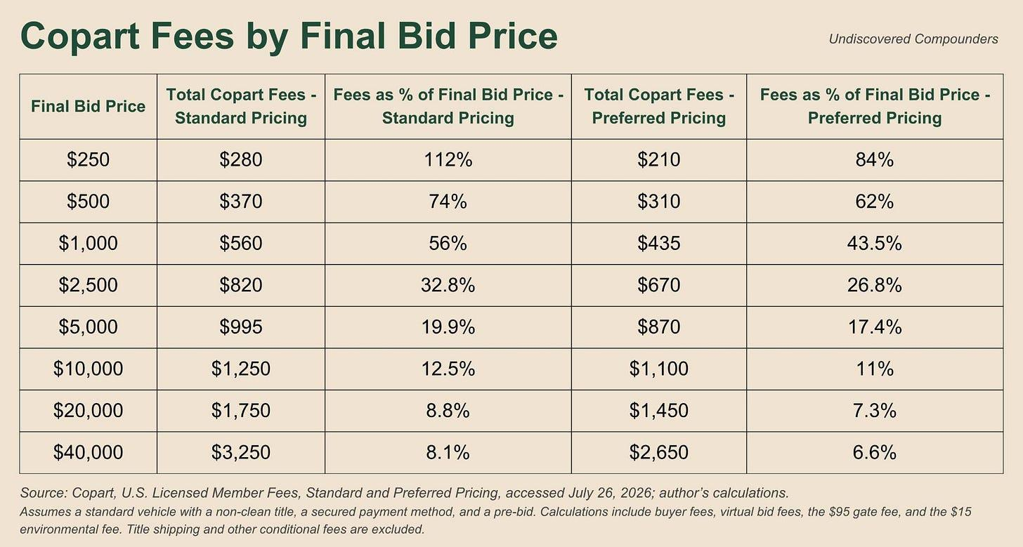

(Note that Copart also offers auctions for lots at $50 and under. That’s literally scrap metal that very often goes to a local buyer, and for which Copart drastically lowers its buyer fees to make the segment viable.)

The initial values may come as a surprise, but the trend is typical: the higher auction prices go, the lower fees become as a percentage of the total, while the absolute dollar amount keeps rising. What’s much less typical is the magnitude, and its specifics:

Between $10,000 and $15,000, the buyer fee is a flat $1,000. The rate drops from 12.5% to 8.7% without Copart collecting any additional buyer fee. As we’ll see, that’s a blessing in disguise.

Above $15,000, the grid becomes a hard floor. 7.50% of the price + a fixed $250, 6.00% under preferred pricing. Past this threshold, Copart becomes an ad valorem tax.

These remain catalog rates. You can’t deduce Copart’s revenue from these figures. The most important point is that the fees actually paid by buyers very probably fall near the bottom of the displayed fee range. Any model that doesn’t at least target that bottom is objectively too... optimistic. Conversely, any model that only accounts for variable fees (buyer fee) completely misses how the model works (I’ve seen several analyses do exactly that).

Yet a $500 car, in practice, looks a lot like a $5,000 or $30,000 car. And yet Copart’s fees can differ by 10x from one to the other. Let’s dig in.

2.11 The convexity of prices

Take a nice little wreck that sells for $5,000. The used-car market drops for whatever reason suits you, and that same little wreck sells for $4,000, a 20% drop. Only Copart’s buyer fee is affected (the rest is fixed), going from $650 to $600. The all-in total therefore goes from $870 to $820, a 5.7% drop.

Most salvage vehicles fall within a $2,500-15,000 range. In that range, the elasticity of revenue per unit to the sale price is on the order of 0.25-0.35 on the buyer side. If, by magic, the Average Selling Price (ASP) drops 20%, revenue per unit will only fall 5-7%. A Copart analysis that reflexively assumes an elasticity of 1, and figures that an X% drop in ASP lowers revenue per unit by X%, is off by a factor of 3-4 in Copart’s average price zone. Yet management spells it out itself: “we also share in a very small portion of that incremental proceed” (CEO, Q3-26).

If I take the total fee values as a function of the car’s price and plot that on a graph, I get a convex curve. This convexity has two important consequences.

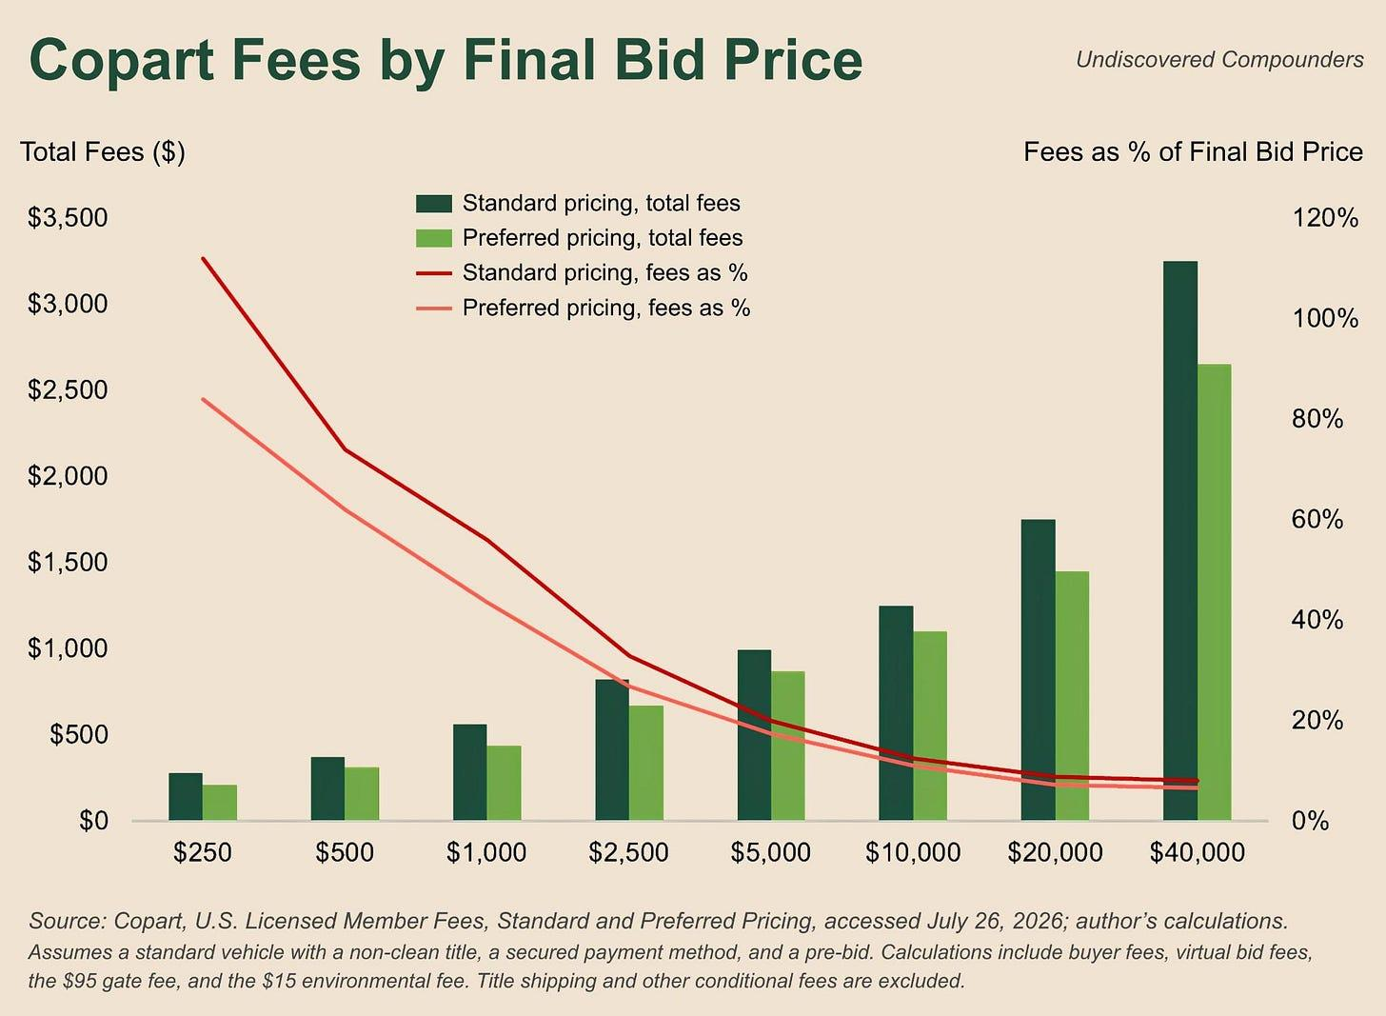

I haven’t found this convexity math in any other Copart writeup, sell-side included. I told you, I take the “deep” in deep dive very seriously. If you do too:

Subscribe

First, mix matters far more than ASP. A hundred $250 wrecks represent $25,000 of value passing through auction, from which Copart collects $21,000 in fees. A single $25,000 vehicle generates only $2,125 in fees for Copart. That doesn’t mean Copart would benefit from selling only scrap, and above all it says nothing about its growth. It simply says that RPU is driven far more by the price distribution than by the average price, and so a model built on an average ASP is chasing the wrong variable. Put differently, in terms of buyer-side revenue, Copart is structurally short the used-car price: the more used-car prices rise, the less it earns proportionally (but careful, more cars at a lower ASP require more towing, more yard space, etc., so this doesn’t imply that operating income increases).

Second, the top of the curve is capped. Above $15,000, Copart’s fees turn into a 6 to 7.5% ad valorem tax. So in that bracket, if the ASP rises 10% (inflation, higher demand for used cars, etc.), revenue per unit in that bracket will rise by close to 10% as well (all the more so the higher the car’s price). The rate itself only rises if the company changes its fee schedule.

Now imagine used-car prices weaken overall. Two things move in opposite directions. The insurer writes a $16,000 check instead of $17,000 to total (prices have fallen), so it totals more often. More vehicles pass through Copart, but they sell for less, so unit economics deteriorate. Liaw, the former CEO, sums it up: “more unit volume, somewhat lesser unit economics” (Q1-26).

Back to Q1-26: an investor reads the conf call and sees that US RPU rose 7% vs. 8.5% for ASP. Put differently, they see that revenue per unit rose less than prices. They conclude that Copart’s growth isn’t keeping up with its market’s. So Copart has no pricing power, maybe even suffers from its clients’ pricing power. Next stock.

The conclusion seems crystal clear, but it’s obviously wrong. It’s a corollary of the heavy weight of fixed fees: Copart is less sensitive to swings in the used-car market’s price itself (all else equal). If prices rise, that pushes insurers more toward repair, so volume falls but ASP rises. If prices fall, volume rises but ASP drops. My take is that this price structure is what allowed Copart, among other things, to compound for decades by making it more resilient, but this resilience comes with an apparent cost:

It can look like a flaw because of a hefty anchoring bias during quarters when ASP rises.

Conversely, it disguises itself as an advantage when ASP falls and RPU falls less (all else equal, mix itself can always change everything).

To put it simply, Copart’s RPU falls less when ASP falls and rises less when ASP rises. So be careful with any comparison between ASP and RPU that doesn’t account for the impact of mix and Copart’s fee structure. (That’s the equivalent of comparing different investors’ performance over less than 5 years without looking at the risk taken (leverage, asset liquidity, etc.). Nobody would dare do that, right?)

And that’s not all: Copart still collects other fees.

2.12 Fees outside the auction

Almost everything that follows is billed based on time.

Even before the car arrives at a Copart site, costs have already been incurred: the tow operator, the impound lot, or storage at a third party’s. Copart’s role is, once again, to arbitrage away constraints, so it arbitrages: it’s Copart that advances these costs (advance charges), “amounts paid to third parties on behalf of insurance companies.” These amounts are receivables collected within the year and don’t enter into any revenue line.

Next comes towing. Towing can involve a mix of players from Copart’s network: subcontractors, its own trucks/drivers, and independent drivers financed by Copart (Truck-in-a-Box). Copart obviously bills for this towing. The car waits at a Copart site, and the space it takes up over the time it spends there is also billed to the insurer (this cost varies by site and by vehicle).

Speaking of space, Copart owns far more land than it uses (notably in anticipation of CAT events). Some of this land is leased out and brings in a bit of revenue for Copart ($20.7M in rental income in FY25).

These are the constraints Copart has been arbitraging away for decades. But it has been pushing the logic even further for some time now.

Scenario. A financed car gets into an accident. The insurer declares it a total loss. To sell it at salvage auction, you need a “clean” title, meaning the lender’s lien has to be released and the original ownership title recovered. For the first 35 years of Copart’s existence, the insurer had to recover the original title. Today, Copart processes more than a million titles itself each year and calls this product Title Express.

The logic is, once again, logical: as long as a lender holds the original title (ranging from the big bank to the small credit union), nothing moves. Copart steps in and makes title recovery a priority. The time saved is on the order of “10 days better or more than the insurance clients can deliver on their own.” Every day saved is one less day of storage, which means a smaller storage bill from Copart to the insurer. It’s a disguised investment: processing speed is typically the kind of variable that helps win contracts with insurers, and a won market is worth far more than a few days of parking. Copart deals with them at the scale of all fifty states and claims that “no carrier who has started with Copart has taken it back in-house” (an insurer that’s tried Title Express has never taken the process back in-house).

That’s it, everything is finally ready, the vehicle can go up for auction, it’s sold, Copart takes its auction-related fees from the insurer (seen above, on the order of 1-2% plus a few other probable fixed fees; as a reminder, both insurers and Copart are very tight-lipped about this), all that’s left is to deliver it to the buyer.

That’s the job of Copart Delivered, the long-distance delivery service (revamped a little over a year ago). These fees are obviously disclosed to the buyer before they bid. We have little information on these costs, except that they rose about $15M year over year in Q3-26, and that they come with “a nice margin.” But this product’s main advantage isn’t its margin: a buyer who knows their freight cost in advance and, above all, doesn’t have to arrange it themselves (we’re talking about an auto professional, not a logistics expert) is probably one additional buyer in the (virtual) auction room.

In the same vein, there are other products whose purpose is to shorten the timeline but that Copart doesn’t charge for (for example Co.ai and the total-loss decision-support tools). They don’t appear in any fee schedule, any revenue line, and some have never even been presented as a sold product.

That’s going to change, partially, in two years. ASU 2024-03 will partially open up the expense black box in FY28 for annual filings and FY29 for quarterly filings, pushing US public companies, Copart included, to break down their expenses in greater detail.¹⁰ Unfortunately, it doesn’t apply to revenue, so the full picture will stay out of reach, but we’ll get more granularity.

In the meantime, we have to make do.

2.13 What the fee schedule can’t tell you

Let’s work backward:

Copart generated $3.97B in service revenue in FY25.

I’ll set the number of units at 4M (the real range is probably around 3.5M-4.5M)

Copart therefore collects $992 in service revenue per vehicle (so seller fees, buyer fees, towing, etc., the whole works)

The fees under Preferred Pricing (which applies to the vast majority of professional buyers) on a car sold for $5,000 (non-clean title, advance order, secured payment) come to $870. That’s only the buyer-side fees (without even talking about delivery).

That leaves less than $122 in seller fees (which include towing, storage, etc.)

If we assume an average seller fee of 1% of the sale price (the low end of the range, probably between 1 and 2%, but nothing official), that leaves $72 for all the other costs.

This result isn’t possible. So one or more assumptions must be wrong:

The 4M-unit assumption may overstate the number of cars. Possible, especially since some of these cars are bought and resold by Copart, so they don’t go through the service bucket.

The blended ASP would be under $5,000. Not impossible, though, but doesn’t solve the problem on its own.

The fees actually collected on the buyer side would be below the catalog schedule. Possible, but probably doesn’t solve the problem on its own either.

Reality probably lies somewhere in a combination of these hypotheses, but it’s not objectively testable. The takeaway is that it’s important to account for the uncertainty around ASP, but also and especially on buyer-side fees (which, ironically, are the only public ones). Any model built on these public schedule rates very probably overstates real fees, even when only accounting for Preferred Pricing rates.

Copart publishes little information; what little it does publish concerns precisely the side where it negotiates nothing and applies these rates to hundreds of thousands of clients, none of whom has significant negotiating power with Copart. Nothing, on the other hand, on the side where every contract is negotiated with insurers it can’t replace. This information asymmetry shows where pricing power exists, and where it stops. The only certainty is that “our industry has always been price competitive” (CEO, Q2-26).

We have one last case left to deal with.

2.14 When Copart buys the car

In FY25, Copart generated $678M of revenue from buying and reselling vehicles directly (14.6% of revenue). Note 1 of the 10-K says where:

Copart is an agent in the United States, Canada, Brazil, Ireland, Finland, the UAE, Oman, and Bahrain,

It acts as both agent and principal in the UK, Germany, and Spain.

Copart keeps repeating that it doesn’t want to own the cars, so why does it buy them?

Off to the United Kingdom, in 2007 to be precise. Four out of five cars totaled by an insurer go through Copart via a purchase program. Makes sense, the whole industry works that way. An insurer has never relied on an auction to determine the price, and has never handed over its carcass in exchange for a promise. The only thing it wants is a check. So Copart buys, loads its UK inventory onto its platform, opens it up to the American buyers it already has, and waits until it has enough data and performance history to show insurers and convince them to move up to the next level: the service program (ideally PIP).

The idea is good, and it’s going to work. But it takes time. A lot of time. 16 years later, the CEO describes the UK market as having “migrated to be a strong majority of those cars being sold on a consignment basis” (Q4-23), meaning they’ve moved to the service program. However, management also writes that the purchase program exists “primarily in the U.K.” That seems contradictory on the surface, but I think it’s talking about the trend vs. the overall reality (the UK being their biggest international market). More and more British insurers are moving to the service program, but there are still a fair number left to convince. Conclusion: the strategy works, but you have to adapt to insurers’ pace of change, which is fundamentally slow.

This change, even a slow one, has a significant impact on the numbers. Back to the past. 1998, to be precise. Revenue fell 9.6% for the year. Yet gross proceeds passed through auction fell only 0.5%. The gap is glaring, but it’s mostly an accounting one. The decline comes from a single line: vehicles purchased at existing sites, -81.6%. The MD&A from that period explains this decline by the conversion of purchase contracts into service contracts. Put differently, Copart convinced US insurers to keep the cars on their balance sheet and sell them at auction on Copart’s platform, where they’d make more money than by getting rid of them quickly and letting Copart take the car onto its own balance sheet along with a bigger margin (in exchange for a lighter balance sheet). That same year, site operating expenses fell from 70.8% to 62.6% of revenue, and the operating margin rose from 14.9% to 20.6%.

27 years later, on a smaller and quieter scale, the FY25 10-K attributes $62.4M of the decline in international vehicle sales to “sellers switching to a consignment model.” Same old story. The segment’s revenue declined and margins rose. This time, management had warned us: “the transition of a top customer in Germany to a consignment model” (CFO, Q2-25).

The strategy is only viable for large-scale sellers. For a good chunk of non-insurance, the strategy is more complex to put in place, especially for individuals, where it’s generally 1 car = 1 player. But that doesn’t stop Copart from trying to achieve the same outcome (taking a commission without carrying the vehicle on its balance sheet), without trying to convince sellers one by one. Copart’s solution? By now you probably already know it: connect the individual with a dealer, while taking a commission along the way that obviously isn’t “captured in our unit sold metrics” (Stearns, the CFO, Q4-25).

The strategy takes shape in Q4-25:

That quarter, total US units come in at -0.6% adjusted for this effect, instead of the -1.8% reported.

In Q1-26, US purchased units show -19.2% as reported vs. +6.2% restated. Along the way, their ASP rises by more than 50%.

For those numbers to reconcile, there’s only one possibility: Copart mostly delegates buying-and-reselling to other players for low-ASP cars. Conversely, it keeps buying and reselling in-house for high-ASP vehicles (the ASP increase wouldn’t have been so large if it had delegated everything). Put differently, Copart is trying to move away from buying and reselling low-ASP non-insurance vehicles (mostly from individuals), while continuing to buy high-ASP vehicles where its margin and its return (time, space, etc.) are higher.

Every time Copart voluntarily stops buying a car, a metric goes down and the economics go up. It’s the only metric in this whole write-up where a decrease is good news. I’m filing it away in my bag of operational and accounting subtleties.

Let’s sum all that up.

2.15 What we know now

We now know who brings the cars in, what they sign, who buys them, and roughly what each side pays for it:

Sellers, who pay a fee based on the net sale price plus various service fees (towing, storage, etc.). The goal is to minimize every constraint and make the process as logistically inexpensive as possible for insurers.

Buyers, whose fee schedule is public but whose actual fees are probably below the catalog rates.

From all this follows an important fact: RPU is the docile term of the equation (Revenue = RPU x Units). Copart’s revenue therefore has limited direct sensitivity to ASP, and so to the vagaries of the used-car market. Indirectly, the effect is self-reinforcing too: a drop in the used-car market raises the probability of totaling, so more cars and more revenue for Copart, which offsets the drop in ASP (and vice versa when used-car prices rise). Copart’s business model is resilient by design. I like that.

Three small subtleties for what follows:

CAT events disrupt period-over-period comparisons.

The shift in Copart Direct from buying (and reselling) certain individually owned cars to connecting the individual with a dealer in exchange for a commission (-19.2% reported vs. +6.2% restated in Q1-26).

The program mix (for example switching from a purchase program to a service program), which completely changes revenue and margins on a market without the underlying market itself really having changed.

That leaves Units, probably the biggest factor behind that -50%. But for that we need to make two detours. The first will be toward the foundation of Copart’s moat.

Off to the Lands.

3. The Lands

Management spent decades building this asset; I could certainly spend a few hours building a map of Copart’s sites (it’s not official, it’s mostly the result of research on Google Maps).

Here it is (I wanted to use a somewhat exotic projection for the world map, Waterman butterfly-style, but my wife convinced me that was a bit too bold an attempt at humor and that I’d be better off sticking to a good old Mercator projection. Maybe next time. Surely.):

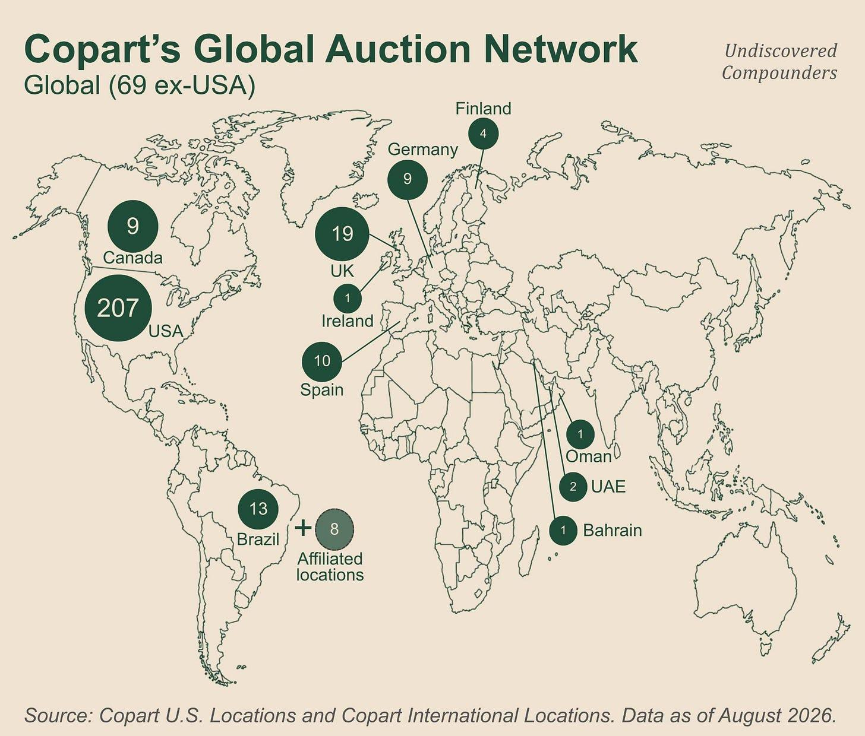

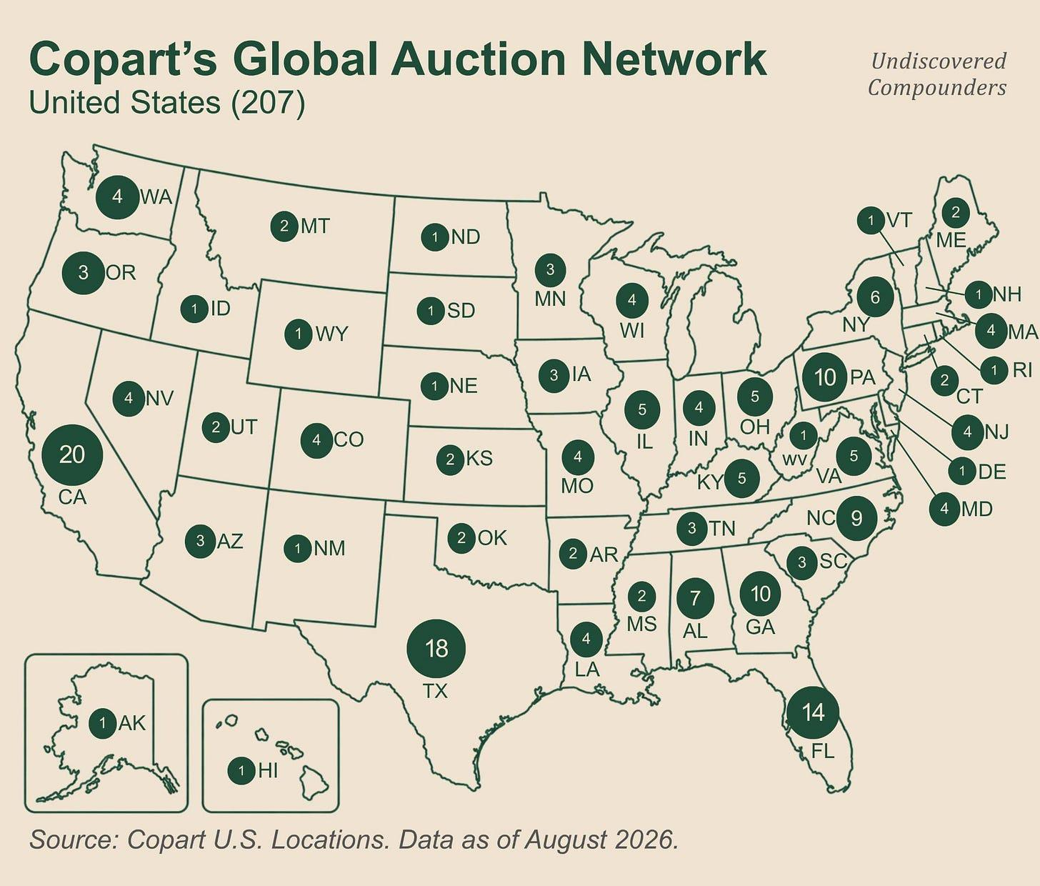

3.1 What a Copart site is

I lied to you. I told you at the very beginning that a Copart site was a giant parking lot. That was for your own good, but I can’t keep up the lie any longer.

Copart sites are defined by law. And that law varies from state to state and country to country. For example, in Ohio, a salvage yard must be at least 50,000 contiguous square feet.¹¹ It must also have a solid fence 6 to 10 feet (2 to 3 meters) high that hides the interior, and an office of at least 225 square feet (21 m²). And I’ll spare you the many other subtleties, or even quirks, of other jurisdictions’ laws.

A wrecked car waiting for its salvage title (45 to 60 days, as a reminder) has to wait in very specific areas, with even more specific regulations. During those two months, the carcass is somewhere, patiently waiting its turn, and none of the players upstream in the chain has room to absorb it. Copart and IAA are the only ones who own this kind of land all over the US and in various countries. The land’s value fundamentally comes from the combination of laws governing that land (including its permits) and the administrative delay for salvage titles.

When asked how AI could threaten Copart, the CEO replies that its main defense is “physical storage capacity, for sure.” No gradient-descent algorithm and no neural-network architecture can copy those permitted, regulated acres. (To be fair, he adds “a global liquid buyer base, for sure, a highly recognized online auction platform, deep regulatory knowledge across 50 states.”)

3.2 The permit vs. the land

Acres, you can find everywhere. Acres with the right to put wrecks on them, far fewer. Let’s call that the entitlement.

Out of 11 US jurisdictions¹²:

4 allow you to open a site without asking.

The other 7 require a permit, which can be denied and in some cases expires after 5 or 10 years.

In California, the DMV only issues the salvage dealer license if the municipality in question doesn’t exercise its veto power.¹³

Once permits are obtained (when necessary), the right to maintain the site can be revoked. Federal regulation lists 3 ways¹⁴: moving the site, expanding its use, or interrupting that use (6 to 12 months depending on the jurisdiction)¹⁵.

That’s the federal level. At the local level, two other possibilities come into play:

Amortization. A municipality decides that a nonconforming but perfectly legal use will become illegal, giving the operator a grace period before closing.¹⁶ There’s no compensation in these cases; the grace period itself is the compensation.

Grandfathering. This applies to zones where no permit is needed. The local jurisdiction can suddenly decide on a ban. In most cases, if the site existed before the ban, its existing use is grandfathered in afterward (yes, that’s a legal moat for certain Copart/IAA sites). In certain specific cases, the local jurisdiction can nevertheless revoke that right (for example, East Palo Alto shut down a local yard that was 75 years old¹⁷, on the basis of a fire that had happened 2 years earlier, by a 6-1 municipal vote).

If a permit or a right of use is lost, what’s the solution? Come back with a better application? In many cases that’s not even the question, and at worst, you lose years. The only other solution is to go find new land elsewhere, but nearby. When that’s possible, and in practice, it increasingly isn’t. The US has become less and less fond of giant parking lots filled with potentially hazardous car carcasses. Put differently, the local stock of permitted land can only shrink, regardless of demand.

Many of Copart’s own sites are “grandfathered in.” Once again, the change in the 10-K’s language reflects this: before FY24, it spoke of “obtaining use permits”; since then, Copart has added the word maintaining: “obtaining and maintaining use permits.” Its record of permit denials is minimal and can, in fact, be summed up in one line (at least, as far as we know): Coweta County, Georgia, in April 2019.¹⁸

So Copart has permitted sites that nobody else can obtain anymore, in a situation where those areas still need these sites regardless. That’s literally a local monopoly. At the scale of the country, that’s a gigantic barrier to entry (obviously it’s not like that everywhere in the US, but it’s not exceptional either).

On top of that, Copart has an advantage over IAA, its only real competitor. Historically, Copart managed to secure the best sites (first-mover advantage), as close as possible to the areas full of salvage vehicles (large and mid-sized cities). Back then, the location of its sites was less regulated on average than today, but it was still regulated, including, for the most part, a minimum distance from residential areas (so, mid-sized and large cities). Since then, urbanization has accelerated and these cities have grown. Copart is therefore physically closer to these cities than it was 20 years ago; sometimes it’s even the only player there.

This scarcity isn’t uniform, and some areas are far more permissive than others, both within the US and across countries. But that still only leaves room for local competition. Recreating the network that Copart and IAA have built would, at this point, require going back in time. That’s why Copart and IAA are a duopoly, and will remain one.

3.3 What happens when you don’t own

Copart owns about 90% of its land. The owners of the remaining 10% aren’t in the salvage business; they’re simply leasing out ground. And they compare what that ground would earn if it were developed as a warehouse or housing development. They couldn’t care less about how hard the permit was to obtain. If they decide it’s better to lease it out for another use, or to sell, the use changes, and the authorization Copart obtained dies with it. This has already happened to Copart.

The disclosed leases include renewal options of up to 40 years at Copart’s discretion (that’s a ceiling, the average length is 8.5 years), sometimes with a right of first refusal or a purchase option. As for whether or not those get exercised, that’s the subject of the next subsection.

3.4 Who built it, and when

For this part, I drew heavily on the book Junk to Gold, which tells the story of its founder Willis Johnson and the founding of Copart. The book is credited to Willis Johnson but was actually written by Marla Pugh.¹⁹ This biography shows that Willis Johnson is cut from the same cloth as Sam Walton or Henry Singleton (and not just because their names all end in “on”). It’s not long, and the return on your time and attention is well worth it, in my humble opinion.

For the audio-inclined, there’s also this excellent analysis of the book by Clay Finck of The Investor’s Podcast channel.²⁰

Copart has had 3 bosses in 44 years:

Willis Johnson, the founder, from 1982 to 2010 (28 years).

His son-in-law Jay Adair took over until 2022 (12 years).

A 4-year interlude under Jeff Liaw (a former CFO who joined in 2016).

Jay Adair took back the role on July 31, 2026.

Copart’s main asset is its land. Land is carried at $2.4B on the balance sheet (at its purchase cost). But understanding the history of this asset is necessary to understand Copart today.

In May 1995, Johnson bought North East Regional²¹, a network of twenty auction sites spread across 11 East Coast states. Copart went from 15 to 42 sites in a single year (the biggest deal of his career at that point). One important little subtlety: he leased the land for ten years, with a purchase option.

I just described the modus operandi that built Copart. Over its first twenty years, Johnson leased almost everything, with purchase options he almost never exercised. For him, location mattered far more than ownership: “As long as we’ve got the land in the right place to put the cars on, we can’t fail.”²² Location, location, and location again.

Let’s look at the value of these locations over time (pre-IPO data isn’t available):

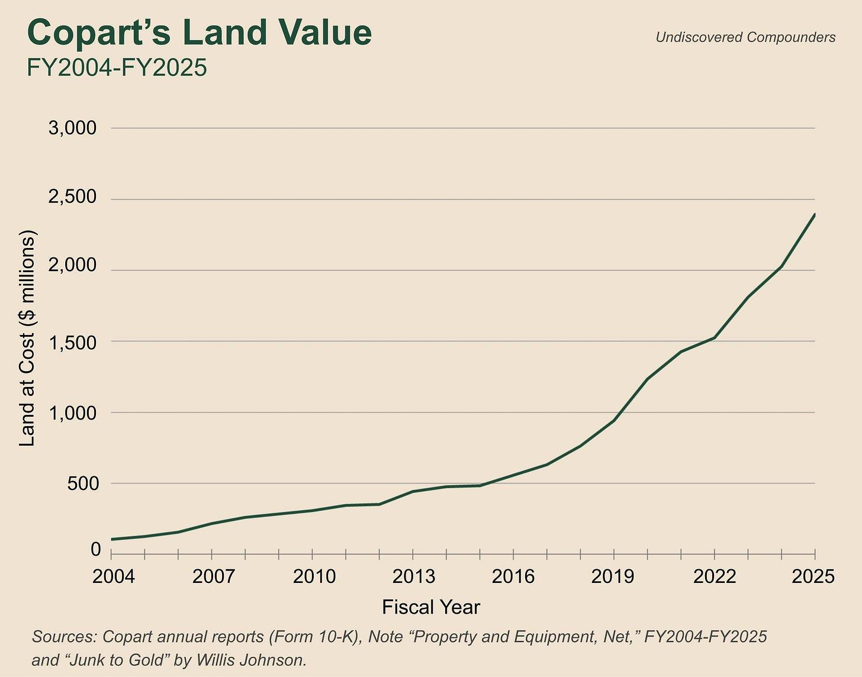

For starters, only 13% of today’s land had been acquired during the Johnson era. The myth of the visionary founder who built everything himself, which I’ve sometimes seen floated, doesn’t hold up to the facts (all the more so since Willis was focused on a leasing strategy that has since been abandoned, or rather adapted). Worth noting that these are purchase costs, so the chart structurally gives less weight to older acres. Copart unfortunately doesn’t publish acreage by year (a shame, I would have loved to make an interactive map of how Copart’s footprint evolved over time to show the moat being born, maybe next time).

A careful eye will notice a stagnation in land growth in two years: 2012 and 2015. Surprisingly, those are the two years when Copart borrowed to buy back its own shares. So this reflects a capital-allocation strategy (one that paid off, but I’ll quantify all that later).

The 2016-2025 decade transformed Copart. In April 2016, Copart kicked off a very basic plan, 20-20-20: 20 sites acquired, 20 expanded, in 20 months. Ten years later, Liaw admitted that at the time “we were shorter on capacity than we should be” (Q2-26; 10 years to own up to a mistake, you have to be patient). The decade averaged $400M of capex per year (land + buildings + all equipment combined). Land alone made up 64.5% of FY25 capex (vs. 42.2% in FY24).

You might think that means acquisitions are intensifying, but it’s the opposite. The buying cycle is winding down, other expenses are declining, and the remaining land-related costs (leasing, expansion, etc.) end up taking a significant share. 8 US openings in FY23, 4 in FY24, and only 3 in FY25 (including 0 acquisitions in FY25). Over the first 3 quarters of FY26, capex falls to $258.6M vs. $481.3M YoY. This decline is strategic too; we’ll come back to it later.

3.5 The contract that drew the map

Remember PIP, the type of contract where Copart takes fees exclusively as a percentage of the sale price, doing away with fees for other services. Among the fees that disappeared, one forced the company to change strategy: towing fees. Blame the geography of the United States.

When Copart signed a PIP contract with insurer AAA in California, it had committed to picking up its wrecks wherever they were, without billing for the trip. That included Reno, a 3-hour drive from the Copart site. By Johnson’s own admission, the former CEO, “the long tows were cutting into my bottom line.”²³

Put yourself in his shoes. You sign a contract where your margin upside is uncapped in exchange for an enormous, instant burden. What do you do? Take a few seconds.

Johnson’s solution was to open sites between existing sites to shorten the trips. “If we can tow a car 50 miles instead of 150 miles, that’s money in the bank.”²⁴ A site opened in Springfield, Missouri let it pull in vehicles that used to go all the way to St. Louis and Kansas City, while freeing up space in both. Tows are shorter and cost less. Cherry on top: capacity even went up. That’s already a very good idea, but once you run the numbers, it becomes a stroke of genius.

A plot of land in Chicago cost around $8M.²⁵ The initial sites had to be close to major cities (where the demand was). But the strategy of increasing network density required leasing land in small towns. And land in a small Texas town cost more like $1-2M. This densification was therefore happening at a lower cost per acre than the assets already in the portfolio. For the same amount of capital, the acreage literally quadrupled. And that’s not all.

Copart signs contracts with insurers. Over a given period, in given territories, under specific conditions. The holy grail is the big national insurer, one that can supply enough volume to bump the company into a different league. As we’ve seen, Copart competes with IAA on price for sellers (so insurers). But for a big insurer, prices matter, though the ability to efficiently cover its large territory matters just as much (an unhappy policyholder is a policyholder who might go check out the competition). As he pursued this growth strategy, Johnson won a contract for part of Allstate’s cars, a national insurer. Even back then, his strategy was clear: “I didn’t want just to be able to handle some of Allstate’s cars; I wanted them all.”²⁶

To sum up the strategy:

Copart wants both to increase its margins and to sign contracts with big national insurers.

To do that, it decides to sign PIP contracts, which give it the ability to raise its margins if it manages to push auction prices up.

These PIP contracts make fixed fees disappear, and Copart pays for towing out of its own pocket.

It buys or leases local land to increase network density, at a lower cost, cutting its costs, increasing its capacity, and increasing car turnover.

It solves the margin problem and now has the assets it needs to convince big insurers to sign bigger contracts.

The strategy was brilliant (though not everything was anticipated exactly like this from day one), but the execution had to match it. I probably wouldn’t be here writing these words if it hadn’t worked out very well.

3.6 How Copart chooses where to buy

For once, the 10-Qs give a complete and consistent answer. Opening a new site requires 5 things:

a market where capacity is lacking,

enough available surface area,

a usable shape and topography,

a major road nearby, and

“most importantly, has the appropriate zoning for our business” (local laws that allow their activity)

Of the 5, 4 describe the land and its surroundings, and one describes the permits. The board is built around these two variables: 7 of 12 directors have “Real Estate” expertise and 5 of 12 have “Salvage Vehicle Remarketing” expertise.

As for the actual strategy, you have to turn to the book. In its early years, Copart generally bought land that was already permitted. For example, when Johnson went from 15 to 42 sites in a year, “because the permits and everything already existed”.²⁷

This strategy still shows up today. Black Horse Pike, New Jersey²⁸ (60 acres for $5M in October 2023) was already permitted to store cars. Same for Washington Township (17 acres for $2.3M, also in October 2023), which was an already-licensed junkyard.

Here comes a new challenger: time. Negotiating and buying this land takes months, sometimes years, and “in some cases decades” (CEO, Q1-25). Hence the enormous importance of forward-looking analysis for Copart: where will it need land, when, and why? Anticipating the need for land 3 years in advance (network development, demographic shifts, emerging/shifting weather patterns, etc.) lets Copart start and finish these negotiations before the need is even felt.

That’s how you keep the insurers happy. Speaking of which, how much would it cost a new entrant to do the same thing?

3.7 Recreating the land

Land on the balance sheet = $2.4B. 18,900 acres directly owned. So $127,000 per acre (the acre count is from December 2025, so this is a floor).

In December 2024, Copart bought Hall Ranch in Punta Gorda²⁹: 835 gross acres for $13.3M, or $15,928 per acre. In April 2025, it bought 40.3 acres in West Palm Beach³⁰: $65.0M, or $1.61M per acre.

To sum up, two acre purchases in the same state, four months apart, with a 100-fold difference in price, each roughly an order of magnitude away from the average. No mystery. Location, location, and location again. Interpreting these numbers isn’t going to be easy.

Among purchases with publicly disclosed prices since 2019, Copart has bought 1,185 acres for $174.2M³¹, or a weighted average of $147,000 per acre vs. $127,000 based on historical cost. The story that old land, carried at its purchase price after decades of appreciation, would be worth 3-4x its book value is therefore only half true, and it rests on a tiny handful of sites. 55% of today’s sites already existed in FY12, although, once expansions are included, the majority of today’s acreage has been acquired since 2016, and the land carried on the books at that fiscal year-end represents only 15% of today’s land book value. That’s the share that’s had time to compound a bit. That doesn’t justify a book value understated by a factor of >=2.

Now, the part that really interests us. Putting a number on recreating this network for a new competitor.

There are 4 types of acres:

The reserve acre, the one held in anticipation of the CAT event. I’ll use Punta Gorda again as an example: about $16k per acre + about $100k of site work per acre (grading + gravel). Let’s round to $120k per reserve acre (in reality it varies a lot depending on the land’s base quality, but the impact of that variation is minor, so the margin of error is acceptable).

The network-density acres. Industrial land that’s still available and permittable, the acres on which a competitor could rebuild the network with unlimited capital. Between $250-400k per acre (ground + site work; unofficial estimate, Matthews IOS Sector Update, March 20, 2026).³² I’ll use $300k.

The contested acre. A permitted acre in areas where it’s no longer possible to obtain permits for new land. Estimated at $1.5-2.5M per acre (site work is trivial here, Ascension Advisory, Nov. 3, 2025).³³ I’ll use $1.5M.

International. I’ll leave it out of the estimate. IAA doesn’t have as developed an international network as Copart. Only US (about 200) + Canada (15) + UK (15) + Australia (5).

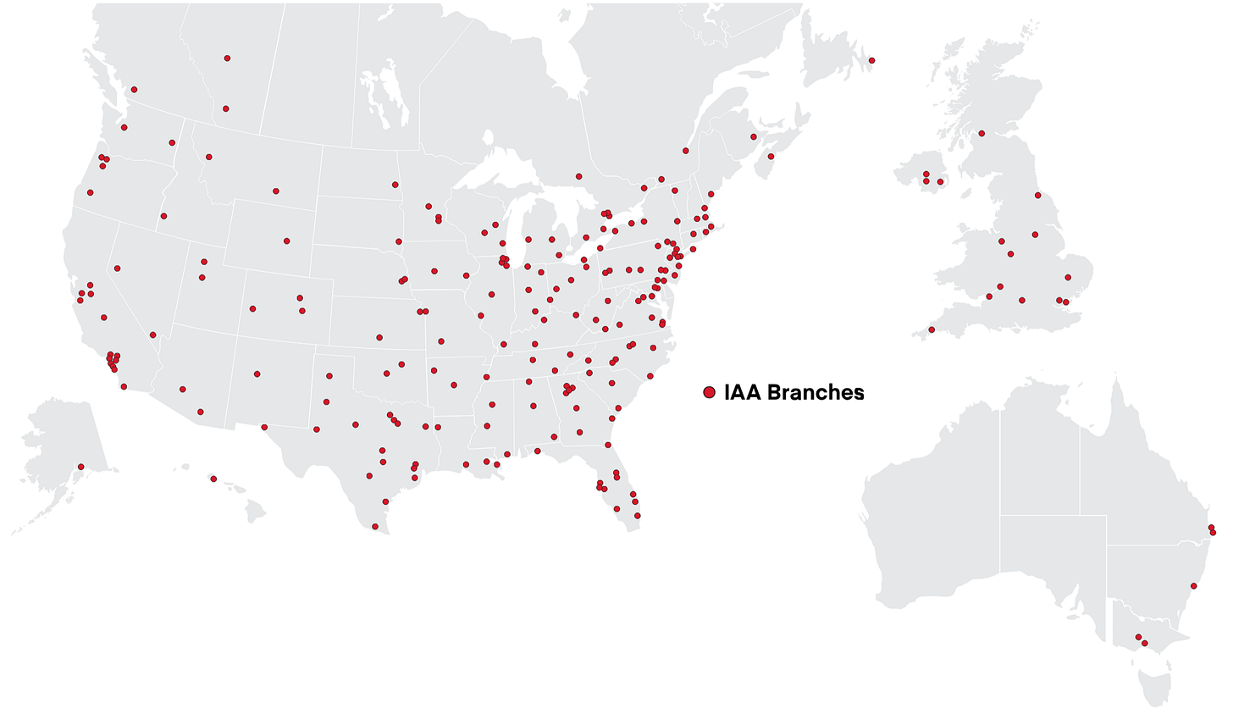

(Map of IAA’s sites, I counted them myself, so I could be off by 2-3 sites.)

We have the total number of acres. The estimated average price. All that’s missing now is the breakdown:

12% reserve acres. Management estimated its stock of reserve acres at more than 2k (CEO, Q1-25 conf call). We know that by the end of FY25, Copart operated more than 19.1k acres in the US, and that between Q1-25 and today, a good portion of the US acres bought were reserve acres, hence my 12%.

78% network-density acres. This is the residual obtained by subtracting the previous and the next categories.

10% contested acres. This is where the estimate is shakiest; I’ll lean toward underestimating it out of conservatism. I counted about 1/4 of sites located in 10 coastal states with high barriers to permitting. But these sites tend to be smaller on average, so I bring it down to 10%. If this percentage rises, the difficulty of recreating the network increases accordingly.

A little weighted arithmetic and we land on a result of $7.7B to recreate the network. In theory.

In practice, you have to allow for years, even decades, to buy and permit this land, all while operating it profitably. Above all, you’d have to acquire some in areas where the entire supply is already in the hands of Copart or IAA (contested acres). But suppose you manage to do all that anyway (which implies spending tens of billions of dollars at a loss for years or decades), you still have to build your own online auction platform, convince buyers to come, and above all convince sellers to come, the famously conservative insurers who already have two players they’ve been doing business with for decades. The logical loop from earlier still applies: no sellers, no buyers; no buyers, no sellers.

Aside from a few local players, the salvage-vehicle processing industry is destined to remain a duopoly. The only scenario I can see is a federal law that upends the industry from top to bottom, but we’re talking infinitesimally small odds here.

Let’s stay on this a bit longer.

3.8 CAT capacity

About 2,000 acres sit idle nationwide, and stay idle for good (Liaw, Q1-25, spoken remarks). Those 2,000 acres represent at least a tenth of the land it owns, with roughly half allocated to the very areas Helene and Milton passed through in the fall of 2024, not counting Hall Ranch’s 400 usable acres.

In August 2023, Copart deployed hundreds of people in Florida ahead of Idalia’s landfall. The storm made landfall, “the towing largely never materialized” (Q4-23), and the costs were incurred anyway. Same story a year later with Debby and Ernesto. When the storm actually hits, the timing mismatch works the same way: Ian, in 2022, first generated $25M in extra costs against $9M in revenue, with the costs hitting immediately and the vehicle sales coming weeks later. FY25 carries $56M in one-time costs for Helene and Milton, and in Q1-26, the mere non-recurrence of last year’s CAT event explains a good chunk of the 184 bp rise in gross margin. The carrying cost, though, never stops: the footprint inflates the property-tax bill, and site-related costs per unit rise about 10% ex-hurricanes (Q3-25).

Nobody at Copart claims otherwise: “catastrophic events are assuredly not per se profitable for Copart,” on a fully loaded basis and over a long horizon (Liaw, Q4-25). In the same answer, he gives the framework: “We are the insurance provider, so to speak, for the insurance industry themselves.” A premium pays for itself over the whole contract rather than on any single claim. And the documented decision criteria are operational: cycle time and the ability to absorb a storm. You saw this last criterion climb one spot in the selection list, the only movement on the whole list, and an account can be terminated with 30 to 90 days’ notice.

What these acres buy is a higher probability that an insurer stays. And that pays off every year, CAT event or not. You have to see it as an investment that only makes sense over the long term (with the help of the law of large numbers, and climate change).

3.9 Making the land produce

A purchased acre is only the first step. It has to be graded, graveled, fenced, equipped with a building, and of course, permitted if necessary. When the storm hits, capacity is measured in days. The land can almost never hold every single car, so Copart has to have flawless logistics in the worst moments, from vehicle recovery through outbound shipping, with everything in between.

An obvious solution could be to stack the cars. That’s possible in some cases, but a law can limit this strategy, and when it’s not the law, it can be the permit itself: the zoning variance approved in Logan Township (New Jersey, April 2026) authorizes 4,467 spaces.³⁴ In these cases, the constraint comes before the land’s raw surface area even matters (exceptions can occasionally be granted).

It’s also for this kind of extreme situation that Copart launched its Title Express product (recovering, on the insurer’s behalf, titles stuck with the lender in a few days instead of a few weeks), which “makes better use of our storage capacity as well” (Liaw, Q2-25). The product is recent, but its effectiveness can be measured indirectly: in Q1-26, US inventory fell 17%, part of which is tied to cycle-time gains that increase “the overall processing capacity of our existing facilities” (Stearns, Q1-26). The logic has its limits, since part of that 17% is also due to fewer units processed, which frees up capacity to work through older stock.

The same reasoning applies to every site during less “hot” periods; Copart simply has more room for error.

3.10 The limits of the land

An acre only earns its keep under two conditions: a car has to be totaled, and it has to need somewhere to wait. Everything that happens before even a single inch of the vehicle reaches the land has nothing to do with the land. That includes the claim, the tipping-point threshold, and the contract that determines whether the carcass actually goes to a Copart site. The car still has to go through an insurance claim in the first place. It still has to be insured in the first place. Driving uninsured may be illegal, but it’s an industry variable that affects both insurers and Copart, especially right now (we’ll come back to it).

These cars have 4 possible fates: they’re either repaired directly by the owner, or kept (just in case), or sold directly to a local auto professional, or, most likely, end up in impound yards.

Even making it to the insurance-claim stage isn’t a done deal for Copart. An acre is tied to a market, which is itself tied to one or more contracts. Beyond variation in demand on the insurer side, in some contracts the insurer has the option to sell elsewhere (locally or to IAA): “Even an insurance carrier can sell their cars through other intermediaries” (CEO, Q4-25).

For non-insurance, it becomes far too complex to fit into this deep dive (believe it or not, I’m trying to keep it simple, despite +55k words). Each one has hundreds of reasons and dozens of ways to bypass Copart.

Copart competes mainly on the supply of cars; the land is just a means of boosting demand to make supply easier, while also increasing operational efficiency.

This land is therefore the main weapon for competing. A necessary weapon to win, but not a sufficient one. Good thing, that’s our next topic (nice transition, huh, it’s almost as if there were some kind of logic to it).

Subscribe

4. The competition

4.1 Who the competitors really are

The list of competitors in Item 1 of every 10-K:

FY05: ADESA, Auction Broadcasting Company, IAA, Manheim, SADISCO, Greenleaf, and LKQ.

FY25: RB Global (which owns IAA), Manheim, ACV Auctions, Carvana, Openlane, plus LKQ (with the addition of “other regional, and local dismantlers” in FY23).

Five to seven competitors worth mentioning in a 10-K. Yet I’ve been talking to you about a duopoly from the start. Copart first, IAA second (as a side note, management has never once said “IAA” or “RB Global” on a conf call). So what, was I wrong? I might disappoint you, but no. It’s all just a question of scope. In the business of storing totaled cars awaiting sale, Copart and IAA really are a duopoly. The other competitors only come into play elsewhere (auctions, appraisal, towing, etc.).

This question of scope is central. Insurance vs. non-insurance, repairable cars included or not, etc. You have to be precise. What dictates how precise we can be is the availability of information. And for once we’re in luck: an analyst asked a related question, and the CEO answered in detail about competition in general. His answer is very detailed and logical, so I’ll quote it in full:

“We view our opportunity and our threats much more expansively than that. In terms of the clients we serve, yes, there are insurance carriers, and yes, there are banks and rental car companies and dealers and individuals.

If we sell X cars, the actual number of auction-mediated vehicles that are sold in the U.S. per year is multiples of that. It’s 5x or more of the volume that we sell per year. That frankly remains true even for the specific sellers you described, that there are always options they can consider. Even an insurance carrier can sell their cars through other intermediaries. They can have more of them repaired. In many respects, we compete with the repair shops.

The higher the returns we generate, the more we can win the rights to resolve that claim versus the repair industry. The lower the returns we generate, the more we lose head-to-head against the repair shops as well. There are a number of competitive threats that we face on any given day.

I think we still have a lot of conviction that if we deliver excellent auction returns and deliver excellent service, I think you know what that means, but that means expediting cycle times, retrieving cars very quickly from where they sit, especially when they accrue storage. It means interacting with policyholders very effectively, in particular on the title procurement, Title Express side of the house, so that we can resolve claims amicably with their customers who otherwise may churn if experiencing a tough claims resolution process.

Anyway, the long-winded answer to your question, but we view it much more expansive than that. We have many-fold opportunities to win, many-fold opportunities to lose. That’s our job to do.” CEO, Conf call Q4-25.

Such a complete answer on such an important topic, I’m almost touched.

To sum up, there are 4 families of competitors:

The auction house across the street: IAA (RB Global)

The whole-car houses: Manheim, ACV, Carvana, and Openlane. They handle auctions for cars that still run and, for the most part, fight over the 20% that’s non-insurance (rental companies, banks, certain dealer vehicles, etc.).

The dismantlers: LKQ and a whole slew of local players. They buy the wreck directly from the insurer (when they don’t buy it at auction via VB3, Copart’s auction platform).

The body shops: another slew of more or less local players. It’s all or nothing. Either the car gets repaired, good for them, bad for Copart, or it doesn’t get repaired, good for Copart, bad for them. Management is mostly referring to them when it says: “we compete against all alternatives for a car” (CEO, Q3-25).

These are 4 families with a crowded graveyard behind them. A great many players have disappeared over the years Copart has existed, not just the ones listed in the 10-K. The trend is clear: the market matures, the smallest players die out, or get bought (including big ones like IAA), and the relevant big players have become national players.

One small scope detail: everything here is US-specific. Every foreign market has its own players, its own quirks, etc. For now, we’re focusing exclusively on the US market. We’ll analyze foreign markets much later.

Back to the US, let’s dive into IAA. Finally.

4.2 IAA

A little IAA history to start with (it’s the only big competitor, so we can afford to be thorough)³⁵:

1982. Incorporated in California under the name Los Angeles Auto Salvage, Inc., with a single yard.

October 1991. The company becomes Insurance Auto Auctions (IAA) and lists on the Nasdaq the following month.

1993-1995. After the IPO, salvage pools consolidate (58 across 24 states by the end of 2000).

May 2005. Kelso & Company (a PE fund) takes it private for about $385M.

November 2006. KAR Holdings is formed “for the purpose of consummating a merger with ADESA” (the era’s big name in running-car auctions).

April 20, 2007. ADESA is acquired for cash. IAA, that same day, “was contributed by affiliates of Kelso & Company and Parthenon Capital.” Translation: IAA is contributed as the initial stake.

December 2009. KAR lists on the NYSE, raising $300M (25 million shares at $12).

June 28, 2019. A spin-off without an IPO: the shares are simply distributed to KAR’s shareholders.

March 20, 2023. Ritchie Bros (a Canadian giant that mostly sells construction equipment) buys IAA (paid mostly in new shares). The surviving entity is called IAA Holdings, LLC.

Ritchie Bros Auctioneers renames itself RB Global.

(Kudos to all the bankers who found reasons to justify acquiring, and then spinning off, more than once.)

That’s a lot of transitions. The company was publicly listed from 1991 to 2005, then from 2019 to 2023. What’s going to interest us is the second period. In some cases we have information going back to FY16. Notably: from 2016 to 2022, IAA grew its unit count in 5 of 7 years (negative in 2020 and 2022).³⁶

Yet Luxor Capital (one of Ritchie Bros’s shareholders)³⁷ said IAA was bleeding on all fronts, and that one of its big clients (a major insurer, State Farm) was leaving state by state. Fine. The fund openly opposed the acquisition and campaigned against it among the other shareholders. Other funds, like Ancora, have pushed back on Luxor Capital's arguments. But the fact that it only moved to online auctions in the US starting during Covid (even though it had been available in the UK since 2005)³⁸ is, in my view, a perfect example of the reasons behind IAA’s struggles: a strategy stuck in a constant cycle of reacting to problems, where solutions take months, even years, to implement.

So how do you explain the rise in units, then? More units, but lower quality: lower resale values, and with the same logistical headaches as vehicles worth 10 times as much. To grasp the scale of the problem, here’s a line from IAA management: “U.S. volume excluding the one large customer grew 5% in 2022.”³⁹ To be honest, when I read that in a conf call, I move straight on to the next stock. It’s the equivalent of “I took a bullet in the thigh, but my arm’s doing pretty well.” Going private in 2023 was necessary for its survival.

Since 2024, the trend has reversed. IAA has regained its strength⁴⁰:

RB Global’s automotive lots go from 2.3M in FY24 to 2.45M in FY25, with 6 consecutive quarters of growth,

$2.5B of debt against a guided adjusted EBITDA of around $1.5B for 2026 (or 1.65x ex-lease debt),

$500M in share buybacks announced in March 2026.

In its latest quarter, in early August, RB Global printed +11% growth in automotive units⁴¹. So well above Copart. Worth tempering that, since this figure also includes units from RB Global segments outside IAA. They don’t give the breakdown, but their explanation is clear: “our largest automotive insurance partner across all 50 states in both personal auto and commercial lines,” including “substantial additional volume across 30 states.”

On the other hand, these volumes come at the expense of fees. RB Global’s take rate (what it keeps for every $100 that passes through its auction platform, a figure Copart doesn’t publish) has been falling steadily: 21.4% to 20.7% and then to 20.0% over three quarters. That’s a sign there really was a price war to win Progressive’s volumes, one Copart refused to participate in, and that IAA won by choosing to lower its seller fees: “volume-related price incentives in automotive.”⁴²

The trend over these last few quarters, including the most recent one, therefore largely favors IAA over Copart (even if IAA is paying for part of that trend with its own margins). So it’s no coincidence that Copart is down around 50% while RB Global is near its ATH (that was true until 3 weeks ago, when RB Global dropped 30% since its last quarter print). We’ll get the chance to pick all of this apart in more depth. It’s even the heart of the current thesis.

The reality is hard to argue with: the new owner knows how to manage the business and has the means to do it.

What does Copart say about it? “I haven’t seen where IAA’s products have dramatically changed.” (I’m kidding, they didn’t say IAA, they said “their”; good, you’re following along.)

Time for the comparison.

4.3 The two buyer fee schedules

On buyer fees, it’s simple: it’s the same grid. Identical, with two small exceptions (a few bracket cutoffs, minor stuff). The real difference is in the flat fees: $95 gate fee for Copart vs. $105 “service fee” for IAA + $20 title fee on every purchase.⁴³ To sum up: a non-clean lot at $8,000 under standard pricing = $1,175 at Copart vs. $1,205 at IAA. If IAA is competing with Copart on price, this isn’t where it’s happening.

There are too many buyers for any one of them to force price competition. The price similarity is the reflection of a duopoly that knows it’s a duopoly. Nothing really surprising. The battle is elsewhere.

What happens under buy-and-resell for Copart’s own account?

Two possible cases: insurance vs. non-insurance. Non-insurance is too small and too variable. Buying and reselling with insurers is what counts. If you’ve been following along, you know that’s mostly abroad (a matter of insurer habits). For example in the UK, some insurers award the contract to the company that is willing to pay the highest price. If Copart has to compete on the buy side, the vehicle passing through its own P&L completely changes the incentives, and resale price matters even more for Copart.

But that’s still only a small share of revenue; the real competition plays out elsewhere.

4.4 Where the competition really plays out

In February 2026, an analyst asked the CEO whether the industry is getting more aggressive on price. The CEO at the time answered by ranking the factors:

The sale price achieved, first and by a wide margin. No surprise there, that’s what incentivizes supply upstream in the chain.

Cycle time, next. Here you have to put yourself in the insurer’s shoes: it doesn’t want to overload its balance sheet, and would rather the processing of wrecked cars (towing + appraisal) be faster, so it can reimburse the policyholder sooner and not push them toward a competitor.

Fees paid to Copart come in “on a tertiary, maybe further down still than that” (CEO, Q2-26).

Response to natural disasters enters as a standalone criterion in FY10 and moves from 5th to 4th in FY24.

Open the 2005 10-K and the price of services is third there too. Can you imagine Walmart saying that? Worse, Costco? No. Apple, on the other hand, sure. Hermès, without a doubt. Calm down, I’m not trying to imply that Copart is a luxury business, just that the price of services sits in third place, and the consequence is that providers are judged on service quality, for example cycle time (which is second). But an insurer counts its money in and its money out, and knows that with Copart, its main inflow will be the car’s sale price (which doesn’t directly depend on Copart’s service quality, except for the cleaning before the photos, that part is very important).

To sum up, competition mostly plays out on service quality and on the final sale price obtained at auction.

Take inspection: to streamline the process, Copart offers more than 100 offices at its own sites for the adjusters insurers send when they’re weighing repair vs. total.

Title handling, by contrast, isn’t dual-sourced once an insurer uses Copart. At auction, a conservative insurer dual-sources: a bit of volume at Copart, a bit at IAA. On titles, never: the CEO says it himself, it’s “all or nothing,” “virtually every Title Express client has virtually every title then procured by us” (CEO, Q2-25).

Towing, for its part, is often decided before the insurer is even notified. After an accident, the police directly call the tow operator on their on-call list, and the truck heads out without anyone having chosen it: “the direction of that initial tow often happens without the insurance company’s knowledge” (CEO, Q2-25). That’s the link in the chain Copart is working its way upstream toward, and the job is still ongoing: “We are moving upstream” (CEO, Q3-26).

To sum up: Copart arbitrages away as many constraints as it can, folding it into its own process, and every step of the process it has taken off its clients’ hands would require the client to hand those logistics over to one or more competitors (depending on the service), or to redo certain steps itself. The notice period is 30 to 90 days, sure, but the time it takes to rebuild the process doesn’t follow that rule.

Insurers aren’t locked in with IAA or Copart, then, but switching carries a real logistical cost. It’s obviously each side’s job to minimize that friction too. This client stickiness matters even more for small insurers, for whom switching friction matters even more since their resources to absorb it are limited.

Copart’s former CEO very neatly sums up everything I just said: “market share will take care of itself” (CEO, Q3-25), provided you deliver the best return. The duel is therefore “on the basis of delivered economic outcomes” (CEO, Q2-26).

All that’s left is to define what “return” means in this context and how to measure it.

4.5 How to measure a delivered outcome

I’ll spoil it right away: measuring performance isn’t exempt from the industry’s tendency toward secrecy.

But we do have a few fairly rough figures, and we need to keep a few subtleties in mind when analyzing them.

4.5.1 Comparison between competitors

Here we’re going to compare Copart and IAA (and their handful of competitors).

The first thing that makes the job easier: “no given car is ever transacted on multiple platforms” (CEO, Q1-24). So we can directly compare platform returns without any statistical tricks.

Ideally, we’d compare similar cars with similar damage on both platforms. Copart and IAA have published their sales data for the last 10 years, so I pulled all the raw data and… I’m kidding. Obviously they haven’t done that. The only thing we have is the ASP (and only Copart’s...), and it has a certain talent for lying:

ASP rises when the auction has done its job, but it also rises when the mix skews toward higher-quality vehicles overall (in other words, less damaged).

ASP depends on the used-car market. If used-car prices fall, repairs make less sense, so the insurer totals more lightly damaged vehicles, so ASP mechanically rises (and vice versa when used-car prices rise).

Not only does it tend to lie, but we don’t always have the tools to catch it lying.

For an insurer, the logic is simpler: it looks at gross return: the price obtained at auction divided by the vehicle’s pre-accident value. That’s “the one measure that much of the insurance industry uses” (CEO, Q1-26), and obviously no insurer publishes it. It’s their best tool for comparing Copart and IAA (and the few other local players); they’re not going to hand either company the cards it needs to compete more effectively.

However, it seems Copart has access to certain information. In Q4-25, its sale prices grow at “more than five times the rate of service providers similar to ours.” A bold analyst had the nerve to ask how that figure was measured, and what insurers said about it. The CEO’s answer: “We understand our number.” I appreciate the effort. 3 months later, management cites “more than threefold”.

But nothing beats a shareholder fight when it comes to getting a bit of information. Let’s go back to when RB Global (Ritchie Bros at the time) bought IAA. Remember Luxor Capital, the fund that was against the acquisition and wrote a letter to shareholders to convince them to vote no. In that same letter, it cites the following figure: roughly 3x as many unique visitors at Copart.⁴⁴ On top of that, half of IAA’s visitors also visit Copart, vs. only 21% of Copart’s visitors also visiting IAA (in absolute terms the numbers are close, which makes sense: a visitor who visits IAA and then Copart tends to visit both regularly).

I deliberately left one argument unstated, and maybe you caught it: insurers sign contracts, so the performance comparison becomes limited once the contract is signed. Yes. And no. For a small insurer, the argument holds. For a big insurer, it has dozens of branches spread across the whole US. As long as it splits its volumes between Copart and IAA across its branches, it can effectively compare their performance in real time.

To sum up: the only method we have available for judging Copart’s platform performance vs. IAA’s is ASP, and it’s a variable muddied by factors that, as a shareholder, you can’t always correct for (for lack of information). The insurer thinks in terms of gross return, but that’s a variable neither Copart nor IAA has full visibility into (they’re being pitted against each other).

One choice insurers make, however, can give us a clue about the outcome of this comparison.

4.5.2 Comparing a single entity over time

The shift to pure sale. (Quick reminder: pure sale = the insurer lets Copart or IAA run the auction to extract maximum value; managed sale = the insurer imposes its own conditions, for example a minimum price.)

By moving to pure sale, the insurer tells Copart: handle it, I trust you to extract more value than I could. But that trust has limits. The insurer keeps an eye on the auctions, watches the number of buyers, pricing trends, etc. And this trust comes with no notice period. An insurer can decide to switch back to managed at any time (at the contract level, not auction by auction).

The pure-sale-to-total ratio is therefore the variable most sensitive to insurers’ satisfaction with the returns Copart delivers, the one that will move before volumes or client relationships start deteriorating. The trend over the last 10 years has been toward pure sale, with several big insurers now at 100% pure sale. Still according to the CEO, Copart’s pure-sale volumes are “an order of magnitude higher” than those of other platforms. Yes, that’s still a line from management, but this is one of the rare management teams where giving the benefit of the doubt isn’t a bad idea.

Even though the trend is positive for Copart, it’s limited to the volume insurers actually send to Copart. And that volume, they actively adjust.

4.6 The duopoly clients keep alive

As we’ve seen, an insurer thinks in terms of 50 years, and big insurers have resources that small ones don’t necessarily have. For example, splitting volumes between the two big players to keep the duopoly from turning into a monopoly. At least in the past. What about the future?

A big insurer that thinks in terms of 50 years knows one thing: its competitors also think in terms of 50 years. It’s a mature market where everyone tries to stay ahead of everyone else while knowing they can never truly break away from the pack. From this certainty comes a kind of collective intelligence (probably helped along by meetings with one another, I have no doubt): insurers, more or less deliberately, look out for each other.

This deep dive is already plenty long, so let’s stick to our duopoly. What’s the impact, in your view? It’s simple, like in nature: insurers’ collective intelligence acts as a guardrail on individual behavior. Concretely, even if a big insurer suddenly decides to give all its volume to Copart, the others will find a way to compensate by giving theirs to IAA.

For example, back when IAA published its own accounts, it drew about 40% of its revenue from its three biggest US insurer clients.⁴⁵ At Copart, no client exceeded (or exceeds) 10% of consolidated revenue, so at most 29.99% for its 3 biggest clients (more likely under 25%).

As a reminder, “the top 10 biggest auto insurers together represent 75% of the market, with number 10 accounting for about 3% market share.” So mathematically, the same names sit behind the majority of the duopoly’s P&Ls. Hence the ceiling. Copart’s share is capped by insurers’ collective intelligence, which keeps them from concentrating everything with one player, even if, hypothetically, service quality is worse elsewhere. Conversely, Copart will keep a certain share of insurers’ vehicles even if its service deteriorates.

In terms of revenue, neither player can totally lose, but neither can totally win either. Downstream, though, that’s a different story.

4.7 The asymmetry of accounts

Copart and RB Global have almost identical revenue, but everything else looks almost exactly opposite.

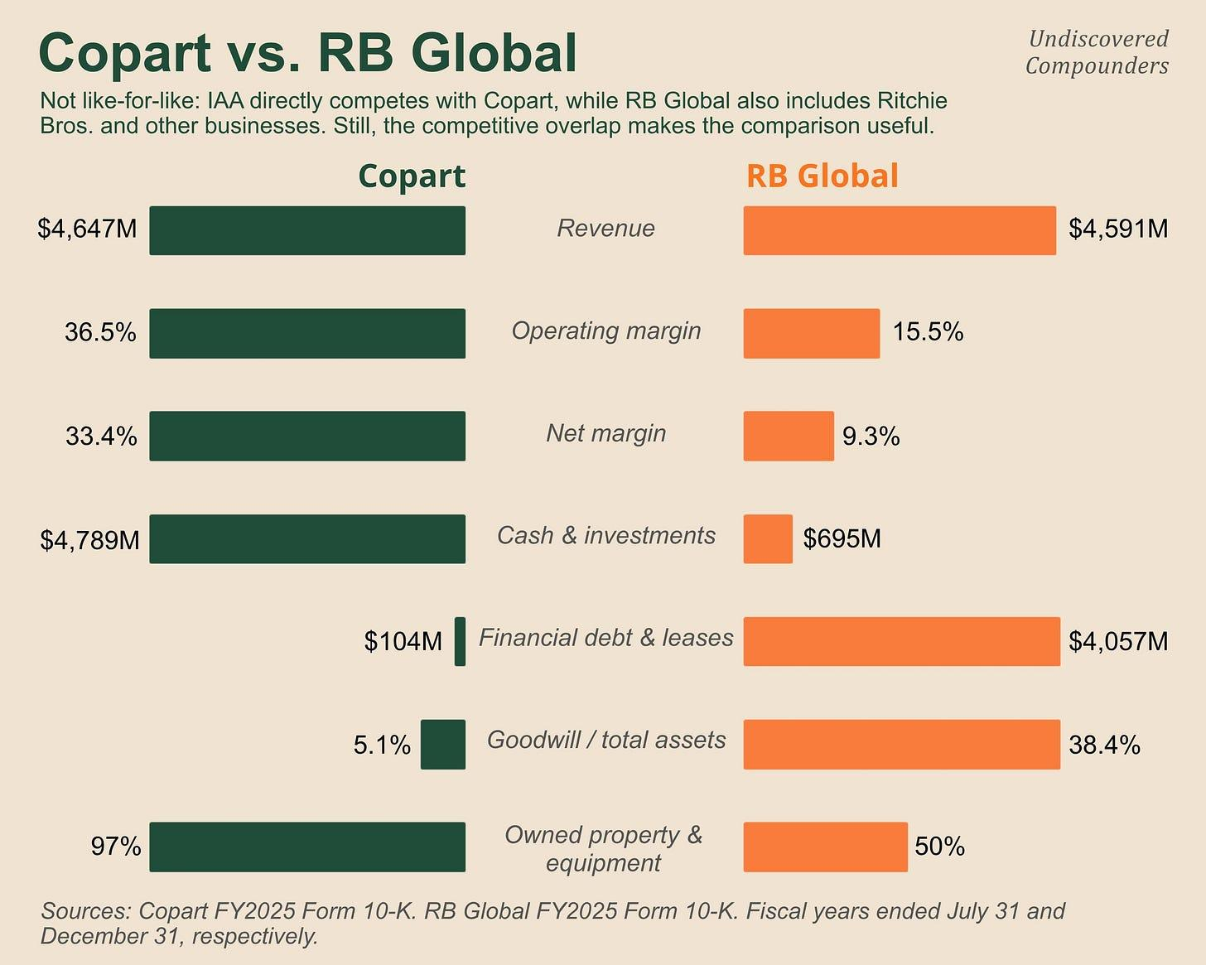

Based on the latest filings:

RB Global carried $1.6B of capitalized lease obligations vs. $1.54B of net PP&E.⁴⁶ Not all of it is tied to IAA (IAA probably accounts for roughly half of RB Global’s revenue), but the trend is clear.

Copart carried $0.093B of capitalized lease obligations vs. $3.72B of net PP&E. I won’t insult you by pointing out the difference between the two (appreciate the paralipsis).

We spent the entire previous section demonstrating that land is the foundation of the industry’s moat, and IAA leases most of it. IAA leases its moat. And the strategy isn’t new; it was inherited like a poisoned chalice:

“The majority of our salvage auction vehicle facilities are leased” (10-K FY19)⁴⁷

7 years and 2 owners later: “Most of IAA’s salvage auction vehicle facilities are leased” (10-K FY25)⁴⁸

Management itself acknowledges that lease renewals “may adversely affect us if the renewal terms of those leases are unacceptable.”⁴⁹

Yet IAA and Copart started from roughly the same position. During those early years, Copart also leased its land and didn’t exercise its purchase options. Once Copart had densified its site network enough, it began buying, taking advantage of its newly strengthened balance sheet. Meanwhile, IAA was spun off from KAR, then bought out, while its successive owners had other bills to pay (ADESA first, then the merger). This gap between the two balance sheets reflects ten years of different capital-allocation strategies, driven by very different management teams (pro-shareholder vs. a founder thinking on a 20-year horizon).

Let’s temper that a bit.

At worst, it weighs on the P&L, margins, and everything else shareholders care about. But as we’ve seen, IAA has a structural position in the market. A few leases and lost plots of land aren’t going to change that.

But IAA’s lack of flexibility, notably during CAT events, makes it very unlikely that it’ll become the leading player in this duopoly (the book, admittedly written by Copart people, recounts specific situations where this played out).

Worse than the car that goes to the other platform is the one that goes to neither.

4.8 Competing with repair

It’s finally time to talk about body shops. All or nothing. Repair = one less car potentially passing through Copart for that claim.

First key observation: in the first quarter of 2026, the US total-loss rate was 23.6%, up almost 6 points in four years. Out of four wrecked cars, 3 get repaired and only one potentially passes through the gate of a Copart site. The Copart vs. IAA duel (and a few other local players) only plays out across 1/4 of the total pool. The remaining 3/4 is decided across thousands of repair shops.

We’re talking about a nationwide phenomenon in an industry where Copart is a giant. So you might assume this number is the result of factors both exogenous and endogenous to Copart. And you’d be right.

The exogenous causes are the most important. Important enough to deserve an entire section (the next one, in fact, I do try to do things properly). Here we’re going to focus on the endogenous factors, the ones Copart can influence.

For starters, the returns generated at auction. Copart’s CEO claims that this is “literally one of the critical drivers” behind the rise in the total-loss share. On paper, that’s possible. If we go back to our circular logic: more buyers -> higher ASP -> better returns for sellers -> more sellers -> more supply on the platform -> more buyers, etc. A network effect, in short.

But this logic has been true for years. It’s the core of Copart’s business model. Copart may have improved over the period in question, but at this point, it’s easy to doubt that’s the whole story. And you’d be right again.

Copart has actively worked over the last few years to increase the share of totaled cars by offering a new tool (or rather a repurposed one) to influence insurers. We’ve already mentioned it, so you can probably guess it. A hint: it’s a recent service designed to directly compete with body shops.

Well done to those who got it: Co.ai (formerly Pro Quote), the suite of AI visual-recognition tools that uses just a few photos sent by the insurer to assess the damage and help quickly decide whether the vehicle is worth repairing or not (as a reminder, it’s a decision-support tool, not a decision-making one). Obviously, the tool is free for insurers (note that once the models are developed and the UX is in place, maintenance costs are minimal; Copart even grows its database with every new case).

Sure, insurers ask for certain assurances that the tool isn’t too biased, but that doesn’t stop Copart from quietly nudging toward totaling. To do that, it provides not just the repair-cost estimate range, but also the ratio of repair costs “net of what they would achieve at auction” (CFO, fireside Baird, June 2024).

As for whether Copart succeeds or fails with these efforts, we have very few clues. In the base case, we’ll infer it from the numbers a few quarters later. At best, we’ll get a comment from management in response to a curious analyst.

But this particular form of competition is no exception to the industry’s law of secrecy, which Copart zealously embraces: “When we do win, we’re not going to tell people that we won” (CEO, Conference July 2026).

Finally, time for the exogenous factors, which include one of the main arguments advanced by the bears (if not the main one).

Subscribe

5. Total-loss frequency

5.1 The equation and its implications

About 80% of Copart’s revenue directly depends on one number:

Total Loss Frequency (TLF) = totaled claims / total claims

This number is the sum of millions of individual decisions. So let’s start with just one.

We’ve already seen how an insurer thinks, but just in case:

If the insurer repairs = appraisal cost + replacement vehicles + storage at the tow operator’s + repairs

If the insurer totals = ACV (Actual Cash Value, what Copart calls PAV) paid out to the insured - what the insurer nets by reselling the wreck

The decision therefore comes down to an inequality the industry calls the total loss formula: Cost of Repair + Salvage Value > ACV (I just added salvage value to both sides to isolate ACV).

Very important vocabulary point: Total Loss Frequency is the term used by CCC Intelligent Solutions in its annual Crash Course report on US claims analysis. In the industry, the abbreviation TLF is used for Total Loss Formula. However, I’ll be using the concept of Total Loss Frequency far more than Total Loss Formula, so I’m taking the liberty of using TLF for Total Loss Frequency. My apologies in advance to industry regulars.

Generally, the damaged vehicle is worth at least 20-30% of its ACV at Copart auctions. Put differently, an insurer is highly likely to total once repair costs climb to 70-80% of ACV. Sometimes less, even much less. It depends on a lot of things, including a fair number Copart can actually influence.

Nothing beats an example.

A car with a $10,000 ACV and an $8,000 repair estimate.

Copart tells the insurer it can sell it for $1,900 net. Totaling therefore costs it $10,000 - $1,900 = $8,100 net vs. $8,000 to repair. It repairs.

A new buyer, worthy of the best plot twists the silver screen has to offer, shows up and bids $2,100. Totaling now costs it $7,900 net. It totals.

(One small subtlety: totaling doesn’t mean giving up on repair. It simply means the insurer lets someone else handle it, often someone with cheaper repair costs or fewer regulatory constraints.)

Copart can raise TLF by maximizing the price the insurer can get at auction. Back to our circular chicken-or-egg logic: + supply -> + demand -> better prices -> + supply, etc.

On top of that, Copart has an ally in this battle, the best ally you could imagine: time. Every day that passes tips the equation a little further toward totaling, through storage costs and the rental car paid for on behalf of the policyholder. Not counting the time it takes to order parts for repairs. All these time-driven costs push the equation in Copart’s favor. To put it more punchily: an insurer that takes three weeks to decide has already shifted its own threshold without deciding anything.

The insurer’s job is therefore to decide, claim by claim, according to these 3 criteria:

maximize the value extracted from each car,

minimize the risk taken on by its repair/total decisions, to stay resilient in case of a CAT event (time passing, a swelling balance sheet, etc.),

keep its clients satisfied.

Take this logic, transpose it across hundreds of insurers throughout the US, and you get a Total Loss Frequency of 23.6%: 23.6% of claims are totaled vs. 76.4% repaired. The company that produces this number had the bright idea of giving it another name: it calls it Total Loss Share of Claim Count.

5.2 Total Loss Share of Claim Count

5.2.1 The numbers

Total Loss Share of Claim Count = Total Loss Frequency (TLF) = 23.6% (Adair, Conf Call, July 2026).

This figure comes from CCC Intelligent Solutions⁵⁰, the maker of the software used to process a large share of US auto-claim estimates (while writing this deep dive, Copart was “in talks to buy CCC Intelligent Solutions”).⁵¹ From all this raw data, the company puts out a full report, and this ratio is part of it. So it’s not exhaustive, but it’s broad: “27 of the top 30 automotive insurance carriers,”⁵² with more than 300 insurers in total. We don’t know, however, what share of total claims runs through its software. It’s not the truth, but it’s a good (probably very good) proxy. No other CCC competitor publishes similarly useful data.

The main flaw with this number is that it only counts what goes through an insurance company. The rental company that self-insures and makes the decision itself? Not counted. The bank, the dealer, the individual? Not counted either. The argument “no big deal, that’s only 1/5 of Copart’s revenue” doesn’t necessarily hold here. The two segments’ shares of Copart’s revenue aren’t necessarily representative of their respective overall size. If X% of existing insurance vehicles pass through Copart, but only X/5% of existing non-insurance vehicles pass through Copart, the total number of vehicles is the same in both categories. Obviously, this is just a thought experiment, very probably far from reality, but it still shows that this figure’s lack of coverage isn’t trivial.

One small subtlety: the figure can cover all categories combined (23.1% in 2025) or exclude comprehensive claims (23.9% in 2025; excluding non-collision coverage: hail, flood, fire, recovered theft, and glass).⁵³

Another, much bigger subtlety: more and more small claims are going unreported. CCC attributes the phenomenon to rising deductibles and insurance costs in general, which results in what CCC describes as “concentrating severity among the claims that are reported.”⁵⁴ So part of the observed rise is first and foremost a measurement problem, where the denominator is artificially shrunk. CCC is kind enough to publish what’s needed to measure the measurement error itself: in 2025, repairable-claim volume fell 9.7% while total-loss valuations fell only 2.9%.⁵⁵ This measurement error barely affects Copart, since these small accidents have, on the face of it, little chance of being totaled.

We finally have the groundwork to move on to interpretation.

5.2.2 The trend

I’ll let the CEO open this one: the rate “continues its inexorable rise,” and this increase is “consistent with nearly the entirety of the history of our company.”

We’re talking about a 4-5x increase over Copart’s lifetime. As early as 1990, the figures were running around 5%. In 2006, when CCC began publishing it, the figure was 15.3%.⁵⁶ In 2015, the figure stood at 15.6%, having stagnated for nearly a decade. Then, starting in 2015, it took off: 16.7% in 2016, all the way up to 23.1% in 2025. Note a significant pullback in 2021-2022, down to 17% in 2022, following the explosion in used-car prices.

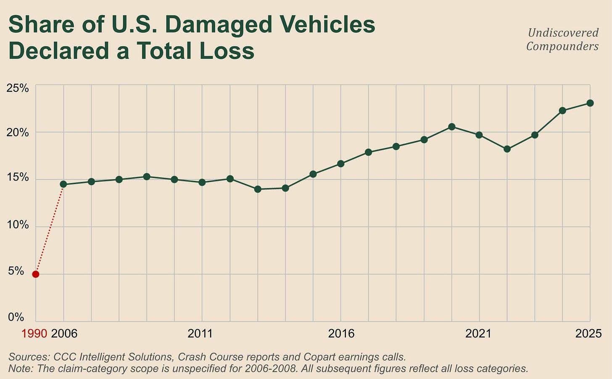

Management believes this trend will continue, and went on record saying so. In FY22, right at the trough of the ratio’s pullback, the 10-K read “We believe the long-term trend of increases in total loss frequency will continue.” Reality proved management right fairly quickly.

Let’s analyze the facts behind management’s reasoning.

5.3 Repair and recovery

5.3.1 Global trends

Three big trends are reshaping the total vs. repair balance:

Repair costs are rising.

Salvage recovery value is rising too.

The number of accidents is falling (I’ll save that for 5.6).

All three favor totaling (the inequalities from 5.1), and it might be tempting to call this a Lollapalooza effect. Almost. In reality, all three trends are largely the consequence of a single variable: the increasing technological complexity of cars. The shareholder letter talks about “some 1,000-3,000+ semiconductors” vs. “literally zero 50 years ago.” (Obviously, inflation heavily affects the first two, and road-safety/prevention measures heavily affect the third. Nothing is monocausal.)

What tempers this fact is that these technologies are concentrated in spots that are very well protected from typical accidents... no, I’m kidding, again. All these components are spread out along the car’s outer edge: bumpers, fenders, mirrors, windshield. Take your pick. Makes sense, a sensor that watches the road has to be somewhere it can actually see the road. Consequence: small, expensive parts are among the first exposed in an accident. No model year is going to fix that. A visual sensor needs photons, and it won’t pick up the relevant photons hidden behind the engine.

This phenomenon shows up very clearly at the repair shop:

About 50% more parts per repair over ten years.

Average repair time has gone “from 25 hours to 30 hours” (CFO, fireside Baird, June 2024).

An average cost above $4,730 in 2024, +3.8% for the year (including +3.1% in labor rates and 4% in parts).⁵⁷

The creation of a new job title: electromechanic. A bumper with a built-in radar no longer just gets swapped out on its own; the sensor has to be recalibrated, and of course, that gets billed separately. A calibration was required in 24% of authorized-network estimates in the first quarter of 2024 (32% in the latest reading).⁵⁸

Let’s temper that last point a bit: part of the bill is due to import tariffs on parts. But let’s temper the tempering too: when an analyst asked whether the 2018-2019 tariffs showed up in the total-loss rate, the answer was “not one we could isolate, no.”

To sum up, if tariffs have an impact, it’s probably minor on this front. The overall trend remains obvious.

5.3.2 Local trends

When you study the repair industry and its recent shifts, two other trends could, on paper, offset these increases:

The consolidation of repair shops.

Reused/salvage parts.

The concentration of repair shops in the hands of a few big players should create economies of scale that are partly passed through to customers. Reality stopped there. It was even a tad ironic. Across a $48B-a-year US collision-repair industry with about 40,000 shops⁵⁹, the only documented effect of scale runs the other way: Boyd’s boss (one of the groups that’s taken the most share) publicly told its insurer clients to expect “much more in the way of increases.”⁶⁰ Turns out economies of scale turned into pricing power (I obviously haven’t found any source that precisely quantifies the impact of all this).

Next, reused parts, meaning parts pulled off a dead car to be put back on a living one. That’s obviously cheaper than an OEM part, so the bill gets smaller. So more repairs. So Copart gets sad. The reasoning holds, but we said reality was ironic: the wreck supplying those cheaper used parts often comes through an auction, often held on VB3, Copart’s platform: “as reflected in demand from dismantlers.” On this variable, Copart is more or less agnostic.

To sum up: everything keeps lining up to send more cars through Copart. But watch out for the traps in Units. Not only does a higher total-loss percentage mean nothing without an accident-rate percentage, but a change in units can only be properly read alongside a change in ASP. We’ll come back to both.

And where does that leave insurers in all this?

5.3.3 The consequences for the insurer

Let’s put our insurer hat back on (it’s starting to look a bit worn out, which is a good sign).

The cost of the repair is only half our problem; the other half is how much we get if we resell the carcass. But a dead lane-departure camera doesn’t stop the car from actually driving, only from making the repair economically viable. According to the CEO, a lot of the modules that make repair economically unviable for the insurer are “not necessarily fundamental to the operation of the car itself”; the vehicle remains “acutely valuable to South America, Eastern Europe, Africa.” So a major source of demand for these vehicles comes from... exporters (good, you’re following along).

This demand does show up in the valuation of these types of vehicles. At Copart, these vehicles, even though declared total losses, trade close to the wholesale value of running, non-totaled vehicles on auction platforms like Copart’s.

So is this phenomenon what explains the recent 4.1% YoY rise in US insurance clients’ ASP (a record ASP)?

5.4 The marginal vehicle

It’s... complicated. Let’s start with management’s point of view.

Management describes them this way: “Those are primarily higher value units” (CFO, fireside Baird, June 2024). To be more precise, they’re seen as units that sell for more than past averages and that give the ASP “a buoy or a floor” (CFO, fireside Baird, June 2024). As a reminder, Copart sells “actual cars and not selling baskets of parts” (mostly; you do see the occasional lot of spare parts here and there). These vehicles very often go for $5,000, $10,000, $15,000, sometimes $20,000 and up. That’s exactly the type of vehicle international buyers target, “more focused on those borderline total losses and repairable vehicles.”

So newer vehicles tend to be totaled relatively often, and to sell at auction at higher ASPs than older vehicles. But, plot twist, that doesn’t mean they total more than older vehicles do:

45.3% of vehicles 13 years and older that go through a claim end up as a total loss,⁶¹

vs. 10% of the current model year, a 4.5x difference running in the opposite direction from what electronics alone would suggest,

and to drive the point home, 70% of total losses involve vehicles 7 years and older.⁶²

To sum up: I said new ADAS (Advanced Driver Assistance System) technology in vehicles pushes toward totaling, and yet older vehicles get totaled 4.5 times more often than newer vehicles loaded with tech. Why?

I’ll let you try to solve this contradiction yourself, it can be fun (and no, I didn’t make a mistake, calm down).

If repair costs weren’t the answer, the only solution left is PAV (Pre Accident Value, or ACV under its other name; Copart just uses the term PAV, and insurers ACV, roughly speaking). And indeed, on a car older than 13 years, it has fallen sharply. Makes sense, cars generally lose value as they age, especially as new cars pull further away with technology and features that would have been the stuff of dreams 20 years earlier.

Meanwhile, the repair estimate has fallen far less. A door, a can of paint, and labor hours haven’t dropped in price; most have actually gone up. On the totaling side, sure, there’s no blind-spot radar to make it easy to total a 13-year-old car, but a bumper and an airbag are enough.

Newer models total more at the same age (higher repair costs), but older vehicles still total more often than newer ones do (lower ACV relative to repair cost).

Ok, the logic is clear. But where does the 4.1% YoY ASP increase actually come from, then?

I’m being generous, so I’ll give you another chance to think it through yourself. Small hint: it’s a matter of timing.

This rise in ASP mostly comes down to the aging of the fleet: it’s relatively old vehicles that still retain a non-negligible residual value that are increasingly tipping toward totaling rather than repair. More precisely, in the 7-12-year bracket, the total-loss valuations went from 33.4% in 2020 to 41% today.⁶³ At the same time, the share of newer vehicles is smaller now than it was a few years ago. For instance, there are 12M fewer vehicles 6 years old or younger on the road today than in 2020.⁶⁴

To sum up, the recent rise in ASP mostly comes from a growing share, in the overall mix, of vehicles that are relatively easy to total while still being worth more than even older vehicles. New technology does have a real effect on the total-loss share, but for now this population of vehicles is too small to have a significant effect at the aggregate level.

For now, my take is that this is more a matter of timing than of technology. The same mechanism at play right now will still be at play later: today’s newer vehicles are going to take up more and more of the overall vehicle mix. They’ll probably still be totaled at similar rates, so their share of totaled vehicles is going to rise. Their ACV will mechanically be higher than that of older vehicles (today’s 7-to-12-year-olds), and will therefore help push ASP up. I obviously don’t have what I’d need to weigh the two against each other, and nobody publishes what it would take to do that.

I’ll save this phenomenon’s impact on Copart’s revenue for later.

For now, we still have two important vehicle types left to cover. First, electric.

5.5 Electric vehicles

This shouldn’t surprise you, but the logic doesn’t change. Electric vehicles “total, if anything, more easily.” No, not because of the battery, as you might intuitively think, but, once again, because of their peripheral sensors. But, once again, the statistics are distorted.

For 2025, the total-loss rate for electric vehicles comes out at 12.7% vs. 23.1% for the market as a whole.⁶⁵ But electric vehicles account for only 3.7% of the market’s claims, versus 9.7% of claims for vehicles 3 years old and under.⁶⁶ So a fleet that’s practically brand new, compared to a fleet with a median age of +10 years.

If you control for age, the gap evaporates (Battery Electric Vehicle = BEV; Internal Combustion Engine = ICE; source: Mitchell)⁶⁷:

Q1-24: BEV: 9.93% vs. ICE: 9.51% for 2021+ model years. (What this means: in Q1-24, among 2021-or-newer electric vehicles that had a claim, 9.93% were totaled, vs. 9.51% for gas-powered vehicles from the same period.)

Q2-24: 9.16% vs. 9.45%. BEVs slipped slightly below ICE vehicles.

Q3-24: 9.9% vs. 9.98%. 8 basis points, basically nothing.

Q1-26: 12% vs. 13% for gas-powered vehicles under 6 years old. Still below.

HLDI (Highway Loss Data Institute)⁶⁸ finds the same thing for 2013-to-2019 model years (mileage-adjusted, of course).

Why, in Q1-24, were electric vehicles totaled a bit more often than gas-powered ones, going against the overall trend? Once again, the culprit is ACV. It had dropped sharply, making repair costs disproportionate relative to totaling. Here, though, we can’t use the aging explanation to justify this drop. In this case, it really is a localized slump in the electric-vehicle market. Over the same period, used-EV values collapsed: -46% since October 2022 vs. -17% for the market.⁶⁹ Once again, it’s the denominator that’s at fault.

One of the main reasons an electric vehicle gets totaled is its battery pack (hundreds, even thousands of lithium-ion cells, replaced as a single block the moment it’s suspect). That can represent up to 40% of the vehicle’s value, or around $15,000 to replace.⁷⁰ Half of claims that require replacing it end up as a total loss.⁷¹

But it’s still time to temper this. First, the cost: the repair-cost gap with a hybrid fell from $1,809 in 2020 to $445 in 2025.⁷² Given the vehicles’ value, that’s a nearly trivial gap. Then, scale: electric vehicles account for only 1.9% of the US fleet.⁷³ Cherry on top, 2025 was the first year both EV sales and EV market share declined.⁷⁴

For now, the impact of electric vehicles on Copart’s business model is minor, and it looks set to stay that way for a while yet.

Let’s move on to the overall fleet (and its accidents).

5.6 The fleet on the road, and its accidents

The big trend in the global auto industry since 2020 has been the drop in new-vehicle sales. Today’s new vehicles are obviously tomorrow’s used vehicles, so the ones Copart cares about.

So what, is Copart’s vehicle pool going to dry up starting in 2027? In this industry, it’s never that simple.

The former CEO answered this question last spring. According to him, each annual cohort of new vehicles hitting the market is just one layer in “a layer cake of more than a decade’s worth of new car shipments.” If you suddenly remove the entire 2021 model year, that’s just one layer missing out of a whole that has a good dozen of them.

A visual image, however, is no substitute for the rigor of numbers. About 300 million vehicles are on the road in the United States⁷⁵, with 14 to 18 million new vehicles added each year depending on the economy. So each new model year makes up about 5% of the fleet. On top of that, it takes about a decade for a new vehicle to enter the age bracket where total-loss risk is high (that age bracket is shrinking for the newest vehicles). So for Copart, a slump in vehicle sales will only have a potential impact after a certain number of years.

The same logic applies to waves of new-vehicle leasing. Even after the 2-3 years it takes to reach the used-car market, they’re still too new to fall meaningfully within Copart’s addressable pool. Before hitting the market: “off-lease volume is not per se a specific catalyst.”

For Copart, the most important variables of the US vehicle fleet are its size, its age, and the miles it covers.

As for size, the fleet keeps growing steadily. Not very surprising, but we’ll explain why anyway further down.

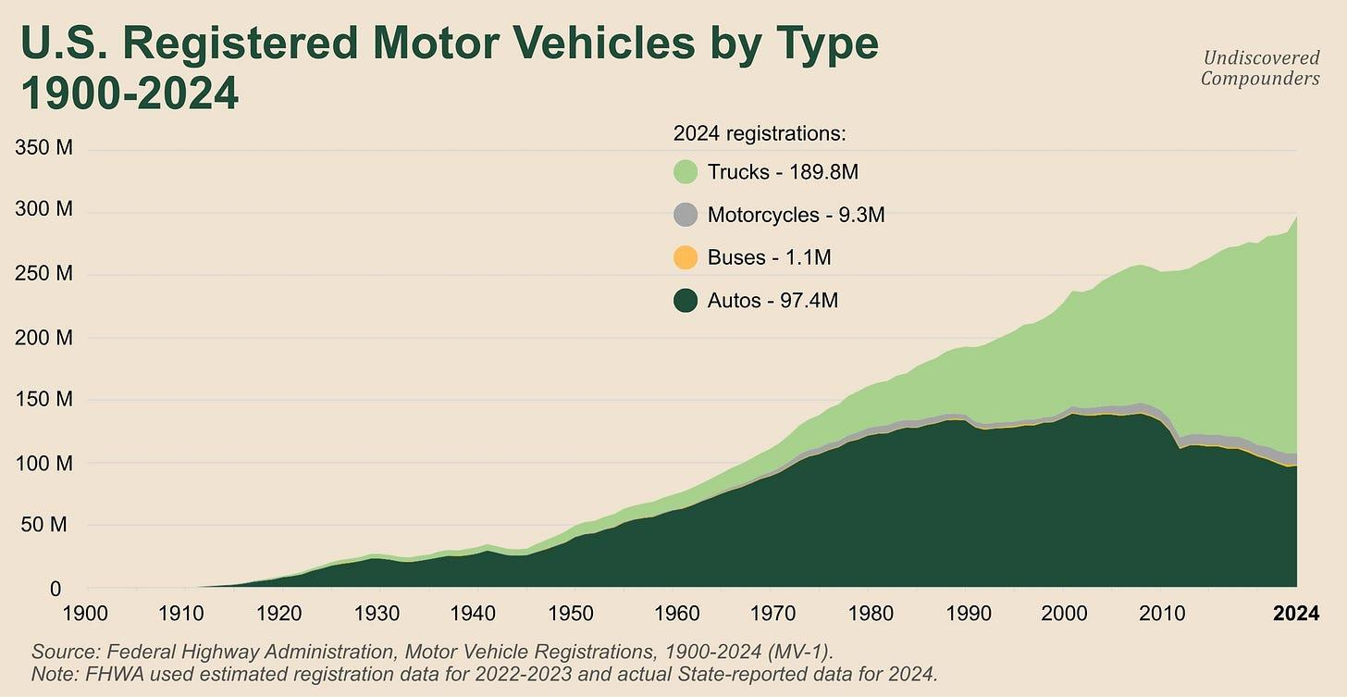

As for age, the average vehicle on the road is nearly twice as old as it was 30 years ago.⁷⁶

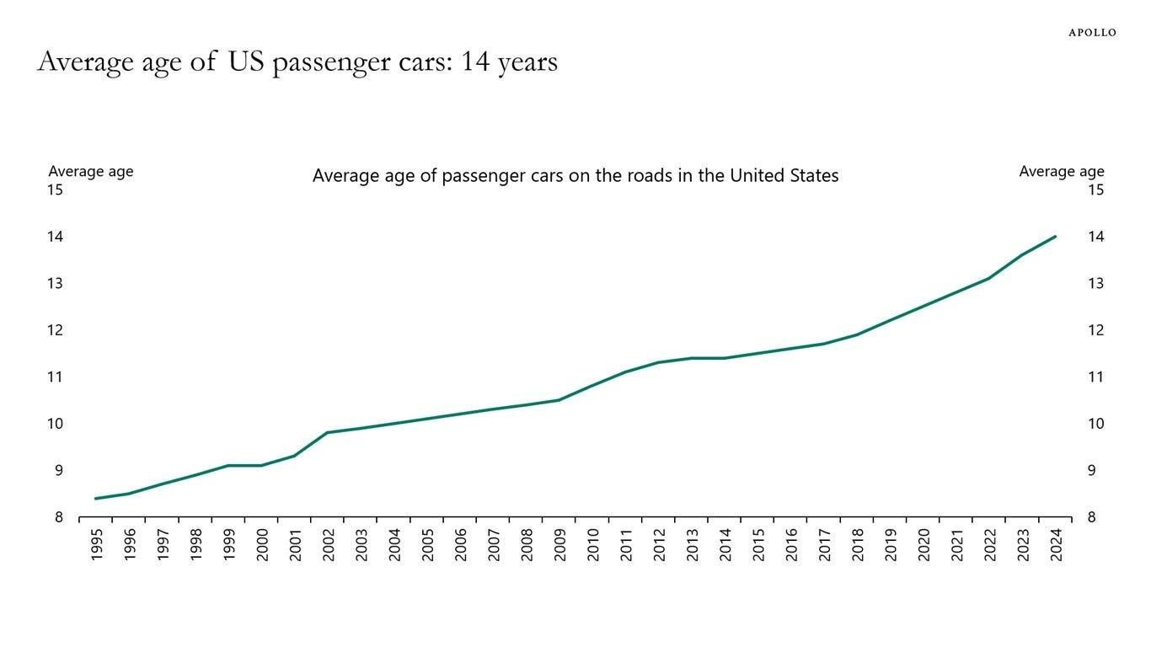

The trend is clear and should hold over the coming years as new-vehicle prices keep rising overall. All by itself, this chart shows that Copart’s US business model can’t collapse overnight because of a vehicle-supply problem. In any case, that’s not where the bulk of the uncertainty lies for Copart.

That leaves miles driven, and almost obviously (given the number of vehicles), they’re rising.

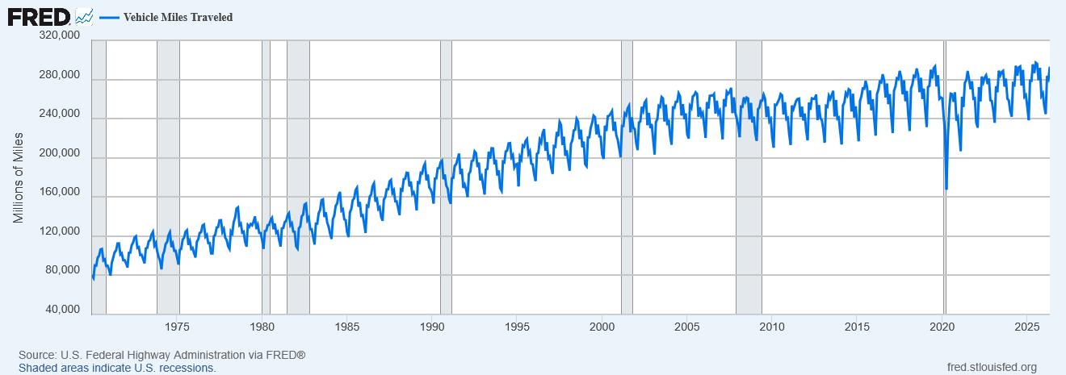

Now, why these trends?

For starters, the US population has grown at roughly 1% a year and has nearly doubled since 1960.⁷⁷ Yet miles driven have quadrupled over that period.⁷⁸ Sure, there are more people, sure there are more cars, but this figure tells us people are driving more miles on average than before (unless the US has developed the gift of ubiquity, in which case, dear US reader, feel free to confirm that for me).

This 2x difference between the growth in miles driven and population is the result of both falling car prices relative to average income and how much easier cars have become to use, notably through infrastructure development (roads, parking, etc.). That said, there’s the huge dip during Covid, which wasn’t fully recovered until five years later (remote work, changing habits, health trends, etc.)

OK, the big national trends are running in Copart’s favor. But miles driven are only a proxy for Copart. What matters at the national level for Copart is the number of accidents.

And there, the trend runs counter to Copart: since 1990, approximately one-third fewer crashes and fatalities per million miles driven (Department of Transportation)⁷⁹. For Copart, this is the flip side of ADAS (Advanced Driver Assistance Systems), which makes it easier to total a car once there’s an accident, but which, on the other side, reduces how often accidents happen in the first place.

If you add all that up, what do you get? According to the CEO, over the same period: “in absolute terms, that decline has only been 8% because of the offsetting effects of the growth in population and vehicle miles traveled.” The rise in the number of vehicles plus the rise in miles driven have offset a large chunk of the drop in accidents per mile driven. Whether this trend holds up over time is one of Copart’s long-term risks. If, one way or another, the decline in accidents isn’t offset by one or more variables, units will face structural decline. Sure, a units figure always has to be read alongside an ASP, but in a structural decline spanning several decades, ASP very probably won’t compensate. This is, in fact, one of Copart’s main long-term risks. We’ll come back to it.

For now, accident data alone is too indirect for our analysis; the variable at the core of Copart’s business model is total-loss frequency. Here too, management settles the question without hesitation: the decline in accident rates is “not nearly enough to offset” the rise in total-loss frequency, and “the number of cars that are totaled in absolute terms still grows.”

Still, this is the variable that determines Copart’s performance. You can’t just trust management, however honest it may seem. As an investor, I have two datasets available to me:

The DOT data is public, but it comes out “on a lagging basis.” That’s the equivalent of looking at the numbers and saying “yep, that’s indeed how the past went.”

There’s another measure that focuses on the volume Copart can actually process. It counts insured accidents: earned car years, insured exposure measured in vehicle-years, and the frequency of paid claims. It comes from ISO Fast Track, and it’s such a good dataset that Copart itself cites it quarter after quarter.⁸⁰ But it isn’t public.

So are we doomed to uncertainty? No. Luckily for us, there’s Berkshire Hathaway. More precisely, the auto insurer it acquired a few decades ago, GEICO. For context, GEICO accounts for roughly 1/8 of personal auto policies in the US.⁸¹ In its quarterly report, it gives accident frequency. Q1-26: +5 to 7% for bodily injury,⁸² +2 to 4% for property damage and collision. For extrapolation purposes, the law of large numbers comes to our rescue. At this scale, it’s very likely that the national trend is fairly close to GEICO’s numbers. Yes, I know, sampling bias, confounding variables, etc., but it’s still the best proxy we have.

To sum up:

The short-to-medium-term trends in the US auto market favor Copart.

The best way to track these short-term trends without explicitly trusting Copart’s management is to read Berkshire Hathaway’s quarterly reports.

Why make life this complicated? We’re talking about trends that are nearly a century old. Extrapolating one or two more decades shouldn’t be epistemically bold, right? In theory, yes; in practice, it’s always complicated. Living through an era in which major technological revolutions are piling up doesn’t help. It’s finally time to talk about the self-driving car.

5.7 Self-driving

I’m sure those of you who already know the Copart story a little have been waiting for this subsection from the start. (I’ll have you know I took a wicked pleasure in making you wait. But I’m glad you made it this far, you didn’t just do a text search, did you?)

It’s the favorite argument of quite a few Copart bears: if the car eventually drives itself, it stops crashing, and if it goes mainstream, Copart’s entire business model collapses.

That’s too binary for the reasoning to hold as is. I break the problem down into 3 dimensions:

Current scale

Timing

The self-driving car inside Copart’s machine

5.7.1 Current scale

First, let’s quantify the current order of magnitude.

Waymo, Alphabet’s subsidiary, runs about 4,000 vehicles for 500,000 paid rides a week.⁸³ These rides account for roughly 95% of US commercial autonomous miles.⁸⁴ If you compare that with miles driven in the US across all operators, that’s 1 in 15,500 miles.⁸⁵ And the total miles Waymo has driven since its founding add up to roughly 35 minutes of American road traffic.⁸⁶

Today, the self-driving car doesn’t even warrant a footnote in Copart’s financial statements.

For the future, though, that’s another story.

5.7.2 The clock

The clock. First let’s frame this a bit and go back to the mechanism we just saw. The fleet keeps growing in size and aging slowly. It’s a pool that heroic assumptions can’t make disappear. Copart still has at least 15 years’ worth of existing vehicles that can eventually run through its auctions. But after that?

Let’s suppose the self-driving car really does take off (which, in my view, is clearly not a given), and look at what history tells us about the adoption of automotive technology.

Take the most “well-known” ones: the frontal airbag, ESC, the backup camera, and automatic emergency braking. All of them were made mandatory on new vehicles. Yet each took between 18 and 23 years to reach 95% of vehicles on the road.⁸⁷ If you look at past forecasts for these adoption dates from the institutes whose job it is to make them (for example: the Highway Loss Data Institute), you’ll notice a near-systematic overestimation of how quickly these technologies are adopted (for instance, ESC saturation was originally forecast for 2029⁸⁸, and has now been pushed back to 2034).

An even more concrete example: adaptive cruise control with lane centering (roughly speaking, the essential building block of assisted driving, not autonomous, assisted, I insist). It currently equips only 7% of the fleet⁸⁹, and forecasts put 95% penetration at 2050 at the earliest (with the optimism these forecasts are known for, potentially).

Even if the self-driving car really does take off, the timeline will probably be measured in decades. At least, going by the past. But that only pushes back the potential timeline; it doesn’t quantify either the outcomes of this risk or its probability distribution. I’ll save that for later.

In the meantime, we still have to see how self-driving interacts with Copart’s model.

5.7.3 The self-driving car inside Copart’s machine

Would you be surprised if I told you the self-driving car doesn’t go through Copart?

Take Waymo, by far the biggest self-driving fleet in the US: these are self-insured fleets managed by Alphabet. If a vehicle never goes through insurance, it won’t go through Copart (that logic isn’t always true, but here it is). Copart, for that matter, has no visibility at all into whether they get totaled, and the effect on auction activity is therefore, for now, “a de minimis effect.”

The logic of the accident itself is different. Out of 78 serious accidents recorded by Waymo (August 2025 to March 2026)⁹⁰, 48 are rear-end collisions, 24 of them while the vehicle was stopped at a light or a stop sign. It turns out that removing the driver removes the accidents the driver causes, not the ones inflicted on them. A not-at-fault vehicle is still a damaged vehicle, self-driving or not.

But the technology is still too immature and too sparsely adopted for us to generalize anything from it. But this will come in handy later.

This subsection was only a description of the current situation. I’m keeping the self-driving car as a risk in the risk section (consistency above all). Small spoiler: I think the impact of self-driving vehicles on the US auto industry over the coming decades is being massively overestimated (often on purpose).

5.8 Legislation

It’s time to keep the promise made back in 2.2.2 and come back to legal thresholds. It’s not hugely important, but I’ve seen a few bull/bear arguments floating around that were built on new laws misunderstood by the people making them.

US states can be split into three different regimes:

25 jurisdictions, DC included, have a damage ratio⁹¹ (repair cost / ACV) written into law: 65% in Nevada at the low end of the range⁹², 75% in 15 states⁹³, and the rest in the 70-80% range.

Some other states, like Texas, set an upper bound without specifying a precise percentage, for instance “exceeds the actual cash value.”⁹⁴

The rest use a formula (repair cost plus salvage value against vehicle value), or nothing at all, and the insurer sets its own threshold entirely.

And even then, treat 25 jurisdictions as a loose upper bound: Florida only targets the uninsured,⁹⁵ Indiana and Minnesota the self-insured, while 4 states only target newer vehicles. So, for our purposes, the number of states whose legislation actually targets an insurer that’s a Copart client is lower.

Ok, but just to make sure we’re on the same page: raising the legal threshold, what does that actually change for Copart?

What’s your guess?

Not much. Because we’re talking about the salvage-vs-clean status threshold, not the totaling threshold (vocabulary back in 2.2.1 if needed).

The law only shifts the threshold above which a salvage title becomes mandatory, but that changes nothing about the fact that it’s still the insurer who decides whether to total or not. The insurer very often totals before this legal threshold is even reached (based on its own economic calculation).

I see two specific impacts on Copart:

The final price Copart can get for it on its platform. This price varies strongly depending on the title (clean vs. salvage). More clean vehicles are associated with a better ASP.

A potential decrease in volume. A clean vehicle is, in principle, wanted by more buyers, and some contracts between insurers and Copart don’t necessarily cover clean vehicles. So the insurer can redirect these new clean volumes created by the legal change somewhere other than Copart. In practice, I judge the impact to be minor, for two reasons. A clean vehicle that was once totaled will carry that history “for life” (Carfax, AutoCheck). That’s an indelible mark that makes the car less desirable than a clean vehicle that was never totaled. On top of that, Copart itself owns a tool specifically built to capture these volumes, Copart Select (created in late 2023), specifically for clean vehicles (in the legal sense), with guarantees that don’t apply to non-clean ones (“Copart’s Arbitration Policy gives you up to 21 days & 300 miles to file a claim”; I should note I’ve never seen management explicitly say that insurers’ totaled clean volumes go through Copart Select. That’s an extrapolation on my part, nothing more).

Nothing beats an example: Iowa raised its salvage threshold from 50% to 70% in 2021.⁹⁶ But that’s only an administrative category change; the insurer runs the same economic calculation to decide whether to total or not. And if it totals, it keeps sending roughly as many vehicles to Copart. Oklahoma made a similar move (from 60% to 70%), taking effect in November 2026.⁹⁷

To sum up, overall, state legislation isn’t all that impactful for Copart or insurers. Overall. In specific cases, though, it can sting.

South Dakota, SB 227 (February 2026)⁹⁸: a ban on declaring a total loss until repair costs reach 75% of value, unless the owner requests it in writing. Here we’re no longer dealing with the administrative salvage/non-salvage logic that only kicks in after the insurer has decided to total. We’re talking about an actual obligation to repair. The Senate passed it 27 to 6 in mid-February. A week later, on February 24, the House transportation committee killed it 8 to 3⁹⁹, after the insurance lobby argued that a rule this rigid “could keep unsafe vehicles on the road.”¹⁰⁰ It’s clear that if it had passed, it would have cost local insurers dearly, and it would have meant a bit less volume for Copart.

I’m not going to keep stacking up examples, varied as they are, or the word count is going to hit six figures (and neither you nor I want that).

The situation between Copart, insurers, and state legislation can be summed up in 4 points:

Overall, the impact of any single state’s legislation isn’t decisive; the national trend is what counts.

The national trend is to leave the majority of the cards in insurers’ hands.

Locally, a state can sometimes pass a law that breaks from this trend and either strongly favors Copart or materially hurts it.

In general, Copart and insurers fight the same battles. What’s good for Copart is generally good for insurers, and vice versa. And they both know very well how to make their interests heard.

No problem on that front, but still worth watching.

5.9 The trend summed up

Let’s sum up:

Total Loss Frequency (TLF) = Totaled claims / Total claims.

Total Loss Formula: Cost of Repair + Salvage Value > ACV

This frequency is measured by a software vendor using claims processed through its own system. It’s not the national frequency, but it’s probably a good proxy.

This ratio is determined insurer by insurer, each with its own internal threshold, region, and constraints.

It’s rising because the repair estimate (Cost of Repair) keeps climbing while the fleet’s ACV keeps falling, so the equation tips an ever-growing number of cars toward total loss.

Copart controls one of the three terms in this formula, salvage value, and is largely at the mercy of the other two. Its only other notable lever is Co.ai, its suite of repair-cost diagnostic and decision-support tools, which it provides free to insurers (with the goal of pushing more decisions toward totaling, let’s not kid ourselves).

Now for what comes next.

Copart is convinced TLF will keep rising over the coming decades. This isn’t just conference-call marketing. It manages its main asset, its land, based on its expectations for how TLF will evolve: “a function of our expectation that total loss frequency will continue to grow” (CFO, fireside Baird, June 2024). So it buys acres based on this conviction (even if these purchases have slowed in the US).

But let’s push the logic a bit further. Cars keep getting more modern, repair costs keep rising, and used-car prices rise along with them. Makes sense. But by Copart’s own admission: a rise in used-car prices “may decrease salvage frequency and adversely affect our growth rate” (FY16). We’ve already seen why. If used-car prices climb, the payout required to total a vehicle gets bigger, the insurer totals less, and Copart’s units decline. Sure, ASP mechanically rises, but as we’ve seen, the buyer-side fee curve is convex.

Right now, this modernization phenomenon isn’t yet showing up meaningfully at Copart, where the vehicle pool underlying this revenue skews toward vehicles more than 7 years old. But what about in ten years? In 20 years?

Nothing is less certain. The price of today’s “expensive” technology could completely collapse in the future. Or, conversely, explode. Either way, I stand by the argument I used for self-driving vehicles: it seems nearly impossible to me for a technology to go mainstream while it’s expensive (and stays expensive), given that viable, cheap alternatives exist. The trend of declining new-vehicle sales will keep tracking the price of those new vehicles, and will therefore depend partly on the quantity/quality of the technology built into them. (Once again, international is a natural hedge against this trend; whether that hedge will be enough, we’ll come back to it.)

I promise I won’t let my opinion creep into the valuation, and both the ideal scenario and the adverse scenario will get their own place.

In fact, we should hold onto two important rules from this section for later on:

Extrapolating CCC’s series and adding a premium, because Copart pushes toward totaling, would be double counting. Total-loss frequency rises partly because Copart offers better auction prices. It’s subtle, but I’ve already seen this mistake made.

The two terms on the right-hand side of the equation Units = Reported Accidents x TLF aren’t independent. Recently, a rise in insurance premiums and deductibles caused a drop in the number of insured vehicles (so a drop in the volume of vehicles that can be totaled), then a drop in the reporting of small accidents (artificially inflating TLF). Making estimates from this equation will require accounting for this interdependence.

So much for the subtleties, but there’s one undeniable fact: the variable at the very heart of Copart’s business model, ASP, is at an all-time high while the stock price has been cut in half because of the drop in Units.

The facts are true, but the situation is both simpler and more complex than it looks.

6. The crux

6.1 A summary of the current situation

One of the big US insurers (every source names Progressive, so I will too) reportedly moved almost entirely over to IAA. The competitor’s units are climbing while Copart’s are declining. That’s the big bear argument of the last few quarters.

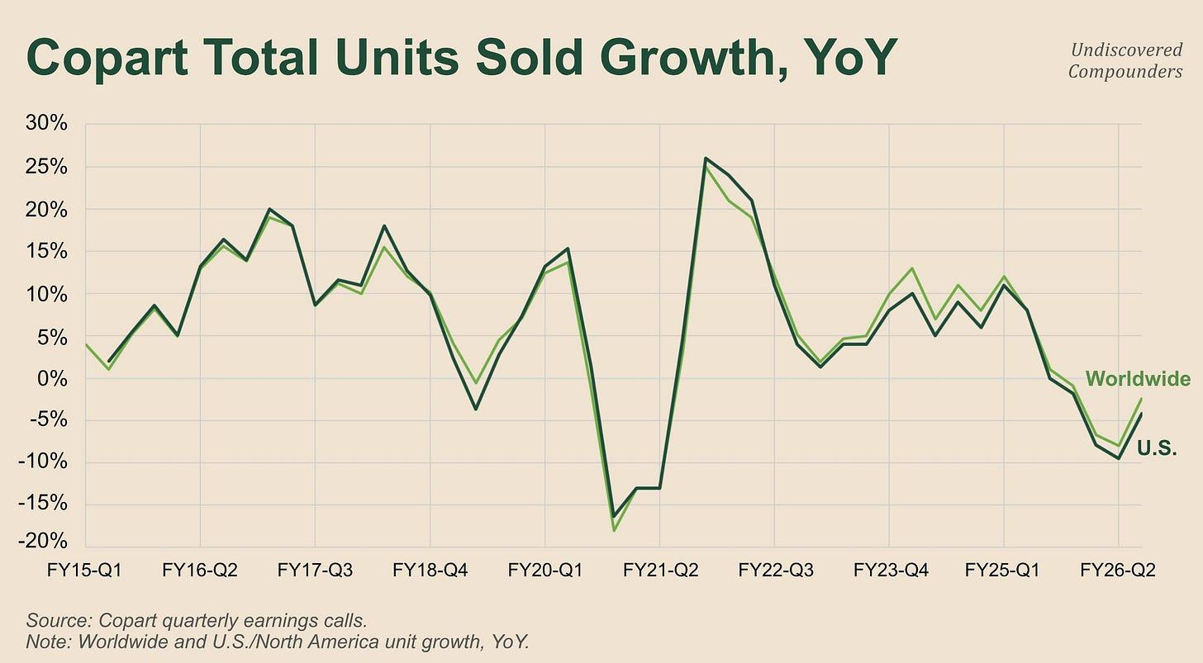

The numbers: the drop in units is real and prolonged. It’s not just one bad quarter out of nowhere. It’s a trend that’s been going on for more than a year. That said, there’s an improvement in the latest quarter, partly due to a base effect. These are insurance + non-insurance units combined, but the trend stays clear.

The timeline: May 2025, the company is at its ATH. Q3-25 comes out after the close on May 22, below analyst estimates (8% vs. 10%), and the stock drops 12% the next day. From there, it’s a slow, inexorable decline. Q4-25 buys some time. Sell-side notes from October/November 2025 talk about a shift in Progressive’s salvage business, supposedly going from 75% to 90% at IAA in 30 days. Meanwhile, Copart’s unit count declines. Everything seemed to show Copart losing market share. At every conf call, analysts grilled management on these facts, with more and more intensity as the calls went on: price competition, market-share loss, etc. The worry was palpable on the calls. And in the price too.

What does management say about it?

First, the facts: they brought back the former CEO who ran Copart from 2010 to 2022, in July 2026 (to be honest, he never really left). They brought out the big guns. Cause and effect, impossible to say, but from a Bayesian standpoint, that’s not nothing.

In terms of what was actually said, it depends. On the specific case of Progressive:

“Yeah, there is a unit loss. There was an account that was lost in some ways, and in some ways, Copart chose not to do business.” ... “I won’t mention the company” … “That has historically happened” … “I don’t view that as some fundamental change in the relationship we have with all of our clients.” (Conf Call, July 2026)

For starters, this explanation comes months after the fact, during the CEO-transition conference call. Second, it’s the new CEO speaking (the founder’s son-in-law). Is it an attempt to reassure the market? Is it a burst of excess honesty in a somewhat solemn moment? I don’t know. Either way, he half-admits it really was a matter of price, and that Copart refused to lower its own fees.

That’s the situation at a quick glance, which can be summed up as: the business is going elsewhere because Copart is too expensive. Now, let’s analyze and pick this apart in depth, and answer two questions:

Is it true?

If so, is it secular or cyclical?

6.2 The clean series

I’ve spent 30k words and more subsections than I can count on two hands telling you to watch out for the numbers and their interpretation, and yet, in the previous section, I talked to you about US insurance numbers while showing you insurance + non-insurance numbers. That’s sacrilege. But it was deliberate. Those are the numbers management gives out all the time, so they’re the easiest to get, and they conveniently happen to confirm the potential thesis.

Here, let’s take US Insurance Units, CAT-included and ex-CAT, vs. the same data but US + International. (Unfortunately, Copart’s figures are only given on conf calls, and they’ve only been giving them out very recently.)

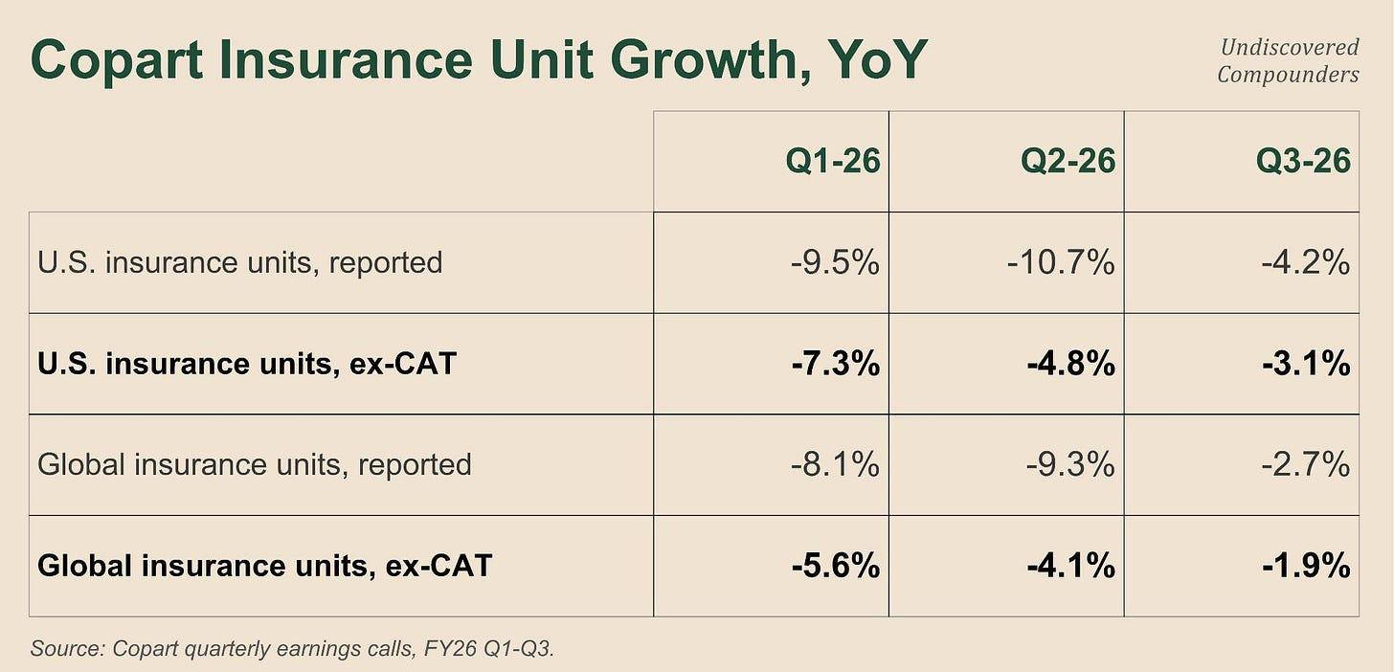

What jumps out is just how much CAT events distort the data. A careless eye can easily fall into the trap. What interests us is the underlying trend:

The trend is clearly negative, with a Q1 trough and a retracement over the last two quarters.

International slightly offsets this downward trend. So the problem is mostly a US one.

As a reminder, a units figure should never be read without its ASP (promise, this will be the only reminder in this section), and if you’ve got a good memory, you know Copart’s ASP is at its ATH, at +4.1% YoY in the latest quarter. Over these same nine months, revenue is roughly flat, -0.2%.

Copart used to compound its revenue and its EPS at around 10%. There’s clearly a problem, but the situation looks far more complex than the one described in 6.1. Perfect. That’s where the edge is created.

6.3 The dislocation

Let’s go take a look at insurers.

An auto insurer lives and dies by a fairly straightforward ratio: what it pays out (claims + expenses), divided by what it takes in (premiums). That’s the combined ratio. Below 100, it makes money on its underwriting; above it, it loses money on every policy it writes. In 2023, US personal auto came in at 104.9¹⁰¹, so the entire industry was underwriting at a loss.

Only price can fix this ratio, and insurers came out swinging: the auto insurance price index rose +20.3% over twelve months in December 2023.¹⁰² The following year, the combined ratio came back to 95.3.¹⁰³ Not bad, huh, 9.6 points in 1 year. The best year of the decade.

But nobody raises their rates 20% in a year without some kind of blowback. Even less so in a sector as competitive, and with as little customer stickiness, as insurance. Especially since it’s not hard for a policyholder: a few clicks on an insurance comparison site and it’s done. Even if everyone is too expensive, the policyholder can simply go without coverage altogether (even though driving uninsured is illegal). So it’s a trade-off for an insurer: fix its margin, or go chase new clients. Flat, even negative, growth can therefore be the price of the fix.

Let’s apply all of this to our situation.

Progressive’s personal auto combined ratio stood at 88.5 in 2025¹⁰⁴, when the industry was still at 95.3 a year earlier. It did the opposite of everyone else: targeted rate cuts, “in states and markets where margin allows,”¹⁰⁵ and an ad budget that more than tripled, from $1.6 billion in 2023 to $5.1 billion in 2025.¹⁰⁶ Lower prices + an advertising blitz.

And it works: +13% in policies in force (PIF, the number of auto insurance policies) for the year, on $66 billion of written premium.¹⁰⁷ Record margin and double-digit growth while most of the industry was picking up the pieces (GEICO also stands out, with a combined ratio of 84.7¹⁰⁸, but with estimated PIF growth of only about 2%¹⁰⁹). The salvage provider just has to patiently wait a few months for the vehicles to show up proportionally.

So over this period, Progressive stands out completely from other insurers: very good margins while the others are still trying to fix theirs, and an advertising blitz while most of the other big insurers were just trying not to lose too many clients.

6.4 Coverage

Let’s go back to that overall +20% insurance-premium increase from 2023, but this time from the policyholder’s perspective.

Quick reminder: the industry measures its exposure in insured vehicle-years, earned car years. One car covered for twelve months = 1; 2 cars covered for 6 months = 1 too. Between the accident and the total loss, you still need an insurer covering the damage to the vehicle itself.

Q4-25 (calendar), insured vehicle-years fell 4.0% while the vehicle fleet on the road grew 1.4%. So more vehicles on the road, and yet a lower share of the overall fleet that’s insured. A lot lower. Copart’s management even mentions the fact that, among those still insured, a fair number of policyholders have downgraded their coverage (to the point where the policy no longer even covers reimbursing their own car, so no totaling): “from collision coverage to liability only.” There are also those who kept their coverage but, because of rising deductibles (on top of rising premiums), report fewer small claims: -7.5% in collision claim frequency (Q2-25). Everything points to fewer vehicles getting totaled, so less salvage volume.

“Yes, but still, RB Global managed to grow its unit count over the period while Copart was losing units”, you might say.

True. Over Copart’s exact window, ex-CAT, RBG actually posts +5.9%¹¹⁰, but across all suppliers combined (you know them by now: rental company, fleet, bank, and even international). RBG itself explains that, over part of the period, this growth came largely from non-insurance: “a greater proportion of remarketed vehicles relative to insurance vehicles.”¹¹¹

Let’s lay out the numbers for Copart: 5.1 points of US decline ex-CAT over the first 3 quarters of FY26. What we’d need is the entire industry’s salvage volume over the same window. If you’ve been following along, you know we don’t have it. Time to put all this exhaustive work to use.

Salvage = Claims x Total-loss rate. Luckily, we have both of these data points. But we’re going to have to get clever.

It takes about three months between a reported claim and the sale under the hammer (mostly thanks to getting the salvage title from the DMV). The units Copart sells over its first three quarters of FY26 therefore come, roughly speaking, from claims filed in the second half of 2025.

Over that half-year, claims fall 4.5% on average¹¹² (6% then 3%, ex-weather) while the total-loss rate rises 1.8% on average (+3.2% and +0.4%). 4.5% - 1.8% = 2.7%.¹¹³

So the entire industry’s wreck pool shrank by about 2.7%. Weather excluded on both sides, since Copart’s -5.1% is also ex-CAT.

Copart -5.1%. The industry, -2.7%. So there are 2.4 points left to explain. So the theory that “Copart is losing market share to its competitor in US insurance” explains at most about half of Copart’s unit decline (roughly, these are statistics).

Let’s check that other half.

6.5 The carrier mix

Let’s go take another look at insurers. Yes, again, but case by case this time. So far we’ve treated all insurers as alike. Obviously, that’s not the case.

For 2025:

Progressive, with 18.6% of US market share¹¹⁴ -> PIF growth (auto insurance policies) +13%

State Farm, 18.6% -> 2-3% (estimated, since it’s not publicly traded: premiums +5.6% and price +3%¹¹⁵, the rest is volume)

GEICO, 11.6% -> 2%

Allstate, 10.2% -> 2%

Only one insurer grows in double digits; the rest are nearly flat. And the remaining half contains hundreds of insurers with far greater dispersion in performance. We’re forced to drop the assumption of uniformity.

Let’s pull out the calculator again. First, let’s assume that PIF growth = salvage growth = revenue growth for Copart. That’s wrong, but we can’t do better. Let’s then assume Copart accounts for 50% of US insurance salvage volume and IAA 33%, with the rest being regional players (that’s an assumption, but reality is surely not far off). If Progressive sent 25% of its volume to Copart, then its weight at Copart would be 0.186 x 0.25 / 0.5 = 9.3%.

But that 25% isn’t from a direct source, so let’s vary the scenarios, just to be safe:

25% -> 9.3%

15% -> 5.6%

10% -> 3.7%

Whatever happens, Progressive has a smaller weight in Copart’s mix than it does in the overall market. Put differently, Copart is structurally underexposed to the one insurer that grew significantly over the period.

We have our mix-weight gaps. All that’s left is to calculate the growth gaps and multiply the two together.

Progressive does +13%. The weighted average of the 4 big insurers above comes to +5.6%, the whole group representing 59% of the market. The insurers making up the remaining 41% (mostly regional mutuals) publish nothing. We still need one last assumption. Let’s set average policy growth at +0.5%, which amounts to assuming the remaining 41% is declining by about 7%. That’s a lot, but why not, it makes the bear case worse.

So Progressive would be 12.5 points above average (13 - 0.5). Perfect, let’s multiply:

(0.186 - 0.093) x 12.5 = 1.2 points

(0.186 - 0.056) x 12.5 = 1.6 points

(0.186 - 0.037) x 12.5 = 1.9 points

There you have it: the impact Copart’s underexposure to Progressive had on its unit growth under these different scenarios. These are extrapolations from changes in policy counts to changes in wrecks. The extrapolation is limited, but it remains directionally valid. My 0.5% assumption bothers you? Then let’s move it around. If I take -1%, the central scenario becomes 1.8 points. If I take +2%, the central scenario becomes 1.4 points. A 0.4-point swing.

We had 2.4 points left to explain after the overall industry trend, and Copart’s underexposure to Progressive accounts for between 1.2 and 1.9 of them. So there are between 0.5 and 1.2 points left to explain.

You now have every number you need to judge whether this quote from the CEO was an excuse or a description:

“We may be in a uniquely, or unusually, Copart adverse, moment in time in that respect, right? That some of the carriers that we are strongest with have not grown as much… over the past 12 or 24 months.” (Liaw, Conf Call Q2-26)

So what’s hiding behind these remaining 0.5-1.2 points?

6.6 What’s left over

The current bear thesis has an answer: Progressive was sending 75% of its salvage to IAA, and reportedly moved to 90%, over about thirty days, in late 2025 (the infamous sell-side notes). None of Copart, Progressive, or RB Global discloses this split, so it’s inherently unverifiable.

Well... I can show that this is false, or at least very incomplete.

Progressive has 18.6% market share; assume 15 points of its volume shift, and Copart accounts for 50% of salvage: 0.186 x 0.15 / 0.5 = 5.58%. That transfer alone would cost Copart 5.58 points of units.

If we carry the same logic over to IAA: 0.186 x 0.15 / 0.33 = 8.45%. This single client would hand IAA 8.45 points of growth. Over the window studied, RB Global did +5.9% ex-CAT.

Sure, I’ve said over and over that Units and revenue aren’t linear, that you need ASP to measure things properly. But here the number is enormous. We spent two subsections explaining that about 4% of Copart’s decline was tied to the industry’s own dynamics, all so we could end up with a single variable that, on its own, explains more of the loss than there actually was in total.

The narrative misses for both companies, in the same direction, by comparable amounts.

Let’s develop the logic a bit further just to be sure:

Copart’s 50% market share figure could be off by 10 points, 20 at the very most. Nothing that fixes the absurdity of the numbers.

The 18.6% is an official figure, but it’s based on policies, not units. Here too, though, the margin of error is minor. What’s more, Progressive insures an older fleet than the average of other insurers, so it probably produces more wrecks per policy than average.

That leaves the 15-point shift. It’s the only variable with enough range to absorb a gap this absurd, and it’s also the only one that doesn’t come from an official document.

Let’s flip the logic around: how many points of shifted volume would actually be consistent with the observed numbers? If we’re aiming for 1.2 points of volume gap (the top of my range), we get 0.186 x Y / 0.5 = 1.2; Y = 3.22%. This 3.22% shift corresponds to 1.8% of growth for IAA, which, again, remains more or less consistent with reality.

According to my calculations, then, the real volume shift is closer to 3-4% than to 15%. According to my calculations. I’m not saying that’s reality, and it very probably isn’t. It simply shows that the “Copart is losing to its competitor” narrative doesn’t hold up to the numbers at all.

If all 3 channels behind the drop in Units share the same cause, all that’s left is to find out whether that cause is here to stay or not.

6.7 Cyclical vs. secular

Let’s look at these channels.

6.7.1 Prices

For prices, here are the 12-month changes in US auto insurance prices:

+20.3% in December 2023

+6.1% in June 2025¹¹⁶

+0.2% in April 2026

On a monthly basis, over the last five readings: -0.3%, 0.0%, +0.1%, -2.0%, -0.3%.¹¹⁷ No doubt about it, price growth has essentially stopped. And it’s even about to turn negative. I could quote plenty of insurers, but Berkshire Hathaway’s 2025 annual report already says it all: “Competitors’ rate reductions may extend that pressure into 2026.”¹¹⁸ To remove any doubt, one of the big auto insurers (via GEICO) describes its competitors’ price cuts as a threat to its own margins.

What drained the salvage pool was the sheer scale of the rate hikes. And that scale has now disappeared, and could even reverse. It’s hard to predict the behavior of the insured and uninsured at a nationwide scale, and I’m not going to try, but every incentive points toward the numbers going back up.

6.7.2 The Mix effect

The mix effect depends on the relative growth of insurers that send a big share of their volume to Copart vs. those that don’t. I have no proof, but given the numbers, it’s highly likely Progressive is the biggest insurer for which Copart holds the least volume. So the problem can be summed up as Progressive’s growth vs. everyone else’s.

Here are the numbers I found:

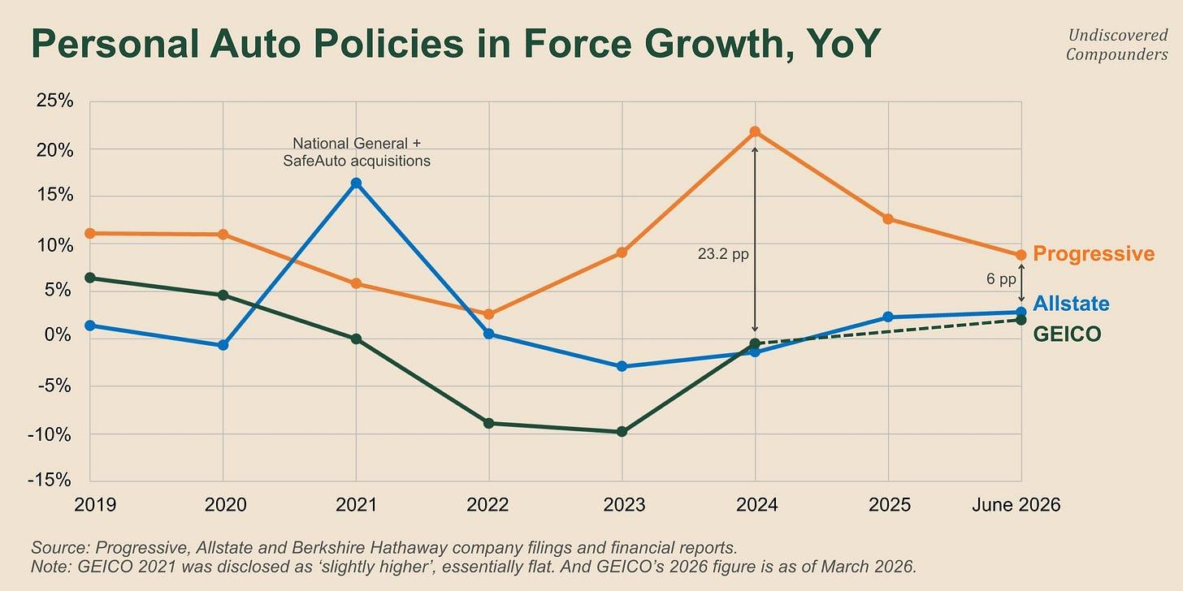

Progressive clearly exploded post-Covid, while the two other big insurers with known figures struggled more. On paper, this cycle is now turning.

In practice, it’s almost inevitable that Progressive’s run slows down and other insurers’ pick up. Insurance is an extremely competitive industry, where the product on offer is easy to compare and where switching costs generally aren’t enough to outweigh a cheaper price from a competitor.

To push the cycle argument further, the median age of the 10 biggest US auto insurers (together accounting for more than 75% of the market) is 101 years. Think of insurance as a kind of peloton where nobody can really break away, but where everyone tries anyway, and above all where everyone tries not to get left behind.

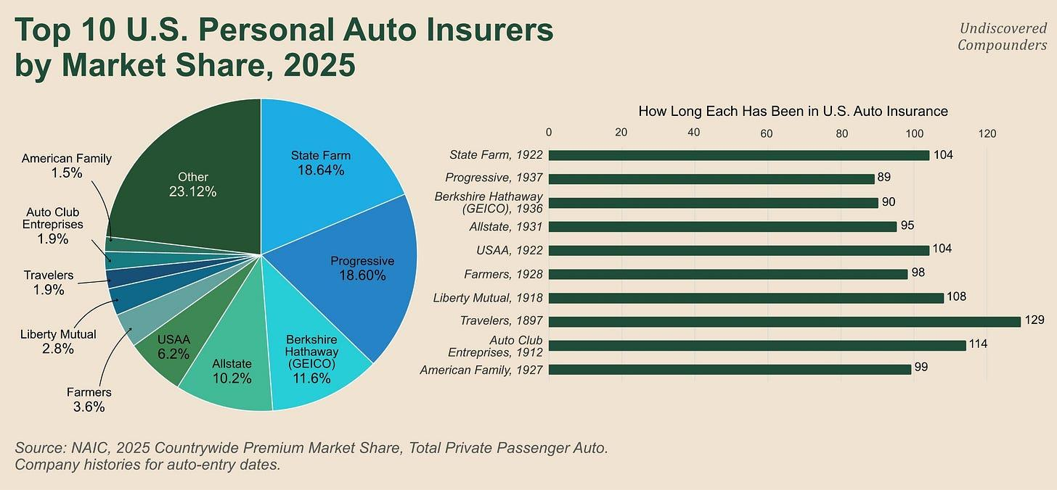

A short stretch of pure interpretation: I suspect Copart is less interested in Progressive’s salvage than in other insurers’, because of the lower average price of the vehicle fleet it insures compared to its competitors’. I even think that’s one of the reasons that led to the decision to let negotiations fail. This low-ASP volume strategy doesn’t fit with Copart, whose strategy for the past few years has been the opposite: raising its ASP. I don’t have proof, strictly speaking, but the loss of Progressive’s salvage coinciding with an ASP at its all-time high is, in my view, a clue.

6.7.3 The Progressive shift

Three possible cases (more in reality, but let’s take two extremes and a “middle” one):

Progressive shifted all its volume to IAA, in which case Copart can’t lose any more of it.

Progressive shifted the famous 15%, leaving about 10 percentage points of its volume still at Copart (still according to the same sources).

Progressive only shifted some 3-5%, and there are still about 20 percentage points left.

In two cases out of three, Copart still has a potential pool left to lose. In two of the three cases, we’re talking about several points of Copart’s unit volume, potentially around 9 points in the third case.

Three arguments help frame these cases:

In my view, it’s unlikely that a big insurer would go 100% with a single salvage provider. First, operationally, that doesn’t always make sense (Copart’s network is slightly bigger than IAA’s, and the two don’t fully overlap). Second, it’s a matter of negotiating power. Going 100% gives the provider another card it could use to exercise pricing power, if it has any. Unlikely, but not impossible.

A lost account can be won back later, and vice versa. Copart could keep losing its remaining potential volume from Progressive while potentially winning back other volume it had already lost.

Progressive very probably took advantage of its negotiating leverage after cutting its prices while everyone else was raising theirs. Given what we’ve already covered in this section, it’s possible that Progressive keeps losing steam and is less eager to renegotiate. Possible; as for probable, I have no idea.

The conclusion here is less definitive. The risk still exists, and its damage is potentially real. I’ll insist on this: it exists from the investor’s point of view. If Copart no longer has any Progressive volume left, the risk turns into an opportunity. If the risk does materialize, and Copart keeps losing Progressive volume, it’s possible we’ll never know. If it wins volume back, it’s also possible we’ll never know.

The risk exists because we don’t know. This sentence always holds true, but all the more so with Copart.

We finally have everything we need to reach a conclusion on the validity of the recent bear thesis.

6.8 Mr. Market’s timeline vs. reality

Nothing beats a timeline for the big picture.

2023. US auto insurance posts a combined ratio of 104.9. To sum up, the entire industry is underwriting at a loss, on average.

Late 2023. A loss-making industry can’t last, so insurers raise rates. To be honest, they blow them up: +20.3% over twelve months. The fix was necessary. The scale of it, less obviously so.

2024. The combined ratio comes back to 95.3. Margins are restored, but the bill is coming.

2025. Policyholders increasingly cancel their insurance and stop reporting small claims. Insured vehicle-years fall 4%. The bill has arrived; the wreck pool has shrunk.

2025, on the insurer side. Progressive posts a combined ratio of 88.5 while everyone else is still fixing theirs. It cuts its prices, triples its ad budget to $5.1 billion, and grows policies +13%. The other three big ones grow around 2%. The insurance market reshuffles its deck yet again.

May 22, 2025. Copart posts 8% growth instead of the 10% the market was expecting. A very high multiple gets punished with a 12% drop the next day.

Summer and fall 2025. Units keep declining. At every conf call, analysts grill management a bit harder. Management stays just as tight-lipped.

October 28 and November 24, 2025. Sell-side notes assume Progressive shifted its salvage from 75% to 90% at IAA over thirty days.¹¹⁹ In the following weeks, public press articles pick up these notes. Meanwhile, the stock keeps falling.

First half of 2026. IAA prints positive numbers, Copart negative ones. The “Copart is losing market share” thesis looks more and more “obvious” on the surface, and more and more analyses adopt it. The price keeps falling.

July 2026. Jay Adair comes back to replace his replacement and states that one account was lost, without putting a number on anything.

Q2-26 (published August 4). RB Global posts +11% in automotive units, using the words “net market share gains,” and explains its quarter by the extension of its biggest insurance contract to all 50 states.¹²⁰ Another sign of the Progressive shift, and a potential sign it’s continuing.

Today. Copart is down about 50%, at valuations close to historic lows (P/E, EV/FCF, P/FCF, etc.)

Now, the less obvious reality:

From August 2025 to April 2026, Copart loses 5.1 points of US insurance units ex-CAT. That’s the one number we need to explain to distinguish cyclical from structural.

The entire industry’s wreck pool declines 2.7% over the same window, so that’s the first chunk accounted for. 2.4 left.

Copart’s client book skews toward insurers that didn’t grow. That costs another 1.2 to 1.9 points, without a single vehicle changing hands. Between 0.5 and 1.2 left.

The lost account sits somewhere in that remainder, along with every other micro-variable that makes investing complicated. Reality is closer to a 3-point shift in Progressive’s volume allocation than to a 15-point shift.

So: half comes from the industry, a third from the mix, a sixth from the account. Roughly.

All three trace back to the same 2023 shock. The pool contracts because rates exploded. The deck gets reshuffled because rates exploded. Progressive had the means to negotiate elsewhere because rates exploded.

The three variables behind Copart’s decline share one cause, the overall rise in insurer prices, and that cause is now disappearing, even reversing.

Over these nine months, revenue is down 0.2%, with an ASP at its ATH (a mix of falling units + rising ASP is typical of an insurance cycle).

Is the bear thesis “Copart is losing significant market share to its competitor, potentially marking a shift in the duopoly” true? No. By far the most plausible thesis is: insurers raised prices too much, the salvage vehicle pool shrank across the board, and Copart paid an even steeper price for it because of its insurer mix, and because it refused to cut its own prices during what were very likely negotiations with Progressive (the strongest clue being RB Global’s take rate falling 1.4 points over 3 quarters while its volumes were rising).

Is it secular or cyclical? Recent numbers clearly tip the scale toward cyclical, with an early sign of a turnaround.

Did all this justify sending Copart back to historically low valuations? Probably not. Were bearish narratives created on purpose? It’s possible: “There is a lot of noise and a lot of rhetoric out there” … “I think they’re hearing a narrative, potentially that’s out there in the industry, potentially from a competitor.”

Does this create a great entry opportunity? The fact that the market has gotten the past wrong, and so very probably the future too, doesn’t mean the distribution of possible futures is a good fit for an investment. That’s the role of this second part of the deep dive.

You’re just one click away from more deep dives like this.

Subscribe

7. The financials

7.1 A quick glance

Here are Copart’s financials over the last 10 years + TTM through the latest quarter.

7.1.1 The P&L

The surface-level analysis leaves no doubt: revenue more than 3x’d in 10 years, net income 6x’d over the same period, margins expanding, share count shrinking, etc. This is an exceptional company, period.

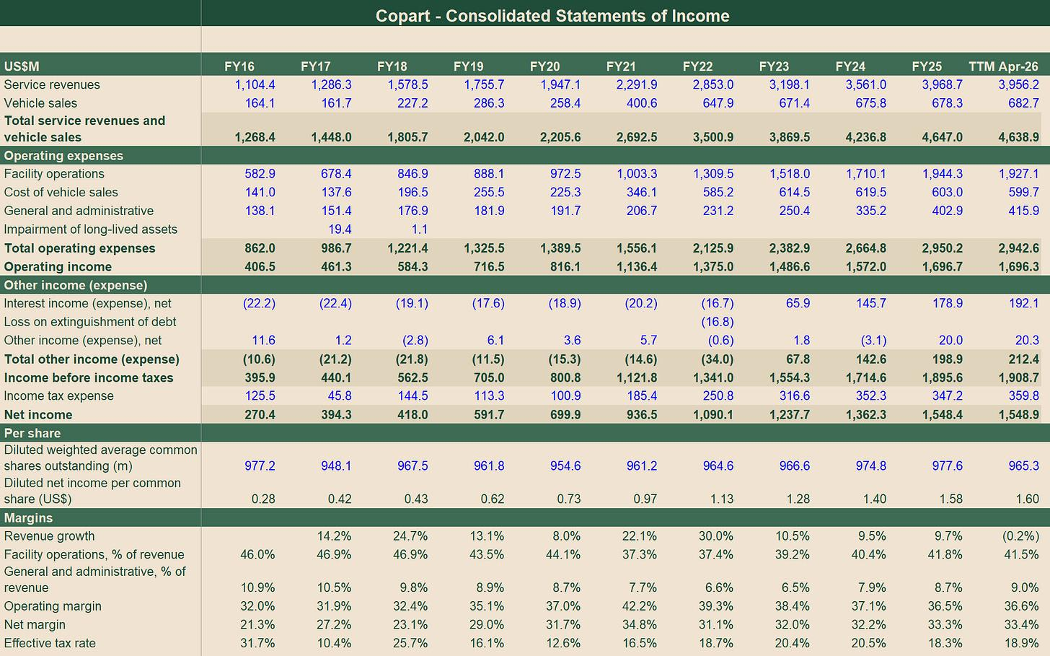

7.1.2 Balance sheet

Cash on the balance sheet is up more than 10x in 10 years and accounts for over 1/3 of assets. Only $517.8M of goodwill after 20 years of acquisitions, with current liabilities of $683.3M vs. more than 8x that in current assets. No debt.

In short, a fortress balance sheet.

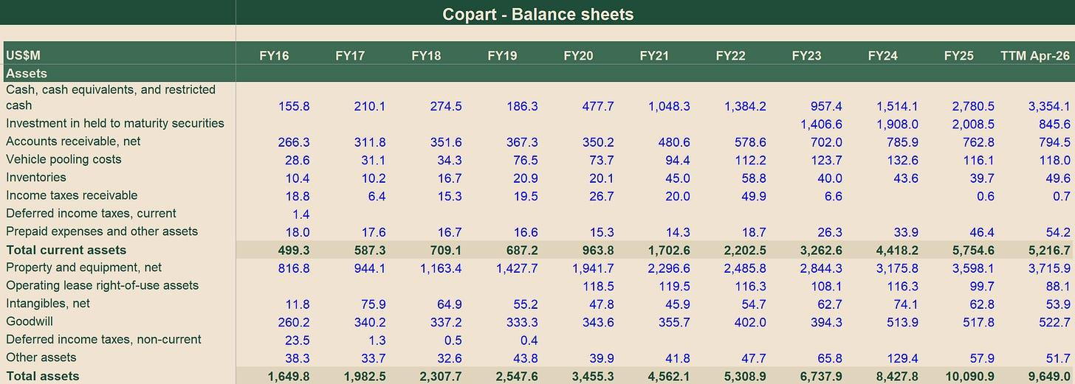

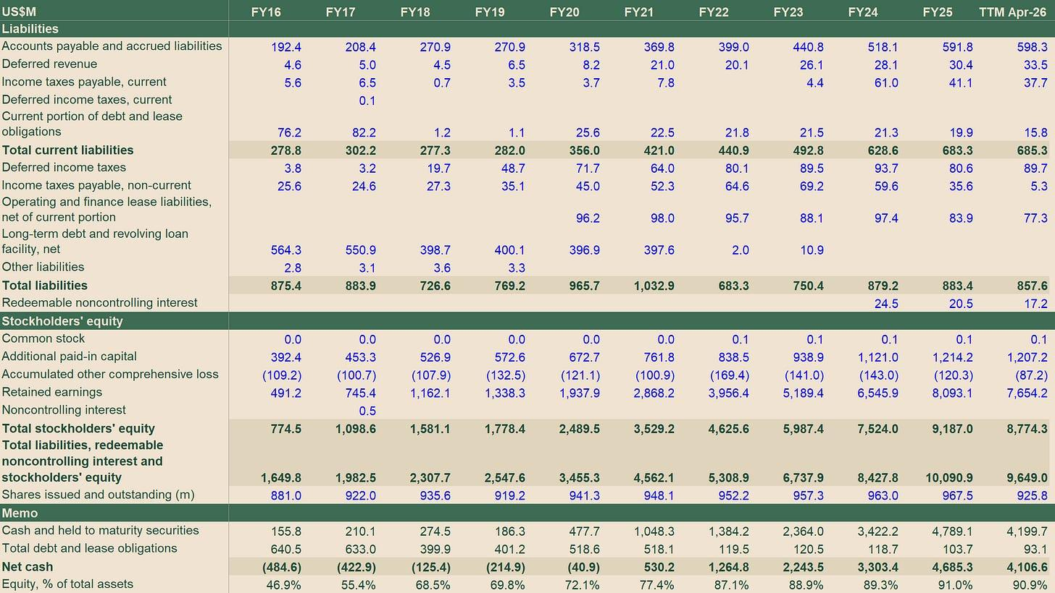

7.1.3 Cash Flow Statement

A large part of net income converts into free cash flow, with working capital needs on the order of 1% of operating cash flow. Only one line really weighs on it, and that’s CapEx. We’ll come back to it in detail.

Everything else is mostly cash moving around, with purchases of securities that essentially amount to parking it.

One new development: $1.6B of share buybacks in the TTM after 6 fiscal years without a single buyback. We’ll come back to this too.

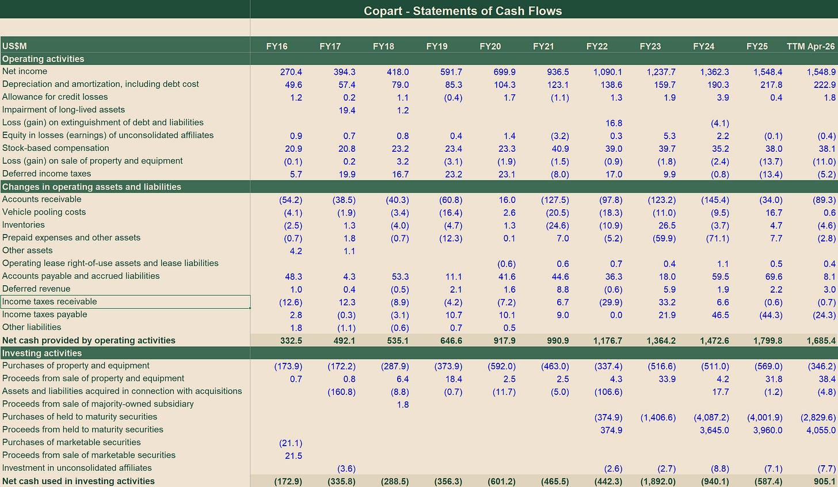

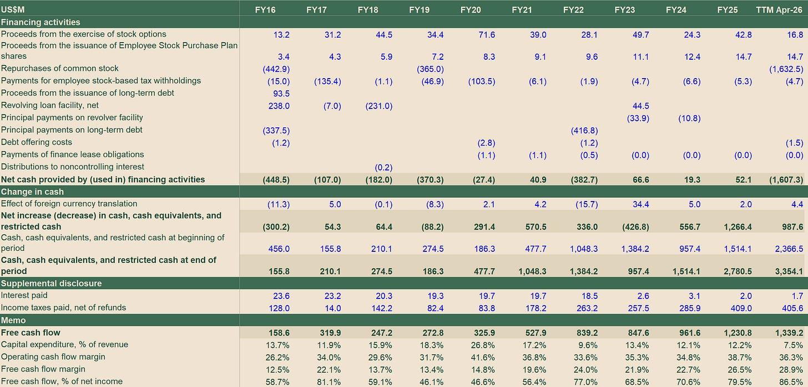

7.1.4 How to read the numbers

This entire section is going to dig into the financials and the subtleties buried in them. So I’m laying out four assumptions, four lenses that will hold for the whole section.

2 revenue lines for 2 different businesses. Buy-sell accounts for 14.6% of revenue but only 4.4% of operating income (FY25). It’s typically the kind of line that distorts every ratio, minimizing or exaggerating the weight of certain information. Every ratio in this section will be calculated on service revenue rather than total revenue.

One aggregated cost line. Facility operations ($1.9B in FY25) = site labor + transportation + maintenance and property taxes + marketing and auction fees + cost of vehicles sold. We get no breakdown of these components. What’s more, depreciation has no line item on the income statement; the $217.8M in the cash flow statement comes from facility operations and G&A, but again with no breakdown. So the fixed/variable split can’t be calculated from the outside (at least until ASU 2024-03 kicks in in FY28, I can’t wait).

Land sits at purchase price. Land purchases are spread over 20 years and the land itself doesn’t depreciate. So calculating a return on capital on this balance sheet amounts to calculating a return with a stale denominator that flatters the ratio quite zealously (if only because of inflation). Quick reminder: IAA operates with a leveraged balance sheet, which makes comparing their respective returns inconsistent.

FCF reflects a decision. Capex is discretionary: no material non-cancellable investment commitment at close for 3 fiscal years running. In fact, capex is down 46.3% over the first 3 quarters of FY26. Free cash flow over any given period therefore reflects a decision before it reflects the business’s cash-generating capacity. In both directions.

Hold on to all of this: it’ll carry us through the rest of the deep dive.

7.2 Where the costs go

The costs of the buy-sell business are mostly the value of the cars at purchase. The only viable way to analyze these costs is through the used-car market. I’m not here to analyze the used-car market to try to anticipate its future. So we’ll focus on the bulk of revenue: service revenue.

A single line absorbs half of service revenue. $1.94B of site costs in FY25, vs. $402.9M of corporate overhead.

Here are the trends over the last 10 years.

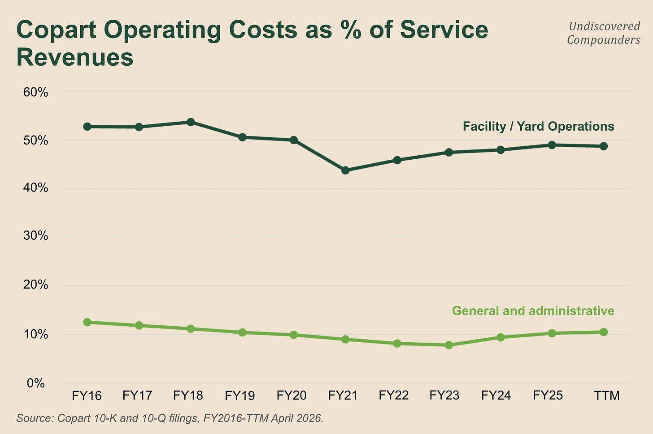

A plateau around 53% through FY18, a descent to 43.8% by FY21, and a climb back since. These extremes aren’t directly driven by operations. For example, in 2021 service revenue was up 17.7% while site costs rose only 3.2%. The cause is a broad-based rise in used-car prices that inflates revenue while costing Copart almost nothing extra.

So what does that add up to overall?

Operating margin as a percentage of service revenue: 36.8% in FY16, 42.8% in FY25, so 6 points higher. Let’s break down this increase (still as a percentage of service revenue):

site costs: +3.79 (52.78% → 48.99%)

overhead: +2.35 (12.50% → 10.15%)

buy-sell gross margin: -0.19

So the sites delivered two-thirds of the margin expansion over the decade shown. We could stop there, but it’s by digging into what’s hiding behind these numbers that we find, in my view, the best visualization of Copart’s moat.

Take the simplest situation, a marginal unit. A new car arrives at a Copart site that’s already open. The land is already paid for, so this car only costs towing and handling; this is precisely where the land’s operating leverage comes into play. This effect is artificially dampened by the fact that Copart still buys unoccupied land to this day in anticipation of future need (admittedly, less and less). This land therefore weighs on site costs without contributing to revenue (for now). Put all of that together, and you get the +3.79 points over 10 years.

Now G&A, which consists “primarily of executive management, accounting, data processing, sales personnel, professional services, marketing expenses, and technology enhancements and maintenance.” On the face of it, I don’t find it very intuitive that this contributes so much to margin expansion. This is where the duopoly comes in:

Sellers are, at most, a few hundred players, three-quarters of the market boiling down to a good dozen of them. No need to carpet-bomb them with marketing.

The buyer base is already well known to both Copart and its competitor. If your supply is broad enough for long enough, a network effect will form (with its circular logic we’ve already seen plenty of times). No need for marketing there either.

Copart is a middleman that everyone already knows, so every new unit that passes through Copart costs it relatively little, or even nothing at all.

Copart’s moat therefore plays out in two acts in its P&L:

the incremental monetization of the land with every new unit that passes over it,

the acquisition costs it doesn’t have to incur for that new unit.

But that’s the theory, or rather the practice in an ideal world (that’s probably a pleonasm). In fact, three factors distort these ratios and mask their trends:

Used-vehicle prices. A higher ASP = a higher RPU without it costing Copart a single extra dollar. This mechanism distorts the denominator, and that’s how, in 2021, Copart’s operating margin climbed to 49.58% with 43.78% of site costs and 9.02% of overhead. It obviously works in both directions.

CAT events that drive up service costs: notably overbooked tow operators who sharply raise their rates. For example, $56M of extra cost in 2025 tied to Helene and Milton, or 1.4 points of service revenue.

Site depreciation. Copart buys land and builds on it; depreciation of the buildings falls into site costs, so into the numerator. And it’s climbing: $142M in FY23, $192M in FY25, or 4.4% then 4.8% of service revenue. Buildings are what’s inflating this line: their gross carrying value went from $1.34B to $1.68B in two years.

The recent past is a great example. From FY23 to FY25, the ratio worsened from 47.5% to 49.0%. Adjust just for hurricanes Helene and Milton, and the 2025 ratio falls to 47.6%. FY26 will therefore need to be read through this lens. Gross margin gains 184 bps in Q1-26, largely because there was no CAT event, unlike Q1-25. The bull sees margins turning back up, the bear sees volumes falling, but both mostly just watched the extra costs disappear and weather-driven volumes decline.

The term “extra costs” tied to CAT events is actually a bit of a misnomer. You should think of it as a form of investment in intangibles. By absorbing every cost overrun itself, Copart is telling its insurer clients: “Look, even in the service program, I’m willing to absorb the expense. I keep managing efficiently despite an event several standard deviations out, and I make sure to clear the wrecks as fast as possible so you can reimburse your own policyholders as fast as possible.” So the right way to read it is:

strip out CAT events to judge a fiscal year’s operating efficiency,

count them as a client-relationship expense when judging the franchise.

What can we anticipate going forward?

Volatility. Lots of volatility. From FY23 to FY25, G&A went from 7.8% to 10.2% of service revenue (10.5% TTM). So there’s a shorter-term countertrend within the long-term trend. The cause, you’ve probably guessed, is inflation. Copart is hit by inflation on the input side, with part of that impact offset on the output side (via the rise in ASP). On the input side:

Site costs: subhaul, labor, insurance, maintenance.

SG&A: outside providers (legal, compliance, IT rollouts), sales force expansion, premises, travel.

It’s also, once again, time for me to push back against fellow analysts.

I’ve read that the long-term trend of rising operating margins is going to be capped because of a mature US market, unless international growth (in the service program) compensates. I disagree, for 2 reasons:

Copart has been buying less and less land in recent years; if the trend holds (which is likely), that will limit the amount of new depreciation that would otherwise weigh on the numerator.

Even a mature US market with stagnant or even shrinking units can still offer Copart growth if the ASP rises. I don’t know how units will behave going forward, but the long-term trend clearly points toward a rising ASP. And Copart makes more revenue, at a better margin, on high-ASP units (pricing grid, per-acre profitability, etc.)

Operating margin and its breakdown are something I’ll keep watching closely for as long as I follow Copart. This lens delivers a lot of information quickly, which is pretty valuable with a management team this secretive.

7.3 When the machine stalls

Since 2010, only 2 fiscal years show declining operating income. They’re back to back: FY13 and FY14:

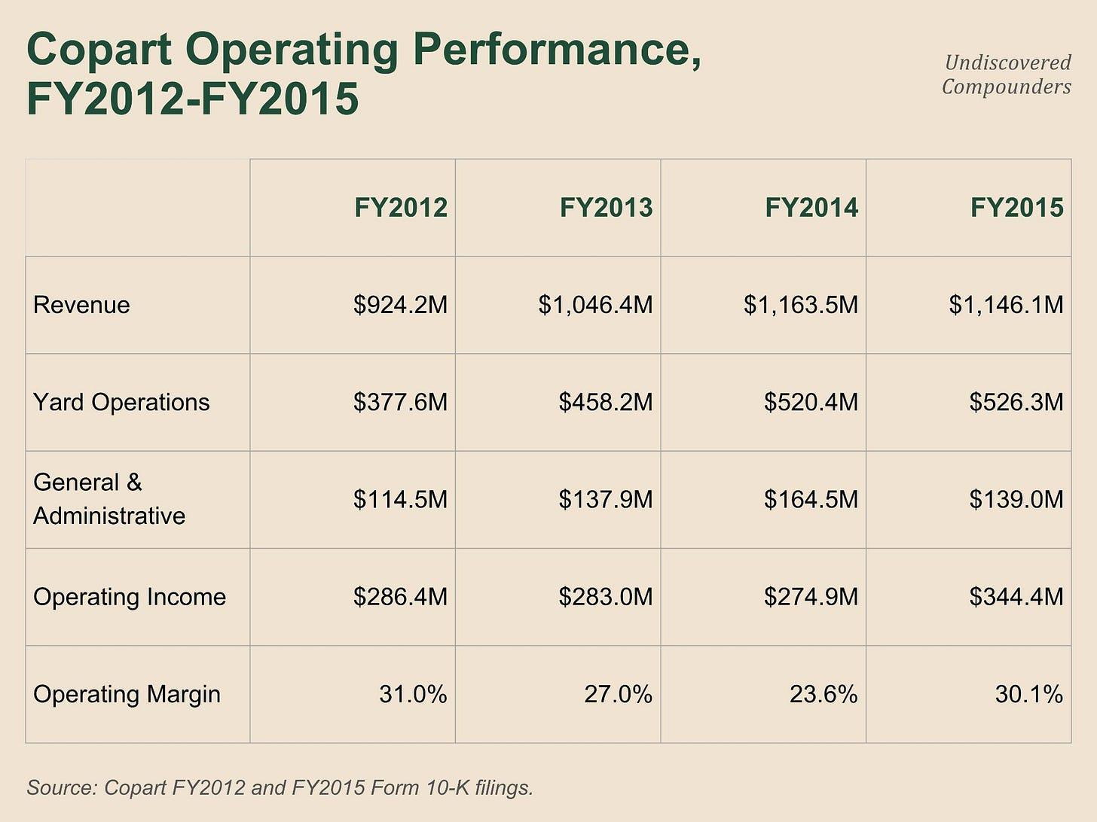

Margins on reported revenue, not service revenue, unlike the rest of the chapter: Copart didn’t break out that split before FY16. Since everything that follows reads in dollars, it doesn’t change the demonstration.

Why? What do you think caused this decline? Congratulations in advance to whoever figures it out.

First off, demand has nothing to do with it. Over these two years, revenue rose 25.9%. Copart is selling more and earning less, to the tune of 7 points of margin gone.

If it’s not revenue, it has to be expenses. From FY12 to FY14, site costs rose 37.8% and overhead 43.7%, against 25.9% for revenue. There’s volatility everywhere, but not the kind that suits Copart (on the surface, at least). Yet at the time Copart had already been around for 30 years. Sure, the US market wasn’t mature yet, but this is an explosion in spending, not a little enthusiasm.

So where does it come from? FY13 arrives with $84.0M of acquisitions, the largest line item of the window through FY17 inclusive. Goodwill climbs from $196.4M to $267.5M during the year, and Capex nearly 2.5x’d in a single year. Why? 5 sites in São Paulo, one in Dubai, one in the UK. 1 in Montreal and 1 Brazilian bidder in FY14. Meanwhile, US land purchases are frozen: land at cost rises 2.1% in FY12 and only 1.3% in FY15.

So the US machine didn’t stall: it’s simply that the P&L absorbed the cost of entry into new markets for 2 consecutive fiscal years: newly acquired sites still operating at their initial unit economics, a headquarters that obviously had to grow to administer all of it, and two years to bring them up to Copart’s standards.

All that for what? In FY15, revenue falls 1.5% and operating income climbs 25.3%. Site costs rise +1.1% for the year, and overhead falls 15.5% in dollars. Corporate overhead had grown; it was finally trimmed. Two years to create the “problem,” one to fix it.

I take 4 things away from this analysis:

Never trust the headline numbers, and always dig deeper by asking “why?”

Whoever’s looking for a historical unit decline that damaged Copart’s results won’t find one. Whoever makes “Copart loses market share, therefore units, therefore revenue, therefore net income” their base case is taking on significant risk (the market very rarely rewards those who make a scenario that has never happened into their base case). I’m not saying it’s impossible, only that the burden of proof lies with this scenario, and that, as I showed in the previous section, it isn’t viable.

Management couldn’t care less about shareholders’ hand-wringing; they only care about long-term value creation. Copart chose to use a period of strong growth to invest in the future, even if it meant turning that momentum into two consecutive years of bad performance on paper. Over that period, Copart’s price stagnated in a tight range (the market literally said “let’s wait and see,” before exploding in early 2016 and delivering a 17x by its 2024 peak).

A lesson for the rest of this piece. When Copart plants its flag in a new market, the income statement pays for it for several quarters, even two years, before the payoff shows up. I’m tucking this one away in my satchel.

7.4 What one point of unit growth means for earnings

For the 17th time in this deep dive, a unit figure needs ASP to be interpreted correctly (I’m joking, I haven’t counted, but it’s not impossible). Granted, but the rest of this deep dive would be easier if I had a way to convert unit growth into earnings.

I have one. But before you judge me, remember: all models are wrong, but some are useful.

7.4.1 The logic

How do you convert a point of unit growth into dollars?

First off, we don’t have an absolute unit value. We never have, so we’ll have to approach it differently. I’m going to make the very bold assumption that Copart’s annual unit volume represents 100%, so one percentage point represents 1% of annual units (that’s an attempt at humor to say I’m converting this into %). What remains is figuring out which car we’re talking about.

Copart can buy and resell a car (insurance buyback program or non-insurance) or Copart can simply auction it and charge a service fee. That gives us 3 buckets: buy-sell, service, and the sum of the two.

Reading the income statement, we have 3 lines that map to these buckets:

Service revenue for the service.

Buy-sell gross margin for the buy-sell business.

Site costs, which concern both without Copart quantifying the split. So I allocate these site costs proportionally to their respective weights. (A relatively safe assumption.)

Next, fixed costs need to be separated from variable costs. If I treat all costs as variable, a point would be worth $16.2M for services, $17.0M once you add in buy-sell margin ($75.3M in FY25, or 0.75M/point; rounded). If, conversely, I treat them all as fixed, a point would be worth $40.4M. The two estimates are 2.4x apart. So this needs refining.

Starting with G&A. Almost none of it changes whether one more or one fewer car passes through Copart’s hands. So I treat it all as fixed (403M in FY25). That assumption stops working at 100k cars, but the benefit of simplicity wins out here. Treating G&A as fixed, the lower bound rises to $21.0M (17+403/100; rounded).

Lastly, site costs ($1.94B): a good chunk of them depend directly on the number of units (towing, handling, yard maintenance, etc.). Others much less so (property taxes, rent, insurance, etc.). No breakdown for this either, but fortunately I’m a very skilled statistician and I possess mathematical weapons the common man does not: I split the difference (I picked up this trick during my PhD, dark times). So I treat half of site costs as independent of unit count. Under this assumption, one point of unit growth is now worth $30.75M (21+19.5/2).

7.4.2 The formula

Now all that’s left is to take these values and weight them by the US vs. international mix (for once, the filings give us everything we need):

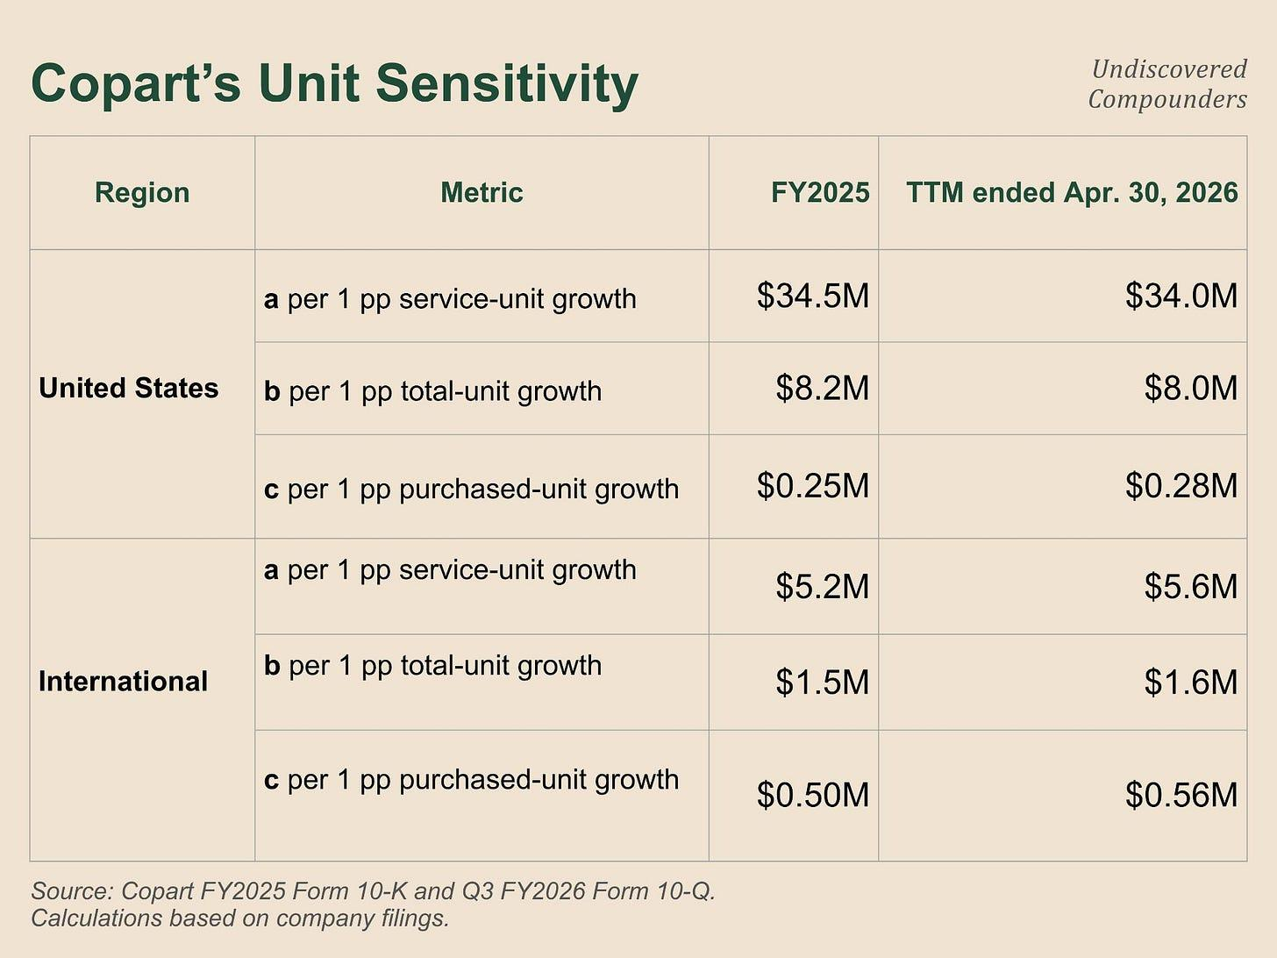

From this we can calculate earnings for all of our scenarios (a, b, and c being points of growth):

earnings = a x (points of service units) - b x (points of total units) + c x (points of purchased units)

b is the only term subtracted because it represents variable site costs (the fixed portion of site costs is already accounted for in a and c).

For example, if US and international units each rise by a point, we get: 34.5-8.2+0.25 = +$26.5M for the US and 5.2-1.5+0.5 = $4.2M for international. In total, one point of across-the-board unit growth adds $30.7M of EBIT (and the reverse is true for a decline; $30.8M using TTM figures).

There you go. That’s it. No ANOVA or logarithmic regressions. A bit of logic and a finger in the wind.

7.4.3 The complexity of the real world

Let’s step out of the hypothetical and back into the present. Get your calculator out too, because we’re going to work with growth rates. (One clarification: I’m going to lean on the approximation ln(1+X) ≈ X when X is small, which is a largely acceptable approximation for our situation. To be honest, I’ve been leaning on it since the start, but especially here.)

In Q3-26, international service revenue rises 17.9%, and RPU (revenue per unit) 10.5%. Dividing the growth factors, we get international service unit growth of +6.7% (1.179/1.105). In the same paragraph, Copart gives us total international units, +5.9%. The difference lets us infer the growth of international buy-sell units, which comes out to 1.4% ((5.9 - 0.85 x 6.7) / 0.15).¹²¹

Not everything moves the same way. This is already more complex than my earlier example.

Let’s head back to the US. Vehicle sales revenue falls 0.4% with the ASP up 23%. We do the same division as before and get -19.0%. Copart specifies that total US units fell 4.2%; 3.3% if you strip out Copart Direct (nearly the entirety of the US buy-sell business), whose volume dropped 26.3%. We finally have what we need to isolate Copart Direct’s share of US units: (-4.2 - (-3.3)) / (-26.3 - (-3.3)) = -0.9/-23 = 3.9%. Copart Direct US therefore accounts for 3.9% of US units. We round to 4% to account for other purchased units outside Copart Direct.

To sum up, total US units fell 4.2%, but US service units only fell 3.6%; the remaining 0.6% comes entirely from the 4% of buy-sell volume that fell 19% (as a reminder, this is a deliberate Copart strategy: “as we continue to strategically shift lower-value units to our direct buy channel,” putting the seller and the dealer directly in touch in exchange for a commission). Which is the opposite of international, where the service side was pulling the total upward.

If you read the formula blindly, looking only at the total figures, you get an EBIT decline of $111M (26.5 x 4.2) for the US. But by distinguishing each segment, you get an EBIT decrease of $93M (34 x (-3.6) - 8 x (-4.2) + 0.28 x (-19.0)). This $18M gap is explained by the fact that the cars whose gross sale value disappeared from the P&L are the ones on which Copart wasn’t charging a service fee (and its associated nice margins). International moves less, between $25M and $29M depending on the assumed share of purchased units (same equation as above), against $27M blind.

My choice to build the formula by differentiating segments within a given geography does make the framework a bit more complex, but above all far more faithful. It remains an approximation, notably because of the necessary fixed-vs-variable site cost split assumption, but it has the advantage of introducing the same bias across segment results, keeping comparisons meaningful even when the assumption is wrong (but useful).

Two clarifications before moving on:

The coefficients are built on a full fiscal year, or rather on 4 consecutive quarters. If you plug in quarterly growth rates (and I will), you’re implicitly assuming those rates hold for 4 quarters. I could have built a quarter-based formula, but that’s 4x as many imprecise assumptions and 4x the complexity. No thank you.

This formula and these figures don’t account for ASP variation; they assume it stays equal to that of the period analyzed. Fortunately, we can add a few assumptions if needed. But we’ll save that for the growth outlook and valuation.

We still need a few more weapons/tools before moving on.

7.5 Capex, and what normalization really tells us

Land is important enough that we spent an entire section on it. Now it’s time to put numbers on what the land costs once it’s been purchased: how much capex to keep the machine running as-is, and how much to grow it.

Once again, Copart doesn’t make this split. Once again, I’ll use the finger-in-the-wind approach.

First, maintenance CapEx. I have 2 rough proxies at my disposal:

Depreciation. This is the accounting measure of what wears out. $188.9M on fixed assets and $13.0M on software in FY25, or $201.9M (35.5% of reported capex).

Non-land capex. Out of FY25’s $569.0M, everything that isn’t land comes to $202.1M: buildings, trucks, furniture, software. This is a ceiling, since some of these buildings sit on new land and therefore support growth.

$0.2M gap between the two. That proves nothing, but it’s reassuring. I add $30M because the depreciable base is carried at historical cost and replacing it costs more today. So we land on $230M of maintenance capex per year.

Both methods assume that one purchased acre never replaces another. Yet we already saw in Section 3 that Copart could buy acres it was already leasing, or “lease buyouts of certain facilities” (Q3-26). So a portion of what I classify as growth capex is actually replacement capex. Put differently, $230M is a floor.

For growth capex, all that’s left is to take total capex and subtract $230M. $569M - $230M = $339M of growth capex in FY25. $907M over the last 3 fiscal years.

This growth capex goes toward 3 things:

Buying land ahead of time in anticipation of a future need (legislative change, CAT event risk, demographic shift, etc.).

Expansions of yards already owned.

Lease buyouts.

Now, in dollars.

Free Cash Flow = Operating Cash Flow - Total Capex. Subtract only maintenance capex and you get what the owner can pull out without shrinking the business.

In FY25: $1.8B OCF - $230M of maintenance capex = $1.57B vs. $1.23B of reported FCF, or 1/4 more.

In TTM: the surplus drops to $116M, or 1/10 of FCF.

The one-quarter became one-tenth without my estimate changing at all. What changed is total capex. Over 9 months it goes from $480M to $260M, nearly cut in half. And even then, growth capex is what’s getting cut, not maintenance. In practice, growth capex alone must have fallen to roughly one-third of its previous level, maybe less.

Let me put my contrarian hat back on. I recently came across the argument that capex is going to slow down and that this will free up cash. The likely source of the reasoning is Adair himself: “We’ll have to do a little bit of development still, we’ve got a little bit of add-ons, nothing like you saw the last 10 years… That’s definitely going to slow down.” (Conf call, July 2026).

I disagree. Let’s split FY25 capex into land ($367M) vs. everything else ($202M). Halve the land figure to simulate the capex slowdown, and capex comes to around $390M (or $180M below FY25). Except TTM Q3-26 capex is already below that, at $350M, at least 2/3 of which is maintenance capex. The vast majority of this slowdown is already in the past. Unless the CEO starts selling off acres to shrink maintenance capex (which is no longer a slowdown but a contraction), the argument no longer holds. By my estimate, if management stops all growth (a notch stronger than a “slowdown”), FCF can still rise by roughly $100M (give or take a few tens of millions).

For me, the argument is dead, and I’m setting it aside for good.

What’s left is the consequence of this slowdown. As we’ve seen, Copart almost always buys its land ahead of time, generally 3 years out. So if this growth slowdown is going to create a capacity constraint, it should show up within about 3 years (the decline has been under way for several fiscal years already). Or, more likely, given its track record, management anticipates it won’t need this land. The only explanation is that management anticipates volumes will stagnate or decline and is therefore choosing to spend less in preparation. This will come in handy later.

7.6 A summary of the present and the recent past

Let’s look at the present.

In TTM Q3-26: volume is falling, but pricing is offsetting it. Result: revenue is flat, and so is operating income ($400k of difference on $1.7B).

If you strip out the impact of CAT events, the site cost ratio between FY23 and FY25 stays relatively flat. The cost increase comes mostly from SG&A itself (which has no CAT effect to hide behind): from 7.8% to 10.2% over the same window, driven largely by inflation.

The balance sheet isn’t just free of constraints; it also gives Copart the flexibility to act as it pleases for a long time. Two recent strategic choices stand out:

A significant reduction in acquisitions in recent years, with a major reduction in growth capex in recent quarters, and a CEO signaling that this strategy will continue.

$1.6 billion already returned to shareholders through share buybacks in nine months, after 6 fiscal years without a single buyback.

It’s finally time to move on to capital allocation.

8. Capital allocation

8.1 What to do with each dollar

Copart has $4.2B of cash on the balance sheet (a bit more than 40% of its assets) and produces roughly $1.34B of FCF/year. So there are a lot of dollars to put to use, and even more that will need to be put to use.

A dollar at Copart has 4 possible destinations.

Land. Return = roughly 30% after tax. This figure comes from operating income ($1.7B in FY25) divided by capital actually employed ($4.6B; total assets - cash and investments) - operating liabilities ($663M). The return is flattered because the land on the balance sheet sits at purchase price (some of it is over 20 years old, but it carries proportionally less weight), but that doesn’t really change the trend. If it’s worth double today, the 30% becomes 20%.

The balance sheet: 4.2%. Nothing magic here, it’s just the interest received relative to cash. $142M over nine months, or $190M annualized, on an average balance of $4.5B. Mostly Treasury bills under twelve months. It also provides intangible benefits. Copart deliberately keeps a solid balance sheet to reassure insurers that Copart will still be around in 30 years. Copart will very probably always keep a significant amount of cash.

Buybacks: the math is simple, but the returns vary widely. Copart doesn’t pay a dividend. That’s good news here, because the shareholder captures all the growth in FCF/share, plus or minus whatever the market decides to do with the multiple. FCF/share growth has run at 18% a year since 2009. Depending on the window chosen, the range runs from 13% to 24%. Let’s take 15%, to be conservative. All that’s left is to factor in the multiple. Over a 5-year horizon, if Copart buys back at 18x P/E and the stock comes back down to 12x, the return falls to 6%. If the multiple climbs back toward 25x, the return rises to 23%. If the multiple holds, 15%.

M&A: no idea, despite 8 acquisitions in 20 years. We’ll come back to it.

Among the 4, ranked by how scalable each use of cash is:

Cash is scalable virtually without limit.

Share buybacks are scalable as long as multiples are low. If the multiple holds, the next bottleneck is cash. As for the amount of ammunition, Copart could probably spend more than $2B a year if the opportunity is truly attractive.

Land is far less scalable than before (the quantity of land purchased has fallen and management has guided for that to continue) and probably never will be as scalable again in the US market. Count on a few hundred million a year.

M&A is historically limited. A bit more patience.

Cash is the default destination, so I’ll set it aside. Land will soak up a bit of OCF, we’ve already covered that topic. That leaves two possibilities: buybacks and M&A.

Let’s analyze both of these possibilities in detail.

8.2 Share buybacks

8.2.1 The strategy so far

Copart’s lack of debt is a new trend. It carried debt for 11 fiscal years, and over those eleven years it really only drew on its credit lines twice. Each time, it was to buy back its own shares.

A company that wants to buy back its shares in significant quantities has two options:

On the open market, where it buys through the order book, even if that pushes prices up.

A tender offer, where it announces a number and a price (generally above spot), and lets each shareholder decide whether to tender and how much. This costs more by construction, but it limits the risk of pushing prices up (if the company drives the price up 50% with only 20% of its desired buyback quantity, the buyback loses its purpose), and above all, it can be executed much faster.

Essential clarification before we continue: Copart completed four 2-for-1 stock splits between 2012 and 2023 (so a cumulative factor of 16x). A price shown in the 2011 10-K therefore bears no relation to the current price. Everything that follows has been restated on the current basis (prices and share counts). (Don’t thank me.)

On January 14, 2011, Copart draws down the entire $400.0M term loan it had arranged a month earlier, in one go. The same day, it closes a fixed-price tender offer at $2.38 ($38.00 at the time). It overshoots the target: 195M shares repurchased vs. 168M offered, for a total of $463M. It also took the opportunity to buy back shares on the open market over the period. In total, $740M spent (three times the fiscal year’s OCF), 54% of it on credit. All these buybacks shrank the share count by 22% in 12 months.

Second episode, December 2014. Copart places $400.0M of senior secured notes (4.07% to 4.35%). Naturally, they’re secured. Naturally, they’re secured on Copart’s biggest assets: its land. The company that owns 90% of its real estate pledged it as collateral. What follows is a bit comical:

July 2015, Dutch auction. Copart proposes a range of $4.34 to $4.50. It offers to buy back 111M shares. It only gets 50M at $4.50. Less than half.

5 months later it does it again. It offers to buy back 58.5M shares between $4.75 and $5.13. It gets 66.7M at $4.88. I don’t know if shareholders had FOMO; what’s certain is that they missed the biggest two-month run in Copart’s history outside the Dot-com era (to be fair to them, the stock had been stuck in a range for 2-3 years).

The P/E at the time of each of these buybacks sits between 21x and 22x, vs. 20x as I write these lines.

It didn’t do any further buybacks and spent the following years deleveraging, ultimately paying everything off in 2022. In FY16, it was leveraged to 82.4% of its equity. That’s not nothing for a company whose founder has a total aversion to debt.

To sum up: when the company believes its shares are undervalued, it’s ready to pull out the heavy artillery: its accumulated cash, and as much debt as necessary, even if that means pledging its land as collateral (for a management this conservative, that’s, again, not nothing).

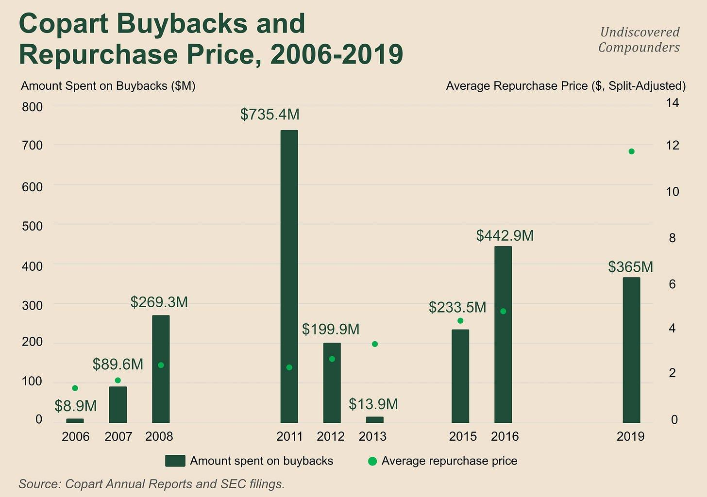

Other rounds of buybacks took place, but nothing as significant as the ones covered here. In total, the share count was reduced by 33.1% over 20 years, but all of it before 2016. Since 2016, the share count has risen 9.8%. Until recently.

8.2.2 The 2026 buybacks

7 years after its last buyback, Copart came back for another round. Here’s the same chart but with 2026.

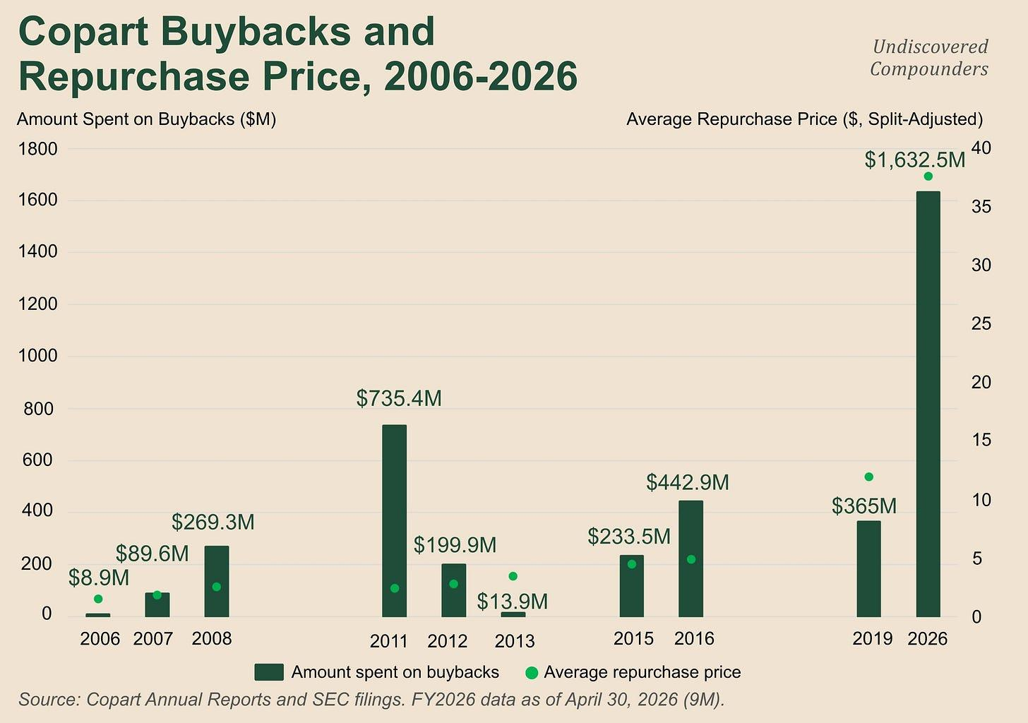

These charts take forever to make. Sharing this deep dive is the best way to make that time worth it. But honestly, I’ll keep making them either way. (I’m not great at CTAs.)

Share

From January 2026 to March 2026, management put its cash to work buying back shares on the open market and through a 10b5-1 plan:

January: 5.5M at $39.82.

February: 22.4M at $37.01.

March: 15.6M at $37.69.

Total: 43.4M shares for $1.6B at $37.6 on average, for an average P/E of 23 (vs. 20x today).

Offsetting that, 1.8M shares were issued over the period, for a 4.3% reduction in share count over 3 quarters.

Nothing before, nothing after. For now. The next quarter will tell us whether the story continues. What we know for now is that the company still has ammunition ($4.2B of cash + $1.25B of undrawn credit line). The authorization dates back to 2011, and still hasn’t been fully used up since. Copart still has the right to buy back 282M shares, or 30% of the current share count. It has plenty of room.

As for cash spent, it held $4.8B of liquidity in July 2025 vs. $4.2B 9 months later. Of the $1.6B it spent, $1B was free cash flow generated over the period. Only $0.6B actually came out of the cash pile.

Before we can judge its future use of cash, we’re still missing one piece.

8.3 M&A

8.3.1 M&A history

A visual. It’s been a while.

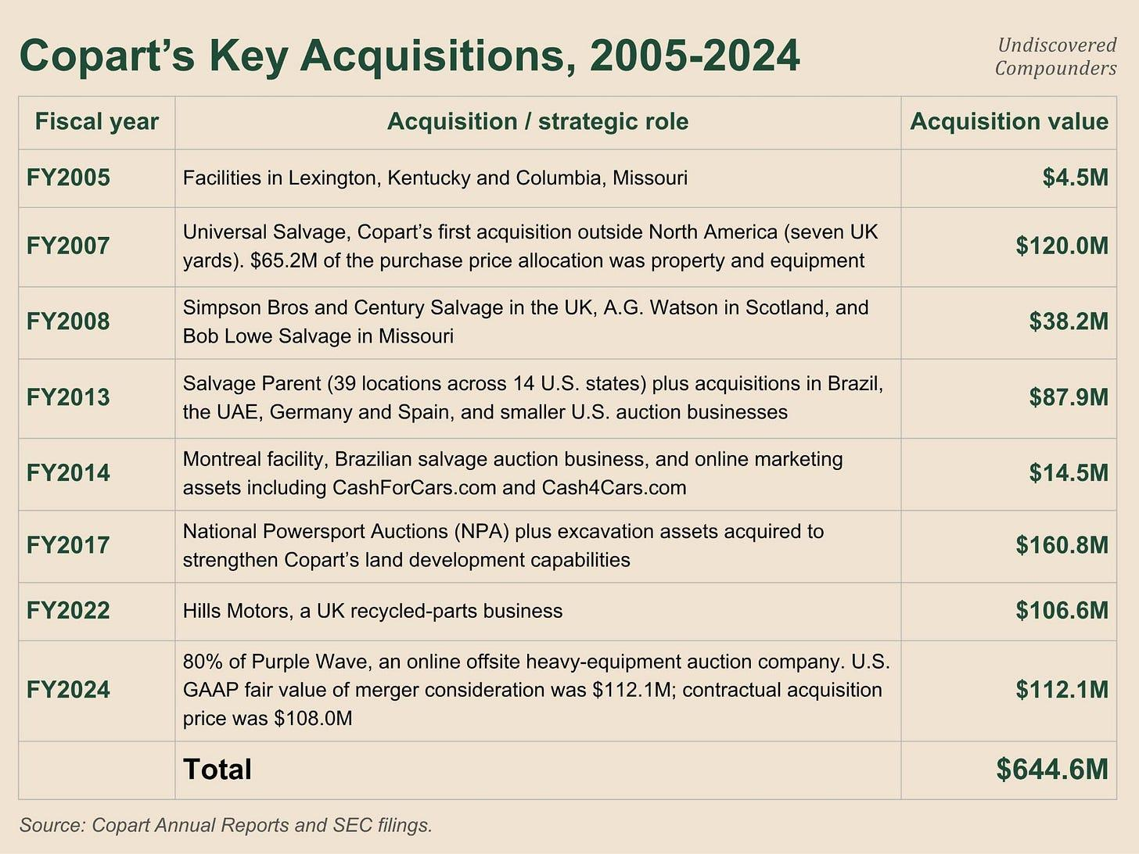

8 disclosed acquisitions in 20 years for a total of $645M, of which $112M paid in stock. Goodwill accounts for a bit over 5% of assets.

Here’s the strategy behind these acquisitions: “all of the M&A that we have done has been in our industry… we can utilize our land or utilize our auction technology.” To sum up, in a field they know very well, one that monetizes assets they already own:

NPA handles motorcycles and boats on land Copart already owns.

Hills Motors recycles parts.

Purple Wave sells industrial equipment with the auction tech.

Naturally, management remains fairly stingy with disclosure, but it was a bit more generous about Purple Wave. We’ll come back to it right after.

The only thing I’ll note is that Copart bought Purple Wave with 2.5M shares at $44.84 a share. When the stock is high, management is willing to dilute (modestly, and on rare occasions); when it’s low, it buys back. Nothing revolutionary, but exactly what you’d want from a management team.

So what about the future?

The latest call, on July 6, at least gives us a fair bit of information. In it, Adair, the new CEO, tells us three things:

“We will be doing M&A obviously, and we’ll be building as well. As you all know, we’re sitting on a ton of cash.”

“I think we’ve got to focus on M&A for all three… they’re all going to be material investments.” (international insurance, domestic whole car, and technology services)

“To do the right deal, I would take on some debt.”

Five months earlier, the previous CEO was far more measured on the same topics. So it seems the new CEO has plans on this front, but what exactly?

One word stands out completely: “material investments.” Up to now, you couldn’t really call Copart’s M&A “material”:

Internationally, M&A has consisted mostly of small-ticket purchases to enter a new market, country by country. Only the purchase of Universal Salvage in the UK in 2007 can be classified as material internationally. But almost 20 years later (and yes, time flies), a transaction would need to be at least four or five times bigger to earn that label today.

In whole car, there’s only Purple Wave.

In technology, the only precedent is a handful of online-marketing assets lumped into a $14.5M bundle in 2014.

Unfortunately I’m not inside the CEO’s head, but if I had to bet on what “material” means, I’d lean toward amounts of at least $500 million, or even more than $1B.

8.3.2 A concrete example: Purple Wave

Copart bought Purple Wave for $112M in 2023.

It’s an online auction platform for construction, agricultural, and fleet equipment (think yellow iron). Unlike Copart, Purple Wave doesn’t move anything (so no land). It’s therefore no surprise that “substantially all of the merger consideration has been allocated to intangible assets, including goodwill.” So the deal’s aim is to let Purple Wave’s auction platform benefit from Copart’s technology (and the 1,000 engineers behind it).

When Adair says “we can utilize our land or utilize our auction technology,” it took Copart 40 years to make its first acquisition in this technology branch (namely, its auction platform). If land is growing scarce in the US, and we’ve already shown that it is, then this is the only branch that remains meaningfully scalable.

As for the deal structure, it’s... interesting. Only 80% of the shares were acquired, with 20% held as a minority interest “redeemable at adjusted fair value from the third anniversary of the acquisition” (so October 2026). Purple Wave keeps its own stock compensation plan for its executives ($1.9M in FY24, $2.3M in FY25). So incentives remain at least somewhat aligned. Did all of that turn out to be enough to create value?

Not quite. Not at all, actually. The minority interest went from $25.2M at closing to $17.2M as of April 30, 2026, with a $3.3M loss attributable to that 20% over those 9 months. So Purple Wave is losing on the order of $20M a year (with $40M of cumulative losses since the acquisition, and those losses are accelerating), on $112M paid. If there are synergies to be had, they’ll need to be realized fast. For now, it looks like a failure and it smells like a failure.

I’d have liked to compare it with other acquisitions, notably Hills Motors, but the only information available is the international segment’s figures. The only certainty is that Copart has never written down goodwill on a business it kept.

To sum up, M&A hasn’t represented a significant bet for Copart since 2008. Management has guided toward future “material” M&A, without us really knowing what the term means in practice. The CEO’s stated strategy: focus on 3 pillars (international growth, domestic whole car, and technology services), and he’s willing to take on debt if necessary. The most recent acquisition, made while Adair was still co-CEO, is, for now, a failure, nearly 3 years after the purchase.

Time to turn to the future.

8.4 What will they do with future cash?

Let’s start with the facts.

Copart signed a new $1.25B credit agreement in January 2026 with Wells Fargo, maturing in 2031, extendable twice for one year each, with a $500M accordion feature on top. If you’ve been following along, those are roughly the same amounts as under the previous agreement. But two things changed:

It’s no longer secured. Copart’s old debt was secured, backed by “substantially all of the assets.” Gone. Now, the bank trusts Copart (Wells Fargo, at least), and the pricing confirms it: a margin of 0.75%-1.125% vs. 1.50%-2.25% in 2020. It seems Copart’s balance sheet is well-regarded by lenders.

The addition of the word “dividends” to the contract. In the contract, funds can be used “for general corporate purposes, including working capital and capital expenditures, dividends,” then buybacks and acquisitions. The 2021 wording didn’t contain that word. I wouldn’t say paying a dividend is likely, but it’s clearly more likely than before.

Let’s move on to what’s likely.

M&A. The US market is a relatively mature market, to the point where management explicitly wants to cut land acquisitions (which have already fallen significantly). Copart’s real source of growth lies in international markets, and historically, that growth has come largely through M&A. What’s more, the CEO himself has spelled out his M&A strategy, specifying that he’s willing to take on debt if the right deal comes along. And one seems to have come along.

On August 18, Bloomberg reported that Copart is negotiating the purchase of CCC Intelligent Solutions (the software that runs most repairable US claims mentioned in 5.2).¹²² More than 300 insurers, 30k body shops, with 94% recurring revenue, for an enterprise value of $5.7B.¹²³ Clearly a big acquisition. On the other side, two private equity funds. Nothing is signed, and there’s no guarantee anything will be. We’ll come back to this potential acquisition in detail later. This kind of news seems to be surfacing more and more often. David Berger’s appointment to the board on August 13, who specializes in “corporate governance, mergers and acquisitions, and shareholder activism,” is a good clue (the only board member with such a specific M&A skill set).

Buybacks should soak up the remaining cash (if there’s any left), provided the multiples allow it. In my opinion, the CEO would be delighted if current multiples held and let him keep buying back shares en masse. But historically, that has been a temporary use of cash, which may help explain the new loan agreement.

The appearance of the word “dividends” in the contract is, in my opinion, not entirely a coincidence, and it’s a sign that Copart is starting to become a mature company. I may be reading too much into this signal, but Copart already has a fortress balance sheet, and if it has neither an M&A opportunity nor a buyback opportunity, paying a dividend is the only use of cash that makes sense.

But here, I’m thinking like an investor. The question is: does management think the same way? Put differently, is it incentivized to create long-term value per share?

9. The people

No surprise, the answer is yes. I could just move on, but you can’t understand Copart without understanding those who built it and those who steer it.

9.1 Who decides, under what incentives?

4 people were making the big decisions up until July 31, 2026:

Willis Johnson (the founder) chaired the board with no executive role,

Adair was Executive Chairman,

Liaw was CEO,

Daniel Englander was lead independent director.

Since July 31, 2026, Liaw has left management and the board. Adair became CEO. So we’re down from 4 to 3 roles at the top: Johnson, Adair, Englander.

On the executive side, the latest proxy (the October 2025 one) discloses 3 executive officers: Adair, Liaw, Leah Stearns (CFO). Since then, Liaw has left and Jane Pocock (head of Copart UK) was appointed President as of August 1, 2026. The FY25 10-K counts 11 members of the C-suite (8 of whom have never been publicly named or listed; secrecy goes that far).

The board now has 11 directors (12 - Liaw), 9 of them independent (2 of whom are Copart alumni), with no other changes over the last two years. In terms of skill sets, 7 are listed as having Real Estate expertise and 5 with salvage vehicle remarketing expertise. No surprise there: combine the two and you get Copart’s business model. Overall it remains a quality board for a midcap, without being exceptional. All hold options that, at a $30 share price, would be worth between $1.3M and $39M (excluding executives).

This was true until August 13, with the appointment of David J. Berger, a partner at Wilson Sonsini, bringing the count back up to 12. To sum up his skill set: “corporate governance, mergers and acquisitions, and shareholder activism.” His profile is therefore a complete departure from Copart’s norm and reflects the CEO’s new growth strategy (that’s the subject of the next section).

Time for the incentives.

9.2 The incentives

Obviously, they’re more than aligned.

Willis Johnson (the founder) holds 55.7M shares, 5.75% of shares outstanding (roughly $1.6B). Jay Adair (the former/new CEO) holds 3.14% (options included; roughly $917M). Let’s round to 9% for the two combined.

As for the rest: 11 other insiders hold 1.1M shares, and the total options held by all insiders excluding Adair and Johnson comes to 6.57M. In total, $231M of equity is held by insiders outside the founders. The C-suite’s options vest under 2 different structures:

20% vest on the first anniversary, then monthly thereafter, with full vesting after 5 years (10-year expiration). The only condition is staying at Copart.

The other portion follows the exact same schedule, but with a stock-price performance requirement: the stock price must have exceeded 125% of the strike price over the preceding 20 trading sessions at the time of exercise.

Next, salaries/bonuses. Salary is quickly dealt with. Executive officers make under $1M a year, with Adair taking home just $1 (he could take $2 for the joke, the rascal). For bonuses, we’re in similar territory (nothing for Adair). 60% is tied to operating income and 40% to personal objectives (for Liaw, for instance, it was “to capture the economic opportunities related to optimizing total loss decision making” in FY25).

One small clarification: the ownership policy requires stock ownership equal to 3x the cash portion of annual compensation (options included). For a director, that works out to roughly $172k of equity. For Adair and his annual cash salary of $1, that comes to $3 (I did the quick math and it checks out: Adair is indeed meeting this requirement).

Overall, power is fairly concentrated in the hands of the two “founders” (for simplicity, I consider that Adair has been around so long and has shaped the company so much that he counts as a “founder”), whose fortunes are overwhelmingly tied to their shares. They have an outstanding track record, with a black box just beneath them that is also properly incentivized.

9.3 Insider buying/selling

I’ll keep this short.

0 buys in 10 years. Not even at the depths of drawdowns. Yet the stock has performed exceptionally well. So this absence isn’t a signal.

On the sell side:

Adair, who sold 500k shares near the ATH in November 2024 at $63.7 (ATH at $64.41, not bad).

Liaw regularly sold part of the shares he received from exercising options (roughly half) from July 2025 through July 2026. His net shareholding therefore mechanically increased over the period.

Daniel Englander (board) sold 80,000 shares at $27.55 on July 13, 2026. There’s a world where Copart was buying back its shares at the exact same time.

A few other directors also sold part or all of the shares they received from exercising options during 2025.

So what, does that mean you should watch out whenever Adair sells significantly? Not even. He and Johnson have sold significant quantities on numerous occasions (relative to their position, obviously) for years. Anyone who sold every single time would have missed out on a great run.

What I take away from this: don’t over-extrapolate from insider behavior. If you really must force a rule: don’t buy when they’re selling en masse. They don’t sell en masse.

9.4 A retrospective on each tenure

Johnson for 28 years, Adair for 12, then Liaw for 4 years, and now Adair back again, saying his “intent is to lead the company for the next 10+ years.”

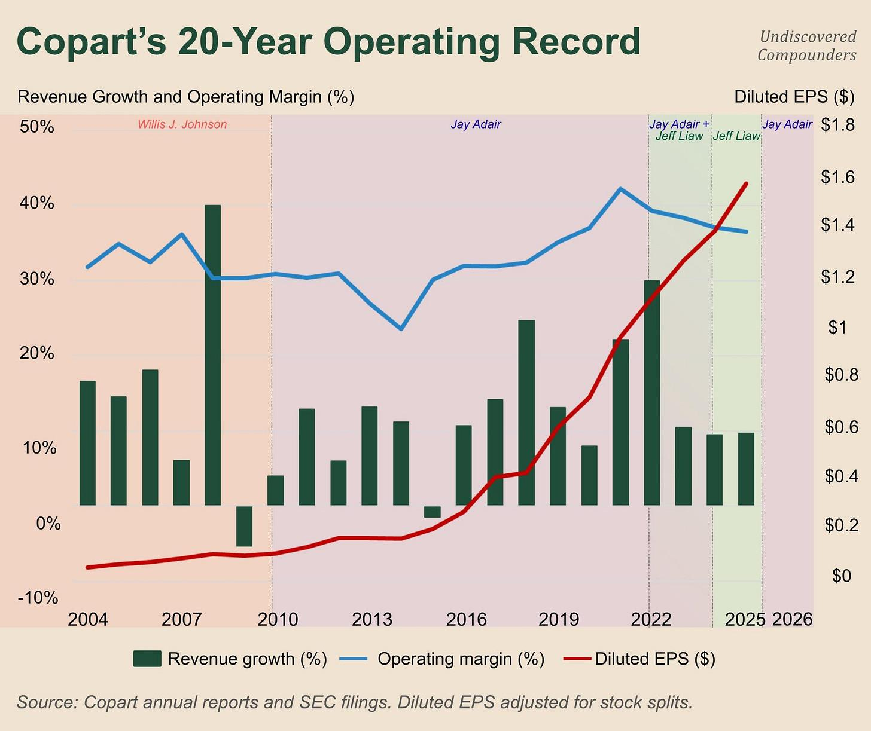

Share

(I’m giving a quick summary here, but I’d recommend the book Junk to Gold, which covers a good chunk of Copart’s history and resolves this chicken-and-egg problem by showing the question simply didn’t exist at the time; no chicken, no egg, as is very often the case with this kind of false paradox.)

Johnson built the business model, then the network by leasing a large number of properties and buying out competitors. He also created the PIP, which shifted responsibility for towing onto Copart. His rural acres are what made those economics work, while also helping him land national insurer accounts, which is how he built that national coverage.

Adair built the online auction platform (of which Johnson said: “I didn’t expect returns to go up”), and drove the international expansion. The product launched online in 1998 (a visionary, there’s no other word for it), with a full switchover in 2003, patented, “I built that product with our team.” Then came the expansion into Canada in 2004, the UK in 2006, etc. He’s the one who came up with the 20-20-20 plan in April 2016: 20 sites acquired, 20 expanded, in 20 months, something Liaw would only admit, 10 years later, was meant to address a capacity shortfall (so tied to a strategic mistake, thankfully corrected). He also showed a bit more financial boldness than Johnson, having leveraged the company on two occasions (something Johnson would probably never have done).

Liaw arrived with a machine that was already fully functional. He was the one who decided on the US slowdown (fewer land purchases + capex cuts), likely because its network is reaching maturity, with unit growth maturing along with it. He didn’t have time to leave a significant strategic footprint. Partly because Copart operates in a sector with a fairly long internal cycle, and partly because, starting in 2025, he had to contend with the difficulties in the US insurance market.

When you think of Copart and its business model, you often think of Johnson, the man who created the model and made it mainstream. But Adair, in my view, deserves even more credit: he took a very good company, adapted its strategy and its vision, turned it into an exceptional one, and scaled it. We’ll never know what happened behind the scenes leading up to Adair’s return (just that the situation required the first off-earnings conference call in decades), but it was probably the best thing that could have happened for Copart in this situation. (Except maybe Copart buying out IAA and somehow getting it past the regulator. I know, I’m dreaming. But imagine it anyway.)

9.5 Is management a moat?

From the start, I’ve talked about land as the foundation of the moat. In 3.7, I put myself in the shoes of someone who wanted to recreate the land network, and I showed that it’s simply impossible, and that a new entrant could only compete with Copart locally. No land, no platform. No platform, no land. Only those who built both at the same time, in an era when no dominant international platform existed, managed to escape this chicken-and-egg logic. Only IAA and Copart pulled it off. That’s why it’s a duopoly. Copart owns this land and is more flexible than IAA, adapting its strategy around insurers’ needs (anticipating land for CAT events with a CAT team, Co.ai for the total-loss decision, the PIP program, etc.). That’s why Copart dominates the duopoly.

That, to me, sums up Copart’s moat.

The CEO would say my reasoning is wrong: “But it mistakes cause and effect.” He goes even further, saying: “Our critical competitive advantage is our ownership mindset.” I think that’s no longer true.

Adair and Johnson couldn’t create Copart today starting from scratch. The land moat is far too wide, and it grows wider every year. The moat is built; Copart and IAA will remain a US duopoly for decades, and Copart will remain the dominant player. Through all of this, management was only ever a moat during the initial buildout (densifying the network, shifting from leasing land to buying it almost systematically, setting up the online platform, etc.). Management’s moat was simply that it proved to be a very good architect of the future moat, within a business model it had created and transformed itself.

Now, the moat already exists. It no longer needs an architect. It needs a landscaper. A management team capable of working in harmony with its environment: adapting where the environment is unyielding, and adapting the environment where it has room to maneuver.

Is Adair a landscaper? I think his 3-pillar M&A strategy and the continued reduction in US land purchases are signs that he is.

Another sign, perhaps the most telling of all, is this quote from the CEO on the latest conf call (I wanted to save it for the conclusion, but it fits perfectly here. I find it incredible):

“We’re going to do what Copart has always done. We’re just going to execute. We’re not going to talk about it. We’re not going to tell people what we’re about to do. When we do win, we’re not going to tell people that we won. We’re just going to do it. Let the results speak for themselves.” (CEO, July 2026)

In my opinion, Copart holds all the cards it needs to keep compounding over the decade ahead. Adair may be the best candidate to adapt the strategy to the uncertain decades ahead, because he brings an inherently long-term perspective, but that doesn’t tell us how the compounding will actually happen. That’s the subject of the next section.

10. Future growth

I’m not a fortune teller. I’m only going to offer a qualitative interpretation of this potential growth, with a quantitative layer where relevant, spelling out the limits of the analysis.

I’m saving the numerical assumptions for the valuation.

10.1 A typology of growth

Can Copart still grow?

Not only does the new CEO say yes, but he has a plan: “There’s really three growth pillars that we focus on: international expansion on insurance, whole car expansion domestically, then technology services for our customers.” As for how the investments will be split: “It’s hard for me to tell you it’s a third, a third, a third, or 40, 40, 20. I will tell you they’re all going to be material investments.” (Kudos to the analyst who rephrased the same question differently but got the same answer.)

But I don’t like it. This typology is too vague for me, all the more so because I suspect the CEO doesn’t share the same vision of growth as I do, a mere investor. He seems to have a somewhat more... personal vision. I count every extra dollar of revenue as growth; the CEO seems to be talking about new sources of revenue instead. For example, growth in insurers’ PIFs (and therefore in US insurance units, all else equal) doesn’t fit into his vision of growth. In mine, it does.

Here’s my vision of growth as a pragmatic investor who has to manage uncertainty.

For my purposes, every future dollar of growth for Copart will fall into one of these 4 buckets:

Insurance US

Non-Insurance US

Insurance International

Non-Insurance International

M&A is a way of buying future growth potential that will land in these 4 buckets. Nothing more. I’m setting aside technology monetization that cuts across segments, or any other platform contained within a segment. I’m basing this on whatever management actually gives us numbers for.

All that’s left is the weights, and here too Copart gives us enough information, even if it takes a bit of arithmetic, once again.

Take geography, where global units are -2.4%, US -4.2%, and international +5.9%. If I reuse the same equation from 7.4, but applied to geography rather than service vs. buy-sell, I get: weight of international units = (-2.4 - (-4.2)) / (5.9 - (-4.2)) = 1.8 / 10.1 = 17.8%. Within the international segment, insurance is +4.6% and non-insurance is +11.2%, for a total average of 5.9%. Running the same calculation again, we find that insurance accounts for 80.3% of international units.

What’s left is insurance vs. non-insurance worldwide. This one’s trickier. The world is -2.4%, with insurance at -2.7% and non-insurance at -1.4%. You can apply the same formula and land on 76.9%. Unfortunately the gap is too small relative to the precision available. Management reports the figures to one decimal place, while the total spread is only 1.3. Depending on the actual figures behind management’s rounding, the final percentage can range anywhere from 69% to 85%. Problem solved: I don’t overthink it and just take the 80% from 2.3.1.

So I have the growth, the weights, and 7.4 tells me what a point of unit growth is worth depending on where it comes from. In Q3-26, the US subtracts $93M of annualized EBIT, and international adds $29M. If I set that against the trailing 12 months’ earnings and assume Q3-26’s growth rates hold for a year:

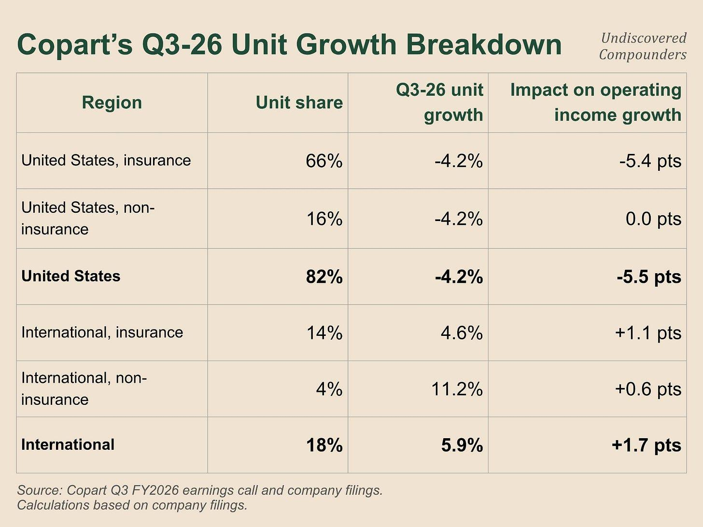

(Not bad, huh? It’s crazy what you can do with single-variable equations and a few assumptions.)

Let’s compare all this to the CEO’s growth plan:

“International expansion on insurance” is the fourth line: +1.1 point.

“Whole car expansion domestically” is the second: 0.

“Technology services” has no line of its own; it’s already embedded in the other revenue lines.

If you project the CEO’s plan forward from this quarter over 1 year, you get 1.1 point, nothing, and nothing measurable. Meanwhile, US insurance loses 5.4 points, 5x the measurable contribution of those pillars combined, in a cyclical context.

Two clarifications before wrapping up:

The zero on whole car mostly reflects Copart’s strategic shift toward becoming a middleman on low-ASP units rather than a buyer, plus a stagnation in the consignment commissions it was already collecting.

This estimate is based on the performance of the last few quarters, which can sometimes be quite deceptive, especially in cyclical sectors (Copart has a cyclical component of its own through the used-car market, but also through the insurance cycle itself). A good quarter could completely change this subsection.

Let’s finally conclude: the growth pillars mentioned by the CEO probably won’t be the source of near-term growth (except perhaps whole car expansion domestically). A continuation of the turnaround in US insurance units, and international insurance to a lesser extent, will probably be the most important factors.

Let’s analyze all of this segment by segment.

10.2 United States, insurance

Remember: Units = Claims filed x Total loss rate x Market share.

The first term swings with the insurance cycle and the broader auto cycle (e.g., miles driven), the second has been climbing for decades, and the third is won and lost through duopolistic competition (and a few local players, to a much lesser extent).

We’ve already seen everything we need to pick this apart.

Following aggressive price hikes from the insurers that make up the bulk of Copart’s mix, Copart absorbed a 5.1-point decline ex-CAT over the first nine months of FY26. Insurance prices were up 0.2% TTM as of April 2026, and several major insurers are already announcing cuts. The turnaround is starting to show (alongside a likely base effect): US insurance units ex-CAT at -7.3% in Q1-26, -4.8% in Q2-26, a bit over -3% in Q3-26.

Every quarter counts. In the meantime, let’s analyze each component in detail.

First off, the cyclical nature of insurance has limits. A policyholder who’s dropped down to liability-only doesn’t move back up to full coverage just because their premium falls 3%. Someone who drops insurance altogether will probably stay that way until they get caught. This is a process that plays out over years. Part of this variable’s impact will probably show up quickly once insurers cut their prices, followed by a more diffuse effect over the medium term through advertising and sustained low prices.

Next, the much-discussed market share, which is as hard to lose as it is to gain. Here you can assume a whole range of scenarios. The only thing that’s more or less certain is that Copart will remain the majority player in the duopoly. From there, you can let your imagination run wild and assume a whole string of scenarios. The only ones you objectively can’t accept are those that assume Copart’s growth comes from significant market share gains (unlikely in the coming years, and above all, it gives the model too much leeway). Even in a bull case. This will carry through into the assumptions.

Where Copart has the most room to benefit is in the market-share mix of its insurer clients: what I call intra-insurance cyclicality. As we’ve seen, Progressive’s growth has been slowing for 2 quarters while growth at Copart’s other major insurer clients has been picking up, and that’s probably what has been driving the early turnaround in US unit growth for Copart. And for me, a continuation of this turnaround will drive a good part of Copart’s growth over the coming quarters.

And long-term growth? It’s simple, I’ll just draw on the last few decades of Total Loss Frequency data.

From 15.6% in 2015 to 23.1% in 2025. We’ve already seen that this is a kind of three-body system with accident count and ASP: the more technology cars contain, the fewer accidents there are, but the more expensive those accidents get, so totaling becomes more frequent while the ASP climbs alongside it. As we’ve seen, the data is far from showing that the decline in accident frequency will offset the rise in TLF and ASP.

This is where most of Copart’s long-term risk sits:

A used-car market that stays elevated for years, which weighs on TLF while pushing up the ASP. If the ASP doesn’t compensate, Copart’s long-term growth is at risk.

Technology that significantly reduces accidents without a matching rise in the ASP.

Or any other variable that reduces accident rates faster than TLF and ASP can offset them. You can obviously think of the self-driving car; we’ll come back to it in the risk section.

Copart currently has two tools to deal with all of this:

Maximize the ASP at its auctions. It already does this: its VB3 platform, its international buyers, etc.

Encourage totaling further upstream, notably via Co.ai to help with total-loss decisions, but more broadly, by stripping out as much friction as possible from the decision to total a car. Copart has recently stated it’s “moving upstream” and having more influence earlier in the chain. Title Express is one example.

Its recent interest in acquiring CCC, the software vendor that helps make the total-loss decision, points the same way. That said, it remains a love-hate relationship with insurers. They’ll probably be reluctant to give Copart too much influence over their own decision-making. So it’s possible insurers oppose this acquisition, and given their close relationships with various regulatory bodies, they could lobby hard for the regulator to block it. “Moving upstream” will surely mean fighting “diplomatically” with insurers. We’ll come back to it in the risks section.

Let’s pull our 7.4 weapon back out: a one-point increase in TLF adds roughly 5% to group EBIT. Given that the rate has gained 7.5 points in ten years, and that every new point lands on a bigger base than the one before, Copart’s performance makes a lot more sense. But it only takes Copart losing an equivalent amount of market share to cancel out the effect of this TLF rise. And that part is at least partly in Copart’s hands.

From a more operational standpoint, forget about growth through expansion into new US geographic areas. As we’ve seen, the number of US sites has remained relatively stable, capex is falling, and management has guided for that decline to continue. Copart’s network has reached near maturity in the US. Obviously there’s still room for a few adjustments, notably around CAT events. But operationally, growth in this segment will come almost exclusively from monetizing this land and/or from the ASP.

To sum up, there are 3 bets, 2 of which Copart can directly influence: a turnaround in the insurance cycle with a mix favorable to Copart (already under way), TLF continuing its decade-long trend despite a lower claims count, paired with a higher ASP, and Copart, on net, not losing market share. That’s how Copart can keep growing significantly in its US insurance business, its biggest segment, over the coming quarters/years.

10.3 United States, non-insurance

Here, Copart is no longer playing the same game. An insurer stuck with a wreck wants to get rid of it. Copart helps them, and that’s that. A leasing company with a car that still runs has far less need for Copart. And yet, this is largely the segment the CEO was pointing to in his 3-part growth plan under “whole car.”

Quick reminder:

Copart Dealer Services, i.e., dealers and the trade-ins they don’t want, NPA included (motorcycles, ATVs, etc.). The largest share of the segment, down in FY25.

Blue Car (banks, corporate fleets, leasing companies, etc.), which was growing at double digits in FY25.

Copart Direct, where Copart buys cars directly from private individuals (the good examples), or connects them with a dealer who buys the car in exchange for a commission (direct buy; the lesser examples). This recent shift caused a -26.3% volume decline on Copart Direct.

Blue Car and the dealers are service businesses, and Copart Direct is buy-sell. So we have two different economics stuffed into a single number.

Here I’m more... skeptical, and I find the bet riskier.

First off, Copart’s moat doesn’t transfer to this segment. A car that still runs doesn’t need to sit around for 6 weeks waiting on its title at the DMV. So no need to park on specialized lots. So no need for the biggest asset and main component of Copart’s moat.

Next, Copart is arriving in a sector that’s already highly competitive, with rivals far more experienced and better equipped than it is. Take the sector’s giants, Manheim, ACV, Openlane, and Carvana¹²⁴: players established for decades with dealer networks and inspection software that Copart doesn’t have. It could build them, but at what cost, and in how much time?

Even if Copart manages to take market share, nothing is guaranteed. For every trade-in, the dealer always has the option of selling it through its own network. The leasing company can repair or keep the car (which is actually what it’s doing right now, which explains the hole in Blue Car over the last few quarters). Worse still, even when they decide to get rid of the car, they can switch to competitors with almost no friction (unlike insurers).

But it also has a weapon the others don’t: cross-selling. Players who come to Copart for non-insurance and who, through the natural pull of the platform, end up buying insurance vehicles (so, more damaged ones). Over 30k customers in the last 3 years. More and more buyers means more and more liquidity, and ultimately, more and more demand: “we have our foot in the door, and we earn the right to sell, quote, better and better cars over time.” Auction-room liquidity is the only asset that fully transfers to this segment.

In practice, management has already invested. US overhead ex-depreciation went from $186M to $327M between FY23 and FY25, mostly for “expansion of our sales force.” So far, that hasn’t translated into any unit growth. One analyst dared to ask the uncomfortable question about this lack of real payoff after 3 years of investment in CDS, Blue Car, and Purple Wave during the July conf call: when do we get operating leverage from it? Adair’s answer: “I think we can leverage it, but I don’t want to be pigeonholed.” He did say more than that, though: “I’d like to see that increase dramatically. To do that, we’re looking at restructuring [...] the goal is that it looks very different in three to four quarters.”

Ok. It’s rare for him to be this precise. For one, it’s the only occurrence of the word “restructuring” across all the conf calls I reviewed (surprisingly, on his return), but on top of that, he gives us something like a deadline: spring-summer 2027. I like that.

So this is Adair’s second growth leg, and he expects significant results over the coming quarters. Nice conclusion. Next up.

10.4 International

10.4.1 The current situation

This is the first growth leg Adair mentions. There’s a reason he cites it first: it’s the one already delivering concrete results. From FY23 to FY25, the segment’s operating margin went from 17% to 27%. Hard not to be satisfied.

But as a shareholder, I have an inalienable right: I can be as demanding as I want. And I’m going to exercise it zealously.

First, a typology. Copart operates in 11 different countries, without giving figures, but we can still do a bit of sorting based on management’s mentions and site counts:

The UK is the core of the segment. It’s actually the only place where we have a real sense of Copart’s power. The UK competition authority credits it with more than 60% of the country’s insurance salvage market across 22 sites total.¹²⁵ This is also IAA’s second-largest market, though IAA is clearly behind Copart there.

Canada second, since it’s systematically the second country management cites after the UK. IAA is present there too.

Brazil next, with Copart’s largest international site network (23 sites, though the country is big and the population is spread out, unlike Canada). Volumes remain low in proportion, in my view, because roughly 7 in 10 vehicles are uninsured.¹²⁶

Then Germany, which runs around 50k vehicles/year (the figure hasn’t moved since 2022).¹²⁷

The rest is relatively small (Spain, Finland, Ireland, and the three Gulf countries).

Internationally, insurance accounts for roughly 80% of units. The rest is dealers and fleet, just like in the US.

A little accounting subtlety, it’s been a while: international service revenue is up 11.4% over the nine months of FY26. Excluding FX, that falls to 5.9%. Half of the growth is tied to a weakening dollar. It’s quite possible this reverses in the coming quarters. 5.9% growth ex-FX doesn’t match Copart’s “historical” 10%.

So the growth is real, but still limited.

10.4.2 The ceiling and the real source of growth

The ceiling is called “who has the right to own the wreck” (I’m pretty sure no one has ever written that sentence before).

When an insurer takes possession of a totaled wreck’s title, it’s left holding 2 tons of scrap metal it doesn’t know what to do with. That’s where Copart comes to the rescue. In some countries, it’s the policyholder who keeps the wreck’s title, and the insurer simply deducts the value from the payout. This is notably the case in Italy, Poland, and the Netherlands, and, until a few years ago, Germany.

Germany changed in 2019, after the Federal Court of Justice ruled that an insurer could offer the injured party an economic incentive to voluntarily hand over the handling of their wreck.¹²⁸ The insurer then pays the full replacement value within a maximum of 3 days, and the wreck goes to the service provider. Copart Deutschland signed its first contract with an insurer 9 months after the ruling.

So a country can be closed to Copart either by law (or, to be more precise, by legal conventions), or by industry habits. But in both cases, the market can open up: legally (in which case Copart has very little room to maneuver), or behaviorally, by convincing insurers that using a provider like Copart makes economic and operational sense for them.

In the second case, Copart fights two battles: getting insurers to choose it as their provider, and getting them to choose the service program over the buy program. As a reminder, that’s what Copart did in the UK, after years, even decades, of lobbying (nothing convinces quite like a highly liquid auction platform). A good chunk of the UK has now moved to the service program (with the accounting subtleties we’ve already covered).

Internationally, Copart is already present in the markets it can legally enter and where doing so is potentially economical. On this front, near-to-medium-term growth is limited. Only a legal change opening the door to Copart in a market can change the situation. But we have no visibility into where, when, or how much. If this variable has an impact, it plays out over a decade or more.

The real driver of near-to-medium-term international growth for Copart is changing insurer habits in the markets where it’s already present. The UK was long a driver of this international growth through the program shift. More recently, it’s been Germany (volumes are stagnant, but they’re generating more and more EBIT). Here too, we don’t really have a precise market-by-market picture. We don’t even know the rough overall size of the conversion pool still available to Copart in these various countries. This pool is mathematically capped, but its ceiling is unknown to us, mere investors. If the CEO mentions it as his first growth leg, we can reasonably assume he still has a few years of potential growth in reserve.

What’s left is the last variable: rising household wealth. A country open to Copart in theory, but where the economics of being present (or heavily present) are limited. The most likely region on this front, in my view, is Latin America. Brazil is actually a perfect example. Copart is already there (IAA isn’t) but the proportion of insured vehicles is low relative to the total population. If Brazil grows wealthier overall, the proportion of insured vehicles will very probably rise along with it. That would be a windfall for Copart, which would just have to expand its network in the country.

The argument also holds for markets where Copart currently has no economic interest in being present at all, but where that economic interest could develop through rapid growth in household wealth. This is very long term, but in my view it’s Copart’s main source of growth on a decades-long scale.

What remains is figuring out how it gets into these new markets.

10.4.3 Non-insurance and the foot in the door

Let’s look at the past.

In Germany, half the volume is non-insurance. Makes sense: Copart entered the country in 2012 by buying WOM (a residual-value exchange). So Copart entered Germany 7 years before it could deal with insurers, through non-insurance M&A. Planned or opportunistic, it doesn’t matter: the day the door opened, it was already in the room.

These non-insurance acquisitions let Copart enter a market without asking anyone’s permission, and let it build a buyer base while forging a reputation, both as a service provider and for its auction platform. Copart is therefore putting the pieces in place to capture insurance the day the legal regime allows it (I have no doubt Copart sometimes helps nudge that along).

In my view, that’s how you should read the recent growth in international non-insurance (+9.1% Q2-26 and +11.2% Q3-26). It only represents 4% of global units, and these are the units that generate the least revenue per car. Winning a single large fleet is enough to bump it up a few percentage points. I look at this more as an indicator of where Copart is setting up shop and where it’s looking to expand in the future. (Some non-insurance players can also become buyers on the platform, too, improving its liquidity and price competitiveness.)

Overall, international non-insurance growth is more a means than an end.

To sum up: in the near term, Copart will grow internationally by pushing insurers toward program changes. This is a growth driver we have very little information on, but we can assume it has enough fuel to last a few years. Longer term, opportunities exist too, and are potentially massive, but they’re inherently very uncertain. International non-insurance is the best clue (or the least bad one, take your pick) we have as to where this longer-term potential may be heading.

10.5 Growth and M&A

10.5.1 What money can buy

What can be bought, why, and which bucket does it fall into?

The CEO’s strategy includes:

“Moving upstream,” so towing management, help with the total-vs-repair decision, title management. There’s been quite a bit of M&A in these areas in recent months, including a fair amount of consolidation, but there are still plenty of M&A opportunities in these segments.

Make acquisitions where Copart “can utilize our land or utilize our auction technology or our knowledge.”

He’s putting the resources in place to do it with the arrival of David Berger on August 13, whose expertise is concentrated almost entirely in M&A and adjacent fields (corporate governance + shareholder activism).

Let’s see what this could produce.

10.5.1.1 The US

Let’s start with the big segment: US insurance.

First, forget significant market-share gains. The only relevant possibility would be buying IAA, and too many people have an interest in making sure that never happens.

Second possibility: M&A used to fill a capability gap or improve the existing offering.

Take ACV Auctions, for example. It’s a wholesale marketplace for dealers (no auction lots). ACV has been exploring a sale since August 11.¹²⁹ In Q2-26, it sold more than 210k vehicles (roughly 850k/year), with annual guidance of about $850M of revenue and $75M of adjusted EBITDA.¹³⁰ The synergies for Copart’s non-insurance business are obvious: dealer relationships, software, offering those vehicles to international buyers, etc. Copart could grow its non-insurance business while capturing some synergies on certain of these assets.

The price ($1.3B EV on $75M EBITDA) will probably be a dealbreaker, but the broader logic still holds. The US auto sector is a relatively mature, competitive market. Copart has the means, and probably the time, to try to grow into new segments. But is it worth Copart building everything itself? No. Clearly not.

M&A remains the most likely and most practical way for Copart to grow in the US market. If it’s allowed to.

CCC will get its own subsection right after this.

10.5.1.2 International

What’s left are my two international buckets, which sit within the first pillar Adair mentions. The logical targets don’t publish any financial figures (WOM in Germany back then, Alcopa would open up France, Pickles in Australia, etc.). They exist. That much, at least, I can confirm.

As we just saw, M&A is the door into international markets, notably to lay the groundwork for future international insurance growth. It’s also what will drive international growth over the long term. To avoid repeating myself needlessly, I’ll point you back to 10.4.2 and 10.4.3, just a few scroll wheel clicks up.

10.5.2 CCC Intelligent Solutions Holdings

In the July conf call, Adair was talking about “material investments.” The evidence arrived while I was writing this piece: Copart is in discussions to buy CCC Intelligent Solutions Holdings, which is itself in discussions with other potential buyers.

As a reminder, CCC is a software vendor for auto claims appraisal. It offers:

Claims Estimating, which produces the repair quote. In practice, the body shop or the appraiser enters the damage, and the software spits out the parts and labor cost. +6,500 body shops use its AI version.¹³¹

Claims Valuation, which produces the vehicle’s pre-accident value. So this is the software that decides how much the car Copart cares so much about is worth. +7M comparable vehicles in its database, 41k(!) municipal tax rates, and 53k state and local fee schedules.¹³² To sum up, when a US policyholder gets their total-loss check, the amount comes from here. It’s so widespread that a whole ecosystem of lawyers and consultants makes a living contesting these valuations.¹³³

Claims Management, for everything to do with the workflow around all of this: the estimate provides the repair cost “that adjusters can compare against total loss valuations.”

Finally, we’re talking about the CEO’s third growth leg: “technology services.” It even has the advantage of “moving upstream.” Let’s revisit the inequality from 5.1: repair cost + salvage value > pre-accident value. Copart controls the second term, and CCC produces the other two. No wonder Copart wants to acquire it. It fits perfectly into the CEO’s strategy.

The price? At $5.7B of enterprise value, we’re talking 11.6x guided EBITDA.¹³⁴ At $7B, 14x. For recurring software growing at 10%, that’s roughly market price.

I think this acquisition is probably one of the best acquisition opportunities available to Copart (probably the best, IAA excluded), for both short- and long-term growth in the US insurance market. But the probability of it actually happening is, in my view, very low. Insurers have every incentive in the world to prevent it, and above all, they have the means to do so.

I won’t even factor it into my valuation, in fact. But I’d be glad to have to correct that.

In the end, 8 acquisitions in 20 years for a cumulative $645M, the biggest of which was $161M. Copart is now discussing a potential deal worth more than 10x everything it has ever spent on M&A combined. Whether the deal happens or not, the capital allocation regime has changed. And that’s a good thing, because it’s the best way to support medium-to-long-term growth across every segment.

10.6 A summary of growth

Copart still has plenty of room to grow, and this growth, from my perspective as an investor, extends beyond the capital-allocation plan laid out by the CEO.

In the near term, this growth should come primarily from a continued turnaround in the insurance cycle, as Copart’s insurer mix becomes more favorable. This view is backed by 100 years of insurance history and by recent data already showing signs of a turnaround. It’s probably the biggest source of growth over the coming quarters, without a single dollar of capex.

Longer term, the opportunities are more numerous, and this is where the CEO’s plan fits in:

The TLF/ASP/accident-count dynamic keeps trending in Copart’s favor, as it has for decades, supported by the rising cost of technology, its increasing prevalence, and inflation.

International insurance growth through penetration of accessible markets via M&A, and through program shifts (from buy to service). This growth may require prior non-insurance development in certain markets (this segment has a minimal direct impact on growth).

M&A or investment that helps Copart push TLF higher in the US insurance market.

Other M&A that would expand Copart’s reach in US non-insurance.

Nearly all of these paths assume one thing: Copart’s auction platform stays competitive, notably by remaining attractive to as many international buyers as possible.

This is the perfect moment for the full CEO quote:

“My intent is to lead the company for the next 10+ years. This is not an interim arrangement. I won’t be going through a process of finding my successor. I’m just going to focus and double down on all of our initiatives to build Copart and to grow Copart. There’s really three growth pillars that we focus on: international expansion on insurance, whole car expansion domestically, then technology services for our customers. I want to be very clear. This is a growth company. There is a lot of noise and a lot of rhetoric out there. I have a pretty good history of saying I don’t listen to the noise. I don’t respond to things. I’m going to continue that.” (Conf Call, July 2026)

Very interesting. Now is the perfect moment to look at the risks.

Subscribe

11. The risks

11.1 The existential risks

This deep dive is thorough enough that we’ve already listed all the main risks, often more than once. So this section is mostly a way to take stock of all these risks and dig deeper into them.

It’s also the section that concentrates the most pessimism, and that’ll feel good after all this bullish information. Because even though I think the market is punishing Copart too hard for the wrong reasons, there are clearly real risks, some of which the market underestimates in my view.

In order from most to least important.

11.1.1 The TLF/ASP dynamic

I’ve probably mentioned this risk in every section. It’s the most central one, and at the same time one of the hardest to anticipate.

The total loss rate is the outcome of a trade-off between two exogenous prices: what the car is worth before the accident, and what it costs to repair. Copart only controls the third term, the smallest one: what the wreck fetches at auction.

It’s a very interdependent system: when used-car prices rise (market moves, more technology packed into cars, etc.), the ACV rises, the insurer totals less, and the ASP goes up. The reverse when used-car prices fall.

Alongside used-car prices, there’s the estimated cost of repair. The quote itself tends to rise because of the sensors living around the periphery of vehicles (parts are expensive, recalibration is needed, etc.). This mechanism pushes TLF upward without pulling the ASP down. On the other hand, they also reduce the number of accidents, but we’ll save that for later.

At the aggregate level, the TLF/ASP dynamic has multiple forces pushing it in opposite directions, but the sum of these forces still favors Copart.

Nothing suggests this dynamic will change in the coming decades. Quite the opposite. The rising average age of the vehicle fleet. Longer repair turnaround times. Inflation pushing up repair costs faster than the ACV (even more so if you factor in rising repair prices from the consolidation of most repair shops into a handful of players). And I could keep going for a while longer. I have no doubt a few quarters/years will happily serve as counterexamples and create some uncertainty.

This TLF/ASP dynamic is the existential risk to Copart, but it’s also a risk Copart has influence over (even more so if it acquires CCC), and one that benefits from a confluence of multiple causes that has been pushing the trend for decades and doesn’t look like it’s changing. Here, this really is a Lollapalooza effect.

As long as accidents don’t drop off a cliff.

11.1.2 The number of accidents

11.1.2.1 The current trend

Copart’s second existential risk. Intimately tied to the previous one, because it’s the term TLF and ASP ultimately get multiplied by. (I note the “irony” of talking about a drop in the number of accidents as a risk.)

Let’s focus on the US. At the global level, Copart is limited by several other factors well before these trends have time to make any significant impact, especially since these trends vary enormously from one country to another.

Forget accidents per mile and its 1/3 drop since 1990. What matters for Copart is the absolute number of accidents, and over the same period that has only fallen 8%. Quick reminder, two big opposing forces produce this dynamic:

Road safety and technology: seatbelts, airbags, ESC, the backup camera, emergency braking. You already know these.

On the other side, a US population that’s grown nearly 40% since 1990, with Americans owning more cars per capita and driving more miles on average.

People drive more, but more safely. This balance then interacts with the TLF/ASP dynamic. The result, for decades, has been a tailwind for Copart and has heavily contributed to its exceptional compounding. But nothing is set in stone, especially at the macro scale: population decline, public transit use becoming more widespread at the expense of car use, or driving simply becoming too expensive, and this tailwind will turn into a headwind.

To be honest, none of the 3 factors is showing up in a significant way. The only one that’s moving is US population growth, which is slowing, but clearly not enough to flip anything. The real risk mostly lies in safety technology.

The question is certainly central, but only over the long term. As a reminder, a safety technology only has an impact once the car is actually on the road. Each model year accounts for roughly 5% of the fleet (a figure that’s been shrinking for a few years). And the 4 safety technologies with the biggest impact took about 20 years to reach 95% of vehicles on the road.

On this front, Copart therefore seems protected over the coming years. What’s more, the technology comes with a rise in repair costs that’s often steeper than the rise in the ACV, pushing the whole thing toward totaling. That’s precisely why, despite the decline in the number of accidents, TLF and ASP have both risen.

Locally, safety technologies might seem to work against Copart, but within the overall accident-count/TLF/ASP dynamic, they’re a force, if not the main force, working in Copart’s favor.

The risk to this thesis is that a trend running for decades changes course over the decades to come.

Speaking of which.

11.1.2.2 The self-driving car

Obviously.

First, a reminder of the present: the self-driving car is still a rounding error. The few thousand cars Waymo runs in the US (and the few dozen Teslas) mean that for every 1 mile driven by a self-driving vehicle, 15,500 are driven by non-self-driving ones.

For the future: the self-driving car mostly replaces, or will replace, individual trips, much like a taxi. In this use case, a self-driving vehicle racks up, on average, 5x more miles than a non-self-driving car. To sum up, in its current use and in that of the next (at least) 10 years, a self-driving vehicle takes miles away from cars that are already on the road, without actually taking them off the road.

My opinion is that this impact, over a 10-year horizon, will be minimal, or even nonexistent, on Copart. Let’s look at this through the sociology of uses, distinguishing 2 cases: cities and everywhere else.

In cities, the ceiling is already known. Uber and Lyft have had 15 years to capture these trips without having to tie up capital in vehicles. They account for between 1.0% and 2.9% of miles driven in the six largest US metro areas.¹³⁵ The robotaxi faces the same ceiling; it will only shift it a little, provided it’s cheaper than a human driver (assuming the self-driving vehicle is fully viable and that everyone thinks purely in terms of price, which is far from a given).

In this situation, the impact on Copart exists but is minimal. The Uber/Lyft cars and taxis being replaced are insured vehicles, which therefore pass through Copart or IAA once totaled. Fewer of these vehicles directly reduce Copart’s volumes. Wrecked self-driving vehicles don’t offset these volumes at all: they’re managed directly by Waymo, and it’s Waymo that decides on totaling and then handles the carcass (for now; the more the technology scales, the more a provider like Copart, with its yards across the whole country, will start to make sense). So this is a straight-up loss of volume for Copart. But the volumes are minimal, less than 1%, probably much less.¹³⁶

Second case, outside cities, where the vast majority of American miles happen.

In these areas, car ownership is almost a condition of living there before it’s a mode of transport. It comes bundled with the house, the garage, and the 20 miles separating home from almost everything else. When an individual with their own car considers the possibility of a self-driving vehicle, they’re not comparing a robotaxi with the decision to own a car in the first place. Rather, they’re comparing the cost of the ride to the marginal cost of their own trip, which is far lower than the robotaxi’s. This competition between robotaxi fares and the marginal cost of driving your own car is the hardest one for the self-driving car to fight, and it’s what will keep robotaxi use outside big cities extremely limited, even if fleet operators manage to make the technology viable on these roads and at these distances, which is VERY far from a given. (I even think it’s probably not economically viable, but that’s not necessary here.)

In both of these situations, the impact on Copart is minimal.

What’s left is the last case: private ownership of self-driving vehicles. Here we’re talking about a very long-term trend: several decades, and then some.

Replacing private non-self-driving vehicles with self-driving ones implies that the self-driving vehicle:

must establish itself as a new technology that completely changes how people use cars;

at prices well above what’s already out there;

while viable, lower-cost alternatives exist;

and must incorporate far more components and materials already subject to supply constraints than a conventional new vehicle.

So this replacement faces a much larger set of constraints.

But let’s take the opposite side.

Once the technology is viable and scalable in theory, the drop in accident rates will simply be a function of the number of vehicles on the road. The impact of each additional vehicle on the accident count will be far greater than that of any other safety technology already widely adopted.

What’s more, these self-driving vehicles won’t pass through Copart if the current trend holds. Even if, as scaling happens, Copart starts handling these vehicles, the reduction in Copart’s accident-driven volumes will, in my view, far outweigh the salvage volumes generated by the few vehicles that do get totaled (keeping the assumption that a self-driving vehicle’s accident rate per mile is far lower than a non-self-driving one’s, which is the very reason for their existence).

Overall, there are two bear cases for Copart stemming from the self-driving car:

Current fleets significantly reduce the use of personal cars.

The vehicle fleet becomes more and more self-driving.

Anyone convinced of either of these two theses can’t, in my view, be bullish on Copart.

I’ve laid out my arguments for why I think their probability is very low (to stay epistemically rigorous). I’m convinced the impact of self-driving vehicles on Copart over the next 20 years will be minor, and comfortably offset by its other sources of growth (I stopped myself from saying 50, again to stay epistemically rigorous).

History fully supports this. The history of technology is full of “superior” but more expensive technologies that fell into obscurity because an almost-as-effective, cheaper alternative was already widely adopted. RFID vs. barcodes, where Walmart nonetheless tried to force RFID use across all its items.¹³⁷ 20 years later, the barcode still dominates. Shanghai’s Maglev. Hydrogen cars. Even electric cars. They were one of the gas car’s biggest rivals around 1900¹³⁸, before losing the battle despite their many virtues (quiet, simplicity, etc.). The gas car, and gasoline itself, were, by comparison, too cheap, and went on to dominate the century (the electric car is now coming back for its potential revenge a century later).

The most likely outcome is that the self-driving car follows the same path as many of these technologies: confined to a minority of the fleet, in specific areas and specific uses.

But these are just arguments and my interpretation of them. It’s not proof. Anyone who wants to invest in Copart needs their own conviction about how well-founded this risk is. Otherwise, you’re taking the risk of letting the usual noise around this topic create undue uncertainty, with all the biases that come with it. It would be a shame to sell just because a billionaire promises, for the umpteenth time, full self-driving in t + 2 years, like he’s been doing for more than 10 years.

11.1.2.3 Everything else

As if this weren’t already complicated enough, there are all the other insurance-side variables that influence this number more locally.

We’ve already covered these too: fewer insured vehicles, coverage dropping to liability-only, small claims no longer being filed, etc. I spent a good chunk of chapter 6 analyzing them, so I’ll just give you my conclusion again: everything suggests this is yet another cycle rather than a new trend.

This is a risk that requires having an opinion on the trend over the next 10 years (and more, for the bolder among us):

Whoever thinks the decline in accident frequency will completely outpace the rise in miles driven, or that miles driven will fall, and that this decline won’t be offset by a higher TLF/ASP, should put Copart straight into the no pile.

Whoever has a doubt, or thinks the answer is no, should then look at the price (if they haven’t already filed it under the too-hard pile). A risk without its potential reward tells you nothing.

But we’ve still got a few more risks to cover before we get there.

11.1.3 The auction room

Obviously. The famous auction room. Along with the land, it’s one of the two assets at the foundation of Copart’s business model, and what forms the core of its moat.

How could it possibly crack after decades of foundation-laying?

3 numbers are enough to guess:

Roughly 40% of units sold at American auctions go to an international buyer.

The average purchase by an international buyer is 38% more expensive than that of a domestic buyer. Overall, international accounts for roughly 1/2 of the value sold.

They help drive up prices and liquidity: “90%+ of our cars have their values affected by international buyers because they bid on many, many more cars still than they buy” (Liaw, Q2-21).

If these international buyers disappear, Copart’s model largely collapses, and the quality of its operating business along with it.

After 50k words, you might be thinking, “Flo, you’re overdoing it here. The network covers more than 160 countries. I’m willing to be conservative in how I think about risks, but come on. It’s impossible for all of this to vanish at once. You yourself said that even with the US-Iran war, the drop in flows from the Middle East was offset by Central Europe, West Africa, Central America, and the Caribbean. If one group disappears, others take its place. That’s even how US insurance ASP hit a record last quarter. So, you’re a nice guy, and I appreciate the quality of your work overall, but here you’re overdoing it. Please don’t invent risks.”

There’s got to be at least one of you who thought that (probably in more colorful terms). To that reader, I'd say: (re)read the transcripts of the 2015 conf calls: “the strengthening dollar suppressed participation by our international buyers, as the percentage of units sold to international buyers was the lowest since our third quarter of fiscal 2009, and the percentage of value sold to international buyers was the lowest since our first quarter of 2005.”

There you have it, the auction room’s worst enemy: dollar strength. A strong dollar reduces the purchasing power of pretty much every international buyer, which reduces the auction room’s ability to generate higher prices, and therefore, insurers total fewer cars.

And yet, the dollar currently sits at the same level as in 2015. Yet you won’t find a single mention of the dollar in recent filings or conf calls, even though the impact of international buyers is greater today than it was 10 years ago (more than 160 countries today vs. 114 in 2017). So level alone isn’t enough. What actually matters is speed, strength, and duration.

A dollar that rises fast, hard, for a long time would be very damaging for Copart. Over the last 50 years, two periods fit these criteria:

1980-1985 (+96% on the US dollar index in 5 years¹³⁹), amid rising rates (peaking at 19%¹⁴⁰) to counter historic inflation (peaking at 14.8%¹⁴¹). This trajectory ended largely because 5 central banks stepped in together to stop it (the 1985 Plaza Accords).¹⁴²

1995-2001 (+50% in 6 years¹⁴³), when the US Treasury deliberately put a strong-dollar policy in place, and capital from around the world rushed into US stocks during the productivity boom (the 1997 Asian crisis and the 1998 Russian crisis also contributed to capital flight from emerging-market currencies into the dollar).

The 2015 move was fast and sharp, sure (+26% in 8 months)¹⁴⁴, but it didn’t last. And it only translated into a relatively bad year for Copart. The consequences were limited and manageable, from my perspective as an investor with my time horizon.

But if the dollar, for whatever macro reason you can imagine, starts moving fast over long stretches again like in 1980, the bullish thesis will die a little more with every month that passes.

This is a risk that could do a lot of damage over the medium term, but is currently unlikely. For one, the dollar index sits near its midpoint of the last 50 years. And the 2 episodes mentioned both started from a weak, even very weak, dollar. Beyond that... that’s it. Going further would mean venturing into a multi-year macro analysis. But financial people already struggle to anticipate the future of a single company one quarter out, so anticipating that of a country over several years, I’d be insulting you if I pretended I could forecast that here, knowing it isn’t my area of expertise.

A strong, fast, and sustained rise in the dollar is the only real risk that can do serious harm to Copart over the next 5 years, but it’s a scenario that hasn’t occurred since Copart became this dependent on international buyers (so 1995-2001 is excluded). Potentially devastating for the thesis, but very unlikely.

11.2 Non-existential risks

Here I’ll list other risks that don’t kill the thesis if they show up on their own, but that, stacked together, can do serious damage. I’ve sorted them by perceived severity (roughly).

11.2.1 Competition

11.2.1.1 The near-to-medium term and the insurance cycle

On one hand, Progressive keeps growing while the insurers that make up the bulk of Copart’s mix keep stagnating for a few quarters. On the other hand, insurers overall are slow to cut their prices, policyholders take longer to upgrade their coverage, and the uninsured take longer to re-insure. Overall, insured vehicle-years are still at -4% in the latest published figures, while the vehicle fleet on the road keeps growing at +1.4%. But these figures are increasingly starting to turn.

If the whole sector returns to insured vehicle-year growth (what I call the insurance cycle turnaround), that turnaround will mostly benefit Copart. It’s almost mathematical:

Copart is seeing its US insurance units fall (less and less), and a number of big US insurers outside Progressive are also seeing their volumes fall.

IAA and Progressive are following the opposite trend.

So Copart is mostly exposed to a mix of insurers that got hit hard by this cycle, and a turnaround in the insurance cycle will mostly come from this mix making up lost ground, which will benefit Copart with a lag: there’s a lag between signing an insurance contract and totaling a car. This is probably why IAA’s US insurance units keep growing even as Progressive’s PIF (policies in force) growth slows.

Ok. So why not wait for this insurance cycle to turn and for growth to come back for Copart? Simply because the opportunity will be gone by then. I’ve already laid out all the reasons why, in my view, this cycle is in the process of turning. My view is probably a minority one relative to the market’s, given the price. Not waiting is, for me, a way of acting on my contrarian opinion versus the market’s. Worst case, I don’t think the stock falls by anything close to the amount it already has, and above all, I’m prepared to wait for this cycle to turn even if it takes longer than expected.

I’m not “afraid” of this risk, but I’ll obviously keep watching it: insured vehicle-year figures, the performance of insurers that disclose their numbers, and of course, growth in service revenue and US insurance units.

11.2.1.2 The long term

I think the near-term bear thesis is wrong, but over the long term, uncertainty is necessarily greater.

Since its acquisition by RB Global, IAA is objectively better run and has resources that IAA on its own, or its previous owners, didn’t have (or at least didn’t have the incentive to allocate to IAA). IAA is a more serious competitor than it was 5 years ago, that’s clear. However, the recent numbers are misleading: a good chunk of IAA’s recent growth was bought at the expense of margins (consolidated take rate down 1.4 points over 3 quarters while volumes rise). If these volumes are largely coming from Progressive, which is very likely, this trend can’t keep going indefinitely (the pool is finite). So you can’t simply extrapolate the recent past into the coming years.

That said, you can still imagine multi-year scenarios where IAA recaptures a significant share of volumes, notably by continuing to compete on price. This kind of scenario will be indirectly baked into the valuation. But for all the reasons we’ve seen in sections 4 and 6, and throughout this deep dive, it’s, in my view, very unlikely.

The only near-certainty we can hold onto is that Copart and IAA will remain a duopoly, and that Copart will remain the dominant member of that duopoly, at least for the coming years (and very probably for the coming decades).

11.2.2 Losing land in a closed zone

Remember grandfathering: an existing site is protected against a ban passed after the site opened, but the ban itself can be imposed at any time.

If this ban (or the loss of a lease) is imposed in a zone where no additional land can be permitted, it would be a permanent loss for Copart’s network, which would have to adapt to this gap (more distance traveled for every vehicle in that zone, etc.), or would see its volumes shifted to a competitor’s sites, if one exists there. (IAA is very exposed to this risk, since the vast majority of its land is leased.)

This is a very rare event that hasn’t happened to Copart recently, but losing a site like this is a crack in its moat that can’t be patched. The filings will tell us (I hope).

11.2.3 Key-person dependency

I said that Copart’s moat is no longer the long-term vision carried by management (i.e., a human moat), but that this old moat led to the current ones: the land + the auction room. I still think that. But the human risk remains present.

Adair, who turned Copart into what it is today, left for only 2 years, during which Copart went through one of the biggest drawdowns in its history, before he came back almost right at the bottom. I’m not playing the cause-and-effect card, but Adair has been Copart’s key man for over 15 years, and according to the latest conf call, he intends to remain so for at least another 10.

Adair’s departure, or more likely his death, would be a significant loss for Copart. One that could make me exit my position instantly, depending on the context.

11.2.4 The CCC price tag

Here the risk is twofold.

As a reminder: on August 18, Bloomberg reported that Copart is negotiating the purchase of CCC Intelligent Solutions (more than $4B of market cap), up against two private equity funds. To date, nothing has been signed by anyone.

The obvious risk would be the purchase itself. The potential price exceeds all of Copart’s past M&A spending combined, and it will very likely involve debt (the CEO said he’s willing to take on debt for the right acquisition, and as we’ve seen, CCC falls into that category). But Copart produces more than $1B of FCF a year, while CCC produces roughly $200-300M; the financing risk is there, but probably manageable.

You can obviously add the risk of the price paid. Copart is very probably willing to pay more because of potential synergies a PE fund doesn’t have (say, being the largest salvage manager in the US), but exactly how much more Copart is willing to pay also adds to the overall risk, especially since Copart’s most recent acquisition, Purple Wave, is still losing money 3 years after the purchase.

The second risk arises if the purchase goes through. CCC is the software in which the total-loss decision gets made, and Copart sells what comes after. By buying CCC, Copart moves into the room where the insurer decides, when Copart is precisely the party that stands to benefit from that decision. Obviously, no insurer wants to enter its estimate into a tool owned by the party with every incentive in the world to push for totaling. If the regulator blocks it, pushed by insurers who know exactly how to make themselves heard (which is likely), Copart loses time and some fees. If the deal goes through, Copart will have to offer its insurer clients enormous assurances so as not to damage its relationship with them, assuming such assurances even exist. The risk here is therefore a relational one, where Copart’s new power asymmetry wouldn’t sit well with insurers and could push them toward competitors.

11.2.5 The return to managed sale

Reminder:

Pure sale = the insurer gives Copart full authority to sell its salvage vehicle at the best possible price.

Managed sale = the insurer decides its own conditions (minimum price, sale terms, etc.).

A return to managed sale adds friction to the auction room in order to satisfy, at least on the surface, the insurer. An insurer protecting itself degrades the return of its rivals, and often its own along the way. Copart obviously prefers pure sale, and a shift by insurers toward managed sales could be harmful to Copart’s long-term growth.

THE trend is entirely the opposite: the vast majority of insurers have moved to pure sale. But going back to managed sale only requires a notice period, so it’s always a possibility. Copart doesn’t publish the pure/managed ratio, but the first usable signal will probably be an ASP declining with no other likely cause.

I see this risk as an accelerant rather than the spark. For example: a strong dollar means fewer international buyers participate. The platform becomes less liquid and less competitive. Insurers stop getting the prices they want, and some of them decide to switch back to managed, increasing friction between supply and demand, and so on.

If management starts talking about “flexibility” on sale terms, that will probably be the moment to take this risk seriously.

11.2.6 VB3’s single point of failure

There’s little chance that a significant share of Copart’s sites could face disruptions severe enough to completely paralyze Copart. For its VB3 platform, that’s a different story.

A cyberattack, an unknown bug, or physical damage to Copart’s IT infrastructure could literally bring the platform down and paralyze Copart for days, even weeks. Beyond the delay and lost revenue, a significant problem with its platform is one of the best sales pitches IAA could ask for, especially with clients as risk-averse as insurers.

For now, there is no known public precedent. What’s more, Copart manages everything in-house and doesn’t depend on a third party to get back up and running. So a low-probability risk, with bounded but potentially significant damage if it drags on.

11.2.7 CAT events

Catastrophes cost Copart money. But you have to see this spending as an investment in intangibles: proof to very conservative insurers, afraid of multi-sigma events, that Copart knows how to handle them. Flooded or mass-destroyed cars handled efficiently and quickly mean policyholders are reimbursed faster, so more satisfied policyholders, and therefore, in turn, more satisfied insurers.

This preparation happens upstream: buying the right land, leaving it empty to preserve capacity, maintaining relationships with tow operators, etc. Copart has done this very well for decades, but a single significant event, truly mishandled, and a reputation built over decades goes up in smoke. Once again, there’s no way to quantify this risk or anticipate it.

11.2.8 Legislation that closes a door

Operating internationally means Copart depends on the laws of each individual jurisdiction (including those of US states).

With more than 160 countries, this inevitably creates legal risk:

Mexico restricted the import of vehicles from the United States by presidential decree in 2008.¹⁴⁵

Ghana voted to ban salvage vehicles outright in March 2020, before suspending the measure right before it took effect (due to threats of protest from dealers and freight forwarders). Ghana came back for another attempt on August 14, 2026, banning, effective October 1, the import of vehicles over 10 years old (later raised to 15 years) and salvage vehicles with major damage.¹⁴⁶

The European Union passed its end-of-life vehicles regulation, adopted at the end of June 2026.¹⁴⁷ The ban will take effect in 5 years. In practice, in 5 years, EU member states:

will no longer be able to export wrecks outside the EU;

any used vehicle shipped outside the EU must carry a valid roadworthiness certificate (a salvage vehicle obviously doesn’t have one).
In this specific case, the effect on Copart is probably positive. Roughly 1.1M vehicles a year were leaving the EU, headed mostly for West Africa and the Eastern Europe-Caucasus bloc.¹⁴⁸ In 5 years, these vehicles will no longer compete with American salvage in these markets. Conversely, it does affect any EU vehicles that might otherwise have been exported through Copart’s platform (to whatever extent there were any).

Copart’s international footprint is diversified enough that no single law, even at the EU scale, could have an existential impact on Copart (excluding a US federal-level law, which is essentially infinitesimally likely, given that salvage titling falls under state law). Internationally, the most damaging thing would probably be a UK law limiting or even blocking Copart’s activity in that region. Given the close legal and diplomatic ties between the US and the UK, that seems very unlikely to me.

In the end, it’s almost certain this risk will resurface someday, but the damage will very probably be limited.

11.2.9 The DOJ

In October 2023, Copart received a letter from the Department of Justice regarding its anti-money-laundering obligations. To sum up: its platform is open to foreign buyers who pay for vehicles and ship them out, and with a platform like that, you have to assume dirty money is very likely flowing through it somewhere. Copart allegedly hadn’t put in place all the necessary measures to keep this hypothetical dirty money from passing through.

That’s the idea, anyway. But it remains fairly vague. 3 years later, nothing more. No indictment, no provision on the balance sheet. It’s probably a dead case, but even if it isn’t, the damage will probably be minor. Brink’s paid $42M after an investigation lasting more than 4 years (<1% of its revenue).¹⁴⁹

I’ll keep an eye on the filings as a formality, but it’s possible we never hear about this again.

11.3 How I approach these risks as an investor

3 of these risks are continuous, variable, and relatively modelable (courtesy of 7.4; remember, all models are wrong, but some are useful). Fortunately, 2 of these 3 risks are existential risks: the TLF/ASP dynamic, and the number of accidents. The insurance cycle isn’t existential, granted, but it’s the most important of the non-existential risks in terms of probability x damage.

The other risks can’t be modeled with even a minimum degree of rigor (that would just be manufacturing false precision). I have nothing that lets me properly put a number on the impact of Adair’s death, a lost piece of land, a change in the law, or a VB3 outage.

My only way of managing the uncertainty of these risks is therefore to shift that uncertainty elsewhere. Those who’ve been reading me for a while already know my method: I’m going to be more conservative on the assumptions that feed into the model.

Once again, my job isn’t to be right: that would be illusory. My job is to make sure it costs me as little as possible when I’m wrong.

We’ve just spent 5k words on risks, and recency bias hands us a nice dose of pessimism. This is the perfect moment to move on to the valuation.

Subscribe

(For anyone interested, you’ll find the eternal list of risks that apply to pretty much every listed company in the 10-K.)

12. Valuation

You'll find the full model below:

Copart Full Valuation Model

12.1 The heart of the matter: the multiple

12.1.1 The logic of the multiple

From the start, I’ve been talking about a drawdown of “roughly 50%” to mask the fact that the price moved a lot while I was writing this deep dive (+30%). Here I need a precise figure, so yesterday’s price: $33 (-48% from the ATH).

Copart’s share price is a multiple applied to a cash flow, plus the cash itself. Between the ATH and today, the cash flow grew 10% and the multiple fell 58%. Thinking in enterprise-value terms, cash-flow growth added $5.6B to enterprise value, while multiple compression wiped out 6.6x that amount.

It’s therefore clear that thinking about Copart’s valuation mostly means thinking about the multiple the market will assign to its cash flows. The recent decline is simply the market deciding to pay a lot less for these flows.

Copart is mature enough that we can work with FCF. Oh joy. Here we go.

In Q3-26 TTM, Copart produced about $1.7B in cash from operations and spent $350M of it on capex, for $1.34B of FCF. Sure, but enterprise value already strips out the $4.2B of cash on the balance sheet, so we also need to strip out the interest income tied to that cash, $170M after tax (the price of glory for holding that much cash). All told, unlevered FCF drops to $1.17B.

Quick recap of FCF at Q3-26 TTM:

Reported FCF of $1.34B -> EV/FCF of 19.7x.

Unlevered FCF of $1.17B -> EV/FCF of 22.5x.

The advantage of unlevered FCF is that it makes it easier to compare the company across different points in time.

Here’s what Copart’s EV/unlevered FCF looks like over 10 years.

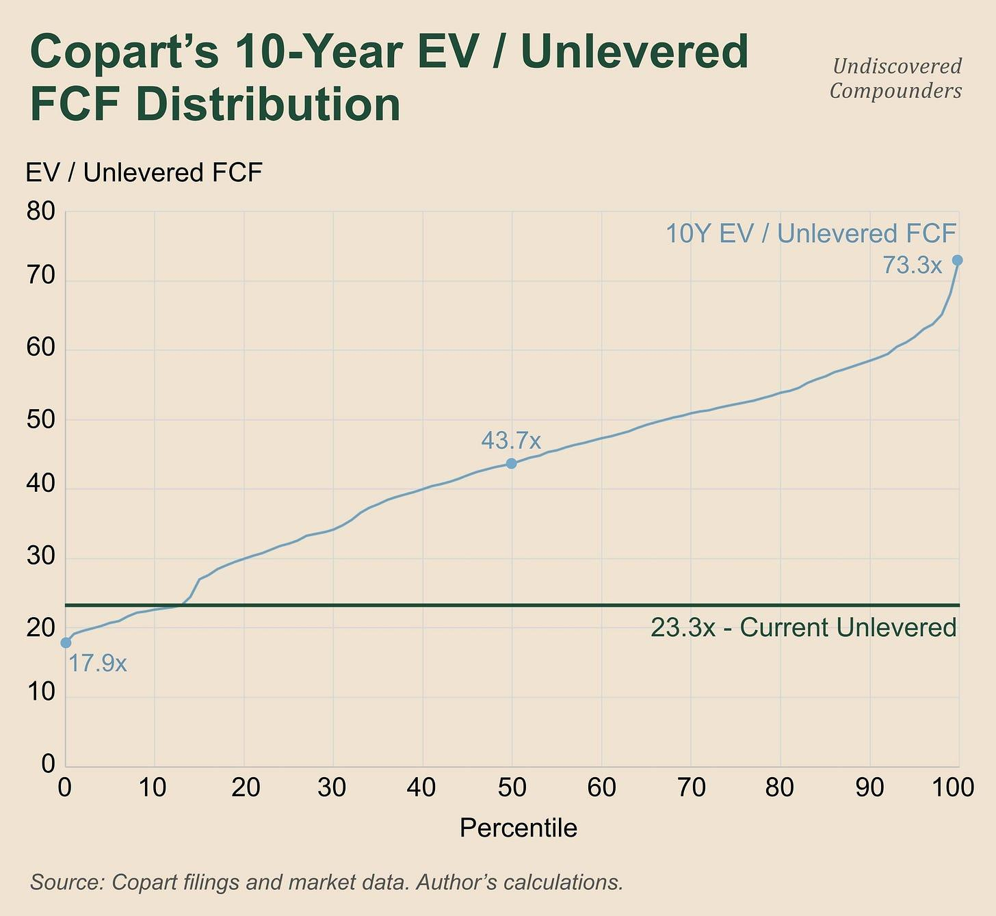

The median is 43.7x. The current valuation of 22.5x sits at the 9th percentile. The recent trough of 17.9x has become the low of the series. That seems relatively low to me for a company whose decline comes from a lower multiple tied to an insurance cycle and Copart’s unfavorable mix, both of which are very probably turning around.

Copart seems to agree, and has decided it’s worth spending its FCF and part of its cash to buy back shares at a pace never seen before.

But unfortunately, it’s more complicated than that.

12.1.2 The limits of EV/unlevered FCF

Unlevered FCF obviously accounts for capex. But capex can swing a lot depending on how much land Copart is buying. Even though Copart doesn’t give the precise capex breakdown, the pre-COVID period was more capex-intensive than post-COVID (the capex/revenue ratio drops by almost a third from FY16-20 to FY21-25; COVID muddies the numbers a bit). These swings weigh on the denominator, so EV/unlevered FCF probably won’t be comparable in 5 years to what it is today, or especially, to what it was 10 years ago. As it happens, this phenomenon tends to flatter current FCF.

Ok, you probably already know this: no valuation method is perfect and each comes with its own biases (all models are wrong, some are useful; I love that quote, it’s probably my favorite). So let’s try others.

I tried doing this using EBIT, but the new biases that show up are not only more numerous, but also more sensitive to assumptions. In short, it’s even worse. I tried a number of other valuation methods, they’re even worse than EBIT. Except one.

The best fit, in my opinion, would be EV/owner earnings (EBIT + D&A - maintenance capex). For that, I’d need to estimate maintenance capex for every year over 10 years. Unfortunately, management doesn’t produce it. Not once.

So I have two options:

Take one percentage and apply it across the whole period.

Dive back into every filing and arrive at a percentage from the few clues available.

Both would be a mistake for the same reason: the result remains very sensitive to the maintenance capex percentage, so I’m still stuck with largely the same problem as unlevered free cash flow. That rules out the single percentage outright, and it also seriously weakens the option of picking a percentage from filings and conf calls. What kills that option is the complexity of the task for a payoff that’s far from guaranteed. Worse still, it would make it harder for you to make the model your own and adapt it to your assumptions, wants, and fears. So the theoretically optimal solution isn’t the practical one.

Another stopgap solution: use a shorter period over which unlevered FCF looks, on average, a bit closer to what it’ll look like in the coming years. I tried it, but the value of each percentile shifts quite a bit depending on the period chosen, and even more so the shorter that period is (the fact that Copart hit its ATH and historically high valuations in 2025 really doesn’t help). In short, that’s not viable either.

So my solution was to keep EV/unlevered FCF, but offset the uncontrollable bias created by swings in FCF and capex spending with more conservative percentile choices.

So now you know the biases baked into the model’s overall structure. On to the method.

12.2 The valuation method

12.2.1 The construction

Here’s my thesis summed up in 5 points:

Copart’s apparent recent weaknesses, and the extremely low valuations that come out of them, are in large part cycle noise.

Growth over the coming quarters/years will be supported by a turnaround in the insurance cycle.

International insurance will support growth over the medium term.

M&A can happen at any point in the coming quarters and materially affect any of the growth levers.

Fears about long-term growth tied to autonomous vehicles are unfounded. That said, I have no certainty about how the TLF/ASP/accident-count dynamic will evolve over the long term/very long term.

The investment thesis is therefore to go long Copart over 2-5 years and bet on a multiple re-rating (which is where most of the potential performance will come from).

The framework is therefore an easy pick:

A 5-year projection with an exit multiple and an IRR.

The 3 usual Bear/Base/Bull scenarios.

An IRR weighted by their probability.

No. Not a full year-by-year DCF with figures down to the cent. As always, I prefer to limit assumptions wherever I can. And given the uncertainty surrounding Copart, not only can I, I have to.

This projection will be based on the two variables from 2.1: Units × RPU, which I’ll convert into EBIT using the tools from 7.4:

Units, split into service/buy-and-resell and US/international.

RPU gets its own incremental margin. An incremental dollar of RPU doesn’t require any additional towing or storage, after all. So I keep the promise from 7.4.3 (I know, you’ve forgotten what that is, but it’s there to show that this whole deep dive was built with the valuation in mind).

Inflation applied to G&A and half of site costs, which I treat as fixed (still the same assumption from 7.4, and still the same wet finger in the wind).

The corollary to all this is that I set operating margin aside. 7.4 already directly accounts for operating leverage, based on Copart’s own numbers. It would make no sense for me to layer my own assumptions back on top of that. Same logic for capex, which simply follows revenue (with the $230M maintenance-capex floor seen in 7.5; as a reminder, I took apart the argument that capex slows down and frees up cash in that same 7.5, so don’t accuse me of being too conservative here).

One small subtlety: my coefficient for converting a unit point into EBIT is denominated in dollars. Obviously, that number grows as the company grows (6x in 16 years). So I converted these dollar amounts into percentages of EBIT. It’s a simple transformation to adapt the tool that let us understand the present so it can also model the future.

12.2.2 The false sampling bias

The big criticism you could level at this model is that it uses Q3-26 TTM numbers to build coefficients that then help model the next 5 years. That’s a sampling bias that could, in theory, completely change the valuation’s results.

That was, in any case, the first criticism that came to mind when I built these coefficients. To be completely honest, when I wrote my first draft of section 7, I only thought these tools would help me analyze the recent/current situation. I wasn’t planning on using them for the valuation at all.

However, it turned out the sampling bias doesn’t really show up in practice. I redid the same model using FY25 numbers and the smoothed numbers from the last 2 and 3 FYs, and, much to my surprise, the results didn’t really change (I won’t get into the details, it’d be a shame to spoil it for you).

I ruled out smoothing over a longer period from the start, to avoid drowning the recent underperformance in the better longer-term performance, especially if, as I assume, cyclicality has a significant impact on recent performance. That’s actually the reason I decided to use the latest quarter on a TTM basis.

But it’s still a judgment call, and an important one. I’ve laid out my method for calculating these coefficients, and they’re inputs in the model. If you’d rather smooth over a longer period, you just need to run a few calculations and change the model’s inputs. The model was built to allow for that. Go for it.

12.3 The variables

6 big variables in total, each broken into 3 flavors (bear/base/bull), with explanations each time. They’re ordered by how they feed into the final result (what creates the flow, what the market pays for that flow, and how Copart allocates its capital).

Everything else is spelled out in the model. If you have a question I haven’t answered here, the answer is probably in the model (still with the goal of not writing a deep dive with a 6-figure word count).

Here we go.

12.3.1 US units

US units account for 82% of global units, and insurance makes up about 80% of that. As a reminder, one point of US units = $26.5M of EBIT, or 1.6% of total EBIT.

All that’s left is to assume the annual unit growth rate over 5 years.

Bear: Not only do the insurance PIFs that make up Copart’s mix fail to return to growth, but Copart also keeps losing volume on top of that. I modeled this with unit declines of 2.5%/year for 2 years (despite the starting growth rate already being negative) and zero growth over the following 3 years. This scenario has never happened in Copart’s history, not even close.

Base: The insurance cycle keeps up its recent shift, but modestly, and taking its time. 0% in FY27 and +2.5%/year after that.

Bull: The insurance cycle also shifts, faster and stronger: +3% in the first year and +4.5% after that.

Quick sanity check just in case: TLF has gained 0.75 points/year over 10 years, or +3.2% unit growth/year on the current base (extrapolating from insurance). If you strip out the erosion in accident rates, about -0.22%/year, you’re left with +3.0%. I set +2.0% in the base case (smoothed over 5 years). So my central scenario runs 1/3 below the decade-long trend, despite the potential tailwind from the insurance cycle turning around (which plays out fully in the bull). This extra conservatism ties back to my promise to shift the uncertainty from risks I can’t model into assumptions I can. Whenever you find me too conservative, this is the reason (maybe it’s a personality trait, but at least in this deep dive I have an “excuse”).

At no point do I assume Copart wins back volume lost to IAA; otherwise, bull-case growth would be much higher, at least for 1 or 2 years. But that’s more an excess of realism than anything else. If Copart does win back volume it lost at Progressive, that will probably play out after these 5 years.

On top of that, I set the US whole car segment aside, despite the CEO himself talking about a complete overhaul with results expected by spring-summer 2027. The impact will very probably not be decisive for my model or for Copart in general, but happy to be surprised.

By the end of the 5 years, US units will have reduced EBIT by $130M in the bear, added $308M in the base, and $736M in the bull. As a reminder, EBIT stands at $1.7B today.

On to the next one.

12.3.2 International units

The remaining 18%. They obviously weigh a lot less on EBIT: 1 point of international units = $4.2M of EBIT (0.25% of the total, six times less than a point of US units). The impact on the thesis is clearly minor.

As a reminder, this is one of the CEO’s growth legs, one that’s already seen investment over the past several quarters.

Bear: +2.5%/year. Nothing the CEO promised happens. No drastic change. Worse, growth slows down. Very little conversion to the service program where it’s possible. In short, a total failure of this growth leg in the CEO’s plan.

Base: +5.5%/year. That’s slightly below the recent pace. You can’t call the CEO’s plan a failure for lack of evidence, but it’s clearly not a success either.

Bull: +8%/year. PIP conversions go well (especially in Germany), and the investments Copart made over the past few quarters bear fruit (nothing exceptional here either). In short, the CEO’s plan more or less worked. Cases where a new market becomes accessible or shifts to the service program could also explain this 8% (though clearly less likely).

By the end of the 5 years, international units will have added $49M of EBIT in the bear, $130M in the base, and $219M in the bull.

12.3.3 Revenue per unit

Now we’re getting into the subtle part. This variable actually contains two: ASP and mix through pricing. As a reminder, fees on the seller side (insurers) are mostly proportional to the sale price, while on the buyer side fees shrink as a proportion of the sale price (the convex curve from 2.11; the higher prices go, the smaller the fixed-fee share gets and the closer fees get to being proportional, and vice versa). That’s what keeps this variable from collapsing when everything goes badly and from soaring when everything goes well.

As a reminder, an incremental dollar of RPU costs almost nothing, because the fixed costs are already paid for (in theory; in practice I’ll still assume a 5% incremental cost for potential marketing or other incentives). All of that holds for the service program (consignment + PIP, since they share the same fixed-cost logic). It’s different for buy-and-resell: if RPU rises because of ASP, it’s very likely that it also costs Copart more to buy. In those cases, the relevant incremental margin is gross margin, at 11%. So all of this needs to be weighted to get the final coefficient. Buy-and-resell makes up 14.6% of revenue, and service (consignment + PIP) the remaining 85.4%:

0.854 x 0.95 + 0.146 x 0.111 = 0.83

RPU growth converts through to EBIT at an 83% incremental margin. I’ll only count 80% just in case.

On to the scenarios. Here, an enormous number of variables affect it, so assuming one concrete scenario doesn’t really make sense. I’m basing this on quarterly RPU changes since 2023. As a reminder, this is mainly where a potential international demand shock from a strong dollar would show up, so I’m going to be particularly conservative on this variable.

Bear: -1.5%/year. Below the worst reading of the last few years.

Base: +3.5%/year. Slightly above the 1st quartile.

Bull: +7%/year. Slightly below the 3rd quartile.

By the end of the 5 years, revenue per unit will have taken out $265M of EBIT in the bear, added $729M in the base, and $1.65B in the bull.

12.3.4 Costs

Here too it’s a two-step process: cost increases in percentage terms that I then translate into EBIT.

This variable captures inflation in G&A and half of site costs, which I treat as fixed:

4.5%/year in bear,

3.75%/year in base,

3%/year in bull.

And that’s it. The other half of site costs varies with volume, so it’s already captured through the first two variables.

To translate this into EBIT, I have to account for the fact that these are percentage changes. So I re-derive the coefficient every year with this formula: (EBIT + G&A + half of site costs) / 100.

More concretely: one point of units is worth 1.81% of EBIT today, 2.55% by year 5 in my bear, and 1.40% by year 5 in my bull.¹⁵⁰

The most attentive of you will notice that the bearish scenario worsens on its own, even though my assumption hasn’t changed between year 1 and year 5. That’s the elegance of the trick: it models the operating leverage that disappears as revenue falls (something a lot of models tend to forget).

There’s still one small... inconsistency left. In my bear, EBIT loses $673M over 5 years. Of that $673M, units account for $81M, RPU for $265M, and cost inflation for $327M. So half of the drop in EBIT comes from management continuing to pay ever-pricier bills while its business shrinks (G&A goes from 9% today to 12.3% by year 5; from 41.5% to 50.6% for site costs, as a percentage of total revenue).

But you’ve read 7.3 (you have read it, right?), and you know that the one time two consecutive fiscal years were bad (FY13 and FY14), management turned off the tap and G&A fell 15.5% the following year (FY15). Adair was already there at the time, so assuming he still knows how to turn off the tap if needed doesn’t seem like too much of a stretch.

But, once again, I account for the uncertainty of unmodelable risks by being more conservative on the ones I can model. So I leave it as is. I’d be lying if I said it wasn’t also out of a love of simplicity.

In FY15, management reduced expenses by cutting head-office costs that had risen largely because of the Brazil expansion it had just started. Now, G&A has risen 60% over the last two years, which probably leaves management some room to cut costs if needed (it’s easier to cut right after you’ve increased spending). I note it, but I do nothing with it. Let’s not make life complicated over a few tenths of a percentage point on a single variable.

12.3.5 The exit multiple

12.3.5.1 The values

As a reminder, this is the big variable in this whole story. For more detail on why I chose EV/unlevered FCF, you can go back to 12.1.

Today, the market values Copart at 22.5x, or the 9th percentile.

So once again I’m basing this on the historical trend:

Bear: 17.5x. Below the lowest value in the series, which is 17.9x (July 21, 2026).

Base: 37.9x, the 35th percentile, below the median.

Bull: 50.9x, the 70th percentile, below the third quartile.

To be explicit:

My bear case implies that in 5 years Copart will trade cheaper than on any single trading day of the last decade.

My base case implies that in 5 years the market will pay less for Copart than it did on 65% of trading days over the last 10 years.

The bull case follows the same logic, but for 30% of trading days. You get the idea.

The base-case multiple alone corresponds to a 68.3% increase over 5 years, or 11%/year.

Besides its enormous weight, the multiple has another characteristic the other variables don’t have: the time horizon.

12.3.5.2 The multiple’s time horizon

A multiple 5 years from now largely reflects the company’s economic health at that point, giving significant weight to its recent performance (narratives drive prices), but it also factors in what investors expect for the years after that.

Setting a multiple in the model 5 years out therefore means having a view on the company 10 years out. Hence the importance of having an opinion on the long-term trend of the TLF/ASP/accident-count dynamic.

Even though the recent price drop was caused by present, local variables, that doesn’t mean resolving them will lead to significant outperformance. Betting on Copart the way I’m modeling it also means betting on Copart 10 years out (that’s true of any model where the multiple is the main variable). That’s actually why this deep dive is so long.

12.3.6 Capital allocation

One big acquisition? Several smaller ones? Dilutive or accretive? Or instead, a focus on buybacks? How many shares bought back at what multiples in each scenario?

And yes, here too the scenarios are numerous. So is the number of assumptions needed to go with them. And once again, the possibilities range from everything to nothing.

I’ll pull out my usual heuristic: simplicity + conservatism. Guess what I did.

Everything stays in cash. I didn’t even bother assuming a different interest rate.

Concretely, net cash goes from $4.2B today to $9.4B in my bear, $13.1B in my base, and $16.3B in my bull. It compounds at 4.2% pre-tax and exits at book value. No buybacks, sure, but I did model 0.4% annual dilution from management compensation, in line with the recent trend.

This capital-allocation choice can be very costly: buybacks made at the right multiple, a solid acquisition, etc., and the weighted IRR can climb several points. The CCC acquisition could almost justify a bull case all on its own. But that’s exactly the problem, you can assume just about anything to justify just about anything. The only choice that was roughly viable was to do nothing.

It’s probably the most conservative choice in this whole valuation, especially for a compounder with this kind of capital-allocation track record. So be it.

12.4 The final table

Here it is.

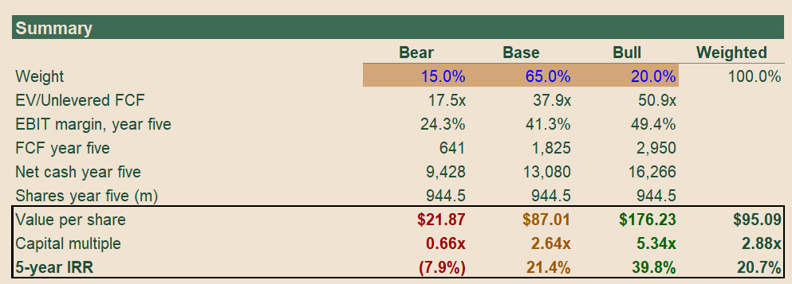

As a reminder (especially for those who scrolled straight down to here): the assumptions in my scenarios are probably more conservative than reality will turn out to be. There are two reasons for that:

Because my goal isn’t to be right, it’s to hurt as little as possible when I’m wrong.

Because Copart gives us very little information. Out of that general silence come two types of uncertainty: the kind I can model, and the kind I can’t. In the second case, I shift that uncertainty into more conservative assumptions on the variables I can model.

Keep that firmly in mind as you read and interpret every number I’m about to give you.

My bear loses you 34% over 5 years. +164% in my base and +434% in my bull.

My probabilities for each scenario are 15% for the bear, 65% for the base, and 20% for the bull (if this were a continuous distribution, that 65% base-case weight would lean more toward the bull side). All told, a weighted IRR of +20.7%.

I obviously can’t give you a mathematical formula that would get you to these weights. They’re the product of hundreds of hours spent analyzing Copart: understanding its business model, its history, its industry, its current situation, its moat, etc. The only thing I can do is explain my reasoning and what supports it from A to Z. Hence these 55k words.

To finish, I usually run a quick check to see what returns look like if I freeze the multiple: -5.2% in bear, +11.7% in base, +21.5% in bull. Weighted, +11.1%. Risk goes down, and so does reward. Makes sense, the multiple has a huge impact on the valuation. But from a risk/reward standpoint, this remains comfortably acceptable.

That leaves the breakdown. Here’s the impact of 4 variables on the results:

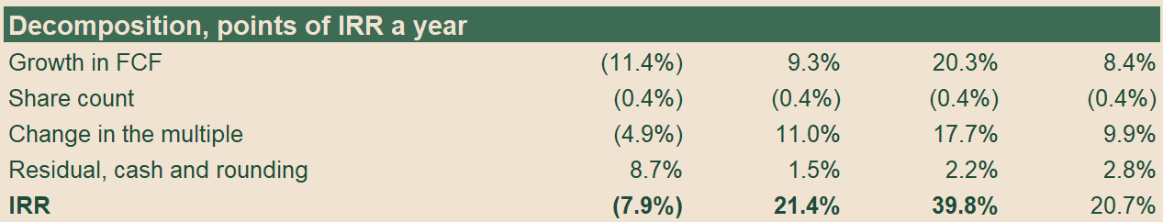

FCF growth is the sum of 4 variables: US units, international units, RPU, and cost inflation. It’s this growth that drives the bear case; makes sense, since the multiple is already low there. Conversely, the multiple has an even bigger impact than FCF growth on the base, and does a lot of the work in the bull case.

One small subtlety in the bear case: cash accumulation is what saves the day. I could have assumed management wastes all that cash, but that would have turned the bear case into a doom case, the kind that lets you say no to absolutely everything. For the doomers out there who’ll say it’s possible management spends its cash on buybacks whose impact on FCF/share isn’t reflected in the share price, you’re right. That’s theoretically possible. In that case EV doesn’t move, and neither does the multiple. So the bear case gets even more bearish if management buys back heavily with no effect. That’s true, but in that case the IRR only drops by 0.9 points (80% of all its FCF over 5 years spent on buybacks at a fixed multiple). Aside from being very unlikely, it doesn’t change the thesis.

However you look at it, Copart, at this price, looks like an attractive opportunity.

12.5 What I’ll be watching

In order:

US insurance units excluding CAT. This is the main metric for testing my countertrend thesis. It’s the heart of my thesis. I expect stabilization in FY27, maybe even a return to growth. If US unit growth still hasn’t shown its face by the first half of FY28, I’ll consider the thesis dead. Watch out for short-term noise. As we’ve seen, there’s a lag between insurance PIF growth and Copart’s unit growth.

Revenue per unit. Management doesn’t always give it. It does give ASP every quarter, though (which is the most important driver of RPU). There are two options. Either you use ASP as a proxy, or you calculate it the way I did in this deep dive: service revenue / units. This second method has the advantage of staying close to the figure management reports on the rare occasions it discloses it. That’s how I’ll track it. (Careful not to read too much into the noise on any single quarter.)

International units. This matters less in terms of raw numbers, but it also says a lot about how effective Adair’s strategy is, and it presumably raises the odds that they keep making good capital-allocation decisions.

US whole car, for the same reasons: whether management’s investments and the CEO’s word are actually worth something. As a reminder, he set his own deadline for spring-summer 2027: “I’d like to see that increase dramatically. To do that, we’re looking at restructuring [...] the goal is that it looks very different in three to four quarters.” (Adair, Conf Call, July 2026)

G&A in dollar terms. This is the only variable where management decides everything. A gap versus my own scenarios isn’t significant on its own. What matters is the reason Copart gives, if it gives one. Here too, it’s more a way of judging capital allocation than anything else.

Be careful not to over-interpret the next 2 quarters. If it’s an insurance cycle, it isn’t over. Even if it does turn around, it can take a few quarters before that shows up clearly in Copart’s numbers. Being contrarian requires a certain tolerance for uncertainty. But that seems to be a necessary quality for being a Copart investor.

There are 3 things that would make me sell Copart almost instantly:

No growth in US insurance units in the first half of FY28, or a return to declining PIFs among the big insurers that make up most of Copart’s mix (very probably GEICO, Allstate, etc.) in H2-FY27.

A very large acquisition that fails to deliver on its promises.

One of the rare but very high-impact risks mentioned in section 11 actually materializing (the CEO’s death, a lasting problem on the VB3 platform, the dollar surging for more than a year, etc.)

Obviously, I’ll be watching all of this very closely and will keep you regularly updated.

Subscribe

It’s high time to wrap up.

13. Conclusion & Disclosure

I think I’ve managed to show that Copart is a wonderful company at a wonderful price. I’ve laid out my thesis point by point, giving you every link in my chain of reasoning. Every number. Every assumption.

I’ve obviously put my own money behind this thesis. It’s still a small position (<5%), and it’s made up entirely of LEAPS options that I roll over as long as the thesis holds. So it’s a position with roughly 3x built-in leverage. I’m ready to add to it as long as the price keeps falling and nothing invalidates any part of my thesis.

To wrap up: why Copart?

I don’t like to label myself, but I’d be lying if I said I don’t have a soft spot for really great companies at good prices. In my view, opportunity cost is my worst enemy, and if I’m going to make a bet whose cost depends directly on time, I’d rather bet on excellent businesses where time is an ally.

I’d already been watching Copart for a while, but to be honest, it was mostly out of curiosity. I didn’t think I’d see prices like this again, at least not prices that would interest me given my focus on small caps. But Mr. Market decided otherwise.

And here I am, a month and a half later, after hundreds of hours of work, writing this conclusion. It’s going to feel strange not living and breathing Copart all day and dreaming about it at night.

This quote resonated so much with what I expect from management that I couldn’t leave it out.

“I think, one, Wall Street’s fickle, two, I never like to predict what investors are going to do and how they’re going to think. I think they’re hearing a narrative, potentially that’s out there in the industry, potentially from a competitor. There’s always two sides to the story. At the end of the day, we’re a phenomenal company. We’ve got amazing people. We’ve got phenomenal relationships with our customers. We’re going to do what Copart has always done. We’re just going to execute. We’re not going to talk about it. We’re not going to tell people what we’re about to do. When we do win, we’re not going to tell people that we won. We’re just going to do it. Let the results speak for themselves.” (CEO, July 2026)

Not bad, huh?

If this deep dive was useful to you, send it to someone who might enjoy it too. Nothing helps this work more than being shared/restacked.

Share

My next deep dive is already underway. Small tease: it’s my second-largest position.

In short, it’s an early quality compounder riding several megatrends, and it just retraced almost 50% (the price was too high). That’s exactly why I’m only talking about it now. This will be fun.

In the meantime, here's a deep dive on my biggest position:



30% of my portfolio is in this company: revenue and EPS up 3x in 3 years, trading at 12x EBITDA, 50% below peers.

Undiscovered Compounders

·

Jun 6

Read full story

Take care,

Flo

Subscribe

1

US Department of Justice, 28 CFR 25.55.

2

Kelley Blue Book, vehicle values FAQ.

3

NAIC, private passenger auto market share data, 2025.

4

Willis Johnson, Junk to Gold (2014).

5

Willis Johnson, Junk to Gold (2014).

6

IAA, 10-K for fiscal 2019.

7

Transportation Today, 15 December 2025, citing BofA and JPMorgan notes.

8

Abetter.bid, registered broker terms and conditions, October 2022.

9

Mexico, decree regulating definitive imports of used vehicles, 2008.

10

FASB, Accounting Standards Update 2024-03, November 2024.

11

Ohio Administrative Code 4501:1-4-04.

12

Author's survey of eleven municipal zoning codes, July 2026.

13

California Vehicle Code 1671(b).

14

23 CFR 751.11.

15

MRSC, nonconforming use guidance, January 2024.

16

Harbison v. City of Buffalo, 4 N.Y.2d 553 (1958).

17

East Palo Alto city council, use permit revocation, July 2026.

18

Coweta County board of commissioners, rezoning denial, April 2019.

19

Willis Johnson, Junk to Gold (2014).

20

The Investor's Podcast, Clay Finck on Junk to Gold, January 2024.

21

Willis Johnson, Junk to Gold (2014).

22

Willis Johnson, Junk to Gold (2014).

23

Willis Johnson, Junk to Gold (2014).

24

Willis Johnson, Junk to Gold (2014).

25

Willis Johnson, Junk to Gold (2014).

26

Willis Johnson, Junk to Gold (2014).

27

Willis Johnson, Junk to Gold (2014).

28

Camden County deed records and local press, October 2023.

29

Gulfshore Business, December 2024.

30

The Real Deal, April 2025.

31

County deed records and local press, seven purchases, 2019 to 2025.

32

Matthews Real Estate, industrial outdoor storage sector update, March 2026.

33

Ascension Advisory, industrial outdoor storage pricing note, November 2025.

34

Logan Township zoning board, use variance, April 2026.

35

Insurance Auto Auctions, SEC filings.
Insurance Auto Auctions, 10-K for fiscal 2000.
Insurance Auto Auctions, merger announcement, February 2005.
KAR Holdings, 10-K for fiscal 2007.
KAR Holdings, 10-K for fiscal 2007.
KAR Auction Services, IPO prospectus, December 2009.
IAA, registration statement on Form 10, 2019.
Ritchie Bros Auctioneers, Form 8-K, March 2023.

36

IAA and KAR quarterly results releases, 2017 to 2023.

37

Luxor Capital, presentation to Ritchie Bros shareholders, February 2023.

38

IAA, 10-K for fiscal 2020.

39

IAA, fourth quarter 2022 results, February 2023.

40

RB Global, fourth quarter and full year 2025 results, February 2026.
RB Global, second quarter 2026 results and 2026 guidance, August 2026.
RB Global, share repurchase programme announcement, March 2026.
RB Global, second quarter 2026 results, 4 August 2026.
RB Global, second quarter 2026 earnings call, 4 August 2026.
RB Global, quarterly results releases, Q4 2025 to Q2 2026.

41

RB Global, second quarter 2026 earnings call, 4 August 2026.

42

RB Global, second quarter 2026 earnings call, 4 August 2026.

43

IAA, published buyer fee schedule.

44

Luxor Capital, presentation to Ritchie Bros shareholders, February 2023.

45

IAA, 10-K for fiscal 2019.

46

RB Global, 10-Q for the first quarter of 2026.

47

IAA, 10-K for fiscal 2019.

48

RB Global, 10-K for fiscal 2025.

49

RB Global, 10-K for fiscal 2025.

50

CCC Intelligent Solutions, Crash Course 2026, March 2026.

51

Bloomberg, 18 August 2026.

52

CCC Intelligent Solutions, 10-K for 2025.

53

CCC Intelligent Solutions, Crash Course 2026, March 2026.

54

CCC Intelligent Solutions, Crash Course 2026, March 2026.

55

CCC Intelligent Solutions, Crash Course 2026, March 2026.

56

CCC Intelligent Solutions, Crash Course 2016.

57

CCC Intelligent Solutions, Crash Course Q3 2025, September 2025.

58

CCC Intelligent Solutions, Crash Course Q3 2025, September 2025.

59

Focus Advisors, 2025 mid-year review, September 2025.

60

Repairer Driven News, March 2022.

61

CCC Intelligent Solutions, Crash Course Q4 2025.

62

CCC Intelligent Solutions, Crash Course, 2025.

63

CCC Intelligent Solutions, Crash Course 2026, March 2026.

64

CCC Intelligent Solutions, Crash Course 2026, March 2026.

65

CCC Intelligent Solutions, From Surge to Stall, May 2026.

66

CCC Intelligent Solutions, From Surge to Stall, May 2026.

67

Mitchell, Plugged-In, Q1 2024.

68

HLDI Bulletin 37-25, December 2020.

69

CCC Intelligent Solutions, From Surge to Stall, May 2026.

70

Thatcham Research, March 2026.

71

CCC Intelligent Solutions, Electric vs. ICE Vehicles, July 2022.

72

CCC Intelligent Solutions, From Surge to Stall, May 2026.

73

CCC Intelligent Solutions, From Surge to Stall, May 2026.

74

US Energy Information Administration, February 2026.

75

S&P Global Mobility, US vehicles in operation, May 2025.

76

S&P Global Mobility, average age of vehicles in operation, May 2025.

77

US Census Bureau, resident population.

78

Federal Highway Administration, vehicle miles travelled.

79

US Department of Transportation, crash data.

80

Verisk, ISO Fast Track Monitoring System.

81

NAIC, private passenger auto market share data, 2025.

82

Berkshire Hathaway, 10-Q for the first quarter of 2026.

83

Waymo, and NHTSA recall filings, 2026.

84

TechCrunch, July 2026.

85

Federal Highway Administration, vehicle miles travelled, and Waymo, 2026.

86

Waymo, safety impact data, 2026.

87

HLDI Bulletin 42-4, May 2025.

88

HLDI Bulletins 28-26, April 2012, and 42-4, May 2025.

89

HLDI Bulletin 42-4, May 2025.

90

Understanding AI, analysis of NHTSA standing general order reports, 2026.

91

Matthiesen, Wickert and Lehrer, automobile total loss thresholds, July 2026.

92

Nevada Revised Statutes 487.790.

93

Repairer Driven News, February 2026.

94

Texas Transportation Code 501.091.

95

Matthiesen, Wickert and Lehrer, automobile total loss thresholds, July 2026.

96

Repairer Driven News, April 2021.

97

Repairer Driven News, February 2026.

98

Repairer Driven News, February 2026.

99

DRG News, 24 February 2026.

100

Insurance Journal, 24 February 2026.

101

NAIC data via the Insurance Information Institute.

102

BLS, consumer price index for motor vehicle insurance, December 2023.

103

NAIC data via the Insurance Information Institute.

104

Progressive, 2025 annual report.

105

Progressive, first quarter 2026 shareholder letter.

106

Progressive, 10-K for 2025.

107

Progressive, 2025 annual report.

108

Berkshire Hathaway, 2025 annual report.

109

Carrier Management, May 2026, reporting Greg Abel.

110

RB Global, Conference Call, Q2-26.

111

RB Global, third quarter 2025 results, November 2025.

112

CCC Intelligent Solutions, quarterly claims data, 2025.

113

Two of the 5 total-loss-rate points used in my calculations can't be dated with certainty to a precise quarter using public sources. Cross-checking the data (sector + mix + lost account, resolved through the Copart/RBG comparison) brings the figure down to -1.9%. However, that figure comes from a smaller data sample over a period when values swung a lot. So it's more likely to be further from reality than my first estimate, which is why I'm sticking with the -2.7% estimate, based on more data. The 0.8-point gap between the two doesn't qualitatively affect the reasoning, as you'll see in the next section.

114

NAIC, private passenger auto market share data, 2025.

115

State Farm, 2025 results, February 2026.

116

BLS, consumer price index for motor vehicle insurance, June 2025 and April 2026.

117

BLS, consumer price index for motor vehicle insurance, April 2026.

118

Berkshire Hathaway, 2025 annual report.

119

BofA note, October 2025, and JPMorgan note, November 2025, relayed by Transportation Today.

120

RB Global, second quarter 2026 results, 4 August 2026.

121

Copart doesn't publish the number of cars it buys, granted, but it does publish 3 growth rates per quarter: total units, service units, and purchased units. Since total unit growth is obviously the weighted average of the other two, you can isolate the split. For FY25, the figures vary quite a bit, but taking the midpoint of the range gives 15% international growth in purchased units versus 4% US growth in purchased units. Weighting those growth rates by the geographic mix given further below (82.2% US and 17.8% international), you get: 0.15 x 0.178 + 0.04 x 0.822 = 0.0596.

122

Bloomberg, 18 August 2026.

123

CCC Intelligent Solutions, 10-K for 2025.

124

OPENLANE, Carvana and ACV Auctions, 10-Ks for 2025, and Manheim company information.

125

UK Competition and Markets Authority, IAA/SYNETIQ decision, March 2022.

126

CNseg, auto insurance penetration study, July 2026.

127

Autohaus, reporting on Copart Deutschland.

128

German Federal Court of Justice, ruling of 25 June 2019.

129

Bloomberg, 11 August 2026.

130

ACV Auctions, second quarter 2026 results, August 2026.

131

CCC Intelligent Solutions, first quarter 2026 results, April 2026.

132

CCC Intelligent Solutions, claims valuation product documentation, 2026.

133

CCC Intelligent Solutions, 10-K for 2025.

134

CCC Intelligent Solutions, second quarter 2026 results, July 2026.

135

Fehr and Peers, September 2018.

136

Fehr & Peers found in September 2018 that Uber + Lyft accounted for 1.0% to 2.9% of miles driven in 6 major US metro areas. Those six account for 8.4% of the country's miles (FHWA, table HM-71, 2023), which puts the nationwide figure at roughly 0.1% to 0.2%. Add smaller cities, where the rate is much lower, and Uber's growth since then, and you're still under 1%, probably well under.

137

Walmart, RFID mandate to its largest suppliers, 2003.

138

US Department of Energy, history of the electric car.

139

ICE US dollar index.

140

Federal Reserve, effective federal funds rate, 1981.

141

BLS, consumer price index, March 1980.

142

Plaza Accord, Group of Five finance ministers, September 1985.

143

ICE US dollar index.

144

ICE US dollar index.

145

Mexico, decree regulating definitive imports of used vehicles, 2008.

146

Ghana, Customs Amendment Act, March 2020, suspended September 2020.
Ghana Standards Authority, public notice on vehicle standards, August 2026.

147

European Union, end-of-life vehicles regulation, adopted 29 June 2026.

148

European Parliament, briefing on the end-of-life vehicles regulation, July 2025.

149

Brink's, settlement with the Department of Justice and FinCEN, January 2025.

150

One small subtlety: the unit point from 7.4.2 ($30.7M) was frozen based on today's EBIT. The underlying base changes every year, though, since it includes G&A and half of the site costs, which I do let evolve in the model. To stay consistent, I have to re-derive the coefficient at every step of the projection using the current year's EBIT: (EBIT + G&A + half of the site costs) / 100.

part: a wonderful company at a wonderful price (I bought it, of course)

It's not a small cap, but the opportunity is too asymmetric to ignore.
Undiscovered Compounders
Aug 29, 2026
Copart (CPRT.NAS) just lost about 50% over the past year, falling back to historically low valuations. I'm convinced the market is wrong, so I bought it.
Of course, you shouldn't invest based on my conviction alone (or anyone else's). That's why I'm giving you the entire thesis behind it: every source, every argument, every figure, every assumption, so that even someone who knows nothing about the company or the industry can form their own judgment. Better still, I built this deep dive so that anyone who reads it in full knows the company and its sector better than 99% of its shareholders.
Over 55k words, representing hundreds of hours of work. I'm also providing a fully built-out valuation model so you can easily plug in your own assumptions. Don't take my word for any of it. Check the work. Then check it again.
This is simply how I work. I take the "deep" in deep dive very seriously, and I respect my readers' intelligence and rigor. One small detail: this piece is entirely free. That's exceptional. Think of it as a preview of the work I deliver behind the paywall. I'm not going to market it; I'll let the quality of the work speak for itself. Let's get into it.
Subscribe
3 things before we start:
- All the sources/citations I don’t attribute by name come from Copart’s recent filings and transcripts. That way I’m not stacking four citations per paragraph and making the whole thing harder to read. When it’s really relevant, I’ll cite the specific filing/transcript.
- This email is a heavy one, so you’ll probably get a much better experience reading it in the app or on the website.
- A word of advice: we’re going to be together for a few hours, so you might want to grab a coffee/tea and a source of glucose. Your neurons are going to need both.

For those who'd rather start compressed, here's a 10-minute version of the most important bits. I can't compress the alpha any more than that.

0. Table of Contents
- The basics
  - The Copart model
  - The land, the crown jewels
  - The auction
  - Scale and pace
- The business model: both sides of the counter
  - The two main variables
  - Salvage vs. non-salvage
    - Vocabulary and logic
    - How it actually plays out
    - The impact of the salvage title
  - The seller who brings the cars
    - The seller typology
    - Properly counting supply
    - Properly qualifying supply
  - The particular paradigm of rental car companies (Blue Car)
  - The three contracts Copart bills the seller for
  - How an insurer account is won, lost, and split
    - Winning a contract
    - Losing a contract
    - The built-in symmetry
  - What the insurer decides
    - Repair vs. Totaling
    - The entire spectrum
    - Copart’s weapons
    - Pure sale vs. managed sale
  - The buyers
    - Buyer typology
    - The power of exporters
  - Cross-selling
  - The buyer fee schedule
  - The convexity of prices
  - Fees outside the auction
  - What the fee schedule can’t tell you
  - When Copart buys the car
  - What we know now
- The Lands
  - What a Copart site is
  - The permit vs. the land
  - What happens when you don’t own
  - Who built it, and when
  - The contract that drew the map
  - How Copart chooses where to buy
  - Recreating the land
  - CAT capacity
  - Making the land produce
  - The limits of the land
- The competition
  - Who the competitors really are
  - IAA
  - The two buyer fee schedules
  - Where the competition really plays out
  - How to measure a delivered outcome
    - Comparison between competitors
    - Comparing a single entity over time
  - The duopoly clients keep alive
  - The asymmetry of accounts
  - Competing with repair
- Total-loss frequency
  - The equation and its implications
  - Total Loss Share of Claim Count
    - The numbers
    - The trend
  - Repair and recovery
    - Global trends
    - Local trends
    - The consequences for the insurer
  - The marginal vehicle
  - Electric vehicles
  - The fleet on the road, and its accidents
  - Self-driving
    - Current scale
    - The clock
    - The self-driving car inside Copart’s machine
  - Legislation
  - The trend summed up
- The crux
  - A summary of the current situation
  - The clean series
  - The dislocation
  - Coverage
  - The carrier mix
  - What’s left over
  - Cyclical vs. secular
    - Prices
    - The Mix effect
    - The Progressive shift
  - Mr. Market’s timeline vs. reality
- The financials
  - A quick glance
    - The P&L
    - Balance sheet
    - Cash Flow Statement
    - How to read the numbers
  - Where the costs go
  - When the machine stalls
  - What one point of unit growth means for earnings
    - The logic
    - The formula
    - The complexity of the real world
  - Capex, and what normalization really tells us
  - A summary of the present and the recent past
- Capital allocation
  - What to do with each dollar
  - Share buybacks
    - The strategy so far
    - The 2026 buybacks
  - M&A
    - M&A history
    - A concrete example: Purple Wave
  - What will they do with future cash?
- The people
  - Who decides, under what incentives?
  - The incentives
  - Insider buying/selling
  - A retrospective on each tenure
  - Is management a moat?
- Future growth
  - A typology of growth
  - United States, insurance
  - United States, non-insurance
  - International
    - The current situation
    - The ceiling and the real source of growth
    - Non-insurance and the foot in the door
  - Growth and M&A
    - What money can buy
      - The US
      - International
    - CCC Intelligent Solutions Holdings
  - A summary of growth
- The risks
  - The existential risks
    - The TLF/ASP dynamic
    - The number of accidents
      - The current trend
      - The self-driving car
      - Everything else
    - The auction room
  - Non-existential risks
    - Competition
      - The near-to-medium term and the insurance cycle
      - The long term
    - Losing land in a closed zone
    - Key-person dependency
    - The CCC price tag
    - The return to managed sale
    - VB3’s single point of failure
    - CAT events
    - Legislation that closes a door
    - The DOJ
  - How I approach these risks as an investor
- Valuation
  - The heart of the matter: the multiple
    - The logic of the multiple
    - The limits of EV/unlevered FCF
  - The valuation method
    - The construction
    - The false sampling bias
  - The variables
    - US units
    - International units
    - Revenue per unit
    - Costs
    - The exit multiple
      - The values
      - The multiple’s time horizon
    - Capital allocation
  - The final table
  - What I’ll be watching
- Conclusion & Disclosure
I’m not a financial advisor and this isn’t financial advice. Your money, your judgment, your risks, your returns. The fine print here.

1. The basics

1.1 The Copart model
A car is involved in a severe crash. The car is towed to a suitable location. An adjuster assesses the cost of repairs and sends his report to the insurer. The insurer compares the estimate to the vehicle’s value before the accident. When the repair estimate comes back too high (generally > 70-80% of the value), the insurer decides not to repair the car. It declares the car a total loss, compensates the owner for its pre-accident value, and takes ownership of the car, which it then resells. The adjuster has done his job, the insured is insured, and the insurer is left with a two-ton wreck taking up space that it doesn’t know what to do with.
Copart’s business model is to arbitrage away as much friction as possible in this process. It picks up the crashed car wherever it is (at a repair shop, on the roadside, etc.) and tows it to one of its 281 sites. Once the car has been assessed and declared a total loss, it cleans it (apparently that’s very important), photographs it from 30 different angles, handles a bit of paperwork, and lists it on its auction platform. The buyer (very often an auto professional) could be in Dubai, in Vilnius, or just three kilometers away. Copart takes a fee from the insurer and from the buyer, and everyone goes home happy.
Copart has provided the capacity, moved the vehicle to its site, provided the land, prepped the car, handled the paperwork, published the listing on its platform, taken care of a bit more logistics, and there you go.
If needed, Copart offers a few additional services. It operates its own appraisal services (Copart Co.ai), its DMV processing services (title transfer, status filing with registration authorities, etc.) and a few other services whose objective never changes: making life simpler for everyone who needs to get rid of a vehicle.
Copart has two types of revenue from vehicle sales:
- Service fees, when Copart positions itself as an agent between a seller and a buyer ($3.97B in FY25, or 85.4% of revenue).
- Buying and reselling vehicles on its own account, often out of obligation ($0.68B in FY25, or 14.6% of revenue). Some service fees can still apply in this case, but they’re fairly immaterial.
More than 85% of its revenue comes from commissions on someone else’s property, and for that 85%, Copart carries neither the inventory nor the working capital that comes with it. The remaining 15% comes largely from how insurers operate abroad and from its own ability to take advantage of its highly liquid auction floor. We’ll obviously come back to all of this in depth.
Copart is a textbook example of arbitraging away constraints that bother everyone, pushed to the extreme over decades. That has made it an unavoidable player in the industry, and it remains one as long as incentives stay aligned.

1.2 The land, the crown jewels
A Copart site is a parking lot. A very large parking lot, and a well-maintained one at that: it’s fenced, drained, lit, and above all, full of crashed cars patiently waiting to be assessed, auctioned, or shipped. The latest 10-K counts 281 of them worldwide. In total, Copart operates “more than 21,000 acres of land globally,” owning more than 90 percent outright.
Copart is the dominant player in a de facto duopoly, and its main competitor is IAA (Insurance Auto Auctions). I’m saving why I call it “dominant,” how the duopoly came about, and why it’ll stay a duopoly for later.

1.3 The auction
Copart began selling cars on its own online platform in 1998 (that’s early, very early, 3 years after eBay) before going fully online in 2003. The platform is called Virtual Bidding Third Generation (VB3) and soaks up a good chunk of the group’s 1,000 engineers.
Like any auction platform, the first link in the chain is the seller, the one who has the car, so in most cases for Copart, the auto insurer. The seller has little involvement on the platform, often acting as little more than an observer. In most cases, Copart picks up the car, brings it to one of its sites, prepares the listing, and sells it (all of it governed by contracts of varying length).
The last link in the chain is the car’s buyer. It’s almost always an auto professional (dismantlers, repairers, exporters, dealers, etc.).
Both parties have their own fee structures that define the industry, but I’m saving that for the next part.

1.4 Scale and pace
Copart was founded in 1982 and has traded on the Nasdaq since 1994. The company’s founder, Willis Johnson (who started out in a junkyard in Vallejo, California), is chairman of the board. Jay Adair (incidentally the founder’s son-in-law) joined Copart in 1989 and was CEO from 2010 to 2022, then became CEO again on July 31, 2026. Jeff Liaw held the role in between (Adair co-led with Liaw from 2022 to 2024). This is the kind of company where there’ll be a lot to say about management and how it’s evolved over time.
But first, a little eye candy:
Revenue that’s 6x’d, net income that’s 10x’d, with 28% of shares retired along the way. Operating margin was 36.5% in the latest fiscal year, with $1.8B of OCF, and $4.8B of cash on the balance sheet with zero financial debt. The US accounts for 83% of revenue, and international markets for 17%. Small subtlety: foreign exporters who buy wrecked cars in the US to export them elsewhere count as US revenue. So the figure lies a little (but I forgive it).
Everything screams exceptional business. It’s a favorite of the quality-investor sect, and deservedly so.
Yet the company has been in free fall since 2025, down about 50% from its high, and back to historically low valuations: the theoretically perfect entry point for a quality investor.
The eternal question: at what price does the probability-weighted range of possible outcomes offer enough return relative to the risks?
First step toward answering it: the business model, and its many, many subtleties.

2. The business model: both sides of the counter

2.1 The two main variables
Revenue = Units x Revenue per Unit (RPU). The number of vehicles put up for sale, multiplied by what Copart collects on each one. Nearly everything else in this deep dive will help us understand, more or less directly, how these two terms move, why, and by how much.
In total, Copart remarkets roughly 3.5 to 4.5M cars a year. Most of that volume consists of salvage vehicles, meaning cars that, at some point in their life, were declared a total loss by an insurer, a rental company, a bank, etc., rather than repaired (they can still be in running condition). The salvage title is the official document issued by a state DMV (Department of Motor Vehicles) that officially recognizes the vehicle as salvage. Unit prices range from a few tens of dollars to several tens of thousands (and more for certain special vehicles), with most of the volume concentrated around $5-10k.
The second variable, RPU, is even more complicated. The fee schedule is public only on the buyer side. Everything on the seller side (so mostly insurers) is close to a closely guarded secret, both on Copart’s side and on the insurers’ own side. But you can manage without it. Keep in mind that RPU depends mainly on the Average Selling Price (ASP, the average price of vehicles sold on Copart’s platform): the higher the ASP, the higher the RPU, and vice versa. So note that a lower number of units paired with a higher ASP (and therefore a higher RPU) can be positive for Copart; that’s part of the essential subtleties to keep in mind.
These two variables (plus ASP) also depend on how the auto sector evolves globally, how the insurance sector evolves, and on macro conditions as well. This will actually be one of the key points of the write-up, and one of the bears’ big arguments. Sometimes wrongly, sometimes rightly. But one thing at a time.

2.2 Salvage vs. non-salvage

2.2.1 Vocabulary and logic
A DMV issues a title with “salvage” written on it. From that point on, the vehicle can no longer legally be driven. Yet a lot has happened between the accident and getting the title, and quite a bit more will happen after.
But first, a little vocabulary.
A DMV can issue 4 types of titles for a car:
- Clean -> No issues, or damage that stayed under the legal threshold set by the state.
- Salvage -> Total loss declared with damage deemed repairable. Registration stays suspended until a state inspector has personally conducted a thorough inspection to determine whether the vehicle can be driven: VIN check part by part against stolen parts, itemized invoices required for every part, before-and-after photos, etc. Nobody goes through this process for fun.
- Rebuilt -> A salvage vehicle that’s been repaired and inspected by the state, back in legal circulation. That said, insurers are less fond of this type of vehicle and sometimes even refuse to insure them.
- Nonrepairable/junk -> Deemed irreparable, never returns to circulation and in most cases goes off for parts.
The logic is simple. However, neither insurers nor Copart think about it quite the same way.
The insurer simply thinks in terms of repairing vs. totaling, based on economic arguments. The salvage/clean process only comes into play if there’s been a total loss.
For Copart, management talks about:
- Clean title -> Never declared a total loss by an insurer.
- Non-Clean Title -> Declared a total loss by an insurer at some point, whether because of an accident five years ago after which it was legally “Rebuilt,” or because of a recent accident that just resulted in a salvage title. This category obviously also includes nonrepairable/junk.
Enough theory, on to practice.

2.2.2 How it actually plays out
Most situations fit the following scenario:
- An incident damages a vehicle. The insurer decides whether to repair or total it before the question of a salvage title even arises.
- If it chooses to repair, the salvage question doesn’t come up and the car keeps its clean title and gets back on the road after repair, with no special inspection.
- If it chooses to total it, the insurer takes ownership of the vehicle (in the large majority of cases), and has a legal obligation to notify the National Motor Vehicle Title Information System (NMVTIS) within 30 days of the total-loss declaration.¹ If the repair cost exceeds a certain threshold of the Actual Cash Value (ACV), the insurer is required to request a salvage title from the DMV (which can take several weeks, even months). These thresholds are set state by state, we’ll come back to them.
So it’s the total-loss declaration that triggers the potential reclassification as salvage. This subtlety is essential, so let me restate it: the salvage-title question only comes up if the insurer has totaled the vehicle. (To be fully rigorous, that’s not always true. For instance, a vehicle can be automatically classified as salvage by the state even if the insurer hasn’t decided on the total loss yet. But those cases are too unusual to be relevant here.)

2.2.3 The impact of the salvage title
In practice, Copart handles a lot of salvage titles. To understand what that implies, let’s go back to the root of Copart’s business model: auctioning off vehicles that not many people want.
The salvage title is going to affect both sides. It’s going to make the price hard to “guess,” and it’s going to make sure fewer people want it.
On price. A salvage vehicle loses its standard valuation, literally. Kelley Blue Book (the car pricing guide consulted by pretty much every player in the US) stops publishing values for salvage vehicles and points to a case-by-case appraisal instead.² Pricing difficulty means arbitrage opportunity. To arbitrage, you need to be able to buy the cars, and that’s where Copart positions itself with its auction platform.
For buyers themselves, it’s very often a matter of law. In a majority of states, you need to hold a specialized license or go through a licensed broker to be able to buy salvage vehicles. It’s purely arbitrary: take two identical cars, with the same damage. One classified clean, one classified salvage. Everyone can buy the first one, while only a very small subset of buyers can buy the second. For nonrepairables, the number of players able to buy them shrinks even further.
Conversely, the US clean vs. salvage distinction doesn’t matter at all to a foreign buyer. This type of buyer thinks almost exclusively in economic terms (economic arbitrage is sometimes just legislative arbitrage in disguise, we’ll come back to it).
Before moving on to buyers, let’s look at sellers.

2.3 The seller who brings the cars

2.3.1 The seller typology
About 80% of the units that pass through Copart’s hands come from insurers and their policyholders. When I write “insurers,” think mainly of the big insurers with nationwide footprints. The top 10 biggest auto insurers together represent 75% of the market, with number 10 accounting for less than 3% market share.³ Each local branch of a big insurer has some discretion, but only some. At the group level, insurers tend to diversify by splitting volumes. We’ll come back to that later. The point to remember here: insurance = a few big clients, but where each big client has a branch-by-branch volume-allocation strategy.
Three sub-segments make up the remaining 20%, what management calls non-insurance:
- Blue Car. Blue Car consists of banks, rental car companies, and fleets. Picture a lender that repossesses a defaulted vehicle in rough shape and doesn’t know what to do with it. The poor thing sometimes even has to go pick it up from the impound lot. The friction is total. Fortunately, Copart has logistics and storage capacity inherited from its insurance business, and these players tend to end up in the same places as insurers (thank urbanization). So Copart took advantage of that to offer them its service, wiping out that friction entirely, to “recover vehicles they previously would have abandoned altogether.”
- Dealers, via Copart Dealer Services (CDS) and National Powersports Auctions (motorcycles, RVs, boats). A trade-in too old or too beat-up for the dealer’s lot goes straight to auction. This is mainly Buy Here Pay Here, meaning in-house financing for borrowers nobody else dares lend to, with the dealer repossessing the vehicle after payment defaults. The dealer hires Copart to auction off these repossessed vehicles on its platform. This is a channel Copart is increasingly opening up to independents and franchisees.
- Copart Direct, formerly Cash for Cars: the individual who sells directly to Copart because Copart makes that buyback simple. Once again, a reduction in friction.
CDS is the biggest of the three, and keeps getting bigger. That’s it, that’s about the only relevant piece of information an analyst has managed to extract from management on this topic. Get used to this pervasive secrecy. Copart has a culture of extreme discretion.
These players and the characteristics of their sectors (where the frictions come from) define the rules of the game for Copart. Obviously, a few important subtleties make those numbers harder to read and interpret.

2.3.2 Properly counting supply
Overall, Copart is at the mercy of supply more than anything else.
Insurers generally sign long-term contracts with Copart. Once Copart has signed the contract, it commits to handling future volume under the agreed terms, regardless of what the future brings. Apart from the occasional contract (re)negotiation, Copart has to handle whatever demand comes in, whether that’s the $250 carcass or the stolen car recovered after the policyholder has already been compensated to the tune of $40k.
In non-insurance, long-term contracts are much rarer, but Copart still remains limited in its choices. It does, however, have some discretion, which it exercises mainly toward one goal: no longer handling vehicles under $1,000, the true wrecks considered junk even by the used-car industry. The goal is to lower Units in order to raise ASP. Small spoiler: it pursues a similar strategy in its own buying-and-reselling business (where it still manages to scrape together a few commissions regardless).
That leaves the ultimate variable that does and inevitably will test Copart’s resilience: the weather. Not the mild autumn weather, the violent kind, several sigma out, that comes and destroys cars by the thousands (hurricanes, hail, floods, etc.), what the industry calls a CAT event (catastrophe event). During every CAT event, Copart’s supply (and the demand for its services: towing, appraisals, etc.) explodes. Copart needs to have the land, the people, and the logistics necessary to handle all of that.
This demand may be imposed, but it’s welcome. If Copart shows its insurer clients that it’s capable of handling the most extreme situations by recovering and selling cars faster, it shows them:
- that it lets them offload policyholders’ unusable carcasses,
- that it speeds up the process leading to the policyholder’s reimbursement (so the policyholder is less likely to switch insurers),
- that it lightens insurers’ balance sheets faster (where applicable).
Show insurers you’re capable of efficiently handling multi-sigma events, and they’ll love you for it. That’s actually a big part of why Copart is the leader of its duopoly, but one thing at a time.
CAT events have enough of an impact on Copart that they publish CAT-adjusted numbers, and it’s far from cosmetic: in Q2-25, US insurance shows +9% as reported and about +2% ex-CAT.
To sum up, reading the numbers on the supply side means accounting for CAT demand and its volatility. Other, more localized adjustments (over 1 quarter or a year) are sometimes necessary (adjustments too many people forget to make), but we’ll come back to that in due time.

2.3.3 Properly qualifying supply
Copart wouldn’t be Copart without its huge pool of buyers, which makes its marketplace very liquid and price-competitive. But I insist: the real bottleneck for Copart is supply.
No client exceeds 10% of consolidated revenue, even when revenue swings sharply. But that doesn’t mean supply is fully diversified: “a limited number of vehicle sellers historically have collectively accounted for a substantial portion.” The scarce resource for Copart is the seller. And in most cases, the seller is an insurer.
A supplier capable of delivering hundreds of thousands of vehicles a year? There’s only a finite number of them. Copart knows them all, they all know each other (quick anecdote: Copart once won GEICO as a major client because the CEO was friends with one of GEICO’s executives).⁴ It’s a small world where everyone knows everyone and everyone knows the reality of the industry: Copart has no single indispensable client, but it can almost never replace an insurer client that leaves.
(For those wondering, yes, some insurers have tried reselling their own salvage vehicles themselves, and thus competing with Copart. But “most vehicle sellers have abandoned or reduced efforts to sell salvage vehicles directly.” That’s a sentence in the past tense, and it’s already dated. My guess is that arbitraging away such a disruptive constraint requires a level of focus that doesn’t survive insurers’ limited capital and attention.)
One last subtlety I haven’t found anywhere else: management’s change in language.
When Copart discussed agreements in its 10-K, it only mentioned “insurance companies.” But since the 2025 10-K, management has referred to “an insurance company, fleet, financial institutions, and rental car companies and other vehicle sellers.” They even talk about “rental car companies.” You might find that trivial, but those who follow me on Substack or on X have seen me mention plenty of studies on the impact of language and word choice in official filings, and in particular, on how much it matters when the wording changes from one filing to the next.
That was in FY25, so that leaves us 3 quarters to check, doesn’t it?
I checked, and it doesn’t settle things either way. Over the first three quarters of FY26:
- non-insurance units declined 1.5%, 2.7%, and 1.4%,
- US dealer holds up (+5.3%, +5%, +1%),
- and Blue Car yo-yos (-1%, -11.8%, +4%, rental calendar effect in the first, repairs at rental companies in the second).
Part of that decline is a model change on Copart Direct, which we’ll talk about a bit further below. The rest has as many causes as it does channels, notably the insurance cycle, which we’ll get the chance to revisit many times over. To sum up, plenty of potential confounding variables, but the change in language is, in my view, a non-trivial piece of information (even if I’m unable to properly qualify or quantify it, future quarters and years will tell us whether I’m wrong).
Still, among all these suppliers, there’s one with its own logic, and the fact that Copart added it to its description of these agreements is fairly significant.

2.4 The particular paradigm of rental car companies (Blue Car)
For a rental car company, a vehicle is an investment that directly contributes to revenue. No cars, no revenue. It doesn’t need insurance; it self-insures through its own P&L and balance sheet. This subtlety has 3 consequences.
When one of these vehicles gets banged up, the rental company has no outsider to consult. It’s its job to decide whether to repair or get rid of the car. But that luxury comes at a cost: every day off the road is a day of lost rental income, so lost revenue. So when it compares the cost of repairs to that of totaling it (totaling, Copart’s hunting ground), the scale tips more and more toward totaling as time goes by. It might therefore want to replace the vehicle by totaling it even if it’s relatively lightly damaged. Put simply: the tipping point shifts further toward totaling for a rental company than it does for an insurer.
And that’s not all.
You’re a rental car company. You own vehicle fleets and rental counters. But you (generally) don’t have big specialized lots to store your unusable vehicles. And Copart “can provide them storage while we’re auctioning the vehicles” (CFO, fireside Baird, June 2024). That’s even, according to management, the most decisive argument for rental companies. Yet another edge that the land makes possible.
Last, processing speed. When the rental company’s vehicle arrives on Copart’s lot, it stands out from the other vehicles in 3 ways:
- Its overall quality is often far better than what you find on the lot.
- Copart doesn’t need to wait for the salvage title to send it to auction.
- Often, the rental company already knows what it wants to do with it.
In the end, a rental company’s cycle time on a car is much lower than an insurer’s: typically within 7 days (true for all non-salvage) versus 45 to 60 days for insurers just to get the salvage title. That gap ends up distorting performance metrics. In Q1-26, US cycle time fell -9% year over year. That could suggest better efficiency on Copart’s side, but it’s largely a reflection of the growing share of units coming from non-insurance, notably rental companies, and their shorter cycle time.
To sum up, rental companies are excellent clients for Copart, but only once they become clients.
Their freedom to repair or not means that sometimes they choose to repair (surprising, isn’t it). Worse, they very often have no contract with Copart unlike insurers, so they can more easily go to a competitor (IAA or local players like dismantlers). These are fairly volatile clients, with fairly volatile numbers. Blue Car ended Q2-26 at -11.8% despite growth in banks and fleets, which was completely offset by the drop in rental companies.
If you add in the cycles of Copart’s other clients:
- dealers, who depend on leasing cycles (clean cars flooding the market and competing with dealer trade-ins),
- the insurance cycle (insurance premiums rise -> policyholder coverage drops -> fewer policyholders -> fewer vehicles coming from those policyholders -> and so fewer vehicles for Copart),
it becomes clear that the various metrics (revenue included) can be fairly lumpy and create a lot of distortion and confusion for a reader moving too quickly.
Copart has recently focused on rental companies, notably by creating an industry executive committee (the Blue Car Advisory Board) that guided the build-out of functions specific to rental companies (and partly to non-insurance in general): intake, inspection, condition reporting, and arbitration. It’s a set of services whose goal is, once again, to reduce friction and push the client toward Copart.
Now on to the contract between the seller and Copart.

2.5 The three contracts Copart bills the seller for
Copart offers 3 types of contracts.
Consignment first. Copart sells the vehicle for a flat fee (the consignment fee) and bills for transport to its site on top, plus of course storage and incidental fees. The flat fee only covers access to the auction platform. Everything else is paid à la carte.
The Percentage Incentive Program (which the company abbreviates as PIP, and so do I). An insurer signs a contract with Copart, which commits to moving every vehicle the insurer recovers in exchange for a predetermined percentage of the sale price. Copart takes on towing at its own cost, sometimes at a loss on individual vehicles, but comes out well ahead overall. This is constraint arbitrage pushed to the extreme, with aligned incentives: Copart has every interest in pushing the auction price up if its compensation depends on the final price.
The purchase program. Copart buys a vehicle at a formula-based price indexed to its pre-accident value, then resells it for its own account. According to management itself, this program exists “primarily in the U.K.”
Two contracts out of three therefore leave ownership with the seller (what I’ll call the service program, vs. the purchase program). A vehicle under a consignment or PIP program never hits Copart’s balance sheet, and revenue is recognized when the auction closes, net (“not gross vehicle selling price”). The corollary is that everything that happens between the roadside and the auction hammer (towing, storage, paperwork, and listing) forms a single performance obligation, summarized in one accounting line. A line that makes up 85% of revenue. Calling that low granularity is probably an understatement, and that uncertainty will be a formidable opponent throughout this deep dive.
In the purchase program, the Copart-seller relationship is “very naturally adversarial”; value extracted by one is a loss for the other. Under PIP, both benefit from every extra dollar the auction brings in. That’s why Copart far prefers the PIP program for the majority of its clients, notably insurers. To the point that when Copart buys the vehicles itself, it sees that as “a transitional step over time to a consignment model” (except for individuals, as we’ll see later).
The idea is to buy in order to reassure the seller and show that the auction platform’s liquidity is enough for the car to sell at a good price, so it can later offer to move them to a different program. It’s a genuine commercial strategy that’s already proven itself, notably in the UK, and that’s playing out more recently in Germany. The one small problem is that the vast majority of them are insurers. You’d be hard-pressed to find anyone more conservative than insurers, most of whom were in business before your parents were even born (and probably your grandparents too). It’s a strategy that takes years, even decades, to put in place, but that stays profitable the whole way through.
That leaves the ultimate question: how much? What percentage, what flat fee, what schedule? No idea. Copart and its clients have every interest in keeping all of that “secret.” The only official piece of information worth anything is that agreements are “customized to each vehicle seller’s needs” (not exactly decisive either, huh). As for unofficial figures, the only one sometimes mentioned is 1-2% in PIP for insurers, but no doubt that’s where competition is fiercest for Copart, and figures can vary a lot from one client to another, one category to another.
That leaves the question of how to win a client and keep them.

2.6 How an insurer account is won, lost, and split
We’re going to focus on US insurers. First because that’s the vast majority of revenue, but also because the rules of the game barely change for this type of client.

2.6.1 Winning a contract
Forget RFPs. Here the sequence is more pragmatic, and it’s been the same for 30 years: a pilot on a limited scope, quantified proof of performance, and the client expanding the scope if satisfied.
Fireman’s Fund, then Farmers, then GEICO, etc.⁵ A few decades have brought some progress, though:
- Copart regularly benchmarks its insurer clients against each other, and quantifies what their own decisions cost them (for example, you’ll earn X% more on our platform if you total this type of vehicle more often at this threshold); that’s the advantage of accumulating a lot of data nobody else can accumulate.
- Copart brings its biggest US insurer clients together every year for its Insurance Advisory Board. Keep your friends close, your enemies closer, knowing that they’re sometimes allies, sometimes enemies.
Every signed contract wins a market. Every contract terminated or not renewed loses one. As for the scale of the market, the language has changed too. We’ve gone from “We typically contract with the regional or branch office” to “with the national, regional or branch office.”
But decision-making power is rarely at the local level. It’s headquarters that decides, and it has one objective: capture as much short-term value as possible without endangering long-term value. In practice: not giving all the contracts to Copart so it doesn’t become too powerful, even if that means signing contracts with IAA even when the deal is sometimes, objectively, less favorable (and vice versa). Simply the strategy of a player thinking 50 years out. It’s not a constant either. Copart and IAA are capable of converting an insurer to a single-source arrangement (notably smaller insurers). The logic still prevails at the scale of the insurance industry overall: the duopoly will stay a duopoly.
As for duration, that’s just as much of a mystery. “Many of our customers are under long-term contracts,” but neither the “many” nor the “long-term” is defined (CFO, fireside Baird, June 2024). Only the notice period is known, at 30 to 90 days depending on the case (an industry figure).⁶ Competition plays out mostly where there’s “the absence of long-term contractual commitments.”

2.6.2 Losing a contract
Copart has already lost clients, sometimes even big ones. Fortunately, here management gives a lot more information: “we aren’t in a position and generally don’t comment on individual accounts” (are you really surprised?). A few rare exceptions exist, notably during the July 6, 2026 call for the CEO transition (Adair, the founder’s son-in-law with 30+ years at the company who’s becoming CEO again): “There was an account that was lost in some ways,” then “in some ways, Copart chose not to do business.”
Why did the incoming CEO decide to talk about this client? Because it made a bit of noise, maybe even a lot.
At the scale of an industry, secrecy never really exists, and hallway rumors eventually make their way all the way to shareholders’ ears: Progressive, one of the auto insurers that’s been outperforming the market for a few years, reportedly moved entirely over to IAA.⁷ No doubt this rumor contributed significantly to the recent decline, which is why management decided to address it during the call. But the precision matters: Copart and the insurer reportedly had disagreements, notably on pricing, and the insurer decided to look elsewhere.
If true, this loss was partly a choice, and above all a way of showing the rest of the industry that Copart has limits on what it’s willing to concede to win a client. From a long-term perspective, that choice can make sense.
We’ll come back to this whole story in detail when we analyze the current bear thesis.

2.6.3 The built-in symmetry
Let’s sum up:
- Allocation happens market by market.
- It’s bidirectional (signing, termination).
- Insurers have a built-in incentive (but not a deterministic one) to split their volumes.
This structure creates a symmetry: what limits Copart’s ability to lose an insurer all at once also limits its ability to win one back all at once. Every win, and every loss, happens market by market, over several fiscal years.
The criteria that trigger a signing or a termination are the same. In FY25, in order of importance:
- return on salvage (profit above all),
- the range of services and their quality (e.g., processing speed),
- price of services,
- ability to absorb a storm (the 5-sigma event, their worst nightmare, which used to rank 5th),
- geographic coverage,
- analytical data.
That’s still management language in an official filing. What actually wins the battle, and how much it costs to compete, will be the subjects of the next two sections.
For now, let’s focus on the power insurers have that Copart doesn’t.

2.7 What the insurer decides

2.7.1 Repair vs. Totaling
The insurer’s logic is simple:
- Repair = Cost of the estimate + Cost of replacement vehicles + Storage cost at repair shops + Cost of the appraisal + Weeks of repairs.
- Total = Reimbursement to the insured for the car’s pre-accident value - what it nets back by reselling the wreck.
An insurer therefore generally chooses to total when the cost of pure repairs approaches 70-80% of ACV, the gap being offset by ancillary costs on one side and the carcass’s value on the other. Reality is a bit more complex, but we’ll come back to it later (5.1). For now, just keep the overall logic in mind.

2.7.2 The entire spectrum
How the insurer decides whether a car gets totaled or not, and whether the vehicle receives a salvage title, falls along a whole spectrum of possibilities (below the legal thresholds, obviously).
At one end of the spectrum, the statutory reflex. Several states impose total loss above a percentage of the intact value. In some cases, insurers have made it their own absolute line. It has the advantage of being simple: above it, everything is totaled, below it, nothing is.
At the other end, case by case. Each situation is evaluated based on repair cost, downtime, expected auction proceeds, etc. A complexity fairly typical of certain insurers.
Between the two extremes, a whole world of possibilities: “there’s a huge dispersion among insurance carriers today.” This dispersion also exists within a single insurer, from one region to another.
The total-loss rate therefore depends on which clients brought their cars in that particular quarter. One more variable that shifts the mix and makes reading the numbers a bit more complex. But it will be very useful to us for filtering out noise later.
Copart, however, doesn’t sit idly by.

2.7.3 Copart’s weapons
For starters, it knows the numbers and the various policies of its insurer clients very well: “by market, by carrier, we know their current total loss frequency thresholds” (CFO, fireside Baird, June 2024). Even insurers themselves don’t have as complete a view on this aspect of their own industry.
But above all, Copart is active. It’s capable of pushing insurers toward salvage rather than repair, all on its own. Try to guess how.
If you guess it, you’ve probably already understood a good part of Copart’s moat.
Last chance.
The resale price. If Copart is able to deliver higher resale prices for the same repair cost, the insurer will choose to total. For that you need a very liquid and very competitive auction platform, which is what Copart offers, with buyers in 160+ countries.
The logic is simple: the more cars Copart offers, the more buyers will go to Copart’s platform, the more competitive prices will be, the more money the seller, including non-insurance sellers, will make on resale, the more cars it will offer, the more cars Copart will offer, etc. This kind of positive-feedback-loop logic, which often resembles chicken-or-egg logic, is typical of certain wide moats (and of the finest companies this world has ever produced, in my humble opinion).
Is Copart satisfied with its clients’ numbers? No: “in many cases, we think they aren’t totaling enough vehicles.” At the same time, if it said yes, that would be the equivalent of saying “we’re capped on this segment.” But management went further: “to capture the economic opportunities related to optimizing total loss decision making” (2025 proxy). It even created new executive positions precisely for this. This is a significant strategy for Copart, and one that could support growth in the years ahead.
It has built the tools to do it: Pro Quote, which became Co.ai in 2025, is a suite of AI visual-recognition tools to quickly assess a vehicle’s damage and quickly determine whether it’s a total loss. It remains a decision-support tool rather than a decision-making one. Copart insists on this; understandably so, given that it’s a tool offered by Copart, which itself has every incentive in the world to push insurers toward totaling (but not to the point of trying to lie “too much” to its handful of insurer clients).
But even convincing them to total isn’t always enough.

2.7.4 Pure sale vs. managed sale
A car has been totaled and put up for auction on Copart’s platform. But who decides the terms of sale (reserve price, acceptance of the final price, etc.)? It depends.
If the insurer tells Copart “handle it, I trust you,” that’s pure sale. If the insurer decides the terms of the sale itself, that’s managed sale.
Overall, the trend is clear. Across Copart’s entire history, the transition has mostly gone from managed to pure, with a strong acceleration over the last 5-7 years. Big insurers generally sell everything through pure sale (except for a few rare exotic vehicles). The mix is a bit more volatile among smaller insurers.
This shift is essential. If everyone were on managed sale, you’d expect tougher sale conditions, which would dampen buyer participation, resulting in lower prices across the rest of the auction, so sellers get less, total fewer vehicles or send them elsewhere, hence fewer buyers, etc. The chicken-or-egg logic also works for negative feedback loops.

To sum up:
- The insurer keeps a certain amount of power over the two decisions that govern volume (total or not) and price (pure or managed sale).
- But Copart also has indirect power over these two decisions. For volume, by offering better prices and tipping the scale more often toward totaling. For price, by convincing insurers of the pure model’s superiority, evidence in hand, by letting the market freely do its pricing work.
Copart’s power over volumes and prices directly depends on its platform’s ability to be as liquid and as competitive as possible (on both the buyer and seller sides). That ability also depends on Copart’s ability to secure the right land in the right places to maximize the vehicle supply on its auction platform.
Notice how the elements that make up Copart’s moat are interdependent. As long as the moat’s foundation, meaning the quantity of land and its location, is preserved, the business as a whole will benefit from it, and the castle will most likely remain unshakeable.
It’s finally time to move on to buyers.

2.8 The buyers

2.8.1 Buyer typology
On the buyer side, buyers are abundant: the platform’s ten biggest buyers together buy “a low single-digit percentage of all the vehicles we sell at U.S. auctions.” That buyer base consists of thousands of “licensed vehicle dismantlers, rebuilders, repair licensees, used vehicle dealers, exporters,” with some participation from the general public at certain sites. In those cases, the individual has to go through a broker registered with the Registered Broker Program, or through a Copart Lounge that an existing member opens on their behalf. Obviously, this broker charges its own margin on top of Copart’s (for example “$299.00 or 5% whichever is greater”⁸).
Access to the platform itself is divided into tiers: Guest, Basic, Premier. The differences mostly come down to fee structures and quality of access, with a special mention for Premier members and their “complimentary safety vest (one per membership year) and water bottle” (the vest is really nice, that’s where Copart’s real moat lies). This hierarchy was long confined to the United States, but it has since been rolled out internationally, with a few subtleties. For example: “except for Copart U.K. where we offer only Guest, and Basic,” which I read as a sign of that market’s low maturity.
Among all these players, one stands out.

2.8.2 The power of exporters
All but one of these buyer types have just one role: extracting value by “touching” the vehicle (repairers, dismantlers, etc.). The exporter plays a different game; its goal is to arbitrage a vehicle’s value between two geographies. It’s a player that, all on its own, brings in other buyers who couldn’t otherwise have accessed the platform. For Copart, that’s an enormous pocket of liquidity it couldn’t get any other way, and one that reinforces its moat.
This arbitrage has two components: a direct price component and a market component.
On price. It’s simple purchasing-power arithmetic: the price of a new or used car relative to purchasing power is much higher in Eastern Europe or Latin America than in the United States. The wrecked vehicle therefore more easily becomes a rational alternative. This arbitrage is subject to legal rules. That’s clearly not the norm, but there is a significant precedent. In March 2008, a Mexican presidential decree restricted vehicle imports from the United States.⁹ The probability isn’t zero, but the potential damage is minimal: Copart’s buyer base is international, and a single country’s law probably won’t have a significant impact.
Obviously, there’s a floor: “You’re not moving a $400 vehicle that’s mostly just its metal” to the other side of the world. Below a certain price, freight costs more than the goods, and the vehicle doesn’t travel. Fortunately, this type of carcass represents only “a very, very tiny fragment of the value of Copart’s auction overall” (CEO, Q3-25).
In the end, about 39% of vehicles sold at US auctions go to an international buyer (measured via IP). In terms of price, “approximately half of our U.S. auction value is going to an international buyer.” That’s enormous. Copart wouldn’t be Copart without these exporters, and these exporters wouldn’t be these exporters without Copart. Here too, everyone extracts value at different stages of the chain, and everyone has an interest in keeping the chain going (what Charlie Munger would call a win-win-win).
This breakdown is essential to understanding Copart’s real diversification. On the books, revenue is recognized in the US. But more than one-third of the vehicles underlying that 85% of US revenue are driven by demand from abroad. International buyers have become increasingly important to Copart, even if the numbers don’t really reflect it. Yet the logic is logical.
Take a slightly dented car with a faulty airbag. In the US, this vehicle isn’t legally drivable. Restoring it involves significant repairs that aren’t very appealing on the US market. An exporter, by contrast, sees the opportunity to buy a car that’s undesirable in the US, but that needs far fewer repairs, or none at all, in other countries with less... restrictive legislation. Apply the same reasoning to the failure of certain costly electrical components, a seatbelt, etc., and you get a whole set of cars that have higher net value abroad than in the US, either because they need fewer repairs or none at all, or because repair costs are much cheaper abroad (notably for anything that involves a lot of labor).
To sum up, the international buyer tends to focus on vehicles with light damage (those barely qualified as total losses and still able to run; a faulty airbag, for instance), and this simple choice alone is enough to produce an average purchase price 38% higher than a domestic buyer’s (Q1-26).
But the exporters’ impact doesn’t stop there.
On the vast majority of vehicles sold, the second bidder is an international buyer. Exporters alone are therefore a category of buyer that drives up the ASP of all vehicles, including the ones they don’t buy. A US buyer therefore pays more for his car on average because an international buyer tried to buy it. A US seller therefore sells his car for more on average because a foreign buyer tried to buy it. Copart collects more fees, and the seller gets a better price and is more likely to come back (including, or even especially, insurers). Hence the enormous importance, for Copart, of having as many varied players as possible competing against each other. For starters, to get better prices on its platform, but also to maintain this effect if certain international channels get disrupted.
A recent example of this is the US-Iran conflict. Because of it, direct participation from buyers in several Middle Eastern markets fell sharply. Yet, adjusted for seasonality, US insurers’ ASP hit an all-time high. The gap was filled by Central Europe, West Africa, and Central America. No channel is irreplaceable, just as no buyer is.
Think of buyers as one giant market. Constant flows of buyers coming in and going out every year, with a few tens of thousands of new members made possible by the “tremendous creative destruction in the automotive rebuilding business.” In total, “300,000 paying registered members at Copart from virtually every non-sanctioned country around the world.”
300,000 is not bad. Next comes cross-selling.

2.9 Cross-selling
The crossover buyer is a member who arrives on the platform with the idea of buying a rental, bank, or dealer car, and who then starts bidding on insurance vehicles. Over the last three years, more than 30k buyers have come in through this door, with a large majority bidding on an insurance vehicle within their first 90 days (Liaw, Q3-26).
The journey isn’t very sophisticated. We’re far from dark patterns and multiple redirects designed to trap the buyer at their own expense: a Google search or a video, a first lot, then an expansion in concentric circles, from one model to another, then further and further out. Obviously, Copart spent nothing to acquire this member. It just sold a bank’s car, collected its fees on both sides of the counter, and gained a buyer along the way. It’s the best possible acquisition channel: it brings in money, without even counting the final sale.
Let’s temper that a bit. In their first year, crossover buyers “had purchased a total of 50 wholesale and 12 insurance vehicles” (FY24 shareholder letter). So that’s roughly 4 to 1. That’s not trivial, but it’s not a game changer either. (Let’s temper the tempering: the quote rests on a sample of one. I work with the scarce information I have...)
But times are changing, and the flows increasingly go both ways.
Starting point: the total-loss frequency is rising. More and more cars incorporate expensive electronic components, significantly raising the cost of repairs for the same amount of damage. Consequence: insurers’ cars increasingly resemble rental companies’ and dealers’ cars. Consequence of the consequence: “enhancing that mutual liquidity.” More liquid auctions = better prices = insurers sending in more cars, etc. I won’t walk you through the whole loop again (not this time).
Copart is obviously active in the process: the eternal texts, emails, SEO, notifications, etc. All the way to the architecture of the auctions: which lots are grouped together, in what order, on which platform, in order to bring the two vehicle worlds closer together. Might as well get some return on those 1k engineers. All of this is fairly recent; the CEO spoke of “a very specific tactical experiment” back in Q4-25.
How much does the buyer pay in all this?

2.10 The buyer fee schedule
Copart publishes its buyer fee schedules directly on its website.
A little guessing game first. In your opinion, on a wreck that sells for $500 at auction, how much does Copart charge in fees on top, as a percentage of the sale price, in the best case? I’m sure you’ll underestimate the amount, even after raising your estimate in light of my overconfidence.
Copart displays its fees, but you still have to do a bit of math yourself to get the total figure. Here are the variables the US fee schedule depends on:
- Non-clean title vs. clean. Non-clean means the vehicle was declared a total loss by an insurer at some point, even if since repaired and roadworthy, which corresponds to the majority of the cars that pass through Copart’s hands. It’s Copart that obtains this title on the insurer’s behalf, state by state, with rules that change at every border. We’ll come back to it later.
- Preferred pricing vs. Standard pricing. To qualify for Preferred Pricing, a buyer must have bought 25 vehicles totaling at least $75,000 over twelve months, across fewer than five bidder accounts (which covers roughly all of its professional clients). The few who don’t meet these criteria fall under Standard Pricing.
- Secured payment (debit card, wire transfer, etc.) vs. unsecured (credit card, Apple Pay, etc.).
- Live bidding vs. an advance limit order. $10 more for live bidding, regardless of the lot’s price.
The all-in total = buyer fee + virtual bid fee (indexed to the bracket and the method of purchase) + gate fee ($95) + environmental fee ($15).
Answer to my guessing game: 62% in Copart fees for a $500 vehicle, and that’s only on the buyer side. At $250, a Standard buyer pays more in fees than the price of the carcass itself, without even counting shipping fees.
The all-in total below adds up the four line items for a non-clean-title vehicle, an advance limit order, and secured payment, at both pricing tiers.
(Note that Copart also offers auctions for lots at $50 and under. That’s literally scrap metal that very often goes to a local buyer, and for which Copart drastically lowers its buyer fees to make the segment viable.)
The initial values may come as a surprise, but the trend is typical: the higher auction prices go, the lower fees become as a percentage of the total, while the absolute dollar amount keeps rising. What’s much less typical is the magnitude, and its specifics:
- Between $10,000 and $15,000, the buyer fee is a flat $1,000. The rate drops from 12.5% to 8.7% without Copart collecting any additional buyer fee. As we’ll see, that’s a blessing in disguise.
- Above $15,000, the grid becomes a hard floor. 7.50% of the price + a fixed $250, 6.00% under preferred pricing. Past this threshold, Copart becomes an ad valorem tax.
These remain catalog rates. You can’t deduce Copart’s revenue from these figures. The most important point is that the fees actually paid by buyers very probably fall near the bottom of the displayed fee range. Any model that doesn’t at least target that bottom is objectively too... optimistic. Conversely, any model that only accounts for variable fees (buyer fee) completely misses how the model works (I’ve seen several analyses do exactly that).
Yet a $500 car, in practice, looks a lot like a $5,000 or $30,000 car. And yet Copart’s fees can differ by 10x from one to the other. Let’s dig in.

2.11 The convexity of prices
Take a nice little wreck that sells for $5,000. The used-car market drops for whatever reason suits you, and that same little wreck sells for $4,000, a 20% drop. Only Copart’s buyer fee is affected (the rest is fixed), going from $650 to $600. The all-in total therefore goes from $870 to $820, a 5.7% drop.
Most salvage vehicles fall within a $2,500-15,000 range. In that range, the elasticity of revenue per unit to the sale price is on the order of 0.25-0.35 on the buyer side. If, by magic, the Average Selling Price (ASP) drops 20%, revenue per unit will only fall 5-7%. A Copart analysis that reflexively assumes an elasticity of 1, and figures that an X% drop in ASP lowers revenue per unit by X%, is off by a factor of 3-4 in Copart’s average price zone. Yet management spells it out itself: “we also share in a very small portion of that incremental proceed” (CEO, Q3-26).
If I take the total fee values as a function of the car’s price and plot that on a graph, I get a convex curve. This convexity has two important consequences.
I haven’t found this convexity math in any other Copart writeup, sell-side included. I told you, I take the “deep” in deep dive very seriously. If you do too:
Subscribe
First, mix matters far more than ASP. A hundred $250 wrecks represent $25,000 of value passing through auction, from which Copart collects $21,000 in fees. A single $25,000 vehicle generates only $2,125 in fees for Copart. That doesn’t mean Copart would benefit from selling only scrap, and above all it says nothing about its growth. It simply says that RPU is driven far more by the price distribution than by the average price, and so a model built on an average ASP is chasing the wrong variable. Put differently, in terms of buyer-side revenue, Copart is structurally short the used-car price: the more used-car prices rise, the less it earns proportionally (but careful, more cars at a lower ASP require more towing, more yard space, etc., so this doesn’t imply that operating income increases).
Second, the top of the curve is capped. Above $15,000, Copart’s fees turn into a 6 to 7.5% ad valorem tax. So in that bracket, if the ASP rises 10% (inflation, higher demand for used cars, etc.), revenue per unit in that bracket will rise by close to 10% as well (all the more so the higher the car’s price). The rate itself only rises if the company changes its fee schedule.
Now imagine used-car prices weaken overall. Two things move in opposite directions. The insurer writes a $16,000 check instead of $17,000 to total (prices have fallen), so it totals more often. More vehicles pass through Copart, but they sell for less, so unit economics deteriorate. Liaw, the former CEO, sums it up: “more unit volume, somewhat lesser unit economics” (Q1-26).
Back to Q1-26: an investor reads the conf call and sees that US RPU rose 7% vs. 8.5% for ASP. Put differently, they see that revenue per unit rose less than prices. They conclude that Copart’s growth isn’t keeping up with its market’s. So Copart has no pricing power, maybe even suffers from its clients’ pricing power. Next stock.
The conclusion seems crystal clear, but it’s obviously wrong. It’s a corollary of the heavy weight of fixed fees: Copart is less sensitive to swings in the used-car market’s price itself (all else equal). If prices rise, that pushes insurers more toward repair, so volume falls but ASP rises. If prices fall, volume rises but ASP drops. My take is that this price structure is what allowed Copart, among other things, to compound for decades by making it more resilient, but this resilience comes with an apparent cost:
- It can look like a flaw because of a hefty anchoring bias during quarters when ASP rises.
- Conversely, it disguises itself as an advantage when ASP falls and RPU falls less (all else equal, mix itself can always change everything).
To put it simply, Copart’s RPU falls less when ASP falls and rises less when ASP rises. So be careful with any comparison between ASP and RPU that doesn’t account for the impact of mix and Copart’s fee structure. (That’s the equivalent of comparing different investors’ performance over less than 5 years without looking at the risk taken (leverage, asset liquidity, etc.). Nobody would dare do that, right?)
And that’s not all: Copart still collects other fees.

2.12 Fees outside the auction
Almost everything that follows is billed based on time.
Even before the car arrives at a Copart site, costs have already been incurred: the tow operator, the impound lot, or storage at a third party’s. Copart’s role is, once again, to arbitrage away constraints, so it arbitrages: it’s Copart that advances these costs (advance charges), “amounts paid to third parties on behalf of insurance companies.” These amounts are receivables collected within the year and don’t enter into any revenue line.
Next comes towing. Towing can involve a mix of players from Copart’s network: subcontractors, its own trucks/drivers, and independent drivers financed by Copart (Truck-in-a-Box). Copart obviously bills for this towing. The car waits at a Copart site, and the space it takes up over the time it spends there is also billed to the insurer (this cost varies by site and by vehicle).
Speaking of space, Copart owns far more land than it uses (notably in anticipation of CAT events). Some of this land is leased out and brings in a bit of revenue for Copart ($20.7M in rental income in FY25).
These are the constraints Copart has been arbitraging away for decades. But it has been pushing the logic even further for some time now.
Scenario. A financed car gets into an accident. The insurer declares it a total loss. To sell it at salvage auction, you need a “clean” title, meaning the lender’s lien has to be released and the original ownership title recovered. For the first 35 years of Copart’s existence, the insurer had to recover the original title. Today, Copart processes more than a million titles itself each year and calls this product Title Express.
The logic is, once again, logical: as long as a lender holds the original title (ranging from the big bank to the small credit union), nothing moves. Copart steps in and makes title recovery a priority. The time saved is on the order of “10 days better or more than the insurance clients can deliver on their own.” Every day saved is one less day of storage, which means a smaller storage bill from Copart to the insurer. It’s a disguised investment: processing speed is typically the kind of variable that helps win contracts with insurers, and a won market is worth far more than a few days of parking. Copart deals with them at the scale of all fifty states and claims that “no carrier who has started with Copart has taken it back in-house” (an insurer that’s tried Title Express has never taken the process back in-house).
That’s it, everything is finally ready, the vehicle can go up for auction, it’s sold, Copart takes its auction-related fees from the insurer (seen above, on the order of 1-2% plus a few other probable fixed fees; as a reminder, both insurers and Copart are very tight-lipped about this), all that’s left is to deliver it to the buyer.
That’s the job of Copart Delivered, the long-distance delivery service (revamped a little over a year ago). These fees are obviously disclosed to the buyer before they bid. We have little information on these costs, except that they rose about $15M year over year in Q3-26, and that they come with “a nice margin.” But this product’s main advantage isn’t its margin: a buyer who knows their freight cost in advance and, above all, doesn’t have to arrange it themselves (we’re talking about an auto professional, not a logistics expert) is probably one additional buyer in the (virtual) auction room.
In the same vein, there are other products whose purpose is to shorten the timeline but that Copart doesn’t charge for (for example Co.ai and the total-loss decision-support tools). They don’t appear in any fee schedule, any revenue line, and some have never even been presented as a sold product.
That’s going to change, partially, in two years. ASU 2024-03 will partially open up the expense black box in FY28 for annual filings and FY29 for quarterly filings, pushing US public companies, Copart included, to break down their expenses in greater detail.¹⁰ Unfortunately, it doesn’t apply to revenue, so the full picture will stay out of reach, but we’ll get more granularity.
In the meantime, we have to make do.

2.13 What the fee schedule can’t tell you
Let’s work backward:
- Copart generated $3.97B in service revenue in FY25.
- I’ll set the number of units at 4M (the real range is probably around 3.5M-4.5M)
- Copart therefore collects $992 in service revenue per vehicle (so seller fees, buyer fees, towing, etc., the whole works)
- The fees under Preferred Pricing (which applies to the vast majority of professional buyers) on a car sold for $5,000 (non-clean title, advance order, secured payment) come to $870. That’s only the buyer-side fees (without even talking about delivery).
- That leaves less than $122 in seller fees (which include towing, storage, etc.)
- If we assume an average seller fee of 1% of the sale price (the low end of the range, probably between 1 and 2%, but nothing official), that leaves $72 for all the other costs.
This result isn’t possible. So one or more assumptions must be wrong:
- The 4M-unit assumption may overstate the number of cars. Possible, especially since some of these cars are bought and resold by Copart, so they don’t go through the service bucket.
- The blended ASP would be under $5,000. Not impossible, though, but doesn’t solve the problem on its own.
- The fees actually collected on the buyer side would be below the catalog schedule. Possible, but probably doesn’t solve the problem on its own either.
Reality probably lies somewhere in a combination of these hypotheses, but it’s not objectively testable. The takeaway is that it’s important to account for the uncertainty around ASP, but also and especially on buyer-side fees (which, ironically, are the only public ones). Any model built on these public schedule rates very probably overstates real fees, even when only accounting for Preferred Pricing rates.
Copart publishes little information; what little it does publish concerns precisely the side where it negotiates nothing and applies these rates to hundreds of thousands of clients, none of whom has significant negotiating power with Copart. Nothing, on the other hand, on the side where every contract is negotiated with insurers it can’t replace. This information asymmetry shows where pricing power exists, and where it stops. The only certainty is that “our industry has always been price competitive” (CEO, Q2-26).
We have one last case left to deal with.

2.14 When Copart buys the car
In FY25, Copart generated $678M of revenue from buying and reselling vehicles directly (14.6% of revenue). Note 1 of the 10-K says where:
- Copart is an agent in the United States, Canada, Brazil, Ireland, Finland, the UAE, Oman, and Bahrain,
- It acts as both agent and principal in the UK, Germany, and Spain.
Copart keeps repeating that it doesn’t want to own the cars, so why does it buy them?
Off to the United Kingdom, in 2007 to be precise. Four out of five cars totaled by an insurer go through Copart via a purchase program. Makes sense, the whole industry works that way. An insurer has never relied on an auction to determine the price, and has never handed over its carcass in exchange for a promise. The only thing it wants is a check. So Copart buys, loads its UK inventory onto its platform, opens it up to the American buyers it already has, and waits until it has enough data and performance history to show insurers and convince them to move up to the next level: the service program (ideally PIP).
The idea is good, and it’s going to work. But it takes time. A lot of time. 16 years later, the CEO describes the UK market as having “migrated to be a strong majority of those cars being sold on a consignment basis” (Q4-23), meaning they’ve moved to the service program. However, management also writes that the purchase program exists “primarily in the U.K.” That seems contradictory on the surface, but I think it’s talking about the trend vs. the overall reality (the UK being their biggest international market). More and more British insurers are moving to the service program, but there are still a fair number left to convince. Conclusion: the strategy works, but you have to adapt to insurers’ pace of change, which is fundamentally slow.
This change, even a slow one, has a significant impact on the numbers. Back to the past. 1998, to be precise. Revenue fell 9.6% for the year. Yet gross proceeds passed through auction fell only 0.5%. The gap is glaring, but it’s mostly an accounting one. The decline comes from a single line: vehicles purchased at existing sites, -81.6%. The MD&A from that period explains this decline by the conversion of purchase contracts into service contracts. Put differently, Copart convinced US insurers to keep the cars on their balance sheet and sell them at auction on Copart’s platform, where they’d make more money than by getting rid of them quickly and letting Copart take the car onto its own balance sheet along with a bigger margin (in exchange for a lighter balance sheet). That same year, site operating expenses fell from 70.8% to 62.6% of revenue, and the operating margin rose from 14.9% to 20.6%.
27 years later, on a smaller and quieter scale, the FY25 10-K attributes $62.4M of the decline in international vehicle sales to “sellers switching to a consignment model.” Same old story. The segment’s revenue declined and margins rose. This time, management had warned us: “the transition of a top customer in Germany to a consignment model” (CFO, Q2-25).
The strategy is only viable for large-scale sellers. For a good chunk of non-insurance, the strategy is more complex to put in place, especially for individuals, where it’s generally 1 car = 1 player. But that doesn’t stop Copart from trying to achieve the same outcome (taking a commission without carrying the vehicle on its balance sheet), without trying to convince sellers one by one. Copart’s solution? By now you probably already know it: connect the individual with a dealer, while taking a commission along the way that obviously isn’t “captured in our unit sold metrics” (Stearns, the CFO, Q4-25).
The strategy takes shape in Q4-25:
- That quarter, total US units come in at -0.6% adjusted for this effect, instead of the -1.8% reported.
- In Q1-26, US purchased units show -19.2% as reported vs. +6.2% restated. Along the way, their ASP rises by more than 50%.
For those numbers to reconcile, there’s only one possibility: Copart mostly delegates buying-and-reselling to other players for low-ASP cars. Conversely, it keeps buying and reselling in-house for high-ASP vehicles (the ASP increase wouldn’t have been so large if it had delegated everything). Put differently, Copart is trying to move away from buying and reselling low-ASP non-insurance vehicles (mostly from individuals), while continuing to buy high-ASP vehicles where its margin and its return (time, space, etc.) are higher.
Every time Copart voluntarily stops buying a car, a metric goes down and the economics go up. It’s the only metric in this whole write-up where a decrease is good news. I’m filing it away in my bag of operational and accounting subtleties.
Let’s sum all that up.

2.15 What we know now
We now know who brings the cars in, what they sign, who buys them, and roughly what each side pays for it:
- Sellers, who pay a fee based on the net sale price plus various service fees (towing, storage, etc.). The goal is to minimize every constraint and make the process as logistically inexpensive as possible for insurers.
- Buyers, whose fee schedule is public but whose actual fees are probably below the catalog rates.
From all this follows an important fact: RPU is the docile term of the equation (Revenue = RPU x Units). Copart’s revenue therefore has limited direct sensitivity to ASP, and so to the vagaries of the used-car market. Indirectly, the effect is self-reinforcing too: a drop in the used-car market raises the probability of totaling, so more cars and more revenue for Copart, which offsets the drop in ASP (and vice versa when used-car prices rise). Copart’s business model is resilient by design. I like that.
Three small subtleties for what follows:
- CAT events disrupt period-over-period comparisons.
- The shift in Copart Direct from buying (and reselling) certain individually owned cars to connecting the individual with a dealer in exchange for a commission (-19.2% reported vs. +6.2% restated in Q1-26).
- The program mix (for example switching from a purchase program to a service program), which completely changes revenue and margins on a market without the underlying market itself really having changed.
That leaves Units, probably the biggest factor behind that -50%. But for that we need to make two detours. The first will be toward the foundation of Copart’s moat.
Off to the Lands.

3. The Lands
Management spent decades building this asset; I could certainly spend a few hours building a map of Copart’s sites (it’s not official, it’s mostly the result of research on Google Maps).
Here it is (I wanted to use a somewhat exotic projection for the world map, Waterman butterfly-style, but my wife convinced me that was a bit too bold an attempt at humor and that I’d be better off sticking to a good old Mercator projection. Maybe next time. Surely.):

3.1 What a Copart site is
I lied to you. I told you at the very beginning that a Copart site was a giant parking lot. That was for your own good, but I can’t keep up the lie any longer.
Copart sites are defined by law. And that law varies from state to state and country to country. For example, in Ohio, a salvage yard must be at least 50,000 contiguous square feet.¹¹ It must also have a solid fence 6 to 10 feet (2 to 3 meters) high that hides the interior, and an office of at least 225 square feet (21 m²). And I’ll spare you the many other subtleties, or even quirks, of other jurisdictions’ laws.
A wrecked car waiting for its salvage title (45 to 60 days, as a reminder) has to wait in very specific areas, with even more specific regulations. During those two months, the carcass is somewhere, patiently waiting its turn, and none of the players upstream in the chain has room to absorb it. Copart and IAA are the only ones who own this kind of land all over the US and in various countries. The land’s value fundamentally comes from the combination of laws governing that land (including its permits) and the administrative delay for salvage titles.
When asked how AI could threaten Copart, the CEO replies that its main defense is “physical storage capacity, for sure.” No gradient-descent algorithm and no neural-network architecture can copy those permitted, regulated acres. (To be fair, he adds “a global liquid buyer base, for sure, a highly recognized online auction platform, deep regulatory knowledge across 50 states.”)

3.2 The permit vs. the land
Acres, you can find everywhere. Acres with the right to put wrecks on them, far fewer. Let’s call that the entitlement.
Out of 11 US jurisdictions¹²:
- 4 allow you to open a site without asking.
- The other 7 require a permit, which can be denied and in some cases expires after 5 or 10 years.
- In California, the DMV only issues the salvage dealer license if the municipality in question doesn’t exercise its veto power.¹³
Once permits are obtained (when necessary), the right to maintain the site can be revoked. Federal regulation lists 3 ways¹⁴: moving the site, expanding its use, or interrupting that use (6 to 12 months depending on the jurisdiction)¹⁵.
That’s the federal level. At the local level, two other possibilities come into play:
- Amortization. A municipality decides that a nonconforming but perfectly legal use will become illegal, giving the operator a grace period before closing.¹⁶ There’s no compensation in these cases; the grace period itself is the compensation.
- Grandfathering. This applies to zones where no permit is needed. The local jurisdiction can suddenly decide on a ban. In most cases, if the site existed before the ban, its existing use is grandfathered in afterward (yes, that’s a legal moat for certain Copart/IAA sites). In certain specific cases, the local jurisdiction can nevertheless revoke that right (for example, East Palo Alto shut down a local yard that was 75 years old¹⁷, on the basis of a fire that had happened 2 years earlier, by a 6-1 municipal vote).
If a permit or a right of use is lost, what’s the solution? Come back with a better application? In many cases that’s not even the question, and at worst, you lose years. The only other solution is to go find new land elsewhere, but nearby. When that’s possible, and in practice, it increasingly isn’t. The US has become less and less fond of giant parking lots filled with potentially hazardous car carcasses. Put differently, the local stock of permitted land can only shrink, regardless of demand.
Many of Copart’s own sites are “grandfathered in.” Once again, the change in the 10-K’s language reflects this: before FY24, it spoke of “obtaining use permits”; since then, Copart has added the word maintaining: “obtaining and maintaining use permits.” Its record of permit denials is minimal and can, in fact, be summed up in one line (at least, as far as we know): Coweta County, Georgia, in April 2019.¹⁸
So Copart has permitted sites that nobody else can obtain anymore, in a situation where those areas still need these sites regardless. That’s literally a local monopoly. At the scale of the country, that’s a gigantic barrier to entry (obviously it’s not like that everywhere in the US, but it’s not exceptional either).
On top of that, Copart has an advantage over IAA, its only real competitor. Historically, Copart managed to secure the best sites (first-mover advantage), as close as possible to the areas full of salvage vehicles (large and mid-sized cities). Back then, the location of its sites was less regulated on average than today, but it was still regulated, including, for the most part, a minimum distance from residential areas (so, mid-sized and large cities). Since then, urbanization has accelerated and these cities have grown. Copart is therefore physically closer to these cities than it was 20 years ago; sometimes it’s even the only player there.
This scarcity isn’t uniform, and some areas are far more permissive than others, both within the US and across countries. But that still only leaves room for local competition. Recreating the network that Copart and IAA have built would, at this point, require going back in time. That’s why Copart and IAA are a duopoly, and will remain one.

3.3 What happens when you don’t own
Copart owns about 90% of its land. The owners of the remaining 10% aren’t in the salvage business; they’re simply leasing out ground. And they compare what that ground would earn if it were developed as a warehouse or housing development. They couldn’t care less about how hard the permit was to obtain. If they decide it’s better to lease it out for another use, or to sell, the use changes, and the authorization Copart obtained dies with it. This has already happened to Copart.
The disclosed leases include renewal options of up to 40 years at Copart’s discretion (that’s a ceiling, the average length is 8.5 years), sometimes with a right of first refusal or a purchase option. As for whether or not those get exercised, that’s the subject of the next subsection.

3.4 Who built it, and when

For this part, I drew heavily on the book Junk to Gold, which tells the story of its founder Willis Johnson and the founding of Copart. The book is credited to Willis Johnson but was actually written by Marla Pugh.¹⁹ This biography shows that Willis Johnson is cut from the same cloth as Sam Walton or Henry Singleton (and not just because their names all end in “on”). It’s not long, and the return on your time and attention is well worth it, in my humble opinion.
For the audio-inclined, there’s also this excellent analysis of the book by Clay Finck of The Investor’s Podcast channel.²⁰

Copart has had 3 bosses in 44 years:
- Willis Johnson, the founder, from 1982 to 2010 (28 years).
- His son-in-law Jay Adair took over until 2022 (12 years).
- A 4-year interlude under Jeff Liaw (a former CFO who joined in 2016).
- Jay Adair took back the role on July 31, 2026.
Copart’s main asset is its land. Land is carried at $2.4B on the balance sheet (at its purchase cost). But understanding the history of this asset is necessary to understand Copart today.
In May 1995, Johnson bought North East Regional²¹, a network of twenty auction sites spread across 11 East Coast states. Copart went from 15 to 42 sites in a single year (the biggest deal of his career at that point). One important little subtlety: he leased the land for ten years, with a purchase option.
I just described the modus operandi that built Copart. Over its first twenty years, Johnson leased almost everything, with purchase options he almost never exercised. For him, location mattered far more than ownership: “As long as we’ve got the land in the right place to put the cars on, we can’t fail.”²² Location, location, and location again.
Let’s look at the value of these locations over time (pre-IPO data isn’t available):
For starters, only 13% of today’s land had been acquired during the Johnson era. The myth of the visionary founder who built everything himself, which I’ve sometimes seen floated, doesn’t hold up to the facts (all the more so since Willis was focused on a leasing strategy that has since been abandoned, or rather adapted). Worth noting that these are purchase costs, so the chart structurally gives less weight to older acres. Copart unfortunately doesn’t publish acreage by year (a shame, I would have loved to make an interactive map of how Copart’s footprint evolved over time to show the moat being born, maybe next time).
A careful eye will notice a stagnation in land growth in two years: 2012 and 2015. Surprisingly, those are the two years when Copart borrowed to buy back its own shares. So this reflects a capital-allocation strategy (one that paid off, but I’ll quantify all that later).
The 2016-2025 decade transformed Copart. In April 2016, Copart kicked off a very basic plan, 20-20-20: 20 sites acquired, 20 expanded, in 20 months. Ten years later, Liaw admitted that at the time “we were shorter on capacity than we should be” (Q2-26; 10 years to own up to a mistake, you have to be patient). The decade averaged $400M of capex per year (land + buildings + all equipment combined). Land alone made up 64.5% of FY25 capex (vs. 42.2% in FY24).
You might think that means acquisitions are intensifying, but it’s the opposite. The buying cycle is winding down, other expenses are declining, and the remaining land-related costs (leasing, expansion, etc.) end up taking a significant share. 8 US openings in FY23, 4 in FY24, and only 3 in FY25 (including 0 acquisitions in FY25). Over the first 3 quarters of FY26, capex falls to $258.6M vs. $481.3M YoY. This decline is strategic too; we’ll come back to it later.

3.5 The contract that drew the map
Remember PIP, the type of contract where Copart takes fees exclusively as a percentage of the sale price, doing away with fees for other services. Among the fees that disappeared, one forced the company to change strategy: towing fees. Blame the geography of the United States.
When Copart signed a PIP contract with insurer AAA in California, it had committed to picking up its wrecks wherever they were, without billing for the trip. That included Reno, a 3-hour drive from the Copart site. By Johnson’s own admission, the former CEO, “the long tows were cutting into my bottom line.”²³
Put yourself in his shoes. You sign a contract where your margin upside is uncapped in exchange for an enormous, instant burden. What do you do? Take a few seconds.
Johnson’s solution was to open sites between existing sites to shorten the trips. “If we can tow a car 50 miles instead of 150 miles, that’s money in the bank.”²⁴ A site opened in Springfield, Missouri let it pull in vehicles that used to go all the way to St. Louis and Kansas City, while freeing up space in both. Tows are shorter and cost less. Cherry on top: capacity even went up. That’s already a very good idea, but once you run the numbers, it becomes a stroke of genius.
A plot of land in Chicago cost around $8M.²⁵ The initial sites had to be close to major cities (where the demand was). But the strategy of increasing network density required leasing land in small towns. And land in a small Texas town cost more like $1-2M. This densification was therefore happening at a lower cost per acre than the assets already in the portfolio. For the same amount of capital, the acreage literally quadrupled. And that’s not all.
Copart signs contracts with insurers. Over a given period, in given territories, under specific conditions. The holy grail is the big national insurer, one that can supply enough volume to bump the company into a different league. As we’ve seen, Copart competes with IAA on price for sellers (so insurers). But for a big insurer, prices matter, though the ability to efficiently cover its large territory matters just as much (an unhappy policyholder is a policyholder who might go check out the competition). As he pursued this growth strategy, Johnson won a contract for part of Allstate’s cars, a national insurer. Even back then, his strategy was clear: “I didn’t want just to be able to handle some of Allstate’s cars; I wanted them all.”²⁶

To sum up the strategy:
- Copart wants both to increase its margins and to sign contracts with big national insurers.
- To do that, it decides to sign PIP contracts, which give it the ability to raise its margins if it manages to push auction prices up.
- These PIP contracts make fixed fees disappear, and Copart pays for towing out of its own pocket.
- It buys or leases local land to increase network density, at a lower cost, cutting its costs, increasing its capacity, and increasing car turnover.
- It solves the margin problem and now has the assets it needs to convince big insurers to sign bigger contracts.
The strategy was brilliant (though not everything was anticipated exactly like this from day one), but the execution had to match it. I probably wouldn’t be here writing these words if it hadn’t worked out very well.

3.6 How Copart chooses where to buy
For once, the 10-Qs give a complete and consistent answer. Opening a new site requires 5 things:
- a market where capacity is lacking,
- enough available surface area,
- a usable shape and topography,
- a major road nearby, and
- “most importantly, has the appropriate zoning for our business” (local laws that allow their activity)
Of the 5, 4 describe the land and its surroundings, and one describes the permits. The board is built around these two variables: 7 of 12 directors have “Real Estate” expertise and 5 of 12 have “Salvage Vehicle Remarketing” expertise.
As for the actual strategy, you have to turn to the book. In its early years, Copart generally bought land that was already permitted. For example, when Johnson went from 15 to 42 sites in a year, “because the permits and everything already existed”.²⁷
This strategy still shows up today. Black Horse Pike, New Jersey²⁸ (60 acres for $5M in October 2023) was already permitted to store cars. Same for Washington Township (17 acres for $2.3M, also in October 2023), which was an already-licensed junkyard.
Here comes a new challenger: time. Negotiating and buying this land takes months, sometimes years, and “in some cases decades” (CEO, Q1-25). Hence the enormous importance of forward-looking analysis for Copart: where will it need land, when, and why? Anticipating the need for land 3 years in advance (network development, demographic shifts, emerging/shifting weather patterns, etc.) lets Copart start and finish these negotiations before the need is even felt.
That’s how you keep the insurers happy. Speaking of which, how much would it cost a new entrant to do the same thing?

3.7 Recreating the land
Land on the balance sheet = $2.4B. 18,900 acres directly owned. So $127,000 per acre (the acre count is from December 2025, so this is a floor).
In December 2024, Copart bought Hall Ranch in Punta Gorda²⁹: 835 gross acres for $13.3M, or $15,928 per acre. In April 2025, it bought 40.3 acres in West Palm Beach³⁰: $65.0M, or $1.61M per acre.
To sum up, two acre purchases in the same state, four months apart, with a 100-fold difference in price, each roughly an order of magnitude away from the average. No mystery. Location, location, and location again. Interpreting these numbers isn’t going to be easy.
Among purchases with publicly disclosed prices since 2019, Copart has bought 1,185 acres for $174.2M³¹, or a weighted average of $147,000 per acre vs. $127,000 based on historical cost. The story that old land, carried at its purchase price after decades of appreciation, would be worth 3-4x its book value is therefore only half true, and it rests on a tiny handful of sites. 55% of today’s sites already existed in FY12, although, once expansions are included, the majority of today’s acreage has been acquired since 2016, and the land carried on the books at that fiscal year-end represents only 15% of today’s land book value. That’s the share that’s had time to compound a bit. That doesn’t justify a book value understated by a factor of >=2.
Now, the part that really interests us. Putting a number on recreating this network for a new competitor.
There are 4 types of acres:
- The reserve acre, the one held in anticipation of the CAT event. I’ll use Punta Gorda again as an example: about $16k per acre + about $100k of site work per acre (grading + gravel). Let’s round to $120k per reserve acre (in reality it varies a lot depending on the land’s base quality, but the impact of that variation is minor, so the margin of error is acceptable).
- The network-density acres. Industrial land that’s still available and permittable, the acres on which a competitor could rebuild the network with unlimited capital. Between $250-400k per acre (ground + site work; unofficial estimate, Matthews IOS Sector Update, March 20, 2026).³² I’ll use $300k.
- The contested acre. A permitted acre in areas where it’s no longer possible to obtain permits for new land. Estimated at $1.5-2.5M per acre (site work is trivial here, Ascension Advisory, Nov. 3, 2025).³³ I’ll use $1.5M.
- International. I’ll leave it out of the estimate. IAA doesn’t have as developed an international network as Copart. Only US (about 200) + Canada (15) + UK (15) + Australia (5).
(Map of IAA’s sites, I counted them myself, so I could be off by 2-3 sites.)
We have the total number of acres. The estimated average price. All that’s missing now is the breakdown:
- 12% reserve acres. Management estimated its stock of reserve acres at more than 2k (CEO, Q1-25 conf call). We know that by the end of FY25, Copart operated more than 19.1k acres in the US, and that between Q1-25 and today, a good portion of the US acres bought were reserve acres, hence my 12%.
- 78% network-density acres. This is the residual obtained by subtracting the previous and the next categories.
- 10% contested acres. This is where the estimate is shakiest; I’ll lean toward underestimating it out of conservatism. I counted about 1/4 of sites located in 10 coastal states with high barriers to permitting. But these sites tend to be smaller on average, so I bring it down to 10%. If this percentage rises, the difficulty of recreating the network increases accordingly.
A little weighted arithmetic and we land on a result of $7.7B to recreate the network. In theory.
In practice, you have to allow for years, even decades, to buy and permit this land, all while operating it profitably. Above all, you’d have to acquire some in areas where the entire supply is already in the hands of Copart or IAA (contested acres). But suppose you manage to do all that anyway (which implies spending tens of billions of dollars at a loss for years or decades), you still have to build your own online auction platform, convince buyers to come, and above all convince sellers to come, the famously conservative insurers who already have two players they’ve been doing business with for decades. The logical loop from earlier still applies: no sellers, no buyers; no buyers, no sellers.
Aside from a few local players, the salvage-vehicle processing industry is destined to remain a duopoly. The only scenario I can see is a federal law that upends the industry from top to bottom, but we’re talking infinitesimally small odds here.
Let’s stay on this a bit longer.

3.8 CAT capacity
About 2,000 acres sit idle nationwide, and stay idle for good (Liaw, Q1-25, spoken remarks). Those 2,000 acres represent at least a tenth of the land it owns, with roughly half allocated to the very areas Helene and Milton passed through in the fall of 2024, not counting Hall Ranch’s 400 usable acres.
In August 2023, Copart deployed hundreds of people in Florida ahead of Idalia’s landfall. The storm made landfall, “the towing largely never materialized” (Q4-23), and the costs were incurred anyway. Same story a year later with Debby and Ernesto. When the storm actually hits, the timing mismatch works the same way: Ian, in 2022, first generated $25M in extra costs against $9M in revenue, with the costs hitting immediately and the vehicle sales coming weeks later. FY25 carries $56M in one-time costs for Helene and Milton, and in Q1-26, the mere non-recurrence of last year’s CAT event explains a good chunk of the 184 bp rise in gross margin. The carrying cost, though, never stops: the footprint inflates the property-tax bill, and site-related costs per unit rise about 10% ex-hurricanes (Q3-25).
Nobody at Copart claims otherwise: “catastrophic events are assuredly not per se profitable for Copart,” on a fully loaded basis and over a long horizon (Liaw, Q4-25). In the same answer, he gives the framework: “We are the insurance provider, so to speak, for the insurance industry themselves.” A premium pays for itself over the whole contract rather than on any single claim. And the documented decision criteria are operational: cycle time and the ability to absorb a storm. You saw this last criterion climb one spot in the selection list, the only movement on the whole list, and an account can be terminated with 30 to 90 days’ notice.
What these acres buy is a higher probability that an insurer stays. And that pays off every year, CAT event or not. You have to see it as an investment that only makes sense over the long term (with the help of the law of large numbers, and climate change).

3.9 Making the land produce
A purchased acre is only the first step. It has to be graded, graveled, fenced, equipped with a building, and of course, permitted if necessary. When the storm hits, capacity is measured in days. The land can almost never hold every single car, so Copart has to have flawless logistics in the worst moments, from vehicle recovery through outbound shipping, with everything in between.
An obvious solution could be to stack the cars. That’s possible in some cases, but a law can limit this strategy, and when it’s not the law, it can be the permit itself: the zoning variance approved in Logan Township (New Jersey, April 2026) authorizes 4,467 spaces.³⁴ In these cases, the constraint comes before the land’s raw surface area even matters (exceptions can occasionally be granted).
It’s also for this kind of extreme situation that Copart launched its Title Express product (recovering, on the insurer’s behalf, titles stuck with the lender in a few days instead of a few weeks), which “makes better use of our storage capacity as well” (Liaw, Q2-25). The product is recent, but its effectiveness can be measured indirectly: in Q1-26, US inventory fell 17%, part of which is tied to cycle-time gains that increase “the overall processing capacity of our existing facilities” (Stearns, Q1-26). The logic has its limits, since part of that 17% is also due to fewer units processed, which frees up capacity to work through older stock.
The same reasoning applies to every site during less “hot” periods; Copart simply has more room for error.

3.10 The limits of the land
An acre only earns its keep under two conditions: a car has to be totaled, and it has to need somewhere to wait. Everything that happens before even a single inch of the vehicle reaches the land has nothing to do with the land. That includes the claim, the tipping-point threshold, and the contract that determines whether the carcass actually goes to a Copart site. The car still has to go through an insurance claim in the first place. It still has to be insured in the first place. Driving uninsured may be illegal, but it’s an industry variable that affects both insurers and Copart, especially right now (we’ll come back to it).
These cars have 4 possible fates: they’re either repaired directly by the owner, or kept (just in case), or sold directly to a local auto professional, or, most likely, end up in impound yards.
Even making it to the insurance-claim stage isn’t a done deal for Copart. An acre is tied to a market, which is itself tied to one or more contracts. Beyond variation in demand on the insurer side, in some contracts the insurer has the option to sell elsewhere (locally or to IAA): “Even an insurance carrier can sell their cars through other intermediaries” (CEO, Q4-25).
For non-insurance, it becomes far too complex to fit into this deep dive (believe it or not, I’m trying to keep it simple, despite +55k words). Each one has hundreds of reasons and dozens of ways to bypass Copart.
Copart competes mainly on the supply of cars; the land is just a means of boosting demand to make supply easier, while also increasing operational efficiency.
This land is therefore the main weapon for competing. A necessary weapon to win, but not a sufficient one. Good thing, that’s our next topic (nice transition, huh, it’s almost as if there were some kind of logic to it).
Subscribe

4. The competition

4.1 Who the competitors really are
The list of competitors in Item 1 of every 10-K:
- FY05: ADESA, Auction Broadcasting Company, IAA, Manheim, SADISCO, Greenleaf, and LKQ.
- FY25: RB Global (which owns IAA), Manheim, ACV Auctions, Carvana, Openlane, plus LKQ (with the addition of “other regional, and local dismantlers” in FY23).
Five to seven competitors worth mentioning in a 10-K. Yet I’ve been talking to you about a duopoly from the start. Copart first, IAA second (as a side note, management has never once said “IAA” or “RB Global” on a conf call). So what, was I wrong? I might disappoint you, but no. It’s all just a question of scope. In the business of storing totaled cars awaiting sale, Copart and IAA really are a duopoly. The other competitors only come into play elsewhere (auctions, appraisal, towing, etc.).
This question of scope is central. Insurance vs. non-insurance, repairable cars included or not, etc. You have to be precise. What dictates how precise we can be is the availability of information. And for once we’re in luck: an analyst asked a related question, and the CEO answered in detail about competition in general. His answer is very detailed and logical, so I’ll quote it in full:
“We view our opportunity and our threats much more expansively than that. In terms of the clients we serve, yes, there are insurance carriers, and yes, there are banks and rental car companies and dealers and individuals.
If we sell X cars, the actual number of auction-mediated vehicles that are sold in the U.S. per year is multiples of that. It’s 5x or more of the volume that we sell per year. That frankly remains true even for the specific sellers you described, that there are always options they can consider. Even an insurance carrier can sell their cars through other intermediaries. They can have more of them repaired. In many respects, we compete with the repair shops.
The higher the returns we generate, the more we can win the rights to resolve that claim versus the repair industry. The lower the returns we generate, the more we lose head-to-head against the repair shops as well. There are a number of competitive threats that we face on any given day.
I think we still have a lot of conviction that if we deliver excellent auction returns and deliver excellent service, I think you know what that means, but that means expediting cycle times, retrieving cars very quickly from where they sit, especially when they accrue storage. It means interacting with policyholders very effectively, in particular on the title procurement, Title Express side of the house, so that we can resolve claims amicably with their customers who otherwise may churn if experiencing a tough claims resolution process.
Anyway, the long-winded answer to your question, but we view it much more expansive than that. We have many-fold opportunities to win, many-fold opportunities to lose. That’s our job to do.” CEO, Conf call Q4-25.
Such a complete answer on such an important topic, I’m almost touched.
To sum up, there are 4 families of competitors:
- The auction house across the street: IAA (RB Global)
- The whole-car houses: Manheim, ACV, Carvana, and Openlane. They handle auctions for cars that still run and, for the most part, fight over the 20% that’s non-insurance (rental companies, banks, certain dealer vehicles, etc.).
- The dismantlers: LKQ and a whole slew of local players. They buy the wreck directly from the insurer (when they don’t buy it at auction via VB3, Copart’s auction platform).
- The body shops: another slew of more or less local players. It’s all or nothing. Either the car gets repaired, good for them, bad for Copart, or it doesn’t get repaired, good for Copart, bad for them. Management is mostly referring to them when it says: “we compete against all alternatives for a car” (CEO, Q3-25).
These are 4 families with a crowded graveyard behind them. A great many players have disappeared over the years Copart has existed, not just the ones listed in the 10-K. The trend is clear: the market matures, the smallest players die out, or get bought (including big ones like IAA), and the relevant big players have become national players.
One small scope detail: everything here is US-specific. Every foreign market has its own players, its own quirks, etc. For now, we’re focusing exclusively on the US market. We’ll analyze foreign markets much later.
Back to the US, let’s dive into IAA. Finally.

4.2 IAA
A little IAA history to start with (it’s the only big competitor, so we can afford to be thorough)³⁵:
- 1982. Incorporated in California under the name Los Angeles Auto Salvage, Inc., with a single yard.
- October 1991. The company becomes Insurance Auto Auctions (IAA) and lists on the Nasdaq the following month.
- 1993-1995. After the IPO, salvage pools consolidate (58 across 24 states by the end of 2000).
- May 2005. Kelso & Company (a PE fund) takes it private for about $385M.
- November 2006. KAR Holdings is formed “for the purpose of consummating a merger with ADESA” (the era’s big name in running-car auctions).
- April 20, 2007. ADESA is acquired for cash. IAA, that same day, “was contributed by affiliates of Kelso & Company and Parthenon Capital.” Translation: IAA is contributed as the initial stake.
- December 2009. KAR lists on the NYSE, raising $300M (25 million shares at $12).
- June 28, 2019. A spin-off without an IPO: the shares are simply distributed to KAR’s shareholders.
- March 20, 2023. Ritchie Bros (a Canadian giant that mostly sells construction equipment) buys IAA (paid mostly in new shares). The surviving entity is called IAA Holdings, LLC.
- Ritchie Bros Auctioneers renames itself RB Global.
(Kudos to all the bankers who found reasons to justify acquiring, and then spinning off, more than once.)
That’s a lot of transitions. The company was publicly listed from 1991 to 2005, then from 2019 to 2023. What’s going to interest us is the second period. In some cases we have information going back to FY16. Notably: from 2016 to 2022, IAA grew its unit count in 5 of 7 years (negative in 2020 and 2022).³⁶
Yet Luxor Capital (one of Ritchie Bros’s shareholders)³⁷ said IAA was bleeding on all fronts, and that one of its big clients (a major insurer, State Farm) was leaving state by state. Fine. The fund openly opposed the acquisition and campaigned against it among the other shareholders. Other funds, like Ancora, have pushed back on Luxor Capital's arguments. But the fact that it only moved to online auctions in the US starting during Covid (even though it had been available in the UK since 2005)³⁸ is, in my view, a perfect example of the reasons behind IAA’s struggles: a strategy stuck in a constant cycle of reacting to problems, where solutions take months, even years, to implement.
So how do you explain the rise in units, then? More units, but lower quality: lower resale values, and with the same logistical headaches as vehicles worth 10 times as much. To grasp the scale of the problem, here’s a line from IAA management: “U.S. volume excluding the one large customer grew 5% in 2022.”³⁹ To be honest, when I read that in a conf call, I move straight on to the next stock. It’s the equivalent of “I took a bullet in the thigh, but my arm’s doing pretty well.” Going private in 2023 was necessary for its survival.
Since 2024, the trend has reversed. IAA has regained its strength⁴⁰:
- RB Global’s automotive lots go from 2.3M in FY24 to 2.45M in FY25, with 6 consecutive quarters of growth,
- $2.5B of debt against a guided adjusted EBITDA of around $1.5B for 2026 (or 1.65x ex-lease debt),
- $500M in share buybacks announced in March 2026.
- In its latest quarter, in early August, RB Global printed +11% growth in automotive units⁴¹. So well above Copart. Worth tempering that, since this figure also includes units from RB Global segments outside IAA. They don’t give the breakdown, but their explanation is clear: “our largest automotive insurance partner across all 50 states in both personal auto and commercial lines,” including “substantial additional volume across 30 states.”
- On the other hand, these volumes come at the expense of fees. RB Global’s take rate (what it keeps for every $100 that passes through its auction platform, a figure Copart doesn’t publish) has been falling steadily: 21.4% to 20.7% and then to 20.0% over three quarters. That’s a sign there really was a price war to win Progressive’s volumes, one Copart refused to participate in, and that IAA won by choosing to lower its seller fees: “volume-related price incentives in automotive.”⁴²
The trend over these last few quarters, including the most recent one, therefore largely favors IAA over Copart (even if IAA is paying for part of that trend with its own margins). So it’s no coincidence that Copart is down around 50% while RB Global is near its ATH (that was true until 3 weeks ago, when RB Global dropped 30% since its last quarter print). We’ll get the chance to pick all of this apart in more depth. It’s even the heart of the current thesis.
The reality is hard to argue with: the new owner knows how to manage the business and has the means to do it.
What does Copart say about it? “I haven’t seen where IAA’s products have dramatically changed.” (I’m kidding, they didn’t say IAA, they said “their”; good, you’re following along.)
Time for the comparison.

4.3 The two buyer fee schedules
On buyer fees, it’s simple: it’s the same grid. Identical, with two small exceptions (a few bracket cutoffs, minor stuff). The real difference is in the flat fees: $95 gate fee for Copart vs. $105 “service fee” for IAA + $20 title fee on every purchase.⁴³ To sum up: a non-clean lot at $8,000 under standard pricing = $1,175 at Copart vs. $1,205 at IAA. If IAA is competing with Copart on price, this isn’t where it’s happening.
There are too many buyers for any one of them to force price competition. The price similarity is the reflection of a duopoly that knows it’s a duopoly. Nothing really surprising. The battle is elsewhere.
What happens under buy-and-resell for Copart’s own account?
Two possible cases: insurance vs. non-insurance. Non-insurance is too small and too variable. Buying and reselling with insurers is what counts. If you’ve been following along, you know that’s mostly abroad (a matter of insurer habits). For example in the UK, some insurers award the contract to the company that is willing to pay the highest price. If Copart has to compete on the buy side, the vehicle passing through its own P&L completely changes the incentives, and resale price matters even more for Copart.
But that’s still only a small share of revenue; the real competition plays out elsewhere.

4.4 Where the competition really plays out
In February 2026, an analyst asked the CEO whether the industry is getting more aggressive on price. The CEO at the time answered by ranking the factors:
- The sale price achieved, first and by a wide margin. No surprise there, that’s what incentivizes supply upstream in the chain.
- Cycle time, next. Here you have to put yourself in the insurer’s shoes: it doesn’t want to overload its balance sheet, and would rather the processing of wrecked cars (towing + appraisal) be faster, so it can reimburse the policyholder sooner and not push them toward a competitor.
- Fees paid to Copart come in “on a tertiary, maybe further down still than that” (CEO, Q2-26).
- Response to natural disasters enters as a standalone criterion in FY10 and moves from 5th to 4th in FY24.
Open the 2005 10-K and the price of services is third there too. Can you imagine Walmart saying that? Worse, Costco? No. Apple, on the other hand, sure. Hermès, without a doubt. Calm down, I’m not trying to imply that Copart is a luxury business, just that the price of services sits in third place, and the consequence is that providers are judged on service quality, for example cycle time (which is second). But an insurer counts its money in and its money out, and knows that with Copart, its main inflow will be the car’s sale price (which doesn’t directly depend on Copart’s service quality, except for the cleaning before the photos, that part is very important).
To sum up, competition mostly plays out on service quality and on the final sale price obtained at auction.
Take inspection: to streamline the process, Copart offers more than 100 offices at its own sites for the adjusters insurers send when they’re weighing repair vs. total.
Title handling, by contrast, isn’t dual-sourced once an insurer uses Copart. At auction, a conservative insurer dual-sources: a bit of volume at Copart, a bit at IAA. On titles, never: the CEO says it himself, it’s “all or nothing,” “virtually every Title Express client has virtually every title then procured by us” (CEO, Q2-25).
Towing, for its part, is often decided before the insurer is even notified. After an accident, the police directly call the tow operator on their on-call list, and the truck heads out without anyone having chosen it: “the direction of that initial tow often happens without the insurance company’s knowledge” (CEO, Q2-25). That’s the link in the chain Copart is working its way upstream toward, and the job is still ongoing: “We are moving upstream” (CEO, Q3-26).
To sum up: Copart arbitrages away as many constraints as it can, folding it into its own process, and every step of the process it has taken off its clients’ hands would require the client to hand those logistics over to one or more competitors (depending on the service), or to redo certain steps itself. The notice period is 30 to 90 days, sure, but the time it takes to rebuild the process doesn’t follow that rule.
Insurers aren’t locked in with IAA or Copart, then, but switching carries a real logistical cost. It’s obviously each side’s job to minimize that friction too. This client stickiness matters even more for small insurers, for whom switching friction matters even more since their resources to absorb it are limited.
Copart’s former CEO very neatly sums up everything I just said: “market share will take care of itself” (CEO, Q3-25), provided you deliver the best return. The duel is therefore “on the basis of delivered economic outcomes” (CEO, Q2-26).
All that’s left is to define what “return” means in this context and how to measure it.

4.5 How to measure a delivered outcome
I’ll spoil it right away: measuring performance isn’t exempt from the industry’s tendency toward secrecy.
But we do have a few fairly rough figures, and we need to keep a few subtleties in mind when analyzing them.

4.5.1 Comparison between competitors
Here we’re going to compare Copart and IAA (and their handful of competitors).
The first thing that makes the job easier: “no given car is ever transacted on multiple platforms” (CEO, Q1-24). So we can directly compare platform returns without any statistical tricks.
Ideally, we’d compare similar cars with similar damage on both platforms. Copart and IAA have published their sales data for the last 10 years, so I pulled all the raw data and… I’m kidding. Obviously they haven’t done that. The only thing we have is the ASP (and only Copart’s...), and it has a certain talent for lying:
- ASP rises when the auction has done its job, but it also rises when the mix skews toward higher-quality vehicles overall (in other words, less damaged).
- ASP depends on the used-car market. If used-car prices fall, repairs make less sense, so the insurer totals more lightly damaged vehicles, so ASP mechanically rises (and vice versa when used-car prices rise).
Not only does it tend to lie, but we don’t always have the tools to catch it lying.
For an insurer, the logic is simpler: it looks at gross return: the price obtained at auction divided by the vehicle’s pre-accident value. That’s “the one measure that much of the insurance industry uses” (CEO, Q1-26), and obviously no insurer publishes it. It’s their best tool for comparing Copart and IAA (and the few other local players); they’re not going to hand either company the cards it needs to compete more effectively.
However, it seems Copart has access to certain information. In Q4-25, its sale prices grow at “more than five times the rate of service providers similar to ours.” A bold analyst had the nerve to ask how that figure was measured, and what insurers said about it. The CEO’s answer: “We understand our number.” I appreciate the effort. 3 months later, management cites “more than threefold”.
But nothing beats a shareholder fight when it comes to getting a bit of information. Let’s go back to when RB Global (Ritchie Bros at the time) bought IAA. Remember Luxor Capital, the fund that was against the acquisition and wrote a letter to shareholders to convince them to vote no. In that same letter, it cites the following figure: roughly 3x as many unique visitors at Copart.⁴⁴ On top of that, half of IAA’s visitors also visit Copart, vs. only 21% of Copart’s visitors also visiting IAA (in absolute terms the numbers are close, which makes sense: a visitor who visits IAA and then Copart tends to visit both regularly).
I deliberately left one argument unstated, and maybe you caught it: insurers sign contracts, so the performance comparison becomes limited once the contract is signed. Yes. And no. For a small insurer, the argument holds. For a big insurer, it has dozens of branches spread across the whole US. As long as it splits its volumes between Copart and IAA across its branches, it can effectively compare their performance in real time.
To sum up: the only method we have available for judging Copart’s platform performance vs. IAA’s is ASP, and it’s a variable muddied by factors that, as a shareholder, you can’t always correct for (for lack of information). The insurer thinks in terms of gross return, but that’s a variable neither Copart nor IAA has full visibility into (they’re being pitted against each other).
One choice insurers make, however, can give us a clue about the outcome of this comparison.

4.5.2 Comparing a single entity over time
The shift to pure sale. (Quick reminder: pure sale = the insurer lets Copart or IAA run the auction to extract maximum value; managed sale = the insurer imposes its own conditions, for example a minimum price.)
By moving to pure sale, the insurer tells Copart: handle it, I trust you to extract more value than I could. But that trust has limits. The insurer keeps an eye on the auctions, watches the number of buyers, pricing trends, etc. And this trust comes with no notice period. An insurer can decide to switch back to managed at any time (at the contract level, not auction by auction).
The pure-sale-to-total ratio is therefore the variable most sensitive to insurers’ satisfaction with the returns Copart delivers, the one that will move before volumes or client relationships start deteriorating. The trend over the last 10 years has been toward pure sale, with several big insurers now at 100% pure sale. Still according to the CEO, Copart’s pure-sale volumes are “an order of magnitude higher” than those of other platforms. Yes, that’s still a line from management, but this is one of the rare management teams where giving the benefit of the doubt isn’t a bad idea.
Even though the trend is positive for Copart, it’s limited to the volume insurers actually send to Copart. And that volume, they actively adjust.

4.6 The duopoly clients keep alive
As we’ve seen, an insurer thinks in terms of 50 years, and big insurers have resources that small ones don’t necessarily have. For example, splitting volumes between the two big players to keep the duopoly from turning into a monopoly. At least in the past. What about the future?
A big insurer that thinks in terms of 50 years knows one thing: its competitors also think in terms of 50 years. It’s a mature market where everyone tries to stay ahead of everyone else while knowing they can never truly break away from the pack. From this certainty comes a kind of collective intelligence (probably helped along by meetings with one another, I have no doubt): insurers, more or less deliberately, look out for each other.
This deep dive is already plenty long, so let’s stick to our duopoly. What’s the impact, in your view? It’s simple, like in nature: insurers’ collective intelligence acts as a guardrail on individual behavior. Concretely, even if a big insurer suddenly decides to give all its volume to Copart, the others will find a way to compensate by giving theirs to IAA.
For example, back when IAA published its own accounts, it drew about 40% of its revenue from its three biggest US insurer clients.⁴⁵ At Copart, no client exceeded (or exceeds) 10% of consolidated revenue, so at most 29.99% for its 3 biggest clients (more likely under 25%).
As a reminder, “the top 10 biggest auto insurers together represent 75% of the market, with number 10 accounting for about 3% market share.” So mathematically, the same names sit behind the majority of the duopoly’s P&Ls. Hence the ceiling. Copart’s share is capped by insurers’ collective intelligence, which keeps them from concentrating everything with one player, even if, hypothetically, service quality is worse elsewhere. Conversely, Copart will keep a certain share of insurers’ vehicles even if its service deteriorates.
In terms of revenue, neither player can totally lose, but neither can totally win either. Downstream, though, that’s a different story.

4.7 The asymmetry of accounts
Copart and RB Global have almost identical revenue, but everything else looks almost exactly opposite.
Based on the latest filings:
- RB Global carried $1.6B of capitalized lease obligations vs. $1.54B of net PP&E.⁴⁶ Not all of it is tied to IAA (IAA probably accounts for roughly half of RB Global’s revenue), but the trend is clear.
- Copart carried $0.093B of capitalized lease obligations vs. $3.72B of net PP&E. I won’t insult you by pointing out the difference between the two (appreciate the paralipsis).
We spent the entire previous section demonstrating that land is the foundation of the industry’s moat, and IAA leases most of it. IAA leases its moat. And the strategy isn’t new; it was inherited like a poisoned chalice:
- “The majority of our salvage auction vehicle facilities are leased” (10-K FY19)⁴⁷
- 7 years and 2 owners later: “Most of IAA’s salvage auction vehicle facilities are leased” (10-K FY25)⁴⁸
- Management itself acknowledges that lease renewals “may adversely affect us if the renewal terms of those leases are unacceptable.”⁴⁹
Yet IAA and Copart started from roughly the same position. During those early years, Copart also leased its land and didn’t exercise its purchase options. Once Copart had densified its site network enough, it began buying, taking advantage of its newly strengthened balance sheet. Meanwhile, IAA was spun off from KAR, then bought out, while its successive owners had other bills to pay (ADESA first, then the merger). This gap between the two balance sheets reflects ten years of different capital-allocation strategies, driven by very different management teams (pro-shareholder vs. a founder thinking on a 20-year horizon).
Let’s temper that a bit.
At worst, it weighs on the P&L, margins, and everything else shareholders care about. But as we’ve seen, IAA has a structural position in the market. A few leases and lost plots of land aren’t going to change that.
But IAA’s lack of flexibility, notably during CAT events, makes it very unlikely that it’ll become the leading player in this duopoly (the book, admittedly written by Copart people, recounts specific situations where this played out).
Worse than the car that goes to the other platform is the one that goes to neither.

4.8 Competing with repair
It’s finally time to talk about body shops. All or nothing. Repair = one less car potentially passing through Copart for that claim.
First key observation: in the first quarter of 2026, the US total-loss rate was 23.6%, up almost 6 points in four years. Out of four wrecked cars, 3 get repaired and only one potentially passes through the gate of a Copart site. The Copart vs. IAA duel (and a few other local players) only plays out across 1/4 of the total pool. The remaining 3/4 is decided across thousands of repair shops.
We’re talking about a nationwide phenomenon in an industry where Copart is a giant. So you might assume this number is the result of factors both exogenous and endogenous to Copart. And you’d be right.
The exogenous causes are the most important. Important enough to deserve an entire section (the next one, in fact, I do try to do things properly). Here we’re going to focus on the endogenous factors, the ones Copart can influence.
For starters, the returns generated at auction. Copart’s CEO claims that this is “literally one of the critical drivers” behind the rise in the total-loss share. On paper, that’s possible. If we go back to our circular logic: more buyers -> higher ASP -> better returns for sellers -> more sellers -> more supply on the platform -> more buyers, etc. A network effect, in short.
But this logic has been true for years. It’s the core of Copart’s business model. Copart may have improved over the period in question, but at this point, it’s easy to doubt that’s the whole story. And you’d be right again.
Copart has actively worked over the last few years to increase the share of totaled cars by offering a new tool (or rather a repurposed one) to influence insurers. We’ve already mentioned it, so you can probably guess it. A hint: it’s a recent service designed to directly compete with body shops.
Well done to those who got it: Co.ai (formerly Pro Quote), the suite of AI visual-recognition tools that uses just a few photos sent by the insurer to assess the damage and help quickly decide whether the vehicle is worth repairing or not (as a reminder, it’s a decision-support tool, not a decision-making one). Obviously, the tool is free for insurers (note that once the models are developed and the UX is in place, maintenance costs are minimal; Copart even grows its database with every new case).
Sure, insurers ask for certain assurances that the tool isn’t too biased, but that doesn’t stop Copart from quietly nudging toward totaling. To do that, it provides not just the repair-cost estimate range, but also the ratio of repair costs “net of what they would achieve at auction” (CFO, fireside Baird, June 2024).
As for whether Copart succeeds or fails with these efforts, we have very few clues. In the base case, we’ll infer it from the numbers a few quarters later. At best, we’ll get a comment from management in response to a curious analyst.
But this particular form of competition is no exception to the industry’s law of secrecy, which Copart zealously embraces: “When we do win, we’re not going to tell people that we won” (CEO, Conference July 2026).
Finally, time for the exogenous factors, which include one of the main arguments advanced by the bears (if not the main one).
Subscribe

5. Total-loss frequency

5.1 The equation and its implications
About 80% of Copart’s revenue directly depends on one number:
Total Loss Frequency (TLF) = totaled claims / total claims
This number is the sum of millions of individual decisions. So let’s start with just one.
We’ve already seen how an insurer thinks, but just in case:
- If the insurer repairs = appraisal cost + replacement vehicles + storage at the tow operator’s + repairs
- If the insurer totals = ACV (Actual Cash Value, what Copart calls PAV) paid out to the insured - what the insurer nets by reselling the wreck
The decision therefore comes down to an inequality the industry calls the total loss formula: Cost of Repair + Salvage Value > ACV (I just added salvage value to both sides to isolate ACV).
Very important vocabulary point: Total Loss Frequency is the term used by CCC Intelligent Solutions in its annual Crash Course report on US claims analysis. In the industry, the abbreviation TLF is used for Total Loss Formula. However, I’ll be using the concept of Total Loss Frequency far more than Total Loss Formula, so I’m taking the liberty of using TLF for Total Loss Frequency. My apologies in advance to industry regulars.
Generally, the damaged vehicle is worth at least 20-30% of its ACV at Copart auctions. Put differently, an insurer is highly likely to total once repair costs climb to 70-80% of ACV. Sometimes less, even much less. It depends on a lot of things, including a fair number Copart can actually influence.
Nothing beats an example.
- A car with a $10,000 ACV and an $8,000 repair estimate.
- Copart tells the insurer it can sell it for $1,900 net. Totaling therefore costs it $10,000 - $1,900 = $8,100 net vs. $8,000 to repair. It repairs.
- A new buyer, worthy of the best plot twists the silver screen has to offer, shows up and bids $2,100. Totaling now costs it $7,900 net. It totals.
(One small subtlety: totaling doesn’t mean giving up on repair. It simply means the insurer lets someone else handle it, often someone with cheaper repair costs or fewer regulatory constraints.)
Copart can raise TLF by maximizing the price the insurer can get at auction. Back to our circular chicken-or-egg logic: + supply -> + demand -> better prices -> + supply, etc.
On top of that, Copart has an ally in this battle, the best ally you could imagine: time. Every day that passes tips the equation a little further toward totaling, through storage costs and the rental car paid for on behalf of the policyholder. Not counting the time it takes to order parts for repairs. All these time-driven costs push the equation in Copart’s favor. To put it more punchily: an insurer that takes three weeks to decide has already shifted its own threshold without deciding anything.
The insurer’s job is therefore to decide, claim by claim, according to these 3 criteria:
- maximize the value extracted from each car,
- minimize the risk taken on by its repair/total decisions, to stay resilient in case of a CAT event (time passing, a swelling balance sheet, etc.),
- keep its clients satisfied.
Take this logic, transpose it across hundreds of insurers throughout the US, and you get a Total Loss Frequency of 23.6%: 23.6% of claims are totaled vs. 76.4% repaired. The company that produces this number had the bright idea of giving it another name: it calls it Total Loss Share of Claim Count.

5.2 Total Loss Share of Claim Count

5.2.1 The numbers
Total Loss Share of Claim Count = Total Loss Frequency (TLF) = 23.6% (Adair, Conf Call, July 2026).
This figure comes from CCC Intelligent Solutions⁵⁰, the maker of the software used to process a large share of US auto-claim estimates (while writing this deep dive, Copart was “in talks to buy CCC Intelligent Solutions”).⁵¹ From all this raw data, the company puts out a full report, and this ratio is part of it. So it’s not exhaustive, but it’s broad: “27 of the top 30 automotive insurance carriers,”⁵² with more than 300 insurers in total. We don’t know, however, what share of total claims runs through its software. It’s not the truth, but it’s a good (probably very good) proxy. No other CCC competitor publishes similarly useful data.
The main flaw with this number is that it only counts what goes through an insurance company. The rental company that self-insures and makes the decision itself? Not counted. The bank, the dealer, the individual? Not counted either. The argument “no big deal, that’s only 1/5 of Copart’s revenue” doesn’t necessarily hold here. The two segments’ shares of Copart’s revenue aren’t necessarily representative of their respective overall size. If X% of existing insurance vehicles pass through Copart, but only X/5% of existing non-insurance vehicles pass through Copart, the total number of vehicles is the same in both categories. Obviously, this is just a thought experiment, very probably far from reality, but it still shows that this figure’s lack of coverage isn’t trivial.
One small subtlety: the figure can cover all categories combined (23.1% in 2025) or exclude comprehensive claims (23.9% in 2025; excluding non-collision coverage: hail, flood, fire, recovered theft, and glass).⁵³
Another, much bigger subtlety: more and more small claims are going unreported. CCC attributes the phenomenon to rising deductibles and insurance costs in general, which results in what CCC describes as “concentrating severity among the claims that are reported.”⁵⁴ So part of the observed rise is first and foremost a measurement problem, where the denominator is artificially shrunk. CCC is kind enough to publish what’s needed to measure the measurement error itself: in 2025, repairable-claim volume fell 9.7% while total-loss valuations fell only 2.9%.⁵⁵ This measurement error barely affects Copart, since these small accidents have, on the face of it, little chance of being totaled.
We finally have the groundwork to move on to interpretation.

5.2.2 The trend
I’ll let the CEO open this one: the rate “continues its inexorable rise,” and this increase is “consistent with nearly the entirety of the history of our company.”
We’re talking about a 4-5x increase over Copart’s lifetime. As early as 1990, the figures were running around 5%. In 2006, when CCC began publishing it, the figure was 15.3%.⁵⁶ In 2015, the figure stood at 15.6%, having stagnated for nearly a decade. Then, starting in 2015, it took off: 16.7% in 2016, all the way up to 23.1% in 2025. Note a significant pullback in 2021-2022, down to 17% in 2022, following the explosion in used-car prices.
Management believes this trend will continue, and went on record saying so. In FY22, right at the trough of the ratio’s pullback, the 10-K read “We believe the long-term trend of increases in total loss frequency will continue.” Reality proved management right fairly quickly.
Let’s analyze the facts behind management’s reasoning.

5.3 Repair and recovery

5.3.1 Global trends
Three big trends are reshaping the total vs. repair balance:
- Repair costs are rising.
- Salvage recovery value is rising too.
- The number of accidents is falling (I’ll save that for 5.6).
All three favor totaling (the inequalities from 5.1), and it might be tempting to call this a Lollapalooza effect. Almost. In reality, all three trends are largely the consequence of a single variable: the increasing technological complexity of cars. The shareholder letter talks about “some 1,000-3,000+ semiconductors” vs. “literally zero 50 years ago.” (Obviously, inflation heavily affects the first two, and road-safety/prevention measures heavily affect the third. Nothing is monocausal.)
What tempers this fact is that these technologies are concentrated in spots that are very well protected from typical accidents... no, I’m kidding, again. All these components are spread out along the car’s outer edge: bumpers, fenders, mirrors, windshield. Take your pick. Makes sense, a sensor that watches the road has to be somewhere it can actually see the road. Consequence: small, expensive parts are among the first exposed in an accident. No model year is going to fix that. A visual sensor needs photons, and it won’t pick up the relevant photons hidden behind the engine.
This phenomenon shows up very clearly at the repair shop:
- About 50% more parts per repair over ten years.
- Average repair time has gone “from 25 hours to 30 hours” (CFO, fireside Baird, June 2024).
- An average cost above $4,730 in 2024, +3.8% for the year (including +3.1% in labor rates and 4% in parts).⁵⁷
- The creation of a new job title: electromechanic. A bumper with a built-in radar no longer just gets swapped out on its own; the sensor has to be recalibrated, and of course, that gets billed separately. A calibration was required in 24% of authorized-network estimates in the first quarter of 2024 (32% in the latest reading).⁵⁸
Let’s temper that last point a bit: part of the bill is due to import tariffs on parts. But let’s temper the tempering too: when an analyst asked whether the 2018-2019 tariffs showed up in the total-loss rate, the answer was “not one we could isolate, no.”
To sum up, if tariffs have an impact, it’s probably minor on this front. The overall trend remains obvious.

5.3.2 Local trends
When you study the repair industry and its recent shifts, two other trends could, on paper, offset these increases:
- The consolidation of repair shops.
- Reused/salvage parts.
The concentration of repair shops in the hands of a few big players should create economies of scale that are partly passed through to customers. Reality stopped there. It was even a tad ironic. Across a $48B-a-year US collision-repair industry with about 40,000 shops⁵⁹, the only documented effect of scale runs the other way: Boyd’s boss (one of the groups that’s taken the most share) publicly told its insurer clients to expect “much more in the way of increases.”⁶⁰ Turns out economies of scale turned into pricing power (I obviously haven’t found any source that precisely quantifies the impact of all this).
Next, reused parts, meaning parts pulled off a dead car to be put back on a living one. That’s obviously cheaper than an OEM part, so the bill gets smaller. So more repairs. So Copart gets sad. The reasoning holds, but we said reality was ironic: the wreck supplying those cheaper used parts often comes through an auction, often held on VB3, Copart’s platform: “as reflected in demand from dismantlers.” On this variable, Copart is more or less agnostic.
To sum up: everything keeps lining up to send more cars through Copart. But watch out for the traps in Units. Not only does a higher total-loss percentage mean nothing without an accident-rate percentage, but a change in units can only be properly read alongside a change in ASP. We’ll come back to both.
And where does that leave insurers in all this?

5.3.3 The consequences for the insurer
Let’s put our insurer hat back on (it’s starting to look a bit worn out, which is a good sign).
The cost of the repair is only half our problem; the other half is how much we get if we resell the carcass. But a dead lane-departure camera doesn’t stop the car from actually driving, only from making the repair economically viable. According to the CEO, a lot of the modules that make repair economically unviable for the insurer are “not necessarily fundamental to the operation of the car itself”; the vehicle remains “acutely valuable to South America, Eastern Europe, Africa.” So a major source of demand for these vehicles comes from... exporters (good, you’re following along).
This demand does show up in the valuation of these types of vehicles. At Copart, these vehicles, even though declared total losses, trade close to the wholesale value of running, non-totaled vehicles on auction platforms like Copart’s.
So is this phenomenon what explains the recent 4.1% YoY rise in US insurance clients’ ASP (a record ASP)?

5.4 The marginal vehicle
It’s... complicated. Let’s start with management’s point of view.
Management describes them this way: “Those are primarily higher value units” (CFO, fireside Baird, June 2024). To be more precise, they’re seen as units that sell for more than past averages and that give the ASP “a buoy or a floor” (CFO, fireside Baird, June 2024). As a reminder, Copart sells “actual cars and not selling baskets of parts” (mostly; you do see the occasional lot of spare parts here and there). These vehicles very often go for $5,000, $10,000, $15,000, sometimes $20,000 and up. That’s exactly the type of vehicle international buyers target, “more focused on those borderline total losses and repairable vehicles.”
So newer vehicles tend to be totaled relatively often, and to sell at auction at higher ASPs than older vehicles. But, plot twist, that doesn’t mean they total more than older vehicles do:
- 45.3% of vehicles 13 years and older that go through a claim end up as a total loss,⁶¹
- vs. 10% of the current model year, a 4.5x difference running in the opposite direction from what electronics alone would suggest,
- and to drive the point home, 70% of total losses involve vehicles 7 years and older.⁶²
To sum up: I said new ADAS (Advanced Driver Assistance System) technology in vehicles pushes toward totaling, and yet older vehicles get totaled 4.5 times more often than newer vehicles loaded with tech. Why?
I’ll let you try to solve this contradiction yourself, it can be fun (and no, I didn’t make a mistake, calm down).
If repair costs weren’t the answer, the only solution left is PAV (Pre Accident Value, or ACV under its other name; Copart just uses the term PAV, and insurers ACV, roughly speaking). And indeed, on a car older than 13 years, it has fallen sharply. Makes sense, cars generally lose value as they age, especially as new cars pull further away with technology and features that would have been the stuff of dreams 20 years earlier.
Meanwhile, the repair estimate has fallen far less. A door, a can of paint, and labor hours haven’t dropped in price; most have actually gone up. On the totaling side, sure, there’s no blind-spot radar to make it easy to total a 13-year-old car, but a bumper and an airbag are enough.
Newer models total more at the same age (higher repair costs), but older vehicles still total more often than newer ones do (lower ACV relative to repair cost).
Ok, the logic is clear. But where does the 4.1% YoY ASP increase actually come from, then?
I’m being generous, so I’ll give you another chance to think it through yourself. Small hint: it’s a matter of timing.
This rise in ASP mostly comes down to the aging of the fleet: it’s relatively old vehicles that still retain a non-negligible residual value that are increasingly tipping toward totaling rather than repair. More precisely, in the 7-12-year bracket, the total-loss valuations went from 33.4% in 2020 to 41% today.⁶³ At the same time, the share of newer vehicles is smaller now than it was a few years ago. For instance, there are 12M fewer vehicles 6 years old or younger on the road today than in 2020.⁶⁴
To sum up, the recent rise in ASP mostly comes from a growing share, in the overall mix, of vehicles that are relatively easy to total while still being worth more than even older vehicles. New technology does have a real effect on the total-loss share, but for now this population of vehicles is too small to have a significant effect at the aggregate level.
For now, my take is that this is more a matter of timing than of technology. The same mechanism at play right now will still be at play later: today’s newer vehicles are going to take up more and more of the overall vehicle mix. They’ll probably still be totaled at similar rates, so their share of totaled vehicles is going to rise. Their ACV will mechanically be higher than that of older vehicles (today’s 7-to-12-year-olds), and will therefore help push ASP up. I obviously don’t have what I’d need to weigh the two against each other, and nobody publishes what it would take to do that.
I’ll save this phenomenon’s impact on Copart’s revenue for later.
For now, we still have two important vehicle types left to cover. First, electric.

5.5 Electric vehicles
This shouldn’t surprise you, but the logic doesn’t change. Electric vehicles “total, if anything, more easily.” No, not because of the battery, as you might intuitively think, but, once again, because of their peripheral sensors. But, once again, the statistics are distorted.
For 2025, the total-loss rate for electric vehicles comes out at 12.7% vs. 23.1% for the market as a whole.⁶⁵ But electric vehicles account for only 3.7% of the market’s claims, versus 9.7% of claims for vehicles 3 years old and under.⁶⁶ So a fleet that’s practically brand new, compared to a fleet with a median age of +10 years.
If you control for age, the gap evaporates (Battery Electric Vehicle = BEV; Internal Combustion Engine = ICE; source: Mitchell)⁶⁷:
- Q1-24: BEV: 9.93% vs. ICE: 9.51% for 2021+ model years. (What this means: in Q1-24, among 2021-or-newer electric vehicles that had a claim, 9.93% were totaled, vs. 9.51% for gas-powered vehicles from the same period.)
- Q2-24: 9.16% vs. 9.45%. BEVs slipped slightly below ICE vehicles.
- Q3-24: 9.9% vs. 9.98%. 8 basis points, basically nothing.
- Q1-26: 12% vs. 13% for gas-powered vehicles under 6 years old. Still below.
HLDI (Highway Loss Data Institute)⁶⁸ finds the same thing for 2013-to-2019 model years (mileage-adjusted, of course).
Why, in Q1-24, were electric vehicles totaled a bit more often than gas-powered ones, going against the overall trend? Once again, the culprit is ACV. It had dropped sharply, making repair costs disproportionate relative to totaling. Here, though, we can’t use the aging explanation to justify this drop. In this case, it really is a localized slump in the electric-vehicle market. Over the same period, used-EV values collapsed: -46% since October 2022 vs. -17% for the market.⁶⁹ Once again, it’s the denominator that’s at fault.
One of the main reasons an electric vehicle gets totaled is its battery pack (hundreds, even thousands of lithium-ion cells, replaced as a single block the moment it’s suspect). That can represent up to 40% of the vehicle’s value, or around $15,000 to replace.⁷⁰ Half of claims that require replacing it end up as a total loss.⁷¹
But it’s still time to temper this. First, the cost: the repair-cost gap with a hybrid fell from $1,809 in 2020 to $445 in 2025.⁷² Given the vehicles’ value, that’s a nearly trivial gap. Then, scale: electric vehicles account for only 1.9% of the US fleet.⁷³ Cherry on top, 2025 was the first year both EV sales and EV market share declined.⁷⁴
For now, the impact of electric vehicles on Copart’s business model is minor, and it looks set to stay that way for a while yet.
Let’s move on to the overall fleet (and its accidents).

5.6 The fleet on the road, and its accidents
The big trend in the global auto industry since 2020 has been the drop in new-vehicle sales. Today’s new vehicles are obviously tomorrow’s used vehicles, so the ones Copart cares about.
So what, is Copart’s vehicle pool going to dry up starting in 2027? In this industry, it’s never that simple.
The former CEO answered this question last spring. According to him, each annual cohort of new vehicles hitting the market is just one layer in “a layer cake of more than a decade’s worth of new car shipments.” If you suddenly remove the entire 2021 model year, that’s just one layer missing out of a whole that has a good dozen of them.
A visual image, however, is no substitute for the rigor of numbers. About 300 million vehicles are on the road in the United States⁷⁵, with 14 to 18 million new vehicles added each year depending on the economy. So each new model year makes up about 5% of the fleet. On top of that, it takes about a decade for a new vehicle to enter the age bracket where total-loss risk is high (that age bracket is shrinking for the newest vehicles). So for Copart, a slump in vehicle sales will only have a potential impact after a certain number of years.
The same logic applies to waves of new-vehicle leasing. Even after the 2-3 years it takes to reach the used-car market, they’re still too new to fall meaningfully within Copart’s addressable pool. Before hitting the market: “off-lease volume is not per se a specific catalyst.”
For Copart, the most important variables of the US vehicle fleet are its size, its age, and the miles it covers.
As for size, the fleet keeps growing steadily. Not very surprising, but we’ll explain why anyway further down.
As for age, the average vehicle on the road is nearly twice as old as it was 30 years ago.⁷⁶
The trend is clear and should hold over the coming years as new-vehicle prices keep rising overall. All by itself, this chart shows that Copart’s US business model can’t collapse overnight because of a vehicle-supply problem. In any case, that’s not where the bulk of the uncertainty lies for Copart.
That leaves miles driven, and almost obviously (given the number of vehicles), they’re rising.
Now, why these trends?
For starters, the US population has grown at roughly 1% a year and has nearly doubled since 1960.⁷⁷ Yet miles driven have quadrupled over that period.⁷⁸ Sure, there are more people, sure there are more cars, but this figure tells us people are driving more miles on average than before (unless the US has developed the gift of ubiquity, in which case, dear US reader, feel free to confirm that for me).
This 2x difference between the growth in miles driven and population is the result of both falling car prices relative to average income and how much easier cars have become to use, notably through infrastructure development (roads, parking, etc.). That said, there’s the huge dip during Covid, which wasn’t fully recovered until five years later (remote work, changing habits, health trends, etc.)
OK, the big national trends are running in Copart’s favor. But miles driven are only a proxy for Copart. What matters at the national level for Copart is the number of accidents.
And there, the trend runs counter to Copart: since 1990, approximately one-third fewer crashes and fatalities per million miles driven (Department of Transportation)⁷⁹. For Copart, this is the flip side of ADAS (Advanced Driver Assistance Systems), which makes it easier to total a car once there’s an accident, but which, on the other side, reduces how often accidents happen in the first place.
If you add all that up, what do you get? According to the CEO, over the same period: “in absolute terms, that decline has only been 8% because of the offsetting effects of the growth in population and vehicle miles traveled.” The rise in the number of vehicles plus the rise in miles driven have offset a large chunk of the drop in accidents per mile driven. Whether this trend holds up over time is one of Copart’s long-term risks. If, one way or another, the decline in accidents isn’t offset by one or more variables, units will face structural decline. Sure, a units figure always has to be read alongside an ASP, but in a structural decline spanning several decades, ASP very probably won’t compensate. This is, in fact, one of Copart’s main long-term risks. We’ll come back to it.
For now, accident data alone is too indirect for our analysis; the variable at the core of Copart’s business model is total-loss frequency. Here too, management settles the question without hesitation: the decline in accident rates is “not nearly enough to offset” the rise in total-loss frequency, and “the number of cars that are totaled in absolute terms still grows.”
Still, this is the variable that determines Copart’s performance. You can’t just trust management, however honest it may seem. As an investor, I have two datasets available to me:
- The DOT data is public, but it comes out “on a lagging basis.” That’s the equivalent of looking at the numbers and saying “yep, that’s indeed how the past went.”
- There’s another measure that focuses on the volume Copart can actually process. It counts insured accidents: earned car years, insured exposure measured in vehicle-years, and the frequency of paid claims. It comes from ISO Fast Track, and it’s such a good dataset that Copart itself cites it quarter after quarter.⁸⁰ But it isn’t public.
So are we doomed to uncertainty? No. Luckily for us, there’s Berkshire Hathaway. More precisely, the auto insurer it acquired a few decades ago, GEICO. For context, GEICO accounts for roughly 1/8 of personal auto policies in the US.⁸¹ In its quarterly report, it gives accident frequency. Q1-26: +5 to 7% for bodily injury,⁸² +2 to 4% for property damage and collision. For extrapolation purposes, the law of large numbers comes to our rescue. At this scale, it’s very likely that the national trend is fairly close to GEICO’s numbers. Yes, I know, sampling bias, confounding variables, etc., but it’s still the best proxy we have.
To sum up:
- The short-to-medium-term trends in the US auto market favor Copart.
- The best way to track these short-term trends without explicitly trusting Copart’s management is to read Berkshire Hathaway’s quarterly reports.
Why make life this complicated? We’re talking about trends that are nearly a century old. Extrapolating one or two more decades shouldn’t be epistemically bold, right? In theory, yes; in practice, it’s always complicated. Living through an era in which major technological revolutions are piling up doesn’t help. It’s finally time to talk about the self-driving car.

5.7 Self-driving
I’m sure those of you who already know the Copart story a little have been waiting for this subsection from the start. (I’ll have you know I took a wicked pleasure in making you wait. But I’m glad you made it this far, you didn’t just do a text search, did you?)
It’s the favorite argument of quite a few Copart bears: if the car eventually drives itself, it stops crashing, and if it goes mainstream, Copart’s entire business model collapses.
That’s too binary for the reasoning to hold as is. I break the problem down into 3 dimensions:
- Current scale
- Timing
- The self-driving car inside Copart’s machine

5.7.1 Current scale
First, let’s quantify the current order of magnitude.
Waymo, Alphabet’s subsidiary, runs about 4,000 vehicles for 500,000 paid rides a week.⁸³ These rides account for roughly 95% of US commercial autonomous miles.⁸⁴ If you compare that with miles driven in the US across all operators, that’s 1 in 15,500 miles.⁸⁵ And the total miles Waymo has driven since its founding add up to roughly 35 minutes of American road traffic.⁸⁶
Today, the self-driving car doesn’t even warrant a footnote in Copart’s financial statements.
For the future, though, that’s another story.

5.7.2 The clock
The clock. First let’s frame this a bit and go back to the mechanism we just saw. The fleet keeps growing in size and aging slowly. It’s a pool that heroic assumptions can’t make disappear. Copart still has at least 15 years’ worth of existing vehicles that can eventually run through its auctions. But after that?
Let’s suppose the self-driving car really does take off (which, in my view, is clearly not a given), and look at what history tells us about the adoption of automotive technology.
Take the most “well-known” ones: the frontal airbag, ESC, the backup camera, and automatic emergency braking. All of them were made mandatory on new vehicles. Yet each took between 18 and 23 years to reach 95% of vehicles on the road.⁸⁷ If you look at past forecasts for these adoption dates from the institutes whose job it is to make them (for example: the Highway Loss Data Institute), you’ll notice a near-systematic overestimation of how quickly these technologies are adopted (for instance, ESC saturation was originally forecast for 2029⁸⁸, and has now been pushed back to 2034).
An even more concrete example: adaptive cruise control with lane centering (roughly speaking, the essential building block of assisted driving, not autonomous, assisted, I insist). It currently equips only 7% of the fleet⁸⁹, and forecasts put 95% penetration at 2050 at the earliest (with the optimism these forecasts are known for, potentially).
Even if the self-driving car really does take off, the timeline will probably be measured in decades. At least, going by the past. But that only pushes back the potential timeline; it doesn’t quantify either the outcomes of this risk or its probability distribution. I’ll save that for later.
In the meantime, we still have to see how self-driving interacts with Copart’s model.

5.7.3 The self-driving car inside Copart’s machine
Would you be surprised if I told you the self-driving car doesn’t go through Copart?
Take Waymo, by far the biggest self-driving fleet in the US: these are self-insured fleets managed by Alphabet. If a vehicle never goes through insurance, it won’t go through Copart (that logic isn’t always true, but here it is). Copart, for that matter, has no visibility at all into whether they get totaled, and the effect on auction activity is therefore, for now, “a de minimis effect.”
The logic of the accident itself is different. Out of 78 serious accidents recorded by Waymo (August 2025 to March 2026)⁹⁰, 48 are rear-end collisions, 24 of them while the vehicle was stopped at a light or a stop sign. It turns out that removing the driver removes the accidents the driver causes, not the ones inflicted on them. A not-at-fault vehicle is still a damaged vehicle, self-driving or not.
But the technology is still too immature and too sparsely adopted for us to generalize anything from it. But this will come in handy later.

This subsection was only a description of the current situation. I’m keeping the self-driving car as a risk in the risk section (consistency above all). Small spoiler: I think the impact of self-driving vehicles on the US auto industry over the coming decades is being massively overestimated (often on purpose).

5.8 Legislation
It’s time to keep the promise made back in 2.2.2 and come back to legal thresholds. It’s not hugely important, but I’ve seen a few bull/bear arguments floating around that were built on new laws misunderstood by the people making them.
US states can be split into three different regimes:
- 25 jurisdictions, DC included, have a damage ratio⁹¹ (repair cost / ACV) written into law: 65% in Nevada at the low end of the range⁹², 75% in 15 states⁹³, and the rest in the 70-80% range.
- Some other states, like Texas, set an upper bound without specifying a precise percentage, for instance “exceeds the actual cash value.”⁹⁴
- The rest use a formula (repair cost plus salvage value against vehicle value), or nothing at all, and the insurer sets its own threshold entirely.
And even then, treat 25 jurisdictions as a loose upper bound: Florida only targets the uninsured,⁹⁵ Indiana and Minnesota the self-insured, while 4 states only target newer vehicles. So, for our purposes, the number of states whose legislation actually targets an insurer that’s a Copart client is lower.
Ok, but just to make sure we’re on the same page: raising the legal threshold, what does that actually change for Copart?
What’s your guess?
Not much. Because we’re talking about the salvage-vs-clean status threshold, not the totaling threshold (vocabulary back in 2.2.1 if needed).
The law only shifts the threshold above which a salvage title becomes mandatory, but that changes nothing about the fact that it’s still the insurer who decides whether to total or not. The insurer very often totals before this legal threshold is even reached (based on its own economic calculation).
I see two specific impacts on Copart:
- The final price Copart can get for it on its platform. This price varies strongly depending on the title (clean vs. salvage). More clean vehicles are associated with a better ASP.
- A potential decrease in volume. A clean vehicle is, in principle, wanted by more buyers, and some contracts between insurers and Copart don’t necessarily cover clean vehicles. So the insurer can redirect these new clean volumes created by the legal change somewhere other than Copart. In practice, I judge the impact to be minor, for two reasons. A clean vehicle that was once totaled will carry that history “for life” (Carfax, AutoCheck). That’s an indelible mark that makes the car less desirable than a clean vehicle that was never totaled. On top of that, Copart itself owns a tool specifically built to capture these volumes, Copart Select (created in late 2023), specifically for clean vehicles (in the legal sense), with guarantees that don’t apply to non-clean ones (“Copart’s Arbitration Policy gives you up to 21 days & 300 miles to file a claim”; I should note I’ve never seen management explicitly say that insurers’ totaled clean volumes go through Copart Select. That’s an extrapolation on my part, nothing more).
Nothing beats an example: Iowa raised its salvage threshold from 50% to 70% in 2021.⁹⁶ But that’s only an administrative category change; the insurer runs the same economic calculation to decide whether to total or not. And if it totals, it keeps sending roughly as many vehicles to Copart. Oklahoma made a similar move (from 60% to 70%), taking effect in November 2026.⁹⁷
To sum up, overall, state legislation isn’t all that impactful for Copart or insurers. Overall. In specific cases, though, it can sting.
South Dakota, SB 227 (February 2026)⁹⁸: a ban on declaring a total loss until repair costs reach 75% of value, unless the owner requests it in writing. Here we’re no longer dealing with the administrative salvage/non-salvage logic that only kicks in after the insurer has decided to total. We’re talking about an actual obligation to repair. The Senate passed it 27 to 6 in mid-February. A week later, on February 24, the House transportation committee killed it 8 to 3⁹⁹, after the insurance lobby argued that a rule this rigid “could keep unsafe vehicles on the road.”¹⁰⁰ It’s clear that if it had passed, it would have cost local insurers dearly, and it would have meant a bit less volume for Copart.
I’m not going to keep stacking up examples, varied as they are, or the word count is going to hit six figures (and neither you nor I want that).
The situation between Copart, insurers, and state legislation can be summed up in 4 points:
- Overall, the impact of any single state’s legislation isn’t decisive; the national trend is what counts.
- The national trend is to leave the majority of the cards in insurers’ hands.
- Locally, a state can sometimes pass a law that breaks from this trend and either strongly favors Copart or materially hurts it.
- In general, Copart and insurers fight the same battles. What’s good for Copart is generally good for insurers, and vice versa. And they both know very well how to make their interests heard.
No problem on that front, but still worth watching.

5.9 The trend summed up
Let’s sum up:
- Total Loss Frequency (TLF) = Totaled claims / Total claims.
- Total Loss Formula: Cost of Repair + Salvage Value > ACV
- This frequency is measured by a software vendor using claims processed through its own system. It’s not the national frequency, but it’s probably a good proxy.
- This ratio is determined insurer by insurer, each with its own internal threshold, region, and constraints.
- It’s rising because the repair estimate (Cost of Repair) keeps climbing while the fleet’s ACV keeps falling, so the equation tips an ever-growing number of cars toward total loss.
- Copart controls one of the three terms in this formula, salvage value, and is largely at the mercy of the other two. Its only other notable lever is Co.ai, its suite of repair-cost diagnostic and decision-support tools, which it provides free to insurers (with the goal of pushing more decisions toward totaling, let’s not kid ourselves).
Now for what comes next.
Copart is convinced TLF will keep rising over the coming decades. This isn’t just conference-call marketing. It manages its main asset, its land, based on its expectations for how TLF will evolve: “a function of our expectation that total loss frequency will continue to grow” (CFO, fireside Baird, June 2024). So it buys acres based on this conviction (even if these purchases have slowed in the US).
But let’s push the logic a bit further. Cars keep getting more modern, repair costs keep rising, and used-car prices rise along with them. Makes sense. But by Copart’s own admission: a rise in used-car prices “may decrease salvage frequency and adversely affect our growth rate” (FY16). We’ve already seen why. If used-car prices climb, the payout required to total a vehicle gets bigger, the insurer totals less, and Copart’s units decline. Sure, ASP mechanically rises, but as we’ve seen, the buyer-side fee curve is convex.
Right now, this modernization phenomenon isn’t yet showing up meaningfully at Copart, where the vehicle pool underlying this revenue skews toward vehicles more than 7 years old. But what about in ten years? In 20 years?
Nothing is less certain. The price of today’s “expensive” technology could completely collapse in the future. Or, conversely, explode. Either way, I stand by the argument I used for self-driving vehicles: it seems nearly impossible to me for a technology to go mainstream while it’s expensive (and stays expensive), given that viable, cheap alternatives exist. The trend of declining new-vehicle sales will keep tracking the price of those new vehicles, and will therefore depend partly on the quantity/quality of the technology built into them. (Once again, international is a natural hedge against this trend; whether that hedge will be enough, we’ll come back to it.)
I promise I won’t let my opinion creep into the valuation, and both the ideal scenario and the adverse scenario will get their own place.
In fact, we should hold onto two important rules from this section for later on:
- Extrapolating CCC’s series and adding a premium, because Copart pushes toward totaling, would be double counting. Total-loss frequency rises partly because Copart offers better auction prices. It’s subtle, but I’ve already seen this mistake made.
- The two terms on the right-hand side of the equation Units = Reported Accidents x TLF aren’t independent. Recently, a rise in insurance premiums and deductibles caused a drop in the number of insured vehicles (so a drop in the volume of vehicles that can be totaled), then a drop in the reporting of small accidents (artificially inflating TLF). Making estimates from this equation will require accounting for this interdependence.
So much for the subtleties, but there’s one undeniable fact: the variable at the very heart of Copart’s business model, ASP, is at an all-time high while the stock price has been cut in half because of the drop in Units.
The facts are true, but the situation is both simpler and more complex than it looks.

6. The crux

6.1 A summary of the current situation
One of the big US insurers (every source names Progressive, so I will too) reportedly moved almost entirely over to IAA. The competitor’s units are climbing while Copart’s are declining. That’s the big bear argument of the last few quarters.
The numbers: the drop in units is real and prolonged. It’s not just one bad quarter out of nowhere. It’s a trend that’s been going on for more than a year. That said, there’s an improvement in the latest quarter, partly due to a base effect. These are insurance + non-insurance units combined, but the trend stays clear.
The timeline: May 2025, the company is at its ATH. Q3-25 comes out after the close on May 22, below analyst estimates (8% vs. 10%), and the stock drops 12% the next day. From there, it’s a slow, inexorable decline. Q4-25 buys some time. Sell-side notes from October/November 2025 talk about a shift in Progressive’s salvage business, supposedly going from 75% to 90% at IAA in 30 days. Meanwhile, Copart’s unit count declines. Everything seemed to show Copart losing market share. At every conf call, analysts grilled management on these facts, with more and more intensity as the calls went on: price competition, market-share loss, etc. The worry was palpable on the calls. And in the price too.
What does management say about it?
First, the facts: they brought back the former CEO who ran Copart from 2010 to 2022, in July 2026 (to be honest, he never really left). They brought out the big guns. Cause and effect, impossible to say, but from a Bayesian standpoint, that’s not nothing.
In terms of what was actually said, it depends. On the specific case of Progressive:
“Yeah, there is a unit loss. There was an account that was lost in some ways, and in some ways, Copart chose not to do business.” ... “I won’t mention the company” … “That has historically happened” … “I don’t view that as some fundamental change in the relationship we have with all of our clients.” (Conf Call, July 2026)
For starters, this explanation comes months after the fact, during the CEO-transition conference call. Second, it’s the new CEO speaking (the founder’s son-in-law). Is it an attempt to reassure the market? Is it a burst of excess honesty in a somewhat solemn moment? I don’t know. Either way, he half-admits it really was a matter of price, and that Copart refused to lower its own fees.
That’s the situation at a quick glance, which can be summed up as: the business is going elsewhere because Copart is too expensive. Now, let’s analyze and pick this apart in depth, and answer two questions:
- Is it true?
- If so, is it secular or cyclical?

6.2 The clean series
I’ve spent 30k words and more subsections than I can count on two hands telling you to watch out for the numbers and their interpretation, and yet, in the previous section, I talked to you about US insurance numbers while showing you insurance + non-insurance numbers. That’s sacrilege. But it was deliberate. Those are the numbers management gives out all the time, so they’re the easiest to get, and they conveniently happen to confirm the potential thesis.
Here, let’s take US Insurance Units, CAT-included and ex-CAT, vs. the same data but US + International. (Unfortunately, Copart’s figures are only given on conf calls, and they’ve only been giving them out very recently.)
What jumps out is just how much CAT events distort the data. A careless eye can easily fall into the trap. What interests us is the underlying trend:
- The trend is clearly negative, with a Q1 trough and a retracement over the last two quarters.
- International slightly offsets this downward trend. So the problem is mostly a US one.
As a reminder, a units figure should never be read without its ASP (promise, this will be the only reminder in this section), and if you’ve got a good memory, you know Copart’s ASP is at its ATH, at +4.1% YoY in the latest quarter. Over these same nine months, revenue is roughly flat, -0.2%.
Copart used to compound its revenue and its EPS at around 10%. There’s clearly a problem, but the situation looks far more complex than the one described in 6.1. Perfect. That’s where the edge is created.

6.3 The dislocation
Let’s go take a look at insurers.
An auto insurer lives and dies by a fairly straightforward ratio: what it pays out (claims + expenses), divided by what it takes in (premiums). That’s the combined ratio. Below 100, it makes money on its underwriting; above it, it loses money on every policy it writes. In 2023, US personal auto came in at 104.9¹⁰¹, so the entire industry was underwriting at a loss.
Only price can fix this ratio, and insurers came out swinging: the auto insurance price index rose +20.3% over twelve months in December 2023.¹⁰² The following year, the combined ratio came back to 95.3.¹⁰³ Not bad, huh, 9.6 points in 1 year. The best year of the decade.
But nobody raises their rates 20% in a year without some kind of blowback. Even less so in a sector as competitive, and with as little customer stickiness, as insurance. Especially since it’s not hard for a policyholder: a few clicks on an insurance comparison site and it’s done. Even if everyone is too expensive, the policyholder can simply go without coverage altogether (even though driving uninsured is illegal). So it’s a trade-off for an insurer: fix its margin, or go chase new clients. Flat, even negative, growth can therefore be the price of the fix.
Let’s apply all of this to our situation.
Progressive’s personal auto combined ratio stood at 88.5 in 2025¹⁰⁴, when the industry was still at 95.3 a year earlier. It did the opposite of everyone else: targeted rate cuts, “in states and markets where margin allows,”¹⁰⁵ and an ad budget that more than tripled, from $1.6 billion in 2023 to $5.1 billion in 2025.¹⁰⁶ Lower prices + an advertising blitz.
And it works: +13% in policies in force (PIF, the number of auto insurance policies) for the year, on $66 billion of written premium.¹⁰⁷ Record margin and double-digit growth while most of the industry was picking up the pieces (GEICO also stands out, with a combined ratio of 84.7¹⁰⁸, but with estimated PIF growth of only about 2%¹⁰⁹). The salvage provider just has to patiently wait a few months for the vehicles to show up proportionally.
So over this period, Progressive stands out completely from other insurers: very good margins while the others are still trying to fix theirs, and an advertising blitz while most of the other big insurers were just trying not to lose too many clients.

6.4 Coverage
Let’s go back to that overall +20% insurance-premium increase from 2023, but this time from the policyholder’s perspective.
Quick reminder: the industry measures its exposure in insured vehicle-years, earned car years. One car covered for twelve months = 1; 2 cars covered for 6 months = 1 too. Between the accident and the total loss, you still need an insurer covering the damage to the vehicle itself.
Q4-25 (calendar), insured vehicle-years fell 4.0% while the vehicle fleet on the road grew 1.4%. So more vehicles on the road, and yet a lower share of the overall fleet that’s insured. A lot lower. Copart’s management even mentions the fact that, among those still insured, a fair number of policyholders have downgraded their coverage (to the point where the policy no longer even covers reimbursing their own car, so no totaling): “from collision coverage to liability only.” There are also those who kept their coverage but, because of rising deductibles (on top of rising premiums), report fewer small claims: -7.5% in collision claim frequency (Q2-25). Everything points to fewer vehicles getting totaled, so less salvage volume.
“Yes, but still, RB Global managed to grow its unit count over the period while Copart was losing units”, you might say.
True. Over Copart’s exact window, ex-CAT, RBG actually posts +5.9%¹¹⁰, but across all suppliers combined (you know them by now: rental company, fleet, bank, and even international). RBG itself explains that, over part of the period, this growth came largely from non-insurance: “a greater proportion of remarketed vehicles relative to insurance vehicles.”¹¹¹
Let’s lay out the numbers for Copart: 5.1 points of US decline ex-CAT over the first 3 quarters of FY26. What we’d need is the entire industry’s salvage volume over the same window. If you’ve been following along, you know we don’t have it. Time to put all this exhaustive work to use.
Salvage = Claims x Total-loss rate. Luckily, we have both of these data points. But we’re going to have to get clever.
It takes about three months between a reported claim and the sale under the hammer (mostly thanks to getting the salvage title from the DMV). The units Copart sells over its first three quarters of FY26 therefore come, roughly speaking, from claims filed in the second half of 2025.
Over that half-year, claims fall 4.5% on average¹¹² (6% then 3%, ex-weather) while the total-loss rate rises 1.8% on average (+3.2% and +0.4%). 4.5% - 1.8% = 2.7%.¹¹³
So the entire industry’s wreck pool shrank by about 2.7%. Weather excluded on both sides, since Copart’s -5.1% is also ex-CAT.
Copart -5.1%. The industry, -2.7%. So there are 2.4 points left to explain. So the theory that “Copart is losing market share to its competitor in US insurance” explains at most about half of Copart’s unit decline (roughly, these are statistics).
Let’s check that other half.

6.5 The carrier mix
Let’s go take another look at insurers. Yes, again, but case by case this time. So far we’ve treated all insurers as alike. Obviously, that’s not the case.
For 2025:
- Progressive, with 18.6% of US market share¹¹⁴ -> PIF growth (auto insurance policies) +13%
- State Farm, 18.6% -> 2-3% (estimated, since it’s not publicly traded: premiums +5.6% and price +3%¹¹⁵, the rest is volume)
- GEICO, 11.6% -> 2%
- Allstate, 10.2% -> 2%
Only one insurer grows in double digits; the rest are nearly flat. And the remaining half contains hundreds of insurers with far greater dispersion in performance. We’re forced to drop the assumption of uniformity.
Let’s pull out the calculator again. First, let’s assume that PIF growth = salvage growth = revenue growth for Copart. That’s wrong, but we can’t do better. Let’s then assume Copart accounts for 50% of US insurance salvage volume and IAA 33%, with the rest being regional players (that’s an assumption, but reality is surely not far off). If Progressive sent 25% of its volume to Copart, then its weight at Copart would be 0.186 x 0.25 / 0.5 = 9.3%.
But that 25% isn’t from a direct source, so let’s vary the scenarios, just to be safe:
- 25% -> 9.3%
- 15% -> 5.6%
- 10% -> 3.7%
Whatever happens, Progressive has a smaller weight in Copart’s mix than it does in the overall market. Put differently, Copart is structurally underexposed to the one insurer that grew significantly over the period.
We have our mix-weight gaps. All that’s left is to calculate the growth gaps and multiply the two together.
Progressive does +13%. The weighted average of the 4 big insurers above comes to +5.6%, the whole group representing 59% of the market. The insurers making up the remaining 41% (mostly regional mutuals) publish nothing. We still need one last assumption. Let’s set average policy growth at +0.5%, which amounts to assuming the remaining 41% is declining by about 7%. That’s a lot, but why not, it makes the bear case worse.
So Progressive would be 12.5 points above average (13 - 0.5). Perfect, let’s multiply:
- (0.186 - 0.093) x 12.5 = 1.2 points
- (0.186 - 0.056) x 12.5 = 1.6 points
- (0.186 - 0.037) x 12.5 = 1.9 points
There you have it: the impact Copart’s underexposure to Progressive had on its unit growth under these different scenarios. These are extrapolations from changes in policy counts to changes in wrecks. The extrapolation is limited, but it remains directionally valid. My 0.5% assumption bothers you? Then let’s move it around. If I take -1%, the central scenario becomes 1.8 points. If I take +2%, the central scenario becomes 1.4 points. A 0.4-point swing.
We had 2.4 points left to explain after the overall industry trend, and Copart’s underexposure to Progressive accounts for between 1.2 and 1.9 of them. So there are between 0.5 and 1.2 points left to explain.
You now have every number you need to judge whether this quote from the CEO was an excuse or a description:
“We may be in a uniquely, or unusually, Copart adverse, moment in time in that respect, right? That some of the carriers that we are strongest with have not grown as much… over the past 12 or 24 months.” (Liaw, Conf Call Q2-26)
So what’s hiding behind these remaining 0.5-1.2 points?

6.6 What’s left over
The current bear thesis has an answer: Progressive was sending 75% of its salvage to IAA, and reportedly moved to 90%, over about thirty days, in late 2025 (the infamous sell-side notes). None of Copart, Progressive, or RB Global discloses this split, so it’s inherently unverifiable.
Well... I can show that this is false, or at least very incomplete.
Progressive has 18.6% market share; assume 15 points of its volume shift, and Copart accounts for 50% of salvage: 0.186 x 0.15 / 0.5 = 5.58%. That transfer alone would cost Copart 5.58 points of units.
If we carry the same logic over to IAA: 0.186 x 0.15 / 0.33 = 8.45%. This single client would hand IAA 8.45 points of growth. Over the window studied, RB Global did +5.9% ex-CAT.
Sure, I’ve said over and over that Units and revenue aren’t linear, that you need ASP to measure things properly. But here the number is enormous. We spent two subsections explaining that about 4% of Copart’s decline was tied to the industry’s own dynamics, all so we could end up with a single variable that, on its own, explains more of the loss than there actually was in total.
The narrative misses for both companies, in the same direction, by comparable amounts.
Let’s develop the logic a bit further just to be sure:
- Copart’s 50% market share figure could be off by 10 points, 20 at the very most. Nothing that fixes the absurdity of the numbers.
- The 18.6% is an official figure, but it’s based on policies, not units. Here too, though, the margin of error is minor. What’s more, Progressive insures an older fleet than the average of other insurers, so it probably produces more wrecks per policy than average.
- That leaves the 15-point shift. It’s the only variable with enough range to absorb a gap this absurd, and it’s also the only one that doesn’t come from an official document.
Let’s flip the logic around: how many points of shifted volume would actually be consistent with the observed numbers? If we’re aiming for 1.2 points of volume gap (the top of my range), we get 0.186 x Y / 0.5 = 1.2; Y = 3.22%. This 3.22% shift corresponds to 1.8% of growth for IAA, which, again, remains more or less consistent with reality.
According to my calculations, then, the real volume shift is closer to 3-4% than to 15%. According to my calculations. I’m not saying that’s reality, and it very probably isn’t. It simply shows that the “Copart is losing to its competitor” narrative doesn’t hold up to the numbers at all.
If all 3 channels behind the drop in Units share the same cause, all that’s left is to find out whether that cause is here to stay or not.

6.7 Cyclical vs. secular
Let’s look at these channels.

6.7.1 Prices
For prices, here are the 12-month changes in US auto insurance prices:
- +20.3% in December 2023
- +6.1% in June 2025¹¹⁶
- +0.2% in April 2026
On a monthly basis, over the last five readings: -0.3%, 0.0%, +0.1%, -2.0%, -0.3%.¹¹⁷ No doubt about it, price growth has essentially stopped. And it’s even about to turn negative. I could quote plenty of insurers, but Berkshire Hathaway’s 2025 annual report already says it all: “Competitors’ rate reductions may extend that pressure into 2026.”¹¹⁸ To remove any doubt, one of the big auto insurers (via GEICO) describes its competitors’ price cuts as a threat to its own margins.
What drained the salvage pool was the sheer scale of the rate hikes. And that scale has now disappeared, and could even reverse. It’s hard to predict the behavior of the insured and uninsured at a nationwide scale, and I’m not going to try, but every incentive points toward the numbers going back up.

6.7.2 The Mix effect
The mix effect depends on the relative growth of insurers that send a big share of their volume to Copart vs. those that don’t. I have no proof, but given the numbers, it’s highly likely Progressive is the biggest insurer for which Copart holds the least volume. So the problem can be summed up as Progressive’s growth vs. everyone else’s.
Here are the numbers I found:
Progressive clearly exploded post-Covid, while the two other big insurers with known figures struggled more. On paper, this cycle is now turning.
In practice, it’s almost inevitable that Progressive’s run slows down and other insurers’ pick up. Insurance is an extremely competitive industry, where the product on offer is easy to compare and where switching costs generally aren’t enough to outweigh a cheaper price from a competitor.
To push the cycle argument further, the median age of the 10 biggest US auto insurers (together accounting for more than 75% of the market) is 101 years. Think of insurance as a kind of peloton where nobody can really break away, but where everyone tries anyway, and above all where everyone tries not to get left behind.
A short stretch of pure interpretation: I suspect Copart is less interested in Progressive’s salvage than in other insurers’, because of the lower average price of the vehicle fleet it insures compared to its competitors’. I even think that’s one of the reasons that led to the decision to let negotiations fail. This low-ASP volume strategy doesn’t fit with Copart, whose strategy for the past few years has been the opposite: raising its ASP. I don’t have proof, strictly speaking, but the loss of Progressive’s salvage coinciding with an ASP at its all-time high is, in my view, a clue.

6.7.3 The Progressive shift
Three possible cases (more in reality, but let’s take two extremes and a “middle” one):
- Progressive shifted all its volume to IAA, in which case Copart can’t lose any more of it.
- Progressive shifted the famous 15%, leaving about 10 percentage points of its volume still at Copart (still according to the same sources).
- Progressive only shifted some 3-5%, and there are still about 20 percentage points left.
In two cases out of three, Copart still has a potential pool left to lose. In two of the three cases, we’re talking about several points of Copart’s unit volume, potentially around 9 points in the third case.
Three arguments help frame these cases:
- In my view, it’s unlikely that a big insurer would go 100% with a single salvage provider. First, operationally, that doesn’t always make sense (Copart’s network is slightly bigger than IAA’s, and the two don’t fully overlap). Second, it’s a matter of negotiating power. Going 100% gives the provider another card it could use to exercise pricing power, if it has any. Unlikely, but not impossible.
- A lost account can be won back later, and vice versa. Copart could keep losing its remaining potential volume from Progressive while potentially winning back other volume it had already lost.
- Progressive very probably took advantage of its negotiating leverage after cutting its prices while everyone else was raising theirs. Given what we’ve already covered in this section, it’s possible that Progressive keeps losing steam and is less eager to renegotiate. Possible; as for probable, I have no idea.
The conclusion here is less definitive. The risk still exists, and its damage is potentially real. I’ll insist on this: it exists from the investor’s point of view. If Copart no longer has any Progressive volume left, the risk turns into an opportunity. If the risk does materialize, and Copart keeps losing Progressive volume, it’s possible we’ll never know. If it wins volume back, it’s also possible we’ll never know.
The risk exists because we don’t know. This sentence always holds true, but all the more so with Copart.
We finally have everything we need to reach a conclusion on the validity of the recent bear thesis.

6.8 Mr. Market’s timeline vs. reality
Nothing beats a timeline for the big picture.
- 2023. US auto insurance posts a combined ratio of 104.9. To sum up, the entire industry is underwriting at a loss, on average.
- Late 2023. A loss-making industry can’t last, so insurers raise rates. To be honest, they blow them up: +20.3% over twelve months. The fix was necessary. The scale of it, less obviously so.
- 2024. The combined ratio comes back to 95.3. Margins are restored, but the bill is coming.
- 2025. Policyholders increasingly cancel their insurance and stop reporting small claims. Insured vehicle-years fall 4%. The bill has arrived; the wreck pool has shrunk.
- 2025, on the insurer side. Progressive posts a combined ratio of 88.5 while everyone else is still fixing theirs. It cuts its prices, triples its ad budget to $5.1 billion, and grows policies +13%. The other three big ones grow around 2%. The insurance market reshuffles its deck yet again.
- May 22, 2025. Copart posts 8% growth instead of the 10% the market was expecting. A very high multiple gets punished with a 12% drop the next day.
- Summer and fall 2025. Units keep declining. At every conf call, analysts grill management a bit harder. Management stays just as tight-lipped.
- October 28 and November 24, 2025. Sell-side notes assume Progressive shifted its salvage from 75% to 90% at IAA over thirty days.¹¹⁹ In the following weeks, public press articles pick up these notes. Meanwhile, the stock keeps falling.
- First half of 2026. IAA prints positive numbers, Copart negative ones. The “Copart is losing market share” thesis looks more and more “obvious” on the surface, and more and more analyses adopt it. The price keeps falling.
- July 2026. Jay Adair comes back to replace his replacement and states that one account was lost, without putting a number on anything.
- Q2-26 (published August 4). RB Global posts +11% in automotive units, using the words “net market share gains,” and explains its quarter by the extension of its biggest insurance contract to all 50 states.¹²⁰ Another sign of the Progressive shift, and a potential sign it’s continuing.
- Today. Copart is down about 50%, at valuations close to historic lows (P/E, EV/FCF, P/FCF, etc.)
Now, the less obvious reality:
- From August 2025 to April 2026, Copart loses 5.1 points of US insurance units ex-CAT. That’s the one number we need to explain to distinguish cyclical from structural.
- The entire industry’s wreck pool declines 2.7% over the same window, so that’s the first chunk accounted for. 2.4 left.
- Copart’s client book skews toward insurers that didn’t grow. That costs another 1.2 to 1.9 points, without a single vehicle changing hands. Between 0.5 and 1.2 left.
- The lost account sits somewhere in that remainder, along with every other micro-variable that makes investing complicated. Reality is closer to a 3-point shift in Progressive’s volume allocation than to a 15-point shift.
- So: half comes from the industry, a third from the mix, a sixth from the account. Roughly.
- All three trace back to the same 2023 shock. The pool contracts because rates exploded. The deck gets reshuffled because rates exploded. Progressive had the means to negotiate elsewhere because rates exploded.
- The three variables behind Copart’s decline share one cause, the overall rise in insurer prices, and that cause is now disappearing, even reversing.
- Over these nine months, revenue is down 0.2%, with an ASP at its ATH (a mix of falling units + rising ASP is typical of an insurance cycle).
Is the bear thesis “Copart is losing significant market share to its competitor, potentially marking a shift in the duopoly” true? No. By far the most plausible thesis is: insurers raised prices too much, the salvage vehicle pool shrank across the board, and Copart paid an even steeper price for it because of its insurer mix, and because it refused to cut its own prices during what were very likely negotiations with Progressive (the strongest clue being RB Global’s take rate falling 1.4 points over 3 quarters while its volumes were rising).
Is it secular or cyclical? Recent numbers clearly tip the scale toward cyclical, with an early sign of a turnaround.
Did all this justify sending Copart back to historically low valuations? Probably not. Were bearish narratives created on purpose? It’s possible: “There is a lot of noise and a lot of rhetoric out there” … “I think they’re hearing a narrative, potentially that’s out there in the industry, potentially from a competitor.”
Does this create a great entry opportunity? The fact that the market has gotten the past wrong, and so very probably the future too, doesn’t mean the distribution of possible futures is a good fit for an investment. That’s the role of this second part of the deep dive.
You’re just one click away from more deep dives like this.
Subscribe

7. The financials

7.1 A quick glance
Here are Copart’s financials over the last 10 years + TTM through the latest quarter.

7.1.1 The P&L
The surface-level analysis leaves no doubt: revenue more than 3x’d in 10 years, net income 6x’d over the same period, margins expanding, share count shrinking, etc. This is an exceptional company, period.

7.1.2 Balance sheet
Cash on the balance sheet is up more than 10x in 10 years and accounts for over 1/3 of assets. Only $517.8M of goodwill after 20 years of acquisitions, with current liabilities of $683.3M vs. more than 8x that in current assets. No debt.
In short, a fortress balance sheet.

7.1.3 Cash Flow Statement
A large part of net income converts into free cash flow, with working capital needs on the order of 1% of operating cash flow. Only one line really weighs on it, and that’s CapEx. We’ll come back to it in detail.
Everything else is mostly cash moving around, with purchases of securities that essentially amount to parking it.
One new development: $1.6B of share buybacks in the TTM after 6 fiscal years without a single buyback. We’ll come back to this too.

7.1.4 How to read the numbers
This entire section is going to dig into the financials and the subtleties buried in them. So I’m laying out four assumptions, four lenses that will hold for the whole section.
- 2 revenue lines for 2 different businesses. Buy-sell accounts for 14.6% of revenue but only 4.4% of operating income (FY25). It’s typically the kind of line that distorts every ratio, minimizing or exaggerating the weight of certain information. Every ratio in this section will be calculated on service revenue rather than total revenue.
- One aggregated cost line. Facility operations ($1.9B in FY25) = site labor + transportation + maintenance and property taxes + marketing and auction fees + cost of vehicles sold. We get no breakdown of these components. What’s more, depreciation has no line item on the income statement; the $217.8M in the cash flow statement comes from facility operations and G&A, but again with no breakdown. So the fixed/variable split can’t be calculated from the outside (at least until ASU 2024-03 kicks in in FY28, I can’t wait).
- Land sits at purchase price. Land purchases are spread over 20 years and the land itself doesn’t depreciate. So calculating a return on capital on this balance sheet amounts to calculating a return with a stale denominator that flatters the ratio quite zealously (if only because of inflation). Quick reminder: IAA operates with a leveraged balance sheet, which makes comparing their respective returns inconsistent.
- FCF reflects a decision. Capex is discretionary: no material non-cancellable investment commitment at close for 3 fiscal years running. In fact, capex is down 46.3% over the first 3 quarters of FY26. Free cash flow over any given period therefore reflects a decision before it reflects the business’s cash-generating capacity. In both directions.
Hold on to all of this: it’ll carry us through the rest of the deep dive.

7.2 Where the costs go
The costs of the buy-sell business are mostly the value of the cars at purchase. The only viable way to analyze these costs is through the used-car market. I’m not here to analyze the used-car market to try to anticipate its future. So we’ll focus on the bulk of revenue: service revenue.
A single line absorbs half of service revenue. $1.94B of site costs in FY25, vs. $402.9M of corporate overhead.
Here are the trends over the last 10 years.
A plateau around 53% through FY18, a descent to 43.8% by FY21, and a climb back since. These extremes aren’t directly driven by operations. For example, in 2021 service revenue was up 17.7% while site costs rose only 3.2%. The cause is a broad-based rise in used-car prices that inflates revenue while costing Copart almost nothing extra.
So what does that add up to overall?
Operating margin as a percentage of service revenue: 36.8% in FY16, 42.8% in FY25, so 6 points higher. Let’s break down this increase (still as a percentage of service revenue):
- site costs: +3.79 (52.78% → 48.99%)
- overhead: +2.35 (12.50% → 10.15%)
- buy-sell gross margin: -0.19
So the sites delivered two-thirds of the margin expansion over the decade shown. We could stop there, but it’s by digging into what’s hiding behind these numbers that we find, in my view, the best visualization of Copart’s moat.
Take the simplest situation, a marginal unit. A new car arrives at a Copart site that’s already open. The land is already paid for, so this car only costs towing and handling; this is precisely where the land’s operating leverage comes into play. This effect is artificially dampened by the fact that Copart still buys unoccupied land to this day in anticipation of future need (admittedly, less and less). This land therefore weighs on site costs without contributing to revenue (for now). Put all of that together, and you get the +3.79 points over 10 years.
Now G&A, which consists “primarily of executive management, accounting, data processing, sales personnel, professional services, marketing expenses, and technology enhancements and maintenance.” On the face of it, I don’t find it very intuitive that this contributes so much to margin expansion. This is where the duopoly comes in:
- Sellers are, at most, a few hundred players, three-quarters of the market boiling down to a good dozen of them. No need to carpet-bomb them with marketing.
- The buyer base is already well known to both Copart and its competitor. If your supply is broad enough for long enough, a network effect will form (with its circular logic we’ve already seen plenty of times). No need for marketing there either.
Copart is a middleman that everyone already knows, so every new unit that passes through Copart costs it relatively little, or even nothing at all.
Copart’s moat therefore plays out in two acts in its P&L:
- the incremental monetization of the land with every new unit that passes over it,
- the acquisition costs it doesn’t have to incur for that new unit.
But that’s the theory, or rather the practice in an ideal world (that’s probably a pleonasm). In fact, three factors distort these ratios and mask their trends:
- Used-vehicle prices. A higher ASP = a higher RPU without it costing Copart a single extra dollar. This mechanism distorts the denominator, and that’s how, in 2021, Copart’s operating margin climbed to 49.58% with 43.78% of site costs and 9.02% of overhead. It obviously works in both directions.
- CAT events that drive up service costs: notably overbooked tow operators who sharply raise their rates. For example, $56M of extra cost in 2025 tied to Helene and Milton, or 1.4 points of service revenue.
- Site depreciation. Copart buys land and builds on it; depreciation of the buildings falls into site costs, so into the numerator. And it’s climbing: $142M in FY23, $192M in FY25, or 4.4% then 4.8% of service revenue. Buildings are what’s inflating this line: their gross carrying value went from $1.34B to $1.68B in two years.
The recent past is a great example. From FY23 to FY25, the ratio worsened from 47.5% to 49.0%. Adjust just for hurricanes Helene and Milton, and the 2025 ratio falls to 47.6%. FY26 will therefore need to be read through this lens. Gross margin gains 184 bps in Q1-26, largely because there was no CAT event, unlike Q1-25. The bull sees margins turning back up, the bear sees volumes falling, but both mostly just watched the extra costs disappear and weather-driven volumes decline.
The term “extra costs” tied to CAT events is actually a bit of a misnomer. You should think of it as a form of investment in intangibles. By absorbing every cost overrun itself, Copart is telling its insurer clients: “Look, even in the service program, I’m willing to absorb the expense. I keep managing efficiently despite an event several standard deviations out, and I make sure to clear the wrecks as fast as possible so you can reimburse your own policyholders as fast as possible.” So the right way to read it is:
- strip out CAT events to judge a fiscal year’s operating efficiency,
- count them as a client-relationship expense when judging the franchise.
What can we anticipate going forward?
Volatility. Lots of volatility. From FY23 to FY25, G&A went from 7.8% to 10.2% of service revenue (10.5% TTM). So there’s a shorter-term countertrend within the long-term trend. The cause, you’ve probably guessed, is inflation. Copart is hit by inflation on the input side, with part of that impact offset on the output side (via the rise in ASP). On the input side:
- Site costs: subhaul, labor, insurance, maintenance.
- SG&A: outside providers (legal, compliance, IT rollouts), sales force expansion, premises, travel.
It’s also, once again, time for me to push back against fellow analysts.
I’ve read that the long-term trend of rising operating margins is going to be capped because of a mature US market, unless international growth (in the service program) compensates. I disagree, for 2 reasons:
- Copart has been buying less and less land in recent years; if the trend holds (which is likely), that will limit the amount of new depreciation that would otherwise weigh on the numerator.
- Even a mature US market with stagnant or even shrinking units can still offer Copart growth if the ASP rises. I don’t know how units will behave going forward, but the long-term trend clearly points toward a rising ASP. And Copart makes more revenue, at a better margin, on high-ASP units (pricing grid, per-acre profitability, etc.)
Operating margin and its breakdown are something I’ll keep watching closely for as long as I follow Copart. This lens delivers a lot of information quickly, which is pretty valuable with a management team this secretive.

7.3 When the machine stalls
Since 2010, only 2 fiscal years show declining operating income. They’re back to back: FY13 and FY14:
Margins on reported revenue, not service revenue, unlike the rest of the chapter: Copart didn’t break out that split before FY16. Since everything that follows reads in dollars, it doesn’t change the demonstration.
Why? What do you think caused this decline? Congratulations in advance to whoever figures it out.
First off, demand has nothing to do with it. Over these two years, revenue rose 25.9%. Copart is selling more and earning less, to the tune of 7 points of margin gone.
If it’s not revenue, it has to be expenses. From FY12 to FY14, site costs rose 37.8% and overhead 43.7%, against 25.9% for revenue. There’s volatility everywhere, but not the kind that suits Copart (on the surface, at least). Yet at the time Copart had already been around for 30 years. Sure, the US market wasn’t mature yet, but this is an explosion in spending, not a little enthusiasm.
So where does it come from? FY13 arrives with $84.0M of acquisitions, the largest line item of the window through FY17 inclusive. Goodwill climbs from $196.4M to $267.5M during the year, and Capex nearly 2.5x’d in a single year. Why? 5 sites in São Paulo, one in Dubai, one in the UK. 1 in Montreal and 1 Brazilian bidder in FY14. Meanwhile, US land purchases are frozen: land at cost rises 2.1% in FY12 and only 1.3% in FY15.
So the US machine didn’t stall: it’s simply that the P&L absorbed the cost of entry into new markets for 2 consecutive fiscal years: newly acquired sites still operating at their initial unit economics, a headquarters that obviously had to grow to administer all of it, and two years to bring them up to Copart’s standards.
All that for what? In FY15, revenue falls 1.5% and operating income climbs 25.3%. Site costs rise +1.1% for the year, and overhead falls 15.5% in dollars. Corporate overhead had grown; it was finally trimmed. Two years to create the “problem,” one to fix it.
I take 4 things away from this analysis:
- Never trust the headline numbers, and always dig deeper by asking “why?”
- Whoever’s looking for a historical unit decline that damaged Copart’s results won’t find one. Whoever makes “Copart loses market share, therefore units, therefore revenue, therefore net income” their base case is taking on significant risk (the market very rarely rewards those who make a scenario that has never happened into their base case). I’m not saying it’s impossible, only that the burden of proof lies with this scenario, and that, as I showed in the previous section, it isn’t viable.
- Management couldn’t care less about shareholders’ hand-wringing; they only care about long-term value creation. Copart chose to use a period of strong growth to invest in the future, even if it meant turning that momentum into two consecutive years of bad performance on paper. Over that period, Copart’s price stagnated in a tight range (the market literally said “let’s wait and see,” before exploding in early 2016 and delivering a 17x by its 2024 peak).
- A lesson for the rest of this piece. When Copart plants its flag in a new market, the income statement pays for it for several quarters, even two years, before the payoff shows up. I’m tucking this one away in my satchel.

7.4 What one point of unit growth means for earnings
For the 17th time in this deep dive, a unit figure needs ASP to be interpreted correctly (I’m joking, I haven’t counted, but it’s not impossible). Granted, but the rest of this deep dive would be easier if I had a way to convert unit growth into earnings.
I have one. But before you judge me, remember: all models are wrong, but some are useful.

7.4.1 The logic
How do you convert a point of unit growth into dollars?
First off, we don’t have an absolute unit value. We never have, so we’ll have to approach it differently. I’m going to make the very bold assumption that Copart’s annual unit volume represents 100%, so one percentage point represents 1% of annual units (that’s an attempt at humor to say I’m converting this into %). What remains is figuring out which car we’re talking about.
Copart can buy and resell a car (insurance buyback program or non-insurance) or Copart can simply auction it and charge a service fee. That gives us 3 buckets: buy-sell, service, and the sum of the two.
Reading the income statement, we have 3 lines that map to these buckets:
- Service revenue for the service.
- Buy-sell gross margin for the buy-sell business.
- Site costs, which concern both without Copart quantifying the split. So I allocate these site costs proportionally to their respective weights. (A relatively safe assumption.)
Next, fixed costs need to be separated from variable costs. If I treat all costs as variable, a point would be worth $16.2M for services, $17.0M once you add in buy-sell margin ($75.3M in FY25, or 0.75M/point; rounded). If, conversely, I treat them all as fixed, a point would be worth $40.4M. The two estimates are 2.4x apart. So this needs refining.
Starting with G&A. Almost none of it changes whether one more or one fewer car passes through Copart’s hands. So I treat it all as fixed (403M in FY25). That assumption stops working at 100k cars, but the benefit of simplicity wins out here. Treating G&A as fixed, the lower bound rises to $21.0M (17+403/100; rounded).
Lastly, site costs ($1.94B): a good chunk of them depend directly on the number of units (towing, handling, yard maintenance, etc.). Others much less so (property taxes, rent, insurance, etc.). No breakdown for this either, but fortunately I’m a very skilled statistician and I possess mathematical weapons the common man does not: I split the difference (I picked up this trick during my PhD, dark times). So I treat half of site costs as independent of unit count. Under this assumption, one point of unit growth is now worth $30.75M (21+19.5/2).

7.4.2 The formula
Now all that’s left is to take these values and weight them by the US vs. international mix (for once, the filings give us everything we need):
From this we can calculate earnings for all of our scenarios (a, b, and c being points of growth):
earnings = a x (points of service units) - b x (points of total units) + c x (points of purchased units)
b is the only term subtracted because it represents variable site costs (the fixed portion of site costs is already accounted for in a and c).
For example, if US and international units each rise by a point, we get: 34.5-8.2+0.25 = +$26.5M for the US and 5.2-1.5+0.5 = $4.2M for international. In total, one point of across-the-board unit growth adds $30.7M of EBIT (and the reverse is true for a decline; $30.8M using TTM figures).
There you go. That’s it. No ANOVA or logarithmic regressions. A bit of logic and a finger in the wind.

7.4.3 The complexity of the real world
Let’s step out of the hypothetical and back into the present. Get your calculator out too, because we’re going to work with growth rates. (One clarification: I’m going to lean on the approximation ln(1+X) ≈ X when X is small, which is a largely acceptable approximation for our situation. To be honest, I’ve been leaning on it since the start, but especially here.)
In Q3-26, international service revenue rises 17.9%, and RPU (revenue per unit) 10.5%. Dividing the growth factors, we get international service unit growth of +6.7% (1.179/1.105). In the same paragraph, Copart gives us total international units, +5.9%. The difference lets us infer the growth of international buy-sell units, which comes out to 1.4% ((5.9 - 0.85 x 6.7) / 0.15).¹²¹
Not everything moves the same way. This is already more complex than my earlier example.
Let’s head back to the US. Vehicle sales revenue falls 0.4% with the ASP up 23%. We do the same division as before and get -19.0%. Copart specifies that total US units fell 4.2%; 3.3% if you strip out Copart Direct (nearly the entirety of the US buy-sell business), whose volume dropped 26.3%. We finally have what we need to isolate Copart Direct’s share of US units: (-4.2 - (-3.3)) / (-26.3 - (-3.3)) = -0.9/-23 = 3.9%. Copart Direct US therefore accounts for 3.9% of US units. We round to 4% to account for other purchased units outside Copart Direct.
To sum up, total US units fell 4.2%, but US service units only fell 3.6%; the remaining 0.6% comes entirely from the 4% of buy-sell volume that fell 19% (as a reminder, this is a deliberate Copart strategy: “as we continue to strategically shift lower-value units to our direct buy channel,” putting the seller and the dealer directly in touch in exchange for a commission). Which is the opposite of international, where the service side was pulling the total upward.
If you read the formula blindly, looking only at the total figures, you get an EBIT decline of $111M (26.5 x 4.2) for the US. But by distinguishing each segment, you get an EBIT decrease of $93M (34 x (-3.6) - 8 x (-4.2) + 0.28 x (-19.0)). This $18M gap is explained by the fact that the cars whose gross sale value disappeared from the P&L are the ones on which Copart wasn’t charging a service fee (and its associated nice margins). International moves less, between $25M and $29M depending on the assumed share of purchased units (same equation as above), against $27M blind.
My choice to build the formula by differentiating segments within a given geography does make the framework a bit more complex, but above all far more faithful. It remains an approximation, notably because of the necessary fixed-vs-variable site cost split assumption, but it has the advantage of introducing the same bias across segment results, keeping comparisons meaningful even when the assumption is wrong (but useful).
Two clarifications before moving on:
- The coefficients are built on a full fiscal year, or rather on 4 consecutive quarters. If you plug in quarterly growth rates (and I will), you’re implicitly assuming those rates hold for 4 quarters. I could have built a quarter-based formula, but that’s 4x as many imprecise assumptions and 4x the complexity. No thank you.
- This formula and these figures don’t account for ASP variation; they assume it stays equal to that of the period analyzed. Fortunately, we can add a few assumptions if needed. But we’ll save that for the growth outlook and valuation.
We still need a few more weapons/tools before moving on.

7.5 Capex, and what normalization really tells us
Land is important enough that we spent an entire section on it. Now it’s time to put numbers on what the land costs once it’s been purchased: how much capex to keep the machine running as-is, and how much to grow it.
Once again, Copart doesn’t make this split. Once again, I’ll use the finger-in-the-wind approach.
First, maintenance CapEx. I have 2 rough proxies at my disposal:
- Depreciation. This is the accounting measure of what wears out. $188.9M on fixed assets and $13.0M on software in FY25, or $201.9M (35.5% of reported capex).
- Non-land capex. Out of FY25’s $569.0M, everything that isn’t land comes to $202.1M: buildings, trucks, furniture, software. This is a ceiling, since some of these buildings sit on new land and therefore support growth.
$0.2M gap between the two. That proves nothing, but it’s reassuring. I add $30M because the depreciable base is carried at historical cost and replacing it costs more today. So we land on $230M of maintenance capex per year.
Both methods assume that one purchased acre never replaces another. Yet we already saw in Section 3 that Copart could buy acres it was already leasing, or “lease buyouts of certain facilities” (Q3-26). So a portion of what I classify as growth capex is actually replacement capex. Put differently, $230M is a floor.
For growth capex, all that’s left is to take total capex and subtract $230M. $569M - $230M = $339M of growth capex in FY25. $907M over the last 3 fiscal years.
This growth capex goes toward 3 things:
- Buying land ahead of time in anticipation of a future need (legislative change, CAT event risk, demographic shift, etc.).
- Expansions of yards already owned.
- Lease buyouts.
Now, in dollars.
Free Cash Flow = Operating Cash Flow - Total Capex. Subtract only maintenance capex and you get what the owner can pull out without shrinking the business.
- In FY25: $1.8B OCF - $230M of maintenance capex = $1.57B vs. $1.23B of reported FCF, or 1/4 more.
- In TTM: the surplus drops to $116M, or 1/10 of FCF.
The one-quarter became one-tenth without my estimate changing at all. What changed is total capex. Over 9 months it goes from $480M to $260M, nearly cut in half. And even then, growth capex is what’s getting cut, not maintenance. In practice, growth capex alone must have fallen to roughly one-third of its previous level, maybe less.
Let me put my contrarian hat back on. I recently came across the argument that capex is going to slow down and that this will free up cash. The likely source of the reasoning is Adair himself: “We’ll have to do a little bit of development still, we’ve got a little bit of add-ons, nothing like you saw the last 10 years… That’s definitely going to slow down.” (Conf call, July 2026).
I disagree. Let’s split FY25 capex into land ($367M) vs. everything else ($202M). Halve the land figure to simulate the capex slowdown, and capex comes to around $390M (or $180M below FY25). Except TTM Q3-26 capex is already below that, at $350M, at least 2/3 of which is maintenance capex. The vast majority of this slowdown is already in the past. Unless the CEO starts selling off acres to shrink maintenance capex (which is no longer a slowdown but a contraction), the argument no longer holds. By my estimate, if management stops all growth (a notch stronger than a “slowdown”), FCF can still rise by roughly $100M (give or take a few tens of millions).
For me, the argument is dead, and I’m setting it aside for good.
What’s left is the consequence of this slowdown. As we’ve seen, Copart almost always buys its land ahead of time, generally 3 years out. So if this growth slowdown is going to create a capacity constraint, it should show up within about 3 years (the decline has been under way for several fiscal years already). Or, more likely, given its track record, management anticipates it won’t need this land. The only explanation is that management anticipates volumes will stagnate or decline and is therefore choosing to spend less in preparation. This will come in handy later.

7.6 A summary of the present and the recent past
Let’s look at the present.
In TTM Q3-26: volume is falling, but pricing is offsetting it. Result: revenue is flat, and so is operating income ($400k of difference on $1.7B).
If you strip out the impact of CAT events, the site cost ratio between FY23 and FY25 stays relatively flat. The cost increase comes mostly from SG&A itself (which has no CAT effect to hide behind): from 7.8% to 10.2% over the same window, driven largely by inflation.
The balance sheet isn’t just free of constraints; it also gives Copart the flexibility to act as it pleases for a long time. Two recent strategic choices stand out:
- A significant reduction in acquisitions in recent years, with a major reduction in growth capex in recent quarters, and a CEO signaling that this strategy will continue.
- $1.6 billion already returned to shareholders through share buybacks in nine months, after 6 fiscal years without a single buyback.
It’s finally time to move on to capital allocation.

8. Capital allocation

8.1 What to do with each dollar
Copart has $4.2B of cash on the balance sheet (a bit more than 40% of its assets) and produces roughly $1.34B of FCF/year. So there are a lot of dollars to put to use, and even more that will need to be put to use.
A dollar at Copart has 4 possible destinations.
- Land. Return = roughly 30% after tax. This figure comes from operating income ($1.7B in FY25) divided by capital actually employed ($4.6B; total assets - cash and investments) - operating liabilities ($663M). The return is flattered because the land on the balance sheet sits at purchase price (some of it is over 20 years old, but it carries proportionally less weight), but that doesn’t really change the trend. If it’s worth double today, the 30% becomes 20%.
- The balance sheet: 4.2%. Nothing magic here, it’s just the interest received relative to cash. $142M over nine months, or $190M annualized, on an average balance of $4.5B. Mostly Treasury bills under twelve months. It also provides intangible benefits. Copart deliberately keeps a solid balance sheet to reassure insurers that Copart will still be around in 30 years. Copart will very probably always keep a significant amount of cash.
- Buybacks: the math is simple, but the returns vary widely. Copart doesn’t pay a dividend. That’s good news here, because the shareholder captures all the growth in FCF/share, plus or minus whatever the market decides to do with the multiple. FCF/share growth has run at 18% a year since 2009. Depending on the window chosen, the range runs from 13% to 24%. Let’s take 15%, to be conservative. All that’s left is to factor in the multiple. Over a 5-year horizon, if Copart buys back at 18x P/E and the stock comes back down to 12x, the return falls to 6%. If the multiple climbs back toward 25x, the return rises to 23%. If the multiple holds, 15%.
- M&A: no idea, despite 8 acquisitions in 20 years. We’ll come back to it.
Among the 4, ranked by how scalable each use of cash is:
- Cash is scalable virtually without limit.
- Share buybacks are scalable as long as multiples are low. If the multiple holds, the next bottleneck is cash. As for the amount of ammunition, Copart could probably spend more than $2B a year if the opportunity is truly attractive.
- Land is far less scalable than before (the quantity of land purchased has fallen and management has guided for that to continue) and probably never will be as scalable again in the US market. Count on a few hundred million a year.
- M&A is historically limited. A bit more patience.
Cash is the default destination, so I’ll set it aside. Land will soak up a bit of OCF, we’ve already covered that topic. That leaves two possibilities: buybacks and M&A.
Let’s analyze both of these possibilities in detail.

8.2 Share buybacks

8.2.1 The strategy so far
Copart’s lack of debt is a new trend. It carried debt for 11 fiscal years, and over those eleven years it really only drew on its credit lines twice. Each time, it was to buy back its own shares.
A company that wants to buy back its shares in significant quantities has two options:
- On the open market, where it buys through the order book, even if that pushes prices up.
- A tender offer, where it announces a number and a price (generally above spot), and lets each shareholder decide whether to tender and how much. This costs more by construction, but it limits the risk of pushing prices up (if the company drives the price up 50% with only 20% of its desired buyback quantity, the buyback loses its purpose), and above all, it can be executed much faster.
Essential clarification before we continue: Copart completed four 2-for-1 stock splits between 2012 and 2023 (so a cumulative factor of 16x). A price shown in the 2011 10-K therefore bears no relation to the current price. Everything that follows has been restated on the current basis (prices and share counts). (Don’t thank me.)
On January 14, 2011, Copart draws down the entire $400.0M term loan it had arranged a month earlier, in one go. The same day, it closes a fixed-price tender offer at $2.38 ($38.00 at the time). It overshoots the target: 195M shares repurchased vs. 168M offered, for a total of $463M. It also took the opportunity to buy back shares on the open market over the period. In total, $740M spent (three times the fiscal year’s OCF), 54% of it on credit. All these buybacks shrank the share count by 22% in 12 months.
Second episode, December 2014. Copart places $400.0M of senior secured notes (4.07% to 4.35%). Naturally, they’re secured. Naturally, they’re secured on Copart’s biggest assets: its land. The company that owns 90% of its real estate pledged it as collateral. What follows is a bit comical:
- July 2015, Dutch auction. Copart proposes a range of $4.34 to $4.50. It offers to buy back 111M shares. It only gets 50M at $4.50. Less than half.
- 5 months later it does it again. It offers to buy back 58.5M shares between $4.75 and $5.13. It gets 66.7M at $4.88. I don’t know if shareholders had FOMO; what’s certain is that they missed the biggest two-month run in Copart’s history outside the Dot-com era (to be fair to them, the stock had been stuck in a range for 2-3 years).
The P/E at the time of each of these buybacks sits between 21x and 22x, vs. 20x as I write these lines.
It didn’t do any further buybacks and spent the following years deleveraging, ultimately paying everything off in 2022. In FY16, it was leveraged to 82.4% of its equity. That’s not nothing for a company whose founder has a total aversion to debt.
To sum up: when the company believes its shares are undervalued, it’s ready to pull out the heavy artillery: its accumulated cash, and as much debt as necessary, even if that means pledging its land as collateral (for a management this conservative, that’s, again, not nothing).
Other rounds of buybacks took place, but nothing as significant as the ones covered here. In total, the share count was reduced by 33.1% over 20 years, but all of it before 2016. Since 2016, the share count has risen 9.8%. Until recently.

8.2.2 The 2026 buybacks
7 years after its last buyback, Copart came back for another round. Here’s the same chart but with 2026.
These charts take forever to make. Sharing this deep dive is the best way to make that time worth it. But honestly, I’ll keep making them either way. (I’m not great at CTAs.)
Share
From January 2026 to March 2026, management put its cash to work buying back shares on the open market and through a 10b5-1 plan:
- January: 5.5M at $39.82.
- February: 22.4M at $37.01.
- March: 15.6M at $37.69.
- Total: 43.4M shares for $1.6B at $37.6 on average, for an average P/E of 23 (vs. 20x today).
Offsetting that, 1.8M shares were issued over the period, for a 4.3% reduction in share count over 3 quarters.
Nothing before, nothing after. For now. The next quarter will tell us whether the story continues. What we know for now is that the company still has ammunition ($4.2B of cash + $1.25B of undrawn credit line). The authorization dates back to 2011, and still hasn’t been fully used up since. Copart still has the right to buy back 282M shares, or 30% of the current share count. It has plenty of room.
As for cash spent, it held $4.8B of liquidity in July 2025 vs. $4.2B 9 months later. Of the $1.6B it spent, $1B was free cash flow generated over the period. Only $0.6B actually came out of the cash pile.
Before we can judge its future use of cash, we’re still missing one piece.

8.3 M&A

8.3.1 M&A history
A visual. It’s been a while.
8 disclosed acquisitions in 20 years for a total of $645M, of which $112M paid in stock. Goodwill accounts for a bit over 5% of assets.
Here’s the strategy behind these acquisitions: “all of the M&A that we have done has been in our industry… we can utilize our land or utilize our auction technology.” To sum up, in a field they know very well, one that monetizes assets they already own:
- NPA handles motorcycles and boats on land Copart already owns.
- Hills Motors recycles parts.
- Purple Wave sells industrial equipment with the auction tech.
Naturally, management remains fairly stingy with disclosure, but it was a bit more generous about Purple Wave. We’ll come back to it right after.
The only thing I’ll note is that Copart bought Purple Wave with 2.5M shares at $44.84 a share. When the stock is high, management is willing to dilute (modestly, and on rare occasions); when it’s low, it buys back. Nothing revolutionary, but exactly what you’d want from a management team.
So what about the future?
The latest call, on July 6, at least gives us a fair bit of information. In it, Adair, the new CEO, tells us three things:
- “We will be doing M&A obviously, and we’ll be building as well. As you all know, we’re sitting on a ton of cash.”
- “I think we’ve got to focus on M&A for all three… they’re all going to be material investments.” (international insurance, domestic whole car, and technology services)
- “To do the right deal, I would take on some debt.”
Five months earlier, the previous CEO was far more measured on the same topics. So it seems the new CEO has plans on this front, but what exactly?
One word stands out completely: “material investments.” Up to now, you couldn’t really call Copart’s M&A “material”:
- Internationally, M&A has consisted mostly of small-ticket purchases to enter a new market, country by country. Only the purchase of Universal Salvage in the UK in 2007 can be classified as material internationally. But almost 20 years later (and yes, time flies), a transaction would need to be at least four or five times bigger to earn that label today.
- In whole car, there’s only Purple Wave.
- In technology, the only precedent is a handful of online-marketing assets lumped into a $14.5M bundle in 2014.
Unfortunately I’m not inside the CEO’s head, but if I had to bet on what “material” means, I’d lean toward amounts of at least $500 million, or even more than $1B.

8.3.2 A concrete example: Purple Wave
Copart bought Purple Wave for $112M in 2023.
It’s an online auction platform for construction, agricultural, and fleet equipment (think yellow iron). Unlike Copart, Purple Wave doesn’t move anything (so no land). It’s therefore no surprise that “substantially all of the merger consideration has been allocated to intangible assets, including goodwill.” So the deal’s aim is to let Purple Wave’s auction platform benefit from Copart’s technology (and the 1,000 engineers behind it).
When Adair says “we can utilize our land or utilize our auction technology,” it took Copart 40 years to make its first acquisition in this technology branch (namely, its auction platform). If land is growing scarce in the US, and we’ve already shown that it is, then this is the only branch that remains meaningfully scalable.
As for the deal structure, it’s... interesting. Only 80% of the shares were acquired, with 20% held as a minority interest “redeemable at adjusted fair value from the third anniversary of the acquisition” (so October 2026). Purple Wave keeps its own stock compensation plan for its executives ($1.9M in FY24, $2.3M in FY25). So incentives remain at least somewhat aligned. Did all of that turn out to be enough to create value?
Not quite. Not at all, actually. The minority interest went from $25.2M at closing to $17.2M as of April 30, 2026, with a $3.3M loss attributable to that 20% over those 9 months. So Purple Wave is losing on the order of $20M a year (with $40M of cumulative losses since the acquisition, and those losses are accelerating), on $112M paid. If there are synergies to be had, they’ll need to be realized fast. For now, it looks like a failure and it smells like a failure.
I’d have liked to compare it with other acquisitions, notably Hills Motors, but the only information available is the international segment’s figures. The only certainty is that Copart has never written down goodwill on a business it kept.

To sum up, M&A hasn’t represented a significant bet for Copart since 2008. Management has guided toward future “material” M&A, without us really knowing what the term means in practice. The CEO’s stated strategy: focus on 3 pillars (international growth, domestic whole car, and technology services), and he’s willing to take on debt if necessary. The most recent acquisition, made while Adair was still co-CEO, is, for now, a failure, nearly 3 years after the purchase.
Time to turn to the future.

8.4 What will they do with future cash?
Let’s start with the facts.
Copart signed a new $1.25B credit agreement in January 2026 with Wells Fargo, maturing in 2031, extendable twice for one year each, with a $500M accordion feature on top. If you’ve been following along, those are roughly the same amounts as under the previous agreement. But two things changed:
- It’s no longer secured. Copart’s old debt was secured, backed by “substantially all of the assets.” Gone. Now, the bank trusts Copart (Wells Fargo, at least), and the pricing confirms it: a margin of 0.75%-1.125% vs. 1.50%-2.25% in 2020. It seems Copart’s balance sheet is well-regarded by lenders.
- The addition of the word “dividends” to the contract. In the contract, funds can be used “for general corporate purposes, including working capital and capital expenditures, dividends,” then buybacks and acquisitions. The 2021 wording didn’t contain that word. I wouldn’t say paying a dividend is likely, but it’s clearly more likely than before.
Let’s move on to what’s likely.
M&A. The US market is a relatively mature market, to the point where management explicitly wants to cut land acquisitions (which have already fallen significantly). Copart’s real source of growth lies in international markets, and historically, that growth has come largely through M&A. What’s more, the CEO himself has spelled out his M&A strategy, specifying that he’s willing to take on debt if the right deal comes along. And one seems to have come along.
On August 18, Bloomberg reported that Copart is negotiating the purchase of CCC Intelligent Solutions (the software that runs most repairable US claims mentioned in 5.2).¹²² More than 300 insurers, 30k body shops, with 94% recurring revenue, for an enterprise value of $5.7B.¹²³ Clearly a big acquisition. On the other side, two private equity funds. Nothing is signed, and there’s no guarantee anything will be. We’ll come back to this potential acquisition in detail later. This kind of news seems to be surfacing more and more often. David Berger’s appointment to the board on August 13, who specializes in “corporate governance, mergers and acquisitions, and shareholder activism,” is a good clue (the only board member with such a specific M&A skill set).
Buybacks should soak up the remaining cash (if there’s any left), provided the multiples allow it. In my opinion, the CEO would be delighted if current multiples held and let him keep buying back shares en masse. But historically, that has been a temporary use of cash, which may help explain the new loan agreement.
The appearance of the word “dividends” in the contract is, in my opinion, not entirely a coincidence, and it’s a sign that Copart is starting to become a mature company. I may be reading too much into this signal, but Copart already has a fortress balance sheet, and if it has neither an M&A opportunity nor a buyback opportunity, paying a dividend is the only use of cash that makes sense.
But here, I’m thinking like an investor. The question is: does management think the same way? Put differently, is it incentivized to create long-term value per share?

9. The people
No surprise, the answer is yes. I could just move on, but you can’t understand Copart without understanding those who built it and those who steer it.

9.1 Who decides, under what incentives?
4 people were making the big decisions up until July 31, 2026:
- Willis Johnson (the founder) chaired the board with no executive role,
- Adair was Executive Chairman,
- Liaw was CEO,
- Daniel Englander was lead independent director.
Since July 31, 2026, Liaw has left management and the board. Adair became CEO. So we’re down from 4 to 3 roles at the top: Johnson, Adair, Englander.
On the executive side, the latest proxy (the October 2025 one) discloses 3 executive officers: Adair, Liaw, Leah Stearns (CFO). Since then, Liaw has left and Jane Pocock (head of Copart UK) was appointed President as of August 1, 2026. The FY25 10-K counts 11 members of the C-suite (8 of whom have never been publicly named or listed; secrecy goes that far).
The board now has 11 directors (12 - Liaw), 9 of them independent (2 of whom are Copart alumni), with no other changes over the last two years. In terms of skill sets, 7 are listed as having Real Estate expertise and 5 with salvage vehicle remarketing expertise. No surprise there: combine the two and you get Copart’s business model. Overall it remains a quality board for a midcap, without being exceptional. All hold options that, at a $30 share price, would be worth between $1.3M and $39M (excluding executives).
This was true until August 13, with the appointment of David J. Berger, a partner at Wilson Sonsini, bringing the count back up to 12. To sum up his skill set: “corporate governance, mergers and acquisitions, and shareholder activism.” His profile is therefore a complete departure from Copart’s norm and reflects the CEO’s new growth strategy (that’s the subject of the next section).
Time for the incentives.

9.2 The incentives
Obviously, they’re more than aligned.
Willis Johnson (the founder) holds 55.7M shares, 5.75% of shares outstanding (roughly $1.6B). Jay Adair (the former/new CEO) holds 3.14% (options included; roughly $917M). Let’s round to 9% for the two combined.
As for the rest: 11 other insiders hold 1.1M shares, and the total options held by all insiders excluding Adair and Johnson comes to 6.57M. In total, $231M of equity is held by insiders outside the founders. The C-suite’s options vest under 2 different structures:
- 20% vest on the first anniversary, then monthly thereafter, with full vesting after 5 years (10-year expiration). The only condition is staying at Copart.
- The other portion follows the exact same schedule, but with a stock-price performance requirement: the stock price must have exceeded 125% of the strike price over the preceding 20 trading sessions at the time of exercise.
Next, salaries/bonuses. Salary is quickly dealt with. Executive officers make under $1M a year, with Adair taking home just $1 (he could take $2 for the joke, the rascal). For bonuses, we’re in similar territory (nothing for Adair). 60% is tied to operating income and 40% to personal objectives (for Liaw, for instance, it was “to capture the economic opportunities related to optimizing total loss decision making” in FY25).
One small clarification: the ownership policy requires stock ownership equal to 3x the cash portion of annual compensation (options included). For a director, that works out to roughly $172k of equity. For Adair and his annual cash salary of $1, that comes to $3 (I did the quick math and it checks out: Adair is indeed meeting this requirement).
Overall, power is fairly concentrated in the hands of the two “founders” (for simplicity, I consider that Adair has been around so long and has shaped the company so much that he counts as a “founder”), whose fortunes are overwhelmingly tied to their shares. They have an outstanding track record, with a black box just beneath them that is also properly incentivized.

9.3 Insider buying/selling
I’ll keep this short.
0 buys in 10 years. Not even at the depths of drawdowns. Yet the stock has performed exceptionally well. So this absence isn’t a signal.
On the sell side:
- Adair, who sold 500k shares near the ATH in November 2024 at $63.7 (ATH at $64.41, not bad).
- Liaw regularly sold part of the shares he received from exercising options (roughly half) from July 2025 through July 2026. His net shareholding therefore mechanically increased over the period.
- Daniel Englander (board) sold 80,000 shares at $27.55 on July 13, 2026. There’s a world where Copart was buying back its shares at the exact same time.
- A few other directors also sold part or all of the shares they received from exercising options during 2025.
So what, does that mean you should watch out whenever Adair sells significantly? Not even. He and Johnson have sold significant quantities on numerous occasions (relative to their position, obviously) for years. Anyone who sold every single time would have missed out on a great run.
What I take away from this: don’t over-extrapolate from insider behavior. If you really must force a rule: don’t buy when they’re selling en masse. They don’t sell en masse.

9.4 A retrospective on each tenure
Johnson for 28 years, Adair for 12, then Liaw for 4 years, and now Adair back again, saying his “intent is to lead the company for the next 10+ years.”
Share
(I’m giving a quick summary here, but I’d recommend the book Junk to Gold, which covers a good chunk of Copart’s history and resolves this chicken-and-egg problem by showing the question simply didn’t exist at the time; no chicken, no egg, as is very often the case with this kind of false paradox.)
Johnson built the business model, then the network by leasing a large number of properties and buying out competitors. He also created the PIP, which shifted responsibility for towing onto Copart. His rural acres are what made those economics work, while also helping him land national insurer accounts, which is how he built that national coverage.
Adair built the online auction platform (of which Johnson said: “I didn’t expect returns to go up”), and drove the international expansion. The product launched online in 1998 (a visionary, there’s no other word for it), with a full switchover in 2003, patented, “I built that product with our team.” Then came the expansion into Canada in 2004, the UK in 2006, etc. He’s the one who came up with the 20-20-20 plan in April 2016: 20 sites acquired, 20 expanded, in 20 months, something Liaw would only admit, 10 years later, was meant to address a capacity shortfall (so tied to a strategic mistake, thankfully corrected). He also showed a bit more financial boldness than Johnson, having leveraged the company on two occasions (something Johnson would probably never have done).
Liaw arrived with a machine that was already fully functional. He was the one who decided on the US slowdown (fewer land purchases + capex cuts), likely because its network is reaching maturity, with unit growth maturing along with it. He didn’t have time to leave a significant strategic footprint. Partly because Copart operates in a sector with a fairly long internal cycle, and partly because, starting in 2025, he had to contend with the difficulties in the US insurance market.
When you think of Copart and its business model, you often think of Johnson, the man who created the model and made it mainstream. But Adair, in my view, deserves even more credit: he took a very good company, adapted its strategy and its vision, turned it into an exceptional one, and scaled it. We’ll never know what happened behind the scenes leading up to Adair’s return (just that the situation required the first off-earnings conference call in decades), but it was probably the best thing that could have happened for Copart in this situation. (Except maybe Copart buying out IAA and somehow getting it past the regulator. I know, I’m dreaming. But imagine it anyway.)

9.5 Is management a moat?
From the start, I’ve talked about land as the foundation of the moat. In 3.7, I put myself in the shoes of someone who wanted to recreate the land network, and I showed that it’s simply impossible, and that a new entrant could only compete with Copart locally. No land, no platform. No platform, no land. Only those who built both at the same time, in an era when no dominant international platform existed, managed to escape this chicken-and-egg logic. Only IAA and Copart pulled it off. That’s why it’s a duopoly. Copart owns this land and is more flexible than IAA, adapting its strategy around insurers’ needs (anticipating land for CAT events with a CAT team, Co.ai for the total-loss decision, the PIP program, etc.). That’s why Copart dominates the duopoly.
That, to me, sums up Copart’s moat.
The CEO would say my reasoning is wrong: “But it mistakes cause and effect.” He goes even further, saying: “Our critical competitive advantage is our ownership mindset.” I think that’s no longer true.
Adair and Johnson couldn’t create Copart today starting from scratch. The land moat is far too wide, and it grows wider every year. The moat is built; Copart and IAA will remain a US duopoly for decades, and Copart will remain the dominant player. Through all of this, management was only ever a moat during the initial buildout (densifying the network, shifting from leasing land to buying it almost systematically, setting up the online platform, etc.). Management’s moat was simply that it proved to be a very good architect of the future moat, within a business model it had created and transformed itself.
Now, the moat already exists. It no longer needs an architect. It needs a landscaper. A management team capable of working in harmony with its environment: adapting where the environment is unyielding, and adapting the environment where it has room to maneuver.
Is Adair a landscaper? I think his 3-pillar M&A strategy and the continued reduction in US land purchases are signs that he is.
Another sign, perhaps the most telling of all, is this quote from the CEO on the latest conf call (I wanted to save it for the conclusion, but it fits perfectly here. I find it incredible):
“We’re going to do what Copart has always done. We’re just going to execute. We’re not going to talk about it. We’re not going to tell people what we’re about to do. When we do win, we’re not going to tell people that we won. We’re just going to do it. Let the results speak for themselves.” (CEO, July 2026)
In my opinion, Copart holds all the cards it needs to keep compounding over the decade ahead. Adair may be the best candidate to adapt the strategy to the uncertain decades ahead, because he brings an inherently long-term perspective, but that doesn’t tell us how the compounding will actually happen. That’s the subject of the next section.

10. Future growth
I’m not a fortune teller. I’m only going to offer a qualitative interpretation of this potential growth, with a quantitative layer where relevant, spelling out the limits of the analysis.
I’m saving the numerical assumptions for the valuation.

10.1 A typology of growth
Can Copart still grow?
Not only does the new CEO say yes, but he has a plan: “There’s really three growth pillars that we focus on: international expansion on insurance, whole car expansion domestically, then technology services for our customers.” As for how the investments will be split: “It’s hard for me to tell you it’s a third, a third, a third, or 40, 40, 20. I will tell you they’re all going to be material investments.” (Kudos to the analyst who rephrased the same question differently but got the same answer.)
But I don’t like it. This typology is too vague for me, all the more so because I suspect the CEO doesn’t share the same vision of growth as I do, a mere investor. He seems to have a somewhat more... personal vision. I count every extra dollar of revenue as growth; the CEO seems to be talking about new sources of revenue instead. For example, growth in insurers’ PIFs (and therefore in US insurance units, all else equal) doesn’t fit into his vision of growth. In mine, it does.
Here’s my vision of growth as a pragmatic investor who has to manage uncertainty.
For my purposes, every future dollar of growth for Copart will fall into one of these 4 buckets:
- Insurance US
- Non-Insurance US
- Insurance International
- Non-Insurance International
M&A is a way of buying future growth potential that will land in these 4 buckets. Nothing more. I’m setting aside technology monetization that cuts across segments, or any other platform contained within a segment. I’m basing this on whatever management actually gives us numbers for.
All that’s left is the weights, and here too Copart gives us enough information, even if it takes a bit of arithmetic, once again.
Take geography, where global units are -2.4%, US -4.2%, and international +5.9%. If I reuse the same equation from 7.4, but applied to geography rather than service vs. buy-sell, I get: weight of international units = (-2.4 - (-4.2)) / (5.9 - (-4.2)) = 1.8 / 10.1 = 17.8%. Within the international segment, insurance is +4.6% and non-insurance is +11.2%, for a total average of 5.9%. Running the same calculation again, we find that insurance accounts for 80.3% of international units.
What’s left is insurance vs. non-insurance worldwide. This one’s trickier. The world is -2.4%, with insurance at -2.7% and non-insurance at -1.4%. You can apply the same formula and land on 76.9%. Unfortunately the gap is too small relative to the precision available. Management reports the figures to one decimal place, while the total spread is only 1.3. Depending on the actual figures behind management’s rounding, the final percentage can range anywhere from 69% to 85%. Problem solved: I don’t overthink it and just take the 80% from 2.3.1.
So I have the growth, the weights, and 7.4 tells me what a point of unit growth is worth depending on where it comes from. In Q3-26, the US subtracts $93M of annualized EBIT, and international adds $29M. If I set that against the trailing 12 months’ earnings and assume Q3-26’s growth rates hold for a year:
(Not bad, huh? It’s crazy what you can do with single-variable equations and a few assumptions.)
Let’s compare all this to the CEO’s growth plan:
- “International expansion on insurance” is the fourth line: +1.1 point.
- “Whole car expansion domestically” is the second: 0.
- “Technology services” has no line of its own; it’s already embedded in the other revenue lines.
If you project the CEO’s plan forward from this quarter over 1 year, you get 1.1 point, nothing, and nothing measurable. Meanwhile, US insurance loses 5.4 points, 5x the measurable contribution of those pillars combined, in a cyclical context.
Two clarifications before wrapping up:
- The zero on whole car mostly reflects Copart’s strategic shift toward becoming a middleman on low-ASP units rather than a buyer, plus a stagnation in the consignment commissions it was already collecting.
- This estimate is based on the performance of the last few quarters, which can sometimes be quite deceptive, especially in cyclical sectors (Copart has a cyclical component of its own through the used-car market, but also through the insurance cycle itself). A good quarter could completely change this subsection.
Let’s finally conclude: the growth pillars mentioned by the CEO probably won’t be the source of near-term growth (except perhaps whole car expansion domestically). A continuation of the turnaround in US insurance units, and international insurance to a lesser extent, will probably be the most important factors.
Let’s analyze all of this segment by segment.

10.2 United States, insurance
Remember: Units = Claims filed x Total loss rate x Market share.
The first term swings with the insurance cycle and the broader auto cycle (e.g., miles driven), the second has been climbing for decades, and the third is won and lost through duopolistic competition (and a few local players, to a much lesser extent).
We’ve already seen everything we need to pick this apart.
Following aggressive price hikes from the insurers that make up the bulk of Copart’s mix, Copart absorbed a 5.1-point decline ex-CAT over the first nine months of FY26. Insurance prices were up 0.2% TTM as of April 2026, and several major insurers are already announcing cuts. The turnaround is starting to show (alongside a likely base effect): US insurance units ex-CAT at -7.3% in Q1-26, -4.8% in Q2-26, a bit over -3% in Q3-26.
Every quarter counts. In the meantime, let’s analyze each component in detail.
First off, the cyclical nature of insurance has limits. A policyholder who’s dropped down to liability-only doesn’t move back up to full coverage just because their premium falls 3%. Someone who drops insurance altogether will probably stay that way until they get caught. This is a process that plays out over years. Part of this variable’s impact will probably show up quickly once insurers cut their prices, followed by a more diffuse effect over the medium term through advertising and sustained low prices.
Next, the much-discussed market share, which is as hard to lose as it is to gain. Here you can assume a whole range of scenarios. The only thing that’s more or less certain is that Copart will remain the majority player in the duopoly. From there, you can let your imagination run wild and assume a whole string of scenarios. The only ones you objectively can’t accept are those that assume Copart’s growth comes from significant market share gains (unlikely in the coming years, and above all, it gives the model too much leeway). Even in a bull case. This will carry through into the assumptions.
Where Copart has the most room to benefit is in the market-share mix of its insurer clients: what I call intra-insurance cyclicality. As we’ve seen, Progressive’s growth has been slowing for 2 quarters while growth at Copart’s other major insurer clients has been picking up, and that’s probably what has been driving the early turnaround in US unit growth for Copart. And for me, a continuation of this turnaround will drive a good part of Copart’s growth over the coming quarters.
And long-term growth? It’s simple, I’ll just draw on the last few decades of Total Loss Frequency data.
From 15.6% in 2015 to 23.1% in 2025. We’ve already seen that this is a kind of three-body system with accident count and ASP: the more technology cars contain, the fewer accidents there are, but the more expensive those accidents get, so totaling becomes more frequent while the ASP climbs alongside it. As we’ve seen, the data is far from showing that the decline in accident frequency will offset the rise in TLF and ASP.
This is where most of Copart’s long-term risk sits:
- A used-car market that stays elevated for years, which weighs on TLF while pushing up the ASP. If the ASP doesn’t compensate, Copart’s long-term growth is at risk.
- Technology that significantly reduces accidents without a matching rise in the ASP.
- Or any other variable that reduces accident rates faster than TLF and ASP can offset them. You can obviously think of the self-driving car; we’ll come back to it in the risk section.
Copart currently has two tools to deal with all of this:
- Maximize the ASP at its auctions. It already does this: its VB3 platform, its international buyers, etc.
- Encourage totaling further upstream, notably via Co.ai to help with total-loss decisions, but more broadly, by stripping out as much friction as possible from the decision to total a car. Copart has recently stated it’s “moving upstream” and having more influence earlier in the chain. Title Express is one example.
Its recent interest in acquiring CCC, the software vendor that helps make the total-loss decision, points the same way. That said, it remains a love-hate relationship with insurers. They’ll probably be reluctant to give Copart too much influence over their own decision-making. So it’s possible insurers oppose this acquisition, and given their close relationships with various regulatory bodies, they could lobby hard for the regulator to block it. “Moving upstream” will surely mean fighting “diplomatically” with insurers. We’ll come back to it in the risks section.
Let’s pull our 7.4 weapon back out: a one-point increase in TLF adds roughly 5% to group EBIT. Given that the rate has gained 7.5 points in ten years, and that every new point lands on a bigger base than the one before, Copart’s performance makes a lot more sense. But it only takes Copart losing an equivalent amount of market share to cancel out the effect of this TLF rise. And that part is at least partly in Copart’s hands.
From a more operational standpoint, forget about growth through expansion into new US geographic areas. As we’ve seen, the number of US sites has remained relatively stable, capex is falling, and management has guided for that decline to continue. Copart’s network has reached near maturity in the US. Obviously there’s still room for a few adjustments, notably around CAT events. But operationally, growth in this segment will come almost exclusively from monetizing this land and/or from the ASP.
To sum up, there are 3 bets, 2 of which Copart can directly influence: a turnaround in the insurance cycle with a mix favorable to Copart (already under way), TLF continuing its decade-long trend despite a lower claims count, paired with a higher ASP, and Copart, on net, not losing market share. That’s how Copart can keep growing significantly in its US insurance business, its biggest segment, over the coming quarters/years.

10.3 United States, non-insurance
Here, Copart is no longer playing the same game. An insurer stuck with a wreck wants to get rid of it. Copart helps them, and that’s that. A leasing company with a car that still runs has far less need for Copart. And yet, this is largely the segment the CEO was pointing to in his 3-part growth plan under “whole car.”
Quick reminder:
- Copart Dealer Services, i.e., dealers and the trade-ins they don’t want, NPA included (motorcycles, ATVs, etc.). The largest share of the segment, down in FY25.
- Blue Car (banks, corporate fleets, leasing companies, etc.), which was growing at double digits in FY25.
- Copart Direct, where Copart buys cars directly from private individuals (the good examples), or connects them with a dealer who buys the car in exchange for a commission (direct buy; the lesser examples). This recent shift caused a -26.3% volume decline on Copart Direct.
Blue Car and the dealers are service businesses, and Copart Direct is buy-sell. So we have two different economics stuffed into a single number.
Here I’m more... skeptical, and I find the bet riskier.
First off, Copart’s moat doesn’t transfer to this segment. A car that still runs doesn’t need to sit around for 6 weeks waiting on its title at the DMV. So no need to park on specialized lots. So no need for the biggest asset and main component of Copart’s moat.
Next, Copart is arriving in a sector that’s already highly competitive, with rivals far more experienced and better equipped than it is. Take the sector’s giants, Manheim, ACV, Openlane, and Carvana¹²⁴: players established for decades with dealer networks and inspection software that Copart doesn’t have. It could build them, but at what cost, and in how much time?
Even if Copart manages to take market share, nothing is guaranteed. For every trade-in, the dealer always has the option of selling it through its own network. The leasing company can repair or keep the car (which is actually what it’s doing right now, which explains the hole in Blue Car over the last few quarters). Worse still, even when they decide to get rid of the car, they can switch to competitors with almost no friction (unlike insurers).
But it also has a weapon the others don’t: cross-selling. Players who come to Copart for non-insurance and who, through the natural pull of the platform, end up buying insurance vehicles (so, more damaged ones). Over 30k customers in the last 3 years. More and more buyers means more and more liquidity, and ultimately, more and more demand: “we have our foot in the door, and we earn the right to sell, quote, better and better cars over time.” Auction-room liquidity is the only asset that fully transfers to this segment.
In practice, management has already invested. US overhead ex-depreciation went from $186M to $327M between FY23 and FY25, mostly for “expansion of our sales force.” So far, that hasn’t translated into any unit growth. One analyst dared to ask the uncomfortable question about this lack of real payoff after 3 years of investment in CDS, Blue Car, and Purple Wave during the July conf call: when do we get operating leverage from it? Adair’s answer: “I think we can leverage it, but I don’t want to be pigeonholed.” He did say more than that, though: “I’d like to see that increase dramatically. To do that, we’re looking at restructuring [...] the goal is that it looks very different in three to four quarters.”
Ok. It’s rare for him to be this precise. For one, it’s the only occurrence of the word “restructuring” across all the conf calls I reviewed (surprisingly, on his return), but on top of that, he gives us something like a deadline: spring-summer 2027. I like that.
So this is Adair’s second growth leg, and he expects significant results over the coming quarters. Nice conclusion. Next up.

10.4 International

10.4.1 The current situation
This is the first growth leg Adair mentions. There’s a reason he cites it first: it’s the one already delivering concrete results. From FY23 to FY25, the segment’s operating margin went from 17% to 27%. Hard not to be satisfied.
But as a shareholder, I have an inalienable right: I can be as demanding as I want. And I’m going to exercise it zealously.
First, a typology. Copart operates in 11 different countries, without giving figures, but we can still do a bit of sorting based on management’s mentions and site counts:
- The UK is the core of the segment. It’s actually the only place where we have a real sense of Copart’s power. The UK competition authority credits it with more than 60% of the country’s insurance salvage market across 22 sites total.¹²⁵ This is also IAA’s second-largest market, though IAA is clearly behind Copart there.
- Canada second, since it’s systematically the second country management cites after the UK. IAA is present there too.
- Brazil next, with Copart’s largest international site network (23 sites, though the country is big and the population is spread out, unlike Canada). Volumes remain low in proportion, in my view, because roughly 7 in 10 vehicles are uninsured.¹²⁶
- Then Germany, which runs around 50k vehicles/year (the figure hasn’t moved since 2022).¹²⁷
- The rest is relatively small (Spain, Finland, Ireland, and the three Gulf countries).
Internationally, insurance accounts for roughly 80% of units. The rest is dealers and fleet, just like in the US.
A little accounting subtlety, it’s been a while: international service revenue is up 11.4% over the nine months of FY26. Excluding FX, that falls to 5.9%. Half of the growth is tied to a weakening dollar. It’s quite possible this reverses in the coming quarters. 5.9% growth ex-FX doesn’t match Copart’s “historical” 10%.
So the growth is real, but still limited.

10.4.2 The ceiling and the real source of growth
The ceiling is called “who has the right to own the wreck” (I’m pretty sure no one has ever written that sentence before).
When an insurer takes possession of a totaled wreck’s title, it’s left holding 2 tons of scrap metal it doesn’t know what to do with. That’s where Copart comes to the rescue. In some countries, it’s the policyholder who keeps the wreck’s title, and the insurer simply deducts the value from the payout. This is notably the case in Italy, Poland, and the Netherlands, and, until a few years ago, Germany.
Germany changed in 2019, after the Federal Court of Justice ruled that an insurer could offer the injured party an economic incentive to voluntarily hand over the handling of their wreck.¹²⁸ The insurer then pays the full replacement value within a maximum of 3 days, and the wreck goes to the service provider. Copart Deutschland signed its first contract with an insurer 9 months after the ruling.
So a country can be closed to Copart either by law (or, to be more precise, by legal conventions), or by industry habits. But in both cases, the market can open up: legally (in which case Copart has very little room to maneuver), or behaviorally, by convincing insurers that using a provider like Copart makes economic and operational sense for them.
In the second case, Copart fights two battles: getting insurers to choose it as their provider, and getting them to choose the service program over the buy program. As a reminder, that’s what Copart did in the UK, after years, even decades, of lobbying (nothing convinces quite like a highly liquid auction platform). A good chunk of the UK has now moved to the service program (with the accounting subtleties we’ve already covered).
Internationally, Copart is already present in the markets it can legally enter and where doing so is potentially economical. On this front, near-to-medium-term growth is limited. Only a legal change opening the door to Copart in a market can change the situation. But we have no visibility into where, when, or how much. If this variable has an impact, it plays out over a decade or more.
The real driver of near-to-medium-term international growth for Copart is changing insurer habits in the markets where it’s already present. The UK was long a driver of this international growth through the program shift. More recently, it’s been Germany (volumes are stagnant, but they’re generating more and more EBIT). Here too, we don’t really have a precise market-by-market picture. We don’t even know the rough overall size of the conversion pool still available to Copart in these various countries. This pool is mathematically capped, but its ceiling is unknown to us, mere investors. If the CEO mentions it as his first growth leg, we can reasonably assume he still has a few years of potential growth in reserve.
What’s left is the last variable: rising household wealth. A country open to Copart in theory, but where the economics of being present (or heavily present) are limited. The most likely region on this front, in my view, is Latin America. Brazil is actually a perfect example. Copart is already there (IAA isn’t) but the proportion of insured vehicles is low relative to the total population. If Brazil grows wealthier overall, the proportion of insured vehicles will very probably rise along with it. That would be a windfall for Copart, which would just have to expand its network in the country.
The argument also holds for markets where Copart currently has no economic interest in being present at all, but where that economic interest could develop through rapid growth in household wealth. This is very long term, but in my view it’s Copart’s main source of growth on a decades-long scale.
What remains is figuring out how it gets into these new markets.

10.4.3 Non-insurance and the foot in the door
Let’s look at the past.
In Germany, half the volume is non-insurance. Makes sense: Copart entered the country in 2012 by buying WOM (a residual-value exchange). So Copart entered Germany 7 years before it could deal with insurers, through non-insurance M&A. Planned or opportunistic, it doesn’t matter: the day the door opened, it was already in the room.
These non-insurance acquisitions let Copart enter a market without asking anyone’s permission, and let it build a buyer base while forging a reputation, both as a service provider and for its auction platform. Copart is therefore putting the pieces in place to capture insurance the day the legal regime allows it (I have no doubt Copart sometimes helps nudge that along).
In my view, that’s how you should read the recent growth in international non-insurance (+9.1% Q2-26 and +11.2% Q3-26). It only represents 4% of global units, and these are the units that generate the least revenue per car. Winning a single large fleet is enough to bump it up a few percentage points. I look at this more as an indicator of where Copart is setting up shop and where it’s looking to expand in the future. (Some non-insurance players can also become buyers on the platform, too, improving its liquidity and price competitiveness.)
Overall, international non-insurance growth is more a means than an end.

To sum up: in the near term, Copart will grow internationally by pushing insurers toward program changes. This is a growth driver we have very little information on, but we can assume it has enough fuel to last a few years. Longer term, opportunities exist too, and are potentially massive, but they’re inherently very uncertain. International non-insurance is the best clue (or the least bad one, take your pick) we have as to where this longer-term potential may be heading.

10.5 Growth and M&A

10.5.1 What money can buy
What can be bought, why, and which bucket does it fall into?
The CEO’s strategy includes:
- “Moving upstream,” so towing management, help with the total-vs-repair decision, title management. There’s been quite a bit of M&A in these areas in recent months, including a fair amount of consolidation, but there are still plenty of M&A opportunities in these segments.
- Make acquisitions where Copart “can utilize our land or utilize our auction technology or our knowledge.”
He’s putting the resources in place to do it with the arrival of David Berger on August 13, whose expertise is concentrated almost entirely in M&A and adjacent fields (corporate governance + shareholder activism).
Let’s see what this could produce.

10.5.1.1 The US
Let’s start with the big segment: US insurance.
First, forget significant market-share gains. The only relevant possibility would be buying IAA, and too many people have an interest in making sure that never happens.
Second possibility: M&A used to fill a capability gap or improve the existing offering.
Take ACV Auctions, for example. It’s a wholesale marketplace for dealers (no auction lots). ACV has been exploring a sale since August 11.¹²⁹ In Q2-26, it sold more than 210k vehicles (roughly 850k/year), with annual guidance of about $850M of revenue and $75M of adjusted EBITDA.¹³⁰ The synergies for Copart’s non-insurance business are obvious: dealer relationships, software, offering those vehicles to international buyers, etc. Copart could grow its non-insurance business while capturing some synergies on certain of these assets.
The price ($1.3B EV on $75M EBITDA) will probably be a dealbreaker, but the broader logic still holds. The US auto sector is a relatively mature, competitive market. Copart has the means, and probably the time, to try to grow into new segments. But is it worth Copart building everything itself? No. Clearly not.
M&A remains the most likely and most practical way for Copart to grow in the US market. If it’s allowed to.
CCC will get its own subsection right after this.

10.5.1.2 International
What’s left are my two international buckets, which sit within the first pillar Adair mentions. The logical targets don’t publish any financial figures (WOM in Germany back then, Alcopa would open up France, Pickles in Australia, etc.). They exist. That much, at least, I can confirm.
As we just saw, M&A is the door into international markets, notably to lay the groundwork for future international insurance growth. It’s also what will drive international growth over the long term. To avoid repeating myself needlessly, I’ll point you back to 10.4.2 and 10.4.3, just a few scroll wheel clicks up.

10.5.2 CCC Intelligent Solutions Holdings
In the July conf call, Adair was talking about “material investments.” The evidence arrived while I was writing this piece: Copart is in discussions to buy CCC Intelligent Solutions Holdings, which is itself in discussions with other potential buyers.
As a reminder, CCC is a software vendor for auto claims appraisal. It offers:
- Claims Estimating, which produces the repair quote. In practice, the body shop or the appraiser enters the damage, and the software spits out the parts and labor cost. +6,500 body shops use its AI version.¹³¹
- Claims Valuation, which produces the vehicle’s pre-accident value. So this is the software that decides how much the car Copart cares so much about is worth. +7M comparable vehicles in its database, 41k(!) municipal tax rates, and 53k state and local fee schedules.¹³² To sum up, when a US policyholder gets their total-loss check, the amount comes from here. It’s so widespread that a whole ecosystem of lawyers and consultants makes a living contesting these valuations.¹³³
- Claims Management, for everything to do with the workflow around all of this: the estimate provides the repair cost “that adjusters can compare against total loss valuations.”
Finally, we’re talking about the CEO’s third growth leg: “technology services.” It even has the advantage of “moving upstream.” Let’s revisit the inequality from 5.1: repair cost + salvage value > pre-accident value. Copart controls the second term, and CCC produces the other two. No wonder Copart wants to acquire it. It fits perfectly into the CEO’s strategy.
The price? At $5.7B of enterprise value, we’re talking 11.6x guided EBITDA.¹³⁴ At $7B, 14x. For recurring software growing at 10%, that’s roughly market price.
I think this acquisition is probably one of the best acquisition opportunities available to Copart (probably the best, IAA excluded), for both short- and long-term growth in the US insurance market. But the probability of it actually happening is, in my view, very low. Insurers have every incentive in the world to prevent it, and above all, they have the means to do so.
I won’t even factor it into my valuation, in fact. But I’d be glad to have to correct that.
In the end, 8 acquisitions in 20 years for a cumulative $645M, the biggest of which was $161M. Copart is now discussing a potential deal worth more than 10x everything it has ever spent on M&A combined. Whether the deal happens or not, the capital allocation regime has changed. And that’s a good thing, because it’s the best way to support medium-to-long-term growth across every segment.

10.6 A summary of growth
Copart still has plenty of room to grow, and this growth, from my perspective as an investor, extends beyond the capital-allocation plan laid out by the CEO.
In the near term, this growth should come primarily from a continued turnaround in the insurance cycle, as Copart’s insurer mix becomes more favorable. This view is backed by 100 years of insurance history and by recent data already showing signs of a turnaround. It’s probably the biggest source of growth over the coming quarters, without a single dollar of capex.
Longer term, the opportunities are more numerous, and this is where the CEO’s plan fits in:
- The TLF/ASP/accident-count dynamic keeps trending in Copart’s favor, as it has for decades, supported by the rising cost of technology, its increasing prevalence, and inflation.
- International insurance growth through penetration of accessible markets via M&A, and through program shifts (from buy to service). This growth may require prior non-insurance development in certain markets (this segment has a minimal direct impact on growth).
- M&A or investment that helps Copart push TLF higher in the US insurance market.
- Other M&A that would expand Copart’s reach in US non-insurance.
Nearly all of these paths assume one thing: Copart’s auction platform stays competitive, notably by remaining attractive to as many international buyers as possible.
This is the perfect moment for the full CEO quote:
“My intent is to lead the company for the next 10+ years. This is not an interim arrangement. I won’t be going through a process of finding my successor. I’m just going to focus and double down on all of our initiatives to build Copart and to grow Copart. There’s really three growth pillars that we focus on: international expansion on insurance, whole car expansion domestically, then technology services for our customers. I want to be very clear. This is a growth company. There is a lot of noise and a lot of rhetoric out there. I have a pretty good history of saying I don’t listen to the noise. I don’t respond to things. I’m going to continue that.” (Conf Call, July 2026)
Very interesting. Now is the perfect moment to look at the risks.
Subscribe

11. The risks

11.1 The existential risks
This deep dive is thorough enough that we’ve already listed all the main risks, often more than once. So this section is mostly a way to take stock of all these risks and dig deeper into them.
It’s also the section that concentrates the most pessimism, and that’ll feel good after all this bullish information. Because even though I think the market is punishing Copart too hard for the wrong reasons, there are clearly real risks, some of which the market underestimates in my view.
In order from most to least important.

11.1.1 The TLF/ASP dynamic
I’ve probably mentioned this risk in every section. It’s the most central one, and at the same time one of the hardest to anticipate.
The total loss rate is the outcome of a trade-off between two exogenous prices: what the car is worth before the accident, and what it costs to repair. Copart only controls the third term, the smallest one: what the wreck fetches at auction.
It’s a very interdependent system: when used-car prices rise (market moves, more technology packed into cars, etc.), the ACV rises, the insurer totals less, and the ASP goes up. The reverse when used-car prices fall.
Alongside used-car prices, there’s the estimated cost of repair. The quote itself tends to rise because of the sensors living around the periphery of vehicles (parts are expensive, recalibration is needed, etc.). This mechanism pushes TLF upward without pulling the ASP down. On the other hand, they also reduce the number of accidents, but we’ll save that for later.
At the aggregate level, the TLF/ASP dynamic has multiple forces pushing it in opposite directions, but the sum of these forces still favors Copart.
Nothing suggests this dynamic will change in the coming decades. Quite the opposite. The rising average age of the vehicle fleet. Longer repair turnaround times. Inflation pushing up repair costs faster than the ACV (even more so if you factor in rising repair prices from the consolidation of most repair shops into a handful of players). And I could keep going for a while longer. I have no doubt a few quarters/years will happily serve as counterexamples and create some uncertainty.
This TLF/ASP dynamic is the existential risk to Copart, but it’s also a risk Copart has influence over (even more so if it acquires CCC), and one that benefits from a confluence of multiple causes that has been pushing the trend for decades and doesn’t look like it’s changing. Here, this really is a Lollapalooza effect.
As long as accidents don’t drop off a cliff.

11.1.2 The number of accidents

11.1.2.1 The current trend
Copart’s second existential risk. Intimately tied to the previous one, because it’s the term TLF and ASP ultimately get multiplied by. (I note the “irony” of talking about a drop in the number of accidents as a risk.)
Let’s focus on the US. At the global level, Copart is limited by several other factors well before these trends have time to make any significant impact, especially since these trends vary enormously from one country to another.
Forget accidents per mile and its 1/3 drop since 1990. What matters for Copart is the absolute number of accidents, and over the same period that has only fallen 8%. Quick reminder, two big opposing forces produce this dynamic:
- Road safety and technology: seatbelts, airbags, ESC, the backup camera, emergency braking. You already know these.
- On the other side, a US population that’s grown nearly 40% since 1990, with Americans owning more cars per capita and driving more miles on average.
People drive more, but more safely. This balance then interacts with the TLF/ASP dynamic. The result, for decades, has been a tailwind for Copart and has heavily contributed to its exceptional compounding. But nothing is set in stone, especially at the macro scale: population decline, public transit use becoming more widespread at the expense of car use, or driving simply becoming too expensive, and this tailwind will turn into a headwind.
To be honest, none of the 3 factors is showing up in a significant way. The only one that’s moving is US population growth, which is slowing, but clearly not enough to flip anything. The real risk mostly lies in safety technology.
The question is certainly central, but only over the long term. As a reminder, a safety technology only has an impact once the car is actually on the road. Each model year accounts for roughly 5% of the fleet (a figure that’s been shrinking for a few years). And the 4 safety technologies with the biggest impact took about 20 years to reach 95% of vehicles on the road.
On this front, Copart therefore seems protected over the coming years. What’s more, the technology comes with a rise in repair costs that’s often steeper than the rise in the ACV, pushing the whole thing toward totaling. That’s precisely why, despite the decline in the number of accidents, TLF and ASP have both risen.
Locally, safety technologies might seem to work against Copart, but within the overall accident-count/TLF/ASP dynamic, they’re a force, if not the main force, working in Copart’s favor.
The risk to this thesis is that a trend running for decades changes course over the decades to come.
Speaking of which.

11.1.2.2 The self-driving car
Obviously.
First, a reminder of the present: the self-driving car is still a rounding error. The few thousand cars Waymo runs in the US (and the few dozen Teslas) mean that for every 1 mile driven by a self-driving vehicle, 15,500 are driven by non-self-driving ones.
For the future: the self-driving car mostly replaces, or will replace, individual trips, much like a taxi. In this use case, a self-driving vehicle racks up, on average, 5x more miles than a non-self-driving car. To sum up, in its current use and in that of the next (at least) 10 years, a self-driving vehicle takes miles away from cars that are already on the road, without actually taking them off the road.
My opinion is that this impact, over a 10-year horizon, will be minimal, or even nonexistent, on Copart. Let’s look at this through the sociology of uses, distinguishing 2 cases: cities and everywhere else.
In cities, the ceiling is already known. Uber and Lyft have had 15 years to capture these trips without having to tie up capital in vehicles. They account for between 1.0% and 2.9% of miles driven in the six largest US metro areas.¹³⁵ The robotaxi faces the same ceiling; it will only shift it a little, provided it’s cheaper than a human driver (assuming the self-driving vehicle is fully viable and that everyone thinks purely in terms of price, which is far from a given).
In this situation, the impact on Copart exists but is minimal. The Uber/Lyft cars and taxis being replaced are insured vehicles, which therefore pass through Copart or IAA once totaled. Fewer of these vehicles directly reduce Copart’s volumes. Wrecked self-driving vehicles don’t offset these volumes at all: they’re managed directly by Waymo, and it’s Waymo that decides on totaling and then handles the carcass (for now; the more the technology scales, the more a provider like Copart, with its yards across the whole country, will start to make sense). So this is a straight-up loss of volume for Copart. But the volumes are minimal, less than 1%, probably much less.¹³⁶
Second case, outside cities, where the vast majority of American miles happen.
In these areas, car ownership is almost a condition of living there before it’s a mode of transport. It comes bundled with the house, the garage, and the 20 miles separating home from almost everything else. When an individual with their own car considers the possibility of a self-driving vehicle, they’re not comparing a robotaxi with the decision to own a car in the first place. Rather, they’re comparing the cost of the ride to the marginal cost of their own trip, which is far lower than the robotaxi’s. This competition between robotaxi fares and the marginal cost of driving your own car is the hardest one for the self-driving car to fight, and it’s what will keep robotaxi use outside big cities extremely limited, even if fleet operators manage to make the technology viable on these roads and at these distances, which is VERY far from a given. (I even think it’s probably not economically viable, but that’s not necessary here.)
In both of these situations, the impact on Copart is minimal.
What’s left is the last case: private ownership of self-driving vehicles. Here we’re talking about a very long-term trend: several decades, and then some.
Replacing private non-self-driving vehicles with self-driving ones implies that the self-driving vehicle:
- must establish itself as a new technology that completely changes how people use cars;
- at prices well above what’s already out there;
- while viable, lower-cost alternatives exist;
- and must incorporate far more components and materials already subject to supply constraints than a conventional new vehicle.
So this replacement faces a much larger set of constraints.
But let’s take the opposite side.
Once the technology is viable and scalable in theory, the drop in accident rates will simply be a function of the number of vehicles on the road. The impact of each additional vehicle on the accident count will be far greater than that of any other safety technology already widely adopted.
What’s more, these self-driving vehicles won’t pass through Copart if the current trend holds. Even if, as scaling happens, Copart starts handling these vehicles, the reduction in Copart’s accident-driven volumes will, in my view, far outweigh the salvage volumes generated by the few vehicles that do get totaled (keeping the assumption that a self-driving vehicle’s accident rate per mile is far lower than a non-self-driving one’s, which is the very reason for their existence).
Overall, there are two bear cases for Copart stemming from the self-driving car:
- Current fleets significantly reduce the use of personal cars.
- The vehicle fleet becomes more and more self-driving.
Anyone convinced of either of these two theses can’t, in my view, be bullish on Copart.
I’ve laid out my arguments for why I think their probability is very low (to stay epistemically rigorous). I’m convinced the impact of self-driving vehicles on Copart over the next 20 years will be minor, and comfortably offset by its other sources of growth (I stopped myself from saying 50, again to stay epistemically rigorous).
History fully supports this. The history of technology is full of “superior” but more expensive technologies that fell into obscurity because an almost-as-effective, cheaper alternative was already widely adopted. RFID vs. barcodes, where Walmart nonetheless tried to force RFID use across all its items.¹³⁷ 20 years later, the barcode still dominates. Shanghai’s Maglev. Hydrogen cars. Even electric cars. They were one of the gas car’s biggest rivals around 1900¹³⁸, before losing the battle despite their many virtues (quiet, simplicity, etc.). The gas car, and gasoline itself, were, by comparison, too cheap, and went on to dominate the century (the electric car is now coming back for its potential revenge a century later).
The most likely outcome is that the self-driving car follows the same path as many of these technologies: confined to a minority of the fleet, in specific areas and specific uses.
But these are just arguments and my interpretation of them. It’s not proof. Anyone who wants to invest in Copart needs their own conviction about how well-founded this risk is. Otherwise, you’re taking the risk of letting the usual noise around this topic create undue uncertainty, with all the biases that come with it. It would be a shame to sell just because a billionaire promises, for the umpteenth time, full self-driving in t + 2 years, like he’s been doing for more than 10 years.

11.1.2.3 Everything else
As if this weren’t already complicated enough, there are all the other insurance-side variables that influence this number more locally.
We’ve already covered these too: fewer insured vehicles, coverage dropping to liability-only, small claims no longer being filed, etc. I spent a good chunk of chapter 6 analyzing them, so I’ll just give you my conclusion again: everything suggests this is yet another cycle rather than a new trend.
This is a risk that requires having an opinion on the trend over the next 10 years (and more, for the bolder among us):
- Whoever thinks the decline in accident frequency will completely outpace the rise in miles driven, or that miles driven will fall, and that this decline won’t be offset by a higher TLF/ASP, should put Copart straight into the no pile.
- Whoever has a doubt, or thinks the answer is no, should then look at the price (if they haven’t already filed it under the too-hard pile). A risk without its potential reward tells you nothing.
But we’ve still got a few more risks to cover before we get there.

11.1.3 The auction room
Obviously. The famous auction room. Along with the land, it’s one of the two assets at the foundation of Copart’s business model, and what forms the core of its moat.
How could it possibly crack after decades of foundation-laying?
3 numbers are enough to guess:
- Roughly 40% of units sold at American auctions go to an international buyer.
- The average purchase by an international buyer is 38% more expensive than that of a domestic buyer. Overall, international accounts for roughly 1/2 of the value sold.
- They help drive up prices and liquidity: “90%+ of our cars have their values affected by international buyers because they bid on many, many more cars still than they buy” (Liaw, Q2-21).
If these international buyers disappear, Copart’s model largely collapses, and the quality of its operating business along with it.
After 50k words, you might be thinking, “Flo, you’re overdoing it here. The network covers more than 160 countries. I’m willing to be conservative in how I think about risks, but come on. It’s impossible for all of this to vanish at once. You yourself said that even with the US-Iran war, the drop in flows from the Middle East was offset by Central Europe, West Africa, Central America, and the Caribbean. If one group disappears, others take its place. That’s even how US insurance ASP hit a record last quarter. So, you’re a nice guy, and I appreciate the quality of your work overall, but here you’re overdoing it. Please don’t invent risks.”
There’s got to be at least one of you who thought that (probably in more colorful terms). To that reader, I'd say: (re)read the transcripts of the 2015 conf calls: “the strengthening dollar suppressed participation by our international buyers, as the percentage of units sold to international buyers was the lowest since our third quarter of fiscal 2009, and the percentage of value sold to international buyers was the lowest since our first quarter of 2005.”
There you have it, the auction room’s worst enemy: dollar strength. A strong dollar reduces the purchasing power of pretty much every international buyer, which reduces the auction room’s ability to generate higher prices, and therefore, insurers total fewer cars.
And yet, the dollar currently sits at the same level as in 2015. Yet you won’t find a single mention of the dollar in recent filings or conf calls, even though the impact of international buyers is greater today than it was 10 years ago (more than 160 countries today vs. 114 in 2017). So level alone isn’t enough. What actually matters is speed, strength, and duration.
A dollar that rises fast, hard, for a long time would be very damaging for Copart. Over the last 50 years, two periods fit these criteria:
- 1980-1985 (+96% on the US dollar index in 5 years¹³⁹), amid rising rates (peaking at 19%¹⁴⁰) to counter historic inflation (peaking at 14.8%¹⁴¹). This trajectory ended largely because 5 central banks stepped in together to stop it (the 1985 Plaza Accords).¹⁴²
- 1995-2001 (+50% in 6 years¹⁴³), when the US Treasury deliberately put a strong-dollar policy in place, and capital from around the world rushed into US stocks during the productivity boom (the 1997 Asian crisis and the 1998 Russian crisis also contributed to capital flight from emerging-market currencies into the dollar).
The 2015 move was fast and sharp, sure (+26% in 8 months)¹⁴⁴, but it didn’t last. And it only translated into a relatively bad year for Copart. The consequences were limited and manageable, from my perspective as an investor with my time horizon.
But if the dollar, for whatever macro reason you can imagine, starts moving fast over long stretches again like in 1980, the bullish thesis will die a little more with every month that passes.
This is a risk that could do a lot of damage over the medium term, but is currently unlikely. For one, the dollar index sits near its midpoint of the last 50 years. And the 2 episodes mentioned both started from a weak, even very weak, dollar. Beyond that... that’s it. Going further would mean venturing into a multi-year macro analysis. But financial people already struggle to anticipate the future of a single company one quarter out, so anticipating that of a country over several years, I’d be insulting you if I pretended I could forecast that here, knowing it isn’t my area of expertise.
A strong, fast, and sustained rise in the dollar is the only real risk that can do serious harm to Copart over the next 5 years, but it’s a scenario that hasn’t occurred since Copart became this dependent on international buyers (so 1995-2001 is excluded). Potentially devastating for the thesis, but very unlikely.

11.2 Non-existential risks
Here I’ll list other risks that don’t kill the thesis if they show up on their own, but that, stacked together, can do serious damage. I’ve sorted them by perceived severity (roughly).

11.2.1 Competition

11.2.1.1 The near-to-medium term and the insurance cycle
On one hand, Progressive keeps growing while the insurers that make up the bulk of Copart’s mix keep stagnating for a few quarters. On the other hand, insurers overall are slow to cut their prices, policyholders take longer to upgrade their coverage, and the uninsured take longer to re-insure. Overall, insured vehicle-years are still at -4% in the latest published figures, while the vehicle fleet on the road keeps growing at +1.4%. But these figures are increasingly starting to turn.
If the whole sector returns to insured vehicle-year growth (what I call the insurance cycle turnaround), that turnaround will mostly benefit Copart. It’s almost mathematical:
- Copart is seeing its US insurance units fall (less and less), and a number of big US insurers outside Progressive are also seeing their volumes fall.
- IAA and Progressive are following the opposite trend.
So Copart is mostly exposed to a mix of insurers that got hit hard by this cycle, and a turnaround in the insurance cycle will mostly come from this mix making up lost ground, which will benefit Copart with a lag: there’s a lag between signing an insurance contract and totaling a car. This is probably why IAA’s US insurance units keep growing even as Progressive’s PIF (policies in force) growth slows.
Ok. So why not wait for this insurance cycle to turn and for growth to come back for Copart? Simply because the opportunity will be gone by then. I’ve already laid out all the reasons why, in my view, this cycle is in the process of turning. My view is probably a minority one relative to the market’s, given the price. Not waiting is, for me, a way of acting on my contrarian opinion versus the market’s. Worst case, I don’t think the stock falls by anything close to the amount it already has, and above all, I’m prepared to wait for this cycle to turn even if it takes longer than expected.
I’m not “afraid” of this risk, but I’ll obviously keep watching it: insured vehicle-year figures, the performance of insurers that disclose their numbers, and of course, growth in service revenue and US insurance units.

11.2.1.2 The long term
I think the near-term bear thesis is wrong, but over the long term, uncertainty is necessarily greater.
Since its acquisition by RB Global, IAA is objectively better run and has resources that IAA on its own, or its previous owners, didn’t have (or at least didn’t have the incentive to allocate to IAA). IAA is a more serious competitor than it was 5 years ago, that’s clear. However, the recent numbers are misleading: a good chunk of IAA’s recent growth was bought at the expense of margins (consolidated take rate down 1.4 points over 3 quarters while volumes rise). If these volumes are largely coming from Progressive, which is very likely, this trend can’t keep going indefinitely (the pool is finite). So you can’t simply extrapolate the recent past into the coming years.
That said, you can still imagine multi-year scenarios where IAA recaptures a significant share of volumes, notably by continuing to compete on price. This kind of scenario will be indirectly baked into the valuation. But for all the reasons we’ve seen in sections 4 and 6, and throughout this deep dive, it’s, in my view, very unlikely.
The only near-certainty we can hold onto is that Copart and IAA will remain a duopoly, and that Copart will remain the dominant member of that duopoly, at least for the coming years (and very probably for the coming decades).

11.2.2 Losing land in a closed zone
Remember grandfathering: an existing site is protected against a ban passed after the site opened, but the ban itself can be imposed at any time.
If this ban (or the loss of a lease) is imposed in a zone where no additional land can be permitted, it would be a permanent loss for Copart’s network, which would have to adapt to this gap (more distance traveled for every vehicle in that zone, etc.), or would see its volumes shifted to a competitor’s sites, if one exists there. (IAA is very exposed to this risk, since the vast majority of its land is leased.)
This is a very rare event that hasn’t happened to Copart recently, but losing a site like this is a crack in its moat that can’t be patched. The filings will tell us (I hope).

11.2.3 Key-person dependency
I said that Copart’s moat is no longer the long-term vision carried by management (i.e., a human moat), but that this old moat led to the current ones: the land + the auction room. I still think that. But the human risk remains present.
Adair, who turned Copart into what it is today, left for only 2 years, during which Copart went through one of the biggest drawdowns in its history, before he came back almost right at the bottom. I’m not playing the cause-and-effect card, but Adair has been Copart’s key man for over 15 years, and according to the latest conf call, he intends to remain so for at least another 10.
Adair’s departure, or more likely his death, would be a significant loss for Copart. One that could make me exit my position instantly, depending on the context.

11.2.4 The CCC price tag
Here the risk is twofold.
As a reminder: on August 18, Bloomberg reported that Copart is negotiating the purchase of CCC Intelligent Solutions (more than $4B of market cap), up against two private equity funds. To date, nothing has been signed by anyone.
The obvious risk would be the purchase itself. The potential price exceeds all of Copart’s past M&A spending combined, and it will very likely involve debt (the CEO said he’s willing to take on debt for the right acquisition, and as we’ve seen, CCC falls into that category). But Copart produces more than $1B of FCF a year, while CCC produces roughly $200-300M; the financing risk is there, but probably manageable.
You can obviously add the risk of the price paid. Copart is very probably willing to pay more because of potential synergies a PE fund doesn’t have (say, being the largest salvage manager in the US), but exactly how much more Copart is willing to pay also adds to the overall risk, especially since Copart’s most recent acquisition, Purple Wave, is still losing money 3 years after the purchase.
The second risk arises if the purchase goes through. CCC is the software in which the total-loss decision gets made, and Copart sells what comes after. By buying CCC, Copart moves into the room where the insurer decides, when Copart is precisely the party that stands to benefit from that decision. Obviously, no insurer wants to enter its estimate into a tool owned by the party with every incentive in the world to push for totaling. If the regulator blocks it, pushed by insurers who know exactly how to make themselves heard (which is likely), Copart loses time and some fees. If the deal goes through, Copart will have to offer its insurer clients enormous assurances so as not to damage its relationship with them, assuming such assurances even exist. The risk here is therefore a relational one, where Copart’s new power asymmetry wouldn’t sit well with insurers and could push them toward competitors.

11.2.5 The return to managed sale
Reminder:
- Pure sale = the insurer gives Copart full authority to sell its salvage vehicle at the best possible price.
- Managed sale = the insurer decides its own conditions (minimum price, sale terms, etc.).
A return to managed sale adds friction to the auction room in order to satisfy, at least on the surface, the insurer. An insurer protecting itself degrades the return of its rivals, and often its own along the way. Copart obviously prefers pure sale, and a shift by insurers toward managed sales could be harmful to Copart’s long-term growth.
THE trend is entirely the opposite: the vast majority of insurers have moved to pure sale. But going back to managed sale only requires a notice period, so it’s always a possibility. Copart doesn’t publish the pure/managed ratio, but the first usable signal will probably be an ASP declining with no other likely cause.
I see this risk as an accelerant rather than the spark. For example: a strong dollar means fewer international buyers participate. The platform becomes less liquid and less competitive. Insurers stop getting the prices they want, and some of them decide to switch back to managed, increasing friction between supply and demand, and so on.
If management starts talking about “flexibility” on sale terms, that will probably be the moment to take this risk seriously.

11.2.6 VB3’s single point of failure
There’s little chance that a significant share of Copart’s sites could face disruptions severe enough to completely paralyze Copart. For its VB3 platform, that’s a different story.
A cyberattack, an unknown bug, or physical damage to Copart’s IT infrastructure could literally bring the platform down and paralyze Copart for days, even weeks. Beyond the delay and lost revenue, a significant problem with its platform is one of the best sales pitches IAA could ask for, especially with clients as risk-averse as insurers.
For now, there is no known public precedent. What’s more, Copart manages everything in-house and doesn’t depend on a third party to get back up and running. So a low-probability risk, with bounded but potentially significant damage if it drags on.

11.2.7 CAT events
Catastrophes cost Copart money. But you have to see this spending as an investment in intangibles: proof to very conservative insurers, afraid of multi-sigma events, that Copart knows how to handle them. Flooded or mass-destroyed cars handled efficiently and quickly mean policyholders are reimbursed faster, so more satisfied policyholders, and therefore, in turn, more satisfied insurers.
This preparation happens upstream: buying the right land, leaving it empty to preserve capacity, maintaining relationships with tow operators, etc. Copart has done this very well for decades, but a single significant event, truly mishandled, and a reputation built over decades goes up in smoke. Once again, there’s no way to quantify this risk or anticipate it.

11.2.8 Legislation that closes a door
Operating internationally means Copart depends on the laws of each individual jurisdiction (including those of US states).
With more than 160 countries, this inevitably creates legal risk:
- Mexico restricted the import of vehicles from the United States by presidential decree in 2008.¹⁴⁵
- Ghana voted to ban salvage vehicles outright in March 2020, before suspending the measure right before it took effect (due to threats of protest from dealers and freight forwarders). Ghana came back for another attempt on August 14, 2026, banning, effective October 1, the import of vehicles over 10 years old (later raised to 15 years) and salvage vehicles with major damage.¹⁴⁶
- The European Union passed its end-of-life vehicles regulation, adopted at the end of June 2026.¹⁴⁷ The ban will take effect in 5 years. In practice, in 5 years, EU member states:
  - will no longer be able to export wrecks outside the EU;
  - any used vehicle shipped outside the EU must carry a valid roadworthiness certificate (a salvage vehicle obviously doesn’t have one).
In this specific case, the effect on Copart is probably positive. Roughly 1.1M vehicles a year were leaving the EU, headed mostly for West Africa and the Eastern Europe-Caucasus bloc.¹⁴⁸ In 5 years, these vehicles will no longer compete with American salvage in these markets. Conversely, it does affect any EU vehicles that might otherwise have been exported through Copart’s platform (to whatever extent there were any).
Copart’s international footprint is diversified enough that no single law, even at the EU scale, could have an existential impact on Copart (excluding a US federal-level law, which is essentially infinitesimally likely, given that salvage titling falls under state law). Internationally, the most damaging thing would probably be a UK law limiting or even blocking Copart’s activity in that region. Given the close legal and diplomatic ties between the US and the UK, that seems very unlikely to me.
In the end, it’s almost certain this risk will resurface someday, but the damage will very probably be limited.

11.2.9 The DOJ
In October 2023, Copart received a letter from the Department of Justice regarding its anti-money-laundering obligations. To sum up: its platform is open to foreign buyers who pay for vehicles and ship them out, and with a platform like that, you have to assume dirty money is very likely flowing through it somewhere. Copart allegedly hadn’t put in place all the necessary measures to keep this hypothetical dirty money from passing through.
That’s the idea, anyway. But it remains fairly vague. 3 years later, nothing more. No indictment, no provision on the balance sheet. It’s probably a dead case, but even if it isn’t, the damage will probably be minor. Brink’s paid $42M after an investigation lasting more than 4 years (<1% of its revenue).¹⁴⁹
I’ll keep an eye on the filings as a formality, but it’s possible we never hear about this again.

11.3 How I approach these risks as an investor
3 of these risks are continuous, variable, and relatively modelable (courtesy of 7.4; remember, all models are wrong, but some are useful). Fortunately, 2 of these 3 risks are existential risks: the TLF/ASP dynamic, and the number of accidents. The insurance cycle isn’t existential, granted, but it’s the most important of the non-existential risks in terms of probability x damage.
The other risks can’t be modeled with even a minimum degree of rigor (that would just be manufacturing false precision). I have nothing that lets me properly put a number on the impact of Adair’s death, a lost piece of land, a change in the law, or a VB3 outage.
My only way of managing the uncertainty of these risks is therefore to shift that uncertainty elsewhere. Those who’ve been reading me for a while already know my method: I’m going to be more conservative on the assumptions that feed into the model.
Once again, my job isn’t to be right: that would be illusory. My job is to make sure it costs me as little as possible when I’m wrong.
We’ve just spent 5k words on risks, and recency bias hands us a nice dose of pessimism. This is the perfect moment to move on to the valuation.
Subscribe
(For anyone interested, you’ll find the eternal list of risks that apply to pretty much every listed company in the 10-K.)

12. Valuation
You'll find the full model below:
Copart Full Valuation Model

12.1 The heart of the matter: the multiple

12.1.1 The logic of the multiple
From the start, I’ve been talking about a drawdown of “roughly 50%” to mask the fact that the price moved a lot while I was writing this deep dive (+30%). Here I need a precise figure, so yesterday’s price: $33 (-48% from the ATH).
Copart’s share price is a multiple applied to a cash flow, plus the cash itself. Between the ATH and today, the cash flow grew 10% and the multiple fell 58%. Thinking in enterprise-value terms, cash-flow growth added $5.6B to enterprise value, while multiple compression wiped out 6.6x that amount.
It’s therefore clear that thinking about Copart’s valuation mostly means thinking about the multiple the market will assign to its cash flows. The recent decline is simply the market deciding to pay a lot less for these flows.
Copart is mature enough that we can work with FCF. Oh joy. Here we go.
In Q3-26 TTM, Copart produced about $1.7B in cash from operations and spent $350M of it on capex, for $1.34B of FCF. Sure, but enterprise value already strips out the $4.2B of cash on the balance sheet, so we also need to strip out the interest income tied to that cash, $170M after tax (the price of glory for holding that much cash). All told, unlevered FCF drops to $1.17B.
Quick recap of FCF at Q3-26 TTM:
- Reported FCF of $1.34B -> EV/FCF of 19.7x.
- Unlevered FCF of $1.17B -> EV/FCF of 22.5x.
The advantage of unlevered FCF is that it makes it easier to compare the company across different points in time.
Here’s what Copart’s EV/unlevered FCF looks like over 10 years.
The median is 43.7x. The current valuation of 22.5x sits at the 9th percentile. The recent trough of 17.9x has become the low of the series. That seems relatively low to me for a company whose decline comes from a lower multiple tied to an insurance cycle and Copart’s unfavorable mix, both of which are very probably turning around.
Copart seems to agree, and has decided it’s worth spending its FCF and part of its cash to buy back shares at a pace never seen before.
But unfortunately, it’s more complicated than that.

12.1.2 The limits of EV/unlevered FCF
Unlevered FCF obviously accounts for capex. But capex can swing a lot depending on how much land Copart is buying. Even though Copart doesn’t give the precise capex breakdown, the pre-COVID period was more capex-intensive than post-COVID (the capex/revenue ratio drops by almost a third from FY16-20 to FY21-25; COVID muddies the numbers a bit). These swings weigh on the denominator, so EV/unlevered FCF probably won’t be comparable in 5 years to what it is today, or especially, to what it was 10 years ago. As it happens, this phenomenon tends to flatter current FCF.
Ok, you probably already know this: no valuation method is perfect and each comes with its own biases (all models are wrong, some are useful; I love that quote, it’s probably my favorite). So let’s try others.
I tried doing this using EBIT, but the new biases that show up are not only more numerous, but also more sensitive to assumptions. In short, it’s even worse. I tried a number of other valuation methods, they’re even worse than EBIT. Except one.
The best fit, in my opinion, would be EV/owner earnings (EBIT + D&A - maintenance capex). For that, I’d need to estimate maintenance capex for every year over 10 years. Unfortunately, management doesn’t produce it. Not once.
So I have two options:
- Take one percentage and apply it across the whole period.
- Dive back into every filing and arrive at a percentage from the few clues available.
Both would be a mistake for the same reason: the result remains very sensitive to the maintenance capex percentage, so I’m still stuck with largely the same problem as unlevered free cash flow. That rules out the single percentage outright, and it also seriously weakens the option of picking a percentage from filings and conf calls. What kills that option is the complexity of the task for a payoff that’s far from guaranteed. Worse still, it would make it harder for you to make the model your own and adapt it to your assumptions, wants, and fears. So the theoretically optimal solution isn’t the practical one.
Another stopgap solution: use a shorter period over which unlevered FCF looks, on average, a bit closer to what it’ll look like in the coming years. I tried it, but the value of each percentile shifts quite a bit depending on the period chosen, and even more so the shorter that period is (the fact that Copart hit its ATH and historically high valuations in 2025 really doesn’t help). In short, that’s not viable either.
So my solution was to keep EV/unlevered FCF, but offset the uncontrollable bias created by swings in FCF and capex spending with more conservative percentile choices.
So now you know the biases baked into the model’s overall structure. On to the method.

12.2 The valuation method

12.2.1 The construction
Here’s my thesis summed up in 5 points:
- Copart’s apparent recent weaknesses, and the extremely low valuations that come out of them, are in large part cycle noise.
- Growth over the coming quarters/years will be supported by a turnaround in the insurance cycle.
- International insurance will support growth over the medium term.
- M&A can happen at any point in the coming quarters and materially affect any of the growth levers.
- Fears about long-term growth tied to autonomous vehicles are unfounded. That said, I have no certainty about how the TLF/ASP/accident-count dynamic will evolve over the long term/very long term.
The investment thesis is therefore to go long Copart over 2-5 years and bet on a multiple re-rating (which is where most of the potential performance will come from).
The framework is therefore an easy pick:
- A 5-year projection with an exit multiple and an IRR.
- The 3 usual Bear/Base/Bull scenarios.
- An IRR weighted by their probability.
No. Not a full year-by-year DCF with figures down to the cent. As always, I prefer to limit assumptions wherever I can. And given the uncertainty surrounding Copart, not only can I, I have to.
This projection will be based on the two variables from 2.1: Units × RPU, which I’ll convert into EBIT using the tools from 7.4:
- Units, split into service/buy-and-resell and US/international.
- RPU gets its own incremental margin. An incremental dollar of RPU doesn’t require any additional towing or storage, after all. So I keep the promise from 7.4.3 (I know, you’ve forgotten what that is, but it’s there to show that this whole deep dive was built with the valuation in mind).
- Inflation applied to G&A and half of site costs, which I treat as fixed (still the same assumption from 7.4, and still the same wet finger in the wind).
The corollary to all this is that I set operating margin aside. 7.4 already directly accounts for operating leverage, based on Copart’s own numbers. It would make no sense for me to layer my own assumptions back on top of that. Same logic for capex, which simply follows revenue (with the $230M maintenance-capex floor seen in 7.5; as a reminder, I took apart the argument that capex slows down and frees up cash in that same 7.5, so don’t accuse me of being too conservative here).
One small subtlety: my coefficient for converting a unit point into EBIT is denominated in dollars. Obviously, that number grows as the company grows (6x in 16 years). So I converted these dollar amounts into percentages of EBIT. It’s a simple transformation to adapt the tool that let us understand the present so it can also model the future.

12.2.2 The false sampling bias
The big criticism you could level at this model is that it uses Q3-26 TTM numbers to build coefficients that then help model the next 5 years. That’s a sampling bias that could, in theory, completely change the valuation’s results.
That was, in any case, the first criticism that came to mind when I built these coefficients. To be completely honest, when I wrote my first draft of section 7, I only thought these tools would help me analyze the recent/current situation. I wasn’t planning on using them for the valuation at all.
However, it turned out the sampling bias doesn’t really show up in practice. I redid the same model using FY25 numbers and the smoothed numbers from the last 2 and 3 FYs, and, much to my surprise, the results didn’t really change (I won’t get into the details, it’d be a shame to spoil it for you).
I ruled out smoothing over a longer period from the start, to avoid drowning the recent underperformance in the better longer-term performance, especially if, as I assume, cyclicality has a significant impact on recent performance. That’s actually the reason I decided to use the latest quarter on a TTM basis.
But it’s still a judgment call, and an important one. I’ve laid out my method for calculating these coefficients, and they’re inputs in the model. If you’d rather smooth over a longer period, you just need to run a few calculations and change the model’s inputs. The model was built to allow for that. Go for it.

12.3 The variables
6 big variables in total, each broken into 3 flavors (bear/base/bull), with explanations each time. They’re ordered by how they feed into the final result (what creates the flow, what the market pays for that flow, and how Copart allocates its capital).
Everything else is spelled out in the model. If you have a question I haven’t answered here, the answer is probably in the model (still with the goal of not writing a deep dive with a 6-figure word count).
Here we go.

12.3.1 US units
US units account for 82% of global units, and insurance makes up about 80% of that. As a reminder, one point of US units = $26.5M of EBIT, or 1.6% of total EBIT.
All that’s left is to assume the annual unit growth rate over 5 years.
Bear: Not only do the insurance PIFs that make up Copart’s mix fail to return to growth, but Copart also keeps losing volume on top of that. I modeled this with unit declines of 2.5%/year for 2 years (despite the starting growth rate already being negative) and zero growth over the following 3 years. This scenario has never happened in Copart’s history, not even close.
Base: The insurance cycle keeps up its recent shift, but modestly, and taking its time. 0% in FY27 and +2.5%/year after that.
Bull: The insurance cycle also shifts, faster and stronger: +3% in the first year and +4.5% after that.
Quick sanity check just in case: TLF has gained 0.75 points/year over 10 years, or +3.2% unit growth/year on the current base (extrapolating from insurance). If you strip out the erosion in accident rates, about -0.22%/year, you’re left with +3.0%. I set +2.0% in the base case (smoothed over 5 years). So my central scenario runs 1/3 below the decade-long trend, despite the potential tailwind from the insurance cycle turning around (which plays out fully in the bull). This extra conservatism ties back to my promise to shift the uncertainty from risks I can’t model into assumptions I can. Whenever you find me too conservative, this is the reason (maybe it’s a personality trait, but at least in this deep dive I have an “excuse”).
At no point do I assume Copart wins back volume lost to IAA; otherwise, bull-case growth would be much higher, at least for 1 or 2 years. But that’s more an excess of realism than anything else. If Copart does win back volume it lost at Progressive, that will probably play out after these 5 years.
On top of that, I set the US whole car segment aside, despite the CEO himself talking about a complete overhaul with results expected by spring-summer 2027. The impact will very probably not be decisive for my model or for Copart in general, but happy to be surprised.
By the end of the 5 years, US units will have reduced EBIT by $130M in the bear, added $308M in the base, and $736M in the bull. As a reminder, EBIT stands at $1.7B today.
On to the next one.

12.3.2 International units
The remaining 18%. They obviously weigh a lot less on EBIT: 1 point of international units = $4.2M of EBIT (0.25% of the total, six times less than a point of US units). The impact on the thesis is clearly minor.
As a reminder, this is one of the CEO’s growth legs, one that’s already seen investment over the past several quarters.
Bear: +2.5%/year. Nothing the CEO promised happens. No drastic change. Worse, growth slows down. Very little conversion to the service program where it’s possible. In short, a total failure of this growth leg in the CEO’s plan.
Base: +5.5%/year. That’s slightly below the recent pace. You can’t call the CEO’s plan a failure for lack of evidence, but it’s clearly not a success either.
Bull: +8%/year. PIP conversions go well (especially in Germany), and the investments Copart made over the past few quarters bear fruit (nothing exceptional here either). In short, the CEO’s plan more or less worked. Cases where a new market becomes accessible or shifts to the service program could also explain this 8% (though clearly less likely).
By the end of the 5 years, international units will have added $49M of EBIT in the bear, $130M in the base, and $219M in the bull.

12.3.3 Revenue per unit
Now we’re getting into the subtle part. This variable actually contains two: ASP and mix through pricing. As a reminder, fees on the seller side (insurers) are mostly proportional to the sale price, while on the buyer side fees shrink as a proportion of the sale price (the convex curve from 2.11; the higher prices go, the smaller the fixed-fee share gets and the closer fees get to being proportional, and vice versa). That’s what keeps this variable from collapsing when everything goes badly and from soaring when everything goes well.
As a reminder, an incremental dollar of RPU costs almost nothing, because the fixed costs are already paid for (in theory; in practice I’ll still assume a 5% incremental cost for potential marketing or other incentives). All of that holds for the service program (consignment + PIP, since they share the same fixed-cost logic). It’s different for buy-and-resell: if RPU rises because of ASP, it’s very likely that it also costs Copart more to buy. In those cases, the relevant incremental margin is gross margin, at 11%. So all of this needs to be weighted to get the final coefficient. Buy-and-resell makes up 14.6% of revenue, and service (consignment + PIP) the remaining 85.4%:
0.854 x 0.95 + 0.146 x 0.111 = 0.83
RPU growth converts through to EBIT at an 83% incremental margin. I’ll only count 80% just in case.
On to the scenarios. Here, an enormous number of variables affect it, so assuming one concrete scenario doesn’t really make sense. I’m basing this on quarterly RPU changes since 2023. As a reminder, this is mainly where a potential international demand shock from a strong dollar would show up, so I’m going to be particularly conservative on this variable.
Bear: -1.5%/year. Below the worst reading of the last few years.
Base: +3.5%/year. Slightly above the 1st quartile.
Bull: +7%/year. Slightly below the 3rd quartile.
By the end of the 5 years, revenue per unit will have taken out $265M of EBIT in the bear, added $729M in the base, and $1.65B in the bull.

12.3.4 Costs
Here too it’s a two-step process: cost increases in percentage terms that I then translate into EBIT.
This variable captures inflation in G&A and half of site costs, which I treat as fixed:
- 4.5%/year in bear,
- 3.75%/year in base,
- 3%/year in bull.
And that’s it. The other half of site costs varies with volume, so it’s already captured through the first two variables.
To translate this into EBIT, I have to account for the fact that these are percentage changes. So I re-derive the coefficient every year with this formula: (EBIT + G&A + half of site costs) / 100.
More concretely: one point of units is worth 1.81% of EBIT today, 2.55% by year 5 in my bear, and 1.40% by year 5 in my bull.¹⁵⁰
The most attentive of you will notice that the bearish scenario worsens on its own, even though my assumption hasn’t changed between year 1 and year 5. That’s the elegance of the trick: it models the operating leverage that disappears as revenue falls (something a lot of models tend to forget).
There’s still one small... inconsistency left. In my bear, EBIT loses $673M over 5 years. Of that $673M, units account for $81M, RPU for $265M, and cost inflation for $327M. So half of the drop in EBIT comes from management continuing to pay ever-pricier bills while its business shrinks (G&A goes from 9% today to 12.3% by year 5; from 41.5% to 50.6% for site costs, as a percentage of total revenue).
But you’ve read 7.3 (you have read it, right?), and you know that the one time two consecutive fiscal years were bad (FY13 and FY14), management turned off the tap and G&A fell 15.5% the following year (FY15). Adair was already there at the time, so assuming he still knows how to turn off the tap if needed doesn’t seem like too much of a stretch.
But, once again, I account for the uncertainty of unmodelable risks by being more conservative on the ones I can model. So I leave it as is. I’d be lying if I said it wasn’t also out of a love of simplicity.
In FY15, management reduced expenses by cutting head-office costs that had risen largely because of the Brazil expansion it had just started. Now, G&A has risen 60% over the last two years, which probably leaves management some room to cut costs if needed (it’s easier to cut right after you’ve increased spending). I note it, but I do nothing with it. Let’s not make life complicated over a few tenths of a percentage point on a single variable.

12.3.5 The exit multiple

12.3.5.1 The values
As a reminder, this is the big variable in this whole story. For more detail on why I chose EV/unlevered FCF, you can go back to 12.1.
Today, the market values Copart at 22.5x, or the 9th percentile.
So once again I’m basing this on the historical trend:
- Bear: 17.5x. Below the lowest value in the series, which is 17.9x (July 21, 2026).
- Base: 37.9x, the 35th percentile, below the median.
- Bull: 50.9x, the 70th percentile, below the third quartile.
To be explicit:
- My bear case implies that in 5 years Copart will trade cheaper than on any single trading day of the last decade.
- My base case implies that in 5 years the market will pay less for Copart than it did on 65% of trading days over the last 10 years.
- The bull case follows the same logic, but for 30% of trading days. You get the idea.
The base-case multiple alone corresponds to a 68.3% increase over 5 years, or 11%/year.
Besides its enormous weight, the multiple has another characteristic the other variables don’t have: the time horizon.

12.3.5.2 The multiple’s time horizon
A multiple 5 years from now largely reflects the company’s economic health at that point, giving significant weight to its recent performance (narratives drive prices), but it also factors in what investors expect for the years after that.
Setting a multiple in the model 5 years out therefore means having a view on the company 10 years out. Hence the importance of having an opinion on the long-term trend of the TLF/ASP/accident-count dynamic.
Even though the recent price drop was caused by present, local variables, that doesn’t mean resolving them will lead to significant outperformance. Betting on Copart the way I’m modeling it also means betting on Copart 10 years out (that’s true of any model where the multiple is the main variable). That’s actually why this deep dive is so long.

12.3.6 Capital allocation
One big acquisition? Several smaller ones? Dilutive or accretive? Or instead, a focus on buybacks? How many shares bought back at what multiples in each scenario?
And yes, here too the scenarios are numerous. So is the number of assumptions needed to go with them. And once again, the possibilities range from everything to nothing.
I’ll pull out my usual heuristic: simplicity + conservatism. Guess what I did.
Everything stays in cash. I didn’t even bother assuming a different interest rate.
Concretely, net cash goes from $4.2B today to $9.4B in my bear, $13.1B in my base, and $16.3B in my bull. It compounds at 4.2% pre-tax and exits at book value. No buybacks, sure, but I did model 0.4% annual dilution from management compensation, in line with the recent trend.
This capital-allocation choice can be very costly: buybacks made at the right multiple, a solid acquisition, etc., and the weighted IRR can climb several points. The CCC acquisition could almost justify a bull case all on its own. But that’s exactly the problem, you can assume just about anything to justify just about anything. The only choice that was roughly viable was to do nothing.
It’s probably the most conservative choice in this whole valuation, especially for a compounder with this kind of capital-allocation track record. So be it.

12.4 The final table
Here it is.
As a reminder (especially for those who scrolled straight down to here): the assumptions in my scenarios are probably more conservative than reality will turn out to be. There are two reasons for that:
- Because my goal isn’t to be right, it’s to hurt as little as possible when I’m wrong.
- Because Copart gives us very little information. Out of that general silence come two types of uncertainty: the kind I can model, and the kind I can’t. In the second case, I shift that uncertainty into more conservative assumptions on the variables I can model.
Keep that firmly in mind as you read and interpret every number I’m about to give you.
My bear loses you 34% over 5 years. +164% in my base and +434% in my bull.
My probabilities for each scenario are 15% for the bear, 65% for the base, and 20% for the bull (if this were a continuous distribution, that 65% base-case weight would lean more toward the bull side). All told, a weighted IRR of +20.7%.
I obviously can’t give you a mathematical formula that would get you to these weights. They’re the product of hundreds of hours spent analyzing Copart: understanding its business model, its history, its industry, its current situation, its moat, etc. The only thing I can do is explain my reasoning and what supports it from A to Z. Hence these 55k words.
To finish, I usually run a quick check to see what returns look like if I freeze the multiple: -5.2% in bear, +11.7% in base, +21.5% in bull. Weighted, +11.1%. Risk goes down, and so does reward. Makes sense, the multiple has a huge impact on the valuation. But from a risk/reward standpoint, this remains comfortably acceptable.
That leaves the breakdown. Here’s the impact of 4 variables on the results:
FCF growth is the sum of 4 variables: US units, international units, RPU, and cost inflation. It’s this growth that drives the bear case; makes sense, since the multiple is already low there. Conversely, the multiple has an even bigger impact than FCF growth on the base, and does a lot of the work in the bull case.
One small subtlety in the bear case: cash accumulation is what saves the day. I could have assumed management wastes all that cash, but that would have turned the bear case into a doom case, the kind that lets you say no to absolutely everything. For the doomers out there who’ll say it’s possible management spends its cash on buybacks whose impact on FCF/share isn’t reflected in the share price, you’re right. That’s theoretically possible. In that case EV doesn’t move, and neither does the multiple. So the bear case gets even more bearish if management buys back heavily with no effect. That’s true, but in that case the IRR only drops by 0.9 points (80% of all its FCF over 5 years spent on buybacks at a fixed multiple). Aside from being very unlikely, it doesn’t change the thesis.
However you look at it, Copart, at this price, looks like an attractive opportunity.

12.5 What I’ll be watching
In order:
- US insurance units excluding CAT. This is the main metric for testing my countertrend thesis. It’s the heart of my thesis. I expect stabilization in FY27, maybe even a return to growth. If US unit growth still hasn’t shown its face by the first half of FY28, I’ll consider the thesis dead. Watch out for short-term noise. As we’ve seen, there’s a lag between insurance PIF growth and Copart’s unit growth.
- Revenue per unit. Management doesn’t always give it. It does give ASP every quarter, though (which is the most important driver of RPU). There are two options. Either you use ASP as a proxy, or you calculate it the way I did in this deep dive: service revenue / units. This second method has the advantage of staying close to the figure management reports on the rare occasions it discloses it. That’s how I’ll track it. (Careful not to read too much into the noise on any single quarter.)
- International units. This matters less in terms of raw numbers, but it also says a lot about how effective Adair’s strategy is, and it presumably raises the odds that they keep making good capital-allocation decisions.
- US whole car, for the same reasons: whether management’s investments and the CEO’s word are actually worth something. As a reminder, he set his own deadline for spring-summer 2027: “I’d like to see that increase dramatically. To do that, we’re looking at restructuring [...] the goal is that it looks very different in three to four quarters.” (Adair, Conf Call, July 2026)
- G&A in dollar terms. This is the only variable where management decides everything. A gap versus my own scenarios isn’t significant on its own. What matters is the reason Copart gives, if it gives one. Here too, it’s more a way of judging capital allocation than anything else.
Be careful not to over-interpret the next 2 quarters. If it’s an insurance cycle, it isn’t over. Even if it does turn around, it can take a few quarters before that shows up clearly in Copart’s numbers. Being contrarian requires a certain tolerance for uncertainty. But that seems to be a necessary quality for being a Copart investor.
There are 3 things that would make me sell Copart almost instantly:
- No growth in US insurance units in the first half of FY28, or a return to declining PIFs among the big insurers that make up most of Copart’s mix (very probably GEICO, Allstate, etc.) in H2-FY27.
- A very large acquisition that fails to deliver on its promises.
- One of the rare but very high-impact risks mentioned in section 11 actually materializing (the CEO’s death, a lasting problem on the VB3 platform, the dollar surging for more than a year, etc.)
Obviously, I’ll be watching all of this very closely and will keep you regularly updated.
Subscribe
It’s high time to wrap up.

13. Conclusion & Disclosure
I think I’ve managed to show that Copart is a wonderful company at a wonderful price. I’ve laid out my thesis point by point, giving you every link in my chain of reasoning. Every number. Every assumption.
I’ve obviously put my own money behind this thesis. It’s still a small position (<5%), and it’s made up entirely of LEAPS options that I roll over as long as the thesis holds. So it’s a position with roughly 3x built-in leverage. I’m ready to add to it as long as the price keeps falling and nothing invalidates any part of my thesis.
To wrap up: why Copart?
I don’t like to label myself, but I’d be lying if I said I don’t have a soft spot for really great companies at good prices. In my view, opportunity cost is my worst enemy, and if I’m going to make a bet whose cost depends directly on time, I’d rather bet on excellent businesses where time is an ally.
I’d already been watching Copart for a while, but to be honest, it was mostly out of curiosity. I didn’t think I’d see prices like this again, at least not prices that would interest me given my focus on small caps. But Mr. Market decided otherwise.
And here I am, a month and a half later, after hundreds of hours of work, writing this conclusion. It’s going to feel strange not living and breathing Copart all day and dreaming about it at night.
This quote resonated so much with what I expect from management that I couldn’t leave it out.
“I think, one, Wall Street’s fickle, two, I never like to predict what investors are going to do and how they’re going to think. I think they’re hearing a narrative, potentially that’s out there in the industry, potentially from a competitor. There’s always two sides to the story. At the end of the day, we’re a phenomenal company. We’ve got amazing people. We’ve got phenomenal relationships with our customers. We’re going to do what Copart has always done. We’re just going to execute. We’re not going to talk about it. We’re not going to tell people what we’re about to do. When we do win, we’re not going to tell people that we won. We’re just going to do it. Let the results speak for themselves.” (CEO, July 2026)
Not bad, huh?
If this deep dive was useful to you, send it to someone who might enjoy it too. Nothing helps this work more than being shared/restacked.
Share
My next deep dive is already underway. Small tease: it’s my second-largest position.
In short, it’s an early quality compounder riding several megatrends, and it just retraced almost 50% (the price was too high). That’s exactly why I’m only talking about it now. This will be fun.
In the meantime, here's a deep dive on my biggest position:

30% of my portfolio is in this company: revenue and EPS up 3x in 3 years, trading at 12x EBITDA, 50% below peers.
Undiscovered Compounders
·
Jun 6
Read full story
Take care,
Flo
Subscribe
1
US Department of Justice, 28 CFR 25.55.
2
Kelley Blue Book, vehicle values FAQ.
3
NAIC, private passenger auto market share data, 2025.
4
Willis Johnson, Junk to Gold (2014).
5
Willis Johnson, Junk to Gold (2014).
6
IAA, 10-K for fiscal 2019.
7
Transportation Today, 15 December 2025, citing BofA and JPMorgan notes.
8
Abetter.bid, registered broker terms and conditions, October 2022.
9
Mexico, decree regulating definitive imports of used vehicles, 2008.
10
FASB, Accounting Standards Update 2024-03, November 2024.
11
Ohio Administrative Code 4501:1-4-04.
12
Author's survey of eleven municipal zoning codes, July 2026.
13
California Vehicle Code 1671(b).
14
23 CFR 751.11.
15
MRSC, nonconforming use guidance, January 2024.
16
Harbison v. City of Buffalo, 4 N.Y.2d 553 (1958).
17
East Palo Alto city council, use permit revocation, July 2026.
18
Coweta County board of commissioners, rezoning denial, April 2019.
19
Willis Johnson, Junk to Gold (2014).
20
The Investor's Podcast, Clay Finck on Junk to Gold, January 2024.
21
Willis Johnson, Junk to Gold (2014).
22
Willis Johnson, Junk to Gold (2014).
23
Willis Johnson, Junk to Gold (2014).
24
Willis Johnson, Junk to Gold (2014).
25
Willis Johnson, Junk to Gold (2014).
26
Willis Johnson, Junk to Gold (2014).
27
Willis Johnson, Junk to Gold (2014).
28
Camden County deed records and local press, October 2023.
29
Gulfshore Business, December 2024.
30
The Real Deal, April 2025.
31
County deed records and local press, seven purchases, 2019 to 2025.
32
Matthews Real Estate, industrial outdoor storage sector update, March 2026.
33
Ascension Advisory, industrial outdoor storage pricing note, November 2025.
34
Logan Township zoning board, use variance, April 2026.
35
Insurance Auto Auctions, SEC filings.
Insurance Auto Auctions, 10-K for fiscal 2000.
Insurance Auto Auctions, merger announcement, February 2005.
KAR Holdings, 10-K for fiscal 2007.
KAR Holdings, 10-K for fiscal 2007.
KAR Auction Services, IPO prospectus, December 2009.
IAA, registration statement on Form 10, 2019.
Ritchie Bros Auctioneers, Form 8-K, March 2023.
36
IAA and KAR quarterly results releases, 2017 to 2023.
37
Luxor Capital, presentation to Ritchie Bros shareholders, February 2023.
38
IAA, 10-K for fiscal 2020.
39
IAA, fourth quarter 2022 results, February 2023.
40
RB Global, fourth quarter and full year 2025 results, February 2026.
RB Global, second quarter 2026 results and 2026 guidance, August 2026.
RB Global, share repurchase programme announcement, March 2026.
RB Global, second quarter 2026 results, 4 August 2026.
RB Global, second quarter 2026 earnings call, 4 August 2026.
RB Global, quarterly results releases, Q4 2025 to Q2 2026.
41
RB Global, second quarter 2026 earnings call, 4 August 2026.
42
RB Global, second quarter 2026 earnings call, 4 August 2026.
43
IAA, published buyer fee schedule.
44
Luxor Capital, presentation to Ritchie Bros shareholders, February 2023.
45
IAA, 10-K for fiscal 2019.
46
RB Global, 10-Q for the first quarter of 2026.
47
IAA, 10-K for fiscal 2019.
48
RB Global, 10-K for fiscal 2025.
49
RB Global, 10-K for fiscal 2025.
50
CCC Intelligent Solutions, Crash Course 2026, March 2026.
51
Bloomberg, 18 August 2026.
52
CCC Intelligent Solutions, 10-K for 2025.
53
CCC Intelligent Solutions, Crash Course 2026, March 2026.
54
CCC Intelligent Solutions, Crash Course 2026, March 2026.
55
CCC Intelligent Solutions, Crash Course 2026, March 2026.
56
CCC Intelligent Solutions, Crash Course 2016.
57
CCC Intelligent Solutions, Crash Course Q3 2025, September 2025.
58
CCC Intelligent Solutions, Crash Course Q3 2025, September 2025.
59
Focus Advisors, 2025 mid-year review, September 2025.
60
Repairer Driven News, March 2022.
61
CCC Intelligent Solutions, Crash Course Q4 2025.
62
CCC Intelligent Solutions, Crash Course, 2025.
63
CCC Intelligent Solutions, Crash Course 2026, March 2026.
64
CCC Intelligent Solutions, Crash Course 2026, March 2026.
65
CCC Intelligent Solutions, From Surge to Stall, May 2026.
66
CCC Intelligent Solutions, From Surge to Stall, May 2026.
67
Mitchell, Plugged-In, Q1 2024.
68
HLDI Bulletin 37-25, December 2020.
69
CCC Intelligent Solutions, From Surge to Stall, May 2026.
70
Thatcham Research, March 2026.
71
CCC Intelligent Solutions, Electric vs. ICE Vehicles, July 2022.
72
CCC Intelligent Solutions, From Surge to Stall, May 2026.
73
CCC Intelligent Solutions, From Surge to Stall, May 2026.
74
US Energy Information Administration, February 2026.
75
S&P Global Mobility, US vehicles in operation, May 2025.
76
S&P Global Mobility, average age of vehicles in operation, May 2025.
77
US Census Bureau, resident population.
78
Federal Highway Administration, vehicle miles travelled.
79
US Department of Transportation, crash data.
80
Verisk, ISO Fast Track Monitoring System.
81
NAIC, private passenger auto market share data, 2025.
82
Berkshire Hathaway, 10-Q for the first quarter of 2026.
83
Waymo, and NHTSA recall filings, 2026.
84
TechCrunch, July 2026.
85
Federal Highway Administration, vehicle miles travelled, and Waymo, 2026.
86
Waymo, safety impact data, 2026.
87
HLDI Bulletin 42-4, May 2025.
88
HLDI Bulletins 28-26, April 2012, and 42-4, May 2025.
89
HLDI Bulletin 42-4, May 2025.
90
Understanding AI, analysis of NHTSA standing general order reports, 2026.
91
Matthiesen, Wickert and Lehrer, automobile total loss thresholds, July 2026.
92
Nevada Revised Statutes 487.790.
93
Repairer Driven News, February 2026.
94
Texas Transportation Code 501.091.
95
Matthiesen, Wickert and Lehrer, automobile total loss thresholds, July 2026.
96
Repairer Driven News, April 2021.
97
Repairer Driven News, February 2026.
98
Repairer Driven News, February 2026.
99
DRG News, 24 February 2026.
100
Insurance Journal, 24 February 2026.
101
NAIC data via the Insurance Information Institute.
102
BLS, consumer price index for motor vehicle insurance, December 2023.
103
NAIC data via the Insurance Information Institute.
104
Progressive, 2025 annual report.
105
Progressive, first quarter 2026 shareholder letter.
106
Progressive, 10-K for 2025.
107
Progressive, 2025 annual report.
108
Berkshire Hathaway, 2025 annual report.
109
Carrier Management, May 2026, reporting Greg Abel.
110
RB Global, Conference Call, Q2-26.
111
RB Global, third quarter 2025 results, November 2025.
112
CCC Intelligent Solutions, quarterly claims data, 2025.
113
Two of the 5 total-loss-rate points used in my calculations can't be dated with certainty to a precise quarter using public sources. Cross-checking the data (sector + mix + lost account, resolved through the Copart/RBG comparison) brings the figure down to -1.9%. However, that figure comes from a smaller data sample over a period when values swung a lot. So it's more likely to be further from reality than my first estimate, which is why I'm sticking with the -2.7% estimate, based on more data. The 0.8-point gap between the two doesn't qualitatively affect the reasoning, as you'll see in the next section.
114
NAIC, private passenger auto market share data, 2025.
115
State Farm, 2025 results, February 2026.
116
BLS, consumer price index for motor vehicle insurance, June 2025 and April 2026.
117
BLS, consumer price index for motor vehicle insurance, April 2026.
118
Berkshire Hathaway, 2025 annual report.
119
BofA note, October 2025, and JPMorgan note, November 2025, relayed by Transportation Today.
120
RB Global, second quarter 2026 results, 4 August 2026.
121
Copart doesn't publish the number of cars it buys, granted, but it does publish 3 growth rates per quarter: total units, service units, and purchased units. Since total unit growth is obviously the weighted average of the other two, you can isolate the split. For FY25, the figures vary quite a bit, but taking the midpoint of the range gives 15% international growth in purchased units versus 4% US growth in purchased units. Weighting those growth rates by the geographic mix given further below (82.2% US and 17.8% international), you get: 0.15 x 0.178 + 0.04 x 0.822 = 0.0596.
122
Bloomberg, 18 August 2026.
123
CCC Intelligent Solutions, 10-K for 2025.
124
OPENLANE, Carvana and ACV Auctions, 10-Ks for 2025, and Manheim company information.
125
UK Competition and Markets Authority, IAA/SYNETIQ decision, March 2022.
126
CNseg, auto insurance penetration study, July 2026.
127
Autohaus, reporting on Copart Deutschland.
128
German Federal Court of Justice, ruling of 25 June 2019.
129
Bloomberg, 11 August 2026.
130
ACV Auctions, second quarter 2026 results, August 2026.
131
CCC Intelligent Solutions, first quarter 2026 results, April 2026.
132
CCC Intelligent Solutions, claims valuation product documentation, 2026.
133
CCC Intelligent Solutions, 10-K for 2025.
134
CCC Intelligent Solutions, second quarter 2026 results, July 2026.
135
Fehr and Peers, September 2018.
136
Fehr & Peers found in September 2018 that Uber + Lyft accounted for 1.0% to 2.9% of miles driven in 6 major US metro areas. Those six account for 8.4% of the country's miles (FHWA, table HM-71, 2023), which puts the nationwide figure at roughly 0.1% to 0.2%. Add smaller cities, where the rate is much lower, and Uber's growth since then, and you're still under 1%, probably well under.
137
Walmart, RFID mandate to its largest suppliers, 2003.
138
US Department of Energy, history of the electric car.
139
ICE US dollar index.
140
Federal Reserve, effective federal funds rate, 1981.
141
BLS, consumer price index, March 1980.
142
Plaza Accord, Group of Five finance ministers, September 1985.
143
ICE US dollar index.
144
ICE US dollar index.
145
Mexico, decree regulating definitive imports of used vehicles, 2008.
146
Ghana, Customs Amendment Act, March 2020, suspended September 2020.
Ghana Standards Authority, public notice on vehicle standards, August 2026.
147
European Union, end-of-life vehicles regulation, adopted 29 June 2026.
148
European Parliament, briefing on the end-of-life vehicles regulation, July 2025.
149
Brink's, settlement with the Department of Justice and FinCEN, January 2025.
150
One small subtlety: the unit point from 7.4.2 ($30.7M) was frozen based on today's EBIT. The underlying base changes every year, though, since it includes G&A and half of the site costs, which I do let evolve in the model. To stay consistent, I have to re-derive the coefficient at every step of the projection using the current year's EBIT: (EBIT + G&A + half of the site costs) / 100.

Margin Valley Research

Copart ($CPRT) Deep Dive

NASDAQ: $CPRT
Margin Valley Research
May 23, 2026
There’s a particular kind of business I keep coming back to: one that looks boring on the surface, sits inside an industry nobody wants to talk about at dinner, and quietly compounds capital at rates that embarrass most “innovative” companies on the cover of business magazines. Copart is that business.
It runs salvage yards. It auctions wrecked cars. It has done so for more than 40 years. And while everyone was chasing the next AI darling, Copart turned $1 invested at its 1994 IPO into well over $300 today, growing revenues at a 15.5% CAGR over the last decade with returns on invested capital north of 30%, no debt to speak of, and a balance sheet sitting on billions in cash.
So why am I writing this now, and not telling you to buy it?
Because price matters. The same business that I’d happily own for the next 20 years is currently trading at a level that, in my view, doesn’t yet offer an adequate margin of safety. The investment case here isn’t whether Copart is a great company; that question was settled long ago. The real question is whether the next decade of growth justifies today’s multiple, and whether the emerging risks (EV adoption, RB Global’s broader ecosystem play, autonomy on the horizon) deserve more weight than the market is currently giving them.
In this deep dive, I’ll walk through how Copart actually makes money, why its moat is harder to replicate than most people realize, the secular tailwinds that I think still have years to play out, and the bear case that any serious investor needs to sit with. At the end, I’ll share my valuation framework and the price at which I’d start putting capital to work.
This is a watchlist piece, not a buy recommendation. But it’s the kind of business worth understanding cold before the market gives you a reason to act.
Subscribe

Business Overview

What Copart Does
Copart is a global online vehicle auction platform that remarkets and sells used, wholesale, damaged, clean title, and salvaged vehicles to dealers, dismantlers, rebuilders, and individuals. The majority of its listings come from insurance companies, with whom Copart has established IT integrations and exclusivity agreements with major industry players like Allstate and Nationwide. While competitors mostly lease their salvage yards, Copart owns them near key metropolitan areas for logistical efficiency, which creates high barriers to entry and a direct response to insurance companies’ needs.
Copart VB3 platform | Margin Valley Research
The company operates a 100% digital marketplace through its patented VB3 Virtual Bidding platform, selling vehicles on behalf of insurance companies, banks, fleet operators, and car dealerships. Most of Copart’s revenue comes from service fees rather than direct vehicle sales; the latter only happens in specific markets like Germany and the U.K., or during periods of high used-car prices. So the main revenue generation activities include auction listing and transaction fees paid by buyers and sellers, along with ancillary service fees for towing, storage, title processing and logistics.
Through its core VB3 platform, Copart hosts daily and weekly live online auctions, allowing members to browse, bid on, and win vehicles from their computers and mobile devices, connecting sellers to a vast network of buyers from over 190 countries. While Copart caters heavily to automotive businesses like body shops, auto dismantlers, and licensed dealers, the platform is also accessible to individual consumers. They offer Basic and Premier memberships, and have “No License Required” vehicles that can be purchased by the general public in many locations.
Copart’s efficient business model has demonstrated consistent growth, underscored by a significant increase in revenues with a much lower rise in administrative expenses, which is only possible due to its asset-light operation (on the inventory side, not land) that leverages technological improvements to drive productivity gains.
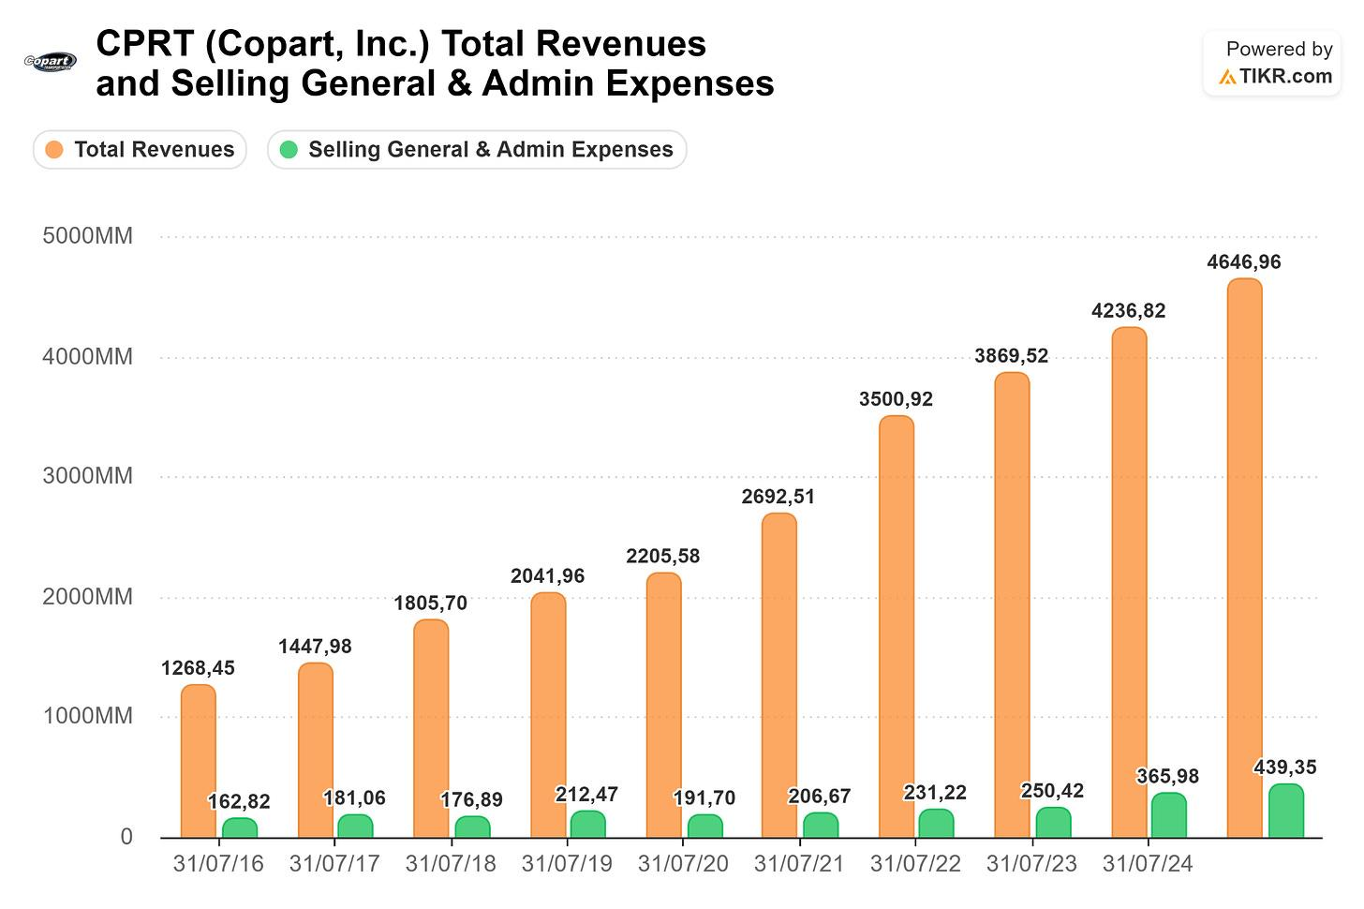
Source: TIKR | Margin Valley Research
Subscribe

How the Two-Sided Marketplace Works
In simple terms, Copart is a niche salvage vehicle auction marketplace, connecting buyers with sellers, where approximately 80% of the sellers are insurance companies. These insurers consider vehicles totaled when an accident causes a level of damage where repairing isn't the most economically beneficial option. The process happens in a defined cycle: once a claim is filed, it's assigned to an adjuster who investigates, inspects the vehicle, and estimates repair costs. Based on that, the decision to repair or declare a total loss is made. When the actual cash value of the car is higher than repair costs, the insurer declares a total loss and offers a payout based on the car's market value before the accident; and that's where Copart enters.
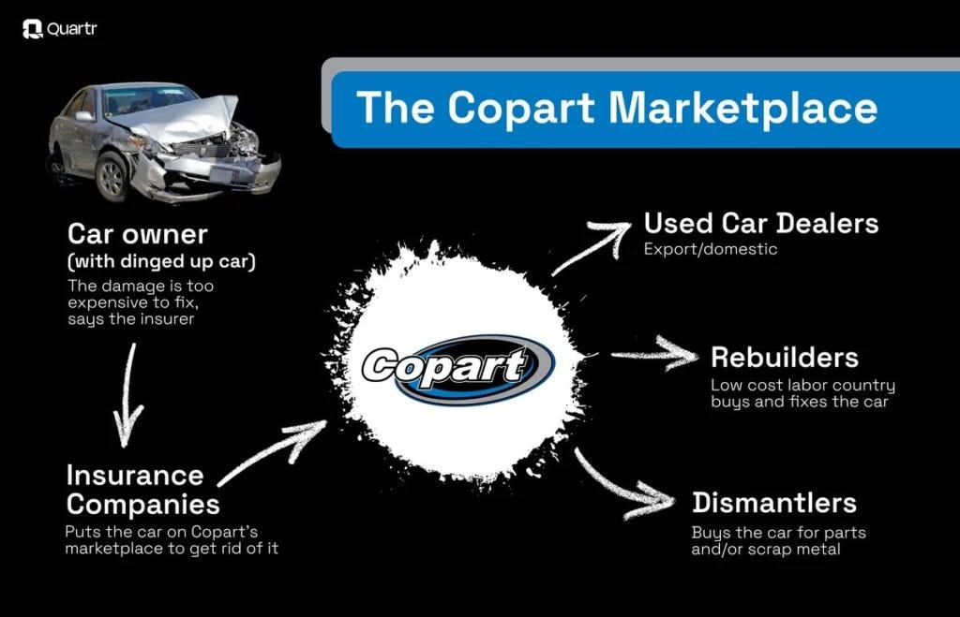
Source: Quartr | Margin Valley Research
When the insurer wants to begin the process, the vehicle is towed to a Copart storage yard, photographed, title transfers and all the paperwork are prepared, and then it moves to an online auction to be put in front of a broad, global base of buyers. Once it’s bought, Copart generates additional revenue by handling the delivery logistics. Vehicles are consigned almost 80% of the time rather than owned, meaning the company doesn’t tie up balance sheet capital in inventory, which limits balance sheet intensity. Supply is driven primarily by accident frequency and total-loss rates rather than economic cycles, which allows the company to not only handle but grow during downturns. In 2020, despite COVID, Copart managed to grow revenues by 8%.
This marketplace mechanism creates a flywheel where more inventory attracts more buyers, and more buyers result in higher bids for sellers.
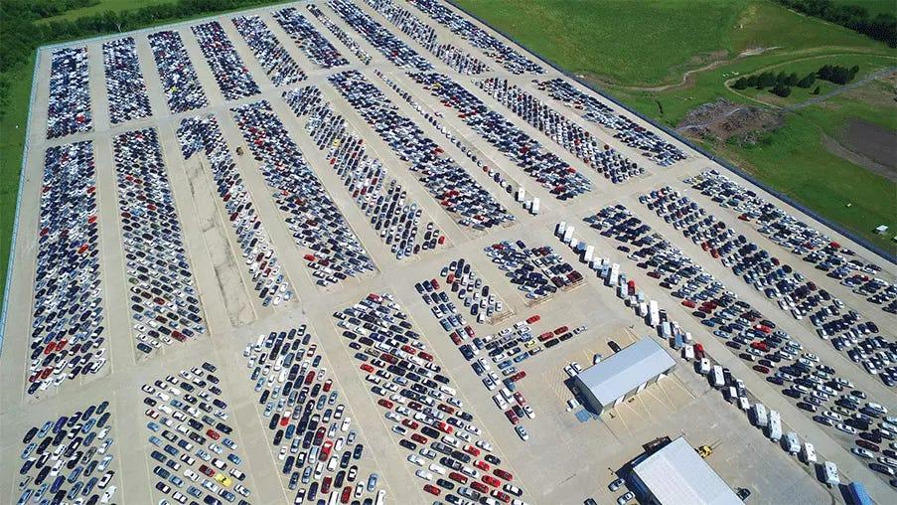
Copart Dallas South Texas yard | Margin Valley Research
Share

History & Origin Story
Willis Johnson founded Copart in 1982 from a single scrap yard in Vallejo, California. Today, the company operates more than 200 facilities across 11 countries, spanning more than 20,000 acres of land globally.

Willis Johnson on the left
Johnson was 34 when he started the company, and his story embodies the aspiring young American entrepreneur who went from rags to riches. By the early ‘90s, Copart began expanding through private loans and equity, growing to four locations in Northern California. By March 1994, the same month as its IPO at $12 on the NASDAQ, it had already added another eight facilities in Oregon, Washington and Texas. Willis, famous for saying you should “Earn a PhD in Common Sense”, relentlessly embraced new technology, scaled the salvage yard expansion business model, secured partnerships with insurance companies, and borrowed ideas from companies in other industries, including Disneyland. The result was turning a small junkyard into an empire worth approximately $59B at its peak. Even Charlie Munger described Johnson as a “talented fanatic” who revolutionized the auto salvage industry.
Copart’s rapid growth was possible not only through fast salvage yard acquisition but also through acquisition of other companies. In May 1995, the acquisition of NER Auction Group led the company to double its number of facilities across the U.S. With a growing presence in the country, Copart began looking for regional and national contracts with leading insurance companies, solving their pain point of getting the highest value for totaled vehicles.
By 2003, the VB2 online auction bidding platform was launched (later upgraded to VB3 in 2013), and with more than 100 locations at the time, industry practices were permanently changed. Salvage yards transformed from unorganized lots of wrecked cars into a structured, clean, cataloged business with a retail-like experience for buyers. Johnson’s vision moved the traditional, localized salvage yard auction model to a dominant, tech-forward, and eventually web-based global marketplace that now sells more than four million vehicles each year through its VB3 technology.
The international expansion began in 2003, with the opening of a Canadian yard, and in 2007, Copart was already growing its footprint overseas to the U.K. By 2018, the expansion into Finland happened with the acquisition of Autovahinkokeskus, having already grown to the United Arab Emirates, Brazil, Bahrain, Oman, Spain, Ireland and Germany in the previous years.

The Business Model

1. Principal vs. Agency model distinction
In most vehicle auction businesses, the auctioneer buys the vehicle from the seller (insurance company), takes it onto their balance sheet, and then resells it for a profit. That’s the principal model: the company owns the inventory, carrying the risk of the car sitting unsold or selling below the purchase price.
Copart operates primarily as an agent. They don’t buy the car. Instead, they take it as a consignment, handle all the logistics (towing, storage, titling, photography), run the auction, and collect the fees from both sides. The insurance company remains the owner until a buyer wins the auction.
Operating with the agency model brings multiple financial advantages: the company holds no inventory risk on the balance sheet, revenue is fee-based and more repeatable, capital doesn’t get tied up in depreciating assets, and margins are more predictable because there’s no spread risk between what they paid and what the car sells for. It also means Copart’s incentive is perfectly aligned with the seller: both want the highest possible auction price, because their fees are tied to sale proceeds. This makes insurers trust them more than a principal-model competitor who might have conflicting interests.
The principal model also has its own advantages, the main one being directly benefiting from increasing used car prices. Copart built a mix of both models that allows the business to continue growing with less risk, independently of the economic cycle, while taking the upside in markets like Germany and the U.K., where it makes sense. According to the most recent 10-K, from FY 2025, service revenue accounted for 85% of total revenue, while vehicle sales accounted only for 15%, so the predominant model is largely the agency one.
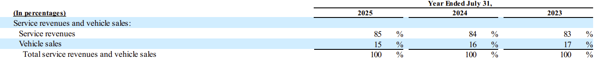
Source: Copart FY 2025 10-K Report | Margin Valley Research
Subscribe

2. Fee structure
The buyer pays multiple layered charges on top of their winning bid. The most common are the Buyer Fee (which varies depending on the vehicle’s price), a Gate Fee for vehicle handling, an Environmental Fee, and a Virtual Bid Fee for bidding online. The Gate Fee is currently $95, covering administrative and relocation costs, and the Environmental Fee is $15 per sold item. The buyer fee is structured in tiers: Basic members pay a 10% fee on all purchases while Premium members pay 5%. The total cost of a vehicle can run 15 to 22% above the winning bid when all fees are accounted for.
On the seller’s side, a commission is paid as a percentage of the final sale price, plus a listing fee of $50, and an administrative fee of $30 for processing the sale. Storage fees apply for the time a vehicle remains unsold, and there are transportation-related costs for moving vehicles on and off the lot.
Beyond auction-related fees, Copart also earns revenue from ancillary services, such as towing, title processing, and post-sale delivery logistics.

3. Moat
Copart owns more than $2B worth of land; while some consider it a capital burden, that's exactly the part of the moat that can't be replicated. Salvage yards face a specific location dilemma: they can't be located near residential areas due to noise and waste, but they also can't be too far from major cities, since that would substantially increase towing costs and drive greater operational inefficiencies. Licenses are also hard to obtain, so Copart's 40+ years of land expansion is a moat by itself. With today's AI developments, the hard part isn't replicating a platform similar to VB3; it's obtaining the considerable amount of capital required to acquire salvage yards' unique locations, most of which are already owned by Copart. Just in the past 10 years, land value on the balance sheet grew at a ~15% CAGR.
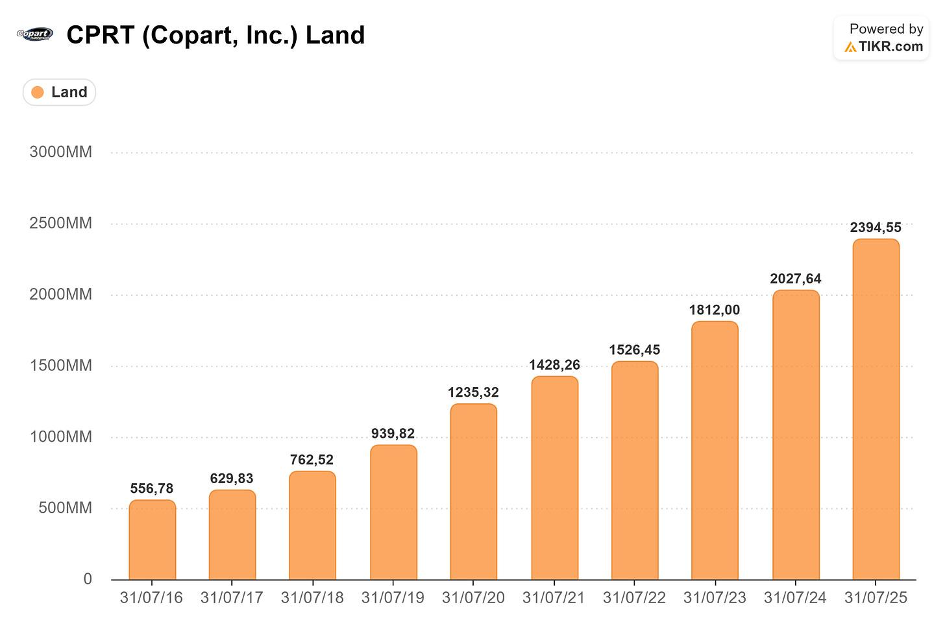
Source: TIKR | Margin Valley Research
While land is the main pillar of the moat, Copart also benefits from its global buyer network. The patented VB3 auction platform connects salvaged vehicles to roughly one million registered buyers across 180+ countries. The large buyer base drives up auction participation and average selling prices, which in turn incentivizes auto insurance companies, who supply over 80% of vehicle volume, to list their inventory with Copart and further deepen insurer relationships already built over decades.
The company also provides operationally integrated services for insurance carriers (such as Title Express and end-to-end logistics), making it highly disruptive and operationally costly for insurers to switch to a rival when Copart frees them entirely from the whole process.
Deep insurer relationships, proprietary technology, a two-sided marketplace, land-based cost advantages, and a hands-off process that creates high switching costs together make Copart’s wide economic moat.

Competitive Landscape
Copart dominates the global salvage auction market (holding approximately 40% of the industry’s share in 2025), sharing a virtual duopoly with its primary direct competitor, Insurance Auto Auctions (IAA, acquired by Ritchie Bros. Auctioneers). Unlike Copart, which owns its real estate infrastructure, IAA operates on a leased-land model, giving them short-term flexibility but higher structural lease costs. Due to land restrictions, the Copart and IAA duopoly is very hard to disrupt with the emergence of a third player, simply because there isn’t enough space for a new competitor to copy the business model.
Manheim is the undisputed market leader in the whole-car (undamaged) auto auction segment. However, its digital channels like Manheim Express increasingly overlap with parts of Copart’s business, particularly for total-loss and fleet vehicles. Other smaller players like Auto Auction Inc. and various independent salvage pools hold fragmented regional market share.
Key competitive advantages against rivals are the vast owned infrastructure near major metropolitan areas (which, due to zoning restrictions and vast capital requirements, creates high barriers to entry), along with integrated IT systems and exclusive long-term contracts with top-tier insurance carriers, locking in a consistent, high-volume supply of total-loss vehicles.

Secular Tailwinds
Technology is being rapidly implemented in modern vehicles, and with it come more fragile parts and rising repair costs, which lead to more cars being totaled because the proceeds of selling them in a deteriorated condition (Actual Cash Value) are greater than the cost of repairing them. For example, if a car is worth $15,000 and repairs are estimated at $11,000, plus the car has a salvage value of $3,000, the total financial impact to the insurer is $14,000. Because $14,000 is close to the $15,000 value, or crosses your state's threshold, the company will "total" the car.
The Total Loss Formula:
Cost of Repairs + Salvage Value Actual Cash Value (ACV)
Since 2021, according to the Bureau of Labor Statistics, vehicle repair and maintenance costs have climbed a staggering 33%, so for most people the days of dropping a few hundred dollars on a routine car repair and not losing sleep over it are largely over. For moderate-level work, the average car repair has now hit $838.
There are several interconnected factors driving prices higher:
- Shortage of skilled labor: The Bureau of Labor Statistics shows that experienced mechanics and technicians are retiring faster than young workers are learning the craft. As a result, repair shops are offering premium wages and bonuses to attract qualified candidates, which leads to more costs being passed on to customers. The average mechanic is now in his late 40s while there aren’t enough 20-something year-olds training to replace them, so this is a multi-decade structural problem if there are no real measures to reverse the trend.
- Modern car complexity: 2026 vehicles are basically computers on wheels, with 50 to 150 electronic control units managing everything from fuel injection to climate control. This drives greater performance and safety, but when something needs to be repaired, the specialized diagnostic equipment and training required ends up driving billable hours up. A modern transmission can have more than 8 gears that require specific equipment, so repair shops have no choice but to charge premiums, which leads to the number of vehicles being totaled at an all-time high. In 2025, nearly one in four vehicles involved in a crash was declared a total loss, hovering around 22.8%, partly due to complex Advanced Driver Assistance Systems (ADAS).
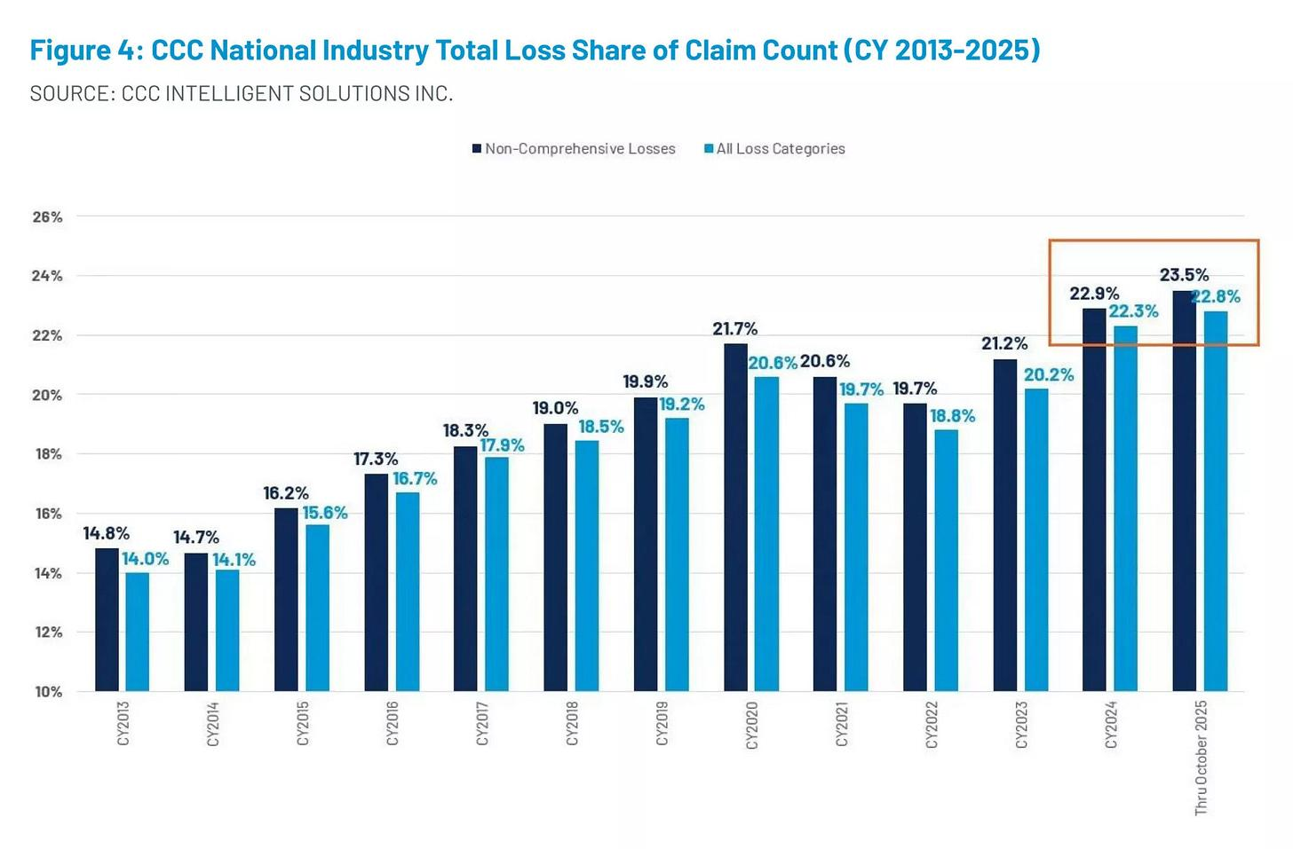
Source: CCC Intelligent Solutions | Margin Valley Research
- Income growth vs Repair Costs growth: For the past few years, median household income has grown around 3 to 4% annually while repair costs have been climbing at 6 to 7% yearly. This is a gap that compounds over time.
Copart also benefits disproportionately from the increasing worldwide adoption of EVs that come with inherent complications like battery fires and higher repair costs. By early 2026, over 20 million electric cars were sold globally each year, making up roughly 25% of all new passenger vehicle sales. Long-term market projections estimate that electric vehicles could account for more than 80% of global new car sales by 2040. The demand for used cars is also expanding due to surging manufacturing costs, inflation, high interest rates, and shifting consumer preferences, and this specific market is projected to grow at a 6% CAGR between 2025 and 2030, which increases the number of bidders in Copart’s auctions.
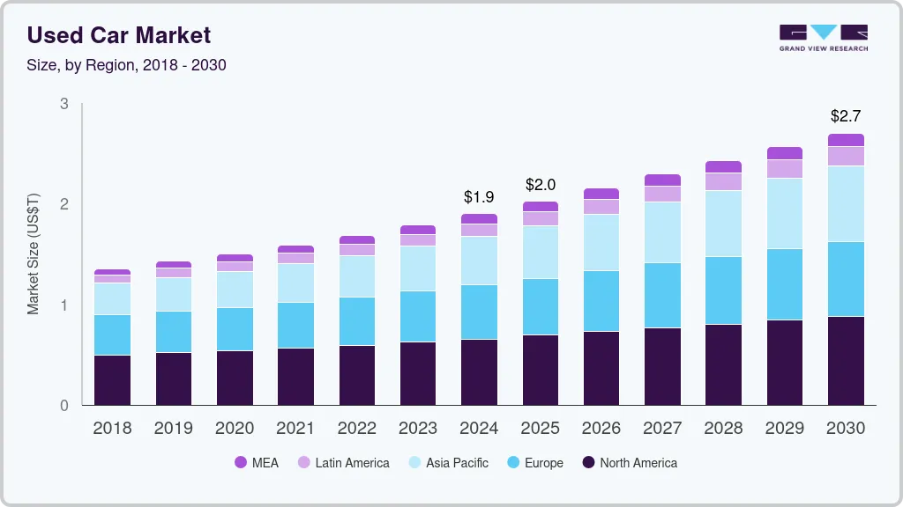
Source: Grand View Research | Margin Valley Research
Extreme climate events boost Copart’s sales volume in specific fiscal years, but due to their unpredictability, I’d only consider them a one-time event and not a structural tailwind.
Subscribe

Financial Analysis
Revenue growth > 10% ✅ 10-Year CAGR: 15.5%
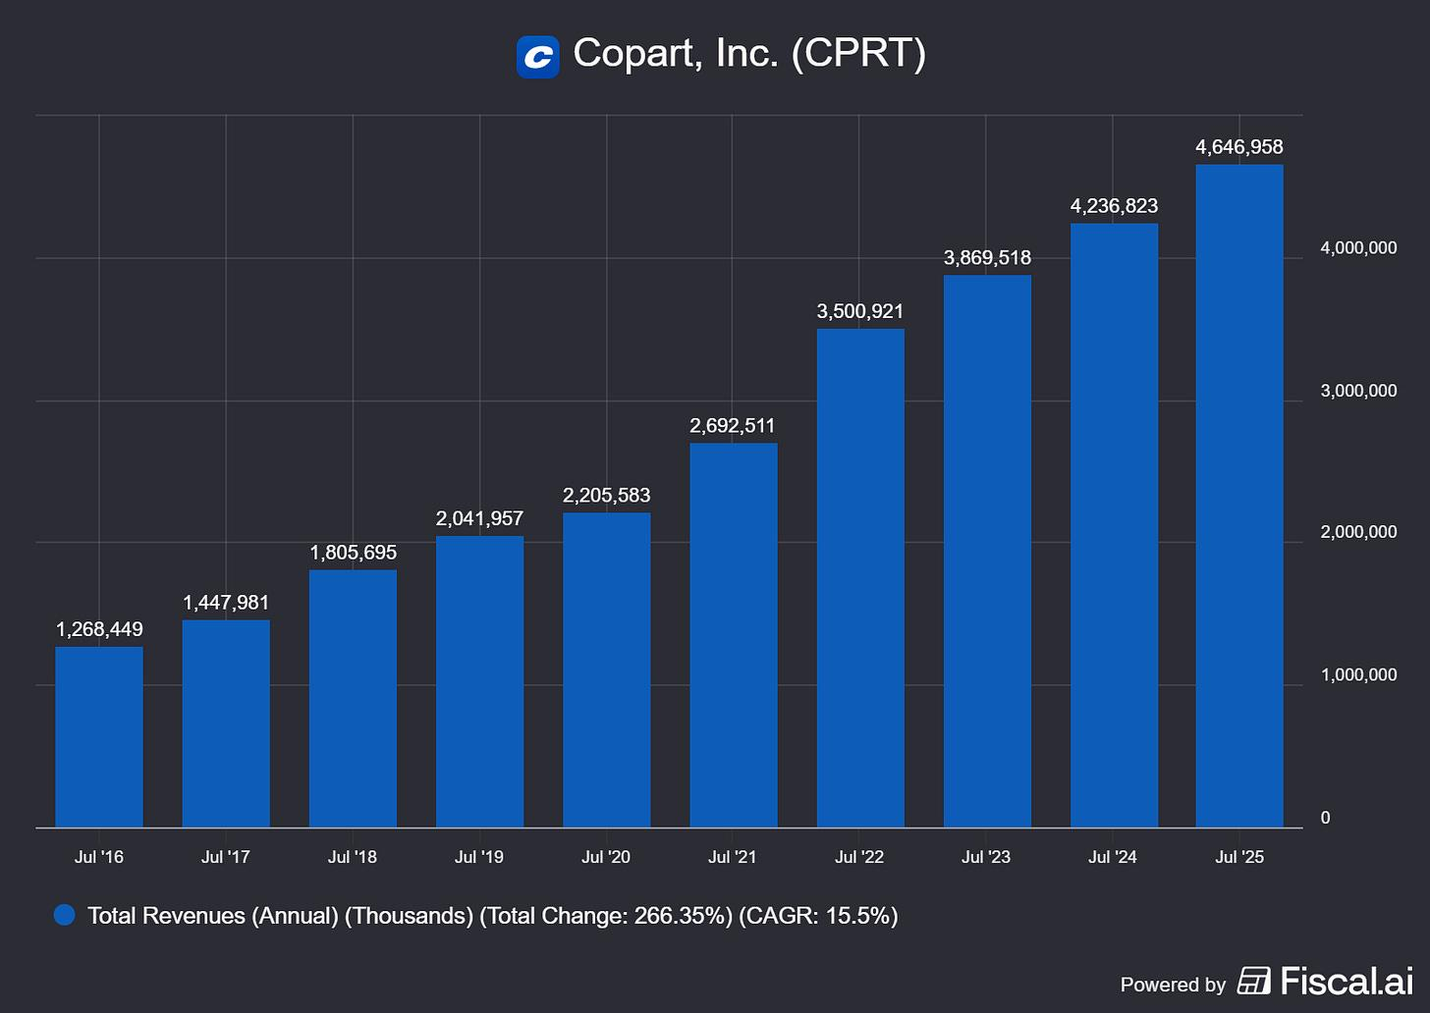
Earnings growth ≥ revenue growth ✅ EPS 10-Year CAGR: 21.4%
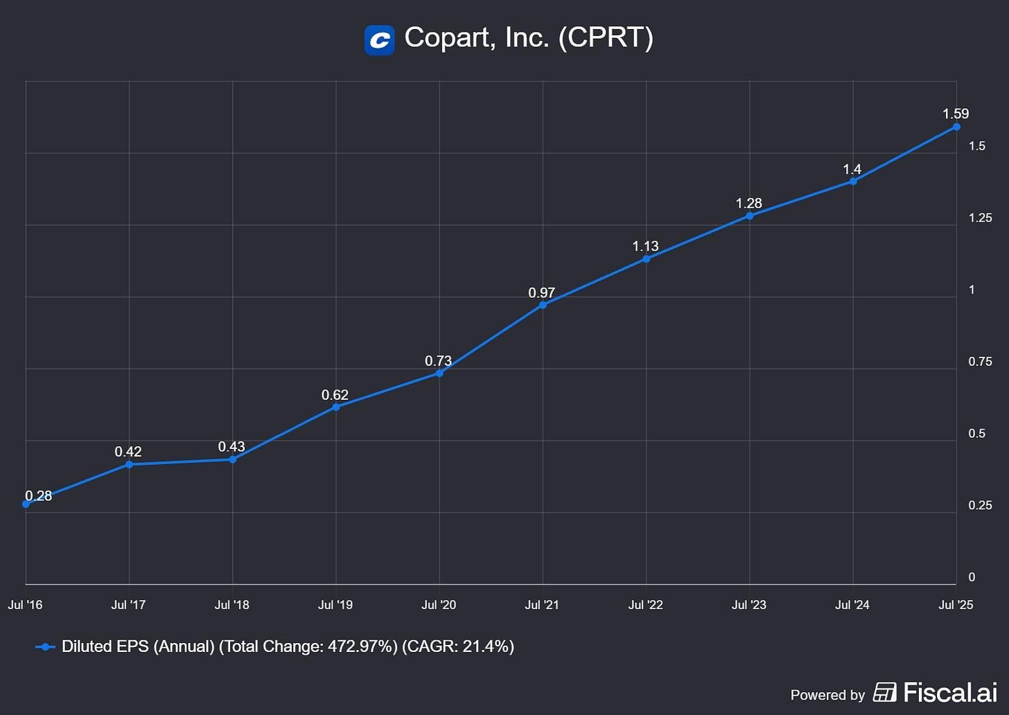
ROIC ≥ 15% ✅ FY 2025 ROIC: 30.1%
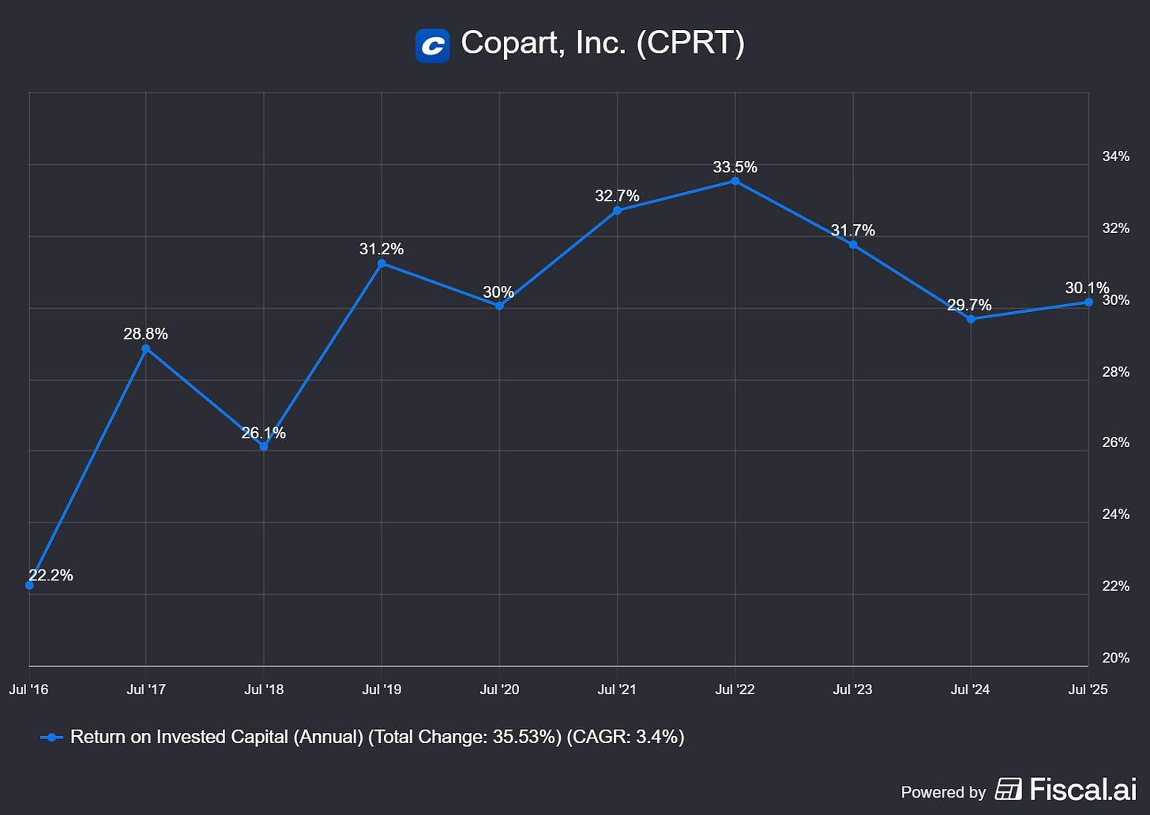
ROE ≥ 15% ✅ FY 2025 ROE: 18.5%
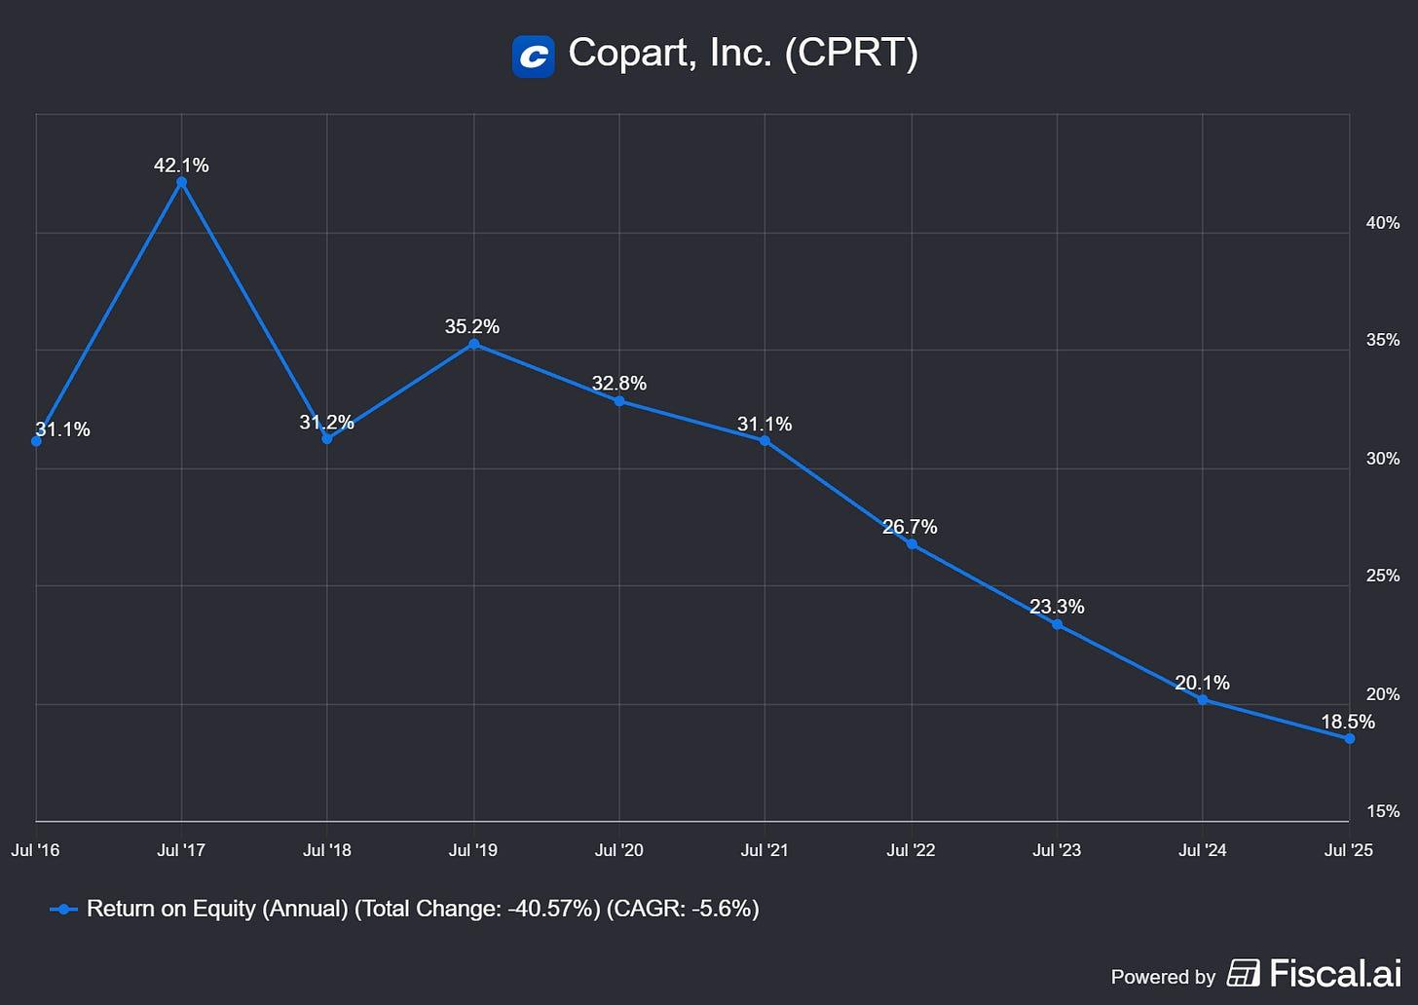
Gross Margin rising ✅ FY 2025 Gross Margin: 45.2%
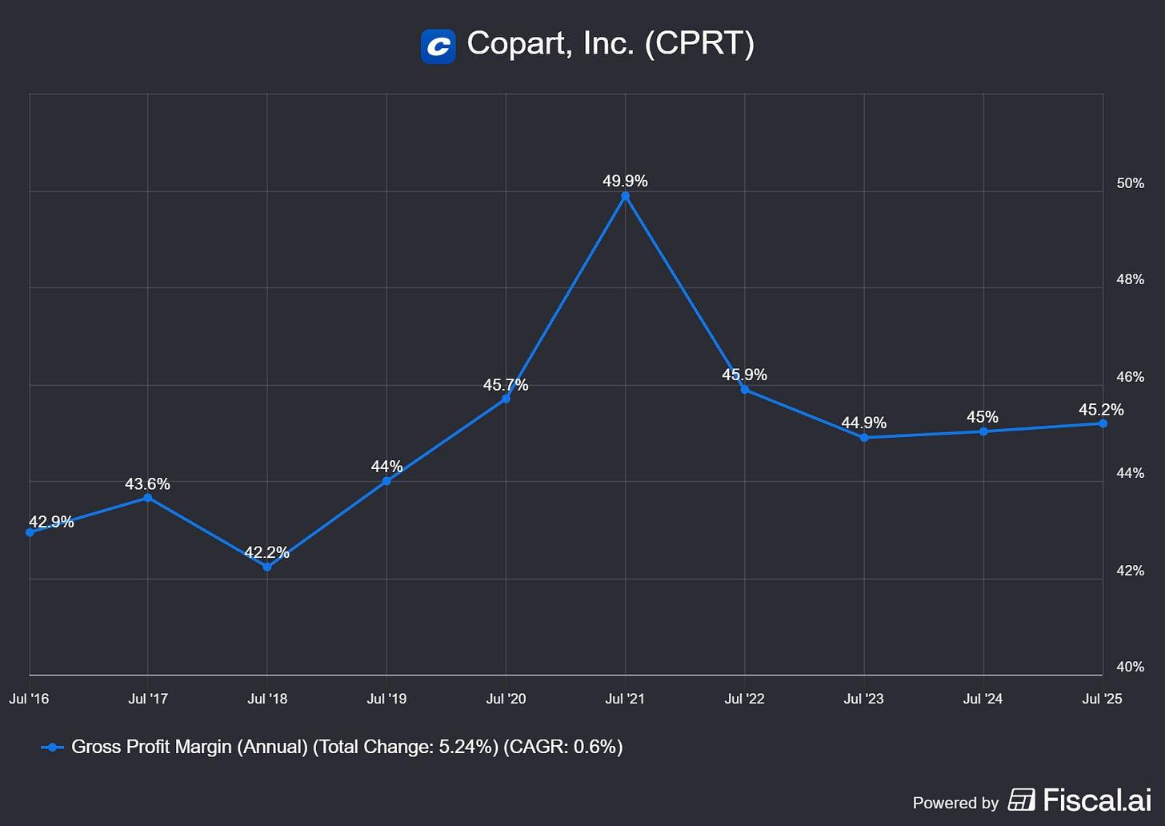
Operating Margin rising ❌ FY 2025 Operating Margin: 36.5%
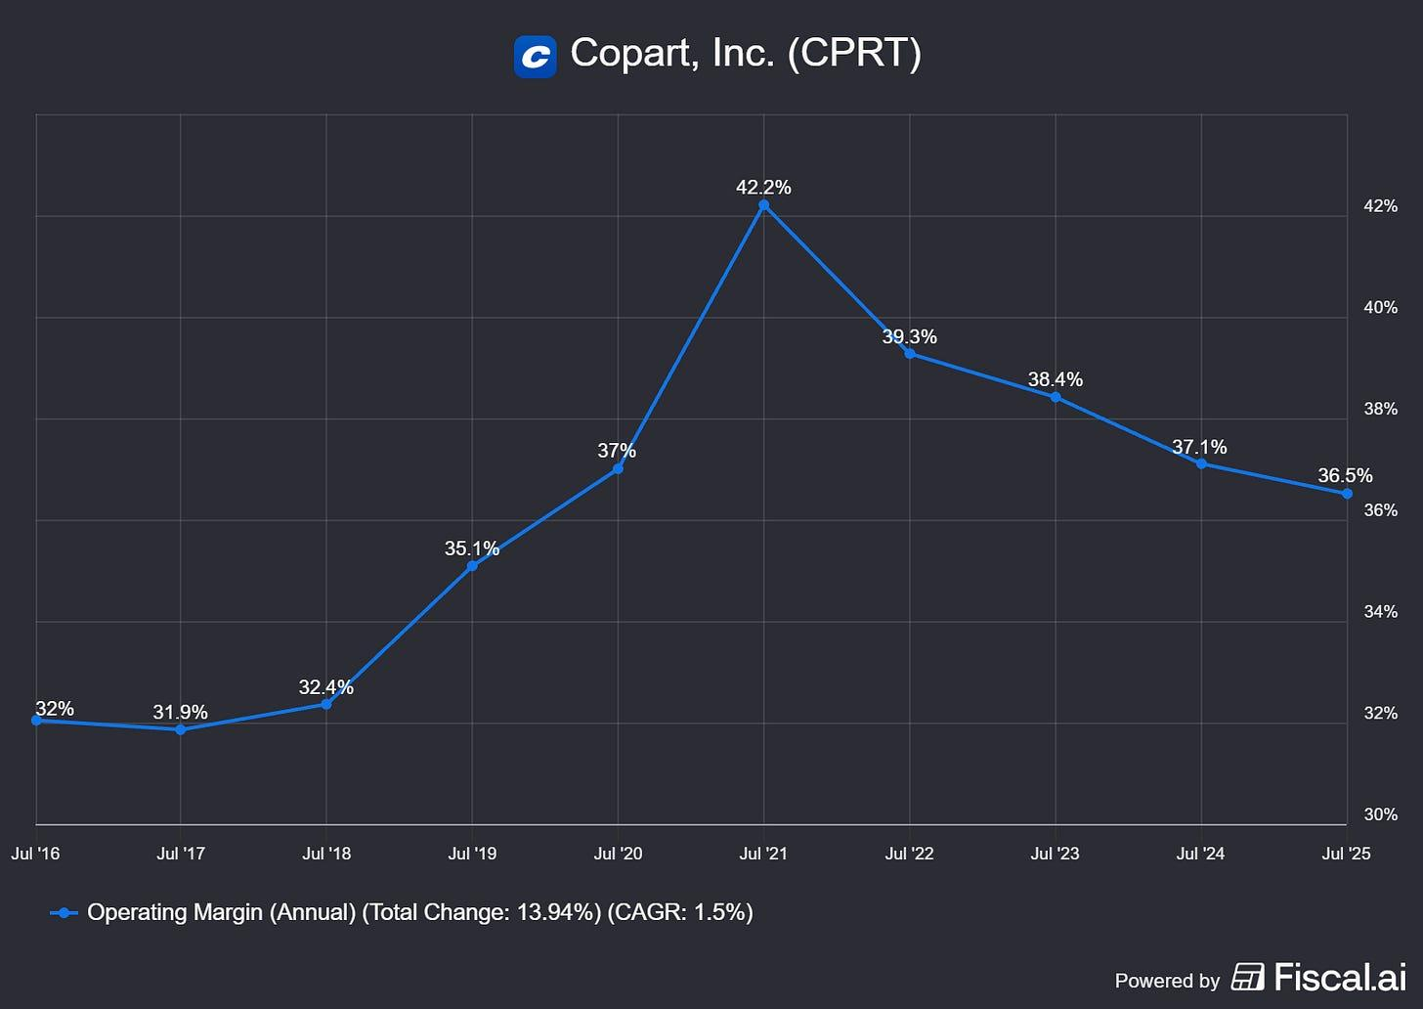
FCF positive & growing over time ✅ FCF 10-Year CAGR: 26.5%
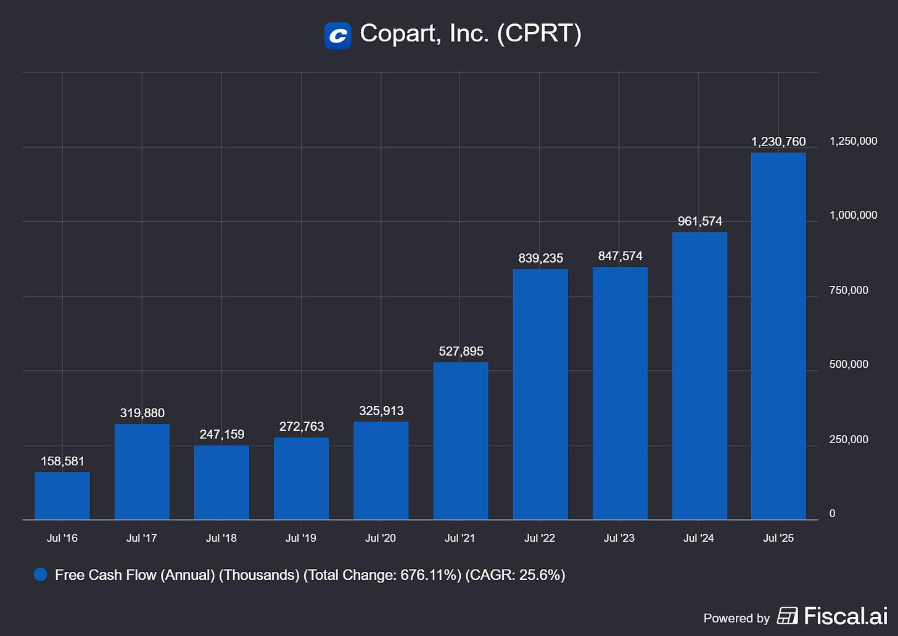
Share Count stable or falling ✅
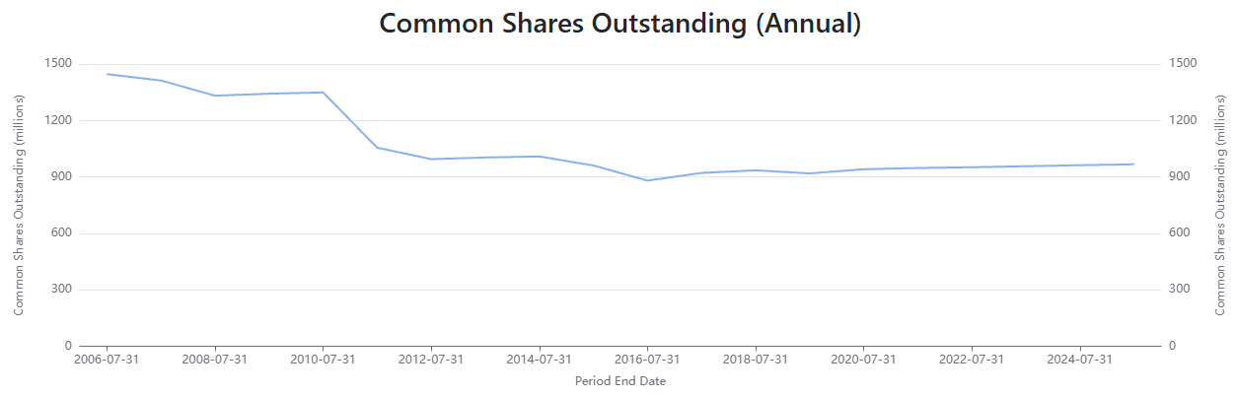
Just a quick note on the declining ROE and operating margin: these are the result of a business that’s growing strongly, but is becoming more capital intensive and investing ahead of revenue growth. The main drivers are the heavy investment cycle in new salvage yards and land (leading to the elevated capital expenditures shown below), operating costs growing faster than revenue as capacity keeps increasing, and ROE being diluted by a huge cash balance, as Copart accumulated billions in cash and Treasury investments with very little debt. This creates a mathematical effect where equity keeps rising rapidly while net income grows more slowly.
For the past year, the stock valuation became more attractive, and Copart resumed its opportunistic share buyback program, repurchasing over $500 million worth of shares over two quarters (specifically during their fiscal second and third quarters), including approximately 5.5 million shares at an average price of $39.82. Also, between November 2025 and January 2026, Copart repurchased over $218 million worth of common stock. This shows that management is highly disciplined; rather than buying back shares blindly on a set schedule, management historically pauses the program when the stock trades at premium multiples to avoid destroying value for shareholders. They actively resumed repurchases following the significant pullback in the share price. Since the original plan’s inception in 2003, the company has cumulatively repurchased over 470 million shares for billions of dollars, maintaining a robust, almost debt-free balance sheet with billions in liquidity.
Share

Management & Culture
Willis Johnson founded Copart in 1982 and stayed as CEO until 2010. He was the visionary looking to modernize the salvage vehicle auction market, and his obsession with operations, yard expansions, and grit was the main driver behind one of the best compounding track records you’ll find.
Jayson Adair, his son-in-law, joined Copart in 1982 and rose internally through operations, serving as CEO between 2010 and 2022, leading the technology transition from physical salvage auctions to online auctions and the VB2/VB3 systems while expanding internationally. Jeff Liaw took office in 2024 and is seen as intellectually aligned with the long-term culture. We can see that, as Liaw took advantage of the recent stock valuation dip to repurchase shares at a price that’s expected to create value for shareholders, while focusing on the decade-long business model focus of expanding yard acquisitions in the U.S. and internationally.
Jayson Adair received the historical compensation of a $1 yearly salary while retaining significant equity and benefiting from long-term stock appreciation, totally in line with shareholders’ interests. He still owns more than 2% of the company, and Willis Johnson also remains with more than 5%, a position worth billions.
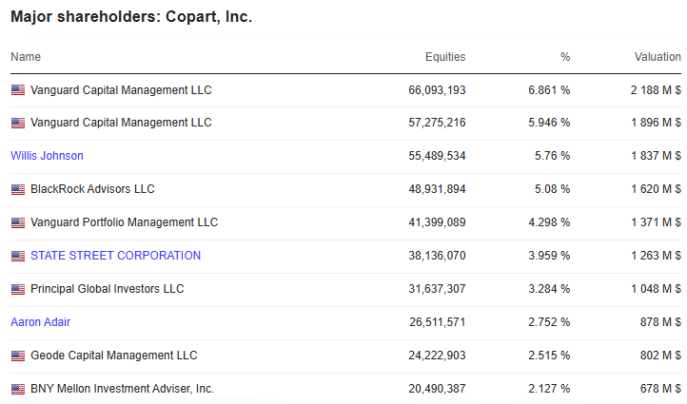
Source: MarketScreener | Margin Valley Research
Jeffrey Liaw is the first Copart CEO not owning meaningful equity in the company, receiving a base salary of $900k with a cash bonus of $1.093M in FY 2025. The cash bonus is tied to operational metrics that also create value for shareholders when met, but the compensation isn't as heavy equity-based as it used to be.
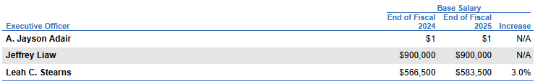
Source: Copart DEF 14A | Margin Valley Research
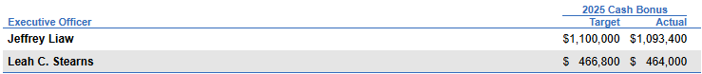
Source: Copart DEF 14A | Margin Valley Research

Risks & Bear Case
As the pace of EV adoption increases, improvements in repair economics might harm Copart’s total unit volumes. Mitchell reported that the average BEV repair severity in the U.S. declined roughly 10% quarter-over-quarter in Q1 2025, as more collision shops become EV-certified, improving cycle times and reducing unnecessary battery replacements. One of the biggest reasons for EVs to be totaled was due to battery-case damage, sometimes minor, that could be economically repaired, and manufacturers have been looking to fix this as batteries are becoming modular instead of a full pack. The Thatcham/Generational research cited median battery health around 93.5% after 4 to 5 years and 85% after 8 to 9 years, which improves insurer willingness to repair older EVs.
The acquisition of IAA by RB Global in 2023 led to a combined company that became a much broader remarketing and asset-disposition platform, spanning salvage autos and heavy equipment auctions. The main risk for Copart isn’t that IAA suddenly becomes a better salvage operator; it’s that RB Global creates a broader ecosystem insurers prefer using. RB Global has a broader pitch for institutional clients, as it offers most of the same services Copart provides, plus clean-title vehicle remarketing, heavy equipment disposition, financing, and many other adjacent offerings, all under one umbrella. As RB Global provides a much broader service stack, insurers could allocate more volume to them and pressure Copart’s take rates, operating margins, and incremental market-share gains.
The current insurance cycle is a “hard market”, which happens when insurers raise premiums aggressively, tighten underwriting, and try to restore profitability after losses surge, driven by higher repair costs, used-car price volatility, CAT losses, or increasing modern car complexity. Higher premiums lead to the issue management referenced, which is more people driving underinsured, or even uninsured. U.S. personal auto insurers suffered major underwriting losses in 2022 to 2023 before profitability began recovering in 2024 to 2025 due to premium increases and stabilizing claims.
Companies like Waymo are reporting materially lower injury-crash rates than human drivers across millions of miles on autonomous vehicles. Autonomy lowers collision frequency, but these vehicles are the most ADAS-equipped, containing multiple technological parts that require sensor replacement and full recalibration even for minor accidents, so repair costs rise dramatically, and therefore more cars are totaled. While this transition is decades-long and geographically uneven, if true Level 4 / 5 eventually cuts crashes by 70 to 90% while repair severity only doubles, that would pressure Copart long-term and impact the terminal growth rate.
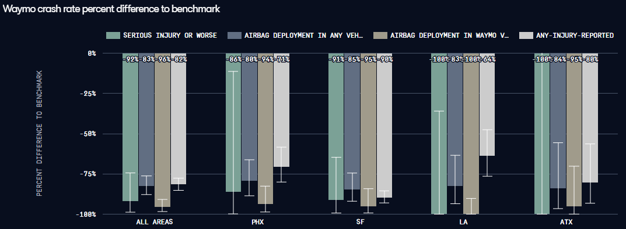
Source: Waymo | Margin Valley Research | The graphs show the percent difference between the Waymo and human benchmark crash rates by location, with 95% confidence intervals. A negative number means the Waymo Driver reduced crashes compared to the human driver. Confidence intervals that do not cross 0% mean the percent difference is statistically significant.
Subscribe

Valuation
Copart sits at the intersection of a marketplace/network-effect business, a logistics/infrastructure business, and an issuer-services platform, so I consider EV/EBITDA, P/E, and P/FCF the most important multiples to start the valuation and compare with RB Global.
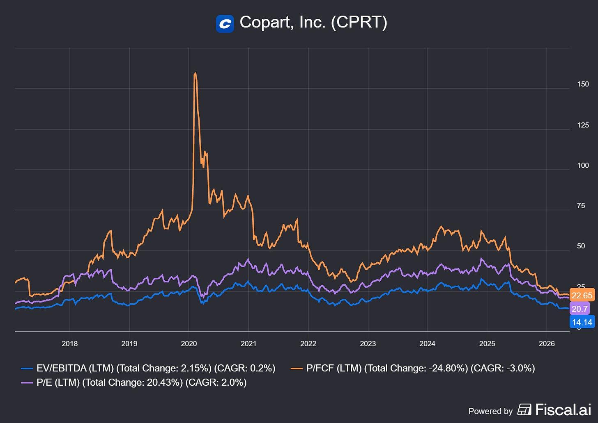
These three multiples point to lower valuations relative to the average of the past 10 years, so investors are discounting lower growth for the next few years, considering that the days of higher double-digit growth are largely gone.
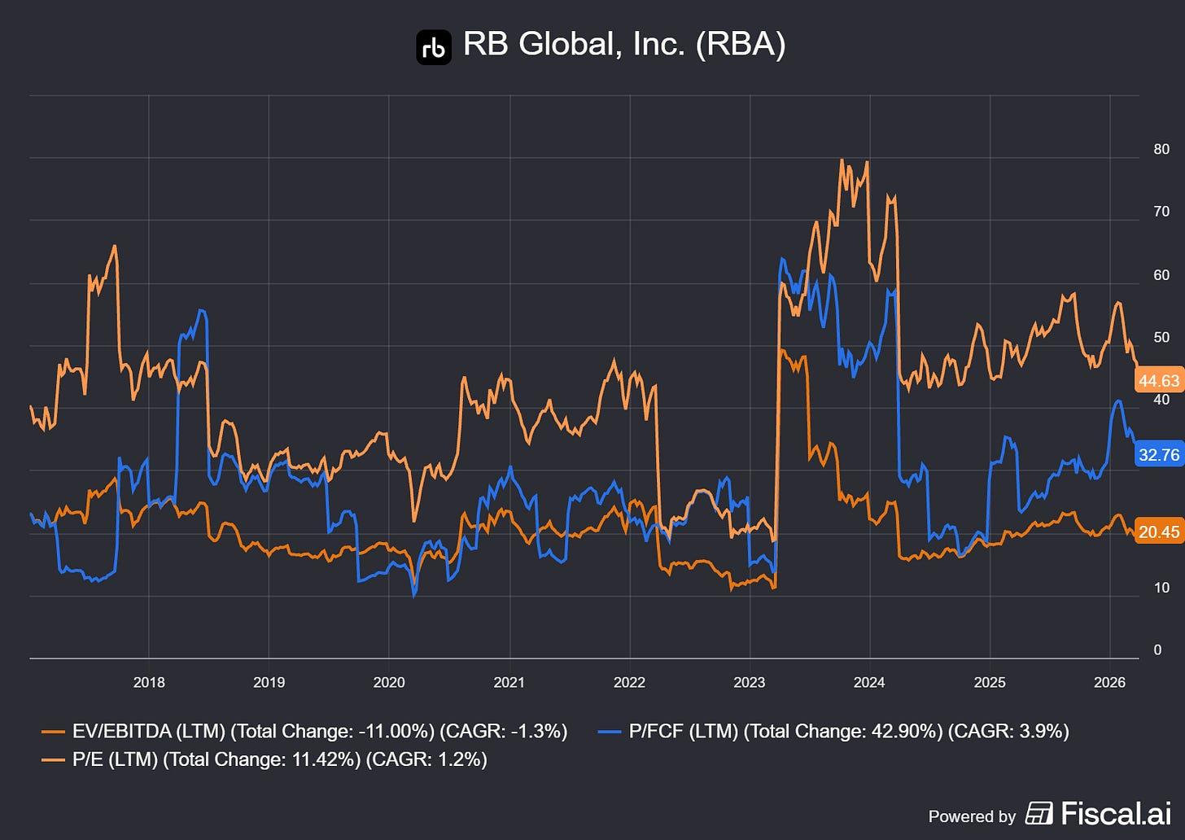
RB Global, Copart’s most important competitor, now trades at a premium. The stock didn’t register the same negative performance over the last year and that’s reflected in the multiples.

DCF Framework & Scenario Analysis
Copart is difficult to value using conventional short-duration DCF frameworks because a large portion of its economics are driven by long-term structural advantages rather than near-term cyclicality.
The company benefits from a combination of rising vehicle complexity, increasing total-loss frequency, global buyer network effects, and high incremental margins. As a result, the key valuation question isn’t whether Copart can grow over the next few years, but how long it can sustain elevated returns on capital and pricing power.
To account for this, I built a three-scenario DCF framework (Bear, Base, Bull) focused on the operational drivers that matter most:
- Insurance salvage unit growth;
- Revenue per unit;
- Operating leverage;
- CapEx intensity;
- Terminal growth rate.
Rather than relying on a single revenue CAGR assumption, the model explicitly forecasts the mechanics of Copart’s salvage value ecosystem and how those economics translate into free cash flow generation over time.
At its core, Copart’s revenue model can be simplified as:
Revenue = Units x Revenue per Unit
Where unit growth is primarily driven by:
- accident frequency;
- total-loss frequency;
- catastrophe frequency;
- and market share gains.
Meanwhile, revenue per unit benefits from pricing power, ancillary services, and higher salvage values.
The Bear, Base, and Bull cases primarily differ in their assumptions around:
- EV/ADAS-driven total-loss frequency,
- catastrophe volume,
- insurer salvage throughput,
- margin expansion,
- and valuation normalization.
Importantly, even the Bear case assumes Copart retains structurally high profitability due to its dominant marketplace position and network advantages.
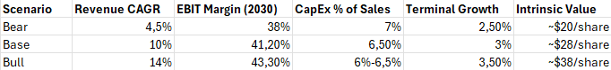
Source: Margin Valley Research
In order to consider starting a position, I’d look for a 20% margin of safety on the Base scenario intrinsic value, at roughly ~$23/share.

Conclusion
So here’s where I land.
Copart is, by almost any measure, one of the highest-quality businesses in the public market. A 15.5% revenue CAGR over a decade. A 30% ROIC. A nearly debt-free balance sheet sitting on billions in liquidity. A founder-built culture that still owns meaningful skin in the game. A duopoly position in an industry protected by physical infrastructure that simply cannot be replicated at this point, no matter how much capital a challenger brings to the table. And on top of all that, secular tailwinds (rising vehicle complexity, growing total-loss frequency, EV adoption) point in the right direction for the next decade.
If you handed me Copart at the right price and told me to put it away for 20 years, I’d do it without losing a minute of sleep.
But that’s the catch: at the right price.
The market is currently asking me to pay a premium for a business that, based on my Base case, is worth roughly $28 per share. I want a 20% margin of safety on that number before I act, which puts my entry around ~$23. Management itself has shown, with admirable discipline, that they understand the same math: they paused buybacks when the stock was expensive and resumed aggressively when it pulled back to the high $30s. I’m willing to be more patient than they were, and I think the bear case risks (RB Global’s broader ecosystem play, improving EV repair economics, the long-tail threat of autonomy) justify that patience.
There’s an investing lesson buried in this piece that I think is worth saying plainly. Quality and price are two separate questions, and confusing them is one of the most expensive mistakes you can make. Copart is quality. Whether it’s a buy today is a different question, and right now, my answer is no. It goes on the watchlist, and I wait for the market to give me a reason.
If that day comes, I’ll be ready. If it doesn’t, there’s no shortage of other businesses worth studying with the same rigor, and I’d rather hold cash than reach for a stock just because it’s good. Good companies bought at bad prices are still bad investments.
Until then, this one stays on the bench.

The Magnificent 493

Copart (CPRT) update

Three weeks ago we put Copart on our watchlist. Q4 results and a massive deal just gave us our answer.
The Magnificent 493
Sep 15, 2026
Three weeks ago, I wrote about Copart trading near a 10-year valuation low ($30–$34/share), asking whether it was a genuinely wrecked stock or a hidden bargain. My stance back then was “watching, not owning,” waiting on three key signals: U.S. volume stabilization, strategic clarity from returning CEO Jay Adair, and progress on an unresolved DOJ inquiry.
With full-year numbers out and a major acquisition on the table, we got answers. But as the stock sits near $31, those answers force us to pull our model apart from scratch.
(If you missed the original thesis on Copart’s land-ownership moat and business model, read the August 27th deep dive linked below.)


Copart (CPRT): Wrecked stock or hidden bargain?
The Magnificent 493
·
Aug 27
Read full story

Financials
- Q4 revenue: $1.152 billion, up 2.4%
- Q4 gross profit: $481.4 million, down 5.5%
- Q4 operating income: $368.9 million, down 10.6%
- Q4 net income attributable to Copart: $327.4 million, down 17.4%
- Q4 diluted EPS: $0.35, down from $0.41
- Full year revenue: $4.666 billion, up 0.4%
- Full year net income attributable to Copart: $1.484 billion, down 4.4%
- Full year diluted EPS: $1.55, down from $1.59
This is a worse quarter than the one I wrote about in August. Q3 showed operating margin actually improving and diluted EPS up 2.4%, propped up by buybacks but still positive. Q4 shows real deterioration: gross profit down, operating income down double digits, net income down 17.4%. The full-year numbers now show Copart earning less per share than it did a year ago. Whatever stabilization I was hoping to see in the last piece, this quarter is evidence against it.

Where the pressure is
Facility operations costs grew 7.7% in the quarter against revenue growth of just 2.4%, real operating deleverage at the yard level. General and administrative expenses jumped 16.6%. Facility depreciation and amortization rose 14%. None of these are one-off in the sense of appearing in a single line and vanishing, but I’d flag the G&A jump specifically: Jeff Liaw’s departure was effective July 31st, the last day of this fiscal quarter, and a CEO transition of that kind typically carries real severance, search, and advisory costs that land in G&A around exactly the period they landed here. I don’t have a clean breakout of how much of that 16.6% is transition-related versus recurring cost growth, and I want to be upfront that I’m inferring this. It’s a plausible explanation for part of the spike.
Below the operating line, two more things are worth flagging for quality of earnings. Interest income, net, fell 20.5% in the quarter, a direct consequence of the cash pile shrinking as buybacks ran through the year, and now a structural headwind going forward since a meaningful chunk of what’s left is about to go out the door for the ACV deal. And other income swung from a $16 million gain a year ago to a $3.8 million loss this quarter, a roughly $19.8 million negative swing that I can’t fully explain from the release alone. Both of these sit below operating income, so they don’t distort the segment-level story, but they’re both real drags on this quarter’s bottom line that aren’t obviously part of the core auction business.
Segment by segment, the story is entirely a US problem. US operating income fell 12.7% in the quarter. International operating income grew 3%. For the full year, US operating income fell 4.2% while international grew 8.2%. Whatever is going on with Copart’s business, it’s concentrated at home.

The balance sheet and cash flow
- Total assets: $10.028 billion, essentially flat YOY
- Cash, cash equivalents and restricted cash: $1.908 billion, down from $2.781 billion
- Held-to-maturity securities: $2.582 billion, up from $2.009 billion
- Total debt: effectively none, just $88.4 million of lease liabilities
- Stockholders’ equity: $9.097 billion, down slightly from $9.187 billion
OCF for the full year fell 10.9% to $1.604 billion, a bigger drop than net income’s 4.4% decline, and the gap is mostly working-capital timing: accounts receivable grew faster this year, and a roughly $49 million swing in income taxes receivable suggests the company effectively overpaid or prepaid taxes relative to what it expensed. Neither is a red flag about the underlying business, but OCF falling faster than net income is exactly the kind of quality-of-earnings gap worth checking every quarter.
The more interesting cash flow story is capex, which fell 40.7% for the year to $337.4 million from $569 million. Copart’s land-banking strategy is inherently lumpy, big purchases happen when the right parcels become available, not on a smooth annual schedule, so a single year’s pullback isn’t necessarily a signal of anything. But it’s worth watching whether FY2027 capex snaps back or stays low, since continued land accumulation is a real part of the moat story I described in the last piece.
Full-year share repurchases came to $1.633 billion, and here’s something I only caught by comparing this release against the prior quarter’s numbers: that figure is barely different from the $1.63 billion Copart had already spent through nine months, at a weighted average price of $37.63, as of the last piece. That means the fourth quarter, when the stock was trading meaningfully below that average price, saw little to no incremental buyback activity. I don’t know why. It could be a blackout period ahead of the CEO transition, it could be capital being held back in anticipation of the ACV deal, or it could just be a pause. But a management team that was buying aggressively at $37 and went quiet once the stock got cheaper is worth keeping an eye on.

The ACV Auctions acquisition
This is the news that actually changes the shape of the thesis, and it landed the same evening as the earnings release. Copart agreed to acquire ACV Auctions, a Buffalo-based digital marketplace for dealer-to-dealer wholesale vehicle transactions, for $10.5 a share in an all-cash deal worth approximately $1.9 billion, a 45% premium to ACV’s last unaffected close. The deal is structured as a tender offer, funded entirely from cash on hand with no financing condition, and is expected to close by the end of calendar 2026 pending majority tender and antitrust clearance. ACV will keep operating as an independent subsidiary.
Jay Adair’s own words: this creates “an industry-leading end-to-end vehicle remarketing platform that is fully digital,” spanning dealer trade-ins, wholesale vehicles, insurance salvage, and international resale.
Strategically, I understand the logic. ACV operates in a roughly 20-million-vehicle-a-year dealer-to-dealer wholesale market that barely overlaps with Copart’s core salvage business, and its VIPER AI-powered inspection technology is a real, differentiated asset. This is genuine adjacent-market expansion.
Financially, it’s a much harder call. ACV guided to a full-year 2026 unadjusted loss of $44 million to $49 million, against adjusted core profit of $73 million to $77 million. Copart is paying a 45% premium for a business that loses money on a GAAP basis today, funded by drawing down roughly 40% of the cash and securities pile that gave Copart its “no debt, total optionality” balance sheet in the first place. Copart itself says the deal will be neutral to earnings in its first full year and only begin adding to EPS in fiscal 2028. This is a two-year-plus bet before it shows up as accretive.
I’m not treating this as a verdict on whether the deal is smart. I’m treating it as a first, large, public test of exactly the question I raised about Adair’s return in the last piece, whether his second tenure produces a real strategic shift. It has, within weeks of taking over. Whether it’s the right shift is something I think we genuinely won’t know for at least a year.
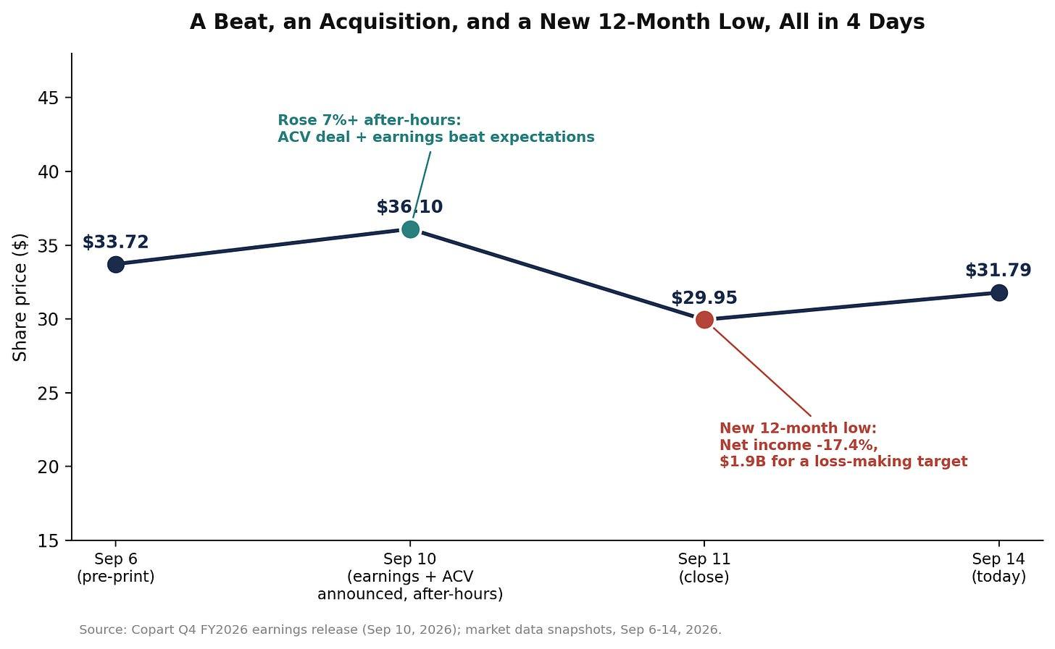
Generated using Claude
The stock rose more than 7% in after-hours trading the night of the announcement, then fell to a new 12-month low of $29.95 the very next trading session as the market had a full day to digest both the earnings miss and the price tag on a loss-making acquisition. It’s since recovered modestly to ~$31.7 as of this writing.

Peer comparison
Copart trades at roughly 20.5x trailing earnings and 13.4x EV/EBITDA at today’s price. RB Global, its primary competitor following the 2023 IAA acquisition, trades at a richer 24.5x forward P/E and 18.1x EV/EBITDA. On every capital-efficiency metric I can compare, Copart remains the structurally better business. The market is now paying a lower multiple for the higher-ROIC company and a higher multiple for the lower-ROIC one, largely because RB Global is the one with growth momentum right now (units up roughly 4.7% year over year against Copart’s decline) and Copart is the one absorbing bad news. That’s a real repricing of relative quality versus relative momentum, and it’s the clearest evidence I have that the market is, at least partly, extrapolating this quarter’s weakness rather than pricing Copart’s structural advantages at face value.

Valuation
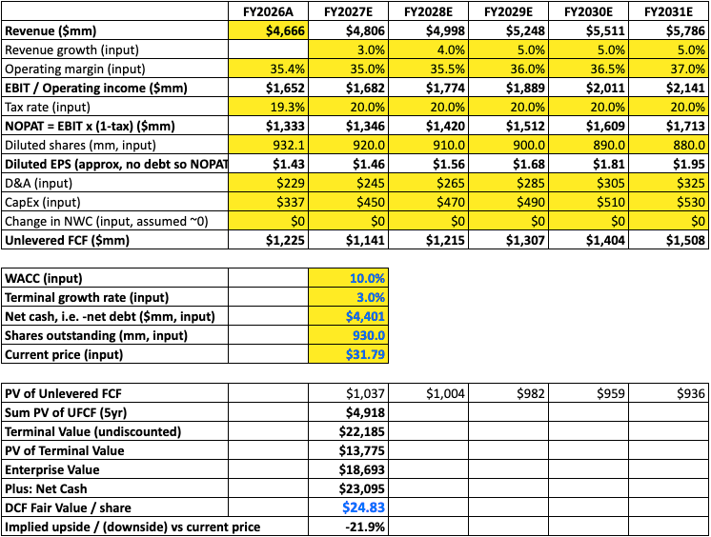
Copart gives no formal guidance. Every assumption from FY2027 forward is mine, built from the trend in this release and sell-side consensus as a reference. Treat this as more judgment-dependent than my other work.
WACC is 10%, essentially the cost of equity since there’s no debt, beta around 1.1 on a 4.2% risk-free rate and 5% equity risk premium, rounded up one tick for conservatism. Terminal growth rate: 3%.
The key judgment call is operating margin. I’ve got it dipping to 35% in FY2027 as the new product investments and ACV integration costs run through, then recovering gradually to 37% by FY2031. That recovery isn’t guaranteed. If margins stay compressed around 34-35%, the model produces $22.08. The bull case, closer to sell-side consensus on both growth and margin recovery, produces $28.62. Both are below today’s price of $31.79.
The base case fair value is $24.83, approximately 22% below where the stock trades. The only way to justify the current price on a DCF is an 8.5% discount rate with 4% terminal growth, which is a set of assumptions I can construct but don’t fully believe given an open DOJ investigation and the first annual US service revenue decline in recent memory.
The PAT multiple cross-check lands in the same place. At a 20x exit multiple on FY2031 net income, discounted back at 9.7%, you get $24.50. At 25x, which is not an unreasonable multiple for this business if the operating picture stabilizes, you get $30.63, just below today’s price. The stock is priced for a multiple recovery that the numbers don’t yet support.
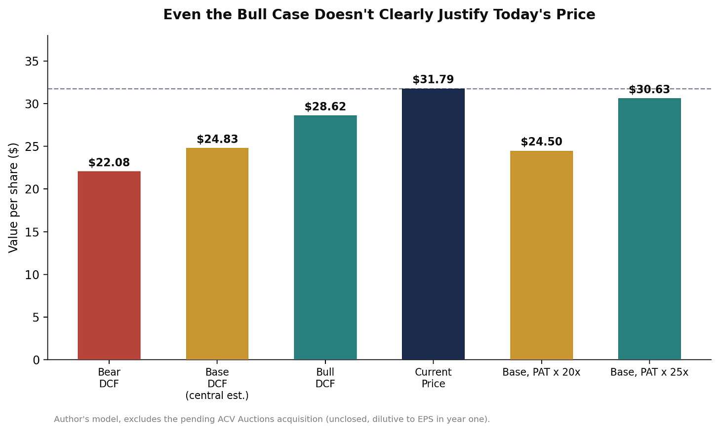

Key risks
The ACV integration. A $1.9 billion all-cash purchase of a currently loss-making business, explicitly not accretive until fiscal 2028 by management’s own admission, is real execution risk layered on top of everything else in this thesis.
Two open regulatory matters now, not one. The DOJ money-laundering investigation, first disclosed in October 2023, remains unresolved with no update on timing, scope, or outcome as of the most recent filings I could find. The ACV deal adds a second, more conventional antitrust review on top of that. Neither alone is likely fatal to the thesis. Together, they’re two separate binary events the stock now has to clear.
Competitive share loss continuing. RB Global’s momentum against Copart’s volume decline was the single most uncertain risk in my last piece, and this quarter’s US-specific weakness doesn’t resolve that question either way.
Capital allocation credibility. Buybacks stalling in the exact quarter the stock got cheapest, followed immediately by a large, dilutive-for-now acquisition, is a pattern I want to see explained by management.

Growth opportunities
The total loss frequency tailwind is real and structural: at 23.6% and rising, more cars are being written off entirely rather than repaired every year, which mechanically grows Copart’s addressable pipeline over time regardless of how the full-coverage insurance question resolves. International growth, up 8.2% in operating income for the full year against a 4.2% US decline, shows the business isn’t purely a US story even though the current problems are. And if the ACV thesis is right, even on the company’s own multi-year timeline, Copart owns a genuinely differentiated end-to-end position spanning salvage, wholesale, and international resale that neither RB Global nor any pure salvage competitor can currently match.

Where I land
The last piece ended with three things to watch: US volume stabilization, evidence of real strategic change from Adair, and the DOJ matter. I got clear answers on exactly none of them in the direction I’d have wanted. Volumes didn’t stabilize, this quarter was worse than the one before it. Adair has absolutely made a real strategic move, but it’s one that adds risk and multi-year uncertainty rather than resolving any. And the DOJ investigation sits exactly where it did in August: unresolved, unquantified, and now joined by a second regulatory review.
My DCF puts fair value at $24.83. My bear and bull cases bracket that at $22.08 and $28.62. My PAT cross-check, even reaching for a generous 25x exit multiple, tops out at $30.63. Every single one of those is at or below today’s $31.79. That’s a different, more cautious conclusion than the last piece. Three weeks ago I thought the multiple compression looked overdone. Having now rebuilt the cash flows from scratch against a genuinely worse quarter and a genuinely riskier balance sheet, I think the compression has been substantially rational.
This remains an excellent operating business. A 27.5% return on the capital actually deployed in the auction operations is a figure very few public companies can claim, and the land-ownership moat I wrote about in August hasn’t gone anywhere. But “excellent business” and “buy the stock here” are different claims, and my own numbers don’t support the second one yet. My price target is $25, roughly in line with my base-case DCF. I’m not moving this off the watchlist. If anything, after this quarter, there’s more to watch than there was three weeks ago.

Daan | InvestInsights
Deep dives

Copart, Inc. – A one-of-a-kind business with a killer business model (Deep Dive)

Let me take you through everything you need to know about this excellent compounder with one of the best business models you'll come across!
Daan | InvestInsights
Jun 28, 2025
Looking for a top compounder with a strong track record, healthy financials, a great moat, and great organic long-term growth prospects? In other words, are you looking for a gem to buy and forget about for the next 10 years?
Copart, the undisputed global leader in online vehicle auctions and remarketing services, should be on your list of considerations, without a doubt. This company is truly exceptional and tends to fly under the radar, not creating flashy headlines but delivering strong, anti-cyclical compounding results year after year, driven by a compelling underlying market that benefits from strong secular organic growth drivers.
Most importantly, the company has a formidable moat that makes it nearly impossible to disrupt, ensuring the durability of its business model and minimal competition. Additionally, it has a pristine balance sheet, delivers strong margins from a capital-light business model, and consistently achieves strong reinvestment metrics.
This really is a one-of-a-kind business and an investor’s dream.
Sadly, that is also exactly how it tends to be priced by investors. Copart rarely trades at a discount, with its high-quality business consistently earning it a premium. Notably, Copart shares have faced pressure recently, reaching a fresh 12-month low, driven by the company's near-term headwinds and an elevated investment cycle.
Now, even at a 12-month low and after losing some 15% YTD, shares still trade at over 30x this year’s earnings, which isn’t cheap, but recent weakness might just give us an opportunity to pick up some shares in this brilliant business at a fair price, or does it?
To find out, in this article, I will take a deep dive into Copart, discussing its fundamentals, business model, moat, growth prospects, finances, recent performance, and medium- to long-term outlook.
In other words, this article will provide investors with all they need to know about Copart. Let’s delve in!


Want to support our work and receive much more [FREE] investment content like this? Make sure to subscribe!
Subscribe

A one-of-a-kind business with a killer business model

Company fundamentals + business model
As always, let’s start from the beginning: What is Copart?
Founded in 1982 and headquartered in Dallas, Texas, Copart, Inc. is a global leader in online vehicle auctions and remarketing services, specializing in the resale and remarketing of salvage and clean title vehicles. What this means exactly is that Copart operates an online auction platform, selling mostly damaged or unwanted vehicles (or parts), most often on behalf of insurance companies, dealers, and fleets.
The company sells these vehicles through its proprietary online auction platform, VB3, connecting sellers and buyers worldwide. It sells these vehicles and parts to a diverse base of buyers, including licensed dealers, dismantlers, rebuilders, exporters, and end-users.
In terms of global exposure, the company operates across 11 countries and has buyers in over 190 countries. Copart's global footprint spans across North America, Europe, the Middle East, and parts of Asia, enabling it to serve a broad and growing international customer base. At the same time, the company remains U.S.-heavy, generating 80% of its revenues in the United States.
The company sources vehicles primarily from insurance companies (75-80% of inventory), which supply damaged or totaled cars following accidents, natural disasters, or theft recoveries. In addition to insurers, Copart also works with banks, financial institutions, fleet operators, car dealerships, and individual sellers to expand its inventory. As a result, the company has over 265,000 vehicles available online on any given day and sells more than 3 million per year.
Notably, in most situations, Copart only functions as a middleman between the insurance companies and buyers, earning fees every time a car is sold. In these situations, Copart doesn’t own the cars. Instead, it acts like a marketplace or service provider, running the auction, finding buyers, handling paperwork, and charging fees to both the seller and the buyer for facilitating the sale. This is the core of Copart’s business — it’s stable, scalable, and highly profitable because Copart doesn’t carry the financial risk of owning inventory.
This business model keeps it capital-light, highly profitable, and insulated from the cyclical swings in demand and car prices the broader industry is subject to. These “fee cars,” as Copart calls them, are roughly 80% of its business.
Through its extensive network of storage facilities and logistics services, Copart offers a comprehensive solution that includes vehicle transportation, title processing, appraisal services, and international shipping assistance. Its ability to manage the entire lifecycle of a vehicle, from intake to sale and post-sale services, allows it to provide a seamless experience for both sellers and buyers.
Additionally, there are instances where Copart purchases vehicles outright and resells them. These are called purchase units. Copart steps in to purchase certain vehicles when it believes it makes sense, often in situations where there isn’t a seller directly looking to auction. However, because Copart then owns these cars temporarily, this side of the business involves more risk and is much more sensitive to changes in used car prices or overall demand.
This represents a significantly smaller portion of total sales and revenue, but it reduces the company's dependence on external suppliers, such as insurers, which is a valuable aspect of diversification. This now accounts for the remaining 20% of revenues.
So, just to take a step back now: How does Copart generate revenues?
- Buyer Fees: Fees charged to buyers for each winning bid (typically scaled based on sale price).
- Seller Fees: Fees charged to insurance companies and other sellers for processing and selling vehicles.
- Auction Listing Fees: Charges for listing, handling, and processing vehicles.
- Title Processing Fees: Handling of title transfer, lien resolution, and paperwork.
- Transportation & Logistics Services: Towing, storage, and vehicle movement for insurers and sellers.
These together account for roughly 80% of revenue. The remaining 20% is generated through vehicle sales. In this category, Copart takes temporary ownership of inventory and recognizes full vehicle sale proceeds as revenue, unlike fee-based service revenue.
- Non-insurance sellers (dealers, fleet operators, rental companies, finance companies, repo agencies).
- Purchased Inventory: Occasionally, Copart acquires and resells vehicles directly (still asset-light, but different accounting treatment).
- International Sales: Some vehicle export sales may fall into this category.
As previously noted, while these revenues carry a higher risk, they provide valuable supply diversification. This also includes international revenues and the recent acquisition of Purple Wave. For reference, Purple Wave is a business Copart acquired to expand beyond its core insurance salvage auctions. While Copart primarily deals with damaged cars and light trucks, Purple Wave focuses on auctioning heavy equipment, construction machinery, agricultural equipment, trucks, trailers, and industrial assets. These are typically sold by businesses, municipalities, farms, or construction companies rather than by insurance companies.
By acquiring Purple Wave, Copart has diversified its auction business beyond vehicles, giving it access to a new group of sellers and buyers, and adding another growth lever that isn’t directly tied to auto salvage or insurance claims. Quite valuable and further strengthening its moat.
Ultimately, Copart’s business model is highly scalable and asset-light, which, combined with its technology-driven platform and massive network effects, has enabled Copart to become a dominant player in the industry. It holds a market share of approximately 65% in both the U.S. and internationally, and together with IAA, controls approximately 80% of the market.
Yes, Copart practically operates a monopoly.
Most importantly, its market share is growing as well, as Copart is well outpacing the competition, fully benefiting from network effects. The competition simply cannot keep up with its superior technology, scale advantage, breadth of inventory, and massive user base; more on this (its moat) later.
Through these subsequent network effects, operational efficiency, and the healthy growth in the underlying market, driven by growing demand for used vehicles across multiple markets, Copart has delivered excellent financial results over the last decade.
- Averaged a 15% revenue CAGR over the last 10 years
- Averaged a 16% revenue CAGR over the last 5 years.
- Averaged a 28% EPS CAGR over the last 5 years.
- Averaged a 22% EPS CAGR over the last 10 years.
These are absolutely blinding numbers and massively impressive.
However, potentially even more impressive, the company consistently delivers these strong results. This is driven by its highly predictable and economically insensitive revenues. The majority of Copart’s business comes from insurance companies auctioning total-loss vehicles. Total-loss events (accidents, thefts, floods, hurricanes, fires, etc.) happen regardless of macroeconomic conditions. People don’t stop having accidents in recessions, and so Copart’s business keeps running at any time.
Additionally, demand for salvage vehicles — whether for parts, repairs, or resale — remains strong in almost all environments. International buyers (Copart’s largest growth area) are often purchasing lower-cost vehicles for markets where new cars are prohibitively expensive.
And finally, Copart doesn’t own the inventory it sells (most often); it acts as a service provider. This keeps gross margins stable, as revenue is tied to auction fees, rather than vehicle prices or holding costs.
As a result, even in 2008-09 (GFC), Copart delivered positive revenue growth, and over the last 10 years, it has delivered only six quarters of negative growth (including 2 during COVID), with its deepest drop just -4%. This is truly a testament to the quality of this business and its brilliant, fee-based, asset-light model.
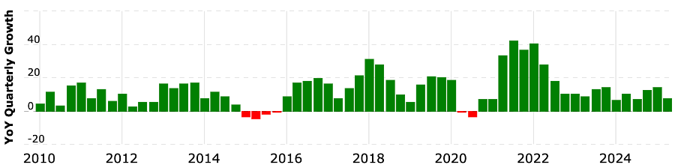
Copart’s quarterly YoY growth rates (Macrotrends)
Long story short, Copart is a brilliant one-of-a-kind business. It has a capital-light, highly scalable, and anti-cyclical business model and has grown into a dominant force in the relevant markets, practically operating a monopoly. With the same industry also experiencing steadily growing organic demand, Copart is able to deliver strong compounding results year after year, facing barely any cyclicality.
I mean, what is there not to like about this business model?
And yet, the even more impressive and important quality of this business is its massive moat.

Subscribe

Competitive edge (moat)
One of the most important questions in the building of any investment thesis to ask yourself is: Does this business have a moat/competitive advantage that ensures durability and should make it a long-term winner?
For Copart, the answer to this question is a convincing “Yes.” Copart has a very strong moat, and arguably one of the widest in the vehicle remarketing industry. Its competitive advantage is built on multiple durable pillars that are very hard for competitors to replicate.
For starters, there are the strong network effects, which I referred to earlier. At its core, Copart runs a two-sided marketplace with buyers and sellers. The more inventory Copart has, the more attractive it becomes to buyers. The more buyers it has, the more valuable it is to sellers. This flywheel is self-reinforcing.
Furthermore, with over 300,000 registered buyers across 190 countries, Copart has significantly deeper liquidity than its competitors, enabling it to secure better pricing for sellers and achieve higher conversion rates. This size only continues to attract more users and buyers, as both parties favor Copart over competitors due to its size on either side of the transaction. This is a massive competitive advantage.
Closely tied to this, Copart’s long-standing relationships (often decades) with suppliers, mostly insurers, also give it an advantage and add to its moat. You see, Copart has long-term relationships with most major U.S. insurance companies, which provide the bulk of its vehicle supply. Switching to a competitor like IAA would entail disruption, potentially lower realized prices, and a less liquid buyer base — creating high switching costs for sellers. These relationships are more than simple vendor contracts—they involve integrated systems, data sharing, and tailored auction solutions.
To provide further background on the importance of these relationships, Copart’s insurance partners are crucial to its business model and competitive advantage, forming the backbone of its vehicle supply and revenue streams. Insurance partners include major U.S. carriers like GEICO, Progressive, Allstate, State Farm, and Nationwide, among others. These relationships deliver a steady, high-volume, and relatively predictable flow of salvage vehicles.
Knowing that these insurance partners will not go anywhere else and will only use Copart for decades to come creates a significant moat on the supply side.
At the same time, Copart’s brand is also highly trusted. International buyers often prefer Copart for quality, reliability, logistics, and title management. This strengthens its position as the default auction platform on both the buy and sell sides.
And there is more. Another competitive advantage worth pointing out is real estate and technology.
Copart owns most of its yards outright — over 250 locations globally — which creates enormous scale advantages. Acquiring, permitting, and developing this land takes years and often faces regulatory hurdles. Many competitors lease land, which leaves them vulnerable to rising costs or losing capacity. Copart’s real estate footprint gives it unmatched storage capacity, flexibility during volume spikes (such as catastrophes), and lower long-term costs.
Additionally, Copart’s technology investments, such as its VB3 auction platform and the Title Express service, are powerful differentiators. Title Express now processes around one million titles per year, improving cycle times and seller satisfaction. Meanwhile, its proprietary VB3 online auction platform is widely regarded as the best in the industry. Copart was among the first to fully embrace online-only auctions and now benefits from years of data, optimization, and customer familiarity.
Due to its size, technology platform, and owned infrastructure, Copart operates at a lower cost per vehicle compared to its smaller peers. This allows it to reinvest aggressively in growth while maintaining high margins and returns on capital.
Pretty neat, right? These factors create a massive moat for Copart. It is wide, diversified, and still widening. It would be extraordinarily difficult and expensive for any new entrant to replicate its combination of technology, land assets, global buyer base, insurer relationships, and brand trust.
This is exactly why Copart is consistently outgrowing IAA, its closest peer, and widening the competitive gap, not facing stiff competition from them. One can simply compare growth. Even though Copart is the larger of the two, it is still outgrowing its closest peer.
- Over the past 5 years, Copart has grown revenue at a 16% CAGR.
- Before being acquired by Ritchie Bros in 2023, IAA’s growth was much more modest, generally low- to mid-single digits.
This widening reflects Copart’s stronger insurance partner retention and new account wins. Major insurers, such as GEICO, Progressive, and Allstate, are deeply integrated with Copart.
Copart really is a power in the industry, and it is fully benefiting.

Organic growth drivers
So, we have a favorable business model, a dominant market position, and a massive moat allowing it to keep gaining market share and neglecting any risk of disruption.
The only question remaining, then, is how fast its addressable market is growing. Once again, this looks brilliant for Copart, as trends driving growth over the last decade remain in place and become even more powerful.
Surprisingly (at least, I thought so), the online salvage auctions market is a highly attractive and rapidly growing one, benefiting from secular growth drivers that aren’t going anywhere.
First and foremost, rising total-loss frequency has been a powerful secular force for Copart’s business. Simply put, as modern vehicles become more complex and safer, thanks to advanced sensors and chips, repair costs have escalated. All these technological parts are incredibly expensive and complex to replace and repair.
Consequently, insurance companies increasingly declare vehicles as total losses. Copart’s leadership notes that total-loss frequency “has grown more than fourfold since 1990” and remains above pre-pandemic levels. This trend underpins much of its organic growth in volume. More total losses mean more business for Copart, and this trend continues to grow.
Additionally, population growth and increased vehicle miles traveled (VMT) also contribute. The U.S. population has roughly doubled since 1960, and VMT has quadrupled. Even though crash frequency per mile has declined (due to increased safety), the aggregate level of total losses remains strong, creating a steady supply for Copart’s auctions. So, even though people crash less, the higher mile count still leads to growth in total losses, growing Copart’s supply.
As a result of these secular developments, which show no signs of weakness, the North American online salvage auctions market is expected to continue growing at a robust 14% CAGR through 2030, which should provide Copart with ample growth opportunities. Meanwhile, Copart is expanding its international presence, with growth expected to be even more considerable outside of North America, projected to grow at a 24% CAGR.
In short, Copart’s addressable market is expanding rapidly, and its strong positioning suggests it’s well-positioned to capture a substantial share of this multi-billion-dollar growth opportunity.
All things considered so far, you won’t be surprised to hear that Wall Street’s expectations for Copart over the next 5 years are optimistic. Although it is facing some near-term weakness (about which more will be discussed in a moment), expectations are for Copart to continue growing sales at a double-digit rate. Personally, I believe a low double-digit CAGR (10-12%) over the next 5 years is very likely, possibly even conservative, and with limited economic sensitivity, that is a very strong prospect.
On that note, let’s delve deeper into the company’s recent performance, developments, and financials.

Subscribe

Copart faces some cyclical headwinds, but remains in great health
While Copart’s CAGR results over the last 5 and 10 years are mighty, as pointed out earlier, Copart has seen growth moderate a bit (to roughly a 10% CAGR) in the post-COVID years. Why?
In 2021-2022, vehicle prices (both retail and salvage) spiked due to tight supply, low new car inventories, and COVID disruptions, which fully benefited Copart. However, as new car production normalized in the years that followed, used vehicle and salvage values have declined from peak levels, reducing Copart's fee-per-vehicle growth. This has created tough comps even if volumes remain stable or grow.
In most industries, revenue softness would be a cyclical contraction. For Copart, this is more like a return to steady-state growth after an unusual multi-year tailwind. Nothing to worry about – growth remains healthy enough.
Looking at the latest quarter, for which Copart reported results in late May, Copart reported total fiscal Q3 revenue of $1.2 billion, up “just” 8% YoY and sitting roughly in line with consensus estimates. As you can see below, revenue growth tends to fluctuate as neither demand nor supply is constant.
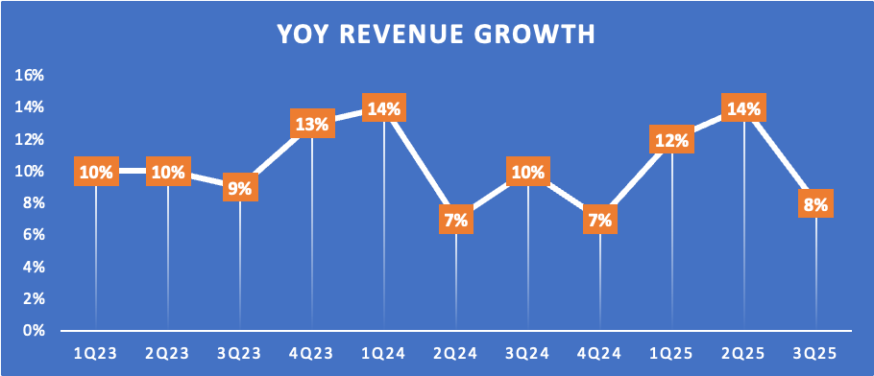
By region, growth was driven by 18% growth in international sales and 8% sales growth in the U.S., or 7% excluding cat units. As explained previously, Copart deals with fee units (only middleman fees) and purchase units (own inventory). Additionally, there are cat units, which are vehicles that come from natural disasters such as hurricanes, floods, hailstorms, and wildfires. These are still fee units, but Copart sometimes separates them out to highlight abnormal volume spikes during catastrophe seasons. So, excluding these one-offs, U.S. growth was 7%.
Examining the underlying dynamics, let’s start with insurance, as this is Copart’s primary supplier. For fiscal Q3, Copart reported that global insurance volume remained relatively flat year-over-year, with a nominal decline of 0.3% globally in unit sales and 0.9% in the United States. In other words, Copart sold about the same number of insurance cars as it did a year ago. However, if we adjust for the fact that 2024 had an extra business day (because it was a leap year), then volumes were actually up slightly — 1.3% globally and 0.6% in the U.S.
Meanwhile, total loss frequency continues to rise YoY, hitting 22.8% in fiscal Q3, up a strong 100 bps YoY, which indicates this underlying trend remains strong. What this number means exactly is that 22.8% of all insurance auto claims (accidents, damage, thefts, etc.) resulted in the car being declared a total loss rather than being repaired, which fuels Copart’s business.
However, this means we have a strongly rising total loss rate but flat volumes. According to Copart, this difference has two reasons:
- The numbers aren’t perfectly precise. The way “total loss frequency” is measured can change after the fact, because some claims are reclassified later. So, there’s a bit of noise and delay in the data.
- There are some macro headwinds. For example, there’s a rise in the number of uninsured or underinsured drivers, which can reduce the number of cars funneled through insurance channels — and therefore through Copart.
Over time, these cyclical forces will reverse, but in this specific quarter, this posed a headwind in the company’s largest channel.
Nevertheless, correcting for the leap year, total unit sales increased by 2% year-over-year, which is healthy enough. By region, U.S. unit sales were flat, driven by a 1% decrease in insurance units, offset partially by 14% growth in non-insurance units. Internationally, unit growth was 6% YoY, with 9% growth in fee units but a 13% decline in purchase units due to a shift in preference from large insurers outside of the U.S.
Overall, this slower supply led to a global 10% decline in inventory YoY, or quite literally fewer cars on its auction. According to management, the inventory currently reflects the cyclical impacts associated with an increasing share of underinsured and uninsured motorists, as well as varying growth trajectories among insurance carriers.
The number of vehicles coming into their auctions is being affected by two things right now. First, there are more drivers who don’t have enough insurance or no insurance at all, which means fewer of their cars end up being processed through insurance companies and sent to Copart. Second, not all insurance companies are growing at the same pace, so some insurers are sending in fewer cars while others may be sending in more. These two factors are influencing the overall number of cars Copart has in its system at the moment, though this number tends to fluctuate.
Overall. I believe Copart’s business remains fundamentally strong, but current growth is being held back by temporary supply-side pressures. Total loss frequency, which drives long-term supply, continues to rise, showing the structural health of the model. However, more uninsured and underinsured drivers, along with uneven growth across insurance carriers, limited the number of vehicles flowing into Copart’s auctions this quarter.
Adjusted for the leap year, unit volumes still grew modestly, helped by strength in non-insurance and international sales. While inventory levels are temporarily lower, these are cyclical factors, not a sign of weakening demand or market position. Copart remains well-positioned for long-term growth once these short-term headwinds ease.
Moving to the bottom line, it hasn’t been all plain sailing for Copart in recent quarters. If we look at Copart’s gross margin, we can see considerable weakness over the last four quarters, which can be attributed to a mix shift and some inflationary cost pressures, but none to actual operational weakness.
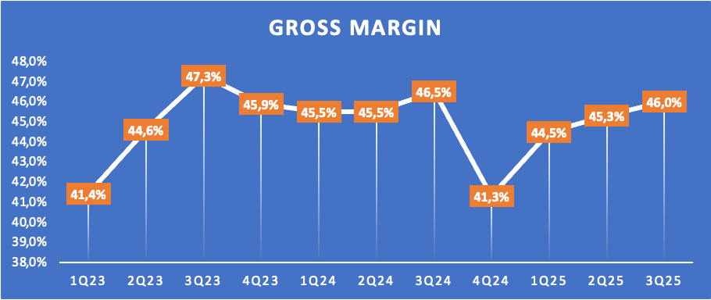
First, Copart has been seeing stronger growth in non-insurance and international units, which generally carry slightly lower margins compared to its core U.S. insurance fee business. International operations, especially as they scale up, often involve higher costs per unit sold due to logistics, regulation, and market development. Similarly, non-insurance sales sometimes include more lower-margin vehicles or seller types that don’t generate the same fee structure as insurance consignments.
Additionally, cost inflation is playing a role. Higher labor, towing, yard operations, transportation, and facility costs have been modestly pressuring margins. Copart has done a good job managing these increases, but the cumulative effect is still evident in gross margin compression.
Overall, it’s not a sign of underlying weakness in the model — it’s mostly a function of sales mix shifting toward newer segments, some inflationary cost growth, and the normal volatility that comes when volumes and unit types fluctuate in the short term. The core fee-based, high-margin U.S. insurance business remains very healthy, and Copart’s gross margin is best-in-class.
In addition to some weaknesses, Copart has also been heavily investing in facility capacity, its towing and real-time tech tools, and doubling the size of its specialized sales teams, particularly for Purple Wave. These investments put additional pressure on near-term margins, which, combined, have been spooking investors over recent quarters, though Copart’s bottom line remains strong overall.
Looking at the latest quarter, Copart reported a gross profit of $552 million, up roughly 5% YoY. This translates into a gross margin of 46%, down 50 bps YoY, as we can clearly see margins recover after a deep drop in fiscal Q4 2024, as inflationary pressures ease.
Further down the line, this resulted in a net income of $407 million, up 6% YoY, or $0.42 per share, in line with consensus estimates. This also includes $7 million from interest income, as Copart has invested a portion of its cash pile into treasury securities.
This translates into a really strong fiscal Q3 net income margin of 33.9%, which is up 10 bps YoY. Thanks to strict cost control, Copart’s gross margin weakness hasn’t shown too much of an impact on the company’s net income margins, apart from limited expansion compared to prior years.
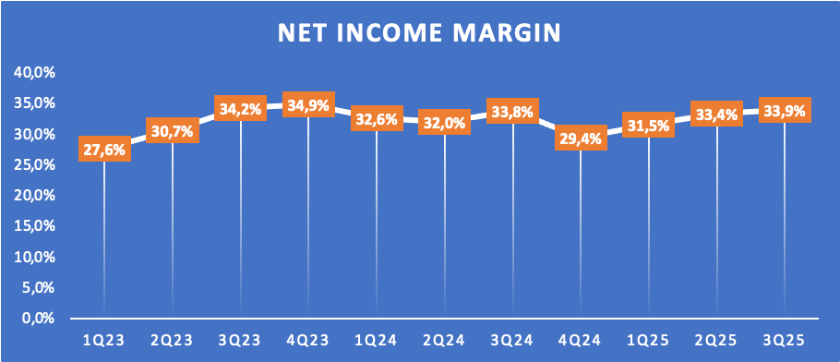
Finally, in terms of financial health, Copart appears to be in excellent shape. The company ended the latest quarter with $5.6 billion in liquidity, comprising $4.4 billion in cash and $ 1.2 billion in capacity under a revolving credit facility. Meanwhile, Copart holds virtually no debt on its balance sheet, leaving it in a pristine financial position with ample liquidity, especially considering the business now also generates almost $1 billion in FCF annually.
This is really impressive.
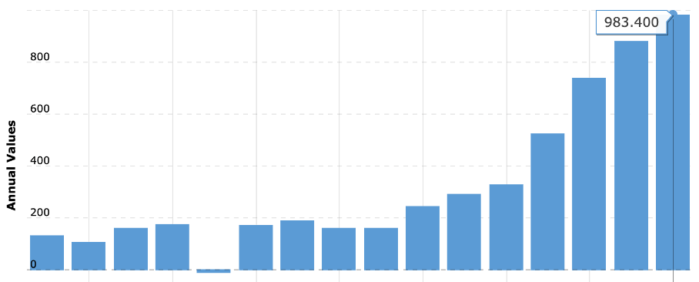
Copart’s annual FCF (Macrotrends)
And crucially, Copart management has shown a great ability to reinvest all these cash flows into the business to fuel long-term growth, as proven by an excellent ROE and ROCE.
Copart’s ROE has remained strong, though it has moderated from its earlier peak:
- 2024 TTM (as of July 31, 2024): 20%
- 2023 average: 23%
- 2022 average: 27%
- 5‑year average (2019–2024): 26%
Copart consistently delivers excellent returns on invested capital:
- 2021 = ROIC of 21%
- 2022 = ROIC of 24%
- 2023 = ROIC of 20%
- 2024 = ROIC of 17%
- TTM (as of early 2025) = ROIC of 16%
What does stand out across both numbers is that they have declined from peak levels in recent years. Generally, falling ROIC is a big negative, as it shows the company is no longer able to use its cash as efficiently as it grows. At least, that’s what it means in most circumstances. However, Copart is an exception.
Crucially, the drop in Copart’s ROIC over the past couple of years doesn’t reflect operational weakness but rather changes in the capital base driven by deliberate, long-term strategic investments.
One of Copart’s biggest competitive advantages is its network of owned storage yards. Over the past few years, the company has made significant capital investments to acquire additional land and expand existing storage capacity. Because these real estate investments are capitalized on the balance sheet, they increase invested capital immediately, while the revenue and profits tied to these yards are only realized gradually over time as volumes build. This creates a short-term ROIC compression — invested capital rises faster than operating profit.
Copart has also invested heavily in technology (e.g., VB3 platform, Title Express), international operations, logistics infrastructure, and towing capacity. These investments are designed to scale the business for higher volumes, but again, the returns come with a lag. This kind of "build it before you need it" strategy temporarily lowers ROIC because you're deploying capital ahead of the corresponding profit growth.
Meanwhile, the core business remains extremely profitable and capital-efficient — management is simply playing a long game to support much larger volumes down the road. Still, these numbers remain healthy today, and I expect them to improve as the rate of investments eases off and earlier investments start paying off as volumes build.
In the meantime, Copart continues to deliver excellent results, showing a strong ability to reinvest and maintain a pristine balance sheet in the meantime.
Regarding the recent performance and margin compression, I am not overly concerned. Despite facing some near-term pressure over recent quarters, the company remains in excellent financial health and exhibits no fundamental or operational weaknesses. While these cyclical sales and margin pressures have impacted consumer sentiment, I am convinced these are only temporary. I remain confident in Copart’s ability to consistently deliver double-digit growth and steadily expanding margins.
Fundamentally, Copart is showing brilliant numbers all around.

Before we move on, just a quick word…
Want more out of your subscription?
InvestInsights PRO - $7.50/month ($70/annually)
- An additional 2-5 premium stock analysis monthly.
- Full insight into my own portfolio (15% return CAGR since 2022).
- Monthly portfolio updates + Instant transaction alerts (Fully transparent)
- A complete overview of all my target prices and ratings (Excel file).
- Exclusive access to the PRO subscribers Discord channel
- Instant access to earlier premium analysis on, for example, Adobe, Thermo Fisher, Spotify, and The Trade Desk.
Subscribe

Outlook & Valuation
As for Coparts’ outlook, a lot has already been touched upon so far in this analysis. As pointed out earlier, looking at the fundamentals of its business and the expected growth in the underlying industry, I strongly believe Copart should be able to keep delivering double-digit sales growth in the medium-to-long term, fueled by secular trends, market share gains, and excellent execution.
Meanwhile, growing operating leverage, the easing of near-term headwinds, and a slowing rate of investments should allow for solid margin expansion in the years ahead, which I expect to result in low-teens EPS growth.
These estimates indicate somewhat slower growth than we have seen from the company over the last decade, but we should acknowledge that the company has grown significantly in size, making it challenging to maintain this level of growth organically.
Ultimately, considering all factors, I now expect the following results from Copart through fiscal year 2028. This accounts for some macroeconomic headwinds that are expected to persist into FY26 and ease in the years after.
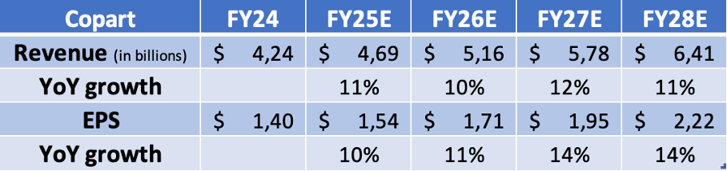
So, where does this leave us in terms of valuation? As I mentioned earlier, Copart shares generally trade at a premium, and rightfully so. Interestingly, shares have faced significant weakness over the last year or so, as investors have become more cautious in the face of near-term macroeconomic weakness, inflationary pressures, and higher investments, leading to somewhat slower revenue growth and some margin pressure.
However, as discussed, long-term trends remain intact, and the company shows no operational weakness. Nevertheless, Copart shares now trade at a 12-month low of $48 per share, which is down 11% over the last 12 months and 16% YTD. As a result, Copart shares now trade at roughly 31x this year’s earnings, and while still quite a demanding multiple, this is well below its 5-year average of 35x and roughly in line with its 10-year average of 30x, so I would say that, based on historical numbers, this looks relatively fair.
Meanwhile, an EV/EBITDA of 23x suggests a slight discount to its 10-year average of 25x, and a FCF multiple of 40x is well down from a 10-year average of 66x. So, adjusting for a strong balance sheet or using real cash flows, Copart shares don’t look too expensive on a relative basis at all.
Of course, paying 40x FCF or 31x earnings is in no way cheap, but we should consider the sheer quality of this business and the premium it deserves. Copart has a brilliant, capital-light, anti-cyclical, highly scalable business model, a mighty market position (practically no competition), a very strong moat, healthy double-digit organic growth in its underlying market, industry-leading and growing margins, and consistently strong reinvestment metrics… can we (investors) ask for much more?
The result? A company growing both sales and profits at a very strong rate and with plenty of room to keep delivering double-digit sales growth and low-teens profit growth for at least another decade.
No wonder this company is awarded a premium multiple – companies like these simply don’t come on sale. Historically, any sort of discount or considerable share price weakness has proven a great buying opportunity.
I don’t think this time is any different. Paying 31x earnings for a company growing at such a strong clip, with no risk of disruption and barely any exposure to macroeconomics or cyclicality, seems quite fair.
Using a 32x multiple on my fiscal FY27 EPS estimate, which is closer to historical multiples, I calculate an end-of-fiscal FY27 target price of $62.40. From a current share price of $48, this suggests potential annualized returns of roughly 12%, which I deem really healthy returns.
So, does this make Copart shares a buy today? My answer is Yes! I believe the risk-reward and potential returns here are compelling enough to start a small position in this brilliant compounder.
However, I would prefer a bit more downside protection before buying more aggressively. If shares drop further to below $45 per share, I believe the risk-reward ratio becomes much more compelling, and the shares become a no-brainer.
For now, DCAing into a position appears to be a solid strategy.

Fiscal.ai

Copart: From Scrap to Scale

A Market Darling Down 50%
Fiscal.ai
Aug 27, 2026

Hey there👋 Welcome to the first ever Fiscal.ai substack post.
Today we’re taking a look under the hood at one of the most critical companies in the automotive industry, Copart.
Let’s dive in!

“Most people kept paper records of all their parts. But I was one of the first in the business to computerise inventory. I spent $110,000 on a large reel-to-reel computer, about double the amount most people spent on a house at the time. Other people thought I was crazy (or stupid - or maybe both) to spend so much money on a computer for a wrecking yard. But I was never afraid to spend money on technology if it could help us be more efficient. And it turned out that the whole industry would end up computerising once they saw the benefits it gave people. As large and foreign as this machine seemed back then it paid off because it gave me a complete picture of the business and the inventory, which in turn gave me more knowledge and control over the yard which helped me make money.”
- Willis Johnson, Founder & President of Copart
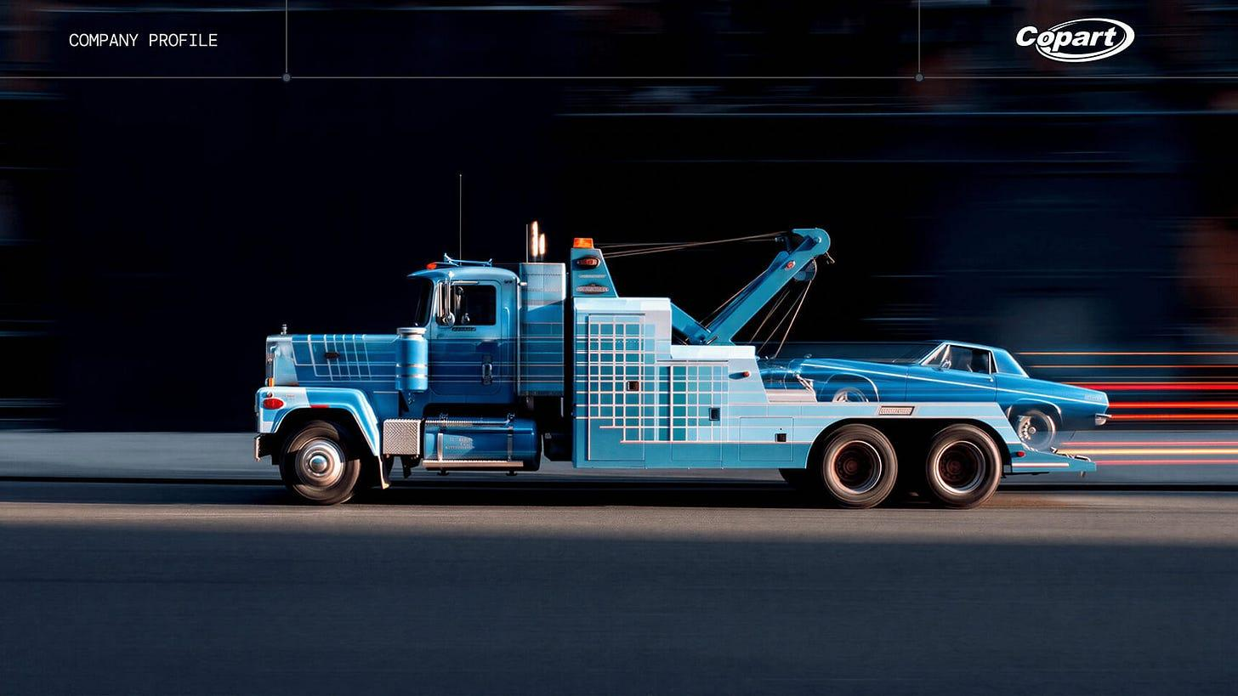

From Scrap to Scale: Copart’s History
Copart was officially born in 1982, but its roots date back to nearly 20 years prior.
As a teenager, Oklahoma-native Willis Johnson, got his first glimpse into the hidden value of car parts through his father’s scrapyard. With the hands-on experience of dismantling vehicles himself, Johnson quickly discovered that when it came to salvage vehicles, if you knew what was under the hood and had customers willing to buy the parts, there was plenty of money to be made.
Although he saw the potential value in the dismantling business, Johnson also recognized that most scrapyards were poorly run. Most scrapyard owners would buy a wrecked car, spend tons of time dismantling them, then cataloging each individual part to sell to walk-in customers. The process was slow, inconsistent, and inefficient. He knew this business couldn’t scale.
So in 1972, after returning from a one-year tour in Vietnam, Johnson scraped together all the money he had and bought a 5-acre dismantling yard in Rancho Cordova, California. This time, he ran things his own way. Instead of carrying “a little bit of everything” like most scrapyards, he decided to specialize his yard specifically on the Chrysler brand. This was one of the first major efficiency gains he implemented, and it not only led to less time on the shelves for his inventory, but it ended up resulting in a massive boost in sales too.
As local mechanics and buyers began to recognize Johnson’s yard as the only Chrysler brand specialist in the area, they knew exactly where to go when they needed a specific Chrysler part. Here’s what Johnson had to say about the benefits of specialization:
“Before we specialized, Curtis and I were running between $3,500 and $5,000 worth of parts a month at Mather. After specializing, we were running around $3,500 worth of parts a day.”

Johnson parlayed his success with his first yard into several more, each time replicating this specialized model.
But it wasn’t just specialization that enabled Copart to stand out above other scrapyards. Johnson implemented several other initiatives that made Copart dramatically more efficient than competitors. One of those being the “U-Pull-It” model.
In 1982, Willis Johnson introduced a revolutionary self-service auto salvage system that he called “U-Pull-It”. Instead of the standard process of hiring a team of mechanics to disassemble a car then sell the parts himself, Willis Johnson let customers pay an entry fee to bring their own tools and extract the parts themselves. This was far more efficient as it resulted in less labor, high-margin entry fees, and still similar revenue from actually selling the parts.
That same year, Willis Johnson decided to put a huge chunk of his money at risk by purchasing BTS Auctions for $1 million. BTS was a well-established vehicle auction operation at the time. Unlike typical scrapyards that focused on disassembling vehicles, BTS worked with insurance companies to find buyers through auctions for their totaled vehicles.
While a $1 million purchase might sound trivial compared to Copart’s current market cap of $26 billion, the BTS acquisition completely transformed Copart’s business model from a capital-intensive junkyard operator to a wide moat, capital-efficient auctioneer.

Where does Copart fit in the Auto industry now?
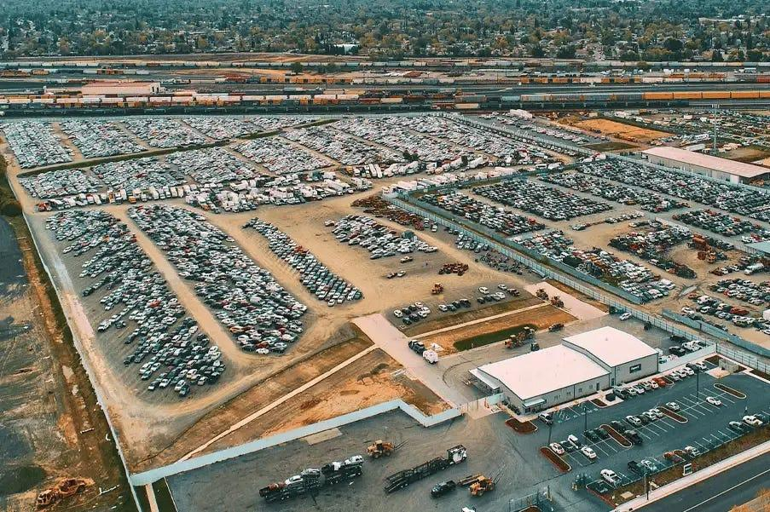
The best way to understand Copart’s role in the automotive industry is to actually walk through an example of a totaled vehicle.
Imagine you (an insured driver) get in an accident and your car takes some pretty serious damage. What would happen next?
The first thing you’ll want to do is take pictures of everything and file an insurance claim. Your insurance company will then arrange a local tow truck to take the car to an approved collision repair shop or a temporary storage lot. While it’s in the shop or the storage lot, the insurer will have an adjuster look at the damage and determine what the repair costs would be compared to the pre-accident value of the car. If the repairs would cost too much (usually 70%-80% of the vehicle value), the insurance company will then declare the car “totaled” or a total loss.
That’s where Copart comes in.
Once the car is declared a total loss by the insurance company, their internal system will then auto-populate a dispatch order to the nearest salvage yard operator that they work with. This usually comes down to one of two companies, Copart or IAA (Insurance Auto Auctions). Those two companies alone account for roughly 80% of all salvage yards in the United States.
Assuming they decide to assign the vehicle to a Copart salvage yard, Copart would then send one of their tow trucks to move the vehicle to their own salvage yard. During this process, the insurance company would be required to pay Copart various fees for things like shipping, storage, etc.
Once it’s on Copart’s lot, Copart will do some light cleaning of the vehicle and take extensive pictures. They will then list the vehicle on their website at Copart.com where they conduct an online auction for the car.

Once the vehicle is on Copart’s website, hundreds of thousands of potential buyers will be able to bid. These buyers typically include dismantlers, rebuilders, scrap dealers, etc. Once the auction is over, the buyer will pay a commission to Copart (usually 10%-15% of the purchase price) and send a tow truck to Copart’s yard to pick it up.
One important thing to note here is that Copart was the pioneer in the digital auction space. Historically, a salvage auction required buyers to physically show up to a specific lot, but in the 1990s and early 2000s, Johnson built a centralized database to track inventory across all his yards and allowed buyers to start bidding online. By 2003, Copart became the first in the industry to move to a completely online auction model.

A Durable Duopoly
The junkyard market, or “vehicle remarketing industry” as some people like to call it, has several tailwinds that have increased vehicle volumes over the decades.
For starters, there are far more cars on the road today than there were 50 years ago. On average, the total number of vehicles in America has grown by about 2% annually since the 1970s. Additionally, the average age of these vehicles has continued to rise, and since older cars carry lower baseline market values, it doesn’t take much to declare a car a total loss.
The other, less obvious tailwind has been the dramatic rise in total loss frequency. In the 1980s, for every 25 vehicles involved in an accident, 1 would be declared a total loss. Today, that number stands at just 1 in 4.
As automotive production has become more advanced and more efficient, manufacturers have been able to pack far more value into each vehicle. With so much complexity and high value parts under the hood like sensors and cameras, replacement and recalibration can be very expensive. That means even a minor fender bender can result in such high repair costs that insurance companies have no choice but to declare the vehicle a total loss.
With more and more totaled vehicles every year, insurers need a place to put them. That’s why the salvage market is so resilient. Here’s how Willis Johnson describes it:
“Think of us like the local sewer system. We’re a utility. Nothing can get rid of us - nothing. Two of the biggest businesses in the world are car manufacturers and insurance companies. If insurance companies don’t write insurance policies on cars, then they’re out of business. If manufacturers don’t make cars, then they’re out of business. They’re always gonna make cars, and they’re always gonna insure them. We’re the guy in between. As long as we’ve got the land in the right place to put the cars on, we can’t fail. We are like the septic tanks of the sewer system. You can’t have the system without us.”
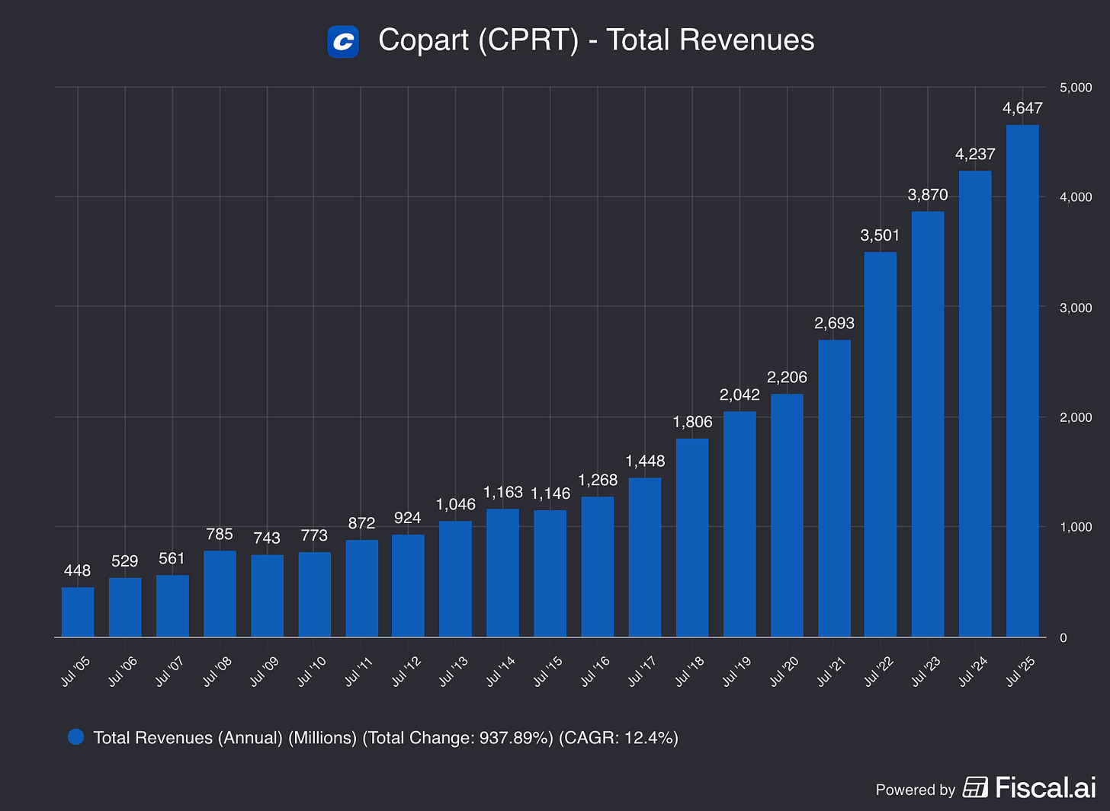
Source: CPRT Income Statement on Fiscal.ai
Today, this industry is dominated almost entirely by two companies, Copart and IAA.
Unlike Copart, which was built by a single management team, one junkyard at a time, IAA was born out of an aggressive roll-up strategy. Founder Bradley Scott took IAA public in 1991 with just 5 locations to get access to investor capital. Following the IPO, IAA went on a massive acquisition spree throughout the 1990s. By 1996, they operated 46 different locations, or nearly 10x their amount from five years prior.
However, while IAA was focused on moving fast, they made a few decisions that some might consider short-sighted. For example, unlike Copart which bought all of their physical land outright, IAA chose to lease their real estate so they didn’t have to spend a bunch of cash upfront. This helped them grow quicker, but as real estate prices have risen over the years, escalating lease renewal costs have put pressure on margins.
Additionally, as the salvage auction process moved increasingly online, IAA chose to buy its auctioning software from outside vendors. Copart, on the other hand, built its virtual bidding system internally. By owning their tech stack, Copart was able to diagnose issues and make changes much faster than IAA. This allowed them to build a much more seamless experience for online buyers.
Today, it’s clear that the long-term focused decision making from Copart has paid off. As IAA changed ownership over the years, Copart stuck to its knitting and continued to take market share. Copart now processes about 4 million vehicles annually compared to IAA’s ~2.5 million.
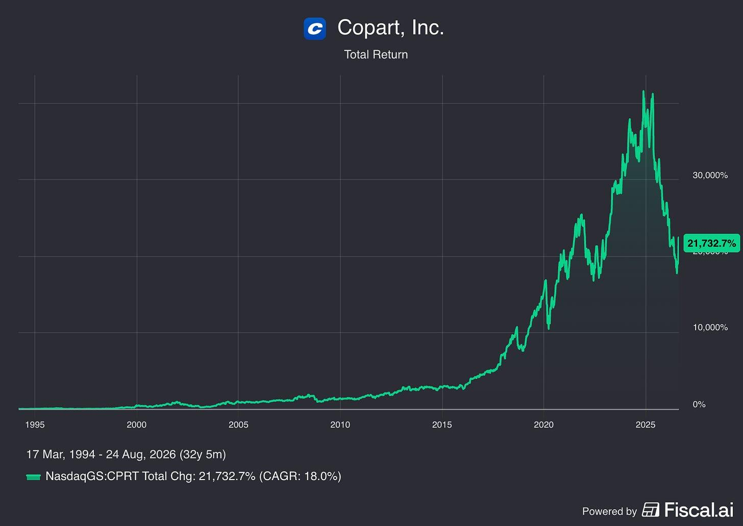
Source: CPRT Total Return on Fiscal.ai

Overlapping MOATs
Today, Copart benefits from several different competitive advantages that, in combination, create a virtually impenetrable moat for the business.
1. Owned Real Estate
Copart owns 90% of the land (or ~20,000 acres) that their 200+ salvage yards operate on. This is a truly massive cost advantage. While other competitors (most notably IAA) face escalating lease renewals, Copart’s land costs are locked in permanently.
2. Network Effect
Remember, Copart doesn’t own the vehicles on its lots. The insurance companies do. So from the insurance companies perspective, all they want is to sell their totaled vehicles for the highest possible price.
Copart’s online auctions are home to more than 750,000 registered buyers across 190+ countries. With more buyers than anywhere else, Copart gets more competing bids. More competing bids means more revenue per vehicle for the insurer.
On the flip side, buyers want access to the most possible inventory. Since Copart processes the most vehicles, that’s where the buyers have to go.
3. Customer Lock-In
Copart was the first operator to really professionalize the digital salvage auction process. This has created a bigger advantage than even they probably imagined.
Copart’s API is deeply embedded in the workflows of the largest US auto insurers. With a single click of a button, an insurance adjuster can trigger a workflow that schedules a Copart tow, books a yard slot, and submits all the necessary documentation.
To switch away from that process would require a massive multi-year enterprise IT project.

What’s Happening Lately?
As of this writing, shares of Copart are in one of their largest drawdowns in more than 20 years. Down 48% from their 2025 highs.
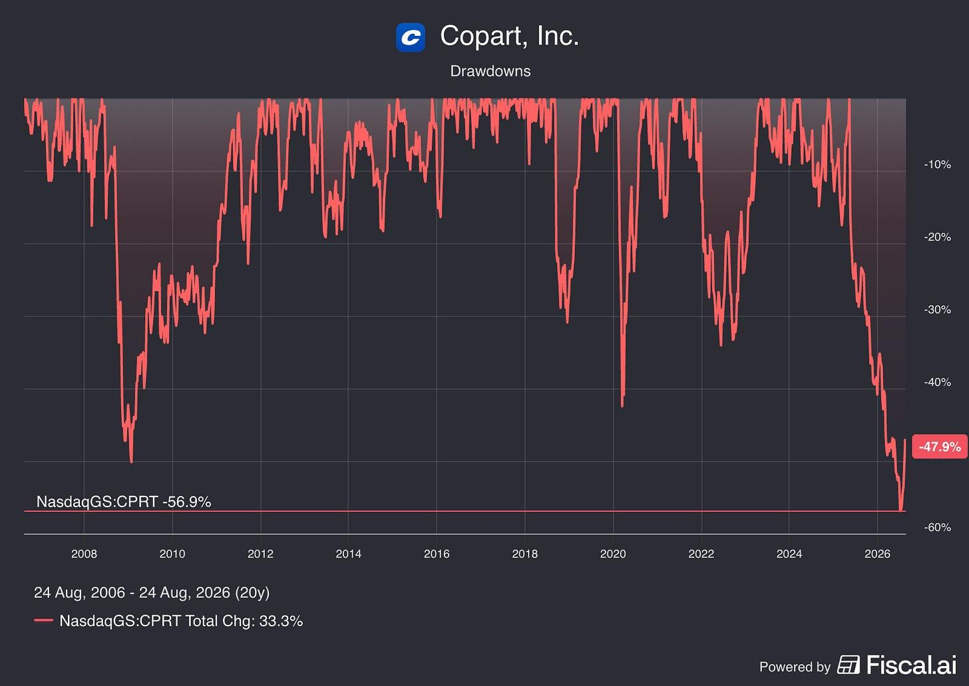
Source: CPRT Drawdowns on Fiscal.ai
This shouldn’t come as much of a surprise to those that have followed Copart’s recent results.
The company is currently growing at their slowest rate in a decade, and analysts are estimating that revenue will decline for FY2026 compared to FY2025.
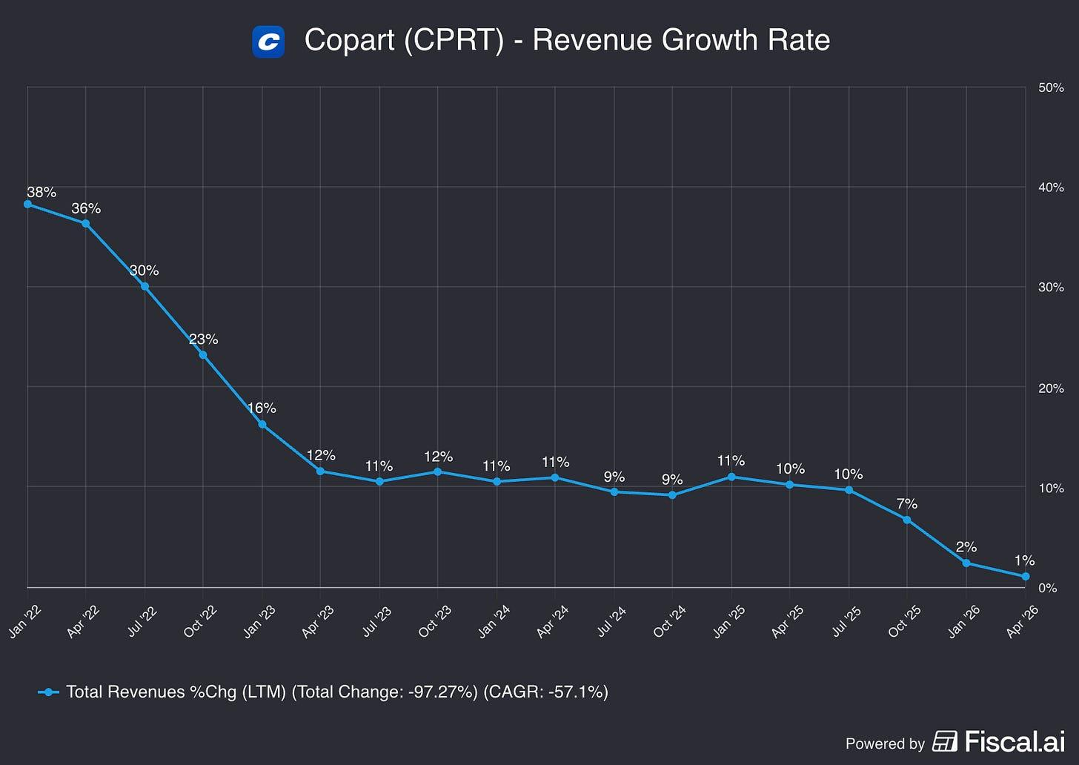
Source: Revenue Growth Rate on Fiscal.ai

Why the Slowdown?
Copart’s vehicles processed in the US declined by 4.2% year-over-year in the most recent quarter. That goes against the long run trend, so let’s look under the hood (pun intended) at what’s driving the volume drop.
For starters, overall auto insurance claims are down compared to last year. This stems from affordability concerns from consumers. As many auto insurers have hiked their premiums in recent years to restore profitability, millions of drivers with older, paid-off vehicles have decided to switch from collision coverage to cheaper, liability-only plans. While this means fewer vehicles are being routed through Copart’s yards, Copart’s management team has stated that these trends tend to be cyclical historically.
The second, perhaps more concerning factor, comes down to a single insurance carrier. Progressive.
Progressive is now the largest auto insurance company in the US, and over the last several years, they have been making an intentional push to drive volume away from Copart, and towards IAA instead. According to industry reporting, Progressive has instituted this shift because they’ll be able to get more custom service and pricing concessions from IAA.
Since Progressive is IAA’s largest customer by a significant margin, IAA apparently provides Progressive with some major perks including rapid vehicle pick-up times, superior salvage yard storage locations, and cleaner vehicle preservation. This shift from a single insurance carrier has in Copart ceding some market share back to IAA.
To add fuel to the fire, shortly after Q3 earnings, the company announced that Jeff Liaw would be stepping down as CEO, to be replaced by former CEO Jay Adair. For a company that has had very little executive turnover since its founding, this naturally created even more alarm among investors.


Are Copart’s Problems Temporary?
There’s no question that Copart is facing some very real headwinds at the moment. Between Progressive’s volume shift, an industry-wide claims slowdown, and the recent CEO shakeup, there’s valid reason for investors to be concerned.
However, with the company trading at its lowest valuation in a decade, the question investors should be asking themselves is whether or not these headwinds are temporary or structural?
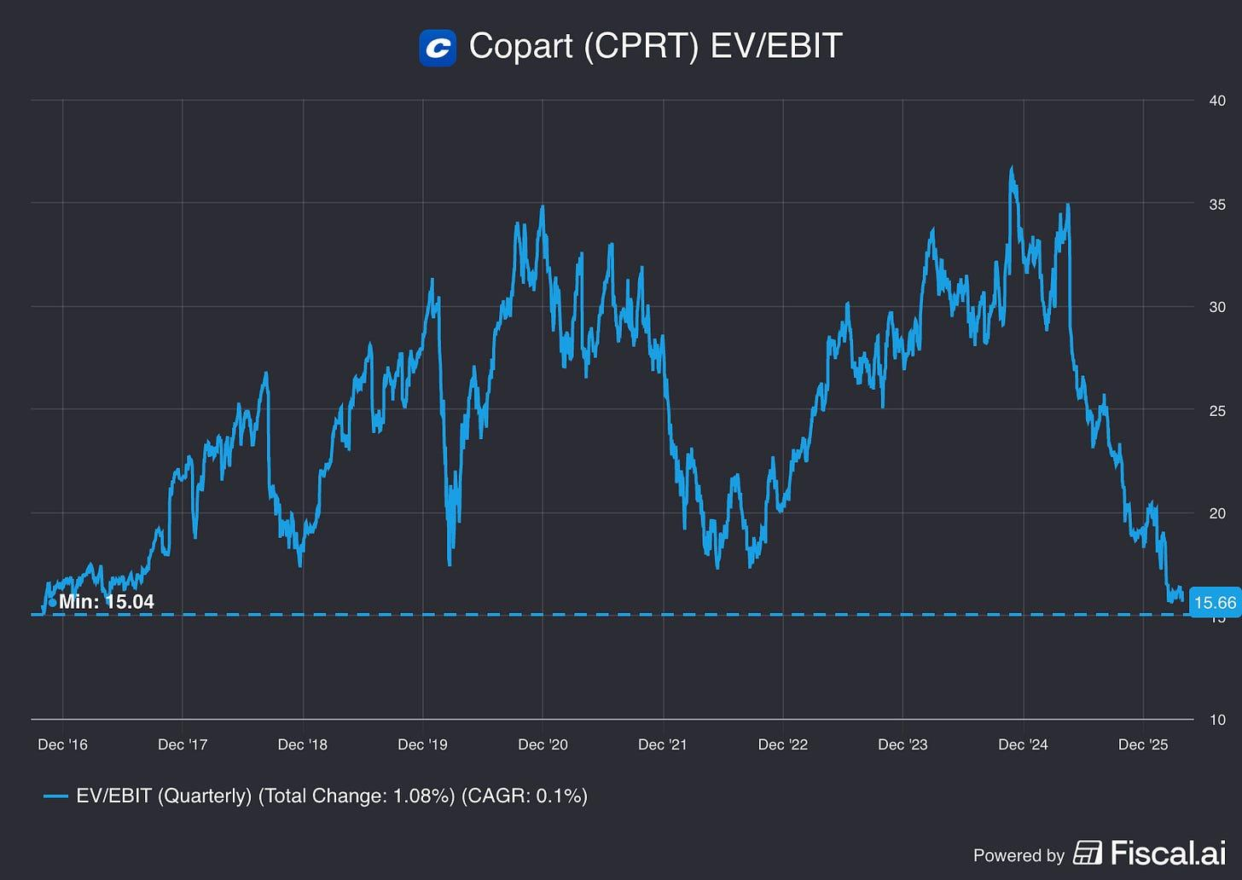
Source: EV/EBIT on Fiscal.ai
Regarding the industry slowdown, it’s important to distinguish between claims and collisions. While overall claims have dropped due to rising insurance premiums, industry data shows that collisions are still hitting record highs, the number of vehicles on the road is still increasing, and loss frequency is still rising. So, structurally, there are still a growing number of vehicles that can be disassembled.
On the claims side, premium affordability is fundamentally cyclical. Following the recent premium rate hikes, the leading U.S. auto insurers are all reporting near record profit margins. Just take a look at Progressive’s recent underwriting margin.
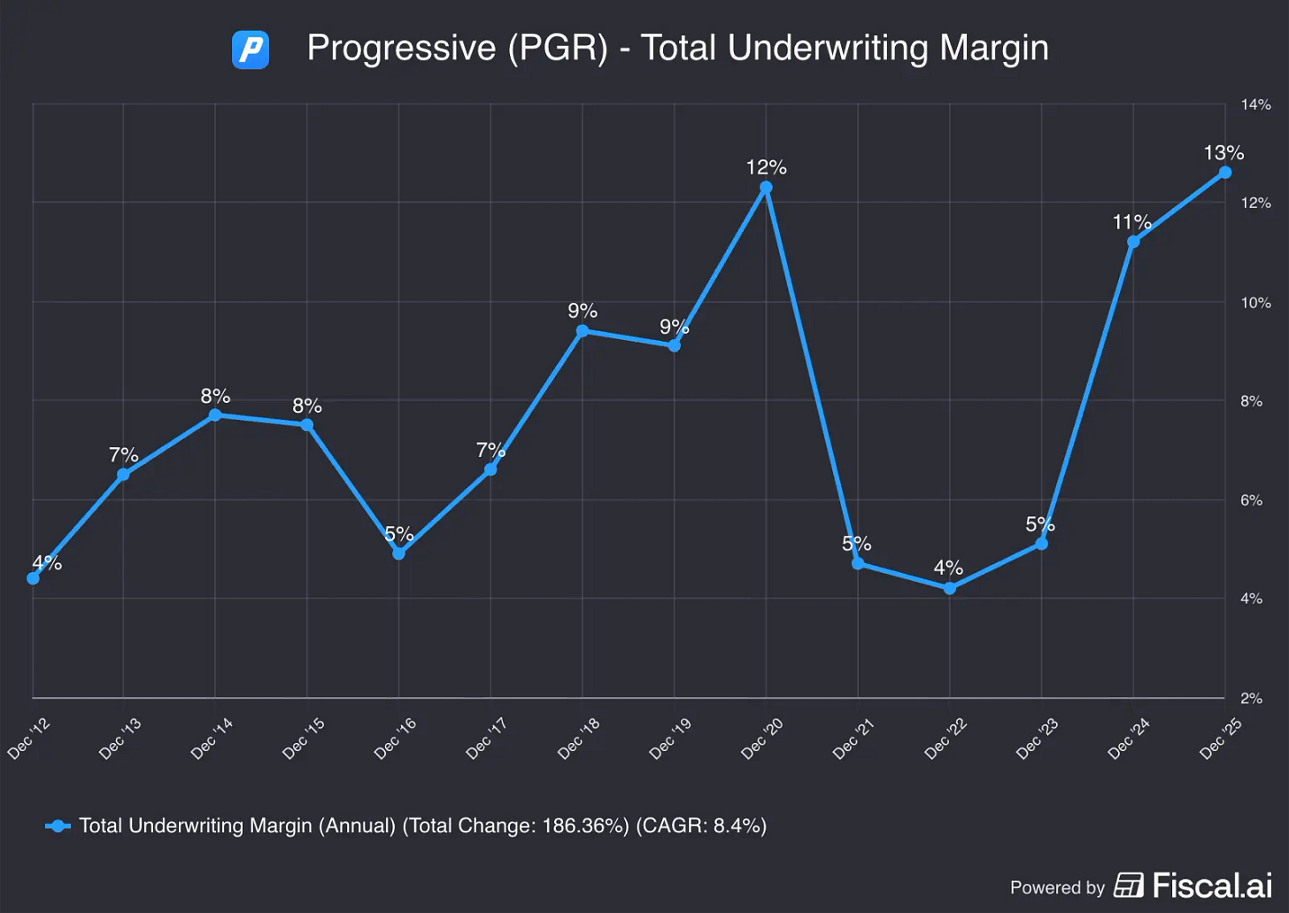
Source: PGR Total Underwriting Margin on Fiscal.ai
With the auto insurance industry being hyper competitive, the insurers are already beginning to lower rates again to win over drivers.
Beyond that, Progressive’s volume shift to IAA should have a ceiling. Since Copart operates more salvage yards and has more acreage across the country than IAA, Progressive still has to run some volume through Copart. Industry reports have suggested that Progressive wants to continue steering about 20% of volume through Copart.
So, in short, these problems do appear largely temporary, and the competitive advantages that have carried Copart over the last 4 decades still seem to be intact.
And it looks like Copart’s management team shares that belief.
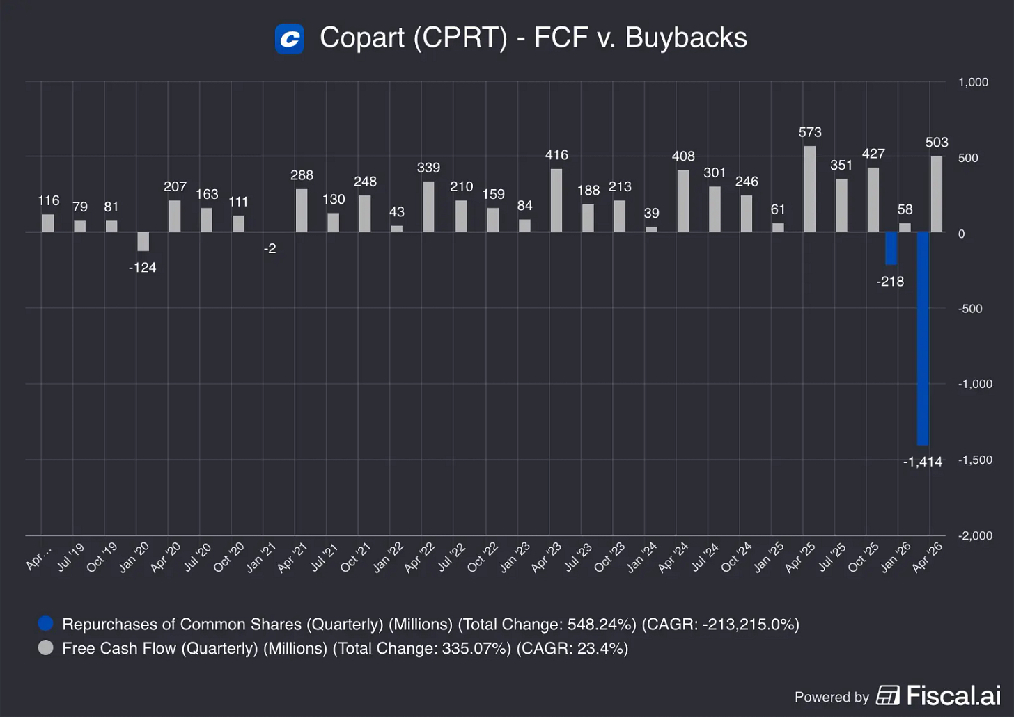

Burn the Index

Is Copart a Buy After the Q4 Results and the Acquisition of ACV Auctions?

Results and thesis check
Burn The Index
Sep 16, 2026
Wow. Quite the week for Copart shareholders. Not only did the company drop - dare I say - disappointing Q4 numbers, they also announced the acquisition of ACV Auctions.
Shareholders must’ve blinked twice when they read the news. Finally some of that massive cash pile is being deployed on something other than buybacks.
Investors were happy, excited, hopeful and depressed. All in one day:
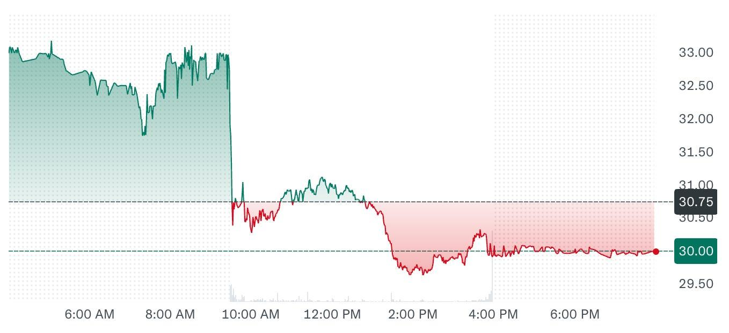
Stock price movement on Friday September 11th 2026
Here’s my take on the results and the acquisition, as well as my next steps.

Welcome to Burn The Index. I look for undervalued quality businesses with an attractive growth profile. Subscribe for free and join hundreds of other investors to make sure you don’t miss out on the next briefing.
Subscribe

Copart Q4 Results Were Not Convincing
The Q4 results were really just a confirmation of what was already developing in Q3. Revenue growth was moderate (up 2.4% YoY), driven by higher average selling prices (ASP). Volumes dropped, especially in the US.
The volume drop is driven by two factors really. For one, insurance premiums have risen over the past years, leading to fewer collisions claims and higher deductibles. In other words: the consumer is stretched and saving money where possible.
In addition, Copart lost a US insurance customer. When asked about it, the CEO downplayed it as “nothing to see here”, rather than give a straight forward answer. He might be right, but the messaging fell short of being unambiguous.
Gross profit margins dropped approx. 4.5% on the back of accelerated upfront spending on new strategic offerings like long-haul delivery (Copart Delivered), Title Express, and wholesale facilities.
At the same time, operational costs increased 12.7%, and interest income decreased because of the big buyback program earlier in the year. After all was said and done, diluted EPS went from $0.43 in Q3 to $0.35 in Q4.
On the bloated operational cost per vehicle, Jay Adair, the CEO, flagged two measures: direct cost management and unit volume leverage.
It’s fair to say that Q4 wasn’t pretty. However, none of these headwinds are structural in my opinion, but rather temporary in nature.
Costs are something you can contain, the consumer will come back when the insurance market gets softer again, and investments in strategic offerings hurt short term, but will drive growth over the mid- to long-term. Losing a customer is not something I was waiting for, but it does not seem to be a systemic issue.

The Logic Behind the ACV Auctions Acquisition
For those who are not familiar with ACV Auctions, its main product is a digital marketplace where dealers and companies (like banks, fleet managers, and rental car firms) trade used cars, backed by real-time data so buyers know what they’re getting.
The company also offers services that support the whole process, such as transportation, dealer financing, and software/ AI tools to inspect vehicles for damage, help dealers buy cars directly from consumers, and give up-to-date pricing and condition information.
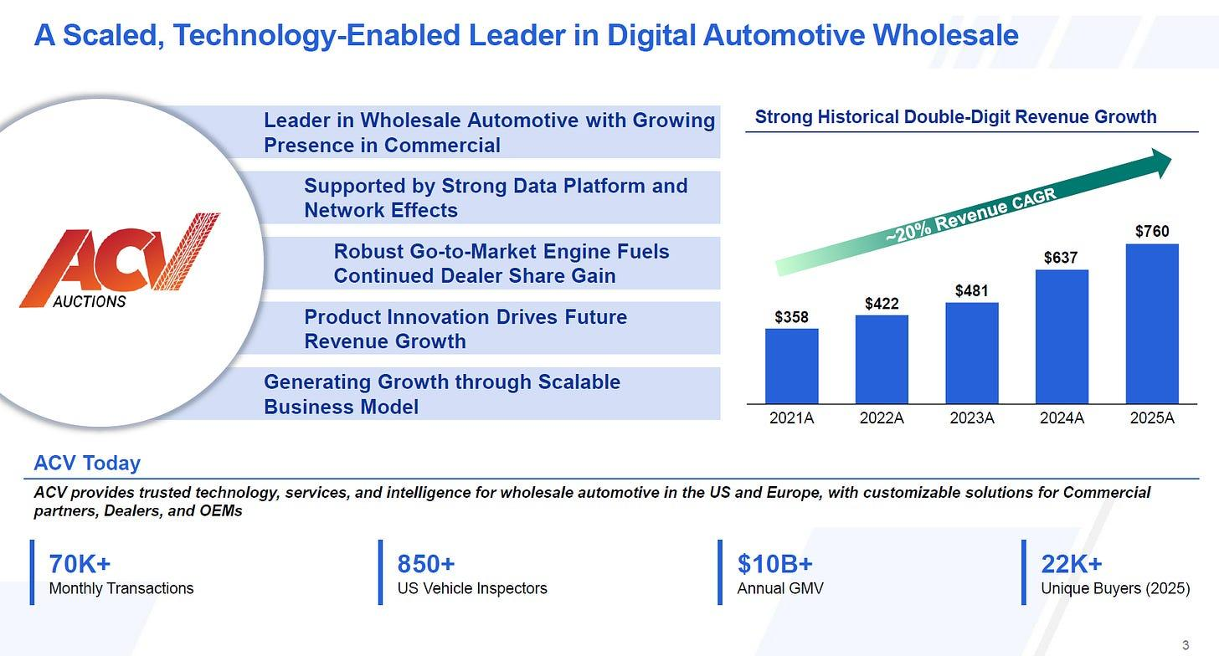
Copart Investor Presentation
Copart will acquire ACV Auctions in an $1.9 billion all cash deal which is expected to close at year end. Copart will have $2.6 billion in the bank after this acquisition, which is a comfortable position to be in.
ACV will generate approx. $800-850 million in revenues and a net loss of approx. $60-65 million for FY2026. Management expects to be breakeven in 2027, and profitable from 2028 onwards.
Now for the important part. Why ACV Auctions? Well, Copart gets a much deeper, real-time picture of a vehicle’s condition and pricing across the used-car market (thanks to ACV’s software and data), as well as direct relationships with franchise dealers it didn't have before.
Guru Gems wrote an interesting take on this as well:
This is not Copart’s first go at whole car, meaning undamaged vehicles rather than salvage.
It launched Dealer Services back in 2007, and sellers other than insurers now make up about a quarter of its volume. But its own Copart Direct programme saw volume fall 34.5% this year, and the franchise dealers never really came.
The deck says the same thing more politely: “ACV’s […] dealer base adds upstream supply Copart does not currently address”.
For ACV, the win is capital and scale. ACV has been growing fast but operating at a loss, and being merged with Copart, a company with a fortress balance sheet, removes a lot of financial pressure. It gives them additional breathing space to develop a great product. ACV also gets access to Copart's massive physical network (over 275 locations) and international buyer reach in over 185 countries.
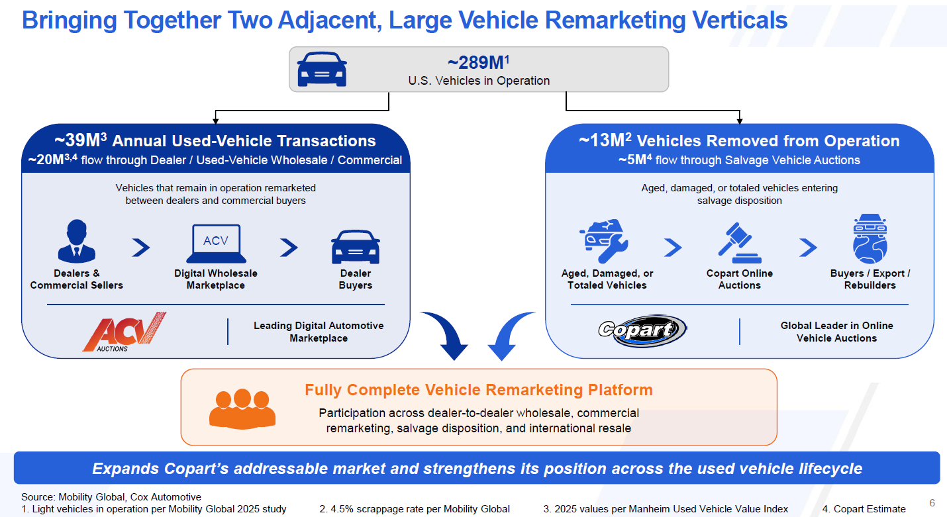
Copart Investor Presentation
For the combined company, I think the benefit is coverage. Copart's physical, salvage-heavy footprint plus ACV's digital, franchise-dealer-focused wholesale business means vehicles can flow through one combined ecosystem covering trade-in, wholesale auction, transport, and eventual retail or salvage disposition.
Of course, these are all “potential synergies”, so we have to wait and see which ones convert.

My Next Move

The Fat Pitch
CPRT: Copart (13)
Sep 17, 2026

FY2026 Updates
CPRT published their FY26 results and it wasn't too different from prior quarters, except for a big announcement of $1.9b to buy ACV Auctions, a publicly traded company operating the largest dealer-to-dealer wholesale vehicle digital auction business in the US.

FY26 highlights were:

Revenues $4.7b (+0.4% YOY). This year was a mild hurricane season, excluding CAT events growth was +2.4%. This is not a good result but it's expected during a cyclical trough and losing Progressive Insurance (PGR) as a supplier.

Operating income $1.65b, margins 35.4% lower than last year's 36.5%. This is due to continued investments into long-haul delivery, titling services, and wholesale services.

Free cashflow (without SBC) of $1.2b was flat against last year. But on per share basis it grew +5%.

Shares repurchased $1.6b (most of it in Q3, zero in Q4). FY25 was nil.

ACV acquisition $1.9b not closed yet and not reflected in financials. After this cash would be $2.6b, with zero debt. The financial position is still strong.

Unit volumes are one of the important metrics to CPRT business. This year global units fell -5.5% (-3.1% ex-CAT) attributed to the US segment -6.9%, partly offset by International segment +3.7%.

Looking at insurance units, the US segment fell -8% because they lost PGR. Excluding that, units actually grew +2.3%. International segment did well at +11.2%.

Despite lower units, the average selling price (ASP) for US insurance grew +3.7% against Manheim index +2.8%.

Revenue & unit growth quarterly

Total loss frequency is still at record highs of 23.3%.

International buyers continue to play a major role, making up 38% of US units, and 46% in dollars.

In summary, unit volumes fell but ASP increased, so revenues marginally improved by +0.4%.

However, costs increased due to investments, so operating income fell by -2.6%.

The operating results for FY26 was not good. This is not surprising, the auto insurance sector is facing affordability issues that are just starting to ease. Losing PGR as a key supplier of salvage is not good news, but Jay Adair sent an important message:

You either can generate the liquidity that are going to bring the dollars in for the customer. Or you’ve just got to cut pricing dramatically, we don’t need to play that game.

ACV Deal
The acquisition plays on one important idea: ACV does not have the physical assets side of running the used car business. But CPRT can provide this critical infrastructure.

ACV makes money through its digital marketplace that connects 22,000+ buyers and 14,900+ sellers of used vehicles. A vehicle trade-in is inspected on the dealer’s lot by one of ACV’s 850 inspectors, whose condition report feeds into a live 20-minutes auction.

They generated $760m in revenues for 2025, with only $19m in gross fixed assets. They don't own a single piece of land, so it essentially runs a digital platform matching buyers and sellers.

Revenues can be broken down into:

Auction fees $348m (46%).

Services $296m (39%) such as transportation and ACV Capital (dealer financing of inventory).

Customer assurance revenue $82m (11%) from sellers guaranteeing the vehicle will sell.

Data/software makes up the remaining 4%.

At 2025, gross fixed assets were $19m and were made up of short-lived assets (computers, equipment, furniture, leasehold improvements, vehicles).

The interesting part is the cost structure of ACV, out of total expenses of $823m, the 2 main categories are:

Marketplace service cost $288m.

Technology & operations $183m.

These 2 factors alone make up 57% of total cost. After this acquisition, they can send units through CPRT infrastructure and very likely improve their cost structure.

Furthermore, benefits for CPRT are clear:

CPRT has the land and gains additional volume from ACV.

Both companies have proprietary data and auction systems. Some synergies could be extracted.

CPRT will have an immediate presence in wholesale auctions. 25% of CPRT volume is from non-insurance (banks, rental fleets, dealer services), which benefits from ACV’s network.

Here's a summary from CPRT investor slides:

ACV has $205m long-term debt and $242m cash. So its enterprise value is almost equal to market value. The price tag of $1.9b is 2.5x revenue and 32x adjusted EBITDA of $59m (2025 figures, main adjustments are adding back SBC $57m, D&A $17m, most of D&A is just amortization of software).

At 20% ROI, the deal has to generate $380m of incremental operating income. Honestly, it looks very difficult in the near term.

Management expects earnings to be EPS-neutral in FY27 and incremental earnings to show up in FY28.

Our Opinion
Like most people, we know ACV will surely add unit volumes and operating as a standalone subsidiary it will benefit from CPRT infrastructure. But we really don't know how fast, and how much incremental earnings it can bring.

We must see improvements unit volumes, ASP, and ROIC as we go beyond 2027.

Lucas | Summit Stocks
Copart ($CPRT): Revisiting the Investment Thesis
Copart Q2 & Q3 2026 stock update
Lucas | Summit Stocks
Jul 15, 2026

In my Copart deep dive in December 2025, I argued that the market had become too pessimistic on the business.

Despite operating one of the strongest business models I had ever researched, the stock had fallen roughly 40% from its highs. Investors worried that slowing insurance volumes signaled a structural slowdown, while autonomous driving cast a long shadow over the industry’s long-term future.

Copart’s revenue growth had also slowed down due to weaker insurance volumes, tough comparisons with periods of elevated catastrophic events (leading to higher volume for Copart), and a shift away from the purchase contract model, which reduced revenue but improved the business.

While the market was skeptical of Copart’s future, my conclusion was different. I believed the insurance weakness was primarily cyclical rather than structural. Insurance companies were writing off fewer vehicles because consumers had begun cutting insurance coverage after years of premium inflation, not because Copart had lost its competitive position.

Meanwhile, the long-term autonomous driving risk appeared overstated given the extremely gradual pace of vehicle fleet turnover, the continued rise in total loss frequency, and the ongoing improvement in the quality of Copart’s inventory.

Copart: A Buy After a 40% Drawdown
Copart: A Buy After a 40% Drawdown
Lucas | Summit Stocks
·
December 25, 2025
Read full story
Since publishing that research, Copart has reported two quarterly results, announced a surprise CEO transition, initiated a meaningful (and rare) share repurchase program, and continued investing across its business.

The stock, however, has remained under pressure. Since my deep dive, shares are down another 30%. Copart stock is now down about 57% from its all-time high in 2025.

In this stock update, I will discuss whether the investment thesis has changed and whether today's valuation makes Copart a strong buy.

Subscribe for free to discover high-quality investment opportunities. Upgrade to paid for deep-dive stock research, portfolio updates, and full access to Capaxe.

kushaagrasood001@gmail.com
password
kushaagrasood001@gmail.com
Subscribe
The Original Copart Thesis
Before discussing everything that has happened, it is worth briefly revisiting why I invested (a very small stake) in Copart in the first place.

Copart operates the world's leading online marketplace for total-loss and salvage vehicles. While the business is technically an auction company, I think that description undersells what the company has built over the past decades and the critical role it plays within its industry.

Copart is really a global marketplace connecting mostly insurance companies with hundreds of thousands of buyers across more than 160 countries.

The business benefits from several reinforcing competitive advantages.

First, Copart operates an increasingly liquid marketplace. More buyers attract more sellers, while more sellers attract more buyers. This network effect improves price discovery and ultimately generates higher recovery values for insurance companies, making Copart an even more attractive partner.

Second, the company owns one of the largest salvage yard networks in the industry. Suitable industrial land close to major population centers has become increasingly difficult to acquire due to zoning restrictions and permitting hurdles. Those physical assets create barriers to entry that are almost impossible to replicate quickly.

Third, Copart has built deep relationships with insurers by becoming far more than just an auction platform. The company manages towing, title processing, catastrophe response, and increasingly supports insurers earlier in the claims process through technology. These services create meaningful switching costs and strengthen customer relationships over time.

Finally, management has consistently demonstrated a remarkable ability to allocate capital. Rather than maximizing short-term earnings, Copart has spent decades investing in land, technology, and marketplace liquidity while maintaining one of the strongest balance sheets in the industry.

As a result of these advantages, Copart's revenue has compounded at 15% annually over the long term, operating margins have grown to 37%, and ROIC approaches 30% excluding excess cash.

getcapaxe.com
But if the business is so great, why has the stock performed so poorly recently?

kushaagrasood001@gmail.com
password
kushaagrasood001@gmail.com
Subscribe
Why Are Shares In a Drawdown?
When I published my original deep dive, the market had become increasingly concerned that Copart's best years were behind it.

Revenue growth had slowed materially following several years of exceptional performance. Insurance volumes were weakening, catastrophic losses had normalized, and quarterly results no longer reflected the double-digit growth investors had become accustomed to.

Quarterly revenue growth has declined to just 2% YoY | getcapaxe.com
At the same time, concerns surrounding autonomous driving continued to weigh on the stock, with investors questioning the durability of Copart's terminal value because of the uncertainty around whether a future with fewer accidents would ultimately reduce the supply of salvage vehicles.

Competitor IAA was also executing better under new ownership, and Copart was losing market share as a result. I still believed Copart was the stronger business, and insurers are incentivized to balance market share between the two, but it did not help sentiment or short-term growth.

Taken together, these factors led investors to believe that Copart was structurally weakening into a slower-growing business deserving of a lower valuation multiple.

I disagreed. Strong businesses tend to stay strong, and Copart is one of them.

My view was that investors were extrapolating temporary industry headwinds too far into the future.

The insurance market has always been cyclical, and I believed the weakness in volumes reflected a difficult point in that cycle rather than a deterioration in Copart’s competitive position.

Likewise, I believed the market underestimated Copart's ability to evolve alongside the automotive industry. As vehicles become more technologically advanced and more expensive to repair, the economics of Copart's marketplace continue improving in ways that are not immediately visible through quarterly volume figures alone.

Those conclusions ultimately led me to initiate a position despite the overwhelmingly negative sentiment.

Seven Months Later
The market narrative surrounding Copart has changed remarkably little.

The stock continues to trade below its all-time highs because investors remain focused on many of the same concerns that weighed on sentiment at the end of 2025. Insurance volumes remain subdued, and revenue growth has yet to fully accelerate. Investors have also had to digest an unexpected CEO transition following Jeff Liaw's departure.

It is also worth mentioning that, over the past several months, investor capital has become increasingly concentrated in AI and semiconductor companies, while high-quality compounders such as Copart have fallen out of favor simply because they are not part of the AI hype cycle.

I discussed this in more detail in my latest portfolio update if you are interested.

June 2026 - Portfolio Update
June 2026 - Portfolio Update
Lucas | Summit Stocks
·
Jul 6
Read full story
Despite these continued concerns, however, I believe the evidence accumulated over the past few months actually reinforces the original investment case.

Subscribe for free to discover high-quality investment opportunities. Upgrade to paid for deep-dive stock research, portfolio updates, and full access to Capaxe.

kushaagrasood001@gmail.com
password
kushaagrasood001@gmail.com
Subscribe
Has the Investment Thesis Changed?
After reviewing Copart's results over the past seven months, I think the answer is largely no.

If anything, several developments have strengthened the original investment case.

The headline numbers remain rather weak. Revenue growth is still well below historical averages, insurance volumes remain under pressure, and investors continue waiting for a recovery in the insurance cycle.

Yet looking beyond those headlines tells a different story.

The underlying business continues moving in exactly the direction I expected when I initiated my position.

The Insurance Cycle Remains the Dominant Story
Both the Q2'26 and Q3'26 earnings calls pointed to the same conclusion: the weakness in insurance volumes continues to be driven by the insurance cycle rather than a deterioration in Copart's competitive position.

During the second quarter, global insurance units declined 9% (4% excluding catastrophic events), contributing to a 3.6% decline in revenue. The third quarter showed improvement, with revenue returning to 2.1% growth while insurance volumes declined a more modest 2.7%. Excluding catastrophe volume, the decline was just 1.9%.

Despite slower revenue growth, the latest quarter saw a sharp rebound | getcapaxe.com
Importantly, management continues attributing this weakness to the same factors discussed throughout the past year.

Following the inflationary period of 2022 through 2024, insurers sharply increased premiums to restore profitability. Consumers responded by raising deductibles, reducing collision coverage, or moving toward liability-only insurance. Fewer insured vehicles naturally translate into fewer claims and, ultimately, fewer salvage assignments entering Copart’s marketplace.

The third-quarter call contained perhaps the strongest evidence supporting this explanation.

According to ISS Fast Track, earned car years declined 4% YoY despite the number of vehicles on U.S. roads increasing 1.4%. In other words, Americans continue owning more vehicles while choosing to insure fewer of them. Management also highlighted that roughly 25% of vehicle repairs are now self-pay, another sign that consumers are increasingly absorbing repair costs themselves.

Perhaps most encouragingly, management noted that some insurers are already becoming more aggressive again as industry conditions normalize, supporting the view that these headwinds are cyclical rather than structural.

The Long-Term Growth Story Remains Intact
The more important story is that the long-term drivers continue moving in the right direction.

Total loss frequency reached 24.2% in late 2025 and remained elevated at 23.6% during the following quarter, nearly five percentage points higher than four years ago.

Perhaps Copart's most critical KPI is the average selling price (ASP) of the vehicles going through its platform. In Q2'26, the ASP of U.S. insurance units increased 6% YoY, or 9% excluding catastrophic events, "yet again outpacing industry trends."

In Q3’26, ASP increased 4.6% YoY despite a normalization in broader used vehicle prices, reaching a seasonally adjusted record.

“Industry-wide vehicle values have normalized somewhat from the elevated levels we observed during supply chain constrained period of 2021 and 2022 as evidenced by Manheim indices and otherwise. We are nevertheless generating record average selling prices for our U.S. insurance consignors.”

—ex-CEO Jeff Liaw, Q2’26 earnings call

Copart Continues Moving Upmarket
One of my original observations was that Copart was gradually moving beyond traditional salvage vehicles.

This trend is simply continuing.

Higher repair costs continue pushing more lightly damaged vehicles onto the platform, resulting in higher average selling prices and attracting a broader buyer base. At the same time, Copart continues expanding its whole-car business through rental companies, dealers, financial institutions, and corporate fleets.

The two trends increasingly reinforce each other.

Management disclosed that over 30,000 buyers first entered Copart through non-insurance vehicles during the past three years, with the majority bidding on insurance vehicles within 90 days. As more whole-car buyers join the marketplace, liquidity improves, auction proceeds rise, and insurers recover more value, further strengthening the economics of the total-loss model.

Jay Adair Returns as CEO
The largest development since my original thesis was Jeff Liaw’s decision (was it really his decision?) to step down as CEO, with former CEO Jay Adair returning to lead the company.

While Adair has been with the company for an incredible 37 years, this transition does introduce some uncertainty to the investment case.

Copart held an additional conference call to update investors on the situation. Based on the call, Adair does not seem to be simply returning to maintain the status quo. He also does not intend to stay for a short while:

“My intent is to lead the company for the next 10+ years. This is not an interim arrangement. I won’t be going through a process of finding my successor. I’m just going to focus and double down on all of our initiatives to build Copart and to grow Copart.”

Instead, he appeared eager to accelerate the business.

Adair repeatedly emphasized three strategic growth pillars: expanding the international insurance business, accelerating the domestic whole-car opportunity, and deepening Copart's technology services for insurers.

He also seemed more open to acquisitions, even though Copart has historically been exceptionally conservative and disciplined with capital allocation.

I like the stronger emphasis on international growth, as well as expanding the whole-car business, which has always been an important part of my thesis, but for now it still seems strange that Jeff Liaw had to leave. Copart did not explicitly state why Liaw left or under what terms.

I still have a great deal of confidence in management and remain bullish.

kushaagrasood001@gmail.com
password
kushaagrasood001@gmail.com
Subscribe
Valuation
At the time of my deep dive, market expectations remained somewhat elevated, with 12% annual free cash flow growth needed to justify the share price, which was around $39 at the time.

I then said:

“If the stock were to fall into the low $30s, Copart would need to grow free cash flow at a rate below 10% to justify the price. At that point, the risk-reward would become very compelling in my view.”

We are now in the high $20s, and so the risk-reward has become compelling. With TTM FCF of $1.34 billion, Copart's FCF needs to grow at less than 5% annually to justify today's price.

getcapaxe.com
That is a very low hurdle.

In fact, Copart trades at a P/FCF of just 19x, which is low for a company of Copart's quality.

Copart now trades at a valuation where I am comfortable adding shares to make the stock a more meaningful position in my portfolio. Over the past seven months, Copart has been more or less a tracker position.

I will very likely add Copart to the portfolio below $30 per share. Paid subscribers will be notified when I add shares.

The Pursuit of Compounding

Copart: The Real Estate King of the Junkyard

A deep dive into Copart's operating margins, and how a 40-year real estate strategy created an inflation-proof moat that competitors can’t replicate.
The Pursuit of Compounding
Dec 27, 2025
If an investor is looking for high-quality industrial compounders, Copart (CPRT) always deserves attention. Summit Stocks recently wrote a wonderful overview of the company, that we would encourage all readers to check out.
In short, Copart is a global online vehicle salvage and auction company, that operates in a duopoly shared with IAA (now part of Ritchie Bros). Unlike IAA, Copart owns 90+% of the land it operates on, and so it has very limited lease liabilities.
Summit Stocks
Copart: A Buy After a 40% Drawdown
Read more
9 months ago · 24 likes · 11 comments · Summit Stocks
Copart also consistently posts operating margins that make software companies jealous. For Fiscal Year 2024, Copart reported an operating margin of 37.1%. This surpasses Google and Apple!
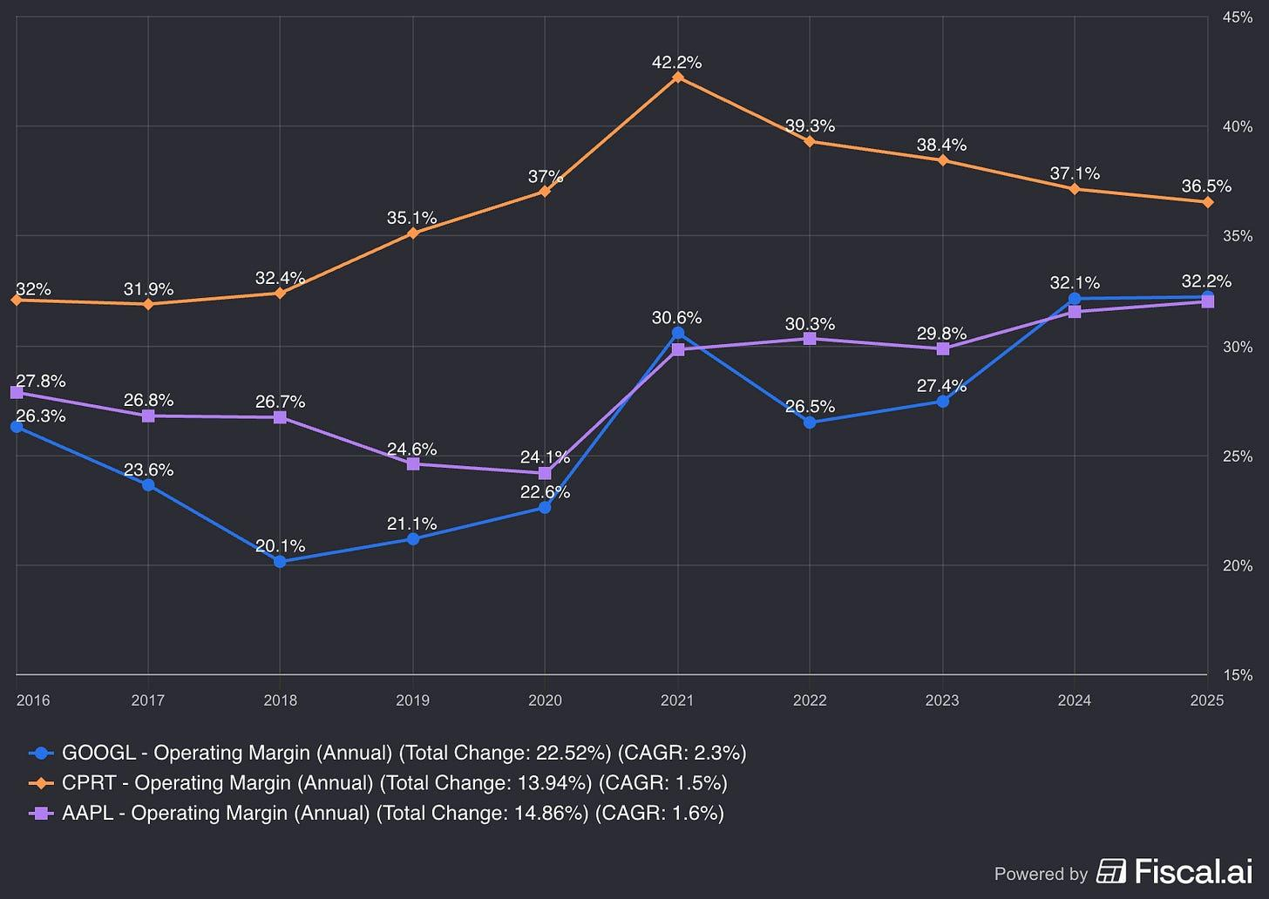
Source
How does a capital intensive auction and salvage business, that moves millions of mangled cars through muddy lots, achieve such operating margins? A typical logistics or industrial heavy-equipment business is lucky to hit 15%. Are Copart’s margins deceptive or overstated? This is what we’ll dive into today.
This Substack is reader-supported. To receive new posts and access content behind the paywall, please consider becoming a paid subscriber.
Subscribe

Copart's margins are certainly not fraudulent. Are they overstated though? This is a nuanced question as the “overstated margins” are legitimate, as they are directly due to one of Copart’s competitive advantages - land ownership. As Copart buys its land (Capital Expenditure) rather than leasing it (Operating Expense) the company skips a massive expense line - rent - from the Income Statement and instead places the land as an asset on their balance sheet.

Where’d the Expenses Go?
To understand why Copart’s P&L looks so good, you have to look at what isn’t there.
In the salvage auction industry, land is often a constraint. When a car is totalled, it has to go somewhere. It sits for 60 to 90 days while titles are processed and auctions are held. This requires thousands of acres of industrial land, zoned for outdoor storage—a category of real estate that local governments hate approving (the “Not In My Backyard” or NIMBY problem).
Copart’s primary competitor, IAA, spent years following a “Capital Light” strategy. They leased their yards to keep their Return on Invested Capital (ROIC) high and their balance sheet light. Copart took the opposite approach. They bought everything. Today, Copart owns approximately 90% of the land it uses for operations.

The GAAP Distortion
Under Generally Accepted Accounting Principles (GAAP), if you lease a yard, you pay rent, and that rent reduces your Operating Income. If you own the yard, you pay zero rent. You capitalize the land purchase on the Balance Sheet. And crucially, land does not depreciate. Thus, land expenses are not captured under D+A on the income statement. Buildings and equipment on the land would be, although not the land itself.
Further, if Copart was leasing the land and decided to make a “leasehold improvement” - for example installing a specific drainage system - then under GAAP the depreciation schedule is the useful life of the asset or the remaining lease term, whichever is shorter.
Prior to being taken over by RBA, IAA’s public disclosures showed that they typically entered into long-term leases for its auction sites, which often included initial terms of 10 to 15 years. These leases frequently contained multiple 5-year renewal options, allowing the company to maintain its footprint for decades if desired. So, in theory, the longest IAA could depreciate a lease improvement would be 15 years, although the weighted average would probably be less than 15 years.
However, Copart owns the vast majority of land they operate on, their leasehold improvements would be handled differently. Instead of going direct to D+A their improvements would be immediately capitalized as an asset (under Property, Plant, and Equipment on the balance sheet) and the depreciation schedule is instead fixed- generally 15 years for land improvements or 39 years for buildings. This means that, relative to a competitor with a leasing model, Copart’s equivalent D+A expense would be less as their depreciation schedule is longer. This lease vs ownership depreciation difference contributes a structural “optical” advantage on the Income Statement.
So, while a competitor pays millions in rent (lowering margins) and depreciation (lowering margins), Copart pays neither on its land portfolio. This is why Copart’s Operating Margins look so good! As land ownership is intrinsic to their model, then there’s nothing further to see right?
One issue is that it partially obscures the true operating margin of the underlying auction and salvage business. If the operating business is sputtering, it may not become immediately apparent due to the land ownership. The other issue is that the cost of owning that land is the Opportunity Cost of Capital. Copart has billions tied up in dirt that could be deployed elsewhere.
To find the “real” operating margin of the underlying operating business, we have to charge Copart rent for its own land. We have to imagine Copart is two companies rolled into one - a landlord (PropCo) and an auction and salvage business (OpCo). When we break it down this way, we can see that the operating margins of the auction and salvage business are lower than at first glance.

Calculating the “Real” Margin
To standardize Copart’s earnings against a normal company that pays rent, thus allowing for apples to apples comparison of operating margin, we can perform Forensic Lease Adjustment.
Let’s imagine Copart spins off it’s land ownership into a Property Company (PropCo), separating it from the auction and salvage business Operating Company (OpCo).
We can then estimate the Fair Market Value (FMV) of Copart’s land portfolio and apply a market-rate Cap Rate (yield) to calculate what the PropCo would charge OpCo.

Step 1: Valuing the Dirt
Copart carries its land on the balance sheet at historical cost. If they bought 100 acres outside Atlanta in 1995, it’s on the books at 1995 prices.
Since 2020, rents for Industrial Outdoor Storage (IOS) properties have skyrocketed by 123%. Institutional money is flooding the space, driving cap rates down and values up.
Given this inflation, Copart’s book value is wildly understated. A conservative estimate puts the Fair Market Value of their portfolio at 2.5x their book value, or roughly $4.5 billion.

Step 2: Imputing the Rent
The OpCo would pay fair market rent to the PropCo. In the current interest rate environment, a 7.0% cap rate is a reasonable proxy for industrial heavy-usage sites. We can then calculated the rent the OpCo would pay.
Imputed Rent for Fiscal 2024 = $4.525 Billion x 7.0% = $317 Million

Step 3: The Adjusted Operating Margin
Now we insert this theoretical expense into their annual income statements from 2020 to 2024
Made by author from company filings
As we can see, owning the land adds a 640 - 760 basis point tailwind to the overall operating margin, and the operating margin of the underlying auction and salvage business is materially lower than first glance.
If Copart were to spin off its real estate into a REIT (OpCo/PropCo split), the “OpCo” would likely report the 29.6% margins as calculated above, while the “PropCo” would collect the $317 million in rent. The consolidated entity, however, enjoys the synergy of both.
As a comparator, prior to being taken over IAA reported operating margins in the low 20s. On a purely operating basis (ex land ownership), Copart is still a superior salvage and auction company.
Copart’s operating margin remains exceptional for the industrial sector. The 750 basis point spread represents the return on Copart’s multi-decade real estate strategy. This is not a quality-of-earnings concern but rather a quantification of their robust competitive moat.
The company has strategically cornered a valuable resource - industrial land - while also hedged itself against the 123% inflation in industrial rents that has plagued competitors. Copart is continually converting what would be an expense for others into retained earnings for shareholders.

“So What? Just Follow the Cash and it Works Itself Out”
So far one could accuse us of writing about an Income Statement accounting nuance that is nerdy and not meaningful! An astute reader might ask: “If Copart spends $500 million buying land, isn’t that cash leaving their bank account just like rent? Why does it matter how it shows up on the income statement? The cash is gone.”
While the cash outflow is real in both scenarios, the quality of that outflow is fundamentally different.
The Renter (Competitor) will pay their rent, which hits the Operating Cash Flow (OCF) as the rent expense will reduce net income.
However the Owner (Copart) doesn’t pay rent expense and so their net income is higher. Copart’s OCF looks massive ($1.47 Billion in 2024) because the land cost bypasses it. Instead, they use their operating cash flow to buy land. This hits Investing Cash Flow as Capital Expenditures (CapEx).
As the Renter doesn’t buy land, their CapEx line item will be materially smaller. So, to normalize for this difference, we must look at Free Cash Flow (FCF) as this is where it all shakes out.
Even though it’s capital intensive - land costs lots of money - we can see that Copart generates an immense (and growing) FCF.
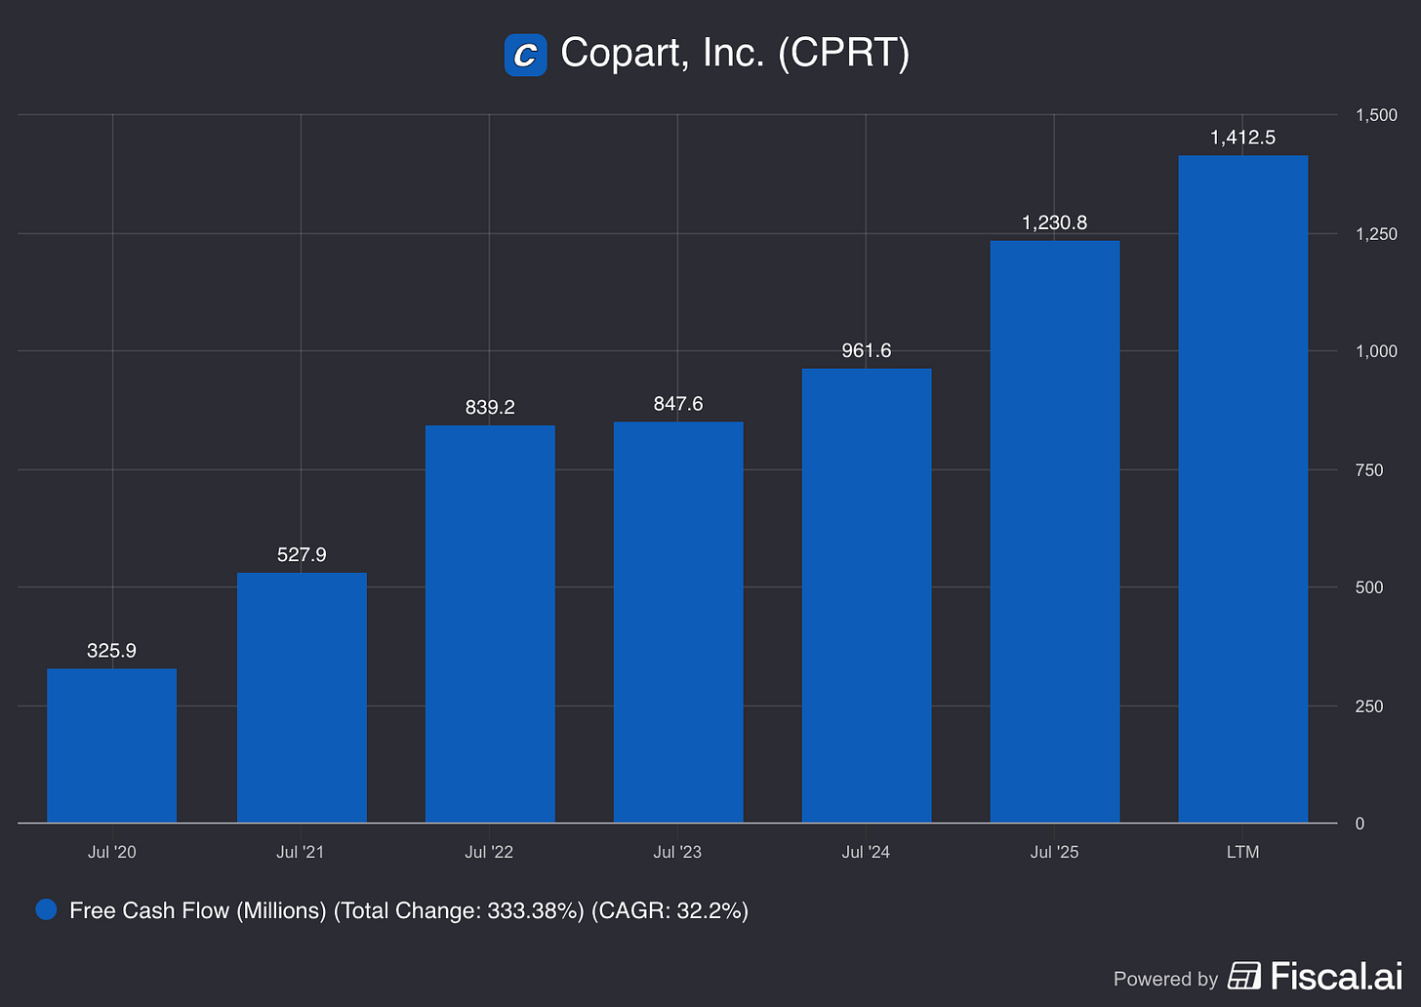
Source
We can take this one step further and ask “What are the Free Cash Flow Margins?” - how much of Copart’s revenue turns into Free Cash Flow?
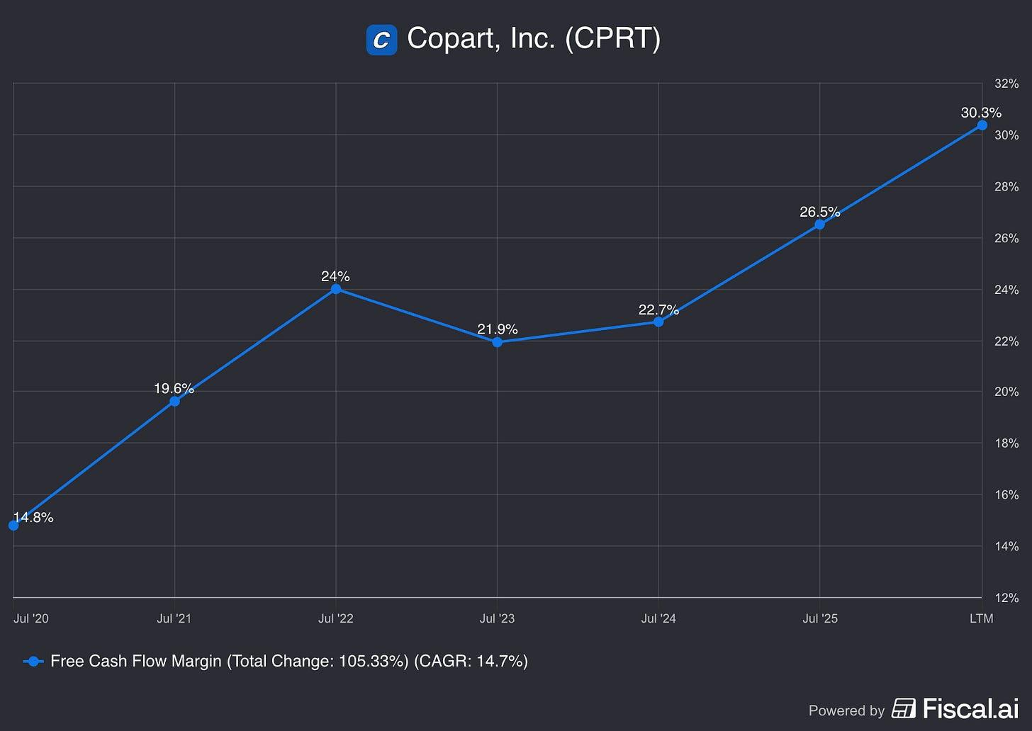
Source
In the last five years Copart’s FCF Margins have more than doubled. For reference, for Fiscal 2022 IAA’s (its last full year as a public company) FCF margin was about 15%. Why are these FCF margins increasing so rapidly? In part, it’s because spending $500M on CapEx is superior to spending $500M on rent

The Asset Swap vs. The Expense
When a competitor pays rent, that cash is burned. It purchases a temporary service (occupancy) and vanishes. When Copart spends $500M on land, they are swapping assets - they trade depreciating Cash for appreciating Land.

The Inflation Hedge
This creates an innate inflation hedge, and gives Copart an immediate economic leg up on any renting competition. The renter faces annual rent escalators. If IOS rents rise 123% (as they did from 2020-2024), the renter’s expenses explode, crushing operating margins.
On the other hand, Copart’s cash cost is fixed at the moment of purchase. A yard bought in 2010 has substantially smaller expenses (relative to the renter). They are immune to the rent inflation that eats away at their competitors operating margins.
Further, Copart’s CapEx is largely discretionary. If Copart stopped buying land tomorrow, their CapEx would plummet, and their Free Cash Flow would instantly jump to nearly equal their Operating Cash Flow (~$1.5B). A renter does not have this luxury; they pay rent forever.

The Verdict
We can see that Copart’s strategy of owning - rather than leasing - creates a material impact on their income and cash flow statement.
Even when their operating margin is “adjusted” to look only at the underlying operating business, it remains exceptional for the industrial sector. The 750 basis point spread represents the return on Copart’s multi-decade real estate strategy - they are the financial receipt for 40 years of contrarian capital allocation. This is a quantifiable demonstration of their robust competitive moat.
The company has strategically cornered a valuable resource - industrial land- while also hedging itself against the 123% industrial rent inflation that has plagued competitors. Copart is continually converting what would be an expense for others into retained earnings for shareholders.
Further, this robust competitive land ownership moat contributes substantially to the generation of FCF and the protection of FCF margins that cannot be replicated without owning the land.
Although this all may seem like accounting minutiae that may not impact the overall investment thesis, it is still important to recognize the drivers of what we look at as investors. There is a possibility that the land ownership may partially obscure deteriorations in the operating business, and so it is something that an investor should consider monitoring.
Thanks for reading! Please feel free to leave your thoughts with us in the comments section below!

Clayton Capital Insights

Copart: An A+ Business at an Attractive Price

Why I Bought Copart Near a Five-Year Low
Clayton Capital Insights
Aug 03, 2026
∙ Paid
Copart is the world’s largest provider of online auctions and vehicle remarketing services. In other words, Copart owns thousands of acres of junk yards in which they conduct salvage vehicle auctions.
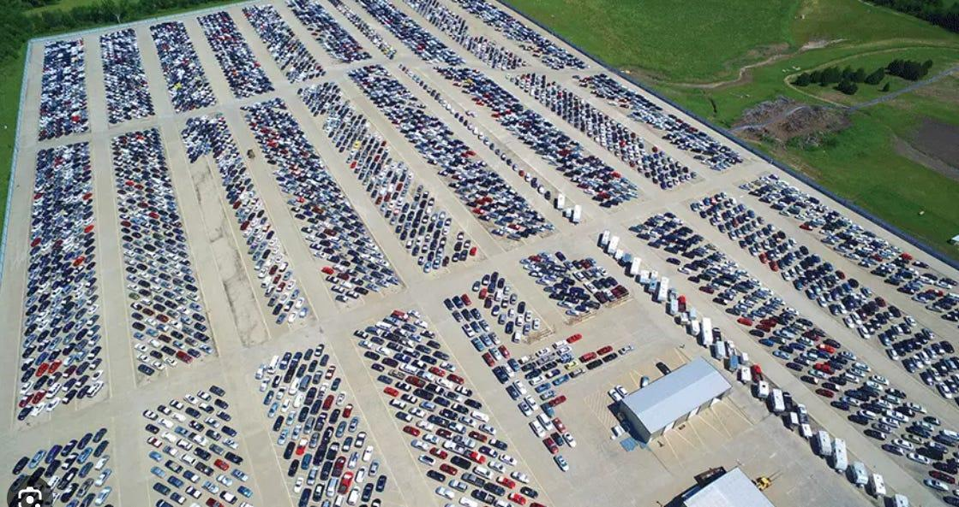
Copart receives most of its vehicles (about 80%) from insurance companies like State Farm, GEICO, Allstate and others - vehicles that are deemed to be a total loss. Sellers also include car dealers, individuals, car rental companies, banks, and fleet operators. Buyers include vehicle dismantlers, vehicle rebuilders, repair shops, used vehicle dealers, and individuals.
Copart operates in what is effectively a duopoly with Insurance Auto Auctions (IAA), which is owned by RB Global (RBA). It is estimated that Copart and IAA control 80 – 90% of the North American salvage auto auction market, with Copart controlling about 45 - 50% share and IAA 35 - 40%.
I have followed Copart for several years. The business has always impressed me, but the valuation always seemed a bit pricey. After the recent selloff, however, I believe investors have an opportunity to buy one of the highest-quality compounders in the public markets at a much more attractive price.

Copart’s Business Model
Most vehicles are sold on consignment, with Copart acting as an agent. Copart collects the auction proceeds from the buyer, deducts its fees, and then pays the remaining proceeds to the seller.
Roughly 85% of Copart’s revenues come from service fees where they collect fees on everything from memberships, financing, shipping, vehicle bidding, transaction, storage, titling, selling, and relisting. The other 15% of Copart’s business is vehicle sales, where they actually buy the cars and sell them for their own account.
On average, Copart might collect something like 5% - 15% of the sale price per vehicle sold. This can fee can be as low as 1% or as high as 20%+ depending on the vehicle and sale price.

What Has Caused the Selloff in Copart Stock?
I recently started buying Copart because it trades near a five-year low based on its stock price and near a 10 year low in terms of its price to earnings ratio.
Copart’s stock is trading down primarily because of a temporary slowdown in total-loss insurance claims along with a leadership transition, which is actually a positive as I’ll explain later.
Over the past several years, Copart has faced temporary headwinds as elevated inflation and sharply higher auto insurance premiums caused many consumers to reassess their insurance coverage.
Some policyholders increased deductibles, dropped comprehensive and collision coverage on older vehicles, or allowed policies to lapse altogether. As a result, fewer insured vehicles entered the total-loss claims process, reducing the number of salvage vehicles flowing through Copart’s auction platform. While this has pressured vehicle volumes in the near term, I view it as a cyclical rather than structural issue.
Insurance coverage is ultimately a necessity for most drivers, and as affordability improves and industry conditions normalize, I would expect salvage volumes to recover over time.
Incoming CEO Jay Adair had this to say on recent call with investors,
“On cyclical headwinds, we are experiencing the impact of cyclical and, in our view, unprecedented dislocation across the U.S. industry -- the U.S. insurance industry. The 2022 to 2024 inflationary cycle pushed carrier combined ratios out of balance, driving rate increases, which drove consumers to pull back their level of insurance coverage, which was observed through a shift toward higher deductibles and liability-only policies.
I believe that is now softening, and we are starting to see insurance companies become more aggressive again. And much of this is from 2020, COVID, the impact of that, the impact of insurers cutting dividends back and reducing insurance rates. And now we’ve seen kind of the flip side of that, as we have seen in the past year or two, and I think we’re now going to see things kind of normalize. We believe the consumer retrenchment is cyclical, not structural. So, I want to make that very clear.”
At roughly 18x earnings (near a 10-year low) and approximately 13x EV/EBIT after adjusting for its large net cash balance, I believe the market is overly pessimistic on the short-term cyclical headwinds and is underappreciating both the durability of the business and its long-term reinvestment opportunities. Nearly one-third of Copart’s market capitalization is represented by cash, investments and company-owned real estate carried at historical cost.

Cost Advantage Copart has Over IAA
Copart owns 90% of its salvage yards, while its primary competitor, IAA, leases the majority of its locations.
This difference in real estate strategy provides Copart with several long-term advantages. Because it owns most of its yards, Copart is less exposed to rising rents and lease-renewal risk. Ownership also gives management greater flexibility to expand existing locations, add storage capacity and respond quickly to catastrophe events. In addition, much of Copart’s land is carried on the balance sheet at historical cost, meaning its economic value is likely materially higher than its reported book value.
IAA’s leasing strategy may have appeared more capital-efficient in the short term, but it leaves the company more exposed to rent inflation and landlord negotiations. Copart, by contrast, has spent decades assembling a difficult-to-replicate network of strategically located industrial properties. As land values and replacement costs rise, this advantage becomes increasingly valuable.
The difference between the two companies is also evident in their financial performance. Although RB Global no longer separately discloses all of IAA’s historical profitability metrics, I estimate that IAA generated approximately a 15% return on invested capital in the years preceding its acquisition. Copart’s estimated median return on invested capital over the past five years has been closer to 30%.
The margin comparison is similarly striking. IAA’s pre-tax margins averaged approximately 19% during the three years before its acquisition by RB Global, while Copart has produced pre-tax margins of roughly 40% over its last three fiscal years, more than double that of IAA.
These differences cannot be attributed solely to real estate ownership. Copart also benefits from greater buyer liquidity, stronger recovery values, superior operating scale and earlier adoption of online auctions. However, its owned-yard strategy is an important contributor to its lower long-term occupancy costs, operating flexibility and durable competitive advantage.

What Reinforces the Long-Term Duopoly
Copart operates in an effective duopoly with IAA because very few companies possess the land, logistics infrastructure, buyer liquidity and operating capacity required to process salvage vehicles at national scale.
A smaller competitor may be able to serve a local market, but it would be difficult for that company to absorb a meaningful portion of a major insurer’s nationwide total-loss volume. Large insurers generally prefer maintaining relationships with both Copart and IAA, so they are not dependent on a single provider. That dynamic helps preserve two scaled competitors while making it extremely difficult for a third national player to emerge.
A new entrant would need to build substantial yard capacity and logistics infrastructure before insurers could safely award it meaningful volume. Yet without sufficient insurer volume, the entrant would struggle to attract enough buyers to generate competitive recovery values. This creates a classic chicken-and-egg problem that reinforces the existing duopoly.

Network Effects
Copart has built one of the largest and most liquid vehicle auction marketplaces in the world, connecting insurance companies, dealers, fleet operators and other sellers with millions of registered buyers across more than 170 countries.
As more buyers participate in Copart’s auctions, bidding becomes more competitive and recovery values improve. Better recovery values encourage more sellers to route vehicles through the platform, increasing inventory and attracting even more buyers.
This creates a self-reinforcing flywheel:
More buyers lead to better prices, better prices attract more sellers, and more inventory draws even more buyers.
Over time, this network effect strengthens Copart’s competitive position and makes the marketplace increasingly difficult to replicate.

Switching Costs
Copart also benefits from meaningful switching costs once it becomes embedded in an insurer’s operations.
Copart does far more than auction vehicles. It coordinates towing, storage, title processing, claims-system integration, payment collection, compliance and remarketing to a global buyer base.
Moving a large block of business to another provider could disrupt these workflows and, more importantly, risk producing lower salvage recoveries. For an insurer processing hundreds of thousands of total-loss vehicles, even a modest decline in recovery value could outweigh any potential savings from lower fees.

Efficient Scale, Real Estate and Intangible Assets
Replicating Copart’s network would require far more than building an auction website.
A potential competitor would first need to acquire thousands of acres of strategically located industrial land across the country. The challenge extends beyond capital. Salvage yards are difficult to permit because they often face environmental scrutiny, zoning restrictions and local opposition.
Even after assembling the physical network, a new entrant would still need to establish relationships with major insurers, build credibility as a reliable operating partner and attract enough buyers to create competitive auction liquidity.
The true barrier to entry is therefore not capital alone. It is time.
A well-funded competitor could spend years assembling land, obtaining permits, building logistics capabilities and developing customer relationships. During that period, Copart’s own network, buyer base and insurer relationships would likely continue to strengthen.
These advantages have resulted in excellent financial performance.
Over the past decade, Copart’s:
- Gross margins have increased from 43% to 45%.
- Operating margins have increased from 32% to 36.5%
- Net margins have expanded from about 21% to 33%.
- Copart’s revenue has grown about 15% over the last 10 years, and its EPS has grown by about 22% during the same time.
Growth along with increasing margins is a sign of a widening of the competitive moat. These are obviously the types of companies you want to own over the long term.
I estimate that Copart’s median return on invested capital (ROIC) and ROIIC has been about 30 - 35% over the last 10 years. Not only do they have high returns on capital, but I believe they still have a high reinvestment runway.
Stocks with high ROIC and large reinvestment runways can compound wealth for shareholders at a much greater clip than the market indexes.

Copart’s Management Team is Top Notch
Management is another reason I own the stock. Former CEO Jay Adair recently returned to lead the company after helping pioneer Copart’s online auction platform. Together with founder Willis Johnson, management maintains significant ownership and has consistently allocated capital with a long-term mindset.
Adair is chairman and founder Willis Johnson’s son in law. Together they own roughly 8% of Copart’s stock. Adair started working at Copart when he was 19 and learned the business from the ground up. He was instrumental in moving Copart’s auctions online and has track record of creating huge value for shareholders over time.

Opportunistic Share Repurchases
Copart’s management team is selective when repurchasing shares, only buying them back when they believe the stock is undervalued. This is in contrast to many companies that follow a uniform buyback cadence regardless of the stock value. From 2016 - 2025, Copart’s management team only bought back stock twice (once in 2016 and once in 2019) for a total of roughly $822.9 million. With the stock hovering near a decade low price to earnings multiples, Copart repurchased roughly $1.4 billion of stock just last quarter, which is more than 5% of the current market value.
Copart’s executive team operated and continues to operate with an “Outsider’s prospective.” See William Thorndike’s book: The Outsiders: Eight Unconventional CEOs and Their Radically Rational Blueprint for Success.
Copart has focused on long-term value creation for all its stakeholders and doesn’t necessarily care what Wall Street analysts think in the short-term. Here are some interesting comments that CEO Jay Adair made on a recent investor call,
“We’re just going to execute. We’re not going to talk about it. We’re not going to tell people what we’re about to do. And then when we do win, we’re not going to tell people that we won. We’re just going to do it. Let the results speak for themselves.
But at the end of the day, it’s because we’re going to focus on what it takes to win, and I don’t plan to put my playbook for winning out there publicly for my competitor to see. I believe -- I mean I know our customers personally, and I believe our customer relationships are stronger than ever.”
Copart clearly qualifies as an exceptional business. The more difficult question is whether the current valuation offers an adequate return. In the paid section below, I estimate five-year EPS, assign bear, base and bull terminal multiples, calculate probability-weighted intrinsic value, and determine the expected IRR from today’s price. I also cover Copart’s growth opportunities and why their future growth strategy is likely to look a little different than it has in the past.

Anomaly Investment Partners

Copart - The Oldest Fleet in History Meets the Biggest Buyback in History

The U.S. vehicle fleet has never been older. Management has never bought back this much stock. The math doesn't require optimism.
Anomaly Investment Partners
Apr 20, 2026
Most great businesses are hiding in plain sight. They are not found in the headlines, they do not promise to change the world, and they rarely attract the kind of breathless coverage that fills financial media on a slow news day. They just quietly compound, year after year, doing something essential that nobody else can do as well.
Copart is one of those businesses.
At its core, it is a salvage vehicle auction company, the place totaled cars go to die, or more accurately, to be reborn as parts, exports, and second-chance rebuilds. It is not a glamorous description. But behind that unglamorous exterior sits one of the most durable competitive moats in American business: a network of owned land that took decades to permit, a global buyer base that took decades to build, and a management team that has spent forty years thinking in decades.
This piece makes the case that today represents an unusual entry point. The U.S. vehicle fleet has never been older, structural tailwinds have never been better aligned, and management is executing the largest buyback program in the company’s history at a valuation last seen during one of their most aggressive repurchase periods. The bar to a strong return is low, not because the business needs to perform heroically, but because the combination of structural growth, capital discipline, and a reasonable price makes heroics unnecessary.
We will examine the business model, the industry dynamics, the competitive moat, the risks, and the valuation. We will also try to kill the thesis ourselves, because a thesis that cannot survive honest scrutiny is not worth holding.
The junkyard, it turns out, is a very good place to invest.

- A Bit of History: Willis Johnson’s Co-op Part
- The Business Model: From Junk to Gold
- Industry Dynamics: No Accidents? No Problem
- Competition: It's Close, But Not Really
- Autonomous Vehicles and Other Risks: The Actual Math
- Capital Allocation: The Key Ingredient
- Valuation: Not a Seven Foot Bar
- Killing the Thesis
- Conclusion
- Subscribe

1. A Bit of History: Willis Johnson’s Co-op Part
The entrepreneurial journey of Willis Johnson, the founder of Copart, was defined by a childhood spent observing his father analyze business opportunities from classified ads, which eventually led to the family owning a junkyard where Johnson learned to dismantle cars and value their individual components.
After serving as a forward observer in the Vietnam War and receiving a Purple Heart, Johnson returned to the dismantling business but due to differences with his father, he soon struck out on his own by acquiring Mathew Auto Dismantlers, where he lived with his wife in a trailer on-site to save money.
Johnson’s early success was driven by intuitive retail insights, such as breaking down complex assemblies like engines into constituent parts to command a higher total price and organizing them on clean shelves rather than leaving them strewn in a yard.
A pivotal turning point occurred when Johnson decided to specialize in car parts for Chrysler, Dodge, and Plymouth models, specifically choosing brands that other dismantlers viewed as slow-moving. By focusing on these niche products, he turned his suppliers into a customer referral engine and expanded his geographic reach, causing his sales to jump from $3,500 a month to $3,500 a day.
Johnson wasn’t afraid to go against the "Institutional Imperative”, as Buffett would call it; he spent $110,000 on a computer system to track inventory, a sum that cost more than two houses at the time, which allowed him to identify high-margin parts and manage thousands of SKUs more efficiently than paper-reliant competitors. His technological ambition even extended to the California DMV, for which he developed an electronic title processing solution at his own expense to reduce the time cars sat on his lot.
In 1982, Johnson purchased BTS Auctions for $1 million, a move that shifted his focus from dismantling to the vehicle auction business, which he integrated under the name Copart Auctions (which came from the name of a magazine he founded, Co-op Parts). He revolutionized the industry’s economics by introducing the Percentage Incentive Program (PIP), which aligned Copart’s interests with insurance companies by taking a percentage of the final sale price rather than a flat fee, incentivizing Copart to clean and merchandise the salvage vehicles to maximize returns.
After taking the company public in 1994, Copart engaged in a national acquisition race with its largest competitor, IAA. While IAA focused on high-priced city lots and leased land, Johnson insisted on owning the land for his yards to control the business’s long-term destiny and avoid the rising rental costs that eventually hindered his competitors. This became a key factor that has determined Copart’s advantage over IAA.
The transition to a digital powerhouse began in the late 1990s when Jay Adair, his daughter’s boyfriend, who had shown great interest in the business, recognized that buyers were wasting money hiring proxies to bid for them at physical auctions. This led to the 2001 launch of VB1 (Virtual Bidding 1), which integrated internet bids into live auctions. In 2003, Johnson and Adair chose to eliminate live auctions entirely in favor of VB2, a 100% virtual platform that opened the marketplace to global bidders and significantly increased the “returns” (sale price of vehicles) for insurance carriers.
This “bricks to clicks” evolution was further solidified by the company’s performance during Hurricane Katrina, where Copart’s financial resources and uniform operational systems allowed it to process tens of thousands of vehicles in a crisis that overwhelmed less organized competitors. Hurricane Katrina didn’t just solidify Coparts competitive positioning in the industry. It showed what kind of people run the firm. The following is an excerpt from the 2006 Letter to Shareholders (bold letters added):
…Our towing costs doubled and tripled in some cases. Employees were paid bonuses, overtime, per diems and living expenses for the sacrifices they made. Why did we choose to take on these expenses ourselves instead of passing them onto our customers? Because it was the right thing to do.
…To prove it, we went so far as to lease part of our new Livingston yard to our competitor so they would have a place to store vehicles…
We feel that the costs we absorbed will pay off in the future. When another catastrophe hits, our customers know without reservation we will see them through – we will heed their call for help. That’s a value they can’t afford to do without.
We like to partner with this kind of people.
The culmination of this technological journey was the launch of VB3 in August 2013, a third-generation platform that removed membership requirements for viewing auctions and utilized a browser-embedded interface allowing members to monitor multiple auctions simultaneously. VB3 supports dynamic countdowns and interactive features like “Buy It Now” and “Make An Offer,” facilitating the sale of over three million vehicles annually to members in over 165 countries.
Today, Copart leverages advanced machine learning through tools like ProQuote.ai to help insurance companies make instant total-loss decisions, proving that the intuitive “junkyard mentality” of its founder has evolved into a sophisticated global technology leader.
Subscribe

2. The Business Model: From Junk to Gold
Copart operates primarily as a critical intermediary and global marketplace platform that facilitates the disposal and remarketing of vehicles at the end of their typical life cycle. The core of its business model is a two-sided network that connects vehicle sellers, predominantly large insurance companies that have declared vehicles a total loss, with a global base of hundreds of thousands of buyers, including licensed dismantlers, rebuilders, used vehicle dealers, and exporters.

That two-sided network, the biggest in the world, is the fundamental pillar of Copart’s economic moat, Network Effects, which is self-reinforcing: the more sellers, the more supply for buyers and thus the bigger the incentive to fish there. The more buyers, the bigger the demand, and thus the incentive for sellers to join that marketplace.
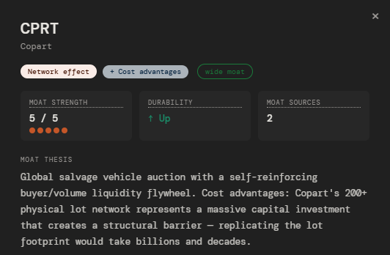
Source: aipmatrix.netlify.app

While insurance companies historically provide over 80% to 90% of the vehicle supply, Copart has increasingly diversified its supplier base to include banks, finance companies, fleet operators, charities, and individual consumers. The company provides a comprehensive suite of mission-critical services that manage the entire salvage process, including vehicle towing, secure storage in its network of over 250 yards, title processing, and merchandising. Central to this model is its proprietary Virtual Bidding technology (VB3), which allows for an entirely virtual, always-on auction environment that removes the need for physical attendance and enables global liquidity.
2.1 How They Make Money
The company’s revenue is generated through two primary streams: 1) service revenues and 2) purchased vehicle sales.
- Service revenues constitute the majority of Copart’s income and consist of various transaction-based fees charged to both sellers and buyers during the auction process. On the seller side, Copart often utilizes its Percentage Incentive Program (PIP), where it earns a predetermined percentage of the final auction price, typically ranging from 10% for high-value units to 20% for older or highly damaged cars. This model aligns Copart’s interests with those of the insurance carriers, as higher auction prices result in higher fees for Copart and better “returns” for the insurer. Other service fees charged to sellers include charges for towing, title processing, storage, and specialized merchandising. On the buyer side, Copart charges commissions based on the average selling price of the vehicle, alongside additional fees for loading, bidding, and annual membership registration. These buyer-side fees generally account for the majority of the company's total service revenue, with estimates ranging from two-thirds to upward of 80% depending on the period.
- The second revenue stream, purchased vehicle revenue, involves Copart acting as a principal rather than an agent. In this capacity, the company purchases vehicles outright, primarily from individuals through its “Cash For Cars” program or in international markets like the United Kingdom and Germany to establish market liquidity, and then resells them for its own account. For these transactions, the entire gross sales price at auction is recorded as revenue. While service revenues are highly profitable with margins often around 40%, the purchased vehicle stream carries lower margin percentages but serves as a strategic tool for expansion and supply diversification. Additionally, in specific markets like Germany and Spain, Copart generates revenue from listing fees paid by insurance experts who use the platform to determine a vehicle’s residual value even if it is not sold directly through a Copart auction.
2.2 Copart’s Positioning in the Industry
Within the global salvage vehicle auction industry, Copart occupies a dominant role as a technological pioneer and a near-monopoly player, sharing approximately 80% of the market with its primary competitor, Insurance Auto Auctions (IAA). We estimate Copart’s market share to be somewhere around 45-50%, with IAA having the other 30-35%. The remaining 20% comes from local players that we believe will eventually become part of either Copart or IAA.
Copart differentiates itself through its insistence on owning more than 90% of the land for its 21,000-plus acres of storage capacity, which provides a significant competitive moat by insulating the company from rising rental costs (unlike for IAA) and providing essential surge capacity to handle the mass influx of vehicles following catastrophic natural disasters.
Its role has evolved from a simple liquidator to a vital 'circular economy' enabler that facilitates the global reuse and recycling of raw materials and automotive parts. Approximately 40% of the vehicles sold through its auctions are restored to drivable condition, while the remainder are harvested for parts. The aging fleet dynamic that drives vehicles into Copart's yards today will, in time, drive the next generation of vehicles there too, not because Copart repaired them, but because depreciation, rising repair costs, and eventual mechanical failure are simply the universal destiny of every car on the road. Copart has positioned itself as the inevitable endpoint of that journey.
Subscribe

3. Industry Dynamics: No Accidents? No Problem
This section addresses one of the two primary pillars of this thesis. Copart’s value proposition to both buyers and sellers is predicated on market liquidity; consequently, the firm’s growth is inextricably linked to its ability to capture increasing volumes of "totaled" vehicles.
3.1 Salvage Industry 101
Generally, vehicles enter Copart’s ecosystem following a collision or significant mechanical failure. At this juncture, the insurer must perform a cost-benefit analysis: is it more economically viable to repair the vehicle or to divest it via the salvage market? Mathematically, a vehicle is totaled if:
Repair Costs > (Pre-Accident Value - Salvage Value)
These three variables serve as the primary levers of salvage volume:
- Repair Costs: An increase in labor or parts costs, ceteris paribus, elevates total loss rates.
- Salvage Value: Paradoxically, as the resale value of scrap and parts rises, insurers are more incentivized to “total” the car rather than repair it.
- Pre-Accident Value (PAV): Conversely, higher PAVs—often driven by a robust secondary used-car market, make repairs more attractive, thereby reducing salvage frequency.
Consider a vehicle with a Pre-Accident Value of $10,000. Following a collision, the insurer estimates repair costs at $6,000 and a potential salvage recovery of $5,000. The right-hand side of the formula, PAV minus salvage value, represents the net cost to the insurer of choosing to salvage: they pay the policyholder the full $10,000 value but recover $5,000 at auction, for a net outlay of $5,000. Repairing the car costs $6,000. Since $6,000 exceeds $5,000, the vehicle is totaled and enters Copart's ecosystem.
$6,000 > ($10,000 - $5,000)
The math is straightforward, but the implications are significant: any force that raises repair costs or increases salvage recoveries simultaneously pushes more vehicles across this threshold.
While the "total loss" formula determines the fate of a damaged vehicle, it only becomes relevant upon the filing of an insurance claim. Without a collision or mechanical failure, the salvage funnel remains empty. This, the frequency of accidents and claims, represents the most critical variable in Copart’s long-term trajectory.
3.2 Industry Trends
The growth of the global salvage vehicle auction industry is propelled by several interconnected drivers, with the steady increase in total loss frequency standing as the most critical secular constant for Copart’s organic expansion.
Total loss frequency, or the percentage of cars involved in accidents that insurers choose to salvage rather than repair, has climbed from approximately 4% in 1980 to over 20% in recent years, with data from 2025 showing rates as high as 23.1%.
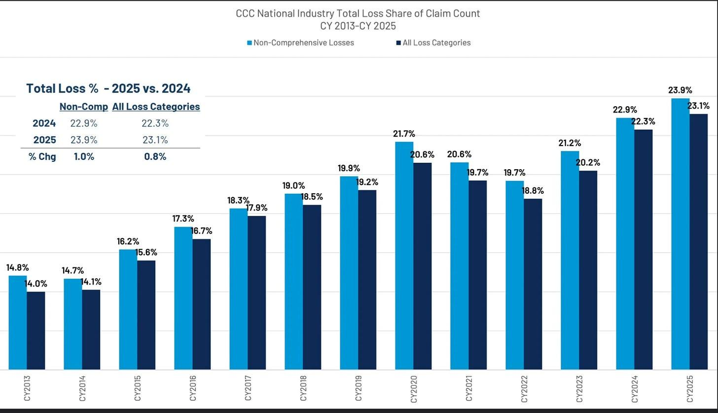
Source: CCC 2026 Report
This upward trajectory is fundamentally dictated by the “salvage equation,” that way explained before: a vehicle is declared a total loss if the cost of repairs, plus supplemental expenses like car rentals, exceeds the vehicle’s pre-accident value minus its projected salvage value at auction. Copart’s ability to generate high returns through its global buyer base actually encourages this trend, as higher projected auction prices make it more economically attractive for insurance carriers to total a vehicle rather than fund expensive repairs.
While the upward trajectory of loss rates is fundamentally positive for Copart’s business model, a more nuanced analysis is required. The loss rate is defined by the relationship between two distinct variables:
- The Numerator: The number of those claims resulting in a “total loss” determination (Total Loss Volume).
- The Denominator: Total insurance claims filed (Claims Frequency).
The strategic value for Copart lies not merely in an “up and to the right” trendline, but in the fact that the numerator is expanding at a higher velocity than the denominator. It is critical to distinguish between a high loss rate and a healthy business environment.
For instance, if total insurance claims (denominator) were to plummet due to external factors, say, adoption of Autonomous Vehicles, the loss rate might mathematically increase even as the absolute volume of salvageable vehicles collapses. Such a scenario would be detrimental to Copart’s revenue, which is driven by unit volume rather than percentage rates.
Therefore, we must investigate the structural drivers behind the increasing loss rate to determine if the current growth is sustainable.
3.3 The Numerator
There are two primary catalysts that help increase the numerator, that is, the number of totaled cars: 1) An increasing average age of the vehicle fleet, and 2) Increasing repair costs.
3.3.1 Average Age of the Vehicle Fleet
The increasing average age of the vehicle fleet makes cars more prone to being totaled because their pre-accident values are lower. Additionally, as vehicles age and their market value depreciates, the threshold at which repair costs exceed their value becomes easier to reach, particularly as repair costs continue to rise secularly due to labor inflation and a shortage of skilled mechanics.
In the United States, the average age of light vehicles reached a record 12.8 years in 2025, continuing a long-term trend from 8.4 years in 2002 and 11.5 years in 2015.
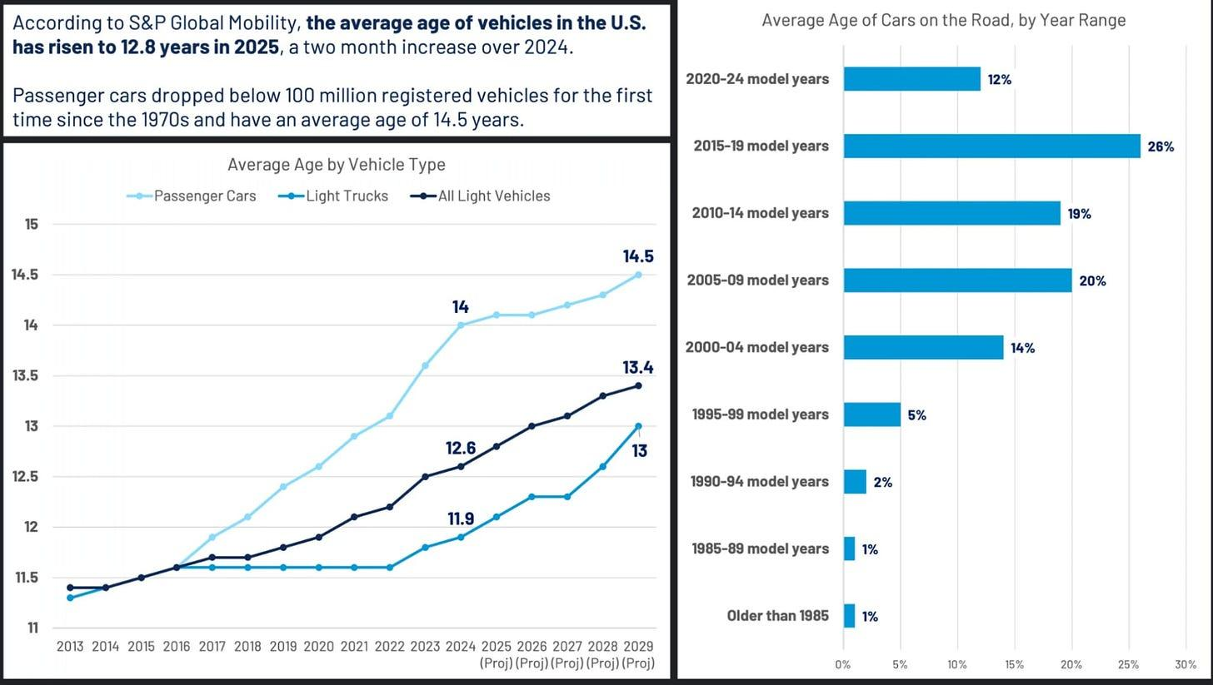
Source: CCC 2026 Report
As illustrated in the above chart, approximately 62% of vehicles on the road are 12 years or older, while a substantial 88% are at least seven years old.
According to S&P Global Mobility, the national “scrappage rate” (the rate at which vehicles are permanently retired from service) has remained stable at approximately 4.5%. Applied to a national fleet of 289 to 300 million units, this translates to an annual retirement volume of 13 to 15 million vehicles.
Given that the average vehicle age has climbed to 12.8 years (and is projected to rise further absent a significant surge in new vehicle sales), and that the average age of a vehicle declared a “total loss” is 10.6 years the industry is positioned for sustained organic growth. We anticipate that as the fleet continues to age, the scrappage rate will experience upward pressure, directly expanding Copart’s addressable volume. This relationship between fleet age and terminal salvage value will be a key driver in our valuation of the firm.
Further evidence of this trend is found in the distribution of total loss valuations. The next chart demonstrates a progressive shift in the composition of totaled vehicles toward older age brackets. This confirms that older vehicles, in aggregate, are increasingly becoming the primary drivers of industry business volume.
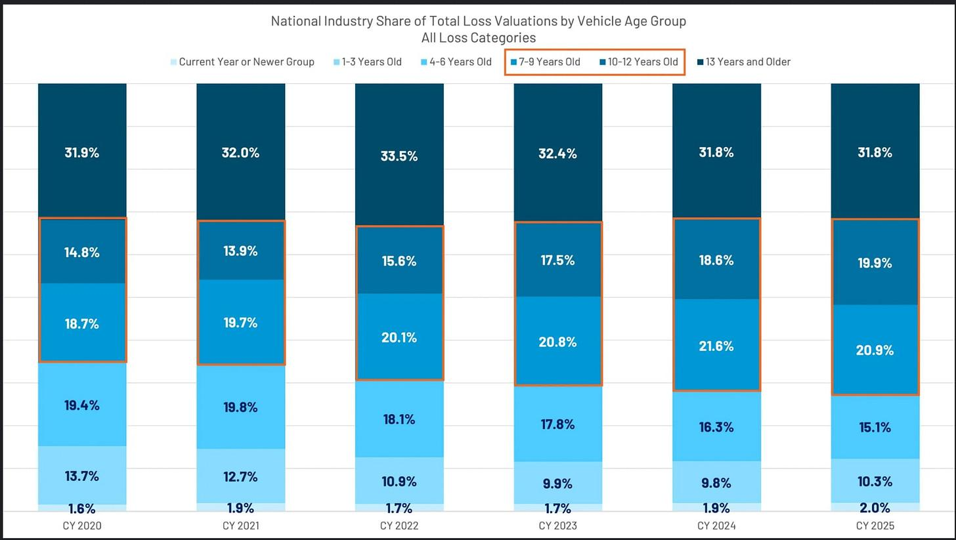
Source: CCC 2026 Report
3.3.2 Increasing Repair Costs
Simultaneously, rapid advances in vehicle technology and complexity have made even newer, high-value vehicles more expensive and difficult to repair. Modern light vehicles now contain between 1,000 and 3,000 semiconductors, compared to virtually zero fifty years ago, and are increasingly constructed with exotic metals and composites to meet federal CAFE standards for fuel efficiency.
Safety features like perimeter cameras, sensors, radar, and LIDAR are often located on the exterior of the car, making them highly vulnerable to damage in even modest fender-benders. The cost to replace these modules, combined with the specialized labor required for calibrations and diagnostics, often results in “economic total losses” for vehicles that appear to have only minor visible damage.
Furthermore, newer vehicles are built with unibody constructions and safety cages that are designed to absorb impact by crumpling, which improves passenger safety but significantly increases the technical complexity and cost of restoring the vehicle to its original condition.
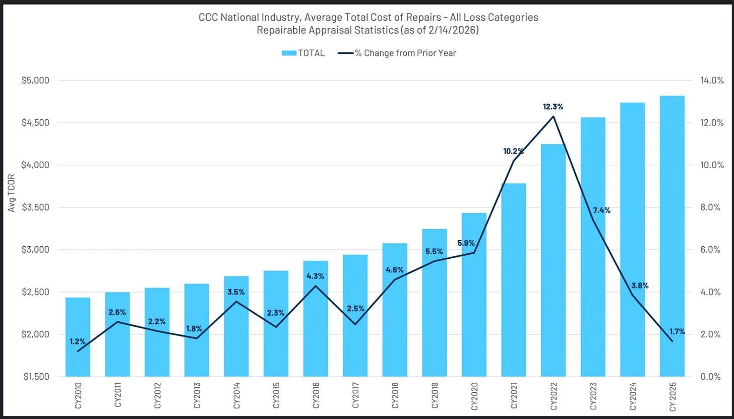
Source: CCC 2026 Report
Beyond vehicle-specific factors, broader demographic and behavioral trends provide a durable foundation for industry volume. While the U.S. population has nearly doubled since 1960, vehicle miles traveled have quadrupled as mobility remains an essential need. Despite long-term moderate declines in the crash rate per million miles driven due to safety technology, the absolute number of accidents has remained relatively stable because of road congestion and the rise of distracted driving related to smartphone usage.
3.4 The Denominator
There are two main factors affecting the denominator (the number of insurance claims: 1) Number of crashes, and 2) Number of vehicles insured.
3.4.1 Number of Crashes
While the increasing complexity of modern vehicles drives higher total loss rates, that same sophistication serves as a primary catalyst for accident prevention. Since 1988, the involvement rate of vehicles in crashes has seen a disciplined decline, falling from 3.9 per million VMT to 2.1 as of 2023, representing a compound annual decrease of approximately 1.8%.
Naturally, a reduction in accident frequency exerts downward pressure on insurance claim volumes, which theoretically limits the pool of potential salvage assets.
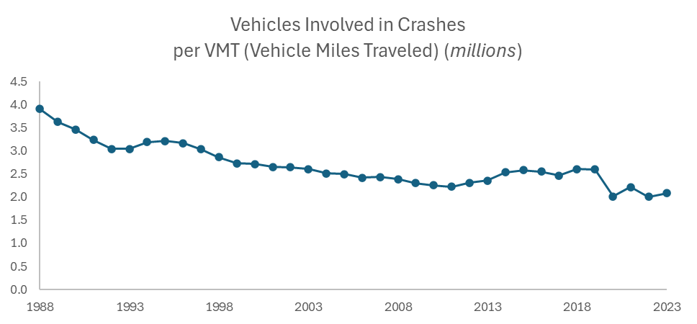
Source: NHTSA
The steady penetration of safety technologies, like Anti-lock Braking (ABS), Electronic Stability Control (ESC), and Advanced Driver Assistance Systems (ADAS), has decoupled vehicle mileage from accident rates.
As the industry moves toward higher levels of autonomous capability, we anticipate this downward trend in frequency will persist. The eventual “inflection point” for the industry may occur when autonomous vehicle (AV) saturation reaches a critical mass, potentially leading to a non-linear collapse in crash frequency. We will discuss this further in a later section.
3.4.2 Uninsured Vehicles
The other trend affecting the number in insurance claims is the amount of uninsured vehicles, or crashes that “go uninsured”.
Data from ISS Fast Track shows that through the third quarter of 2025, all three major physical damage coverages (collision, comprehensive, and property damage liability) experienced a continued decline in frequency, which is measured as paid claim volume relative to the number of vehicles in force. While most personal auto lines saw frequency drift downward over the last two years, bodily injury remained the only outlier to this trend. Furthermore, the total volume of repairable claims declined by 9.7% in 2025 across all coverages.
So what does this mean? In simple terms, a decline in paid claim frequency means that fewer people are asking their insurance companies to pay for repairs after an accident. This doesn't necessarily mean that there are fewer accidents happening; rather, it means that minor accidents are "falling out" of the insurance system because people are choosing not to report them.
This trend diminishes the amount of total claims for several key reasons:
- More consumers are choosing deductibles of $1,000 or higher to lower their monthly premiums. If a car has minor damage that costs $800 to fix, but the driver has a $1,000 deductible, the insurance company won’t pay anything. Consequently, the driver often chooses not to file a claim at all, making that accident “disappear” from official insurance records.
- Many drivers are afraid that filing a claim for a small accident will cause their insurance rates to skyrocket. Because of this “affordability pressure,” they treat minor repairs as discretionary or optional purchases, often choosing to pay for the repair out of their own pocket or simply living with the damage.
- As insurance becomes more expensive, some drivers are switching from “full coverage” to “liability-only” or dropping insurance entirely. If an underinsured driver is at fault in an accident, there is no insurance claim filed for their own vehicle, so it never enters the system to be repaired or salvaged.
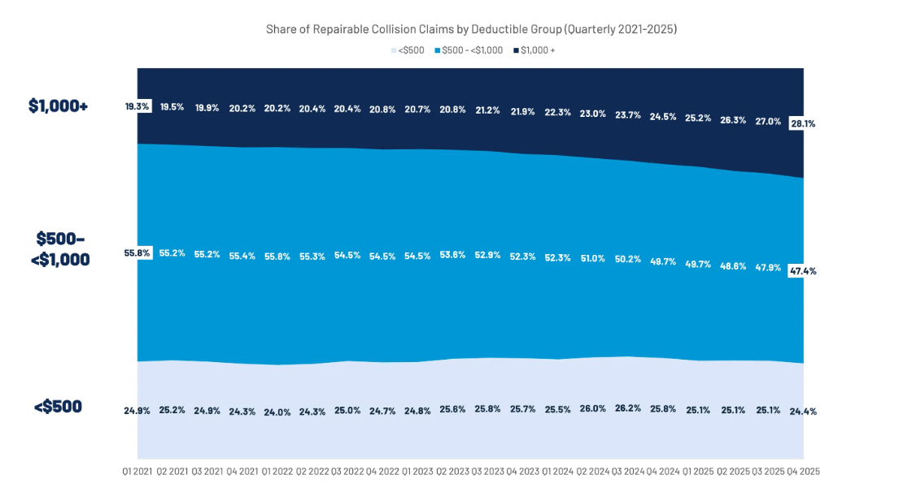
Source: CCC 2026 Report
When paid claim frequency goes down, the total number of claims (the “denominator” in the math of the industry) shrinks. However, large accidents that result in a “total loss” are not optional, they almost always result in a claim because the car is undriveable and the payout is large.
Because the small, easy-to-fix claims are being removed from the pool while the big, totaled-car claims remain, the percentage of claims that end up as “total losses” appears to be rising sharply. This creates a mathematical effect where the industry looks like it is totaling more cars, when in reality, it is simply processing fewer minor repairs.
Some data points that paint the picture:
- 24% of people have downgraded or dropped insurance to free up cash.
- 1 in 3 said they would temporarily go without insurance to free up funds for necessities.
- 1 in 5 would rather go without insurance coverage than pay rising monthly premiums.
- 29% downgraded or canceled insurance in the last year (2024). Car insurance was the most downgraded or canceled at 15%.
- In a recent report, Insurance Research Council estimated that the combined population of uninsured and underinsured on the U.S. roadways was 33.4% as of 2023, representing a 10% increase since 2017.
For a company like Copart, this trend is a “double-edged sword”: while the rate of total losses looks high, the actual volume of cars can be suppressed because some vehicles that should have been salvaged never enter the insurance funnel at all
Ultimately, we must discern which drivers within the total loss equation represent secular, structural shifts and which are merely transitory fluctuations.
3.5 Factors Affecting the Numerator (Total Loss Volume)
- Average Age of the Vehicle Fleet
This is a long-term structural shift caused by a nearly seven-million-unit shortfall in new vehicle sales between 2021 and 2025, which has fundamentally altered the composition of the “car parc”.
Because older cars are worth less, it is mathematically much easier for repair costs to exceed the economic threshold for a total loss.
We consider this trend to be structural because the aging fleet is a multi-year demographic reality that will take decades of new car sales to “cycle through” and refresh.
- Increasing Repair Costs
Modern vehicles are increasingly complex. Even a modest “fender-bender” can now damage expensive electronic modules that require specialized labor for calibrations and diagnostics. This has led to a secular rise in repair severity that consistently pushes vehicles toward being “economic total losses”.
This driver is structural because it is rooted in the irreversible advancement of automotive technology.
3.6 Factors Affecting the Denominator (Total Claims processed)
- Number of Vehicles Involved in Crashes per VMT
Secular improvements in safety technology (ABS, ESC, and increasingly ADAS) have produced a slow, steady decline in the number of accidents per mile driven over several decades, falling from 3.9 per million VMT in 1988 to 2.1 as of 2023. As technology successfully reduces the frequency of collisions, the total number of claims (the denominator) shrinks. While human behavior, such as distracted driving from smartphones, caused a temporary multi-year increase in accident rates after 2011, the long-term technological trajectory is toward fewer accidents.
This is structural because it is dictated by engineering gains that permanently improve vehicle safety.
- Decrease in Insured Vehicles and “Uninsured Claims”
High inflation and rising insurance premiums have created severe affordability pressures for consumers. In response, approximately 24% of consumers reported downgrading or dropping insurance in 2025, with 8% specifically moving from full coverage to liability-only. Furthermore, 26% of policyholders now carry deductibles of $1,000 or more.
Copart’s management has been vocal about this and views it as a cyclical trend rather than a permanent change in the industry.
We agree. Historically, the degree to which motorists maintain full insurance coverage has fluctuated with the economy. If affordability stabilizes and premiums moderate, these smaller claims are expected to return to the system, causing the denominator to normalize.
Ultimately, while the system remains sensitive to cyclical fluctuations, such as the unprecedented 35% spike in used car prices between 2020 and 2023, which temporarily suppressed total loss frequency by making repairs more viable relative to high vehicle values, we believe the long-term trend toward higher salvage rates remains intact.
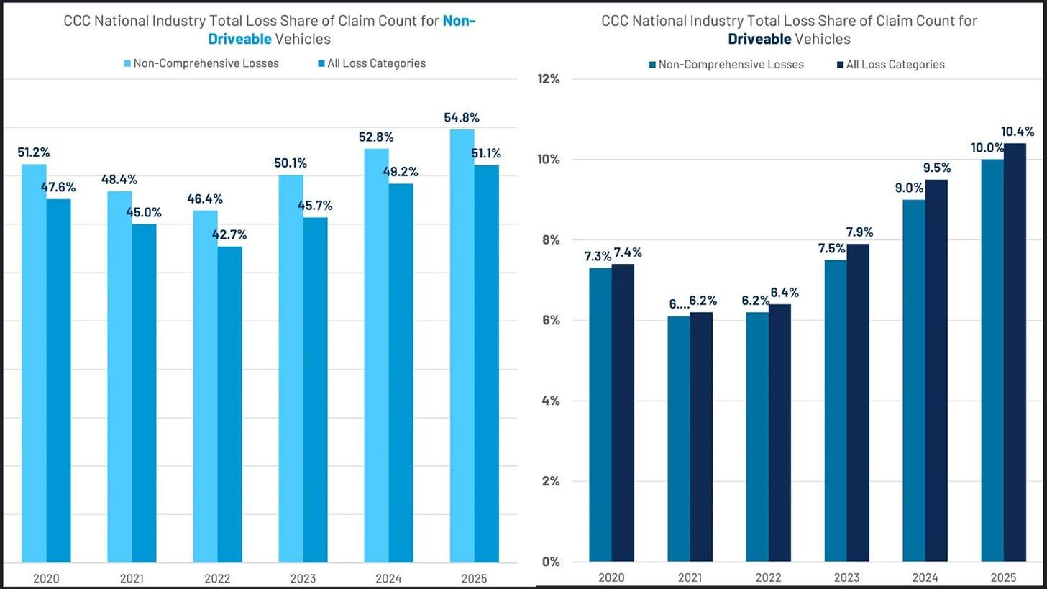
Source: CCC 2026 Report
Subscribe

4. Competition: It’s Close, But Not Really
Copart’s dominant position in the salvage vehicle auction industry is underpinned by a trifecta of competitive advantages: extensive land ownership, a massive global buyer network, and a multi-decade lead in digital auction technology. Collectively, these advantages have created a formidable “moat” that its primary competitor, Insurance Auto Auctions (IAA), has struggled to replicate.
The company’s most significant physical advantage is its real estate strategy, characterized by an insistence on outright ownership of its facilities. While IAA historically followed a “capital-light” model by leasing land to satisfy Wall Street’s preference for high short-term returns on invested capital, Copart’s founder Willis Johnson viewed land as a strategic asset essential for long-term survival (It is estimated that IAA’s Return on Invested Capital would be 50% higher if they owned their land).
Today, Copart owns more than 90% of the acreage on which it operates, managing a global portfolio that has grown to over 21,000 acres. This ownership protects the company from rising rental costs and the leverage of landowners who can “squeeze” tenants during lease renewals. Furthermore, because salvage yards face intense “NIMBY” (Not In My Backyard) resistance, obtaining the necessary zoning and permits for new locations is an arduous process that can take decades, making Copart’s established, permitted footprint virtually impossible for a new entrant to duplicate.
This structural advantage, combined with Copart’s pioneering of the Percentage Incentive Program (PIP) has resulted in a superior financial profile. Copart maintains operating margins of approximately 37% and a ROIC that consistently outpaces IAA’s by 10 to 15 percentage points.
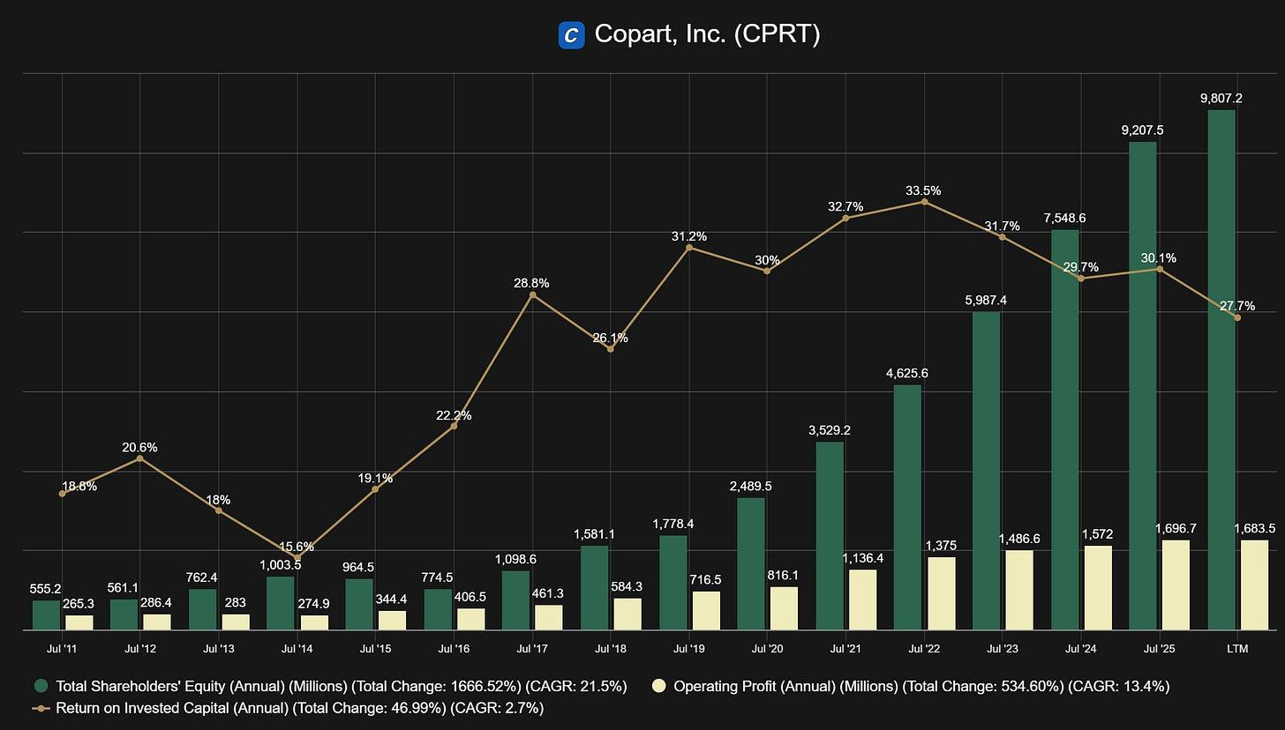
Source: Fiscal.ai
This land footprint also provides critical catastrophe readiness; Copart maintains “Mega Yards” in storm-prone regions that remain largely idle until a disaster strikes, providing the surge capacity needed to process tens of thousands of vehicles instantly (a service level that IAA famously failed to match during Hurricane Katrina).
The international reach is also a major differentiator; while IAA’s buyer base remained largely domestic for years, Copart’s auctions are truly global marketplaces. While there are no clear figures, the general consensus is that Copart currently commands a dominant market share of roughly 47% to 50%, processing over 3 million of the 5 to 6 million vehicles that enter the salvage pool annually. This scale is underpinned by a global liquidity engine consisting of one million registered members across 165 countries; international buyers are particularly vital to this ecosystem, participating in 90% of auctions for rebuildable vehicles and purchasing 40% of Copart’s total U.S. inventory.
Finally, Copart’s technological maturity has allowed it to dictate the pace of industry evolution. The firm secured a massive 17-year head start in digital transformation by eliminating live auctions in 2003, whereas IAA did not fully transition to a 100% online model until the 2020 pandemic. While IAA has made recent strides in operational efficiency, reaching near-parity with Copart’s 40-to-50-day vehicle turnaround benchmark, the cumulative effect of Copart’s early digital adoption, proprietary incentive structures, and owned real estate continues to widen the gap between the two industry leaders.
Subscribe

5. Autonomous Vehicles and Other Risks: The Actual Math
5.1 Safer Vehicles and AVs
As discussed, ADAS has already been reducing crash frequency for decades, yet total loss rates have kept rising, because the severity of the accidents that do occur has more than offset the frequency decline. The more pressing question, then, is not ADAS but full autonomy.
Ok. But how inminent is the threat of AVs really? Ironically, this is the easiest risk to debunk. The transition to a fully autonomous fleet is a multi-decade process; with approximately 300 million light vehicles currently in operation in the U.S. and only 15 to 18 million new cars sold annually, it would take at least 17 to 20 years to cycle this technology through the entire car parc even if every new car sold TODAY were fully autonomous.
The more immediate question is not full autonomy but the incremental effect of ADAS, features like automatic emergency braking, lane-keeping assist, and collision warnings that are already standard on most new vehicles. These systems have contributed to the long-running decline in crash frequency per mile driven, a trend that predates any AV discussion.
However, the data reveals an important asymmetry: while ADAS reduces the frequency of accidents, the vehicles carrying these systems are significantly more expensive to repair when accidents do occur. Sensors, cameras, and radar modules located on the vehicle's exterior are among the first components damaged in a collision, and their replacement requires specialized calibration that commands a premium.
The net effect has been that total loss rates have continued rising even as crash rates have fallen, the severity effect has more than offset the frequency effect. We do not expect this relationship to change materially until autonomous systems are capable of preventing the high-severity crashes that generate total losses in the first place, and that capability remains years away from meaningful fleet penetration.
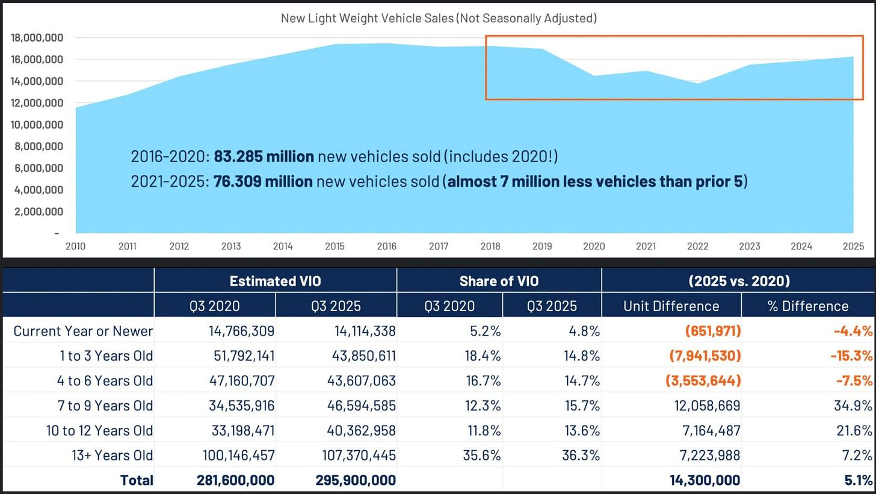
Source: CCC 2026 Report
As illustrated in the preceding data, the composition of the U.S. vehicle fleet has undergone a significant structural shift since 2020. There is a clear bifurcation occurring between newer and older cohorts: the supply of “near-new” vehicles (ages 1–3) has contracted by 15%, while the 4–6 year cohort has diminished by nearly 8%. This scarcity is largely a residual effect of the pandemic-era production deficits and supply chain disruptions.
Conversely, the population of mid-to-late-life vehicles has expanded rapidly. The 7–9 year cohort has surged by 35%, followed by a 22% increase in vehicles aged 10–12 years. Even the most senior bracket—vehicles 13 years and older—grew by 7%. This “aging up” of the fleet explains the record-high average vehicle age and suggests a durable tailwind for the salvage industry. Given that the replenishment of the newer cohorts remains slow, the average age is statistically positioned to continue its upward trajectory for the foreseeable future.
5.2 Nobody Wants a Monopoly
Except Copart and its shareholders.
While not technically a risk, there is a very real limitation to Copart’s dominance in the industry, despite its wide competitive advantages over IAA. The primary limitation on Copart’s domestic market share is that major insurance carriers prefer a stable duopoly over a monopoly to ensure they maintain negotiating leverage. Because vehicle disposal is a mission-critical part of their value chain, insurers do not want to be beholden to a single vendor that could eventually raise pricing or dictate more aggressive contract terms.
To maintain this competitive balance, carriers have historically been willing to give volume to Copart’s main competitor, IAA, even during periods when IAA’s operations were considered inferior, simply to keep them in the game. These carriers often use both providers across different geographies to prevent either company from gaining too much power in a single region.
Large carriers like State Farm have indicated that if the market share becomes too lopsided in Copart’s favor, they are willing to intentionally move volume back to IAA to stabilize the industry.
Consequently, while Copart may be the more efficient operator, its ability to capture the entire U.S. market is naturally capped by its customers’ own self-interest in preserving competition.
5.3 Economic Factors
Macroeconomic sensitivity remains a critical cyclical risk, particularly concerning consumer behavior and used vehicle valuations. During periods of significant inflation and affordability pressure (like right now), consumers often retrench their insurance participation by increasing deductibles, downgrading to liability-only coverage, or forgoing insurance entirely. Vehicles owned by uninsured or liability-only motorists do not enter the traditional insurance salvage funnel if the owner is at fault in an accident, which can cause temporary volume declines for Copart.
The company also experienced an unprecedented anomaly between 2020 and 2023 when used car prices spiked by approximately 55%, which temporarily suppressed total loss frequency because the vehicles’ high pre-accident values made expensive repairs more economically viable relative to salvaging.
This risk is not purely historical. The tariff environment of 2025–2026 is creating a new potential headwind through a similar mechanism: as import tariffs raise the cost of new vehicles, demand shifts into the used market, elevating pre-accident values and once again making expensive repairs more economically viable relative to salvaging. Should this dynamic persist, it could temporarily suppress total loss frequency in the near term. Management has navigated this before, and the structural tailwinds, an aging fleet and rising repair complexity, remain intact underneath any cyclical suppression.
Lastly, Copart is sensitive to fluctuations in commodity prices, specifically the per-ton price of crushed car bodies, which impacts the auction floor price for low-value scrap units.
5.4 Other Risks
Operational and regulatory hurdles further complicate the business environment, specifically regarding land ownership and permitting. Copart’s strategy of owning its land provides a moat, but obtaining the necessary licenses and zoning for salvage yards faces intense “NIMBY” (Not In My Backyard) opposition, which can delay or prevent facility expansions in high-demand areas. If Copart can no longer expand its land, then growth must come from increasing market share and organic industry dynamics.
Internationally, the company must navigate diverse business cultures and legal frameworks. For example, in Germany, policyholders typically retain their totaled vehicles, with insurers paying only the difference between the pre-accident value and a non-binding residual bid. This inefficient process often leaves consumers responsible for disposing of damaged units via low-liquidity channels.
Copart is actively transitioning major German carriers to its proven consignment model. Under this framework, Copart manages the logistics, storage, and global auctioning of the vehicle. This centralizes liquidity, maximizes recovery returns for insurers, and eliminates the administrative burden on the policyholder, replicating the competitive moat Copart enjoys in the North American market.
Subscribe

6. Capital Allocation: The Key Ingredient
Copart’s capital allocation strategy is rooted in a fiscally conservative (net cash), long-term ownership mindset that prioritizes organic reinvestment in physical infrastructure and proprietary technology over immediate shareholder distributions. For nearly a quarter-century after going public in 1994, the company did not repurchase any shares, choosing instead to focus its capital on rolling up the fragmented salvage industry and building a national footprint.
We continue to think on long timelines, investing in the land, technology, and people that will strengthen this business not just for the next few years, but for the decades and generations to come. Our focus has always been on building enduring advantages rather than chasing short-term gains, and that long-term mindsest will continue to guide every major decision we make.
Jeff Liaw, CEO - Letter to Shareholders 2025
This conservative posture was driven by founder Willis Johnson’s historical experience with being cash-strapped in prior ventures, leading to a preference for a fortress balance sheet. It was only in 2007, after management became convinced of the business’s extreme resiliency, that Copart began to deploy excess cash for opportunistic and aggressive share repurchases.
The company’s philosophy on buybacks is to remain patient when valuations are high and strike heavily when the market undervalues the business. This was most notably demonstrated in 2011 when Copart issued its first-ever debt, a $400 million note specifically to fund a massive tender offer at $38/share, which allowed them to repurchase approximately 20%. of the total share count. Following this, they executed another large tender offer in 2016, but they have generally stepped out of the market since 2019 as valuations have remained above the levels management considers “cheap“.
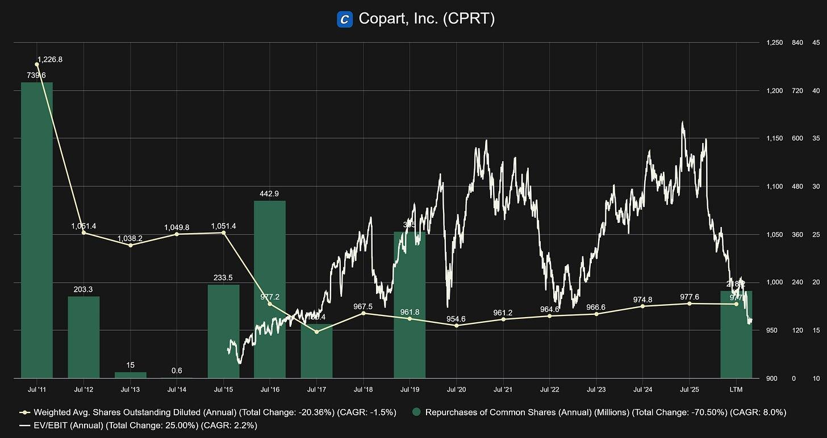
Source: Fiscal.ai
Copart currently trades at approximately 16x EV/EBIT, a multiple last seen in 2016–2017, the period during which management allocated $600 million toward repurchases. The market appears to agree that this is an attractive entry point: management has committed approximately $1.17 billion to buybacks in the current fiscal year alone, the largest dollar-denominated repurchase program in the company's history. This consists of $218 million at $39.82 per share during Q2 2026, followed by an additional $899 million between February and March 2026 at $37.11 per share, a deliberate acceleration as the price fell.
Combined, these actions have retired 3.1% of shares outstanding. The second tranche is not yet visible in trailing financials, meaning the market is pricing Copart on figures that do not yet reflect the full scale of this capital return. With $4.1 billion in pro-forma net cash remaining, the balance sheet provides ample runway to continue. When the people who know this business best are buying it this aggressively, that is a signal worth taking seriously.
While we don’t shy away from buybacks at attractive valuations, we would much rather prefer it if Copart had enough investment opportunities to deploy the hoarded $5 billion of cash into new land and growth initiatives. With returns on capital historically north of 20%, this is what shareholders must hope for.
This is precisely a cornerstone of Copart’s capital strategy, the relentless reinvestment in land ownership, a strategy that sharply contrasts with the “capital-light” leasing model used by its main competitor, IAA.
In fiscal 2020 alone, the company accelerated its spending by investing over $600 million to add 2,000 acres of owned land. This aggressive expansion includes “Mega Yards” in storm-prone regions that remain largely vacant until they provide the necessary surge capacity to handle thousands of vehicles following catastrophic events.
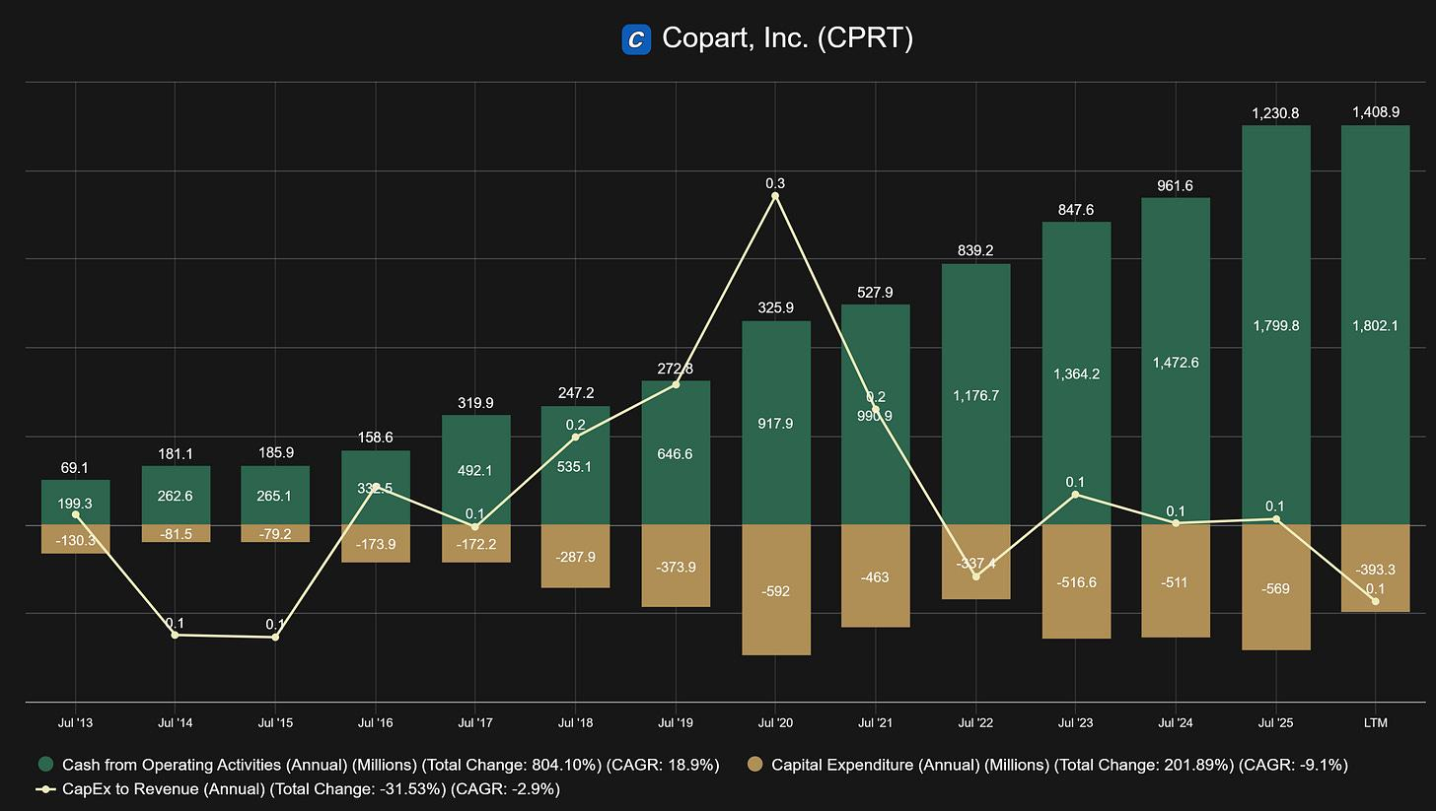
Source: Fiscal.ai
Reinvestment also flows heavily into proprietary technology, with Copart employing approximately 800 people in technology to maintain its lead in virtual bidding systems. These investments include the development of the VB3 platform, mobile bidding applications, and advanced machine learning tools like ProQuote.ai and IntelliSeller that automate total-loss decisioning for insurance carriers.
Copart’s discipline is further evidenced by its refusal to fall for the sunk cost fallacy; in 2014, the company famously wrote off a $29 million investment in an SAP enterprise system because management realized it was not the right tool for their specific operational needs. We welcome management that isn’t afraid to admit mistakes.
Despite the high total capital expenditures, which reached nearly $500 million in 2025, the business is remarkably capital-efficient regarding maintenance Capex. Because Copart’s yards are essentially large, permitted parking lots with minimal structures, the required upkeep is low. Estimates suggest that maintenance Capex accounts for well under 50%, and potentially as low as 25%, of total Capex, meaning the vast majority of Copart’s spending is dedicated to discretionary growth and capacity expansion. This efficiency allows for strong free cash flow conversion, which the company either reinvests into its global “circular economy” engine or preserves to wait for the next major opportunity to be aggressive with capital returns.
Subscribe

7. Valuation: Not a Seven Foot Bar
In our valuation, the objective is not to achieve pinpoint accuracy, but to establish a reliable "ballpark" figure. As Buffett famously suggested, it is better to be roughly right than precisely wrong. We believe a valuation model should be elegant and simple; if a massive margin of safety exists, you shouldn’t need a complex spreadsheet to find it.
7.1 The Volume Equation and Market Share
The total U.S. fleet is approximately 300 million vehicles (Total Fleet). Historically, annual insurance claims represent 10% to 15% of Total Fleet, equating to 30–45 million potential salvage opportunities.
Currently, we estimate the market is closer to the 10% floor. Macroeconomic pressures have forced many vehicle owners to drop insurance entirely or reduce coverage, subduing claim volumes. The math supports this: at 30 million insurance claims and a 22.6% loss rate, the total salvage market sits at 6.8 million vehicles. Given that Copart processes between 3 and 3.5 million vehicles annually, their market share likely falls between the high 40s and mid 50s. At a 48% share, they would process exactly 3.25 million units, suggesting our baseline assumptions are well-grounded.
7.2 Projecting Organic Growth
The critical question is how much Copart can grow from here. While insurance claims may remain muted in the short term due to premium inflation and consumer constraints, we expect the total loss rate to climb. This trend is driven by an aging vehicle fleet and the ever-rising cost of complex repairs.
Our model assumes:
- Insurance Claims: Remain flat initially, gradually rising to 12.5% of Total Fleet (middle of historic range) by Year 5 as economic pressures ease.
- Loss Rate: Continues its historical climb of roughly 0.8% annually, with slight acceleration.
- Conservative Constraints: We assume the Total Fleet remains stagnant, Copart gains no further market share, ancillary business lines (BlueCar, Powersports, etc.) remain flat, and international expansion contributes zero additional growth.
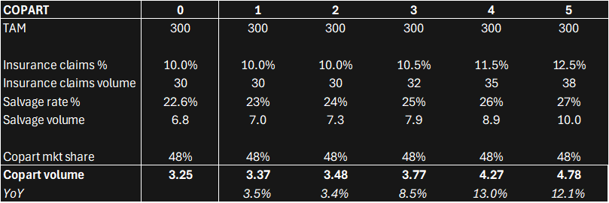
Source: Internal estimates
Under these assumptions, Copart should grow its processed volume at an 8% CAGR, reaching 4.8 million vehicles by Year 5. This represents the company’s organic engine.
7.3 Reinvestment and Inorganic Growth
To calculate inorganic growth, we look at Copart’s capital allocation. Maintenance CapEx has historically accounted for roughly 25% of total spend, leaving 75% for growth. With CapEx averaging 42% of Cash Flow from Operations, this results in a 32% growth reinvestment rate.
While Copart’s ROIC has averaged closer to 30% over the last decade, we have used a more conservative 25%. We also assume the reinvestment rate will moderate over time as the company scales.
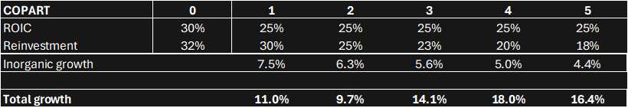
Source: Internal estimates
By adding organic and inorganic growth we arrive to the estimated total growth.
7.4 From Volume to Owner Earnings
Does this growth profile make sense? We believe so. The “roughly right” view suggests slower growth in the immediate future due to inflationary headwinds, followed by a flourish in Years 3–5 as the aging fleet and repair-cost tailwinds take over.
Historically, Copart’s Owner Earnings margin has averaged 17.5%, though the trend is clearly upward due to scale advantages. In the last five years, margins have averaged nearly 25%. While LTM margins have spiked over 30% due to a temporary dip in CapEx, we have modeled a steady 25% margin for our projections. At a 25% margin, normalized owner earnings total $1,155 million (compared to the more than $1,400 million actually generated in the LTM).
Source: Internal estimates
Starting from a normalized base of $1,155 million, we project Owner Earnings to reach $2,205 million by Year 5 (13.8% CAGR). For context, this is significantly more conservative than Copart’s 5-year historical Owner Earnings CAGR of 30%.
7.5 The Per-Share Powerhouse: Buybacks
The final lever is share count. In the twelve months ending March 2nd, Copart repurchased $1,117 million in stock. Following these buybacks, the diluted share count stands at 951 million.
Given their massive cash balance and clear appetite for buybacks at these valuations, we assume the share count will diminish by 4% to 4.8% annually. We have also factored in a “fortress balance sheet” buffer to ensure our buyback assumptions don’t unrealistically deplete cash reserves.
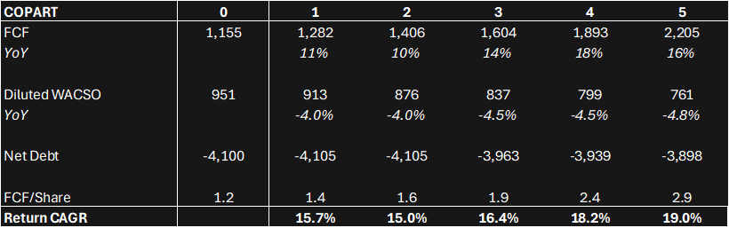
Source: Internal estimates
Keep in mind that this is a conservative estimation, as one would hope reinvestment rates at 25% ROIC remained steady or ideally even increase, rather than fall.
Combined, these factors yield a 19% CAGR in Owner Earnings per share. This represents the shareholder’s "internal" return, assuming no change in valuation multiples.
7.6 Stress Testing: The Multiple Compression Margin
To further stress-test this thesis, we asked: How much could the market multiple contract while still providing an attractive return?
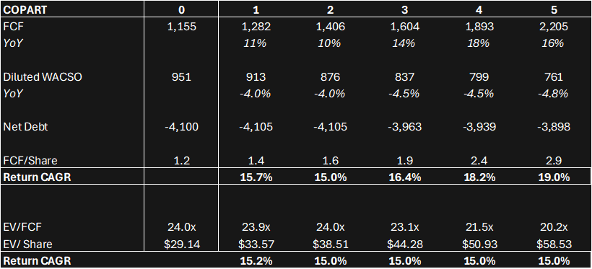
Source: Internal estimates
Our normalized EV/FCF multiple is 24.0x¹ today. As shown above, the multiple could compress to 20x over five years, and the investor would still realize a 15% annualized return (ah, the wonders of compounding). If we use actual current LTM figures (19.7x), the multiple could drop to 16.6x to achieve that same 15% hurdle.
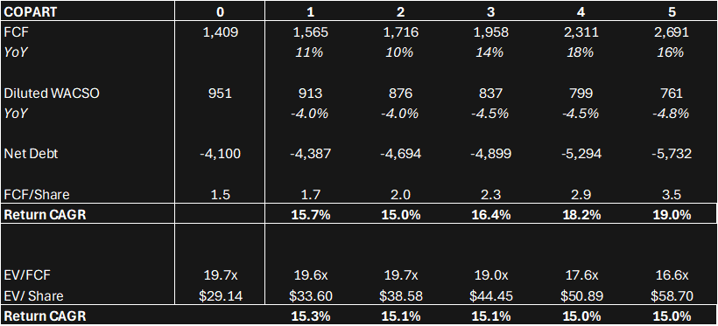
Source: Internal estimates
Copart faces a very low bar to provide market-beating returns. By utilizing conservative growth estimates and factoring in significant multiple compression, we find ourselves in a position where we don't need to be lucky to win. Like Buffett, we prefer stepping over one-foot bars rather than jumping over seven-footers.
Subscribe

8. Killing the Thesis
A good investment thesis must be falsifiable. Rather than cataloguing every conceivable risk, this section focuses on the specific conditions that would cause us to abandon this thesis entirely — not merely worry about it.
The insurance claims recovery doesn’t materialize
The volume growth in our model assumes that the current suppression of insurance claims is cyclical, and that affordability pressures ease over the next three to five years, pulling claims back toward the historical midpoint of 12.5% of the total fleet. If this assumption is wrong, if underinsurance and high deductibles become a structural feature of the American consumer rather than a temporary response to inflation, the organic growth engine stalls. At a flat 10% claims rate, volume growth drops to roughly half our projected rate, driven only by loss rate expansion. That is still a growing business, but it is unlikely to support the current multiple, let alone our return projections.
The signal to watch is simple: are paid claim volumes recovering as insurance premiums moderate? If premiums remain elevated for several years and claim volumes do not recover, we would revisit the thesis.
Used car prices spike persistently
As discussed in section 5.3, elevated pre-accident values make expensive repairs more economically viable and suppress total loss frequency. The 2020-2023 episode was resolved as supply chains normalized and the used car market cooled. The current tariff environment creates a similar risk. What would kill the thesis is not a temporary spike but a multi-year structural elevation in used car prices, driven by persistent import restrictions, chronic new vehicle undersupply, or both, that keeps PAVs high enough to meaningfully erode the total loss rate over the duration of our holding period.
A sustained total loss rate declining back toward 18-19% would be a warning sign worth taking seriously.
IAA becomes a real competitor again
Our thesis tolerates, and even assumes, a stable duopoly. What it does not tolerate is a revitalized IAA. Under the ownership of RB Global, IAA now has access to meaningful capital, global auction expertise, and a parent company with strong institutional relationships. If RB Global successfully closes the operational gap with Copart over the next few years, improving turnaround times, building a comparable international buyer network, and matching Copart’s technology offering, large insurance carriers would have genuine reason to shift volume. Copart’s land ownership moat remains structural and cannot be replicated quickly, but market share and pricing power could erode at the margins.
The metric to monitor is Copart’s seller retention rates and any meaningful changes in contract terms with major carriers. Losing a top-five carrier would be a serious signal.
ROIC on reinvested capital compresses materially
The inorganic growth component of our model assumes Copart can deploy meaningful capital at 25% returns throughout the projection period. As the company approaches $3 billion in annual free cash flow, finding productive uses for that capital at historical return rates becomes progressively harder. New land is scarce, permitted, and increasingly expensive. Technology investments have diminishing marginal returns at scale. If ROIC on incremental capital compresses toward 15% or below, the inorganic growth contribution shrinks substantially and the 19% OE per share CAGR becomes difficult to sustain without an acceleration in buybacks.
The indicator here is straightforward: watch incremental ROIC on a rolling basis. A sustained decline toward the cost of capital would signal that the reinvestment opportunity is narrowing faster than we assumed.
Management abandons capital discipline
This thesis depends on management continuing to behave the way it always has, patient, long-term, unwilling to overpay. The $1.17 billion buyback program at current prices is a strong signal that this culture remains intact. What would concern us is a large, expensive acquisition at a full multiple, a pivot toward dividend payments at the expense of reinvestment, or a sudden appetite for business lines far outside the core salvage competency. Copart has historically avoided all of these traps, and the founder’s influence remains embedded in the firm’s culture. But cultures change, particularly as leadership transitions occur. Jay Adair is the second-generation steward of Willis Johnson’s philosophy, a third transition would be worth monitoring carefully.

What would not kill the thesis
A recession, a single bad hurricane season, a temporary spike in used car prices, a year or two of elevated CapEx, or a modest decline in auction volumes — none of these would cause us to sell. Copart has navigated all of them before, and the structural tailwinds resume on the other side. The thesis breaks on permanent impairment of the volume engine, a sustained erosion of the competitive position, or a fundamental change in capital allocation philosophy. Short of those conditions, we would expect temporary dislocations to represent buying opportunities rather than exit signals.

9. Conclusion
Willis Johnson started with a junkyard, a trailer, and a conviction that most people were thinking about the business wrong. He specialized in the brands nobody wanted, bought the computer nobody else would justify, and built the auction platform that the industry said wasn’t necessary. At every step, the insight was the same: find the thing that is structurally inevitable and position yourself as the only viable way through it.
That instinct is now embedded in the business itself. Every car on American roads is aging. Every new vehicle is more expensive and more complex to repair. Every insurer is doing the same math, and that math increasingly points to the same answer: total it and send it to auction. Copart does not need the world to change in its favor, it needs the world to keep working the way it always has. That is a considerably lower bar.
The thesis rests on three interlocking pillars. The industry has structural tailwinds that are measured in decades, not quarters: an aging fleet, rising repair complexity, and a global buyer network that makes salvage more economically attractive with each passing year. The competitive moat, acres of permitted land, a 17-year head start in digital infrastructure, and an alignment of incentives with the largest insurance carriers in the world, is not something a well-funded competitor can replicate on a five-year timeline. And the valuation, stress-tested against significant multiple compression and deliberately conservative growth assumptions, still clears a 15% annualized return hurdle. The model does not require things to go right. It requires them not to go catastrophically wrong.
The risks are real and we have not looked away from them. A persistent elevation in used car prices, a failure of insurance claims to recover, a revitalized IAA, or a drift in management’s capital discipline, any of these could impair the thesis in ways that would warrant a reassessment. We have been explicit about what we would watch for and what would cause us to change our minds.
What gives us confidence is not that the risks don’t exist, but that the downside protection is structural rather than assumed. Copart’s land cannot be un-owned. Its buyer network cannot be rapidly replicated. Its management has spent forty years demonstrating, in good environments and bad, that they think in decades. And at a moment when the market is pricing the stock as though the tailwinds have stalled, the people who know this business best are deploying $1.17 billion to buy it back.
We started this piece with a man living in a trailer on a junkyard lot, certain he had found something others had missed. We find ourselves in a similar position. The asset is less glamorous than the market tends to reward. The industry is unsexy by design. But the economics are extraordinary, the moat is deep, and the price is right.
Sometimes the best investments look like junkyards from the outside.

This publication is for informational and educational purposes only and does not constitute investment, financial, legal, or tax advice. Investing involves risk, including the possible loss of principal. You should consult with a qualified professional before making any investment decisions. The author may hold positions in the securities discussed.
1
To clarify the relationship between these two figures: both multiples describe the same enterprise value today, anchored to the same EV/share of $29.14. The difference lies in the FCF denominator. Using the reported LTM FCF of $1,409M yields a 19.7x multiple, while normalizing FCF down to $1,155M — to account for the temporary suppression of CapEx — implies a higher 24.0x multiple from the same EV. Neither figure is more 'real' than the other; they are two lenses on the same price. The base case return analysis uses the LTM FCF figure, and the stress test on multiple compression uses the normalized figure. In both cases, the investor earns approximately 15% annually at the modeled terminal multiples.

Compounding Quality

📈 Copart: the Nvidia of Wrecked Cars

Investment case Copart
Compounding Quality
Nov 20, 2024
Copart is one of the Greatest Compounders in the United States.
An investment of $10,000 in Copart turned into $3.2 million (!) since 1994.
Let’s teach you everything you need to know about this beautiful company.
Subscribe

Copart - General Information
- 👔 Company name: Copart
- ✍️ ISIN: US2172041061
- 🔎 Ticker: CPRT
- 📚 Type: Owner-Operator Stock
- 📈 Stock Price: $56.5
- 💵 Market cap: $54.6 billion
- 📊 Average daily volume: $207 million
POLL

What kind of articles do you want to receive?
Stock ideas (like this one)
Deep Dives in Quality Stocks
Insight in my Personal Portfolio
General articles
Other (reply in the comments)

Onepager
Here’s a onepager with the essentials of Copart:
(Click on the picture to expand)
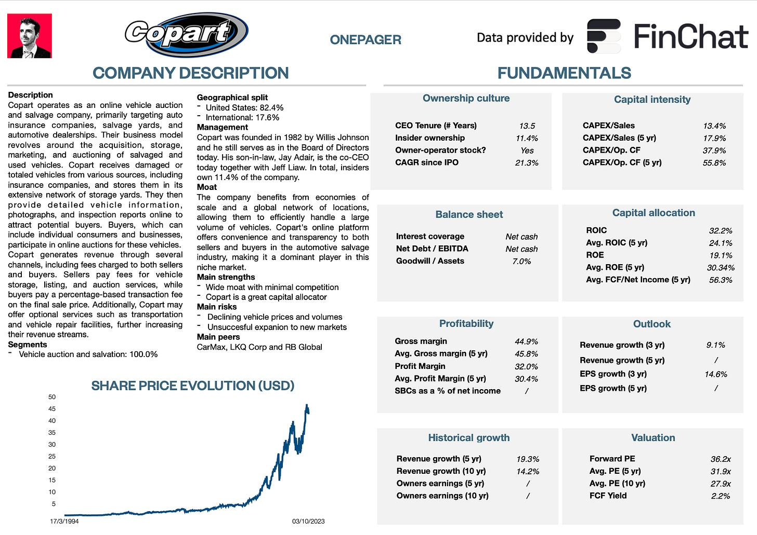

15-Step Approach
Now let’s use our 15-step approach to analyze the company.
At the end of this article, we’ll give Copart a score on each of these 15 metrics, which will result in a Total Quality Score.

1. Do I understand the business model?
Copart makes money via online vehicle auctions. They are active in the buying and selling of used and salvage vehicles. Every day, Copart has more than 175,000 vehicles up for auction.
The American company makes money from fees charged to both buyers and sellers participating in its online auctions.
- Sellers such as insurance companies, salvage yards, and individuals, enlist Copart's services to auction off damaged or surplus vehicles. Copart charges sellers listing fees and a percentage of the final sale price.
- Buyers, including automotive dealers, dismantlers, and the general public, pay a buyer's premium on top of the winning bid.
Copart’s platform provides a global marketplace, connecting buyers and sellers across various regions.
The company employs a bidding system where buyers place competitive bids on vehicles of interest. Copart enhances its revenue through ancillary services, such as vehicle transportation and storage, offered to both buyers and sellers.
Additionally, the company monetizes its global network of facilities, leveraging its physical infrastructure for the storage and processing of vehicles. Copart's business model thrives on the efficient and transparent facilitation of the automotive auction process through its online platform, contributing to its position as a leader in the salvage vehicle market.
Here’s a great visualization of Copart’s business model:
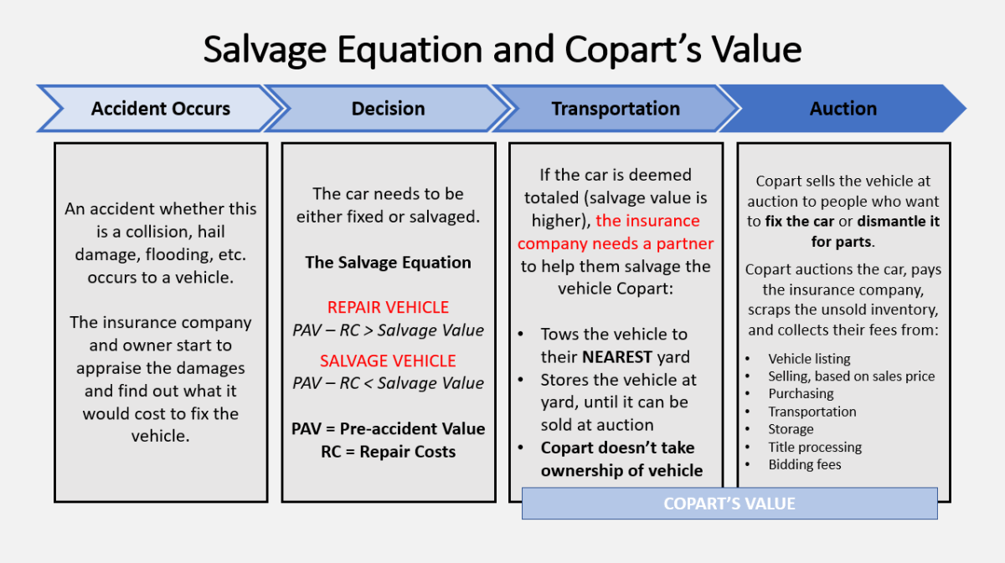

2. Is management capable?
Willis Johnson founded Copart in 1982 out of a single scrap yard in California.
Today, he serves as chairman of the board of directors and he still owns 6.66% of the company.
The story about Willis Johnson and the early days of Copart has been published in the book ‘Junk to Gold’, a must-read for everyone who wants to learn more about Copart.
Today, Willis Johnson’s son-in-law Jay Adair is still the co-CEO of Copart together with Jeff Liaw. Jay Adair owns 3.75% of Copart.
In total, insiders own 11.14% of the company. This means we’re talking about an Owner-Operator stock. Copart has performed really well under Willis Johnson and Jay Adair.
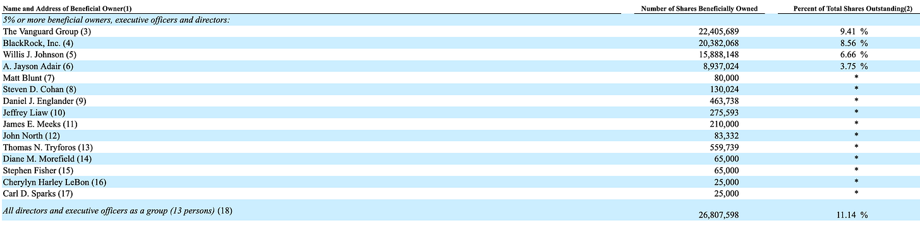
Source: Proxy Statement Copart

3. Does the company have a sustainable competitive advantage?
Copart has a sustainable competitive advantage based on network effects and economies of scale.
- Network effects: The more buyers and sellers use Copart’s auction, the better the selling prices for sellers and the easier it is for buyers to find the vehicle they need. Copart’s auction platform is the largest in the world with 750,000 users in 170 countries. This is virtually impossible to match for new entrants
- Economies of scale: It took Copart decades to acquire the number of locations it owns today. Insurers operate all over the country so Copart's many locations have the advantage that there is always one nearby. Due to its size, Copart can usually guarantee to pick up damaged vehicles within 24 hours. To transport the vehicles, the company has its own fleet at its disposal and if that is not enough, it can rely on relationships with external transport companies.
A high and robust Gross Margin and ROIC often characterize companies with a sustainable competitive advantage:
We aim for a Gross Margin > 40% and ROIC > 15%. Copart ticks both boxes.
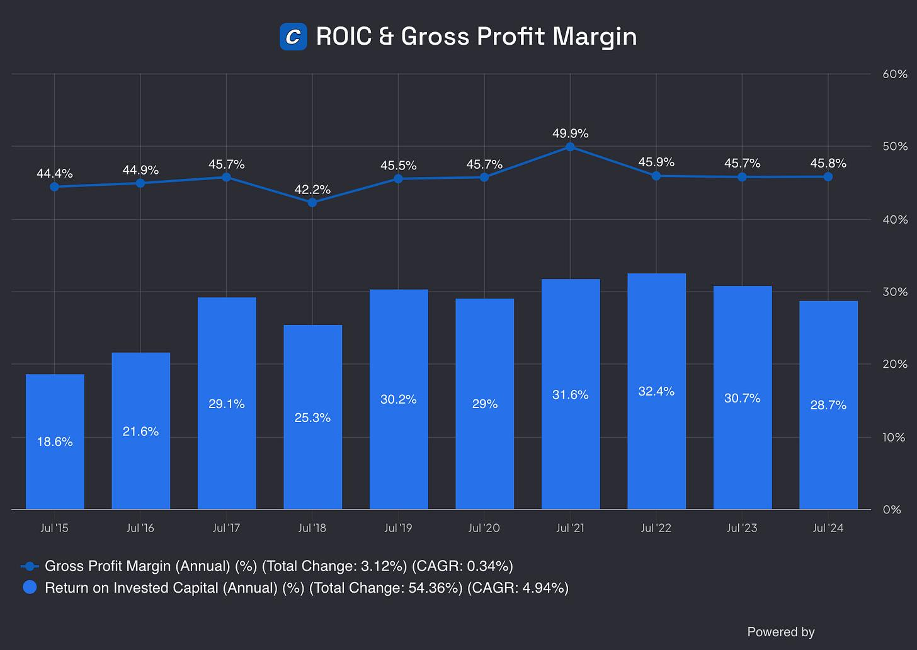
Source: Finchat

4. Is the company active in an attractive end market?
In the years to come, Copart should benefit from 2 main growth drivers:
- Higher total loss frequency:
  - Total loss frequency is the number of vehicles that are declared total losses instead of being repaired.
- Rising auction prices
  - Rising auction prices result in higher commissions for Copart.
In the United States, Copart is active in a duopoly together with Insurance Auto Auctions (IAA). Both companies have a market share of roughly 40%.
While IAA isn’t a listed company, fundamentally Copart is a way better business.

5. What are the main risks for the company?
Some of the main risks for Copart:
- The most important clients for Copart are large insurance clients. These clients can have some pricing power compared to Copart
- More safety in cars will result in fewer accidents and fewer cars that are declared a total loss
- A slowdown in the economy or a recession can lead to reduced demand for used and salvaged vehicles
- Changes in regulations related to salvage vehicle auctions
- Can Copart successfully expand internationally?
- The rise of electric vehicles, ridesharing, and autonomous driving

6. Does the company have a healthy balance sheet?
We look at 3 ratios to determine the healthiness of Copart’s balance sheet:
- Interest Coverage: 82.4x
- Net Debt/FCF: Net cash position (5.3% market cap = cash)
- Goodwill/Assets: 6.8%
Copart’s balance sheet looks very healthy. The company has a net cash position and almost no goodwill on its balance sheet.

7. Does the company need a lot of capital to operate?
We prefer to invest in companies with CAPEX/Sales lower than 5% and CAPEX/Operating Cash Flow lower than 25%.
Copart:
- CAPEX/Sales: 13.1%
- CAPEX/Operating Cash Flow: 36.8%
This capital intensity looks quite high, right?
But hold on!
Remember that there is a difference between Maintenance CAPEX and Growth CAPEX.
- Maintenance CAPEX: Investments made in existing assets
- Growth CAPEX: Investments made in new assets in order to grow
When a company invests a lot in order to grow, its growth CAPEX is very high but these investments might create a lot of value in the long term.
That’s why sometimes (like for Copart) it might make sense to only take the company’s Maintenance CAPEX into account.
As a rule of thumb, we state that the company’s maintenance CAPEX is equal to the company’s Depreciation & Amortiziation.
CAPEX = Maintenance CAPEX + Growth CAPEX
Wherein Maintenance CAPEX = Depreciation & Amortization
CAPEX Copart = $142.8 million (Maintenance CAPEX) + $383.4 million (Growth CAPEX)
When we only take Copart’s Maintenance CAPEX into account, we get the following:
- CAPEX/Sales: 3.6%
- CAPEX/Operating Cash Flow: 10.0%
These numbers already look way more attractive.
Another positive? The heavy investments in future growth also mean that the current Free Cash Flow of Copart is an underestimation of economic reality.
Why? These investments heavily reduce the company’s current free cash flow but these investments will result in a higher FCF in the future.
Now let’s dive into the most important Fundamentals of Copart.
We’ll also give Copart a Total Quality Score and decide whether we’ll buy the company.

8. Is the company a great capital allocator?
Capital allocation is the most important task of management.
Look for companies that put the money of shareholders to work at an attractive rate of return.
Copart:
- Return On Assets: 15.2%
- Return On Equity: 23.5%
- Return On Invested Capital: 32.0%
These numbers look attractive as we want the ROIC to be at least 15%.
Here’s an evolution of Copart’s Return On Assets (ROA), ROE and ROIC:
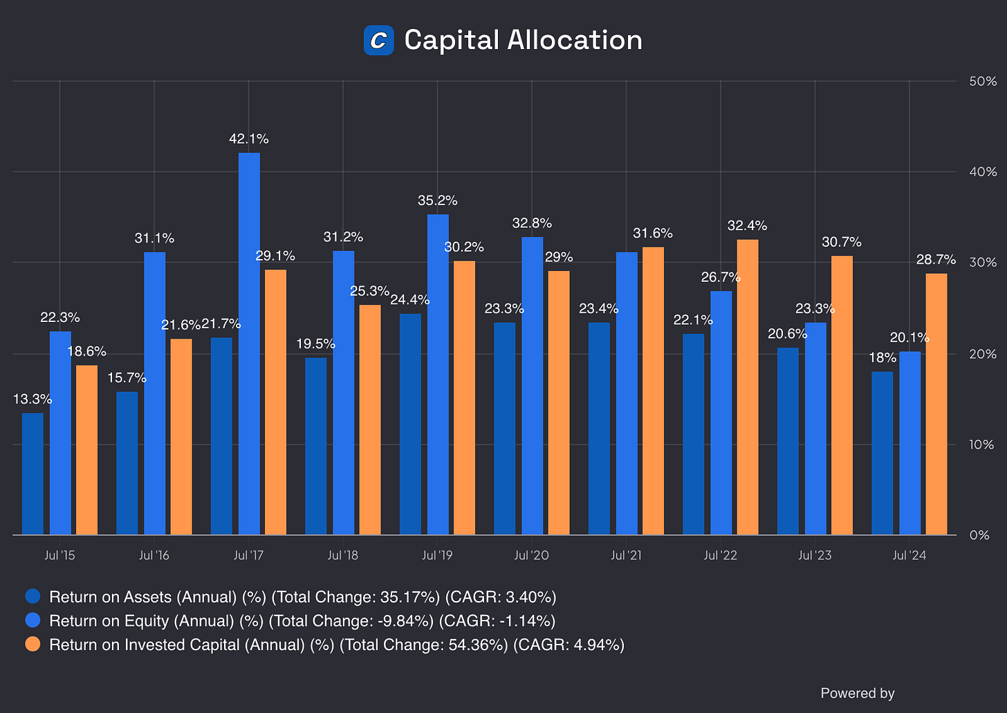
Source: Finchat

9. How profitable is the company?
The higher the profitability of the company, the better.
We seek companies with robust gross margins, a profit margin of at least 10% and we want most Net Income to be translated into Free Cash Flow.
Here’s how things look like for Copart:
- Gross Margin: 46.6%
- Profit Margin: 33.1%
- FCF/Net Income: 68.3%
  - The main reason for the lower FCF/Net Income is that Copart is investing heavily in future growth (see point in 7 of this investment case). As a result, a lower FCF/Net Income is not a negative thing

10. Does the company use a lot of Stock-Based Compensation?
Stock-based compensation is a cost for shareholders and should be treated accordingly.
Preferably we want SBCs as a % of Net Income to be lower than 4%.
SBCs as a % of Net Income higher than 10% are seen as a bad thing according to Compounding Quality.
Copart:
- SBCs as a % of Net Income: 2.8%
- Avg. SBC as a % of Net Income past 5 years: 3.4%
As you can see, Copart doesn’t use a lot of Stock-Based Compensation to reward employees.

11. Did the company grow at attractive rates in the past?
We seek for companies that managed to grow their revenue and EPS by at least 5% and 7% per year respectively.
Copart:
- Revenue Growth past 5 years (CAGR): 14.4%
- Revenue Growth past 10 years (CAGR): 13.1%
- EPS Growth past 5 years (CAGR): 15.7%
- EPS Growth past 10 years (CAGR): 13.8%

12. Does the future look bright?
You want to invest in companies that manage to grow at attractive rates as stock prices tend to follow EPS growth over time.
Copart:
- Exp. Revenue Growth next 2 years (CAGR): 8.7%
- Exp. EBITDA Growth next 2 years (CAGR): 12.0%
- Long-Term Growth Estimate EPS (CAGR): 15.0%
This outlook looks attractive.
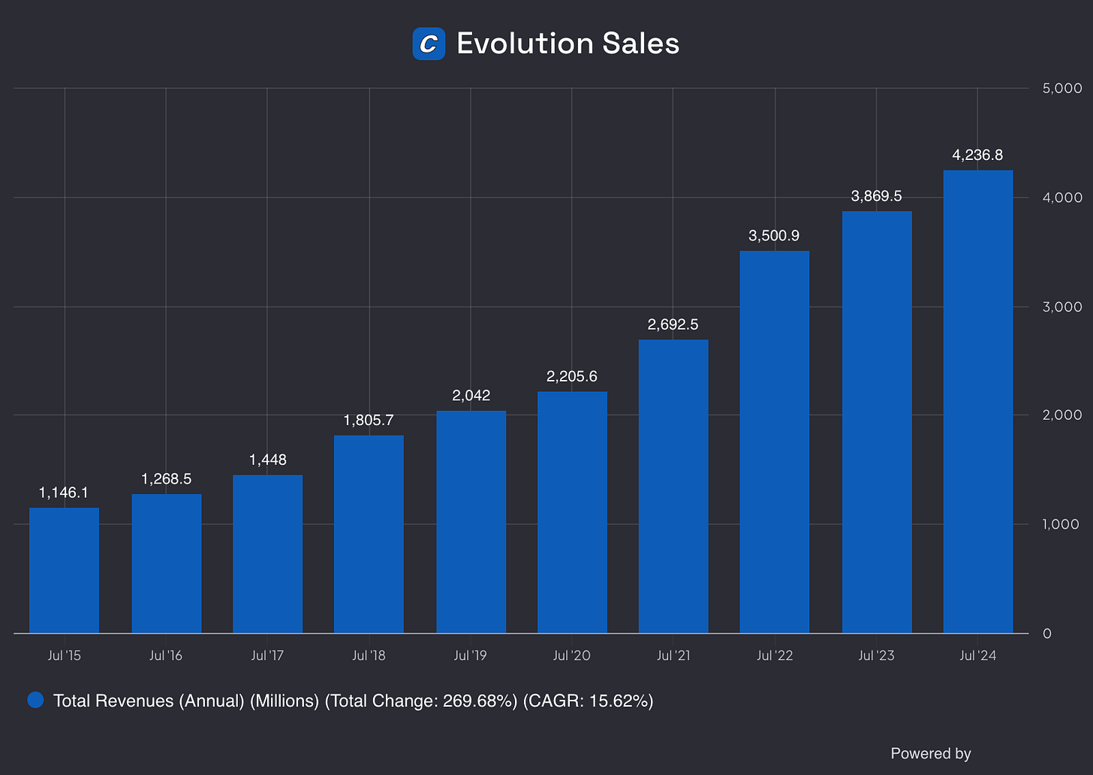
Source: Finchat

13. Does the company trade at a fair valuation level?
We always use 3 methods to look at the valuation of a company:
- A comparison of the forward PE multiple with its historical average
- Earnings Growth Model
- Reverse Discounted-Cash Flow

A comparison of the multiple with the historical average
The first thing we do is compare the current forward PE with its historical average over the past 5 and 10 years.
Today, Copart trades at a forward PE of 36.2x versus a historical average of 31.1xover the past 5 years.
This indicates that Copart trades at rich valuation levels.
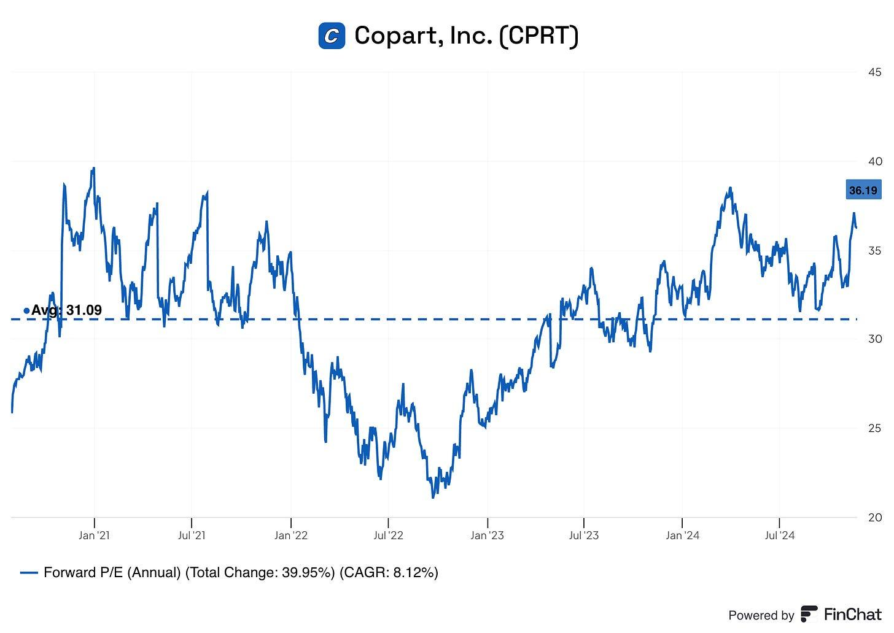
Source: Finchat

Earnings Growth Model
This model shows you the yearly return you can expect as an investor.
In theory, it’s really easy to calculate your expected return:
Expected return = EPS growth + Dividend Yield +/- Multiple Expansion (Contraction)
Please note that my expected earnings growth of 12% is lower than the consensus of analysts. It’s because I like to use a margin of safety.
Here are the assumptions I use:
- EPS Growth = 12% per year over the next 10 years
- Dividend Yield = 0.0%
- Forward PE to decline from 36.2x to 25.0x over the next 10 years
Expected yearly return = 12.0% + 0.0% - 0.1* ((25-36.2)/36.2))= 8.9%
An expected yearly return of 8.9% looks good, but ideally we would like this number to be a bit higher.

Reverse DCF
Charlie Munger once said that if you want to find the solution to a complex problem, you should revert. Always revert. Turn the problem upside down.
A reverse DCF shows you the expectations that are implied in the current stock price.
You try to determine for yourself whether these expectations are realistic or not.
You can learn more about a reverse DCF here: Reverse DCF 101.
The consensus states that Copart’s Free Cash Flow over the next 12 months will be equal to $1.188.7 million.
But please note that Copart is investing heavily in future growth which is why I add the growth CAPEX of $383.4 million to the company’s Free Cash Flow again.
Under these assumptions, our Reverse DCF indicates that Copart should grow its Free Cash Flow by 16.5% per year to return 10% per year to shareholders.
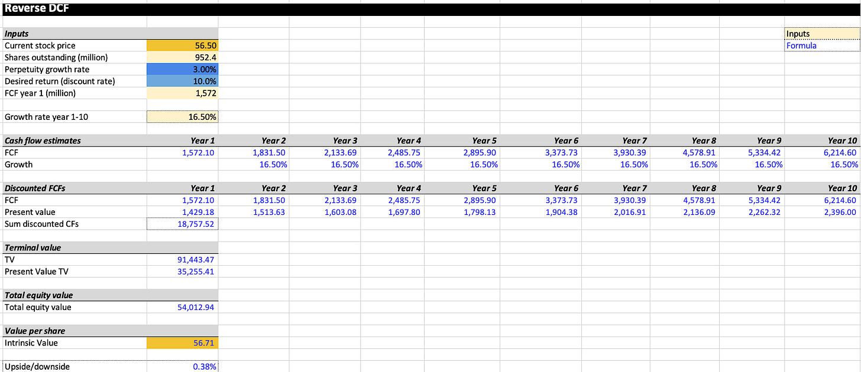

14. How did the Owner’s Earnings of the company evolve in the past?
Over time, stock prices tend to follow the Owner’s Earnings of a company (EPS Growth + Dividend Yield).
That’s why we want to invest in companies that managed to grow their Owner’s Earnings at attractive rates in the past. This is the case for Copart.
Copart:
- CAGR Owner’s Earnings past 5 years: 28.2%
- CAGR Owner’s Earnings past 10 years: 19.8%

15. Did the company create a lot of shareholder value in the past?
We want to invest in companies that managed to compound at attractive rates in the past.
Ideally, the company returned more than 12% per year to shareholders since their IPO.
Here’s how the performance of Copart looks like:
- YTD: +19.0%
- 5-year CAGR: +21.2%
- CAGR since IPO (1994): +21.3%

Bearhold Research
Copart is one of the most quietly exceptional businesses in the United States. It operates in a market that many investors have never thought about, the online auctioning of salvage vehicles, and it has built a position in that market that is almost impossible to challenge. The business requires more land than almost any competitor can afford to acquire, it improves as it gets bigger, and its primary customers have no viable alternative. The stock price at the time of writing reflects a business priced for moderate expectations, which is unusual for a business of this quality.
The two risks that matter, concentration among insurance sellers, and the long-term question of autonomous vehicles, are real and deserve honest treatment. Neither, in my view, overrides the fundamental quality of what has been built here. This report addresses both directly.

At a Glance
Company: Copart, Inc
Ticker: $CPRT · NASDAQ
Sector: Industrials
Industry: Online Vehicle Auctions & Remarketing
Market Cap: $31.9 billion (at $33.06)
Status: Approved
First Coverage: April 2026
Valuation Zone: Attractive (last updated in April 2026)
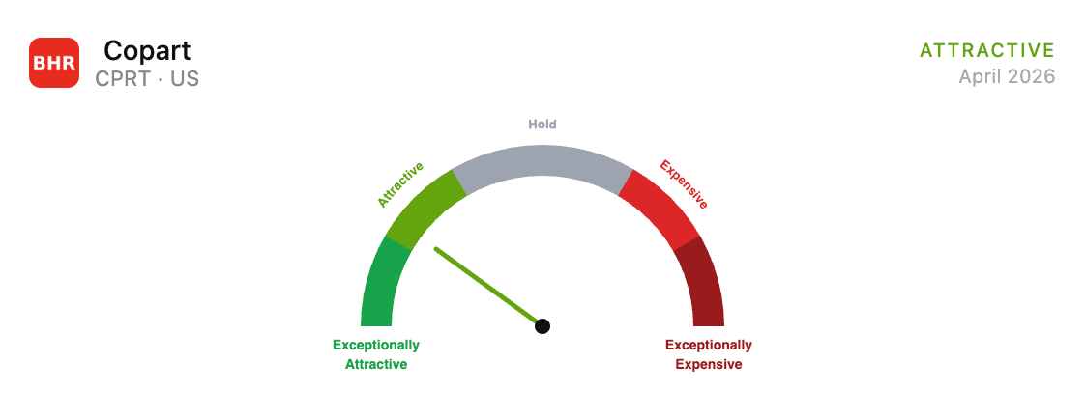

Disclosure update: The author now holds a position in CPRT. The position was initiated after the original publication date of this report. All analysis and conclusions remain unchanged. This report reflects the author’s personal views and is not investment advice. Investing carries the risk of permanent capital loss. Read the full disclaimer here

1. The Business
What it Does
Copart operates online auctions for salvage and total-loss vehicles. When a car is involved in an accident and the insurance company determines that the cost of repair exceeds the vehicle’s value, the car is declared a total loss. The insurance company pays the policyholder the car’s pre-accident value, takes title to the vehicle, and then needs to dispose of it. That is where Copart comes in.
Copart takes possession of the vehicle, transports it to one of its storage facilities, photographs and documents it thoroughly through its proprietary technology, and lists it for sale on its VB3 online auction platform. Buyers from around the world, vehicle dismantlers, rebuilders, used car dealers, exporters, bid against each other in real time. Copart collects fees from both the seller and the buyer. The vehicle sells. The process repeats.
This description makes the business sound simple. It is operationally complex at scale, and that complexity is the foundation of the moat.
How the Company Makes Money
Copart earns fees at multiple points in the process. Sellers, primarily insurance companies, pay processing fees, listing fees, transportation fees, and storage fees. Buyers pay transaction fees, title fees, and loading fees. Because a significant portion of fees are tied to the final auction selling price under Copart’s Percentage Incentive Program, the company has a direct financial incentive to maximise the value each vehicle achieves. This alignment between Copart’s revenue and its sellers’ outcomes is a structural differentiator.
In fiscal year 2025 (ended July 31, 2025), Copart generated total revenues of $4.65 billion, of which $3.97 billion was service revenue and $678 million was vehicle sales revenue, the latter from markets like the UK, where Copart purchases and resells vehicles on a principal basis.
History and Origin
Copart was founded in 1982 by Willis Johnson in Vallejo, California with a single salvage yard. The founding insight was straightforward but consequential: insurance companies needed a professional, efficient, and geographically distributed way to dispose of total-loss vehicles. The fragmented industry of local salvage dealers was not meeting that need well.
The business grew through acquisitions of regional salvage yards over the following decade and went public in 1994. For most of its early history Copart held physical auctions, buyers would travel to its yards to bid on vehicles in person. The transformative moment came when the company began migrating its auction process online in the early 2000s, completing the transition across its US operations by the mid-2000s. This was not an incremental improvement. It was a fundamental reshaping of who could participate in each auction.
By opening every sale to buyers anywhere in the world with internet access, Copart dramatically expanded the pool of bidders competing for each vehicle. More bidders means more competition. More competition means higher prices. Higher prices means insurance companies get better returns on their salvage. Better returns means insurance companies want to work with Copart. The flywheel that would define the business for the next twenty years was set in motion.
Willis Johnson stepped back from day-to-day operations and the company is now led by Jeffrey Liaw, who joined Copart in 2016 as CFO. He was promoted to President in 2019 and became Co-CEO in 2022 before taking over the sole CEO position.
Scale and Footprint
Copart operates in the United States, Canada, the United Kingdom, Germany, Brazil, Spain, Ireland, Finland, the UAE, Oman, and Bahrain. The US business generates approximately 83% of total revenues and is the operational core of the company.
Copart operates over 21,000 acres of land globally, they own more than 90% of their operational land outright, a key differentiator from competitors who typically lease their facilities. In the US alone, Copart owns or leases facilities in every state. The company owns approximately $2.39 billion worth of land on its balance sheet, a figure that significantly understates fair value given how long much of this land has been held and how dramatically land prices around major population centres have appreciated.
The international business is less mature and operates differently in some markets, particularly the UK, where Copart buys vehicles outright. But the global buyer base is central to the model: Copart now maintains a database of approximately 1 million registered members across every continent. The scale of that global buyer pool, and the competitive pressure it places on every auction, remains central to the financial returns Copart delivers to its insurance sellers.

2. The Moat
Source of Competitive Advantage
Copart’s competitive position rests on three interlocking advantages that have strengthened over time. Understanding each one individually understates how they reinforce each other.
The first is physical infrastructure. Copart requires large parcels of land near major population centres to store the high volume of vehicles it processes before they sell. This land is expensive, increasingly scarce, and subject to complex local zoning restrictions that make new entrants face a fundamentally different cost environment than the one Copart faced when it was building its network. The company has spent decades and billions of dollars assembling a footprint that a competitor would need to replicate entirely, at today's land prices, with today's zoning restrictions, competing for the same properties in the same markets. No rational capital allocator would attempt it. This is not a moat that can be disrupted by software or a new technology. It is a physical asset base that took forty years to build.
The second is the global buyer network. Copart has accumulated hundreds of thousands of registered buyers across every continent. The value of this network is directly proportional to its size: more buyers means more competition for each vehicle, which means higher selling prices for insurance companies, which means insurance companies prefer Copart. A new entrant cannot simply build a marketplace without supply. It cannot build supply without having already demonstrated it can achieve competitive selling prices. The chicken-and-egg nature of this problem is the classic marketplace moat, and Copart has been building its side of it for four decades.
The third is the contractual relationships with insurance companies. While no single insurance company accounts for more than 10% of Copart's revenues, an important point to which we will return, the company has established long-term supply agreements with the major carriers. These agreements are built on trust, track record, and the demonstrable financial returns Copart generates for its sellers. Switching costs are not contractual so much as they are practical: an insurance company that moves its business to a smaller competitor will likely see lower auction returns, a worse buyer experience, and disruption to its operations. The cost of switching exceeds the benefit in almost every realistic scenario.

Evidence of the Moat
The financial record is unusually clean on this point. Copart has maintained ROIC consistently above 20% in every year of the past decade, averaging approximately 28% over the last ten years. Operating margins have ranged between 32% and 42% throughout this period. Gross margins have held in a narrow band around 45% for a decade. These are not the numbers of a business that competes on price. They are the numbers of a business that sets the standard.
The most revealing evidence of moat is what has happened to the competition. Insurance Auto Auctions (IAA), Copart's primary US competitor, was acquired by Ritchie Bros. Auctioneers in 2023 after years of underperformance relative to Copart. The combined entity has not threatened Copart's position in any meaningful way.

Moat Trajectory
The moat is strengthening, not weakening. Each additional facility Copart opens makes the network more valuable to insurance sellers because of improved geographic coverage. Each additional buyer who registers on the platform increases the competitive pressure on every auction. Each year of accumulated auction data improves the company’s IntelliSeller tool, which uses machine learning to help sellers optimise their pricing decisions. These are all self-reinforcing dynamics that become harder to replicate as they compound.

Competitive landscape
Copart’s meaningful competition is effectively limited to IAA (now part of Ritchie Bros.) in the US. This is a two-player market for insurance-company salvage vehicles at national scale. Local and regional operators exist but cannot replicate the global buyer network or the geographic coverage that national carriers require. The fact that this market has not attracted more serious competition in four decades is itself informative. The capital requirements are enormous, the zoning challenges are real, and the buyer network takes decades to build.
Thanks for reading Bearhold Research! This post is public so feel free to share it.
Share

3. Financial Performance

Revenue Growth
Copart has grown revenue from $1.15 billion in fiscal 2015 to $4.65 billion in fiscal 2025, a compound annual growth rate of 15% over a decade. For a business operating in physical infrastructure with significant real-world constraints, sustaining that rate over ten years is exceptional.
The growth has been driven by four forces operating simultaneously: an increase in total loss frequency rates as vehicles have become more technologically complex and therefore more expensive to repair; market share gains at the expense of smaller regional competitors; geographic expansion both within the US and internationally; and an increase in revenue per transaction driven by higher average vehicle values and an expanded global buyer network.
In fiscal 2025, total revenues grew 9.7% year over year to $4.65 billion. Service revenues, the higher-quality, fee-based component, grew 11.4% to $3.97 billion. The recent moderation from earlier rates reflects the natural effect of a larger base and some normalisation following the elevated total-loss activity of the pandemic years.

Profitability
Copart’s profitability record is one of the clearest expressions of the structural strength of its competitive position. Operating margin in fiscal 2025 was 36.5%, above the ten-year average of 36.3% and meaningfully higher than the 30.1% the business generated a decade ago in fiscal 2015. The direction of travel matters as much as the level: a business that has expanded operating margins by 6.4 percentage points over ten years while growing revenue at 15% annually is not merely maintaining its competitive position, it is strengthening it. Operating income compounded at 17.3% annually from fiscal 2015 to fiscal 2025, growing from $344 million to around $1.70 billion. This outpaced revenue growth, which is precisely what margin expansion looks like in the financials.
Net income in fiscal 2025 was $1.55 billion, up 13.9% from $1.36 billion in fiscal 2024. The net margin of 33.4% is above the ten-year average of 29.6% and almost double the 19.2% the business earned in fiscal 2015. The steady expansion in net margin reflects operating leverage, the benefit of a larger and more efficient network, and the growing contribution of interest income, the company earned $178.9 million in net interest income in fiscal 2025 on its $4.79 billion net cash position, a meaningful source of earnings that did not exist a decade ago.
On earnings per share: diluted EPS grew from $0.21 in fiscal 2015 to $1.59 in fiscal 2025, a compound annual growth rate of 22.4%, ahead of both revenue and net income growth. This performance was bolstered by an overall reduction in diluted share count, which fell from approximately 1.05 billion in fiscal 2015 to 978 million in fiscal 2025. While the share count has drifted slightly higher since 2021 due to stock-based compensation, the long-term decline reflects the cumulative impact of Copart’s historical share buybacks (especially the aggressive buybacks between 2015-2017) and disciplined capital allocation.

Free Cash Flow
Free cash flow grew from $186 million in fiscal 2015 to $1.23 billion in fiscal 2025, a compound annual growth rate of 20.8% over a decade. That represents a 6.6-fold increase in the business’s capacity to generate cash, which is a meaningful claim about the quality of the underlying economics.
The capex-to-operating-cash-flow ratio tells a particularly revealing story about where the business stands today. Over the past decade, this ratio averaged approximately 44%, meaning Copart reinvested roughly 44 cents of every operating dollar back into the physical infrastructure that generates its competitive moat. In fiscal 2025, that ratio fell to 31.6%, its second lowest level in ten years. The business is indeed entering a higher-harvest phase in the US, but it remains an investment-heavy business globally.

Return on Invested Capital
Over the past decade, ROIC has averaged 28.4% and reached as high as 32% in fiscal 2022. In fiscal 2025, ROIC was 29%, essentially in line with the long-run average. This consistency is more impressive than a single peak figure. A business that has compounded at 15% annually in revenue while sustaining high returns on incremental capital is, by the standard definitions, a genuine compounder. Every dollar reinvested in the business has generated returns well above any reasonable estimate of the cost of capital in every year of the available record.

Balance Sheet
Copart’s balance sheet at July 31, 2025 was exceptional. The company held $2.78 billion in cash and restricted cash plus $2.01 billion in held-to-maturity securities, a combined liquid position of $4.79 billion against total financial debt of effectively zero. Total liabilities of $883 million were overwhelmingly operational in nature. This is a fortress balance sheet. It provides management with complete flexibility to act, whether to acquire land, weather a severe recession, respond to catastrophic weather events, or return capital to shareholders. The net cash position also generates meaningful interest income that did not exist in prior cycles, adding a new dimension to earnings quality.

Capital Expenditure
Copart spent $569 million on capex in fiscal 2025, the majority directed toward land acquisition and facility development. Importantly, the majority of Copart’s capex is growth-oriented, acquiring land and building new facilities that generate long-term structural barriers, rather than maintenance capex spent on preserving the existing asset base. This distinction matters when evaluating the quality of the free cash flow figure.

4. Growth Levers & Addressable Market
Copart is not a business that has exhausted its runway. The US network is maturing, but that maturation is precisely what frees capital and management attention for the next phase of growth. There are four distinct levers that can drive the business forward from here, and they are not speculative: each has evidence of traction today.

A) The structural Tailwind in Total Loss Frequency
The single most important driver of Copart’s domestic volume is total loss frequency, the percentage of accident-involved vehicles that insurers choose to declare a total loss rather than repair. In fiscal 2025, CEO Jeff Liaw described the full-year total loss frequency rate of 22.2% as an all-time annual high. This is not an anomaly. It is the result of forces that have been building for decades and show no sign of reversing.
Modern vehicles are fundamentally more expensive to repair than their predecessors. Advanced driver assistance systems, cameras, sensors, integrated infotainment, and complex structural materials mean that even moderate collision damage frequently triggers repair estimates that exceed the vehicle's value. Electric vehicles add a further dimension: EVs require approximately four additional labour hours per repair compared to internal combustion vehicles and carry roughly 30% higher repair costs. As EV penetration grows and as ADAS technology becomes standard across more model lines and price points, the economics of repair versus total loss continue to shift in Copart's favour. The average age of vehicles on US roads has also reached 12.8 years, meaning a large portion of the fleet consists of older vehicles where even modest damage tips the repair-versus-salvage calculation toward salvage. Each of these trends compounds the other, and none of them is cyclical.

B) International Expansion, the Majority of the Opportunity
The US salvage auction market (calculated based on the Auction Fees paid to the auction house) is estimated at $3.8 billion in 2025 and is projected to reach $7.2 billion by 2030, growing at around 13.6% CAGR. Copart’s domestic service revenue in fiscal 2025 was approximately $3.4 billion (including buyer fees, seller fees, transportation fees, and title processing) meaning the company is already capturing the largest share of a market that is still growing. The domestic runway is real but finite.
The international opportunity is a different order of magnitude. The global online salvage auction market was estimated at $12.4 billion in 2025 and is projected to reach $27.2 billion by 2030 at a 17% CAGR, a faster growth rate than the US market and from a base where Copart's penetration is a fraction of what it has achieved domestically. In fiscal 2025, international service revenue growth reached 18.9% for the full year, significantly outpacing the 10.4% growth in U.S. service revenue. The direction of travel is clear.
The specific international market opportunities are substantial. Germany's online salvage market was worth approximately $1.1 billion in 2025 and is projected to grow at a 21% CAGR through 2030, a market where Copart has been building infrastructure since 2017 and where the transition from a principal-based model to a consignment model is already delivering margin improvement. Brazil sits at approximately $480 million with mid-teens growth. India, which Copart briefly entered and then paused to wait for the market to develop further, is estimated at $230 million and growing at approximately 23% annually, a market that Copart is well-positioned to re-enter as formal insurance penetration and salvage regulation matures. In the UK, Copart already holds approximately 60–70% of the insurance-customer market, making it the dominant operator in Europe's most developed salvage market. Asia-Pacific is the fastest-growing region globally, expanding at a 16–24% CAGR depending on the source.
Copart's international buyer pool is a direct competitive advantage in these markets. The most recent available data indicates that international buyers purchasing US vehicles were acquiring vehicles significantly higher in value than comparable vehicles purchased by domestic US buyers, a reflection of the quality and purchasing power of the global member base Copart has assembled over four decades. That same buyer network can be directed toward inventory in Germany, Brazil, or any market Copart enters, providing an immediate advantage that a local competitor could not replicate. This is network effects working across geographies, not just within them.

C) Expanding Beyond Insurance, Blue Car and Adjacent Categories
Approximately 81% of Copart’s vehicle volume originates from insurance company sellers. That concentration is a risk, but it also reveals the size of the untapped opportunity in non-insurance channels.
Blue Car, Copart’s service offering aimed at banks, rental car companies, and fleet operators, delivered strong double-digit growth in fiscal 2025, as reported in the annual report. This is not a minor product line. Banks and financial institutions need to liquidate repossessed vehicles and lease maturities efficiently; fleet operators and rental companies cycle through vehicles on a regular cadence and need the same combination of geographic reach, global buyer access, and transparent pricing that insurance companies value. As Copart's platform becomes better known outside the insurance vertical, the addressable supply base expands materially without requiring any new infrastructure investment.
Purple Wave, Copart's heavy equipment and agricultural machinery auction platform, delivered continued growth in fiscal 2025. Heavy equipment and farm machinery represent a large and fragmented global market that benefits from exactly the same dynamics that made Copart successful in salvage vehicles: a global buyer pool competing for local inventory, transparent price discovery, and specialist services for sellers who lack efficient alternatives. This is early innings, but the model is proven.

D) The EV Transition as a Structural Accelerator
Electric vehicles are widely discussed as a long-term threat to Copart through the autonomous vehicle channel. The near-term reality is almost exactly the opposite. EVs are more expensive to repair than internal combustion vehicles by a meaningful margin. Battery damage, which occurs in a significant proportion of EV collisions, is frequently uneconomical to repair at all, either because the battery module is deeply integrated into the vehicle’s structure or because replacement costs are prohibitive. This drives EV total loss rates materially above ICE vehicle rates at comparable damage severity levels. As EV penetration of the vehicle fleet grows, still in its early stages globally, it adds a structural tailwind to Copart’s volume that did not exist a decade ago and that will intensify over the coming years before autonomous vehicle adoption becomes a countervailing force.

What the TAM Picture Tells us
A business that controls roughly half of the US domestic market, that is in the early stages of penetrating a $10.6 billion global market growing at 15% annually, and that is actively expanding into adjacent vehicle categories through Blue Car and heavy equipment, is not running out of room. The presence of a massive growth runway is undeniable; the real variable is Copart’s ability to scale operations and deploy capital with its trademark efficiency. Given its historical financial performance, the company has already proven it possesses the discipline to execute.
Thanks for reading Bearhold Research! This post is public so feel free to share it.
Share

5. Management
Update - July 2026: On June 29, 2026, Copart announced that Jeff Liaw will step down as CEO and director effective July 31, 2026. Executive Chairman Jay Adair, Copart’s longest-serving CEO and one of the architects of its current business model, will resume the role upon Liaw’s departure. Liaw will remain available as a Senior Advisor through July 31, 2027, focused on customer transition matters.
The board’s statement framed Liaw’s tenure as operationally successful, citing record transaction values, average selling prices, and auction liquidity achieved under his leadership. No operational or financial cause for the transition was disclosed.
This update does not alter the conclusions of the management assessment below. Adair is a known quantity with a long track record at Copart, his return represents continuity of institutional knowledge rather than an injection of uncertainty. The absence of a disclosed cause warrants monitoring, but nothing in the available information points to a thesis-relevant development at this stage.

Leadership and Tenure
Copart is effectively a founder-influenced business. Willis Johnson, who founded the company in 1982, remains Chairman of the Board. His operating philosophy, own the land, build the infrastructure, focus on seller returns, expand the buyer network, is deeply embedded in how the company operates.
Liaw joined in 2016 as CFO. He brought a sophisticated private equity background (formerly at TPG Capital) that sharpened the company's approach to capital allocation, ROIC, and international M&A. He served as Co-CEO with Jay Adair before becoming the sole CEO on April 1, 2024.
The transition from founder Willis Johnson to his son-in-law Jay Adair (now Executive Chairman), and then to Jeff Liaw, represents one of the most successful leadership successions in the industrial sector. The team's ownership mindset is reflected in their lack of a dividend; they prefer to reinvest every dollar into land or opportunistic buybacks.

Skin in the Game
Insiders, including Willis Johnson and his affiliates, collectively own a significant portion of Copart’s outstanding shares, exceeding 11% of shares outstanding as of the most recent proxy. Executive compensation is weighted heavily toward equity, tying financial outcomes directly to long-term share price performance. Options issued to senior executives include market conditions requiring the stock to trade above a specified price threshold before exercise, a feature that further aligns incentives with shareholder value creation.

Capital Allocation Track Record
Copart’s capital allocation record reflects a management team that has consistently prioritised long-term value over short-term return metrics. The primary deployment of free cash flow has been into land acquisition and facility development, investments that have generated ROIC averaging 28% over the past decade and that have deepened the structural barriers protecting the business.
Copart has historically been a reluctant repurchaser, preferring to build a massive cash pile for internal reinvestment. Aside from a defining $739 million buyback in 2017, the company remained largely dormant on this front until early 2026, when it deployed $500 million to take advantage of recent share price volatility. Combined with a total absence of dividends since its 1994 IPO, this reflects a management team strictly focused on long-term compounding over immediate distributions.
The primary reservation is the accumulation of $4.79 billion in liquid assets earning treasury rates when the business historically generates returns above 20% on invested capital. This is capital that could be working harder.

Communication and Transparency
Copart’s management communicates with shareholders in a manner that reflects genuine confidence in the business and a willingness to engage with difficult questions. Earnings calls are substantive. The risk factor disclosures in annual filings acknowledge real challenges rather than papering over them. The 10-K filings are unusually detailed about the operational mechanics of the business.

6. Valuation

Current valuation
Our valuation framework measures how much of the sum of a company’s future cash flows, discounted back to today at an appropriate rate, is already embedded in the current stock price. Rather than expressing this as a precise figure, we express it as an approximation in years.
At the time of this report, with the stock trading at $33.06, the market is pricing Copart at approximately 16 years of discounted future cash flows. This is an approximation, not an exact calculation. The assumptions embedded in our model are consistent with the company’s current and historical operating performance, they are not heroic, and they are not pessimistic. This figure is monitored and updated on a monthly basis as the stock price and business performance evolve. This places the business in the Attractive zone of the valuation gauge.
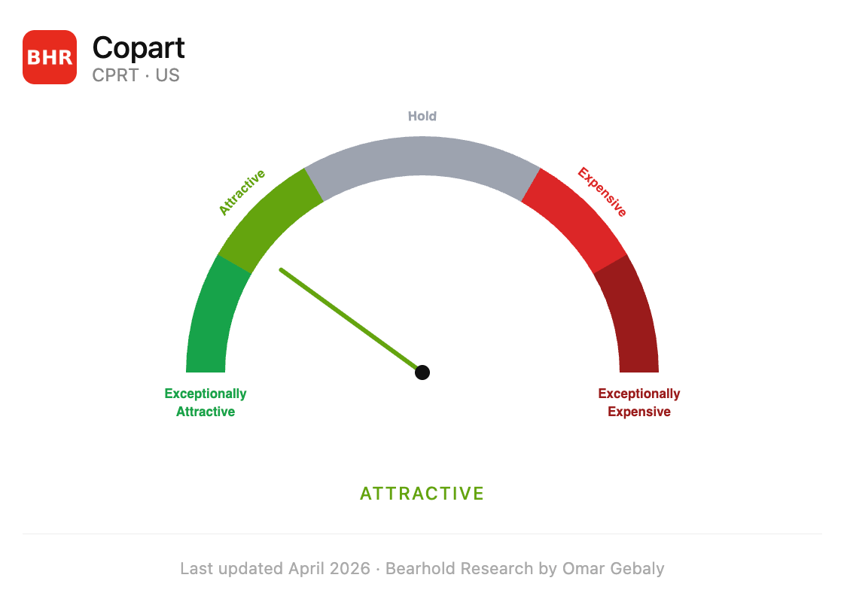
What 16 years means
What 16 years means in practical terms is this: the current price assumes that Copart will stop generating meaningful cash flows after year 16. Every year of cash generation beyond that point comes to you as an investor for free.
For a business with the structural characteristics described in this report, physical infrastructure that compounds in value, a buyer network that deepens with each passing year, contractual relationships with insurance companies that have persisted for decades, and a non-discretionary market that has existed since automobiles did, the question of whether Copart will still be generating substantial cash flows in year 17 and beyond seems like a reasonable bet.

Hold, Add, and Exit Logic
The valuation framework is not a buy-and-sell signal generator. It is a tool for thinking about price relative to value, and for making disciplined capital allocation decisions across the Bearhold Universe.
The current Attractive zone suggests the price does not demand excessive optimism about the future. For a business of this quality, that is a reasonable entry point.
The general logic across all five zones is as follows. In the Exceptionally Attractive and Attractive zones, the price is working in your favour, you are receiving more embedded future cash flows per dollar deployed than the market typically offers for a business of this quality. In the Hold zone, the business is fairly recognised, neither compelling to initiate a new position nor a reason to exit one already held. In the Expensive and Exceptionally Expensive zones, the price is embedding a level of optimism that the historical record does not automatically support.
My approach is straightforward: when a position moves into the Expensive zone, I sell and reallocate the capital to other quality businesses in the Bearhold Universe where the price sits in the Attractive and Exceptionally Attractive zones. The logic is simple, if you own a collection of exceptional businesses, your capital should always be working in the most attractively priced names available to you. Holding an Expensive position when an Attractive alternative exists is an opportunity cost that compounds against you over time. Discipline on the exit is as important as discipline on the entry.

Growth Engines
Every stock price is driven by one of two engines, or both simultaneously. Understanding which is working in your favour, and which might work against you, is as important as understanding the business itself.
The first engine is fundamental growth. Over time, a stock price tracks the growth of free cash flow per share. If a business compounds its FCF per share at 15% annually, that is roughly what the fundamental engine contributes to investor returns over a full holding period. It is steady, it is predictable, and it is the engine that quality businesses run on indefinitely.
The second engine is valuation re-rating. When a stock is mispriced, when the market is embedding fewer years of future cash flows than the business's quality and durability justify, the price tends to correct upward simply to reach fair value. This engine can produce returns that dwarf what fundamentals alone would deliver. It can also run in reverse: when a stock sits in the Expensive zone, the market is embedding too many years, and any mean reversion subtracts from returns even as the business continues to perform. A good business at the wrong price is still a poor investment.
For Copart at the time of writing, both engines appear to be working in the investor's favour. Over the past decade, Copart has compounded FCF per share at approximately 21% annually, one of the strongest rates among large businesses in any sector. That is the fundamental engine, running in full. The valuation engine has room to contribute as well: at 16 years of embedded cash flows in the Attractive zone, the market is not fully pricing the duration and quality of what Copart has built. An investor entering at this price is not relying on optimism, they are being paid by both the business performing and the price catching up.
The risk scenario is equally clear. If the stock moves into the Expensive zone, driven by price appreciation that outpaces fundamental growth, the valuation engine begins working against the position. In that scenario, the approach is to sell and reallocate capital to a quality business in the Bearhold Universe.

7. Risks

Risk 1 - Insurance Company Concentration
Copart obtains approximately 81% of its vehicle volume from insurance company sellers. While no single insurer accounts for more than 10% of consolidated revenues, the collective dependence on a relatively small number of large carriers is a genuine structural risk. If the major US insurers were to consolidate their salvage operations, pursue vertical integration, or develop a credible alternative platform, Copart’s supply would be at risk.
The probability of this materialising is low. Insurance companies are not in the business of operating salvage yards. The operational complexity, the land requirements, and the need to build a global buyer network from scratch are formidable disincentives. Moreover, the financial returns Copart delivers to its insurance partners, through higher auction prices enabled by its global buyer network, are difficult to replicate. An insurer attempting to internalise this function would almost certainly achieve worse financial outcomes than it does today working with Copart.
The risk is real but its probability of materialising is low, and the mechanism by which it would occur requires insurance companies to act against their own financial interests.

Risk 2 - Autonomous Vehicles and Declining Accident Rates
This is the risk that deserves the most honest treatment in any Copart analysis, and the one with the longest time horizon.
The thesis is straightforward: if autonomous vehicles eventually reduce accident rates materially, or eliminate them entirely, the supply of total-loss vehicles that feeds Copart’s business would decline in parallel. A 50% reduction in accident rates would, all else being equal, reduce Copart’s volume significantly.
There are several important qualifications a serious investor must hold simultaneously.
First, the timeline for meaningful autonomous vehicle adoption is deeply uncertain. The promises of full self-driving technology have been pushed out repeatedly over the past decade. Even optimistic estimates place widespread adoption of truly autonomous vehicles well into the 2030s or beyond in the United States.
Second, vehicle complexity has historically been a tailwind for total loss frequency, not a headwind. Modern vehicles, with advanced driver assistance systems, cameras, sensors, and complex structural materials, are more expensive to repair than older vehicles. This has driven total loss frequency higher over the past thirty years even as vehicle safety technology has improved. The transition period from human-driven to autonomous vehicles is likely to involve even more complex and expensive-to-repair vehicles, maintaining or increasing total loss frequency in the near and medium term.
Third, even in a world where US domestic accident rates eventually decline, Copart’s international business and its global buyer network provide a degree of diversification that pure domestic exposure would not.
The autonomous vehicle risk is real, horizon-dependent, and does not present itself as an imminent threat to the business. An investor with a ten-year horizon should have it on the watch list. An investor with a twenty-year horizon needs to weigh it more carefully as part of any thesis.

What Would Change my Mind?
Meaningful and sustained market share losses to IAA or a new entrant, over two or more consecutive years, would be an early warning signal that the moat is weakening. If total loss frequency begins a sustained multi-year decline attributable to measurable reductions in accident rates from driver assistance technology, not just a single year of mild weather, that would require a fundamental reassessment of the long-term volume outlook. If a major insurance carrier publicly announces plans to internalise salvage operations, that would warrant immediate re-evaluation.

8. The Verdict
Copart is the kind of business that takes decades to build and is almost impossible to replicate once built. It occupies a structural position in a non-discretionary market, behind barriers that compound in strength each year, run by a management team whose interests are aligned with long-term shareholders and whose operational record demonstrates consistent execution across three decades.
The two risks discussed, insurance concentration and autonomous vehicles, are not trivial. They are real, they deserve ongoing monitoring, and they prevent this from being a thesis where no adverse scenario is imaginable. But neither risk, assessed honestly against the current time horizon, overrides the fundamental quality of what has been built.
At a valuation of 16 years of embedded cash flows, the market is asking for reasonable performance from a business with an exceptional track record. That is a combination worth owning.
Copart is the kind of business that quietly makes you wealthy if you give it time and leave it alone.

Burn The Index

Is Copart a Buy After the Q4 Results and the Acquisition of ACV Auctions?

Results and thesis check
Burn The Index
Sep 16, 2026
Wow. Quite the week for Copart shareholders. Not only did the company drop - dare I say - disappointing Q4 numbers, they also announced the acquisition of ACV Auctions.
Shareholders must’ve blinked twice when they read the news. Finally some of that massive cash pile is being deployed on something other than buybacks.
Investors were happy, excited, hopeful and depressed. All in one day:
Stock price movement on Friday September 11th 2026
Here’s my take on the results and the acquisition, as well as my next steps.

Welcome to Burn The Index. I look for undervalued quality businesses with an attractive growth profile. Subscribe for free and join hundreds of other investors to make sure you don’t miss out on the next briefing.
Subscribe

Copart Q4 Results Were Not Convincing
The Q4 results were really just a confirmation of what was already developing in Q3. Revenue growth was moderate (up 2.4% YoY), driven by higher average selling prices (ASP). Volumes dropped, especially in the US.
The volume drop is driven by two factors really. For one, insurance premiums have risen over the past years, leading to fewer collisions claims and higher deductibles. In other words: the consumer is stretched and saving money where possible.
In addition, Copart lost a US insurance customer. When asked about it, the CEO downplayed it as “nothing to see here”, rather than give a straight forward answer. He might be right, but the messaging fell short of being unambiguous.
Gross profit margins dropped approx. 4.5% on the back of accelerated upfront spending on new strategic offerings like long-haul delivery (Copart Delivered), Title Express, and wholesale facilities.
At the same time, operational costs increased 12.7%, and interest income decreased because of the big buyback program earlier in the year. After all was said and done, diluted EPS went from $0.43 in Q3 to $0.35 in Q4.
On the bloated operational cost per vehicle, Jay Adair, the CEO, flagged two measures: direct cost management and unit volume leverage.
It’s fair to say that Q4 wasn’t pretty. However, none of these headwinds are structural in my opinion, but rather temporary in nature.
Costs are something you can contain, the consumer will come back when the insurance market gets softer again, and investments in strategic offerings hurt short term, but will drive growth over the mid- to long-term. Losing a customer is not something I was waiting for, but it does not seem to be a systemic issue.

The Logic Behind the ACV Auctions Acquisition
For those who are not familiar with ACV Auctions, its main product is a digital marketplace where dealers and companies (like banks, fleet managers, and rental car firms) trade used cars, backed by real-time data so buyers know what they’re getting.
The company also offers services that support the whole process, such as transportation, dealer financing, and software/ AI tools to inspect vehicles for damage, help dealers buy cars directly from consumers, and give up-to-date pricing and condition information.
Copart Investor Presentation
Copart will acquire ACV Auctions in an $1.9 billion all cash deal which is expected to close at year end. Copart will have $2.6 billion in the bank after this acquisition, which is a comfortable position to be in.
ACV will generate approx. $800-850 million in revenues and a net loss of approx. $60-65 million for FY2026. Management expects to be breakeven in 2027, and profitable from 2028 onwards.
Now for the important part. Why ACV Auctions? Well, Copart gets a much deeper, real-time picture of a vehicle’s condition and pricing across the used-car market (thanks to ACV’s software and data), as well as direct relationships with franchise dealers it didn't have before.
Guru Gems wrote an interesting take on this as well:
This is not Copart’s first go at whole car, meaning undamaged vehicles rather than salvage.
It launched Dealer Services back in 2007, and sellers other than insurers now make up about a quarter of its volume. But its own Copart Direct programme saw volume fall 34.5% this year, and the franchise dealers never really came.
The deck says the same thing more politely: “ACV’s […] dealer base adds upstream supply Copart does not currently address”.
For ACV, the win is capital and scale. ACV has been growing fast but operating at a loss, and being merged with Copart, a company with a fortress balance sheet, removes a lot of financial pressure. It gives them additional breathing space to develop a great product. ACV also gets access to Copart's massive physical network (over 275 locations) and international buyer reach in over 185 countries.
Copart Investor Presentation
For the combined company, I think the benefit is coverage. Copart's physical, salvage-heavy footprint plus ACV's digital, franchise-dealer-focused wholesale business means vehicles can flow through one combined ecosystem covering trade-in, wholesale auction, transport, and eventual retail or salvage disposition.
Of course, these are all “potential synergies”, so we have to wait and see which ones convert.

LongYield

Copart: Is It Expanding Its Moat or Buying Growth?
LongYield
Sep 11, 2026
∙ Paid

The proposed $1.9 billion acquisition would buy a place deeper inside the dealership. Whether it buys Copart-like economics is a much harder question.
What happens when a great auction business buys a different kind of auction business? The tempting answer is scale: more cars, more buyers, more data, and more opportunities to collect a fee. The difficult answer starts with the person deciding where the next car will be sold.
This Substack is reader-supported. To receive new posts and support my work, consider becoming a free or paid subscriber.
Subscribe
An insurer disposing of a damaged vehicle and a dealer moving unwanted inventory can use similar auction software while buying very different services. Their alternatives, switching incentives, service expectations, and tolerance for uncertainty determine how much economic value the auction operator can retain.
Copart’s agreement to acquire ACV therefore deserves a higher standard than strategic adjacency. Investors need to ask whether the combination makes a transaction cheaper to deliver, improves the seller’s net proceeds, and produces enough incremental cash to compensate for the capital committed.
THE LONGYIELD VIEW
The strategic fit is credible. The financial payoff remains unproven. The strongest opportunity is selective: combine dealer relationships and inspection data with the right buyers and physical services. The weakest thesis simply assumes Copart’s existing margins will migrate into dealer wholesale.
01 / THE PRICE OF ENTRY

The deal buys an established network, with a substantial earnings gap
On September 10, Copart agreed to pay $10.50 per ACV share in cash, implying approximately $1.9 billion of equity value. The companies expect closing by calendar year-end 2026, subject to conditions. ACV would remain an independent subsidiary under its existing leadership. Company announcement.
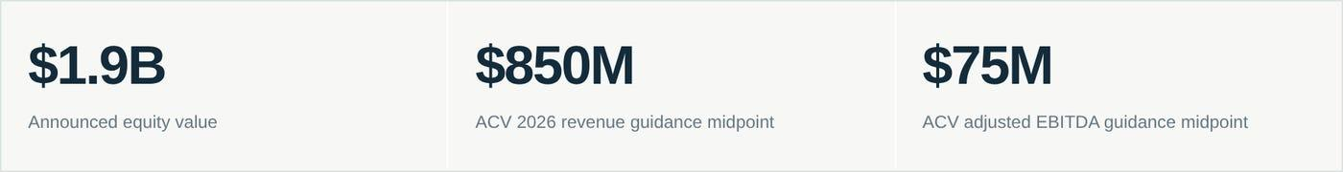
ACV’s August guidance calls for $845 million to $855 million of revenue and $73 million to $77 million of adjusted EBITDA for 2026, alongside a GAAP net loss. Those are standalone forecasts issued before the acquisition announcement, not combined-company targets. ACV Q2 results and outlook.
The headline equity purchase price is 2.24 times midpoint revenue and 25.3 times midpoint adjusted EBITDA. These are equity-price ratios, not enterprise-value multiples. The first ratio can look inexpensive for a technology platform. The second asks investors to pay for a substantial amount of future improvement. Neither captures the cash ultimately available to an owner.
Two details sharpen the interpretation. The announced 45% premium uses ACV’s unaffected August 10 closing price, rather than the immediately preceding close. Management expects the transaction to be EPS-neutral in the first full ownership year and accretive in fiscal 2028 and beyond. It has not supplied a dollar synergy target in the announcement. Transaction terms and expected benefits.
A premium to a depressed or unaffected share price says something about negotiations. It says little about whether the acquired assets earn their cost of capital. Likewise, a favorable earnings comparison can coexist with a disappointing investment return if the opportunity cost of the purchase price is higher.
Our question is consequently specific: what operating changes would allow ACV to generate materially more cash than it could produce independently, and how much of that improvement does Copart’s price already require?
02 / THE MOAT TEST

The scarce asset changes when the seller changes

The Magnificent 493 2

Copart (CPRT): Wrecked stock or hidden bargain?

Copart’s stock is trading at a 10-year valuation low. Here is what the market is getting wrong (and right) about its moat.
The Magnificent 493
Aug 27, 2026
Copart buys wrecked cars from insurance companies and resells them to whoever will pay the most for them: a dismantler, a rebuilder, an exporter shipping the car overseas. That’s been the business since 1982, when Willis Johnson started it out of a single salvage yard in Vallejo, California, after years running his father’s dismantling operation. It went public on Nasdaq in 1994 and has spent three decades expanding from that one lot into roughly 280 locations across 11 countries, with something like a million registered buyers on the platform. That is no where close to as exciting Tesla’s business model is. But, it has made for one of the more durable two-sided marketplaces in American industry, and for most of the last decade the stock compounded quietly enough that most people never noticed.
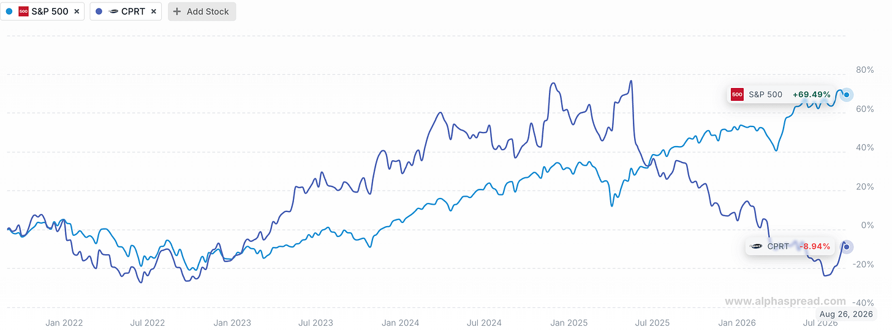
However, it has come in somewhat of the spotlight now, for the wrong reasons. Copart is down roughly 45% from its all-time high above $63 in May 2025, trading in the low-to-mid $30s. Jeff Liaw, CEO since April 2024, announced on June 29th that he’d step down effective July 31st, with Jay Adair, who ran the company from 2010 to 2022, coming back. And for the first time in years, Copart’s main competitor is actually taking share from it. I want to walk through why I still think the underlying business is excellent, and then spend some time on risks ahead.

What actually makes this business hard to compete with
The auction mechanics are simple. Insurer totals a car, hands it to Copart, Copart stores it, photographs it, lists it on their online platform (VB3, rolled out in 2013), and sells it to the highest bidder anywhere in the world. Consignment model mostly, so Copart doesn’t need to own the inventory to make money on it. More buyers competing for each car means a better price for the insurer.

Copart Sun Valley, CA
The part that’s easy to skip past, because it’s not a product feature, is land. Copart owns roughly 90% of the 20,000+ acres it operates, where its historical main competitor leased most of its footprint. That sounds like a boring balance-sheet line until a hurricane hits. Copart keeps “Mega Yards,” mostly idle land in storm-prone regions, specifically so it can absorb tens of thousands of vehicles arriving at once after a catastrophic weather event. A leased-land competitor can’t do that on short notice; you can’t just conjure ten thousand parking spaces the week Hurricane Helene makes landfall. It’s also a better position in an ordinary year: no rent, no lease renewal risk, and land carried on the books at whatever it cost decades ago, worth a lot more than that now. A new entrant would need to assemble a comparable land footprint and then let a chunk of it sit empty most years, waiting for a storm that might not come. I think that’s the actual moat.

The numbers, and where they’re softer than they look
Q3 2026 showed a business under real volume pressure still finding ways to grow.
- Revenue was $1.237 billion, up 2.1%.
- Gross profit came to $572.6 million, up 3.7%.
- Operating income rose 2.8% to $464.3 million
- Operating margin actually improved to 38% of revenue from 37% a year earlier, which for a company facing declining unit volumes is worth sitting with for a second.
- Net income dipped slightly, down 1% to $402.4 million.
- Diluted EPS still rose 2.4% to $0.43 because the diluted share count fell 3.6% on buybacks.
Nine months in, revenue is essentially flat at $3.51 billion, net income essentially flat at $1.157 billion, diluted EPS up 1.7% to $1.2. The business is not really growing right now, propped up modestly by financial engineering rather than operations. I don’t think that’s a scandal, but I do think it’s worth being honest about.
Copart makes its money by auctioning off wrecked vehicles for insurance companies, and its overall revenue is currently holding steady because two opposing trends are balancing each other out. On the negative side, the total number of cars entering Copart's system is shrinking as global sales volume fell 2.7% and US volume dropped 4.2% - mainly because rising insurance rates are leading more drivers to drop full coverage, meaning fewer damaged cars ever reach insurers in the first place. However, Copart is offsetting this drop because the average selling price of U.S. cars hit an all-time high (up 4.1%) and international revenue grew 14.1%, powered mostly by the U.K., Germany, and Canada. US total loss frequency, the share of accidents insurers write off entirely rather than repair, hit a record 23.6% in the most recent calendar quarter, because repair costs and parts prices keep climbing. If that keeps going, more cars flow into Copart’s pipeline over time even as fewer people carry full coverage to begin with. I don’t know yet which force wins.
ROIC has run in the high-20s to low-30s for a decade, currently around 30%. The balance sheet gives management every option: no meaningful debt, $3.35 billion in cash and equivalents plus another $846 million in held-to-maturity T-Bills, over $5 billion in total liquidity including the untapped credit facility. And management has been putting that liquidity to work: 43.4 million shares repurchased for $1.63 billion over the nine months, at a weighted average price of $37.63, well above where the stock trades today. That’s either a very good buy or a mistake management is currently sitting on a paper loss on. I lean toward the former, but it’s a real bet.

Why the stock is where it is
Three things happened:
- The leadership change is the least concerning to me, mechanically. Liaw joined as CFO in 2016, became President in 2019, Co-CEO in 2022, sole CEO in 2024. A decade of institutional knowledge, and he’s staying on as special advisor through the transition. Adair, the guy replacing him, already ran this company for twelve years. This is about as low-risk a succession as a public company can manage on paper.
- More interesting, and more genuinely uncertain, is the competitive picture. Copart’s primary competitor, Insurance Auto Auctions, was acquired by Ritchie Bros. in 2023 and now operates as RB Global. RB Global grew units roughly 4.7% YOY in the most recent comparable period while Copart’s units fell 2.8%. Reporting has pointed to Progressive, a fast-growing insurer, shifting meaningful volume to RB Global as part of a multi-carrier sourcing strategy. Copart still holds an estimated 45-50% of US salvage volume against RB Global’s 30-35%, so this is share moving inside a two-player market, not a new entrant breaking in. But it’s the first real evidence in years that a competitor can take volume from Copart at all.
- There’s also something I missed in my first pass at this company and only caught after going through the 10-Q. The DOJ has an open investigation into Copart, dating back to a letter the company received in October 2023, over potential violations of money-laundering laws related to how it monitors its auction platform members. Copart says it’s cooperating, and the filing gives no indication of scope or likely outcome. It’s been sitting there for almost three years without resolution, which could mean it’s slow-moving and immaterial, or could mean the opposite.
Put those three things together and you get a stock where analyst price targets currently range from the mid-$20s to the low-$50s. The market genuinely disagrees about what this is worth right now.

What would actually break this
If RB Global keeps taking share from Progressive-sized accounts over the next two or three quarters, not just one, that’s a real problem for the “structural duopoly” part of the thesis. Worth tracking unit growth at both companies, not just Copart’s.
If the drop in full-coverage insurance turns out to be a permanent shift in how Americans buy auto insurance rather than a response to a temporary premium spike, that shrinks the pool of cars that ever reach Copart’s system for good, regardless of how the total-loss tailwind plays out.
And the DOJ investigation. I’d put this on the list not because I think it’s likely to be severe, but because I genuinely don’t have a read on it, and “I don’t have a read on it” is itself relevant information for anyone deciding whether to buy the stock this month versus waiting for more clarity.
None of this, as far as I can tell, touches the actual mechanism of the moat. The land is still owned. The buyer network is still global. What’s changed is that the market now has real, current reasons to ask whether “hard to replicate” still means what it used to.

Where we land
Copart is still, by the numbers, an excellent business: 30% ROIC sustained over a decade, no debt, a specific and hard-to-copy structural advantage in land ownership that a well-funded competitor still hasn’t matched. What’s different from a year ago is that there’s now live evidence the moat can be tested, on top of a leadership change the market doesn’t yet fully trust and an open federal investigation nobody can currently size.
Copart currently trades around $30-$34 per share at a P/E ratio of about 19x to 21x. This current P/E represents a roughly 35% to 40% discount from its 5-year median P/E of nearly 33x and its early 2025 peak near 40x. Valuation multiple sits near 10-year historical lows (this makes it extremely attractive, but we need to be rational with the risks mentioned too). Despite the headwinds, Copart still maintains a pristine financial foundation with more cash than debt, industry-leading margins, and strong long-term tailwinds as high vehicle repair costs drive up total loss rates.
I’m watching three things over the next couple of quarters: whether Copart’s US volumes stabilize or keep losing ground to RB Global, whether Adair’s return produces any real strategic shift, and whether the DOJ matter moves toward resolution or just keeps sitting there. All three should be visible well before the above valuation considerations resolves itself. However, the stock will rerate once we have that information.
This isn’t a recommendation to buy, hold, or sell. That depends on your own portfolio and how much uncertainty you’re comfortable holding, and this one has more of it attached than either name we’ve covered so far. We’ll keep watching and tell you what the numbers actually say next quarter.

Tab 19

